

AN INDUSTRIAL TECHNICAL REPORT

FOR

STUDENTS’ WORK EXPERIENCE SCHEME
(SIWES)

UNDERTAKEN AT
NATIONAL CENTER FOR AGRICULTURAL MECHANIZATION (NCAM)

BY

OLUSHOLA JULIUS KEHINDE
MATRIC NUMBER: ND/23/ABE/FT/0012

SUBMITTED TO
THE DEPARTMENT OF AGRICULTURAL AND BIO-ENVIRONMENTAL ENGINEERING
KWARA STATE POLYTECHNIC, ILORIN

JANUARY, 2025

ACKNOWLEDGEMENT
I am deeply grateful to Almighty, who has graciously preserved my life from the beginning to the end of this training program. The experience was truly impactful, but it would not have been possible without the support and assistance of many individuals, to whom I owe my sincere thanks.
First and foremost, I would like to express my heartfelt gratitude to the engineers I worked directly with: Engr. Aregbe, Engr. Gbenga, and Engr. Jamiu (Alfa). Their constant guidance, attention, and mentorship throughout the program were invaluable. I am equally thankful to Engr. Yinka, Engr. Wale and the Workshop Manager Engr. Olubo who offered additional guidance and support during the training.
My appreciation also goes to my fellow SIWES students, Abass, Brother Jamiu, Juwon and Sister Zainab, for their unwavering support and camaraderie.

DEDICATION
I dedicate this report to Almighty for His boundless grace, unwavering love, and immeasurable faithfulness, and for preserving my life throughout the duration of my SIWES program.
I also extend my heartfelt gratitude to my family for their unwavering support and encouragement during the entire training period, and to all my supervisors and colleagues for their cooperation and companionship throughout this journey.

TABLE OF CONTENT

ACKNOWLEDGEMENT ii
DEDICATION iii
TABLE OF CONTENT iv
ABSTRACT vi
CHAPTER ONE 1
INTRODUCTION TO SIWES 1
1.1 Historical Background of SIWES 1
1.2 Aims and Objectives of SIWES 2
1.3 Importance of SIWES 3
CHAPTER TWO 4
ORGANIZATION OVERVIEW AND STRUCTURE 4
2.1 Brief History of the National Centre for Agricultural Mechanization (NCAM) 4
2.2 Aims and Objectives of NCAM 5
2.3 Organizational Structure of NCAM 6
CHAPTER THREE 9
ENGINEERING AND SCIENTIFIC SERVICE DEPARTMENT 9
3.1 Introduction to the Engineering and Scientific Service (ESS) Department 9
3.2 Functions and Responsibilities 12
3.3 Operations Carried Out at the Workshop 13
3.4. Marking-out and Cutting Operation 13
3.4.1 Drilling Operation 13
3.4.2 Welding Operation 13
3.4.3 Grinding Operation 14
CHAPTER FOUR 15
PROJECT WORKED ON AND EXPERIENCE GAINED 15
4.1 Design Considerations for a Melon Sheller 15
4.1.1 Materials Selection 16
4.1.2 Component Description 16
CHAPTER FIVE 18
CONCLUSION AND RECOMMENDATION 18
5.1 Conclusion 18
5.2 Recommendation 18
5.2.1 For the Organization (NCAM) 18
5.2.2 For ITF 19
5.2.3 For the Institution (Unilorin) 19
5.3.4 For the Government 19

ABSTRACT

The Students’ Industrial Work Experience Scheme (SIWES), also known as Industrial Training (IT), is a structured yearly program designed for students in 300 level, particularly those in the Faculties of Engineering and Technology across Nigerian universities. The program spans 12 weeks (i.e Three (3) Months), allowing students to gain practical industry experience. Unlike a vacation job, SIWES is an essential component of academic curricula and a mandatory requirement for graduation. The scheme aims to equip students with the practical skills and exposure necessary to complement their theoretical studies.
This technical report is a detailed account of the SIWES program undertaken by Olushola Julius Kehinde (Matric Number: ND/23/ABE/FT/0012) from the Department of Agricultural Bio-environmental Engineering, Institute of Technology. The training took place at the National Centre for Agricultural Mechanization (NCAM), located at Km 20 Ilorin-Lokoja Highway, Ilorin, Kwara State. The report documents the experiences, knowledge gained, and the various technical activities carried out during the program.
Overall, I gained hands-on experience across various engineering projects and tasks, including the design and development of agricultural machinery such as the Threshing Machine, Groundnut Decorticator, Melon Sheller, and a Shredding Machines. I participated in activities like cutting and grinding metal plates, drilling and shearing metals, and operating bending and shearing machines. I was also involved in assembling machine components, error correction, and supervising welding operations.

CHAPTER ONE

INTRODUCTION TO SIWES

1.1 Historical Background of SIWES
The Students Industrial Work Experience Scheme (SIWES) is a skill acquisition initiative introduced by the Federal Government of Nigeria with the primary objective of bridging the gap between theoretical education and practical industrial experience for students in higher institutions. The scheme is designed to equip students in Engineering, Technology, Sciences, Agriculture, Medicine, Management, and other fields with hands-on experience that complements their classroom learning. The program applies to students in universities, polytechnics, monotechnics, and colleges of education across Nigeria.
SIWES was first introduced during the 1973/1974 academic session and was initially funded by the Industrial Training Fund (ITF). At the time, there was a growing concern that graduates lacked the necessary practical skills and industrial exposure to seamlessly integrate into the workforce. Many industries had to spend extended periods retraining newly employed graduates to equip them with practical skills. The scheme was created to address this deficiency by exposing students to real-world industrial environments during their academic programs, thereby reducing the time and cost involved in training them after graduation.
The scheme has since become an integral part of the Minimum Academic Standards (MAS) as established by the National Universities Commission (NUC), the National Board for Technical Education (NBTE), and the National Commission for Colleges of Education (NCCE). SIWES plays a crucial role in ensuring that students, particularly in technical and vocational fields, experience the practical side of their studies before graduation.

1.2 Aims and Objectives of SIWES
SIWES is a strategic initiative designed primarily to facilitate the acquisition of relevant skills by students in their respective fields of study. By immersing students in real-life work environments, the program enhances their employability and prepares them for the challenges they will face upon graduation. Below are the specific objectives of SIWES:
Provide Industrial Placement: SIWES offers placement opportunities in industries for students enrolled in higher institutions. These placements are approved by the relevant regulatory authorities, such as the National Universities Commission (NUC), the National Board for Technical Education (NBTE), and the National Commission for Colleges of Education (NCCE). The aim is to allow students to acquire hands-on work experience and technical skills relevant to their academic programs.
Prepare Students for the Real Work Environment: The program helps prepare students for the realities of the workplace by allowing them to experience first-hand the dynamics of the work environment. This exposure gives them a clearer understanding of professional expectations and challenges, fostering a smoother transition from school to the workforce.
Enhance Future Employment Opportunities: By offering students exposure to potential employers and work environments, SIWES also serves as a networking opportunity. Students may establish contacts with industry professionals and companies, potentially enhancing their prospects for future employment.

1.3 Importance of SIWES
Since its inception, SIWES has played a critical role in shaping the quality of education and workforce readiness in Nigeria, particularly in the fields of science, engineering, and technology. Below are some of the key contributions of the SIWES program:
- Improvement in Science and Technology Education: The program has significantly enhanced the practical aspect of science and technology education in Nigeria. By providing students with hands-on experience, it complements theoretical learning and produces graduates who are better equipped to apply their knowledge in practical situations.
- Increased Employment Opportunities: Graduates who have participated in SIWES are more employable due to their exposure to real-world work environments. Employers tend to prefer candidates who possess not only academic qualifications but also practical experience, which SIWES provides.
- Better Standard of Living: The program indirectly contributes to an improved standard of living by producing skilled graduates who are more likely to secure well-paying jobs in the industrial and technological sectors. This contributes to national development by creating a pool of highly skilled professionals.
- Production of Skilled Graduates: SIWES ensures that students graduate with not only theoretical knowledge but also the practical skills necessary to thrive in their respective fields.

CHAPTER TWO

ORGANIZATION OVERVIEW AND STRUCTURE

2.1 Brief History of the National Centre for Agricultural Mechanization (NCAM)
The history of the National Centre for Agricultural Mechanization (NCAM) dates back to 1974, when the Federal Ministry of Agriculture and Natural Resources recognized the need for an institution focused on agricultural mechanization. This need was highlighted in a report titled "Proposal for the Establishment of National Centre for Agricultural Mechanization (NCAM)," submitted by a study team. The Centre was formally established by the promulgation of Decree No. 35 of 1990, marking the beginning of its journey toward the development of sustainable mechanization technologies suited to Nigeria's unique agricultural conditions.
A variety of factors motivated the establishment of NCAM. Imported agricultural machinery often proved incompatible with Nigeria’s diverse agro-climatic conditions, crops, and farming systems. Additionally, the socio-economic realities of rural farmers, combined with poor after-sales services, irregular spare part supply, and technical difficulties in maintaining imported equipment, hindered the adoption of foreign technologies. Rural labor shortages due to urban migration, coupled with the low income associated with subsistence farming, further exacerbated the need for indigenous mechanization solutions.
The Federal Government, convinced that Nigeria’s agricultural development could only be sustained through locally developed and manufactured technologies, tasked NCAM with bridging this gap. The Centre has since become the highest level of agricultural research and mechanization in the country and stands as the largest institution of its kind in West Africa.

2.2 Aims and Objectives of NCAM
The primary aims and objectives of NCAM are geared towards advancing agricultural mechanization by developing indigenous technologies and practices. These objectives include:
- Innovative Research and Development: Conduct adaptive and innovative research to develop locally appropriate farming and processing machines.
- Cost-Effective Machinery Design: Design simple, low-cost agricultural equipment that can be manufactured using local materials and skills.
- Certification of Agricultural Equipment: Standardize and certify, in collaboration with the Standards Organization of Nigeria (SON), the machinery and engineering practices used within Nigeria.
- Evaluation of Existing Technologies: Assess and evaluate modern mechanical technologies and equipment developed by other institutions for their suitability and adoption in Nigeria.
- Promotion of Indigenous Mechanization: Ensure that mechanization efforts prioritize local environmental, economic, and social factors, emphasizing equipment that addresses local farming challenges.
NCAM’s focus includes several key agricultural processes such as land clearing, irrigation, soil erosion control, planting, weed management, harvesting, processing, packaging, and storage. By concentrating on these areas, the Centre seeks to remove bottlenecks in agricultural production, thereby promoting efficiency and sustainability. These tasks are carried out in collaboration with other research institutions, government agencies, and private sector partners to avoid duplication of efforts.

2.3 Organizational Structure of NCAM
The organizational structure of NCAM is divided into two broad components: the Administrative and Technical Departments.
(a) Administrative Departments and Units
The administrative wing of NCAM provides the necessary support to ensure the smooth functioning of the Centre. Key units under this department include:
- Director’s Office: Overseeing the overall management of the Centre.
- Testing, Standardization, and Certification Section: Ensuring compliance with industry standards for agricultural equipment.
- Works and Estate Management Section: Managing the Centre’s physical infrastructure.
- Library Section: Maintaining a collection of relevant academic and research resources.
- Internal Audit Unit: Ensuring financial accountability and transparency.
- Publications Unit: Responsible for documenting and publishing NCAM’s research and development work.
- Linkage Program Unit: Facilitating collaboration with external organizations.
- Security Unit: Ensuring the safety and security of the Centre.
- Landscaping Unit: Managing the Centre’s green spaces.
- Computing and Data Processing Unit: Handling the Centre's IT infrastructure and data management.
- Farm Management Section: Overseeing agricultural activities within the Centre.
- Personnel and Finance Department: Managing human resources and financial operations.

(b) Technical Departments
NCAM’s technical departments are responsible for the research, development, and maintenance of agricultural equipment. The major departments are:
- Farm Power and Machinery (FPM): This department designs, develops, and fabricates new agricultural machinery prototypes. They are also tasked with maintaining farm equipment, including tractors and implements such as ploughs, harrows, ridgers, planters, and harvesters.
- Processing and Storage Engineering (PSE): The PSE department focuses on post-harvest processing, storage, and transportation of agricultural products. They work on optimizing the use of agricultural by-products and improving storage techniques to reduce losses.
- Land and Water Management Engineering (LWM): This department deals with soil management, irrigation systems, and crop cultivation. They are responsible for monitoring soil conditions, water usage, and the overall health of crops like tomatoes, cucumbers, and peppers grown at the Centre.
- Engineering and Scientific Services (ESS): ESS serves as the technical nucleus of NCAM, where nearly all the Centre’s technical work is carried out. This department focuses on the design, construction, and maintenance of agricultural machines and equipment.
- Educational, Training, and Extension (ETE): The ETE department plays a critical role in disseminating agricultural knowledge and practices to farmers across the country. It ensures that innovations in mechanization and farming techniques reach those who can apply them in the field, thus contributing to increased agricultural production.
Through these departments, NCAM works to fulfill its mandate of enhancing agricultural productivity and sustainability through mechanization tailored to Nigeria’s unique challenges.
Below is the organizational chart of NCAM:
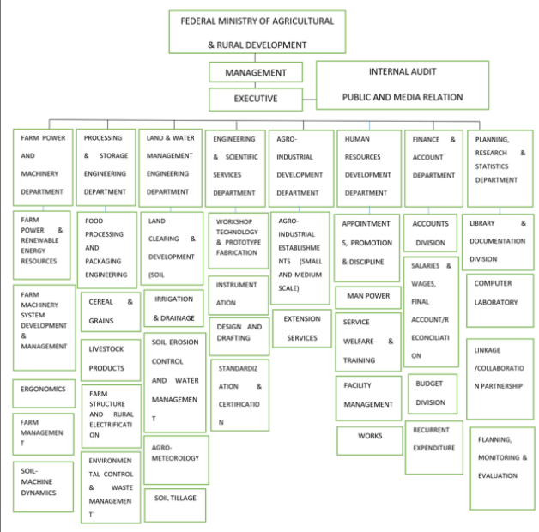
Fig. 2.1: Organizational chart of National Center for Agricultural Mechanization

CHAPTER THREE

ENGINEERING AND SCIENTIFIC SERVICE DEPARTMENT

3.1 Introduction to the Engineering and Scientific Service (ESS) Department
The Engineering and Scientific Service (ESS) Department serves as a technical hub within the center, specializing in the design, fabrication, and maintenance of agricultural machines and equipment. This includes Threshing Machine, various types of Decorticator (for groundnut, cowpea, and multiple crops), Melon Shellers, and more. The department not only focuses on equipment development but also provides services such as operations done on the Lathe Machine e.g. Knurling, Facing, Threading, Drilling to support and aid in the design of machines. ESS serves as the technical nucleus of NCAM, where nearly all the Centre’s technical work is carried out. This department focuses on the design, construction, and maintenance of agricultural machines and equipment.
Organizationally, the Engineering and Scientific Service (ESS) Department is divided into specialized units/sections, each with distinct roles and responsibilities. Internally, the department encompasses several sub-units dedicated to specific areas: Fabrication, Machinist, and Renewable Energy Resources.

Table 3.1 Summary of Tools and Machines in the Farm Power and Machinery Department
S/N | TOOLS AND MACHINES | USES
1 | Vernier Calipers and Micrometer Screw Gauge | Measuring linear, internal, external diameter, and depth of holes.
2 | Measuring Tape | For measuring length.
3 | Try Square | For maintaining square and orthogonal checks.
4 | Scriber | For marking out.
5 | Hacksaw | For cutting materials.
6 | Spirit Level | Used to maintain plane positioning.
8 | Chisel | For force cutting of materials.
9 | Hand Files | Used for surface smoothening.
10 | Work Bench | Where work is performed.
11 | Tap and Wrench | For internal threading.
12 | Stock and Die | Used for external threading.
13 | Spanners | For fastening and unfastening bolts and nuts.
14 | Screw Driver | For fastening and unfastening screws.
15 | Allen Key | For fastening and unfastening Allen screws.
16 | Anvil | Used during forging and hammering.
17 | Guillotine Machine | Used for cutting metal sheets less than 3 mm.
18 | Electric Power Grinder | For grinding rough surfaces and cutting metals.

3.2 Functions and Responsibilities
The department's functions encompass:
- Design and Development: Innovating and enhancing agricultural machinery to boost productivity and minimize labor.
- Fabrication: Creating machinery components and assembling them into functional units.
- Testing: Evaluating machinery performance under various conditions and making necessary adjustments.
- Maintenance: Ensuring the longevity and reliability of machinery through regular upkeep and repairs.
- Training and Support: Educating farmers, students, and professionals on the proper use and maintenance of agricultural machinery.

3.3 Operations Carried Out at the Workshop

3.4. Marking-out and Cutting Operation
Marking out involves accurately delineating the size and shape of steel plates before cutting. Cutting processes involve fracturing the material to remove excess and obtain the final part. Various tools are used to cut materials, with shearing being the most common method. Specialized band saws with hardened blades and a feed mechanism enable even cutting, while abrasive cut-off saws, or chop saws, utilize a steel cutting abrasive disk. Cutting torches can handle large sections of steel efficiently (Adebayo et al., 2023).

3.4.1 Drilling Operation
Drilling is the process of creating round holes in metal pieces using a drilling machine. The vertical drilling machine is commonly used in fitting shops. The process begins by marking the workpiece with a center punch at the designated hole center. The piece is then clamped and positioned on the machine's adjustable table, where a drill is fitted into the chuck. As the spindle lowers, the rotating drill is pressed into the workpiece to produce the desired hole. Coolants such as oil or soapy water are employed to prevent drill edge spoilage during the operation (Khan et al., 2023).

3.4.2 Welding Operation
Welding is a fabrication process that joins materials, typically metals, through fusion. This process often involves melting the workpieces and adding a filler material to form a molten weld pool that solidifies to create a robust joint. Compared to soldering and brazing, which bond materials without melting the base workpieces, welding requires greater temperatures (Weman, 2003).
The number of different welding processes has significantly increased, with over 50 methods currently in use. This discussion will focus on three common electric arc welding types: shielded metal arc welding (SMAW), gas metal arc welding (GMAW), and gas tungsten arc welding (GTAW). All methods employ an electric power supply to create an arc that melts the base metal(s), forming a molten pool where filler wire is introduced to create the weld (Ishola et al., 2023).
- Shielded Metal Arc Welding (SMAW): This process employs a flux-covered metal electrode to create an electric arc, melting both the electrode and the base material. SMAW is known for its flexibility, portability, and versatility, making it suitable for a wide range of metals (Lincoln, 1994).
- Gas Welding: This process, also known as oxy-fuel welding, uses a flame generated by burning oxygen and acetylene to weld metals. While its popularity has decreased in industrial applications, it remains favored for certain tasks like pipe welding and metal fabrication (Weman, 2003).

3.4.3 Grinding Operation
Grinding is a metal removal process utilizing grinding wheels. The workpiece is pressed against a high-speed rotating wheel, with the surplus metal removed through abrasion, yielding a smooth finish due to the small cutting edges on the wheel. Grinding wheels consist of abrasive grains held together by a bond such as clay, shellac, or rubber. There are two main types of abrasives: natural (e.g., corundum and emery) and artificial (e.g., silicon carbide) (Adebayo et al., 2023).

CHAPTER FOUR

PROJECT WORKED ON AND EXPERIENCE GAINED

4.1 Design Considerations for a Melon Sheller
In this project, I worked alongside Engr. Ayobami to develop a Melon Sheller which was requested from Benin Republic. The machine’s design was based on several key criteria. Designing a melon sheller involves some key criteria to ensure it performs efficiently and effectively. Here are some considerations:
- Capacity and Throughput: The machine should be capable of handling a specific amount of melons per hour, depending on the intended scale of operation. This includes factors like the size and weight of the melons and the desired processing rate (e.g., melons per minute).
- Shell Removal Efficiency: The primary function of the machine is to remove the outer shell of the melon without damaging the edible flesh. This requires a suitable mechanism for peeling or cutting that works across various melon types (e.g., watermelon, cantaloupe). The design must account for different rind thicknesses and the shape of the melon.
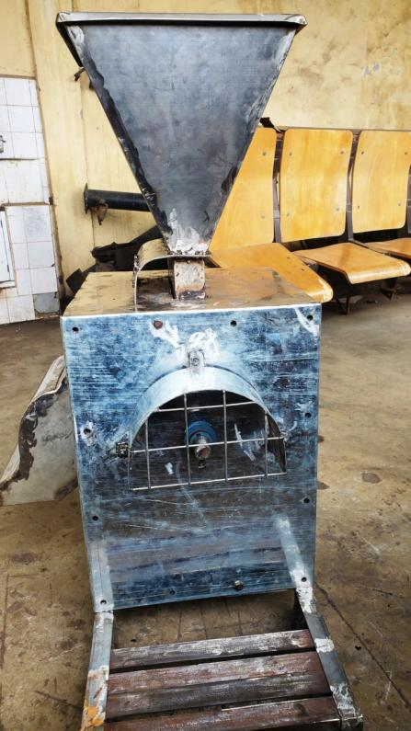
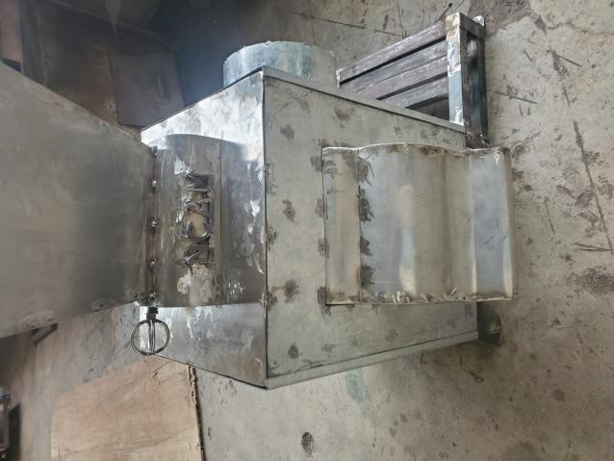
Figure 4.1: A Designed Melon Sheller with NCAM logo inscribed on it

- Noise and Vibration Control: Minimizing noise and vibration is essential for improving operator comfort and complying with workplace regulations.
- Automation and Control: Integration with automated systems for sorting, processing and packaging the shelled melons can improve efficiency. This includes sensors to detect melon size, ripeness, or defects before shelling.
Designing a melon sheller requires careful consideration of these criteria to balance productivity, cost and performance, ensuring high throughput and minimal waste while maintaining the quality of the melon flesh.

Materials Selection
When selecting materials for a melon sheller, the choice of materials is critical to ensuring durability, food safety, efficiency, and ease of maintenance. The materials should be able to withstand the forces involved in shelling, resist wear and corrosion from contact with water-rich melons, and be safe for food processing.

Component Description
The design of a melon sheller involves a variety of components, each serving a specific function to ensure the efficient and safe peeling of melons.
- Frame and Structure: The frame is the structural backbone of the melon sheller. It provides support and houses all other components such as the motors, shelling mechanism, and feeding system.
- Shelling Mechanism: This is the core part of the melon sheller, where the rind of the melon is removed. The shelling mechanism can use cutting blades, rollers, or peeling cups to strip away the outer skin.
- Drive Mechanism: The drive mechanism powers the melon sheller’s moving parts, including the feeding system, rotary blades, and rollers,. It can be powered by an electric motor, hydraulic system or pneumatic system depending on the design.
  - My Participation
Throughout the development and designing of the Melon Sheller and some machines (e.g. Maize Thresher), I actively participating in various stages of the fabrication and assembly process.
I was also responsible for cutting various parts of the Melon Sheller including the stand and frame components using precision tools to ensure they meet the required dimensions. I involved myself in the welding process as well and bending of irons to different angles.
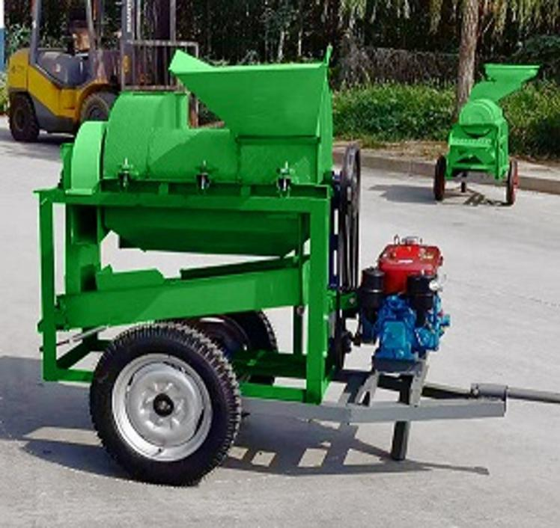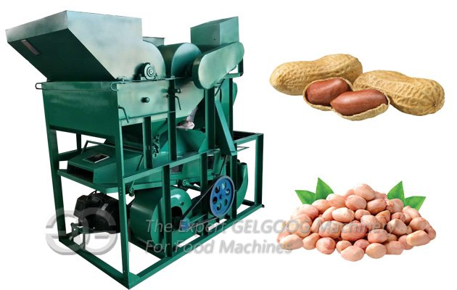
SOME IMAGES OF DIFFERENT MACHINES IN WHICH I PARTICIPATED IN THE DESIGNING AND FABRICATION AND TESTING OF THE MACHINE AS WELL

CHAPTER FIVE

CONCLUSION AND RECOMMENDATION

5.1 Conclusion
Throughout this program, I was involved in multiple aspects of the design, fabrication, assembly, and testing of various agricultural machinery, including the Threshing Machine, Groundnut Decorticator, and several other equipment.
My hands-on experience with cutting, bolting, coupling, and fabricating metal components provided me with a deep understanding of the mechanical aspects of agricultural machinery. This internship not only enhanced my technical skills but also offered valuable insights into the practical challenges and solutions involved in developing agricultural equipment.
Collaborating with engineers and fellow students fostered a team-oriented environment that reinforced the importance of communication and cooperation in engineering projects. Overall, this experience has equipped me with essential skills and knowledge for my future career in agricultural engineering.

5.2 Recommendation

5.2.1 For the Organization (NCAM)
I recommend that NCAM continue to promote hands-on learning opportunities for interns by providing structured training programs that cover a wide range of topics related to agricultural machinery design and fabrication. This will not only enhance the skills of future interns but also contribute to the development of innovative solutions for the agricultural sector.

5.2.2 For ITF
The Industrial Training Fund (ITF) should consider enhancing support for organizations like NCAM to facilitate better training infrastructure. This includes funding for modern equipment and technologies that will help interns gain relevant and up-to-date experience in the field. Regular workshops and seminars can also be organized to bridge the gap between theory and practice.

5.2.3 For the Institution
The University of Ilorin should strengthen its collaboration with industries by fostering partnerships that provide students with more internship opportunities. Integrating practical training into the curriculum will prepare students better for real-world challenges and enhance their employability upon graduation. Additionally, hosting guest lectures from industry professionals can provide students with insights into current trends and practices in agricultural engineering.

5.3.4 For the Government
The government should increase its investment in agricultural technology research and development to promote innovation in the sector. By providing grants and incentives to organizations that focus on developing agricultural machinery, the government can encourage the creation of cost-effective and efficient solutions for smallholder farmers. Additionally, establishing policies that support vocational training in agricultural engineering can equip the workforce with the necessary skills to meet the growing demands of the industry.

