

TECHNICAL REPORT ON
STUDENTS INDUSTRIAL WORKS EXPERIENCE SCHEMES (SIWES)

HELD AT

CHUZY DE-GREAT SERVICES
No 25 Ibrahim Taiwo Road, Ilorin, Kwara State.

PRESENTED BY:

OLOYEDE CALEB AJIBOLA
ND/23/MEC/PT/0192

SUBMITTED TO:

DEPARTMENT OF MECHANICAL ENGINEERING, INSTITUTE OF TECHNOLOGY (IOT) KWARA STATE POLYTECHNIC, P.M.B 1375 ILORIN KWARA STATE

IN PARTIAL FULFILMENT OF THE REQUIREMENT FOR THE AWARD OF NATIONAL DIPLOMA (ND) IN MECHANICAL ENGINEERING DEPARTMENT KWARA STATE, POLYTECHNICS ILORIN, NIGERIA.

AUGUST - NOVERMBER 2024

DEDICATION
I am delight to dedicate this report to Almighty God who gave me the grace and opportunity to complete this programme.

ACKNOWLEDGMENT
I thank God Almighty for his mercy and grace that kept me all through my SIWES period.
I am greatly indebted to my parents, Mr. & Mrs. Oloyede for their morally, spiritually and financially, word of encouragement and prayer given to me, who make my SIWES programme successful and also my relatives and siblings

PREFACE
The student industrial work experience scheme (SIWES) helps in exposing students to the practical application of their course and to get used to equipments and machines used in the factory. The SIWES was established to promote student skill in industrial practice and pre-expose them to working experience in industrial setting.
The SIWES programme covered a period of four months from August to November 2024 and it is a partial fulfilment of a two year academic programme to obtain an ND certificate in Engineering. The report explains the description of work done.

TABLE OF CONTENT

Title page i
Dedication ii
Acknowledgment iii
Preface iv
Table of Content v
CHAPTER ONE
1.0 Introduction 1
1.1 Definition of SIWES 1
1.2 Aim and Objectives of SIWES 1
CHAPTER TWO
2.0 Brief history of the organization 3
2.1 Organization chart 4
CHAPTER THREE
3.0 Workdone 5
3.1 Various tools and equipment and their function in automobile workshop 5
3.2 The Engine 6
3.3 Part of an engine and their functions 6
3.4 The fuel system 13
3.5 Engine system and problem diagnosis 14
3.6 Method of servicing motor vehicle 16
3.7 Different between automatic vehicle and manual vehicle 17
3.8 Launch control 18
3.9 Uses of launch control 19
3.10 Launch control mode of working 19
3.11 Gear box fault and possible causes 19
3.12 Fault and solution on gearbox 20
CHAPTER FOUR
4.0 Experience gain 21
CHAPTER FIVE
5.0 Conclusion 22
5.1 Suggestion and Recommendation to the organization and Polytechnic concerning the SIWES programme 22

CHAPTER ONE
- INTRODUCTION
SIWES program was established in year 1973 by the federal Government of Nigeria through the industrial Training Fund (ITF) under the National Board of Technical Education (N.B.T.E) and it has its head quarters in Jos, plateau state.
There are other reasons behind the establishment of SIWES program, but the major reason is to learn the practical aspect of their field of study while still in course of study, which will help to face the future challenges in their respective field of study.
1.1 DEFINITION OF SIWES
Student Industrial Work Experience Scheme (SIWES) can simply be defined as a course by which student are exposed to practical training in their respective field of study. Its aim is to expose students to work practically in their respective disciplines. However, the scheme therefore was introduce to enable students match theoretical classroom knowledge with related practical knowledge in the industrial environment.
1.2 AIM AND OBJECTIVES OF SIWES
- SIWES helps the student to have experience and develop during industrial training.
- To improve students in the practical aspect of their field.
- It helps to improve quality of student in the level of their technology.
- It makes student to find their interests in the various fields of study.
- To prepare student for the future.

CHAPTER TWO
2.0 BRIEF HISTORY OF THE ORGANIZATION
Ungbeje Motor Clinic was established in year 2005 and it is compose of the highly technical.
The Chairman of the company has experience in automobile fixing and repair especially in all kinds of cars he has works in many company. He has been a Technician Engineer since year 1990. He is an Higher Ordinary National Diploma (HND) holder and a COREN registered Engineer presently he has many apprentice under his company he trained many SIWES students the company has done many cars fittings and repair with difference company and customers and many more.
2.1 ORGANIZATION CHART
MANAGING DIRECTOR

SECRETARY

STORE KEEPER

STUDENTS

CHAPTER THREE
3.0 WORKDONE
3.1 VARIOUS TOOLS AND EQUIPMENT AND THEIR FUNCTION IN AUTOMOBILE WORK SHOP
Tools and equipment is any tool or apparatus that is power or not power tool used in automobile workshops.
- Sets of spanner: they are strong metal with jaw end for fitting over and twisting nut. Different kinds of spanner are adjustable, ring, ordinary, flat and socket spanners.
- Screw driver: used for removing screws, types screw drives are flat and star.
- Pliers: used for holding nuts and bolts, types of pliers are circle, clip long nose and ordinary pliers.
- Adaptor: it is used to hold socket
- Jack: used for lifting vehicle.
- Chisel: for cutting thin sheet metals, types flat and pointed.
- Hammer: for hammering our job. Types of hammer are ball, pen, iron, sledge, milling, millet and ordinary hammers.
- Engine hoist: for removing engine inside vehicle.
- plug spanner: used for removing plugs inside engine
3.2 THE ENGINE
An engine is a machine with moving parts that convert power into motion. The engine is the power house of the motor car; it converts the heat produced by the burning fuel into mechanical energy to turn the wheels. The fuel is a mixture of petrol and air, is burnt in a closed cylinder inside engine hence the name is internal combustion. Petrol and air are mixed in a carburettor and is drawn into a combustion chamber at the top of each cylinder. Pistons inside the cylinder, the compressed mixture which is ignited by a spark plug. As the mixture bums, it expands forcing the piston down on its power stroke.
The up and down movement of the piston is transformed into rotary movement to drive the crankshaft, which in turn transmits power to the wheels, through the clutch, gearbox and final driver. The components part of the car engine are Carburettor, Spark Plug, Piston, Rotary Crankshaft, distributor, oil fitter, oil pump, cylinder block, cylinder head, cylinder, Coil, air fitter, pushrod, valve, fan, fan belt, alternator, timing chain, radiator and gear cover.

3.3 PART OF AN ENGINE AND THEIR FUNCTIONS
Carburettor: Is a device in the internal combustion engine for mixing air with a fuel spray of liquid fuel.
Carburettor is a device for supplying a spark ignition engine with a mixture of fuel and air. Component of carburettors usually include a storage chamber for liquid, fuel, a choke, idling (slow running) jet, a main jet, a venture-shaped, air-flow restriction, an accelerator pump. The quantity of a butterfly-valve reduces the intake of air and allows a fuel- rich charge to be drawn into the cylinders when a cold engine is started. As the engine work up, the choke is gradually open either by hand or automatically by heat- an engine — speed-respossive controllers. The fuel flows out of the idling jet into the intake air as a result of reproduce pressure near the partially closed throttle valve. The main fuel jet comes into action when the throttle valve is further open. Then the venture shaped air-flow restriction create a reduced pressure for drawing fuel from the main jet into the air stream at a rate relates to the air flow so that a nearly constant fuel-air ratio is obtained. The accelerator pump injects fuel into the inlet air when the throttle is opened suddenly

Sparking plug: Is a device for delivering electric current from an ignition system to the combustion chamber of a spark-ignition engine to ignite the compressed fuel/air mixture by an electric spark, while containing combustion pressure within the engine, a spark plug has a mental threaded shell, electrically isolated from a central electrode by a porcelain insulator.

The sparking plug and ignition system

Piston: Is a component of reciprocating engine, reciprocating pump, gas compressor and pneumatic cylinders among other similar mechanisms. It is the moving component that is contained by a cylinder and is made gas- tight by piston rings. In an engine, its purpose it to transfer force from expanding gas in the cylinder to the crankshaft via piston rod and connecting rod. In a pump, the function reversed and force is transferred from the crankshaft to the piston for the purpose of compressing or ejecting the fluid in the cylinder. in some engines, the piston also acts as a valve by covering and uncovering ports in the cylinder wall.
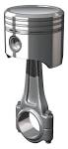
The piston
Crankshaft; is a part of an engine that translates reciprocating linear piston motion into rotation. To convert the reciprocation motion into rotation, the crankshaft has ‘crank throws’ or ‘crankpins’, additional bearing surfaces whose axis is offset from that of the crank, to which the ‘big ends’ of the connecting rods from each cylinder attach. Its typically connects to a flywheel to reduce the pulsation characteristics of the four — strokes cycle, and sometimes a tensional or vibration damper at the opposite end to reduce the tensional vibrations often caused allong the length of the crankshaft by the cylinders farthest from the output end acting on the torsion elasticity of the metal.
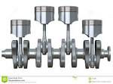

The crankshaft
Oil fitter: An oil fitter is located on the side of the engine block, which is lower, larger part of the engine. An oil pump circulates the oil through the engine and every time the engine oil circulates it passes through the fitter which protects the engine by catching any large particles in the oil that might damage the engine if allowed to circulate freely. The oil fitter serves a dual purpose, as it also protects the engine by retaining a small amount of oil when the car is turned off. The part that makes this retention possible is called the anti-drain back valve. While the engine is at rest, the oil drains into the bottom of the engine without proper lubrication when the car is started again. However the small amount of oil remaining in the fitter will circulate quickly into the top of the engine during the couple of seconds after the car is started, restoring proper lubrication as soon as possible Fig. 9: Oil fitter
Oil pump: it is used to pump oil throughout the engine and it also has a fitter which remove the dirty in the oil before transferring it to the engine.
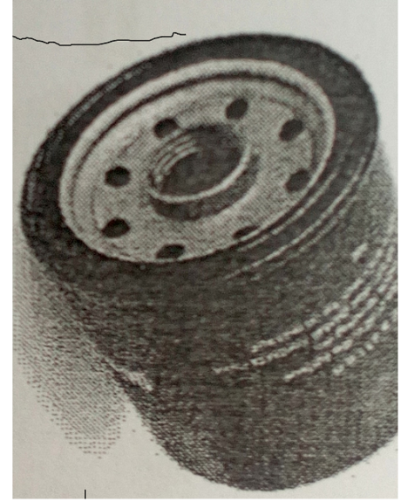
Oil pump
Valve: They are open and close at predetermined times, which for vary with different designs of engine. They control the entry of mixture and allow the exhaust gases to escape. The valves used in motor vehicle engine are called poppet or mushroom valve.
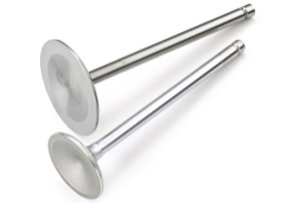
Valve
Fan: Is the device with rotating blades that creates a current of air which cool the radiator.
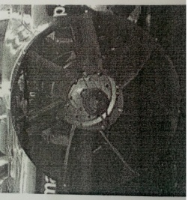
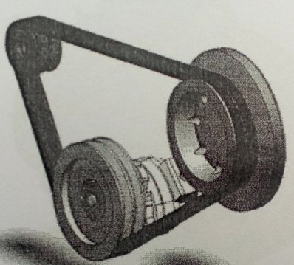
Fan belt: Is a belt which drives the fan that cools the radiator of a motor vehicle. It is a loop with flexible material use as a mechanical linkage for two or more rotating shafts. Belts may be used as a source of motion, to transmit power efficiently, or to track relative movement. Belts are looped over pulleys. In a two pulley, the belt can either drive the pulleys in the same direction or the belt may be crossed, so that the direction of the shaft is opposite. As a source of motion, a conveyor belt is one application where the belt is adapted to the continuously carry a load between two points.

The Fan belt
Radiator: is a cooling device which water in been stored and the water moves into the engine to cool it and return back.
They are heat exchangers use to transfer thermal energy from one medium to another for the purpose of cooling and heating. The majority of radiators are constructed to the function in automobiles, buildings and electronics. The radiator is always the source of heat to its environment,
all through this may be for either purpose of heating, this environment or for cooling the fluid or coolant supplied to it, as for engine cooling. Despite the name, radiators generally transfer the bulk of their heat via convection, not by thermal energy though the term ‘convector’ is used more narrowly. Fig. 17: Radiator
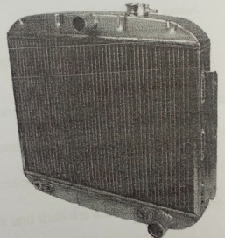

RADIATOR
Top Gasket: it is gasket that sits between the engine block and cylinder head(s) in an internal combustion engine.
Its purpose is to seal the cylinders to endure maximum compression and avoid leakage of coolant or engine oil into the cylinder; such as it is the most critical sealing application in any engine, and, as parts of the combustion chamber it shares the same strength requirements as other combustion chamber components.
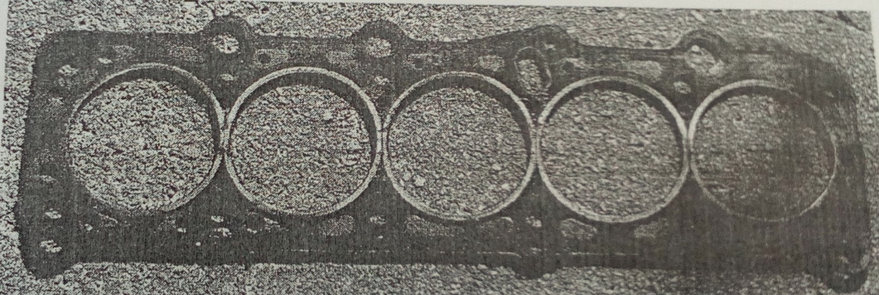
Top gasket
3.4 THE FUEL SYSTEM
The fuel system consists of the fuel tank, fuel gauge, fuel pump, carburettor intake manifold, connecting fuel lines, fuel fitters and accelerator pedals and linkage. The accelerator pedals controls the amount of air fuel mixture entering the engine cylinders and thus the amount of power the engine produces.
1. The fuel tank provides a reservoir or storage container where the fuel is been stored for use.
2. The fuel gauge has an indicator needle on the instrument panel to show how full the tank is and this displayed on the dash board in front of the driver.
3. The fuel pump delivers fuel from the fuel tank to the carburettor under pressure.
4. The carburettor mixes the right proportion of the fuel and air and delivers it into the engine cylinder.

Fuel filter: is a filter in the fuel line that screens out dirt and dust particles from fuel, before getting to the carburettor or injector pump, normally made into cartridge containing a fuel paper.
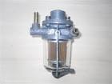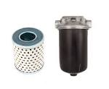
Fuel filters

3.5 ENGINE SYSTEM AND PROBLEM DIAGNOSIS
Engine system and problem diagnosis the engine system as we all know is the conversion of chemical and electrical energy to kinetic energy (which passes motion or movement of the vehicle). These are the main component of vehicle movement.
Therefore, after long months or years of working and the engine develop fault but it is know to everyone using a vehicle that every three to two month on engine oil must be change in a vehicle engine.
However, we should know the types of fault or problem developed in vehicle, the causes and their respective correction.
MISSING WHEN DRIVING A VEHICLE
Causes: if the nozzles is dirty, welt plugs or damage plugs can cause the engine system not function properly.
Solution: changing of the plugs or the plugs should be clean and the nozzles should be service.
HARD STARTING OF VEHICLE
Causes: key starter, fuel pump, disputor timing belt, if all these are not functioning properly it can cause hard starting.
Solution: changing of the key starter, fuel pump and increase the disputor, setting of the timing belt.
MAKING SOME SOUND OR JACKING WHEN DRIVING
Causes: fuel pump, fault may develop true the fuel pump pipe, if the fuel is not supplying to the engine it may causes the jacking, crank shaft and the engine set.
Solution: adjusting the fuel occur from the fuel pump pipe, refill of the crank shaft if it can bear. It should be change and the set belt should also be change.
PUMPING OF WHITE SMOKE FORM THE ENGINE
Causes: melting of the piston rings and dew of the engine oil.
Solution: ringing of the engine or the engine should be change completely, and changing of the engine oil must be done.
PUMPING OF BLACK SMOKE FROM THE ENGINE
Causes: injector or calibrator sometimes the nozzles causes it.
Solution: service them.
BRAKE FAIL PROBLEM
Causes: brake pad or (flexible pipe) master, damage of masters rubbers cause brave problem or if the brake pad is been eaten down causes brake fuel.
Solution: changing of the brake pad or the brake pad should refill, master rubber must be change and replace the cut flexible pipe.
MAKING OF NOISE FROM THE LEGS OF VEHICLE
Causes: noise make from the legs of vehicle can cause from the following. shock absorber, cow ham, uppers ham and shaft, if all these are not working in a good condition or the way they are not suppose to be working, noise will develop from the legs.
Solution: Damage shock absorber should be change, low ham, upper ham if it needs to adjust or change should be done and change of the damage shaft.

3.6 METHOD OF SERVICING MOTOR VEHICLE
A motor vehicle service is a series of maintenance procedures carried out at a set time interval or after the vehicle has travelled a certain distance.
Maintenance tasks commonly carried out during a motor vehicle include;
- Change the engine oil
- Replace the oil filter
- Replace the air filter
- Replace the fuel filter
- Replace the spark plugs
- Tone the engine
- Check level and refill brake fluid
- Check level and refill power steering fluid
- Grease and lubricate component
- Check condition of the tyre
3.7 DIFFERENT BETWEEN AUTOMATIC VEHICLE AND MANUAL VEHICLE
MANUAL VEHICLE
Manual transmission is known as stick-shift stick straight driver or standard transmission. It is the gear, boxes we are most used to the ones that require a pressed down clutch pedal to change these have about several settings including first, second, third, fourth, fifth, sixth and reverse gear neutral position in the middle.
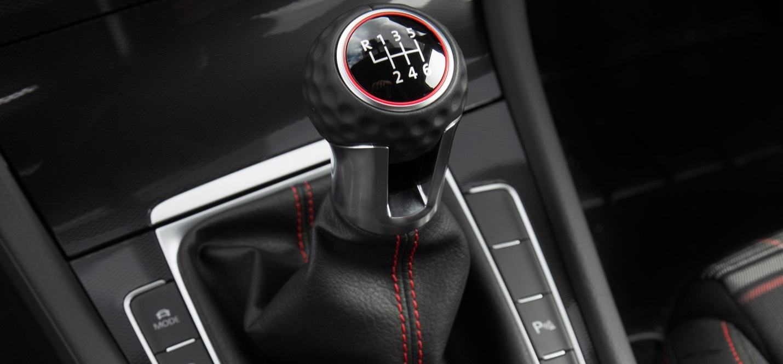

AUTOMATIC VEHICLE
Automatic transmission, this is an automobile gearbox that can change gear automatically as the vehicle moves this means that the driver doesn’t have to do it manually the gear stick will have about four or five settings, including parking reverse, neutral an drive.
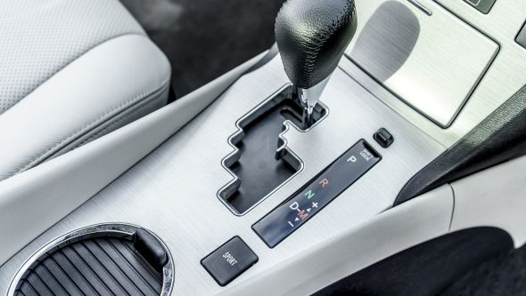
3.8 LAUNCH CONTROL
Launch control operates by using an electronic accelerator and a computer program. The software controls acceleration based on engine specifications to make the car accelerate smoothly and as fast as possible, avoiding slipping of the drive wheels, engine failure due to over-revving, and clutch and gearbox problems. In racing cars, this feature is only available at the start of the race, when the car is stationary in the starting grid. After the car is running at a certain speed, the software is disabled.
3.9 USES OF LAUNCH CONTROL
Launch control is an electronic aid to assist drivers of both racing and street cars to accelerate rapidly from a standing start.
3.10 LAUNCH CONTROL MODE OF WORKING
The software controls acceleration based on engine specifications to make the car accelerate smoothly and as fast as possible, avoiding slipping of the drive wheels, engine failure due to over-revving, and clutch and gearbox problems. After the car is running at a certain speed, the software is disabled.
3.11 GEAR BOX FAULT AND POSSIBLE CAUSES
A gearbox is a mechanical method of transferring energy from one device to another and is used to increase torque while reducing speed. Torque is the power generated through the bending or twisting a solid material.
Gearbox is located of the junction pont of a power shaft, the gearbox is often used to create a right angle change in direction, as is seen a rotary mower or a helicopter.
A gearbox converts the rotational energy of the engine to a rotational speed appropriate for the wheel, manual gearbox require the driver to select manually which gear to use automatic gear boxes on the other hand change to new gears automatically.
Torque – A rotational or twisting effect of a force a moment of force. Torque is measured as on equivalent straight line force multiplied by the distance from the axis of rotation.
3.12 FAULT AND SOLUTION ON GEARBOX
When it refused to change
Causes: - Some fault occur inside the gearbox while some from the electric forth.
Solution:- Service of the gearbox if the fault develop inside the gearbox i.e. cleaning of the vibe and wash away the dirty inside the boxes but if the fault develop from electrical, all the cable cement to the gearbox should be check properly.

CHAPTER FOUR
4.0 EXPERIENCE GAIN
In summary, this program has exposed me to some practical aspect in relation to my course of study (Mechanical engineering) and I benefitted greatly from the grogram. What I learnt at various site involves the following
- Different between Automatic and Manual vehicle
- The requirement need on how a motor vehicle is been service
- Identification of engine component
- Functions of different tools

CHAPTER FIVE
5.0 CONCLUSION
The student industrial work experience scheme (SIWES) in an interesting and programmed that adds more value to students view and objectives of their field of studies.
More so, it adds advancement to the student experience on the theoretical aspect of their course, since they are exposed to the real practical aspect during the programmed.
Furthermore, it widens the horizon of students, because it makes them understand the rules and regulations governing their field of studies. This would guide them when they establish on their own.
5.1 SUGGESTION AND RECOMMENDATION TO THE ORGANIZATION AND POLYTECHNIC CONCERNING THE SIWES PROGRAM
SIWES coordinator and the polytechnic authority should try to stop the habit of rejecting students for SIWES program by the industry. The institution supervisor should make it a priority to visit their designated students in the various organizations to update the student’s log book.
Finally, they should resist the habit of staying in school and wait for their wards to finish the SIWES program only for them to sign their training log book and award them grade of the choices without checking the performance of the student in the field.

