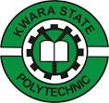

A TECHNICAL REPORT ON THE STUDENT INDUSTRIAL WORK EXPERIENCE SCHEME (SIWES)

HELD AT

KWARA STATE POLYTECHNIC
(I.O.T) ILORIN KWARA STATE

PRESENTED BY
ABDULMUMEEN ABDULSALAM
ND/23/RWE/PT/0002

SUBMITTED TO
THE DEPARTMENT OF RAILWAY ENGINEERING INSTITUTE OF TECHNOLOGY KWARA STATE POLYTECHNIC P.M.B 1375 ILORIN NIGERIA

IN PARTIAL FULFILLMENT OF THE REQUIREMENT FOR THE AWARD OF NATIONAL DIPLOMA (ND) IN RAILWAY ENGINEERING DEPARTMENT KWARA STATE, POLYTECHNIC ILORIN, NIGERIA

AUGUST – DECEMBER, 2024

CERTIFICATION
I hereby certify that this technical report is the hand work of ABDULMUMEEN ABDULSALAM Matric Number of ND/23/RWE/PT/0002 of Mechanical Engineering Technology Department under the supervisor

DEDICATION
This report is dedicated to Almighty God, the fulfiller of destiny. I thank Him for his guidance, protection and for been there for me throughout my industrial training programme.
It is also dedicated to my beloved parents Mr. and Mrs. ABDULMUMEEN and my friends

ACKNOWLEDGEMENT
My appreciation goes to Almighty God, who made me to choose Railway Engineering as my discipline.
However, I will like to thank Industrial Training Fund for their foresight in putting these program and also to the Railway Engineering Department, Kwara State Polytechnic Ilorin Kwara State for providing the platform on which was engage in the training.
I want to thanks my mother Mrs. Abdulmumeen, my brothers and sister and my friends for the encouragement they gave me throughout the industrial training period and for their support.
TABLE OF CONTENTS
Title page i
Certification ii
Dedication iii
Acknowledgment iv
Preface v
Table of contents vi
CHAPTER ONE
1.0 Introduction to SIWES 1
1.1 Amis and Objectives of SIWES 1
CHAPTER TWO
2.0 Description of the Establishment 2
2.1 Location and Brief History of the Establishment 2
2.2 Objective of Establishment 2

2.4 The Various Workshops in the Department and their Functions 3

2.4.1 Machine Workshop 3
2.4.2 Function of Automobile Workshop 4
2.4.3 Function of Weldering and Fabrication Workshop 4
2.4.3 Machine Present in Weldering and Fabrication Workshop 4
CHAPTER THREE
3.0 Activities Carried Out During the Student Industrial Work Experience Scheme (SIWES) Program 5
3.1 Activities on Drilling Machine 5
3.1.1 Boring Operation on Drilling Machine 5
3.1.2 Steps in Taken Boring Operation 5
3.2 Activities on Shaping Machine 6
3.2.1 Steps Involved in Making a Block Square and Parallel 6
3.3 Activities Carried out on Lathe Machine 7
3.3.1 Operation Carried out on Lathe Machine 7
3.4 Activities Carried Out in Weldering and Fabrication Work Shop 8
3.4.1 Arc Weldering Operation 8
3.4.2 Steps Involve in Making of a Coal Pot 8
CHAPTER FOUR
4.0 Experienced Gained During the Industrial Work Experienced (SIWES) 9
4.1 Benefit of the Student Industrial Work Experience Scheme (SIWES) 9
CHAPTER FIVE
5.0 Summary, Conclusion and Recommendation 10
5.1 Conclusion 10

5.2 Recommendations 10
5.3 Suggestion for the Improvement of the Scheme 10

CHAPTER ONE
1.0 INTRODUCTION TO SIWES
HISTORY
The student industrial work experience scheme (SIWES) was established by [ITF] in 1973 to solve the problem of lack of adequate practical skills preparatory for employment in industries by Nigerian graduates of tertiary institutions.
The scheme exposes students of tertiary the word of work. It affords students of tertiary institution the opportunity of being familiarized and exposed to the need experience in handing machinery and equipment which are usually not available in the educational institutions.
The participation in the scheme is a necessary pre-condition for the award of Diploma and Degree certificate in specific disciplines in most higher institutions in the country in accordance with the education policy of the government.
The programme is under the operation of the IT, the coordinating agencies (NUC, NCCE, NBTE), Employers of labour and the institutions whereby, the federal Government of Nigeria is in charge of funding the programme, the beneficiaries, includes undergraduate student of the following Department: Agriculture, Engineering, Environmental, Technology Education, Medical Science and pure and Applied Sciences. It is between the period of four months for polytechnics and colleges of Education, and six months for the Universities.
1.1 AMIS AND OBJECTIVES OF SIWES
- It gives student the opportunity of translating and relating their theoretical knowledge to the real world of work
- It helps in preparing student for the work situation they are likely to meet after graduation
- It exposes students to different machines, equipment’s and devices which are not present in their own school.
- It gives student opportunity of acquiring the knowledge of handing some tools and devices when on working field.
CHAPTER TWO
2.0 DESCRIPTION OF THE ESTABLISHMENT
2.1 LOCATION AND BRIEF HISTORY OF THE ESTABLISHMENT
Kwara state polytechnic, institute of technology (IOT) beside general hospital. Agbo-oba Area and later relocate to Kwara polytechnic permanent site beside Eleko Area Kwara state polytechnic is a Nigeria tertiary institution that was established in 1973 by the then military governor of Kwara state Col. David Bamigboye after the decision to establish a polytechnic in Kwara state was announced in 1971. It is located in Ilorin the capital of Kwara State.
2.2 OBJECTIVE OF ESTABLISHMENT
- To reduces stress or human effort for instance automotive workshop they uses hydraulic jack for lifting vehicles
- To make a new design of tools or equipment (machine workshop)
- To fabricate on metals or to make a new design of metals like coal pot, grinding machine etc. (wledering and fabrication workshop).
MAIN OFFICE
DIRECTOR
SECRETARY
WORKSHOP SUPERVISOR
MANAGER
TECHNICIAN
WORKSHOP

2.4 THE VARIOUS WORKSHOPS IN THE DEPARTMENT AND THEIR FUNCTIONS
The institute has various workshops and are listed below:
- Machine workshop,
- Automotive workshop,
- Welding and Fabrication workshop,

2.4.1 MACHINE WORKSHOP
The production workshop is the workshop where material removing operation takes place, also refers to as machine workshop.
This material removing operation is a type of manufacturing process in which the final product is obtain by removing excess metal from the stock.
Listed below are some of the major machines present in the production workshop;
- Lathe Machine
- Radial Drilling Machine
- Shaping Machine
- Surface/Cylindrical Grinding Machine
- Milling Machine
2.4.2 FUNCTION OF AUTOMOBILE WORKSHOP
Automobile section: this section is divided into two units
- Heavy duty: This unit particular base on repairing and maintenance of heavy duty machines such as pay loader, budozer, excavator, general purpose tractors etc.
- Light duty: this unit base on repairing of wear part and maintenance of light vehicles and official cars of the organization
2.4.3 FUNCTION OF WELDERING AND FABRICATION WORKSHOP
- Place or workshop where two metals are joined together with the use of electrodes
- They are metals with hacksaw
- They uses grinding machine and beach shears
- They use arc weldering for joining two or more metals.
2.4.3 MACHINE PRESENT IN WELDERING AND FABRICATION WORKSHOP
- Beach shears machine
- Guillotine machine
- Shaping machine
- Grinding machine

CHAPTER THREE
3.0 ACTIVITIES CARRIED OUT DURING THE STUDENT INDUSTRIAL WORK EXPERIENCE SCHEME (SIWES) PROGRAM
During the three (3) month industrial training program, I was opportune to learn and carried out different operation on each of the available machine in the workshop some of these will discussed in this chapter
3.1 ACTIVITIES ON DRILLING MACHINE
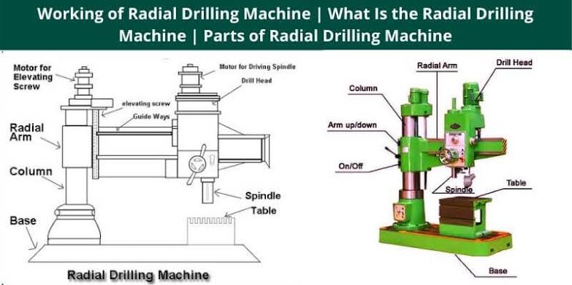

Diagram of Drilling Machine
3.1.1 BORING OPERATION ON DRILLING MACHINE
Boring is a process of enlarging a hole that has already been drilled (or cast) by means of single point cutting tool (or of a boring head containing several tools), such as in boring a gun barrel or engine cylinder.
3.1.2 STEPS IN TAKEN BORING OPERATION
- A work piece was fixed initial diameter which is to be bore to 20mm on the table via vice
- A boring tools was use with 18mm diameter to enlarge the cylindrical hole of the work piece.
- When the desired diameter was enlarged which is of 20mm and to the depth of 30mm as intended.
- Oil was used as the cooling agent (coolant throughout the operation).
3.2 ACTIVITIES ON SHAPING MACHINE
Shaping operation is a process of producing horizontal, vertical on inclined plane surface by mean of a straight line reciprocating single point. Cutting tools similar to those which is used in lather machine.
3.2.1 STEPS INVOLVED IN MAKING A BLOCK SQUARE AND PARALLEL
- Firstly all the dirt and burns from the work piece and the vise was removed or clean.
- The vise jaws was set perpendicular to line of the motion of the ram.
- The tool was et vertical
- The piece was set in the vise with parallel blocks at the bottom.
- Ensuring that all the cutting forces arc against the fixed jaw of the vise.
- The first side of the work piece was done on the machine.
- The second side of the work piece with the first side resting against the fixed jaw was machined.
- The third side opposite to the second side of the work piece with the first side resting against the fixed jaw was machined.
- The fourth side opposite to the first side was machined.
- The two edges which are fifth and sixth edges was machined respectively.

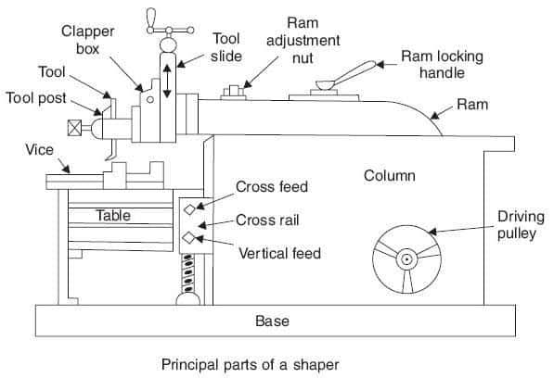

Diagram of shaping Machine
3.3 ACTIVITIES CARRIED OUT ON LATHE MACHINE
Lathe machine is a machine that is use for smoothening tools or to redesign tools like turning or facing.
3.3.1 OPERATION CARRIED OUT ON LATHE MACHINE
- Turning operation was carried out by turning of a rod (iron rod) of 25mm to 16mm.
- Facing operation was carried out on lathe by machine by facing a iron rod of 30mm to 25mm.
- Bolt and nut was made and also tap and dies (manual method).
- Threading operation was carried out by using a coarse thread on the both and nut.
- Vernier calipers was used during the process of turning and facing to check the diameter of the tools.
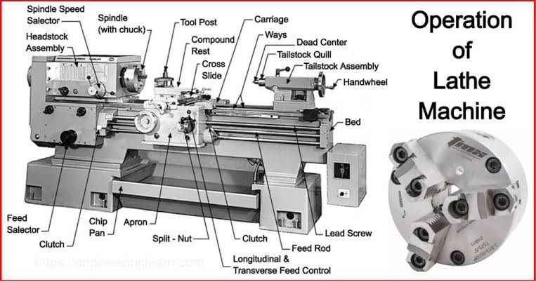
Diagram of Lathe Machine
3.4 ACTIVITIES CARRIED OUT IN WELDERING AND FABRICATION WORK SHOP
3.4.1 ARC WELDERING OPERATION
Arc weldering is a process of joining too metals together using electrode
3.4.2 STEPS INVOLVE IN MAKING OF A COAL POT
- The big metal was cut using hack-saw and the small one was cut using bench shears i.e the one for the handles.
- Grinding machine was used for smoothing of the rough surface.
- Hack saw was also used to cut the mild steel to the size needed.
- Arc weldering operation was carried out for the joining of the metal together.
- If the rod is bend anvil or hammer was used for the straightening of rod.

CHAPTER FOUR
4.0 EXPERIENCED GAINED DURING THE INDUSTRIAL WORK EXPERIENCED (SIWES)
I was able to learn and perfect my skills during the four month industrial training program, held at Kwara State Polytechnic Machine Workshop, Weldering and Fabrication Work Shop, and Automobile Workshop.
4.1 BENEFIT OF THE STUDENT INDUSTRIAL WORK EXPERIENCE SCHEME (SIWES)
- How to turn and face on lathe machine.
- How to use grinding machine for holes.
- How to use grinding machine
- How to fixed a car tyres
- How to use arc weldering to make a coal pot, to use a beach shears and also some machine in the workshop.
- How to use jack for lifting a car.
4.2 What is Internal Thread
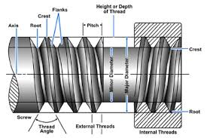
Internal (female) machined threads are threads on concave surfaces. These types of threads are machined with a single lip threading tool. You need internal threads in order to insert the screw into the workpiece. The thread cutting process for internal threads can be done by hand tapping or by machine tapping. Internal thread refers to a helical structure or groove cut inside a cylindrical object, such as a nut or a hole in a larger component. This thread enables the insertion and fastening of a corresponding external thread, such as that found on a bolt or screw.

4.2.1 Key Points about Internal Threads:
- Function: Internal threads are primarily used to create a secure connection between different parts, allowing for easy assembly and disassembly.
- Types: There are several common types of internal threads:
  - Unified Thread Standard (UTS): Common in the US.
  - Metric Thread: Used commonly in Europe and for international applications.
  - BSP (British Standard Pipe): Used for piping applications.
  - NPT (National Pipe Tapered): Used in plumbing and piping.
- Dimensions: Internal threads are defined by several parameters:
  - Diameter: The major and minor diameters are crucial for compatibility with external threads.
  - Pitch: The distance between successive thread peaks.
  - Depth: Refers to how deep the thread is cut into the material.
- Manufacturing: Internal threads can be created through various methods, including:
  - Tapping: Using a tap tool to cut the thread directly in a drilled hole.
  - Molding: In some cases, threads can be formed during the casting or molding process.
- Applications: Internal threads are found in a wide range of applications, including:
  - Fastening components in machinery.
  - Plumbing systems.
  - Assembly of structural elements in construction.

CHAPTER FIVE
5.0 SUMMARY, CONCLUSION AND RECOMMENDATION

5.1 CONCLUTION
The aims of the student industrial work experience scheme are to elevate the student’s knowledge and skills in a specific profession pf their respective fields and at the same time produce graduates who are credible, creative and proficient.
Its basic objective is to expose student to the real working environment and get acquainted with the organization structure, business operations and administrative functions, also to have hands-on experience in the students related field so to be able to relate and reinforce what has been taught at the university.
It will be of great a privilege and honor for me to attest to the fact that the industrial training program indeed serve it purpose in which it was created for, the knowledge and experience gained throughout my industrial training program speak of high value which I possess now and will be willing to develop on it as I build my career in the field of engineering.

5.2 RECOMMENDATIONS
After the completion of my student industrial work experience scheme, with the skills and experience gained through a rigorous training during the program, of cause not an easy task, but knowledge will always come with a price to be paid,
I therefore recommend and advise my fellow students to pay the price, embrace and equip themselves with skills through student industrial work experience scheme program.
5.3 SUGGESTION FOR THE IMPROVEMENT OF THE SCHEME
I suggest that if the scheme want improvement or more student to participate in their work, they have to give the student some money even if it is small end they also have to be checking on the student from time.
All these thing can make the student to participate more on the scheme which can even improve the scheme itself because the student will turn and corporate.

