

STUDENT INDUSTRIAL WORK EXPERIENCE ASND SCHEME (SIWES REPORT:
HELD AT
AK, AUTOS
AMULE BUS STOP AYOBO IPAJA, LAGOS STATE
BY
MAKINDE ABDUL GAFAR
ND/23/MEC/PT/0135

SUBMITTED TO
THE DEPARTMENT OF MECHANICAL ENGINEERING TECHNOLOGY , INSTITUTE OF TECHNOLOGY , KWARA STATE POLYTECHNIC, ILORIN.

DEDICATION
This Siwes reports is dedicated to Almighty Allah the most high , who made it possible for me to participate in this program and also my parent for their loving and caring over me.

CHAPTER ONE
1.1 INTRODUCTION
In some years back in the Nigeria polytechnic, national diploma science students use to go for four month industrial training after the first year in the polytechnic, to let them know more about what they have been done in the school, science students they need to practicalized their work s to make them perfect in t he area of their specialization, it is organized by industrial training funds( ITF)
  - DEFINITION OF SIWES
Student industrial working experience scheme (Siwes) is a program organized by industrial training fund (ITF) for National Diploma science student after their first year ITF) for National Diploma science student after their first year on campus , to help them known more about h e practical aspect of what they have been thought in th e school, thou will do practical in the school but we still have some area where we have to know, that it will help us in future to be able to call ourself a computer operator , programmer a system analyst.
  - AIMS AND OBJECTIVE OF SIWES
- It promotes interaction between student in training and the company staffs.
- It helps us to gain moiré to what to customer.
- It help us to know how to relate to customer
- It help us to be perfect in our course of study
- It help us to know how the computer system is been operate
- It help us to know more about practical aspect of what we have being taught in the school

CHAPTER TWO

THE TRAINING PROGRAM

ORGANIZATIONSTRUCTURE

CHAIRMAN/CEO

DIRECTOR OF SALES
DIRECTORSPAREPARTS
DIRECTORMAINTENANCE&SERVICES
DIRECTORBODYWORK&PAINT

SALES&TRADINGMANAGER

SALESPERSON1

SALESPERSON2
SPAREPARTSSTOREKEEPER

CHIEFMECHANIC

SENIORTECHNICIAN

JUNIORTECHNICIAN

CHIEFELECTRICIAN

SENIORTECHNICIAN

JUNIORTECHNICIAN

MANAGERBODYWORK
MANAGERPAINTING

TECHNICIANINTERIORBODYWORK
TECHNICIANEXTERIORBODYWORK

WORK FLOW IN THE SERVICE SECTION

Customer
Service Advisor

Service Advisor

Store Manager

Some of Special Gift Technical Services Corporate customer include,
Workshop

Technician

DESCRIPTION OF WORKDONE
During my stay in Special Gift Technical Service, I was assigned to the service and maintenance department as a Diagnosis/Mechanical Technician. Job duties in the department includes
Keep equipment available for use, inspecting and testing vehicles; completing preventive maintenance such as engine tune-ups, oil changes, replacing filters, wheel balancing.
Maintain vehicle functional condition by listening to operator complaints; conducting inspections, repairing engine failures, repairing mechanical systems malfunctions; replacing parts and components. Verifies vehicle serviceability by conducting, test drives; adjusting controls and systems.
AUTOMOTIVEMECHANICALSYSTEMS ENGINE
Internal combustion engines run on a mixture office land air, the core of the engine is the cylinder, with the piston moving up and down inside the cylinder and this takes place in a four stroke process, which are intake, compression, Power and Exhaust. The piston moves down on the intake stroke, the intake valve is open and the fuel air mixture is admitted into the cylinder, and the piston moves up during the compression with stroke both valves are closed, compresses the trapped fuel air mixture that was brought during the intake stroke, thereafter the spark plug fires, igniting the compressed air-fuel mixture which produces a powerful expansion of the vapor which is used to drive the crank shaft and this is the power stroke. Finally during the exhaust stroke, where the piston is at the bottom of the cylinder the exhaust valve opens to allow the burned gas to be expelled to the exhaust system.

ENGINE TYPES
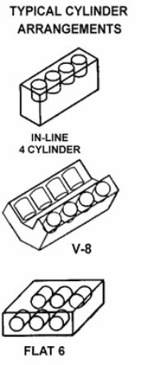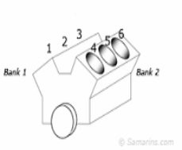The majority of engines in motor vehicles today are four stroke, spark ignition internal combustion engines
There are several engine types which are identified by the number of cylinders and the way the cylinders are laid. Straight line cylinders have their cylinders in row while the “V” arrangement uses two banks of cylinders side-by-side and its commonly used in V-6, V-8 configurations

Fig2.0

Some automobile engine parts include;

SPARKPLUG
The spark plug supplies the spark that ignites the air/fuel mixture so that combustion can occur. The spark must happen at just the right moment for this to work properly

Valves
The intake and exhaust valves open at the proper time to let in air and fuel and tolet out exhaust.
Piston
Piston is a cylindrical piece of metal that moves up and down inside the cylinder.

PISTONRINGS
Piston rings provide a sliding seal between the outer edge of the piston and the inner edge of the cylinder, the rings serves two purposes.
- They prevent the fuel/air mixture and the exhaust in the chamber from leaking into the sump during compression and combustion,
- They keep oil in the sumo from leaking into the combustion area where it would be burn and lost.

The connecting rod connects the piston to the crankshaft, it rotates at both ends so that its angle can change as the piston moves and the crankshaft rotates.
CRANKSHAFT
The crankshaft turns the piston’s reciprocating motion in the cylinder into circular motion.
SUMP (OIL PAN)
The sump surrounds the crankshaft. It contains some amount of oil, which collects in the bottom of the
sump.
CAMSHAFT
The camshaft in an internal combustion engine makes it possible for the engine’s valve to open and close, the asymmetrical lobes of the camshaft correspond to the engine valves
LUBRICATING SYTREM
Oil is the life-blood of the engine. An engine running without oil will last about as long as human without blood. Oil is pumped to all the moving parts of the engine by and oil pump. The oil pump is mounted at the bottom of the engine in the oil pan and is connected by a gear to either the crankshaft or camshaft. This way, when the engine is running the pump is pumping simultaneously. There is usually an oil pressure sensor near the oil pump that monitors pressure and sends this information to a warning light on the dash board (this features is found in modern cars as it might be in your car), when the ignition key is turned on, but before the car is started the oil light should light, indicating that there is no oil pressure yet, but also letting you know that the warning system is working.

COOLING SYSTEM
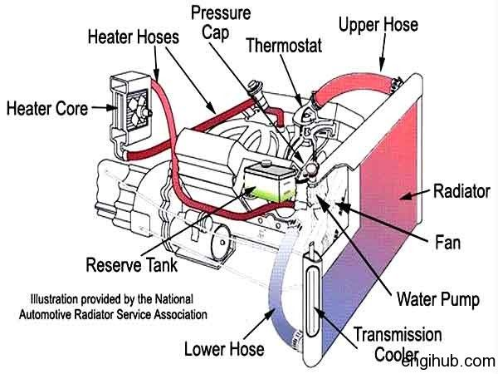

A car engine produces enormous amount of heat when it is running, and must be cooled continuously
to avoid engine damage, generally this is done by circulating coolant liquid usually water mixed with an antifreeze solution through special passages.
How the cooling system work
Actually there are two types of cooling system found on motor vehicles: liquid cooled and air cooled
Air cooled engines are found on a few older cars, but for most part, automobiles and trucks use liquid
cooling systems and that is what this write up will concentrate on subsequently. The cooling system is made up of the passages inside the engine block and heads, water pump to circulate the coolant, a thermostat to control the temperature of the coolant, a radiator cap to control the pressure inside the system, and a plumbing consisting of interconnecting hoses to transfer the coolant from the engine to the radiator and also to the car’s heater system where hot coolant is used to warm up the vehicle’s interior on a cold day. A cooling system works by sending a liquid coolant through passages in the engine block and heads. As the coolant flows through these passages, it picks up the heated fluid then makes its way through a rubber hose to the radiator in the front of the car. As it flows through the thin tubes in the radiator, the hot liquid is cooled by the air stream entering the engine compartment from the grill in front of the car. Once the fluid is cooled, it returns to the engine to absorb ,ore heat. The water pump has the job of keeping the fluid moving through this system of plumbing and hidden passages. In order to prevent the coolant from boiling, the cooling system is designed to be pressurized, under pressure the boiling point of coolant is raised considerably. However, too much pressure will cause hose and other parts to burst, so a system is needed to relieve pressure if it exceeds a certain point and this is job of radiator cap

TRANSMISSIONSYSTEM

A car transmission is simply the assembly of parts, including the gears and the propeller shaft that transmit the power from the engine to the axle.
There are two kinds of transmission: Automatic and Manual Transmission

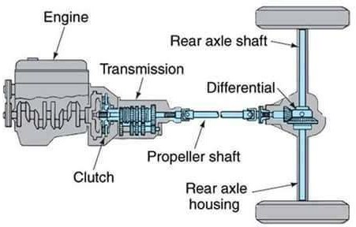

Main components of a transmission are:

Transmission Control Modules: one of the main part of a transmission is transmission control modules, it controls the automatic transmissions, but is nonexistent in manual transmissions. Transmission Filters: Another important component of transmissions is filters. Transmission depend on transmission fluid, s coolant that allows the clutch to engage and disengage, gears to change, valves to open and close, and so on. The filters ensures that any outside particles or substances are not mixed in with the fluid.
Transmission shafts: transmissions are also connected to the engine cranks haft by means of flywheel, since the combustion engine inside the transmission cannot go below particular speed. Therefore, the output of the transmission is done via the driveshaft, hence the name drive wheels of a car.

Manual Vs Automatic Transmission

Manual transmissions typically run longer and are cheaper to fix and repair when compared to automatic transmissions. Nonetheless, many people still prefer automatic transmission because of their ease of use. Manual transmissions are more affordable and more traditional as well. We’ll dive into the various factors with the cost of repairing or replacing a transmission later, as well as many problems that can result, which will require you to repair or replace them. After all, transmissions are not everlasting and like any part of the car, they need fixing on time or another and it’s better to do it when you know approximately what is required and how much it will cost you.

BRAKING SYSTEM
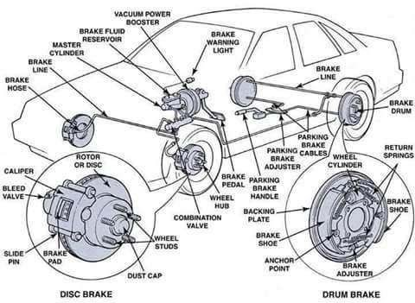
An automatic braking system is a group of mechanical, electronic and hydraulic activated components which use friction/heat to stop a moving vehicle.

How the automotive Braking System works:

When the brake pedal is depressed the pressure on the brake pedal moves a piston in the master cylinder, forcing the brake fluid from the master cylinder through the brake lines and flexible hoses to the calipers and wheel cylinders. The force applied to the brake pedal produces proportional force on each of the pistons. The calipers and wheel cylinders contain pistons, which are connected to a disc brake pad or brake shoe. Each out put pist on pushes the attached friction materiala gains the surface of the all of the brake drum, thus slowing down the rotation of the wheel. When the pressure on the pedal is released, the pads and shoes return to their release positions. This action forces the brake fluid back through the flexible hose and tubing to the master cylinder.

Component of Automotive Braking System

Brake Disc: brake disc are comprised of a disc or rotor, a caliper assembly, disc brake pads and the wheel bearings and hardware necessary to mount the components on the here it is created through hydraulic clines to the vehicle. The calipers connected to the mastery lender through tubes, hoses and valves that conduct brake fluid through the system.
Brake Drum: brake drums are comprised of a drum and backing plate, ahoy borax assembly, brake shoes, wheel cylinder, wheel bearings and hardware necessary to mount these components on the vehicle. The wheel cylinder is connected to the master cylinder through tubes, hoses and valves that conduct brake fluid through the system.
Brake Fluid: Brake fluid is a type of hydraulic fluid used in brake applications for automobiles and light trucks. It is used to transfer force under pressure from where it is created through drably clines to the braking mechanism near the wheels. Braking applications produce a lot of heat so brake fluid must have a high boiling point to remain effective and must not freeze under operating conditions.

FUELSYSTEM

The fuel system is critical in storing and delivering the gasoline or diesel fuel our engine need storing. Think of it as your vascular system, with a heart (fuel pump), veins (fuel lines) and kidneys (filter).A failure in any of these fuel system component has the same devastating effects as in your body.

Component of the fuel system

Fuel tank: basically a holding tank for your fuel. When you fill up at a gas station the gas travels down the filter tube and into the tank. In the tank there is a sending unit which ells the gas gauge how much gas is in the tank. Some fuel thank houses the fuel pump and has more emissions controls to prevent vapors leaking into the gas.
Fuel pump: on newer cars the fuel pump is usually installed in the fuel tank. Older cars have the fuel pump attached to the engine or on the frame rail between the tank and the engine. If the pump sin the tank or the frame rail then it id electric and is driven by your car battery. Fuel pumps mounted to the engine use the motion of the engine to pump the fuel, most often being driven by the camshaft, but sometimes the crankshaft.
Fuel filter: clean fuel is critical to engine life and performance. Fuel injectors and carburetors have tiny openings which clog sails of altering he fuel is an necessity. Filters can be before or a teethe fuel pump. They are most often made from a paper element, but can be stainless steel or synthetic material and are designed to be disposable in most cases. Some performance fuel filters will have washable mesh, which eliminated the need for replacement.

SUSPENSION SYSTEM
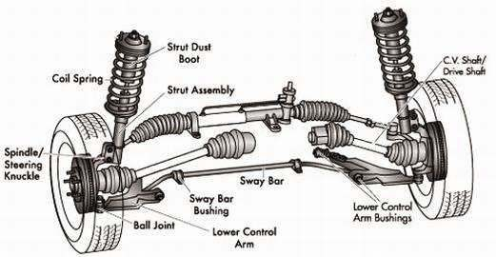
Suspension is the term given to the system of shock absorbers and linkages that connect a car to its wheels. The suspension system has two basic functions: 1) to keep the car’s wheels in firm contact with the road to provide the tractionand2) to provide a comfortable ride for the passengers and isolate them from road noise, bumps and vibrations.

STEERING SYSTEM
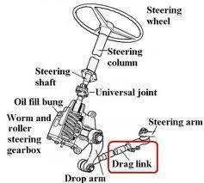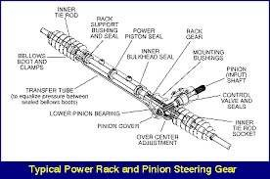
The direction of motion of a motor vehicle is controlled to a desired direction steering system. When the drive returns the steering wheel, a shaft from the steering column turns a Steering gear. The steering gear move steroids that connect to the front wheels. That erodes move the front wheels to the vehicle right or left.
Today, there are two types of steering systems: 1) standard mechanical (reciprocating ball) steering and 2) rack and pinion steering. The standard mechanical steering can be either power-assisted or non power. Rack and pinionisal mortal ways power assisted, although there are cases where it is not.
Standard mechanical (reciprocating ball) steering: The steering wheel is connected to the steering box through the steering column. The steering box turns the rotation of the steering wheel 90ºand, in the case of power steering, uses high-pressure fluid to help actuate the steering. The steering box has an arm attached to the output shaft called the pitman arm. This connects the steering to the steering gear. The pitman arm is connected to one end of the center link (drag link). On the other end of the center link is an idler arm. Between the idler and pitman arms , the drag link is supported in the proper position to keep the left and right wheels working together. The in nertierodends are attached to each end of the center link and provide points for the steering gear. From there it goes to the outer tie rod ends through an adjustment sleeve. This sleeve joins the inner and outer tie rod ends together and allows for adjustment when the front wheels are aligned. The outer tie rods ends are connected to the steering knuckle that actually turns the front wheels. The steering knuckle has an upper and lower ball joint on which it pivots and creates the geometry of the steering axis.
Rack and pinion steering: Rack and pinion steering, on the other hand, basically combines the steering box and drag link into one unit. The steering wheel, through the steering column, is directly connected to the track. Inside the steering rack is apinion assembly that moves which in turn moves the steering gear. One end of the inner tie rod ends is connected to each of this piston and the other end is connected directly to the outer toe rod end. The inner tie rod end is actually threaded into the outer tie rod end and can be rotated to make adjustments during a wheel alignment.
The advantage of rack and pinion steering is that it’s more precise than me chemical system. By reducing the number of parts and pivot points, it can more accurately control wheel direction, making the steering move responsive. The disadvantage of a rack and pinion steering system is that it’s prone to leakage, requiring replacement of the steering rack assembly.

Components of steering system

- Power Steering fluid reservoir

- Power Steering Pump

- Rack and Pinion steering gear

- Steering Wheel

- Pitman Arm

- Steering Box

- Tierod/ Trackrod

- Steering Column and Knuckle

- Drag Link

- Steering Shaft

CHAPTERTHREE

3.0 Repair and Maintenance Process

Mechanical systems in automobiles are a little complex and some problems, may need to be serviced at the repaired shop.

3.1 SAFETY INFORMATION

Most accidents in servicing/mechanical repair involve slips, trips and falls or poor manual handling. Other causes of incidents sometimes resulting in serious injury or death include working under inadequately supported vehicles, incidents involving petrol and vehicle movement.
Keeping work areas free of clutter is an important, but often overlooked, step in running a safe and productive workshop. Requiring appropriate protective gear minimizes eye and finger lacerations, which are common auto body shop injuries. Shops should purchase appropriate eye wear, and make protective gloves available to prevent cuts from glass, sheet metal or other jagged objects.

TOOLSREQUIRED

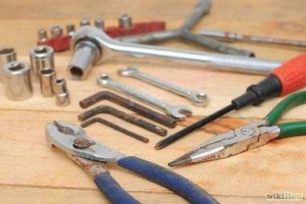
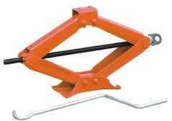
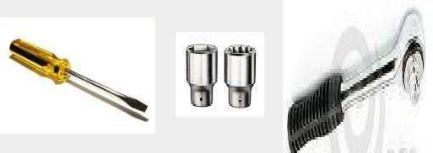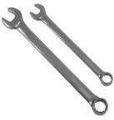

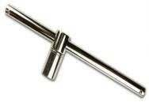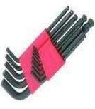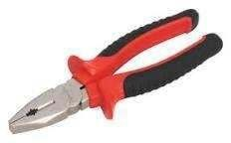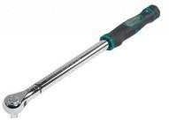

BRAKEPROBLEMS

Brake problems usually indicate the need for certain repairs or replacement parts, so here is a quick review of some common fixes:
LOWBRAKEFLUID This may be the result of worn disc brake pads, or it may indicate a leak in the brake system. If the BRAKEWARNING LIGHT is also on, most likely the problem is a leak (though the Brake Warning light may also come on if the master cylinder reservoir has a fluid level sensor). Leaks are dangerous because they can cause brake failure. The brake calipers, wheel cylinders, brake hoses and lines, and master cylinder all need to being specter. If a leak is found, the defective component must be replaced. Your vehicle should NOT be driven until the leak can be repaired LOW BRAKE PEDAL The brake pedal may below if the shoe adjusters on rear drum brakes are rusted or sticking and not compensating for normal lining wear. Adjusting the rear drum brakes may restore a full pedal. But unless the adjusters are cleaned or replaced the problem will return as the linings continue to wear. Other causes include worn brake linings or a fluid leak.

CHAPTER FOUR
4.1 EXECUTIVE SUMMARY
The student industrial work experience scheme (SIWES) is still development programmed initiated by the industrial training fund (ITF) in 1973 to bridge the gap between theory and practical among student of engineering and technology institution of higher learning in Nigeria. It provides job practical experience in Nigerian students as they were exposed to work methods and techniques in handling equipment and machinery that may not be available in their institution.
At inception in 1974 the scheme started with 754 students from institution and 104 eligible course in 2008, 210290 students from 219 institution particularly in the scheme with over 112 eligible course.
However the repaid growth and expansion of SIWES has occurred against the back drop of successive economic crises which have affected the smooth operation and administration of the scheme.
Most industries in Nigeria today are operating below installed capacity while others are completely street down (manufacturing) association 2003-2006) this is impacted negatively on this scheme as institution of higher learning find insurance difficulty to secure placement for student in industries where they called acquire the much needed practical experience.
4.2 AIMS OF THE STUDY
The aims of the study was to educate the impact of SIWES on technical skill development in Nigeria economy.
This is to enable institution of higher learning and other leaning and others stake holder.

CHAPTER FIVE
    - CONCLUSION
    - PERSONAL AFFAIRS ON A SIWES
I than God for make it possible for me to participate in the industrial training before I am a computer illiterate , but now SIWES and turn me to be come a computer literate.
It is good to go for four m on the industrial training as a science student; a lot of experience will be acquired. A science student without a knowledge of practical, he/she is a figure headed science student, try to go for Siwes , it help a lot .
      - SUGGESTION TO POLYTECHNIC
I suggested that polytechnic should make Siwes compulsory for every science and technology student so that it will make them perfect in practical aspect in their study.

