
REPORT ON
STUDENT INDUSTRIAL WORK EXPERIENCE SCHEME (SIWES)

HELD AT;
PARROT FM (101.1 FM), OKEBABY IKOYI-ILE ROAD, OGBOMOSO, OYO STATE,

BY
BABATUNDE AFEEZ ADEWALE
ND/23/STA/PT/0029

SUBMITED TO
DEPARTMENT OF STATISTICS,
INSTITUTE OF APPLIED SCIENCES,
KWARA STATE POLYTECHNIC, ILORIN.

IN PARTIAL FULFILMENT OF THE REQUIREMENTS
FOR THE AWARD OF NATIONAL DIPLOMA (ND) IN STATISTICS.

August – November, 2024

DEDICATION
This report is dedicated to almighty God, the Supreme Being, the beneficent, the merciful, and the foundation of wisdom, knowledge and understanding to the prudent.

OUTLINE
Title Page 1
Dedication 2
Outline 3
Introduction to SIWES 4
Definition of SIWES 4
Aim and Objectives of SIWES 5
Introduction of Industrial Placement 5
Departments and their function 7
Statistical Work Done 8
Experiences Gained in the Industrial Place 9
Conclusion 10
Recommendation 11

INTRODUCTION TO SIWES
Student industrial work experience scheme (SIWES) was established by Industrial Training Fund (ITF) in 1973/1974 to solve the problem of lack of adequate practical skills preparatory for employment in industries by Nigerian graduate of tertiary institutions.
Prior to the establishment of the schemes, there was a concern among our institution of higher learning lacked practical background studies preparation for employment in the industries.
The student industrial work experience scheme (SIWES) is a skill training program designed to expose and prepare student of agriculture technology, environmental science, medical science and pure & applied science for the industrial work situation one is likely to meet after graduation.
The program was established with various coordinating agencies respect to each tertiary institution in the country. These agencies are:
- NBTE (National Broad for Technical Education)
- NUC (National University Commission) for University
- NCCE (National Commission of College of Education) for colleges of education.
DEFINITION OF SIWES
Student industrial work experience which is a program established by I.T.F (Industrial Training Fund) in 1976 to bridge the gap between theory and practical aspect of learning in a tertiary institutions in Nigeria.
SIWES was established in Nigeria to help student develop on their practical aspect of learning expose them to various techniques in the industry and also help them to know the ways of handling equipment and machineries.
AIM AND OBJECTIVES OF SIWES
The aim and objectives of SIWES are as follows;
- Provide an avenue for students in institution of higher learning to acquire industrial skills and experience in their approved courses of study.
- Prepare students for the industrial work situation which they are likely to meet after graduation.
- Expose students to work methods and techniques in handling equipment and machinery not available in their institution.
- Provide students which they are likely to meet after graduation.
- Expose students to work methods and techniques in handling equipment and machinery not available in their various institutions.

INTRODUCTION OF INDUSTRIAL PLACEMENT
Parrot FM, also known as Ayekooto FM or O-Paro-Ti FM, is an indigenous radio station based in Ogbomoso, Oyo State, Nigeria. It was commissioned on October 1, 2014, by former Governor Otunba Adebayo Alao-Akala with the aim of bridging the communication gap in the region and promoting local cultural values. The station quickly distinguished itself as the first privately owned, independent commercial FM station in the Oyo North Senatorial District. It was officially licensed by the National Broadcasting Commission on April 27, 2015, and operates on a 2-kilowatt transmitter. Under the leadership of Alao-Akala’s son, Olamijuwonlo, Parrot FM has consistently worked to provide a platform for young artistes and to enhance the local heritage through news, entertainment, and cultural programming.

DEPARTMENT IN THE PLACEMENT AND THEIR FUNCTION
- Board of Directors & Senior Management:
Role: Provide strategic oversight and make high-level decisions. They set the station’s vision, policies, and ensure that all departments work in alignment with the overall objectives.

- General Manager:
Role: Oversees daily operations, ensuring that all departments coordinate efficiently. The General Manager implements board policies and manages overall performance.

- News Gathering and Writing Department:
Role: Responsible for collecting, researching, and writing news scripts. This team ensures that current events and stories are accurately reported and ready for broadcast.

- Director of Programmes:
Role: Manages the scheduling and content of all broadcast programmes. This department plans daily shows and coordinates with on-air talent to deliver engaging content.

- Director of Marketing & Advertising:
Role: Handles promotional activities, advertising sales, and revenue generation. This department works to build the station’s brand and secure sponsorship deals while coordinating advertising campaigns.

- Technical/Engineering Department (Chief Engineer & Support Staff):
Role: Maintains and operates all technical equipment including transmitters, audio consoles, and studio gear. They ensure the broadcast signal is clear and manage technical troubleshooting or maintenance issues.

- News and Current Affairs Department (News Editor & Reporters):
Role: Supervises the editorial process, edits news content, and ensures the quality and accuracy of on-air news. Reporters are in the field gathering news while the editor reviews and finalizes the content.

- Studio Production and Maintenance:
Role: Manages the production of live and pre-recorded shows. They are responsible for setting up the studio, coordinating with presenters, and maintaining equipment to support smooth on-air operations.

- Finance, Personnel & Administration Department:
Role: Oversees financial management, human resources, and administrative support. They manage budgeting, payroll, recruitment, and other clerical functions to keep the station running efficiently.

Each of these departments plays a critical role in ensuring that Parrot FM delivers quality content and maintains operational excellence.
STATISTICAL WORK-DONE
Statistics can be said to be about collecting, organizing, summarizing, presenting and analysis of data and there are various method or techniques in which data can be analyze to make a valid and valid conclusion or interpretation of the analyzed data. During my stay at the placement, I was placed in the administrative department. Which I was able to keep records of listener engagement. And I was able to do analysis on a program called Ayekootoe Akekaka for the call-ins, SMS and Whatsapp engagement for 15 days.

Ayekooto Akekaka - Listener Engagement (15 Days)
Day | Call-ins | SMS | WhatsApp | Total Engagement
1 | 20 | 15 | 30 | 65
2 | 25 | 18 | 35 | 78
3 | 18 | 14 | 28 | 60
4 | 22 | 16 | 32 | 70
5 | 19 | 13 | 26 | 58
6 | 24 | 17 | 36 | 77
7 | 21 | 15 | 31 | 67
8 | 23 | 16 | 34 | 73
9 | 20 | 14 | 30 | 64
10 | 26 | 19 | 38 | 83
11 | 22 | 17 | 33 | 72
12 | 25 | 18 | 36 | 79
13 | 21 | 16 | 29 | 66
14 | 23 | 17 | 35 | 75
15 | 30 | 20 | 40 | 90

After recording the data, Multiple bar chart is use to analysis.
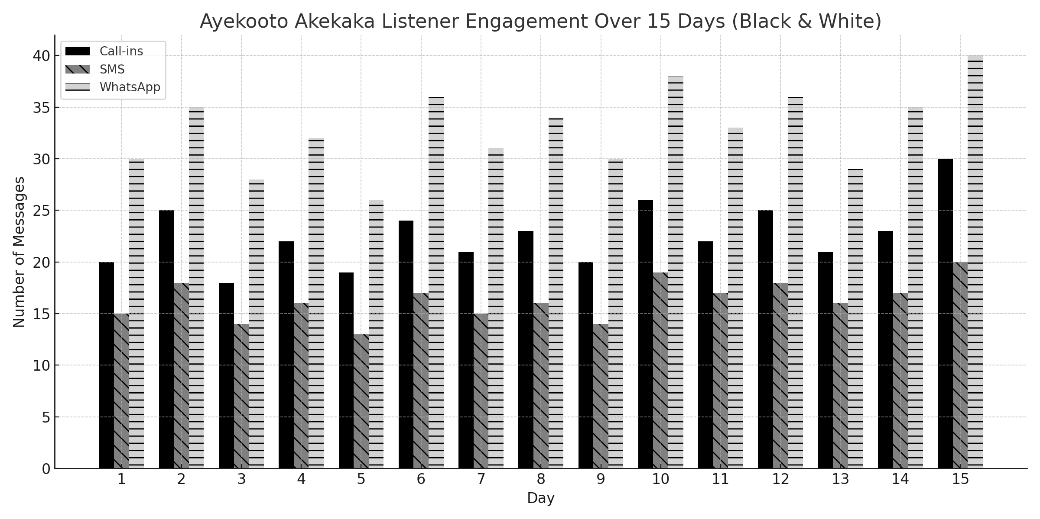

INTERPRETATION

General Insights
- Total Engagement Growth: The overall engagement (call-ins, SMS, and WhatsApp combined) shows an upward trend as we approach Day 15. This indicates that listeners are becoming more involved over time.
- Strong WhatsApp Engagement: WhatsApp consistently has the highest number of interactions, suggesting that the audience may prefer this form of communication, possibly due to convenience and ease.
- Call-ins are Significant: Although call-ins show some fluctuation, they remain a prominent form of engagement, especially towards the last days of the 15-day period. This might indicate that listeners are more likely to call in towards the program's end.
- SMS Consistency: SMS is the least engaging method, but it shows consistent numbers throughout the 15 days, with slight peaks on some days.

EXPERIENCE GAINED IN SIWES PLACEMENT
• Exposure to the inner workings of a radio station—from studio setup and equipment handling (e.g., audio consoles, transmitters, and editing software) to troubleshooting technical issues during live broadcasts.
• Involvement in news gathering, scriptwriting, and the production of live and pre-recorded shows.
• Learning how programmes are scheduled and how content is curated to engage the local community.
• Understanding the roles of various departments (e.g., News & Current Affairs, Technical/Engineering, Marketing, and Administration) and how they work together to deliver a seamless broadcast.
• Familiarity with the regulatory environment (such as licensing and compliance with the National Broadcasting Commission) and the standards required for quality broadcasting.
• Enhanced communication and teamwork skills from working with on-air talent, producers, and technical staff.
• Real-world insights into deadlines, live production challenges, and problem-solving under pressure

CONCLUSION
After my stay at the SIWES placement, which I was placed in the records department in which I input the daily record in the system, and I was able to carry-out some statistical work by practical, I understand that solving the problem of skill acquisition by graduates of Nigerian technical / vocational education is a reason for the establishment of SIWES. It was planned to be a bridge between educational institutions and industrial employers with the latter providing general and specific occupational skills and knowledge. If the scheme is not adequately implemented it becomes difficult for graduates of the system to secure proper understanding of their choice of study and implementing into occupations or make smooth transition to the labor market world.
Incompetence in workplace is related to the kind or quality of training in the school. To improve on the scheme’s implementation students should be placed in industries relevant to their field s of study. There is need for greater cooperation between industries and educational institutions on how best to implement SIWES programme. It can thus be concluded that SIWES offers the students learning experiences which cannot be directly gained in the class room.

RECOMMENDATION
- All the institutions involved should be organizing orientation courses in collaboration with the ITF for their students prior to their attachment with the attendance made mandatory for the students accepted for SIWES and ITF staff.
- ITF should ensure the regular visitation of the ITF officers to supervising Agencies institutions, employers and students on attachment.
- ITF should be providing insurance cover to students on attachment and improve on paying students and supervisors allowances for motivation.
- The Banks should speed up their action at clearing of cheque issued to avoid unnecessary delay.

