

TECHNICAL REPORT ON
STUDENT INDUSTRIAL WORK EXPERIENCE SCHEME (S.I.W.E.S) HELD AT

LEGIT VENTURES

WRITTEN BY

WASIU AHMED OLAYINKA MATRIC NO: ND/23/BFN/FT/0068

SUBMITTED TO: DEPARTMENT OF BANKING AND FINANCE.
INSTITUTE OF FINANCE AND MANAGEMENT STUDIES KWARA STATE POLYTECHNIC, ILORIN.

MARCH 2025
DEDICATION

I dedicate this report first and foremost to Almighty Allah who made it possible for me to go through this SIWES program safely and soundly and who has been there from the beginning to this very point also for the opportunity given to me to be in banking and finance department of this citadel of learning and to complete my 4month SIWES.

TO GOD BE THE GLORY.
ACKNOWLEDGEMENT

My deeper appreciation goes to Supreme God for granting me life, health, favor, wisdom knowledge and understanding all through the period of my SIWES program.

With a deep sense of appreciation, respect and gratitude, I want to say a big thank you to my parents, Mr and Mrs Wasiu, brothers, sisters and other relatives and non-relatives friends, for their caring attitude and support from the beginning of my ND program banking and finance to this point.

I will like to express my gratitude to my honourable (H.O.D) in person of Mr Ajiboye, my SIWES supervisor, and also the entire staff of the Department of Banking and Finance, kwara state Polytechnic Ilorin, I say more grace to your elbow all. I can never forget the unalloyed cooperation of my beloved ones at Sweet Bite Company, and other General Department Management team.
My sincere appreciation also goes to everyone that has been by me all this while. THANKS TO ALL

INTRODUCTION

1.1 Background
CHAPTER ONE

The Student Industrial Work Experience (SIWES) is the accepted skills training programme which form part of the approved minimum academic standard in the various degree programme for all the Nigerian Universities and Polytechnics. It is an effort to bridge the gap existing between the theory and practice of Engineering, Technology, Science, Agriculture, Medical and other professional education programmes in Nigeria Institutions.

The minimum duration of the SIWES is 16 weeks for Engineering and Technology program in the Polytechnic. The Scheme has triple program involving the Student, Polytechnic and Industry. The triple program is well recognized throughout Nigeria.

It is found by the Federal Government of Nigeria and jointly coordinated by the Industrial Training Fund (ITF) and the National Association of Universities, Polytechnic and Technical Schools. The major important factor that makes the Federal Government of Nigeria to establish Student Industrial Work Experience Scheme is the development of students brain toward what they have been taught in the school i.e the practical aspect.

1.2 History of student industrial work experience scheme

SIWES was established by Industrial Training Fund in 1997 to solve the problem of inadequate practical knowledge by Nigerian Graduates of Tertiary Institutions.

The Scheme exposes students to industrial based skills necessary for a smooth transition from theory to practical and also its affords students of tertiary institutions the opportunity of being familiarized and exposed to the needed experience in education institutions. Participation in SIWES has become a necessary precondition for award of diploma and degree certificate in specific discipline in most institutions of higher learning in Nigeria, in accordance with the education policy of government.

1.3 The Objectives of SIWES

The objectives of the Industrial Work Experience Scheme are to:-
(i) Prepare the students for the work situation that they likely to meet after graduation or nearest in the future.

(ii) Provide and avenue for students in the Nigeria Universities, Polytechnics and Technical Schools to transfer theoretical knowledge to practical skills.

(iii) Create room for student to apply the theoretical knowledge which has been promote the technological development and passed from the teacher to the student to the practical work.

(iv) Enlist and strengthen employer’s involvement in the education process of preparing Universities, Polytechnic and Technical School graduates for employment in industry.

(v) Familiar students with work methods and machinery that may not be available in the schools which will help students in machineries and equipment handling.
CHAPTER TWO

2.1 Historical background of the study

Legit venture opposite marvelous Hotel..Kwara state Ilorin

2.2 What is Computer

A computer is an electronic device that manipulates information, or data. It has the ability to store, retrieve, and process data. You may already know that you can use a computer to type documents, send email, play games, and browse the Web. You can also use it to edit or create spreadsheets, presentations, and even videos.

2.3 Types of Computer

Analog computers

Analog computers use continuous physical magnitudes to represent quantitative information. At first they represented quantities with mechanical components but after World War II voltages were used; by the 1960s digital computers had largely replaced them. Nonetheless, analog computers, and some hybrid digital-analog systems, continued in use through the 1960s in tasks such as aircraft and spaceflight simulation.

Digital computers

In contrast to analog computers, digital computers represent information in discrete form, generally as sequences of 0s and 1s (binary digits, or bits). The modern era of digital computers began in the late 1930s and early 1940s in the United States, Britain, and Germany. The first devices used switches operated by electromagnets (relays). Their programs were stored on punched paper tape or cards, and they had limited internal data storage. For historical developments, see the section Invention of the modern computer.
Mainframe computer

During the 1950s and ’60s, Unisys (maker of the UNIVAC computer), International Business Machines Corporation (IBM), and other companies made large, expensive computers of increasing power. They were used by major corporations and government research laboratories,
typically as the sole computer in the organization. In 1959 the IBM 1401 computer rented for

$8,000 per month (early IBM machines were almost always leased rather than sold), and in 1964 the largest IBM S/360 computer cost several million dollars.

Minicomputer

Although minicomputers date to the early 1950s, the term was introduced in the mid-1960s. Relatively small and inexpensive, minicomputers were typically used in a single department of an organization and often dedicated to one task or shared by a small group. Minicomputers generally had limited computational power, but they had excellent compatibility with various laboratory and industrial devices for collecting and inputting data.

Microcomputer

personal computer and peripherals A personal computer and its peripherals. A microcomputer is a small computer built around a microprocessor integrated circuit, or chip. Whereas the early minicomputers replaced vacuum tubes with discrete transistors, microcomputers (and later minicomputers as well) used microprocessors that integrated thousands or millions of transistors on a single chip. In 1971 the Intel Corporation produced the first microprocessor, the Intel 4004, which was powerful enough to function as a computer although it was produced for use in a Japanese-made calculator. In 1975 the first personal computer, the Altair, used a successor chip, the Intel 8080 microprocessor.

Laptop computer

The first true laptop computer marketed to consumers was the Osborne 1, which became available in April 1981. A laptop usually features a “clamshell” design, with a screen located on the upper lid and a keyboard on the lower lid. Such computers are powered by a battery, which can be recharged with alternating current (AC) power chargers. The 1991 PowerBook, created by Apple, was a design milestone, featuring a trackball for navigation and palm rests; a 1994 model was the first laptop to feature a touchpad and an Ethernet networking port.
Embedded processors

Another class of computer is the embedded processor. These are small computers that use simple microprocessors to control electrical and mechanical functions. They generally do not have to do elaborate computations or be extremely fast, nor do they have to have great “input-output” capability, and so they can be inexpensive. Embedded processors help to control aircraft and industrial automation, and they are common in automobiles and in both large and small household appliances. One particular type, the digital signal processor (DSP), has become as prevalent as the microprocessor. DSPs are used in wireless telephones, digital telephone and cable modems, and some stereo equipment.

What is software?

Software is a set of instructions, data or programs used to operate computers and execute specific tasks. It is the opposite of hardware, which describes the physical aspects of a computer. Software is a generic term used to refer to applications, scripts and programs that run on a device. It can be thought of as the variable part of a computer, while hardware is the invariable part.

The two main categories of software are application software and system software. An application is software that fulfills a specific need or performs tasks. System software is designed to run a computer's hardware and provides a platform for applications to run on top of.

Other types of software include the following:

i. Programming software, which provides the programming tools software developers need.

ii. Middleware, which sits between system software and applications. iii. Driver software, which operates computer devices and peripherals. Examples and types of software
Among the various categories of software, the most common types include the following:
• Application software. The most frequently used software is application software, which is a computer software package that performs a specific function for a user or, in some cases, for another application. An application can be self-contained, or it can be a group of programs that run the application for the user. Examples of modern applications include office suites, graphics software, databases, database management programs, web browsers, word processors, software development tools, image editors and communication platforms.

• System software. These software programs are designed to run a computer's application programs and hardware. System software coordinates the activities and functions of the hardware and software. In addition, it controls the operations of the computer hardware and provides an environment or platform for all the other types of software to work in. An operating system (OS) is the best example of system software; it manages all the other computer programs. Other examples of system software include firmware, computer language translators and system utilities.

• Driver software. Also known as device drivers, this software is often considered a type of system software. Device drivers control the devices and peripherals connected to a computer, helping them perform their specific tasks. Every device that's connected to a computer needs at least one device driver to function. Examples include software that comes with any nonstandard hardware, including special game controllers, as well as the software that enables standard hardware, such as USB storage devices, keyboards, headphones and printers.

• Middleware. The term middleware describes software that mediates between application and system software or between two different kinds of application software. For example, middleware lets Microsoft Windows talk to Excel and Word. It's used to send a remote work request from an application in a computer that has one kind of OS to an application in a computer with a different OS. It also lets newer applications work with legacy ones.

• Programming software. Computer programmers use programming software to write code.

Programming software and programming languages, such as Java or Python, let developers develop, write, test and debug other software programs. Examples of programming software include assemblers, compilers, debuggers and interpreters.
CHAPTER THREE

3.0 COMPUTER HARDWARE

i. Central Processing Unit (CPU)

It is responsible for processing information from programs run by your computer. It is referred to as the brain of the computer system. Each CPU has a clock speed that represents the number of instructions it can process in any given second, measured in gigahertz.

ii. Motherboard

It is the central hub that connects and supports all other hardware components in the system. It is just one piece of circuitry for communication between the CPU, RAM, storage devices, and other
peripherals. 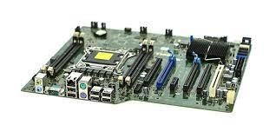
iii. Storage Devices

The devices that are used to store data permanently or temporarily. Broadly they are classified into two major categories: Hard Disk Drive (HDD) and Solid-State Drives (SDD).

iv. Random Access Memory (RAM)

It is a volatile memory that stores data temporarily for quick access by the CPU. It is responsible for holding data and instructions that are currently used by the system.

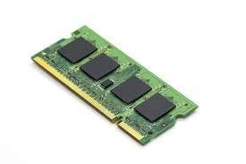
v. Graphics Processing Unit

It renders images, animation, and videos on a computer screen. It can be integrated into the CPU

or come as a separate graphics card. Vi mouse
A computer mouse (plural mice, also mouses) is a hand-held pointing device that detects two- dimensional motion relative to a surface.

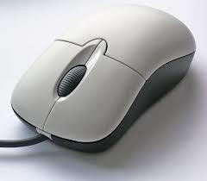

3.1 Uses of computer

1. Business

Almost every business uses computers nowadays. They can be employed to store and maintain accounts and personnel records, manage projects, track inventory and create presentations and reports.

They enable communication with people both within and outside the business using various technologies, including e-mail. They can be used to promote the business and enable direct interaction with customers.
2. Education

Computers can be used to give learners audio-visual packages, interactive exercises, and remote learning, including tutoring over the internet. They can be used to access educational information from intranet and internet sources or via e-books.

They can be used to maintain and monitor student performance, including through the use of online examinations, as well as to create projects and assignments.

3. Healthcare

Healthcare continues to be revolutionized by computers. As well as digitized medical information making it easier to store and access patient data, complex information can also be analyzed by software to aid discovery of diagnoses, as well as search for risks of diseases.

Computers control lab equipment, heart rate monitors, and blood pressure monitors. They enable doctors to have greater access to information on the latest drugs, as well as the ability to share information on diseases with other medical specialists.

4. Retail and Trade

Computers can be used to buy and sell products online – this enables sellers to reach a wider market with low overheads, and buyers to compare prices, read reviews, and choose delivery preferences. They can be used for direct trading and advertising, too, using sites such as eBay, Craigslist, or local listings on social media or independent websites.

5. Government

Various government departments use computers to improve the quality and efficiency of their services. Examples include city planning, law enforcement, traffic, and tourism. Computers can
be used to store information, promote services, communicate internally and externally, as well as for routine administrative purposes.

6. Marketing

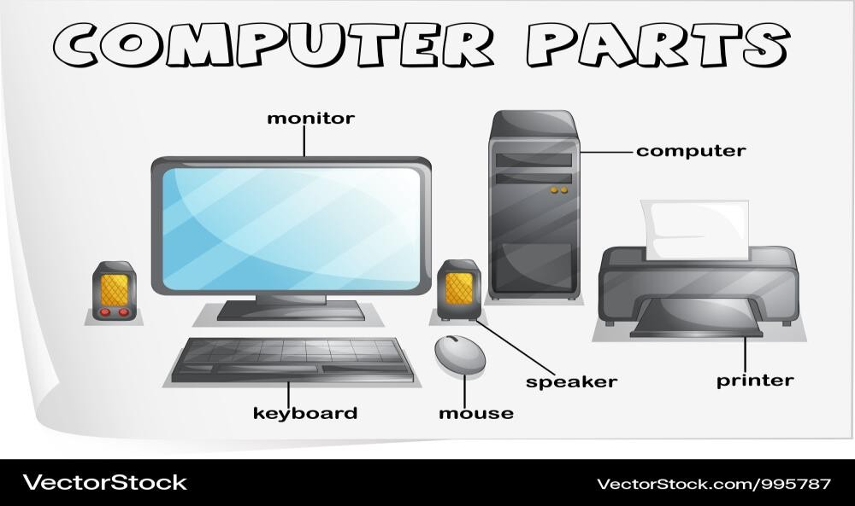Computers enable marketing campaigns to be more precise through the analysis and manipulation of data. They facilitate the creation of websites and promotional materials. They can be used to generate social media campaigns. They enable direct communication with customers through email and online chat.
CHAPTER FOUR

4.0 Start a document

It’s often easier to create a new document using a template instead of starting with a blank page. Word templates come ready-to-use with pre-set themes and styles. All you need to do is add your content.

Each time you start Word, you can choose a template from the gallery, click a category to see more templates, or search for more templates online.

For a closer look at any template, click it to open a large preview.

If you’d rather not use a template, click Blank document.

Open a document

Every time you start Word, you’ll see a list of your most recently used documents in the left column. If the document you’re looking for isn’t there, click Open Other Documents.

If you’re already in Word, click File > Open and then browse to the file’s location.

When you open a document that was created in earlier versions of Word, you see Compatibility Mode in the title bar of the document window. You can work in compatibility more or you can upgrade the document to use Word 2016.

Save a document

To save a document for the first time, do the following:

1. On the File tab, click Save As.

2. Browse to the location where you’d like to save your document.
Note: To save the document on your computer, choose a folder under This PC or click Browse. To save your document online, choose an online location under Save As or click Add a Place. When your files are online, you can share, give feedback and work together on them in real time.

3. Click Save.

Note: Word automatically saves files in the .docx file format. To save your document in a format other than .docx, click the Save as type list, and then select the file format that you want.

To save your document as you continue to work on it, click Save in the Quick Access Toolbar

Open your document in Read Mode to hide most of the buttons and tools so you can get absorbed in your reading without distractions.

1. Open the document you want to read.

Note: Some documents open in Read Mode automatically, such as protected documents or attachments.

2. Click View > Read Mode.

3. To move from page to page in a document, do one of the following:

▪ Click the arrows on the left and right sides of the pages.

▪ Press page down and page up or the spacebar and backspace on the keyboard. You can also use the arrow keys or the scroll wheel on your mouse.
▪ If you’re on a touch device, swipe left or right with your finger.

Tip: Click View > Edit Document to edit the document again.
Track changes

When you’re working on a document with other people or editing a document yourself, turn on Track Changes to see every change. Word marks all additions, deletions, moves, and formatting changes.

1. Open the document to be reviewed.

2. Click Review and then on the Track Changes button, select Track Changes.

Print your document

All in one place, you can see how your document will look when printed, set your print options, and print the file.

1. On the File tab, click Print.

2. Do the following:

▪ Under Print, in the Copies box, enter the number of copies you want.

▪ Under Printer, make sure the printer you want is selected.

▪ Under Settings, the default print settings for your printer are selected for you. If you want to change a setting, just click the setting you want to change and then select a new setting.
3. When you’re satisfied with the settings, click Print.

4.2 EDITING AND FORMATTING A DOCUMENT

To edit a document, open the file in your preferred word processor (like Microsoft Word), then select the text you want to change and type in your edits; to format a document, highlight the text you want to style and use the toolbar options to change the font, size, alignment, bold, italic, underline, or other formatting features depending on your needs.

Key steps for editing and formatting a document:

• Open the document: Access the document you want to edit in your word processing software.

• Select text: Click and drag your mouse over the text you want to modify.

• Edit text: Type new text to replace the selected section.
• Formatting options:

o Font style: Choose a different font from the dropdown menu.

o Font size: Adjust the text size using the size options.

o Bold, Italic, Underline: Use the respective buttons to apply bold, italics, or underline formatting.

o Alignment: Align text left, center, right, or justify using the alignment buttons.

o Paragraph spacing: Modify the spacing between paragraphs.

Important points to remember:

• Highlighting text:

To select specific text for formatting, simply click and drag your mouse over it.

• Using the toolbar:

Most formatting options are located on the toolbar within your word processor.

• Shortcut keys:

Many word processors have keyboard shortcuts for common formatting actions like Ctrl+B for bold or Ctrl+I for italic

4.3 HOW TO USE CORELDRAW

1. Introduction CorelDraw

2. Starting with CorelDraw

Understanding Corel Draw Tools

1. Pick Tools and Freehand Pick Tool

2. Shape Tools

3. Smudge Brush Tool and Roughen Brush Tool

4. Free Transform Tool

5. Smear Tool and Twirl tool

6. Attract tool and Repel tool
7. Crop Tool and Knife Tool

8. Eraser Tool and Virtual Segment Delete Tool

9. Zoom Tool And Pan Tool

10. Freehand Tool

11. Bezier Tool

12. Artistic Media Tool

13. Pen Tool

14. B-Spline Tool

15. Polyline Tool

16. Smart Fill And Smart Drawing

17. Ellipse, Polygon, Star, Complex Star, Graph Paper and Spiral Tool and shapes

18. Text Tool (Artistic Text and Paragraph text)

19. Blend Tool

20. Contour and Distort Tool

21. Drop Shadow Tool

22. Transparency Tool

23. Color Eyedropper tool

24. Outline Pen tool

25. Uniform Fill and Fountain Fill Tool

26. Texture Fill

27. Interactive Fill

28. Mash Fill
Understanding CorelDraw Basic

1. Save File, Export To jpg, pdf and import image

2. Object Position

3. Align and Distribute Object

4. Object order

5. Group, ungroup Object and Lock, unlock Object

6. Distributing object Same Space

7. Undo and Redo and Repeat Object

8. Insert page and insert page number

9. Fit text path

10. Weld Object

11. Trim Object

12. Intersect, Simplify, Front minus Back, Back Minus Front Object

13. Power clip object

CorelDraw Project

1. Brochure Design

2. Business card Design
CHAPTER FIVE

5.0 RECOMMENDATION AND CONCLUSION

5.1 RECOMMENDATION

I use this means to make the following recommendations concerning the training of students in Industrial Attachments

i. I would like to recommend that the Engineering curriculum in the Polytechnics to adjust such as would provide going on industrial attachments for a longer period of time as opposed to 4 months or making the program to occur twice throughout an engineering degree program.
ii. Allowances should be paid to students during their programme just like NYSC and not after.

This would help them a great deal to handle some financial problems during their training course.
iii. The SIWES coordinator and the polytechnic authority should try to stop the habit of rejecting students for SIWES program by the industries
iv. The institution supervisor should make it a priority to visit their designated students in the

various organization to update the student’s logbook

v. Adequate space part should make available to save equipment from deplore condition.

vi. More machines should be made available

vii. Visiting of students during the SIWES program should be ensured by the Industrial Training Fund officials and college coordinators in order to ensure that students get necessary exposure and to boost their morale.

5.2 CONCLUSION

My 6months SIWES program was a huge success and a great time of acquisition of knowledge and skills. Through my training I was able to appreciate my chosen course of study even more, because I had the opportunity to blend the theoretical knowledge acquired from school with the practical hands-on application of knowledge gained here to perform very important tasks that contributed in a way to my productivity in the company. My training here has given me a broader view to the importance and relevance of civil Engineering in the immediate society and
the world as a whole, as I now look forward to impacting it positively after graduation. I have also been able to improve my communication and presentation skills and thereby developed good relationship with my fellow colleagues at work. I have also been able to appreciate the connection between my course of study and other disciplines in producing a successful result.

The Student Industrial Work Experience Scheme (SIWES) is an interesting program that adds more value to students view and objectives of their fields of study.

The Student Industrial Work Experience Scheme (SIWES) has made a great impact in the life of every student that diligently and faithfully participated in the exercise, as a matter of fact, I particularly I’m living testimony to the training.

I hereby encourage and advice every student to be committed to the training scheme, having it in mind that the journey of a thousand miles begins with a footstep.

Error! Bookmark not defined.

