

REPORT ON
STUDENT INDUSTRIAL WORK EXPERIENCE SCHEME (SIWES)
CARRIED OUT AT
HONESTY FARM AND CONSULT MAYA VILLAGE ILORIN, KWARA STATE

BY

UTHMAN ABDULHAMEED OLAREWAJU
ND/23/ABE/PT/0010

SUBMITTED TO
THE DEPARTMENT OF AGRICULTURAL AND BIO ENVIRONMENTAL ENGINEERING, INSTITUTE OF TECHNOLOGY, KWARA STATE POLYTECHNIC, ILORIN.
IN PARTIAL FULFILMENT OF THE REQUIREMENT FOR THE
AWARD OF NATIONAL DIPLOMA (ND) IN MASS COMMUNICATION.

AUGUST, 2024

CERTIFICATION

I hereby certify that UTHMAN ABDULHAMEED OLAREWAJU with matriculation number ND/23/ABE/PT/0010 in the department of Agricultural And Bio Environmental Engineering, Kwara State Polytechnic wrote this SIWES report on completion of his Industrial Training at Honesty farm consult.

…………………………… ………………………..
SIWES Coordinator Signature and Date

…………………… …...…………………..
Supervisor Signature and Date

……………………… ……………………….
Head of department Signature and Date

ACKNOWLEDGEMENTS

With immense please, I will like to give thanks to the people who gave me unending support.

I express my profound thanks Engr O.R Obalowu and all of those who might have indirectly helped me in the cause of my SIWES program.

I will like to thank the entire staff of Kwara State Polytechnic Ilorin. Who made this demanding time joyful but always efficient.

I’m also grateful to fellow SIWES student for making my industrial training interesting, educative and worthwhile. Likewise, I also appreciate all my amazing lecturers in the department for their seasoned lectures and guidance. May the almighty God bless them all.

REPORT OVERVIEW

This report is a complete write up of an Industrial Training Experience carried out for 4 months, which commenced fully from AUGUST, 2024 and ends DECEMBER, 2024 at HONESTY FARM AND CONSULT. The report comprises the background and objectives of SIWES, the description of the organization, its aims and objectives, the experiences gained as an industrial training student as stated in chapter 3 and 4, and the summary, conclusions and recommendations.

It has a total of 5 chapters with some sub-chapters. It also has the preliminary pages, such as the title page, report overview and the table of contents.

TABLE OF CONTENTS

Pages

Title page

Certification Acknowledgement Report Overview Table of content
CHAPTER ONE 1.0ABOUT SIWES
Introduction
  - Aim of SIWES
  - Objective of SIWES

CHAPTER TWO
  - ABOUT PLACE OF ATTACHMENT
  - Brief history
  - Location
  - Objectives

CHAPTER THREE
3.1 WORK CARRIED OUT PART 1
- Housing type
- Materials used
- Feeding pattern and feeds
- Daily routine practices
- Occasional practices
- Safety Guidelines
3.2 Nutritional Requirements of Broilers and Layers
3.3 Factors Affecting Feed Quality

CHAPTER FOUR

  - WORK CARRIED OUT PART 2

4.1 Broiler processing

- Materials used in processing

- Processing steps

- Environmental care

- Safety measures during and after processing

4.2 Marketing and packaging

CHAPTER FIVE

  - Summary

  - Conclusion

  - Recommendations

  - References

CHAPTER ONE

ABOUT SIWES
SIWES was established by ITF (Industrial Training Funds) in the year 1973 to solve the problem of lack of adequate proper skills for employment of tertiary institution graduates by Nigerian Industries. The Students’ Industrial Work Experience Scheme (SIWES) was founded to be a skill training programme to help expose and prepare students of universities, polytechnics and colleges of education for the industrial work situation to be met after graduation.
This scheme serves as a smooth transition from the classroom to the world of work and further helps in the application of knowledge. The scheme provides students with the opportunity of acquainting and exposing themselves to the experience required in handling and managing of equipment and machinery that are usually not made available in their institutions.
Before the inception of the scheme in 1973, there was glaring evidence that inadequate practical exposure of students in tertiary institutions posed serious challenges to both the quality and standard of engineering and technological education in our nation. This resulted in half-baked engineering graduates who needed to undergo a form of training (Industrial Training) to be suitable for employment in industries and firms.
In order to forestall the threat that could bring about industrial regression, the Federal Government through the Industrial Training Fund (ITF), which was established by decree, 47 of 1971 introduced the Student Industrial Work Experience Scheme (SIWES) in 1973.
SIWES exposes students to machines and equipment, professional work methods and ways of safeguarding the work areas and workers in industries and other organizations. It helps the student to know the link between what was learn in the university and what is actually practiced on site. It further helps students to appreciate their field of study better, thereby also determining which area of specialization to go into to contribute to technological development of this nation.

The scheme involves the students, the universities and the industry (employers). It is funded by the Federal Government of Nigeria and jointly coordinated by the National Universities Commission (NUC) and the Industrial Training Fund (ITF).

1.2 Objectives of SIWES

The objectives of the scheme are;

- To mainly facilitate students’ transition from school to the real world of work.

- To bridge the gap between theoretical knowledge acquired in classroom and real time practices in the outside market world.
- To familiarize students with their field-related techniques in handling equipment and machinery.

- To enlist and strengthen employers’ involvement in educational processes and acquaint students with their possible employers after graduation.
- To promote excellent technological know-how and develop highly-skilled labor force towards advancement of the Nation.

CHAPTER TWO ABOUT PLACE OF ATTACHMENT
Brief history and location

Honesty farm an consult is an Agricultural body established 2015 . It is specialized animal production with poultry being its main focus .
The farmland is located in Maya Village , Ilorin and over the 8 year of functioning has expanded greatly and also heading into layers , cockerel and other highly profitable agro ventures
The objectives of this establishment are :
  - Create easy market reach with affordability to consumers
  - Foster growth and positive economic drive in agriculture
  - Serve as job creating alternative
  - Cater for and reduce the common chemical driven agro system
  - Utilize Agriculture as a way to promote the need to recycle and go natural
  - Serve as a mini school to train and re train young and old farmers that would propell Agriculture
  - To become a major contributor in agro development in Kwara State and Nigeria at large

The establishment consists of various sections which work hand in hand to bring about smooth running of the daily activities
The sections include :

- Main farm ( pen )
- Slaughter section
- Office / records
- Packing / storage
- Store ( keeping materials and excess equipment )

Each section is closely monitored and are answerable to a head appointed to them.

CHAPTER THREE

3.1 WORK CARRIED OUT PART 1

Broiler production
Breed broiler is any chicken (Gallus gallus domesticus) that is bred and raised specifically for meat production.^{[1]} Most commercial broilers reach slaughter weight between four^{[2]} and six weeks of age, although slower growing breeds reach slaughter weight at approximately 14 weeks of age. Typical broilers have white feathers and yellowish skin. Broiler or sometimes broiler- fryer is also used sometimes to refer specifically to younger chickens under 2.0 kilograms as compared with the larger roasters.^{[3]}
Due to extensive breeding selection for rapid early growth and the husbandry used to sustain this, broilers are susceptible to several welfare concerns, particularly skeletal malformation and dysfunction, skin and eye lesions and congestive heart conditions. Management of ventilation, housing, stocking density and in-house procedures must be evaluated regularly to support good welfare of the flock. The breeding stock (broiler-breeders) do grow to maturity but also have their own welfare concerns related to the frustration of a high feeding motivation and beak trimming. Broilers are usually grown as mixed-sex flocks in large sheds under intensive conditions.

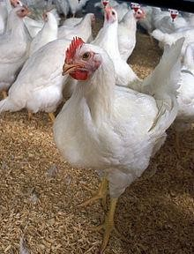

Housing guidelines
These are constructions considered essential to protect the birds from turbulent winds, dust, cold, direct sun light, rain and predators. Buildings are also provided to accommodate feeds and farm equipment. In the tropical environment, an ideal poultry house should not be a completely closed structure. It should be well ventilated, dry cleaned and spacious. It should be of low cost made from locally available building materials.

Site Selection and Lay-Out of Poultry Buildings
- This is a very important point to be considered before establishing a commercial poultry farm.
- The sitting of houses should take advantage of topographical features which will favour air movement.
- Records of local wind speeds and direction should be studied to ensure the best orientation to take advantage of prevailing wind i.e. the house should face away from the direction of the prevailing winds and storms in order to avoid rain and wind drought.
- Sites should be planned to avoid obstructions of air movement by other buildings.
- Avoid areas where there is heavy concentration of livestock activity. If this is not possible, choose a place swept by the prevailing winds before the latter reach other farms.
- The best locations are reserved in descending order for: layer breeder stock, future laying pullets, layers and broilers
- Avoid sites prone to water logging; houses must be on a ground high enough to provide drainage and should be protected against the danger of floods, i.e. they should be located on well-drained sites.
- The site should be accessible from an all season; motorable roads to enhance delivery of feeds; removal of poultry products and wastes.
- A steady source of water and electricity should also be considered.
3.2 Nutritional Requirements of Broilers and Layers
Broilers require a high-energy and protein-rich diet to facilitate rapid muscle growth, while layers need balanced nutrition with adequate calcium and phosphorus to support eggshell formation. Table 2.1 outlines the key nutrient requirements for broilers and layers:
Nutrient | Broilers (%) | Layers (%)
Crude Protein | 22-24 | 16-18
Energy (kcal/kg) | 3000-3200 | 2700-2800
Calcium | 1.0 | 3.5-4.0
Phosphorus | 0.45 | 0.35
Fat | 3-6 | 2-5

Layers Broiler

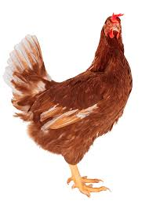
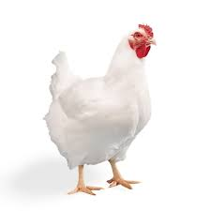
3.3 Factors Affecting Feed Quality
Several factors influence the quality of poultry feed, including ingredient selection, processing techniques, storage conditions, and contamination risks. Ensuring feed hygiene, proper formulation, and correct processing methods are essential for maintaining feed quality.

3.4 Features of Poultry Houses
For poultry farmers constructing housing under tropical environmental conditions, certain requirements must be met if the house is to provide an adequate environment. Considerations for the following factors will avoid pit falls later.

1 Floor of house
The floor should be thick enough to give protection against wetness or dampness during the wet season.
- Concrete floor is mandatory for deep litter system of management especially when the soil is very dense and can absorb and transfer moisture from the lower subsoil.
- Rammed laterite after sand filling may work well, but in such a case, the floor should be raised at least 30cm above the outside ground level, depending on the water level. • The floor should be cemented to make it easy to clean and wash.
- Concrete floor control rat problems in poultry houses.

Width of House
The width from front to back of the open-sided poultry house could be up to 10m (36 ft) in order to ensure effective natural ventilation.
  - Houses that are wider than this may not provide ample ventilation during the dry season. • This recommended width is basic for growing birds, broilers or for laying hens.
  - The houses could be made wider if ceiling fans or air conditioners are installed.

Length of House
A poultry house may be almost of any convenient length.
  - The terrain on which the house is to be built often determines the length.
  - Maximum length of 120metres is acceptable
  - When automatic feeding equipment is to be installed, this will limit the length of the poultry house.
  - Therefore the equipment manufacturer should be consulted about the length of chain and the gears of the automatic feeder before length of the building is determined.

Wall of House

The walls may be built up with cement or mud blocks.
  - The walls can vary from full walls with windows to almost no wall at all i.e. dwarf walls.
  - The same open-sided house suitable for adult birds may be adapted for brooding chicks by covering the open sides with plastic sheets to conserve heat for the young birds during these first few weeks of life.
  - If it is be to open-sided, provision should be made for the erection of pillars at 1.3 to 1.6m (4-5ft) apart.
  - Wooden pillars are good enough but may need to be partially reenforced with concrete up to the length of the solid portion of the wall.
  - The solid portion of the wall should be one-third to half of the total height of the wall/stud . The stud represents the distance from the foundation to the roof line, topped by 0.9 -1.6m wide strip of 1/ 2inch chicken wire mesh.
  - If battery cages are to be used for growers or layers, the solid walls should be less than 0.8m.

Doors of house
Doors of the house should be wide enough; not less than 0.9m • This is to facilitate easy movement of staff, equipment, birds and manure in and out of the house after depopulation. • A footbath/depression at the door step is needed at the foot of each door. • The footbath may be built in at the doorstep or it may be in a movable container.

7. Storage Space
A store may be situated at the middle of the house, but should preferably be a separate building. • There should be two stores: one for eggs, the other for feed and other items needed for farm operation. • The size of such a space should be about one-tenth of the total size of the house.

Poultry Equipment
Poultry equipment is made up of instruments or tools used for a particular job or activity in poultry production management. Poultry houses can not function satisfactorily unless they are properly equipped and supplied with appliances. These are the basic requirements for the successful management of fowls. Poultry equipment vary from the simple to the complex and from the most elementary to the most advanced electronic devices. Poultry equipment can be broadly grouped into those for general applications and those for specific applications. Those for general applications are used at all post-natal stages of growth; these consist mainly of feeders, drinkers and crates. Those for specific stages of growth include brooders for chicks-brooding and nests for layers.

Types of Poultry Equipment
- Feeders

Feeders are appliances used to supply feed to the birds.The construction of feeders should be such as to avoid waste, to prevent fouling of feed with droppings and litter, to facilitate cleaning or washing and should be constructed from durable materials. If timber is used for construction, preservatives like solignum should be used to prevent fungal or insect-damage.

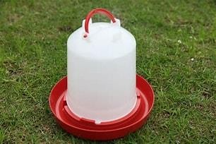
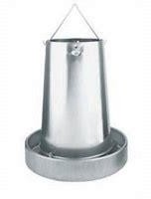
- Drinker
The commonest form of drinker in Nigeria is the water fountain, which may be made of
galvanized iron, aluminum, plastic or clay.
  - They are usually conical or partly cylindricated.

  - They vary in capacity from 2 to 6 or 8 litres.

  - The shape should facilitate quick and thorough washing.

  - Some drinkers are trough-shaped.

  - They are made of galvanized angle iron.

  - Bars spaced at 7.5cm prevent fouling of the water.

  - The trough may be filled manually or by an automatic device based on a spring-loaded ball-

valve attached to the supply pipe.
  - The base of the drinker should have a groove that controls the water flow to the surrounding.

- Perch: This equipment is necessary in deep litter houses.
- It provides resting or roosting places

- It is made of metal, wood, or plastic

- It is of moderate height, to minimize egg breakages.

- Nests

  - This equipment is peculiar to the management of layers and breeders.

  - Nests are compartments in which eggs are laid.

  - The compartments may be such that can be used by one or more birds at a time.

  - Some nests are single or open-fronted nests where dimensions are wide, high and deep.

  - There is a litter-retaining board across the front.

  - There is also an alighting perch at a distance from where the birds can alight before entering the nest.
  - Ideally there should be a means for closing the nests in the evening so that birds don’t roost in and dirty eggs.
  - Nests are usually built with a light frame work covered with cardboard or are of metal construction.
  - The floor of the nest and possibly a section of the side may be constructed with wire mesh.

  - The top should be slopping so that fowls may not roost on the nests.

  - Nests could vary from just a dark corner cordoned off by a few bricks, wood, ceiling board, old basket, old boxes or- purposed built nests.
  - The floor of the nest should have litter material to provide a cushion effect on the egg and reduce breakages. The two-tier single nest The single laying nest
- Crates

These are perforated or well ventilated boxes for the transfer of adult fowls and sometimes growers.
  - The crates could be made of light wood or plastic. framework on iron.

  - They could be used to convey 15-25 birds at a time depending on their age and size.

  - Corners of crate should not be sharp, prevent pilling and suffocation.

- Tools

It is good to be well equipped with tools because it encourages “do it yourself” attitude, which encourages innovation and self relevance. Example: pliers, shovels, wheel barrow, cutlasses, holes, rakes, hammer, saw, screw drivers, scoops, etc.

Feeding pattern and feeds
The birds were fed morning and evening ( ULTIMA FEED ) , the feeders were always examined before the feeds were administered , this was to make sure some of the birds faeces are not mixed with the pellet feeds .
During the evening feeding time the feeders are either topped up or shaked to create a fresh feeling for the bird so a for them to feel the urge of presence of new feed. The birds are always monitored during the feeding to ensure that they are all feeding. In a situation when a bird isn’t feeding well it is separated and observed for necessary actions

Daily routine practices

There are some practices done daily in broiler production which contributes to the successful growth and development of the birds , these practices help to ensure the birds are in good shape and also in early detection of any issues

These practices of great importance are :
- Feeding

The birds are fed twice a day in accordance with the given ratio per bird and all birds are monitored to ensure smooth feeding
- Water

The drinkers are at all times filled with water to prevent dehydration of the birds , and when dirty it is washed and the water is replaced
- Observation

The birds are constantly checked to ensure there is no attack of any kind or cannibalism happening within the pen.

- Hygiene practices

The pen, materials used, the house are always meant to be clean at all times to help maintain good health. The litter material should also be changed when it gets choky.

- Record keeping

Daily numbers are to be taken down to ensure there is a note to fall back on if there is need for reference and progress monitoring.

Occasional practices

Some major occasional practices done for the birds at specific time interval to ensure they are in good condition from time to time are:

- Culling

The birds which are observed to be suffering from one ailment or the other , either by not eating

excluding themselves or some other signs are taken aside for close monitoring and treatments

- Vaccination

The birds are vaccinated before being brought in ( at chick age ) , and weeks into breeding to help fight and prevent them from diseases

- Cleaning and sanitation

Although cleaning is done daily, but as a form of extra hygiene measure a special time is dedicated for thorough cleaning of the pen, equipment and surrounding, This cleaning is also done paying attention to the contents i,e ensuring that less chemical substances are used

CHAPTER FOUR

4.0 WORK CARRIED OUT PART 2

Broiler processing

The broiler processing is an effort to add value to broiler meat and making it available anytime to consumers . Vast number of consumers valued processed and packaged chickens.
When broiler is fully processed it yields carcass and giblets . Aside selling the carcass, the giblets and hind legs are also put up for sale . Giblets include gizzard , liver , heart. The carcass is sold fresh or frozen whole and cut-up .

Materials used in processing
Broiler processing is a way of adding value to live broiler production. Processing offers opportunity to make chickens available all year round to consumers and increase your revenue base. To achieve this, there is need to know and procure basic broiler processing equipment to boost productivity and improve efficiency. Basic broiler processing equipment for small-medium scale is therefore identified below;

- Kill Cone or Slaughtering Cone are funnel-shaped equipment made of stainless steel used for killing birds. It is designed to prevent the birds from flapping its wings or backing out during slaughtering and used to recover blood during bleeding.

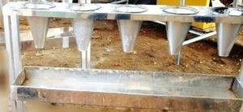

Tank is a tank with boiling water where birds are immersed to loosen the feathers.

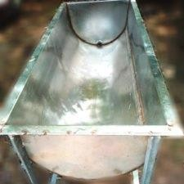

- Rinsing Tank is stainless steel tank used for washing the carcass to reduce bacteria load.

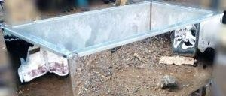

Cutting slab

Where the birds are placed for cutting
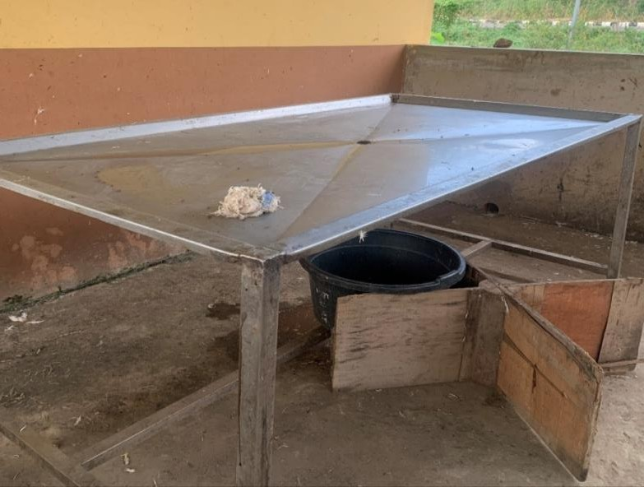

Broiler Processing steps Slaughtering
Birds are deprived of feed for 8 – 12 hours before slaughtering to reduce the amount of feed in the gut and possibility of tearing during processing which would cause faecal contamination of the carcass. Small processors usually place birds in funnel-shaped kill cones while large plants hang them on shackles and stun (the process of electrocuting the bird) them before killing. Kill cones
are sized in such a way that will prevent the birds from flapping their wings or backing out. The use of special lightening (like blue light) in plant calm the bird and prevent flapping and injury. After killing, bird are allowed to bleed thoroughly to prevent dark spot on meats.

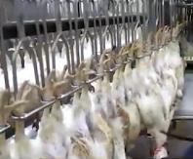

Scalding
Slaughtered birds are immersed in hot water to loosen feathers and facilitate picking; a little drop of liquid soap may be added to scalding water for better penetration. A scalder that will regulate water temperature can be built or bought to handle large number of birds at once. A temperature of 50ºC – 60ºC for 90 – 120 seconds is recommended for scalding broiler.

De-feathering
The quality of the de-feathering is related to the scald. If the scald water is too cool, the feathers won’t loosen; if it is too hot, the skin will tear. In order to handle large number of bird, mechanical picker is recommended. The mechanical picker removes feather by abrasive action of rubber fingers in the picker. Pin feathers and fur may be hard to remove mechanically however; they can be removed by pinning (removal of pinfeathers by hand) and singeing (passing the bird through a flame to remove fur).

Eviscerating
Before evisceration properly begins, the head, oil glands and feet are removed. Evisceration can be done on a flat surface made of stainless steel but easier done on evisceration shackles. Scissors, knife, or a handheld vent-cutter gun with a circular blade, lung puller or a handheld gun used with a vacuum is needed for proper evisceration. Remove inedible viscera or guts (intestines,
oesophagus, spleen, reproductive organs, and lungs). Loosen the crop so it will come out with the guts. The edible viscera are collected.

Washing and Chilling
Washing ought to be done before chilling. The carcass should be thoroughly washed inside and out. At times, additive (like chlorine) may be added to washing water to reduce bacteria load on the carcass. Chilling is done after washing by simply soaking the carcass in chilled water in a tank. Carcass is chilled to a temperature of 5ºC for 4 hours. Carcass can also be air-chilled. Air-chilling takes place in an air-chilling equipment (insulated room or tunnel) in which the temperature is kept between -7ºC and 2°C by coolers in the ceiling. Air is blown from nozzles directly into the cavity of each bird or around it. Chilling prevents microbial growth and improves meat quality.

Packaging and Labeling

Processing up to this stage requires good and befitting packaging. Chicken is commonly put it in a plastic bag and closed with twist-tie. The whole package may be shrink-wrapped before storage to drive out trapped air. Shrink-wrapped chicken looks neat, firm and shelf life is prolonged. Most cut-ups are packaged in tray shrink-wrap. Whole chicken can also be packaged in tray shrink- wrap. Plastic bags can be branded ones with product information or sticker may be affix to the plastic bag.

Environmental care

All the practices done in broiler production can sometimes cause some damages to those carrying it out and those living around the area, thus there is need for attention to be paid to taking care of the surrounding and environs where it is carried out
Some practices like ;
- Avoid use of high gas emitting coal
- Making sure the droppings and deposits are either utilized or sold , all to make sure the choking smell is avoided
- Proper handling and disposing of mortalities
- Making sure the house is sighted away from residential area

Safety measures during and after processing
- Working should be done wearing necessary protectives
- The materials used in the process should always be kept away after use
- All necessary temperature for preserving an holding the birds should not be under or over passed
- The cutting , heating operations should be done with very sharp tools and as careful as possible
- During part separation some parts of the birds are to be handled with care so as not to mess the entire meat
- During work the person in charge should ensure that the floor is washed and disinfected before and after the whole process
- Slip resistant shoes should be worn to protect from slippery floor

Marketing and packaging

The packaging area was put to oversee the putting aside of some parts of the poultry products , some are for exact consumer preference while others are for other use and benefits .During this process some attention is paid to the defaults or breaks present in the birds ( bones or structure ) and / or presence of blood ( some consumer prefer a very neat packing). In order to also ensure a seemless packing , the packing is done immediately the birds are taken out of storage i.e few minutes or an hour before it is being taken or delivered to the eventual consumers.

CHAPTER FIVE
SUMMARY
This report explains the following:
- Broiler housing
- Facts pertinent to an understanding of broiler production
- Preparation on and before the arrival of chicks
- Management of chicks in the brooder
- Dressing, killing and sales of poultry birds.

CONCLUSION
As a means of strengthening students' industrial and practical experience, the SIWES program plays a more important part in the development of Nigerian undergraduates. The program is a good idea with several benefits that cannot be overstated.
The program bears several issues, ranging from overworked kids to feeding becoming survival of the fittest, along with its wonderful creativity. As a result, the curriculum is a combination of learning/practical knowledge acquisition and challenges/difficulties that aid in shaping the student into effective citizens of the country.

RECOMMENDATIONS
To the students who will be undertaking the subsequent program(IT), money should never be your utmost priority, rather search for an establishment that offers services relating to your course of study so as to gain the practical knowledge required for practicing and becoming a professional.
To the industrial training fund (ITF), organizing the program such that the fund will help in the posting or deployment of students due for the program to different establishments as relates to their course of study will help in solving a greater part of the problem encountered during the training months.

