
.

STUDENTS’ INDUSTRIAL WORK EXPERIENCE SCHEME (SIWES)

HELD AT

GENIUS GEO SERVICES LIMITED
SURA SHOPPING COMPLEX SIMPSON STREET, LAGOS ISLAND

BY
HASSAN HALIMAH ASHABI
ND/23/SGI/PT/0017

SUBMITTED TO THE DEPARTMENT OF SURVEYING AND GEO-INFORMATICS, INSTITUTE OF EVIRONMENTAL STUDIES (IES)

2024/2025 Academic Session

Dedication
This SIWES report is dedicated to Almighty God for its successful completion

Acknowledgements
Foremost, my appreciation goes to Almighty God for the successful completion of this SIWES report.
My sincere appreciation goes to Industrial Training and Management of kwara State polytechnic for the opportunities given in having practical idea of what’s learnt in the four wall of a class room.
Lastly, my appreciation goes to my lovely parents MR and MRS HASSAN and to those who were supportive in one way or the other in the success of this work.
Thanks to you all.

TABLE OF CONTENTS
Title Page
Dedication
Acknowledgements
Table of Contents

CHAPTER ONE: INTRODUCTION
1.1 Background of the Study
1.2 Objectives of SIWES
1.3 History of GENIUS GEO SERVICES LIMKITED
1.4 Organizational Structure

CHAPTER TWO:

2.1 Description of Work Done
CHAPTER THREE
3.1 Challenges Encountered
3.2 Lessons Learned

CHAPTER FOUR
4.1 Conclusion
4.2 Recommendations

CHAPTER ONE

INTRODUCTION
1.1 Background of the Study
The Student Industrial Work Experience Scheme (SIWES) was introduced to help bridge the gap between theory and practical application in students' respective fields of study. It provides an avenue where students can gain industry-relevant experience. As a student of Surveying and Geo-Informatics, this scheme serves as a stepping stone into the professional world, offering a firsthand understanding of the real-world implications of the classroom lessons. The scope of my course is wide, encompassing land measurement, data analysis, and mapping, and SIWES offers the environment to practice these skills under supervision. Before embarking on this journey, most of my experience with surveying equipment and software was limited to classroom explanations and occasional lab sessions. The SIWES placement at GENIUS GEO SERVICE LIMITED enabled me to gain exposure to tools like theodolites, total stations, GPS systems, and CAD software. The scheme also helped me understand how surveying contributes to development planning, construction, property documentation, and environmental monitoring. With the ongoing global shift towards digitalization, the experience with modern instruments during the SIWES period was especially crucial. It exposed me to challenges surveyors face in the field and how they resolve them, equipping me with better problem-solving skills. The work experience also improved my time management, teamwork, and communication skills. I was able to understand the importance of data accuracy, report preparation, and client communication. The experience was an integration of technical skill, physical fieldwork, and analytical reasoning. It revealed how different aspects of surveying and geo-informatics are interconnected. It also exposed me to the legal framework guiding land surveying and documentation. Observing surveyors interact with landowners, government agencies, and developers was insightful. The knowledge gained during this experience has increased my confidence and competence as a future professional. I now have a better idea of the areas of specialization within surveying and can plan my career path more effectively. Overall, the SIWES program was essential for building a strong foundation for my future in surveying and geo-informatics.
1.2 Objectives of SIWES
- To expose students to industry practices in surveying and geo-informatics.
- To enhance students' understanding of practical tools and equipment used in the profession.
- To develop students' competence in handling field instruments such as theodolites, total stations, and GPS.
- To provide hands-on experience in field data collection and processing.
- To introduce students to CAD and GIS software for plotting and mapping.

1.3 History of GENIUS GEO SERVICE LIMITED
GENIUS GEO SERVICE LIMITED is a registered surveying firm known for its expertise in land surveying, geospatial data management, mapping, and cadastral survey services. The company was established to meet the increasing demand for precise and reliable surveying services in both the public and private sectors.
Since its inception, GENIUS GEO SERVICE LIMITED has grown significantly and has contributed to several major projects in urban and rural development. The company is driven by the goal of providing accurate spatial data using modern instruments and up-to-date software solutions.
With a team of licensed surveyors, GIS experts, and technicians, the company provides services such as boundary demarcation, topographic survey, layout design, mapping, leveling, and cadastral documentation.
The firm places strong emphasis on training and development, often accommodating students and interns for industrial attachment and practical experience.
Its dedication to professionalism and accuracy has earned it a solid reputation within the industry.
GENIUS GEO SERVICE LIMITED continues to expand its services by incorporating advanced surveying technologies like GPS, drones, and GIS systems to meet the evolving needs of clients.

1.4 Organizational Structure
The company operates under a hierarchical structure beginning with the Managing Director (MD). Reporting directly to the MD are heads of departments such as Operations, GIS, Surveying, and Administration. Each department is managed by professionals with years of field and technical experience. Under the Surveying department, there are team leaders for cadastral, engineering, and topographic survey units. The GIS department handles spatial data processing, mapping, and analysis. CAD technicians and cartographers report to the GIS head for drawing and plot generation tasks. Administrative staff oversee logistics, client relations, and general office management. Field staff are assigned based on project needs and include survey assistants and instrument operators. Interns are attached to senior staff for training and mentorship. Daily meetings are held to plan and evaluate ongoing projects. Communication across departments is maintained through regular reporting and coordination meetings. Project teams are often interdisciplinary to foster collaboration. Safety officers ensure adherence to field safety protocols and equipment use. The structure supports feedback from junior staff tomanagement. Technicians and interns are rotated across departments to broaden their exposure. Supervisors document field activities and submit weekly reports. Staff members are encouraged to contribute suggestions for improved workflow. The structure supports a blend of field and office work to maintain balance. Teams are equipped with mobile communication devices for easy coordination during fieldwork. The inclusive structure fosters learning, accountability, and productivity.

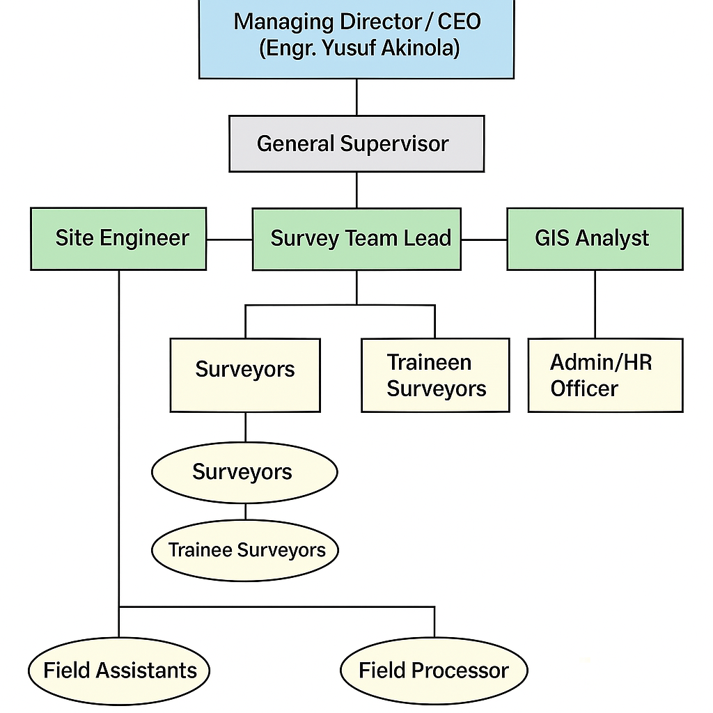

CHAPTER TWO
DESCRIPTION OF WORK DONE
2.1 Description of Work Done
During my SIWES program, I participated in a wide range of surveying activities. These included Theodolite Traversing, where I assisted in setting up and reading angles between survey stations, and I learned how to calculate coordinates using traversing data. We conducted traverses in both open and closed loops, applying corrections for angular misclosures.
I was introduced to Forward Bearing and Back Bearing Calculations, learning how to measure and compute them using compass and theodolite readings. We recorded bearings for various stations and applied them in plotting and determining direction in field mapping.
For Setting Out a Site, I learned how to interpret drawings and use pegs, tapes, and total stations to set out building corners, roads, and boundaries. I was actively involved in marking reference points and ensuring alignment accuracy during site preparation.
We also worked on Plotting on AutoCAD, where I digitized field measurements, plotted traverses, and produced site layouts. I was taught how to import coordinate data, draw boundaries, and label features according to survey standards.
In Cadastral Surveys, I learned how to identify parcel boundaries, prepare survey plans, and ensure accuracy for land documentation. I assisted in field observations and office processing for land registration purposes.
Leveling and Its Types was another key area. We practiced differential, fly, and profile leveling using the automatic level. I learned how to calculate reduced levels, prepare leveling books, and interpret height differences across the site.
We used a wide range of Survey Instruments such as theodolites, total stations, GPS, dumpy level, and measuring tapes. I learned their parts, functions, maintenance, and how to carry out instrument checks before use.
Angular Measurement was taken using theodolites and total stations, and I learned how to read horizontal and vertical angles accurately for plotting and computations.
Linear Measurement involved using tapes, chains, and EDM devices to measure distances. I participated in baseline measurements and learned how to account for slope corrections and errors. We also carried out Leveling Up a Land on Site, ensuring uniform elevation for construction. I assisted in grading and referencing control points across uneven terrain.
In Compass Survey, I used a prismatic compass to measure bearings, plot field data, and create traverse maps. I understood how to correct for magnetic declination.
We finally Plotted Site Graphs, representing terrain and layout visually. Using software tools, we converted field notes into graphical representations showing boundaries, contours, and features. A Reconnaissance Survey (Recck Survey) was usually done before every major work. I was involved in site inspection, planning traverses, and identifying obstacles. This stage helped us plan efficient workflows and select instrument stations.

CHAPTER THREE
CHALLENGES ENCOUNTERED AND LESSONS LEARNED
3.1 Challenges Encountered
One of the main challenges I faced was adjusting to early morning field routines, especially during long travel to remote sites. The physical demand of walking long distances in tough terrain was also challenging at first.
Handling some instruments like the theodolite and total station required precision, and I initially struggled with leveling and aligning the instrument.
Interpreting field notes and converting them accurately into plotted drawings was another challenge, especially when dealing with minor discrepancies in measurements.
Weather conditions like heavy rains and harsh sun sometimes interrupted fieldwork and made it difficult to maintain steady operations.
I also found it hard initially to grasp some AutoCAD functions, especially when importing data and using layers, but with practice, I became more proficient.
Lastly, coordinating tasks in a team required good communication, and I had to learn to be more proactive and attentive to team instructions to work effectively.
3.2 Lessons Learned
I learned the importance of accuracy and consistency in surveying. A small error can affect an entire survey result, so I became more detail-oriented.
The training improved my problem-solving skills, especially when faced with on-site challenges like instrument errors or unclear boundaries.
I also learned that surveying is not just technical but also requires interpersonal skills to deal with landowners, clients, and team members.
Using instruments taught me patience and the importance of following procedures step-by-step to get accurate results. I gained valuable experience with AutoCAD and survey software, which I previously only knew theoretically.
Finally, I learned the value of professionalism, teamwork, and the ethics of the surveying profession, which will guide me in my future career.

CHAPTER FOUR
CONCLUSION AND RECOMMENDATIONS
4.1 Conclusion
My SIWES experience at GENIUS GEO SERVICE LIMITED was highly impactful and fulfilling. I was able to connect the dots between classroom theories and practical applications.
The exposure to real-life surveying projects gave me confidence and improved my technical and analytical skills.
Through fieldwork, I gained competence in using instruments, measuring accurately, and plotting survey data effectively.
I developed a better understanding of land surveying procedures, legal boundaries, and mapping.
The experience also improved my software skills, especially in using AutoCAD for plotting and presenting survey results.
Overall, the training helped prepare me for life after school and strengthened my passion for the field of surveying and geo-informatics.

4.2 Recommendations
Institutions should provide preliminary training on instruments before SIWES to help students start strong.
Survey firms should continue to provide students with hands-on opportunities and assign mentors to guide them.
Students should approach SIWES with a learning mindset, be proactive, and ask questions to maximize their experience.
The use of modern instruments and software should be emphasized more during academic training to match industry demands.
Finally, I recommend GENIUS GEO SERVICE LIMITED to future SIWES students for its supportive environment and wide range of practical learning opportunities.

