

TECHNICAL REPORT
ON
STUDENT INDUSTRIAL WORK EXPERIENCE SCHEME (SIWES)

HELD AT
JAMODAN OIL AND GAS
OLOJO ALABA, MKT RD, LAGOS STATE.
PRESENTED BY
AYINDE OMOTAYO GANIYAT
ND/23/MPE/FT/0095
SUBMITTED TO
DEPARTMENT OF MINERALS AND PETROLEUM RESOURCES ENGINEERING.
INSTITUTE OF TECHNOLOGY
KWARA STATE POLYTECHNIC, ILORIN
IN PARTIAL FULFILLMENT OF THE AWARD OF NATIONAL DIPLOMA (ND) IN MINERALS AND PETROLEUM RESOURCES ENGINEERING.
AUGUST – DECEMBER 2024

DEDICATION
This work is dedicated to the Almighty God, for their love, mercies, guidance and protection during and even after this work.
This work is also dedicated to my lovely and caring parents and wonderful brothers and sisters for their love, support and encouragement.

ACKNOWLEDGEMENT
I wish to acknowledge and thank everyone who contributed one way or the other towards the success of my industrial training.
My special thanks goes to the management and my supervisor for their numerous contribution and effort to make this research a success.
Also, my beloved father and my colleagues for giving me the great opportunity.
I want to say a big thanks to my siblings and my friends for their support and love also my friends for their encouragement and advice.

TABLE OF CONTENTS
Title page
Dedication
Acknowledgement
Abstract
CHAPTER ONE: Introduction
1.1 Historical Background of SIWES
1.2 Aims and Objectives of SIWES
CHAPTER TWO:
2.1 Introduction to the Organization
2.2 Aims and Objectives of the Organization
2.3 Organizational Chart
CHAPTER THREE:
2.1 Experience gained
Chapter four:
3.1 Problems Encountered During the Program
Chapter five:
Conclusion and Recommendation

ABSTRACT

CHAPTER ONE
INTRODUCTION
1.1 Historical Background of SIWES
The Students Industrial Work Experience Scheme (SIWES), is a skills Development programme initiated by the Industrial Training Fund (ITF), in 1973 to bridge the gap between theory and practice among students of Engineering and technology in Institutions of Higher Learning in Nigeria. It provides for on-the-job practical experience for students as they are exposed to work methods and techniques in handling equipment and machinery that may not be available in their Institutions.
SIWES was established by ITF in 1973 to solve the problem of lack of adequate practical skills preparatory for employment in industries by Nigerian graduates of tertiary institutions.
The Scheme exposes students to industry-based skills necessary for a smooth transition from the classroom to the world of work. It affords students of tertiary institutions the opportunity of being familiarized and exposed to the needed experience in handling machinery and equipment which are usually not available in the educational institutions.
Participation in SIWES has become a necessary pre-condition for the award of Diploma and Degree certificates in specific disciplines in most institutions of higher learning in the country, in accordance with the education policy of government.
Duration – Four months for the Polytechnics.
1.2 Aims and Objectives of SIWES
Aim
The aim of the study was to evaluate the impact of SIWES on Technical Skills Development in the Nigerian economy. This is to enable Institutions of Higher Learning and other Stakeholders assess the performance of their roles in the Scheme.
THE ROLE OF THE INDUSTRIAL TRAINING FUND
The Industrial Training Fund (ITF) was established by the decree 47 of 1971 constitution and charged with the responsibility of promoting and encouraging the acquisition of industrial skills, with the view of generating a collection of indigenous trained manpower, sufficient enough to enhance and meet the needs of the economy so as to promote development. Supervision of students, organizing orientation programs, and disbursing allowances to students are some of the roles played by the industrial training fund in the implementation of SIWES.
THE SCOPE AND IMPORTANCE OF SIWES
The scheme covers all science and technological based students in monotechnics, polytechnics and universities in Nigeria, resulting in a high population of students which is easily managed because of the public and private industries that partake in the scheme. SIWES enables students acquire industrial know-how in their field of study particularly in technological based courses. It also enables students experience the application of theoretical knowledge in solving real life problems.
THE ROLE OF THE STUDENT AND THE INSTITUTION
The role of the student is to partake in the program in such a way that he/she will achieve maximum benefit from the program. The student is advised to ask questions, be submissive, and adhere to all the rules and regulations of the organization where he is attached. Identification of placement opportunities, funding of SIWES supervisors and assessment of the student are some of the roles played by the institutions to ensure smooth running of the program.

CHAPTER TWO
2.1 Introduction to the Organization
Jamodan Oil and Gas is a well-established company in Nigeria's petroleum industry, headquartered at Olojo Alaba, MKT Road, Lagos State. The company was founded with a vision to provide high-quality fuel and petroleum products to meet the growing demand of both residential and commercial customers across Nigeria. Over the years, Jamodan Oil and Gas has built a strong reputation for reliability, safety, and customer service.
From its inception, Jamodan Oil and Gas has focused on ensuring the availability of essential petroleum products such as petrol, diesel, and lubricants. The company has expanded its operations through a network of strategically located filling stations across Lagos State and beyond, making it a key player in the Nigerian oil and gas sector.
In addition to retailing fuel, Jamodan Oil and Gas emphasizes sustainability and safety in its operations, ensuring compliance with industry regulations and environmental standards. The company has also made significant investments in modern technology and equipment to improve operational efficiency and reduce environmental impact.
With a commitment to customer satisfaction and continuous growth, Jamodan Oil and Gas continues to expand its presence, becoming a trusted name in the Nigerian petroleum industry.
2.2 AIM AND OBJECTIVES OF THE ORGANIZATION
The primary aim of Jamodan Oil and Gas is to provide high-quality, reliable petroleum products and services that meet the needs of both domestic and commercial customers while ensuring safety, environmental sustainability, and operational excellence within the oil and gas industry.

Objectives of Jamodan Oil and Gas
- Quality Fuel Supply: To supply premium and reliable petroleum products, including petrol, diesel, and lubricants, to customers, ensuring consistency and safety in all fuel deliveries.
- Safety and Environmental Responsibility: To adhere to the highest standards of safety in the operation of filling stations, while minimizing environmental impact by implementing sustainable practices in fuel handling and storage.
- Customer Satisfaction: To offer superior customer service by providing accessible and convenient fueling solutions, addressing customer needs promptly, and creating a positive experience at every touchpoint.
- Operational Efficiency: To enhance operational effectiveness by investing in modern equipment and technology, ensuring smooth and efficient fueling operations, and reducing downtime.
- Regulatory Compliance: To comply with all national and international regulations governing the oil and gas industry, ensuring legal and environmental obligations are met at all times.
- Community Development: To contribute to the local community by creating jobs, providing training opportunities, and participating in community development initiatives that promote social well-being.
- Sustainable Growth: To continually expand its network of filling stations and increase market share by exploring new locations, diversifying services, and improving customer loyalty.

2.3 ORGANIZATION CHART
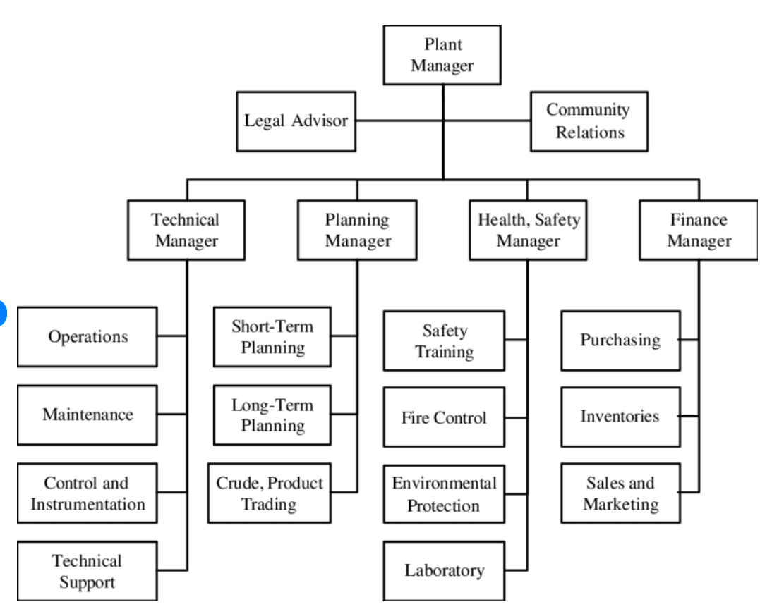

CHAPTER THREE
3.1 INDUSTRIAL TRAINING (SIWES) EXPERIENCE.

Week 1: Introduction and Orientation
- Introduction to the company, staff, and workplace environment.
- Orientation on rules, regulations, and safety measures.
- Overview of the company's operations and work ethics.

Week 2: Handling of Equipment and Safety Procedures
- Introduction to various machines and equipment used in production.
- Learning techniques for proper handling and maintenance of equipment.
- Understanding safety precautions in handling heavy machinery.

Week 3: Crushing Operations and Machine Identification
- Introduction to the primary crushing process of marble using a jaw crusher.
- Identification and functions of different crushing machines, including the blower, bucket classifier, and upper machine.
- Cleaning and lubrication of machines after operation.

Week 4: Packaging and Sealing of Products
- Learning the process of packaging and sealing the final product (POP).
- Hands-on experience using an electric hand-sewing machine for sealing sacks.
- Understanding the importance of proper packaging in industrial production.

Week 5: Uses of Crushed Marble Products
- Introduction to the applications of crushed marble (POP).
- Understanding its uses in artificial decorations and construction.
- Discussion on the importance of quality control in marble processing.

Week 6: Quarry Operations and Material Extraction
- Learning the process of marble extraction from the quarry.
- Sorting marble pieces for crushing and processing.
- Understanding the grading and selection of raw materials.

Week 7: Processing and Separation of Marble
- Separation of valuable marble from waste materials.
- Processing of extracted marble into different grades.
- Quality assessment of processed materials.

Week 8: Introduction to Chipping Process
- Learning about chipping as a method of rock sampling.
- Understanding how chipping is used in marble processing.
- Handling and breaking marble into different sizes for various uses.

Week 9: Offloading and Transportation of Marble
- Offloading a truck of marble for chipping operations.
- Understanding logistics and transportation in the marble industry.
- Learning about the handling of heavy loads safely.

Week 10: Cleaning and Machine Maintenance
- Cleaning of the work environment to ensure safety.
- Understanding how rainwater affects marble storage and processing.
- Maintenance and lubrication of machines to enhance productivity.

Week 11: Chipping Production Process
- Loading marble into the crusher for chipping production.
- Learning how chipping produces fine, coarse, and rough products.
- Understanding the different grades of chipping products.

Week 12: Slab and Chipping Applications
- Learning how chipping is used to break marble into slabs.
- Understanding the role of chipping in removing slag from welds (dressing).
- Exploring different industrial uses of chipping products.

Week 13: Supervision and Teamwork Experience
- Assisting in supervising workers during production.
- Developing teamwork and communication skills.
- Understanding workplace coordination and efficiency.

Week 14: Safety and Emergency Response Training
- Learning about workplace safety protocols.
- Understanding emergency response measures in case of accidents.
- First aid training and fire safety precautions.

Week 15: Review of Production Processes
- Reviewing all the processes learned throughout SIWES.
- Identifying areas of improvement and challenges in marble production.
- Discussion with supervisors on practical experience gained.

Week 16: Report Preparation and Conclusion
- Preparing a comprehensive report on SIWES experience.
- Discussing key takeaways and lessons learned.
- Receiving final feedback from supervisors and concluding the training.

CHAPTER FOUR
4.1 CHALLENGES FACED DURING SIWES AT GERIN FM 95.5 ILORIN
During my SIWES training, I encountered several challenges that impacted my learning experience. These challenges include:
- Harsh Working Environment
  - Working in a dusty and noisy environment made it difficult to concentrate at times.
  - Exposure to heavy machinery and marble dust required extra caution to avoid health risks.
- Physical Demands
  - The job involved a lot of manual labor, such as lifting heavy marble pieces and standing for long hours.
  - Fatigue and body pain were common, especially in the early weeks of training.
- Adverse Weather Conditions
  - Rainfall sometimes disrupted activities, especially outdoor processes like loading and offloading marble.
  - Water accumulation in the work area slowed down operations and required extra effort to clean.
- Machine Handling Difficulties
  - Some of the machines were complex and required time to understand.
  - Occasional machine breakdowns delayed production and training sessions.
- Limited Access to Protective Equipment
  - In some instances, there was a shortage of personal protective equipment (PPE), making work conditions riskier.
  - Dust masks, gloves, and safety boots were not always available in sufficient quantity.
- Communication Barriers
  - Understanding instructions from experienced workers was sometimes challenging due to language differences.
  - Some supervisors were too busy to explain processes in detail, leading to self-learning in certain areas.
- Repetitive Tasks
  - Some daily tasks, such as cleaning the environment and machine maintenance, became monotonous.
  - Lack of variety in tasks reduced engagement and motivation at times.
- Safety Concerns
  - There were occasional risks of injury from falling marble pieces and machine malfunctions.
  - Some workers did not strictly follow safety protocols, increasing the chances of workplace accidents.
- Limited Theoretical Application
  - Some concepts from school were not directly applicable to the work environment, requiring adjustments to practical learning.
  - The real-world industrial setting was different from classroom teachings, making adaptation necessary.
- Workload Management
- Balancing practical work with documentation for my SIWES report was sometimes difficult.
- The workload was heavy on some days, leaving little time for proper report writing.

CHAPTER FIVE
CONCLUSION
My SIWES experience was both challenging and rewarding, providing me with hands-on exposure to industrial processes and workplace dynamics. Throughout the training, I gained practical knowledge in handling machinery, processing marble, maintaining equipment, and understanding safety protocols. The opportunity to work in a real industrial setting helped me bridge the gap between theoretical classroom learning and real-world applications.
Despite facing challenges such as harsh working conditions, machine handling difficulties, and repetitive tasks, I developed resilience, adaptability, and problem-solving skills. Overcoming these obstacles strengthened my ability to work under pressure and enhanced my teamwork and communication abilities.
Overall, SIWES has significantly contributed to my personal and professional development, preparing me for future career opportunities. The experience has deepened my understanding of industrial operations and reinforced the importance of workplace safety, discipline, and efficiency. I am confident that the knowledge and skills acquired during this training will be valuable in my future endeavors.
RECOMMENDATION
As a result of difficulties experienced during the four months SIWES program, I would like to recommend the following changes: The duration of SIWES should be extended so as to enable students be more experienced. The ITF should make monthly allowance available for students, so as to put an end to financial difficulties that may arise as a result of transport problems. The Institutions and ITF should help students to get a place of attachment so that the program may commence as planned.
The following recommendations were based on the findings of the study and as a solution to the identified problems.
PROPER COORDINATION AND SUPERVISION OF THE EXERCISE: The various bodies involved in the management of the SIWES exercise i.e. Industrial Training Fund (ITF), NUC, NBTE and NCCE should come together and fashion out a modality that will ensure smooth operation of the SIWES exercise. Efforts should be made to ensure that students attached to the organization are properly supervised to ensure that what they are doing is in line with the objectives of the SIWES exercise.
The various bodies involved in the management of the SIWES programme should liaise with the various industries ahead of time so as to minimize or reduce to the barest minimum the high level of refusal to accept students for their industrial training participation.
ISSUING OF LOG BOOKS/IT LETTERS ON TIME: The log books used by the student during the industrial training period and the IT letters should be issued to the students at the end of the first semester exam as against the end of second semester examination as this will afford the students enough time to search for place that are relevant to their field of study.
EMPLOYMENT OF EXPERTS: The various institutions should endeavor to employ experts in the areas of career development to manage the student's industrial placement centers.

