
A TECHNICAL REPORT ON STUDENT INDUSTRIAL WORK EXPERENCE SCHEME (S.I.W.E.S)
HELD AT:
MEDBOOM NIG. LTD, ILORIN, KWARA STATE
BY
MURAINA TENIOLA BIDEMI
ND/23/BAM/PT/0879

SUBMITTED TO DEPARTMENT OF BUSNESS ADMINISTRATION AND MANAGEMENT,
INSTITUTE OF FINANCE AND MANAGEMENT STUDIES, KWARA STATE POLYTECHNIC, ILORIN
IN PARTIAL FULFILLMENT OF THE REQUIREMENT FOR THE AWARD OF NATIONAL DIPLOMA (ND) IN THE DEPARTMENT OF BUSINESS ADMINISTARTION AND MANAGEMENT, KWARA STATE POLYTECHNICS.

OCTOBER TO NOVEMBER, 2024
DEDICATION
This report is dedicated foremost to God almighty for his favor, mercy and grace upon my life especially during my 2 month SIWES programme at Medboom Nigeria Limited, Ilorin, Kwara State. I would also like to dedicate it to my parents and siblings for their love and support and everyone else that contributed towards making my SIWES training fun and successful one.

ACKNOWLEDGEMENT
I give thanks to almighty Allah for giving me opportunity to end my SIWES. My sincere gratitude goes to my parents Mr. & Mrs. MURAINA for their immense supports for my academic pursuit, also I will like to express my profound gratitude to my HOD, and the departmental SIWES coordinator, and all my Lecturers for their supports toward the completion those work . I am grateful to Medboom Nigeria Limited, Ilorin, Kwara State, for giving me the platform to learn under their supervision. I pray you live long to eat the fruit of your labour.

TABLE OF CONTENT
Title page
Dedication
Acknowledgement
CHAPTER 1
1.0 INTRODUCTION TO THE TRAINING PROGRAM
1.1 BACKGROUND OF SIWES
1.2 AIMS AND OBJECTIVES
1.3 ROLES OF SIWES
CHAPTER 2
2.O BACKGROUND STUDY OF MEDBOOM NIGERIA LIMITED, ILORIN, KWARA STATE
CHAPTER THREE
3.1 TRAINING/DUTIES UNDERTAKEN BY ME DURING MY SIWES PERIOD
CHAPTER 4
RECOMMENDATIONS
CONCLUSIONS

CHAPTER ONE
GENERAL INTRODUCTION OF SIWESINTRODUCTION AND HISTORY OF SIWES
The Students Industrial Working Experience Scheme (SIWES) is a skill training, program designed to expose and prepare students of universities, polytechnics and colleges of education etc. for industrial work experience application they are likely to meet after graduation. The scheme also afford students the opportunity of familiarizing and exposing themselves to requisite experience in handling equipment and machines that may not be available in their institutions. Before the establishment of the scheme, there was a growing concern among our industrialists that graduate from higher institutions of learning in Nigeria lacked adequate practical background studies preparing for employment in industries. Thus, the employers of labor were not responsive enough to the needs of the employees of labor. It is against this background that ITF was formed in the year 1973/74 so as to acquaint students with the skills of handling machines. The ITF, solely funded in its formative years, but as the financial involvement became unbearable to the fund, it withdraw from the scheme in 1978. The federal government handed over the scheme in 1979 to both the National Universities Commission (NUC) and the National Board for Technical Education (NBTE). Later the Federal Government in November 1984 revert the management and implementations of SIWES program to ITF and it was effectively taken over by the Industrial Training Fund in July 1985 with the funding being solely borne by the Federal Government.

1.1 AIM AND OBJECTIVES OF THE SIWES
The aim of SIWES programme is all about strengthening future employees. Such program is successful attempt to help students to understand the underlying principles of their future work. After passing the programs, the student can concentrate on the really necessary factors of his or her work. Specifically, the objectives of the Student Industrial Work Experience Scheme (SIWES)are to:
- To provide students with industrial skills and needed experience.
- To create conditions and circumstances, which can be as close as possible to the actual workflow?
- To prepare specialist who will be ready for any working situations immediately after graduation.
- To teach students the techniques and methods of working with facilities and equipment that may not be available within the walls of an educational institution.
- To give students the ability to try and apply the given knowledge.
- To help students appreciate the role their profession play in the society..

1.2 ROLE OF BODIES INVOLVED IN THE MANAGEMENT OF SIWES PROGRAMME
The Federal Government of Nigeria, Industrial Training Fund (ITF), the Supervising Agencies; National Universities Commission (NUC), National Board for Technical Education
(NBTE), and National Commission for Colleges of Education have roles assigned to them pertaining management of the SIWES program. The roles are as follows:

FEDERAL GOVERNMENT
- To provide adequate fund to the Industrial Training Fund (ITF) through the Federal Ministry of Industries for the Scheme.
- To make it mandatory for all ministries, companies and prostate to offer place for attachment for students in accordance with the provisions of Decree No. 47 of 1971 as amended in 1990.

THE INDUSTRIAL TRAINING FUND (ITF)
The ITF established by decree No. 47 of 8th October, 1971 with the aim of promoting and encouraging the acquisition of skill in commerce and industry with a view to generate a pool of indigenous manpower sufficient to meet the needs of the economy. To motivate the students, ITF pays some money at the end of SIWES period. This has encouraged the students and the organizations to put in more effort in learning the work and train them with all sincerity. This has also positively affected the economy of the country as the quality of work force has greatly improved. The ITF is to:
- Formulate policies and guidelines on SIWES for distribution to all the SIWES participating bodies, institutions and companies involved in the scheme.
- Regularly organize orientation programs for students prior to their attachment.
- Receive and process, master and placement list from the institutions and supervising agencies i.e. (NUC, NBTE and NCCE).
- Supervise students on industrial attachment
- Disburse supervisory and students allowances
- Organize biennial SIWES National Conferences and Annual SIWES Review Meeting

CHAPTER TWO
This chapter encompasses a detail report on background of the Medboom Nigeria Limited, Ilorin, Kwara State.
3.1 BRIEF HISTORY
Medboom Empire was established over a decade ago under the leadership of Dr. Rotimi Michael Kadir, with a vision to provide top-tier solutions in project management, technical support services, ICT services, and medical services. Since its inception, the company has built a strong reputation for excellence, innovation, and reliability across multiple industries. Medboom has its headquarters situated in Lagos, with branches at the Old college of Health Sciences Ilorn as well as Kwara state Polytechnic, Ilorin.
Starting as a small consultancy firm, Mediboom Empire quickly expanded its scope to offer comprehensive project management solutions, helping businesses streamline operations and achieve their strategic goals. Recognizing the growing demand for technology-driven services, the company incorporated ICT solutions, offering cutting-edge support in software development, network infrastructure, and cybersecurity.
In addition to its expertise in technology and project execution, Mediboom Empire has made significant strides in the healthcare sector, providing medical services that improve accessibility and quality of care. Its team of skilled professionals and strategic partnerships have positioned the company as a trusted provider of technical and medical support services.

3.2 Organizational chart of Medboom Empire
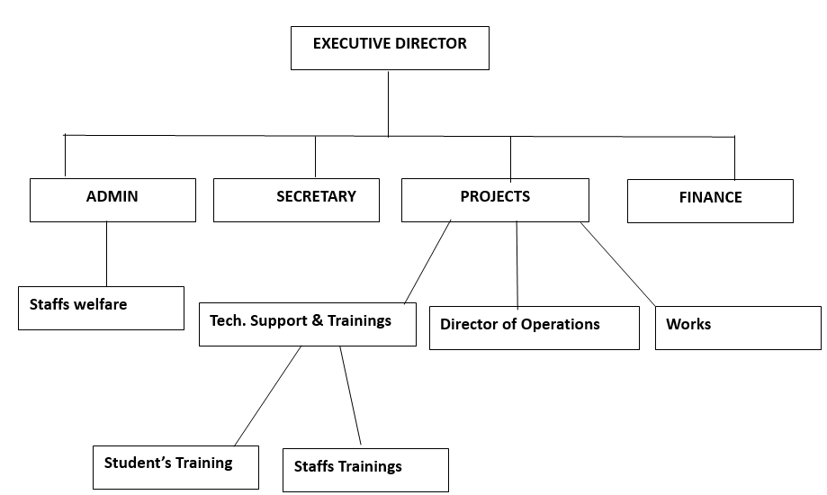

3.3 Responsibilities of Medboom Empire
The company’s key responsibilities include:

1. Project Management Responsibilities:
- Planning, executing, and overseeing projects to ensure timely and successful completion.
- Developing strategies to optimize resources, reduce risks, and improve efficiency.
- Providing consultancy services to businesses and organizations for project execution.
- Ensuring compliance with industry standards and best practices.

2. Technical Support Services Responsibilities:
- Offering technical assistance for hardware, software, and IT infrastructure.
- Diagnosing and resolving technical issues to enhance system performance.
- Providing maintenance, troubleshooting, and IT solutions to businesses and clients.
- Ensuring minimal downtime by implementing proactive support measures.

3. ICT Services Responsibilities:
- Developing and managing IT solutions, including software development and cybersecurity.
- Providing cloud computing, networking, and data management services.
- Enhancing digital transformation for businesses through customized IT solutions.
- Offering ICT training and consultation to improve technological adoption.

4. Medical Services Responsibilities:
- Delivering quality healthcare solutions and medical consultancy.
- Providing medical equipment supply and support services.
- Implementing healthcare technology solutions for better patient care.
- Ensuring compliance with medical regulations and industry standards.

CHAPTER THREE
EXPERIENCE GAINED
3.1 DUTIES, ACTIVITIES AND ENGAGEMENT DURING SIWES
The two (2) months period of SIWES with the Medboom Nigeria Limited, Ilorin, Kwara State was indeed great and a success. Through this period of training I was exposed to real practical of Business Administration profession and entering of data. I was exposed to many activities which are heighted hereafter.

3.2 GENERAL ACTIVITIES UNDERTAKEN AT MEDBOOM NIG. LTD.
As a Business Administration student undergoing the Student Industrial Work Experience Scheme (SIWES) at Mediboom Empire, I gained valuable practical experience in various aspects of business operations, project management, technical support services, and ICT services. My internship provided hands-on exposure to real-world business activities, enhancing my administrative, managerial, and technical skills. Below are some key areas of experience gained:

1. Project Management Experience
- Assisted in project planning, scheduling, and execution.
- Learned how to prepare project proposals, reports, and documentation.
- Gained insights into risk management and problem-solving in project execution.
- Observed the coordination between different teams to ensure project success.

2. Business Administration & Office Management
- Developed skills in office organization, record-keeping, and documentation.
- Assisted in preparing invoices, budgets, and financial reports.
- Learned how to handle client inquiries and provide customer service.
- Understood the importance of teamwork and effective communication in business operations.

3. ICT and Technical Support Services
- Gained basic troubleshooting knowledge in hardware and software issues.
- Learned about ICT service delivery, including networking and cybersecurity.
- Assisted in managing and updating company databases and digital systems.
- Acquired knowledge of digital transformation and IT solutions for business efficiency.

4. Business Strategy & Customer Relations
- Learned the importance of business strategy in achieving organizational goals.
- Assisted in market research and analysis to improve business performance.
- Gained experience in customer service, handling inquiries, and resolving complaints.
- Understood how branding, marketing, and ICT solutions contribute to business growth.

5. Professional & Personal Development
- Improved my communication, teamwork, and leadership skills.
- Learned time management and the ability to work under deadlines.
- Understood workplace ethics, professionalism, and corporate culture.
- Developed problem-solving and decision-making skills in a business setting.
Overall, my SIWES experience at Mediboom Empire was highly beneficial, bridging the gap between academic knowledge and real-world business applications. It provided me with practical skills, industry insights, and professional exposure, preparing me for future career opportunities in Business Administration.

CHAPTER FOUR
SUMMARY, CONCLUSION AND RECOMENDATION
4.1 SUMMARY
Having read through in between the lines and pages of this report, one will accept that the importance of industrial attachment which was introduced in the 70s cannot be overemphasize as it plays a vital role in bridging the gap between theoretical and practical aspect. The scheme which was introduced years ago has in my opinion turn out to be a great height to higher education in Nigeria given the present state of the nation’s educational sector; My SIWES experience at Medboom Nig. Limited, Ilorin was highly educational and insightful. It provided me with practical exposure to Business administration and enhanced my understanding of business structure and strategies. The experience has strengthened my career aspirations and prepared me for future roles in the public sector.
4.2 CONCLUSION
Finally, the success of the scheme as could be seen is dependent on the Ministries, Industrial Training Fund, Institutions, Employers of Labour and the general public involved in the articulation and management of it. It is pertinent to mention that the scheme is aimed at promoting the much-desired technological know-how for the advancement of the nation. This laudable scheme amongst others will surely develop the much-needed well skilled and articulated labour force required to build an indigenous self-reliant economy envisaged for Nigeria. I think once again it is appropriate to thank the virtue of this scheme.

4.3 RECOMMENDATION
For effective performance of students in their various fields of study and to avoid idealness and redundancy the following were recommended;
  - The government and relevant stakeholders should brace up to the need for supporting the scheme through professional and financial encouragement.
  - Students on SIWES should be supervised at least three (3) times during industrial training to make sure that the student is on the right tract.
  - Adequate training facilities should be provided to ensure successful training for student on industrial training.
  - Government and allied stakeholders should implement the real objectives of SIWES as provided in the ITF document and the suggestions highlighted above, so that the students of technology, engineering and related courses will greatly benefit with practical skills.

