

TECHNICAL REPORT ON
THE STUDENT INDUSTRIAL WORKS EXPERIENCE SCHEME (SIWES)

HELD AT

KWARA STATE TELEVISION AUTHORITY, APATA YAKUBA, ILORIN, KWARA STATE

PRESENTED BY

OLASHEU IDRIS AREMU
ND/23/MAC/PT/0814

SUBMITTED TO:
DEPARTMENT OF MASS COMMUNICATION, INSTITUTE OF INFORMATION AND COMMUNICATION TECHNOLOGY [I.C.T.] KWARA STATE POLYTECHNIC, ILORIN.

IN PARTIAL FULFILLMENT OF THE REQUIREMENT FOR AWARD OF NATIONAL DIPLOMA (ND) CERTIFICATE IN MASS COMMUNICATION

AUGUST- NOVEMBER 2024
DEDICATION
I dedicate this Students Industrial Work Experience Scheme (SIWES) report to Almighty Allah for his grace and mercy towards the completion of the SIWES programme.

ACKNOWLEDGEMENT
Special appreciation goes to my parent Mr&Mrs Olasheu for their love and care. applaud them for making me fall in love with education.
My gratitude is incomplete without acknowledging my maternal family for their support and contribution to my onward progress in life.
I also commend my supervisor, Mr. Abdulkadir Ajadi Kolawole for his intellectual contribution and support during my SIWES
A big thanks to my colleagues from different institution that formed the group members during my training.

TABLE OF CONTENT
Title Page i
Dedication ii
Acknowledgement iii
Report Overview iv
Table of Contents v

CHAPTER ONE: Introduction
1.1 Background to the Study 1
1.2 Objectives of SIWES 2
1.3 History of Siwes 3

CHAPTER TWO: Description of Establishment of Attachment
2.1 History of Kwara Television Authority 5
2.2 Departments and their function 7
2.3 organogram 8
2.4 Vision Statement 9
2.5 Mission Statement 9
2.6 Core Value 9

CHAPTER THREE: Actual Work Done with Experience Gained
3.1 Siwes Experiences 11
3.2 Experience at News and Current Affairs 11

CHAPTER FOUR: Actual Work Done with Experience Gained (Cont’d)
4.1 Siwes Experience 13
4.2 Experience at Program department 13 CHAPTER FIVE: Summary and Conclusion
5.1 Conclusion 15
5.2 Recommendation 15

CHAPTER ONE
INTRODUCTION
1.1 MEANING OF SIWES
The Students’ Industrial Work Experience Scheme (SIWES) is a program that is coordinated by the Industrial Training Fund (ITF), in conjunction with the National University Commission (NUC).
The SIWES program is designed to engage students in various degree programs in order to provide the student with practical experience in various fields of study and to expose them to actual working conditions.
This program involves the ITF, students and industries. It is meant to bridge the gap between theory and practical work, sharpen students’ skills and understanding of actual work processes and also provide an avenue to acquire more knowledge.
The Student Industrial Work Experience Scheme [SIWES] is the accepted skill training program which forms part of approved medium academic standards in the various degrees program of the Nigeria tertiary institutions.
This scheme helps student in their various field to know or have knowledge and picture of what they have been studying in school which enable the student to practicalize the theoretical aspect of his profession. This scheme contributes largely to prepare the student for any future engagement exposing him to atmosphere of veracity and adaptation.
1.2 AIMS AND OBJECTIVE OF SIWES
- Student industrial work experience scheme [SIWES] provide avenue for student to acquire industrial skill and experience in their approved course of study
- Expose students to work methods and techniques in handling equipment and machinery that may not be available in their institutions;
- Enlist and strengthen employers’ involvement in the entire educational process through SIWES.
- To provide opportunity for students to apply their knowledge in real work situations thereby bridging the gap between theory and practice.
- To earnest placement and strengths employees involvement in the education process of preparing student for employment in industries.
- To ease the transition from school to the world of work and enhance students contact for later job.
1.3 HISTORY OF SIWES
The early phase of science and technology in Nigeria was characterized by the theoretical lectures in polytechnics and universities which have proven to be an ill method of teaching students in Universities and Polytechnics graduate with little or no technical experience in their course of study.
In the same vein, students’ inability to contribute to the society in hampering the growth and development of our country it was in this view SIWES was introduced to the industrial and Education sector.
SIWES is the acronym for Student’s Industrial Work Experience Scheme. SIWES was established in the year 1973 in order to improve the standard of Education in Nigeria.
SIWES was funded by ITF (Industrial Training Funds) during it early stage not until it was difficult to continue for economic stress: then the responsibility was shared between Industrial Training Funds (ITF) and the Federal Government.
SIWES is a scheme for the duration of sixteen weeks (4 months). SIWES is done after the first year in polytechnics (ND1) and done after second year or third year in University depending on the institution.

CHAPTER TWO
2.1 HISTORY OF KWARA TELEVISION AUTHORITY
Kwara State Television was establish in 1997 by Alhaji Shaaba Lafiaji the then Executive Governor of the state. The Television Station was promulgated into law in 1999 with six departments which are Administration, News and Current Affairs, Programs, Engineering, Accounts and Marketing.
Mallam Ishaq Moddibo Kawu was the pioneer General Manager of the television station. One of the former governors of the state, Alhaji Mohammed Lawal merged both the state broadcasting corporation and television station which was referred to as Kwara State Broadcasting Corporation, after the tenure of Malla Moddibo Kawu, Governor Lawal appointed Alhaja Meiro Mustapha as the Director General to run the affairs of both agencies.
Alhaja Mustapha was succeeded in year 2003 by Alhaji Salami Ayilara who was appointed chairman, a position he held for three months, following which Mallam Lasisi Bello former Director Programs of the station took over as the General Manager in the same year.
Mallam Lasis Bello who took over the mantle of leadership was there till the year 2005 when Mallam Tajudeen AbdulKareem was appointed the next General Manager. Mallam Tajudeen was however removed by Doctor Bukola Saraki Who became the state governor at the time.
Engineer Kolawole Tomori the Director Engineering of corporation was announced the Acting General Manager after the exits of Mallam Tajudeen AbdulKareem. Engineer Tomori’s tenure terminated two years later with the appointment of another Acting General Manager in person of Mallam Nurudeen Imam Abdulrahim with effect from 3rd June, 2009 and later became the substantive general manager of the station on 27th February, 2009.
On the 16th of June, 2010, Barrister Mahmood Abdulraheem replaced Mallam Imam as the general manager for a period of nine months before he was replaced temporarily by the state commissioner of information Mr. Tunji Moronfoye Who also doubles as the administrator of the corporation. Mr Moronfoye held sway until Alhaji Adewale Adebowale Adedeji the General Manager of the state radio station was made General Manager of both the radio and the television stations.
In Novermber 2012, Alhaji Abdulfatai Adewale Adebowale was appointed the general manager by his Excellency, Governor Abdulfatah Ahmed and on the March 5th 2019, Mallam Olarenwaju Sambo Qudus was appointed as acting General Manager of the corporation till date.
2.2 DEPARTMENTS AND THEIR FUNCTIONS
- ADMINISTRATION DEPARTMENT: This is a department that is in charge of keeping proper records of the staffs of the organization, supervises the running of the affairs and maintenance of discipline in the entire station.
- NEWS AND CURRENT AFFAIRS DEPARTMENT: It is the department that is in charge of news production and current affairs in various languages for the station.
- ACCOUNT DEPARTMENT: It is in charge of keeping the financial details and transactions of the station for both the money coming in and out.
- ENGINEERING DEPARTMENT: It is a department that is in charge of engines and all electronic equipment in the television station. It has various unit such as outside broadcasting, maintenance, V.T.R, transmitter, power plant. It is the heart of the station.
- PROGRAMS DEPARTMENT: This is the department that is in charge of the program production, it has various units such as production, presentation and film.
- MARKETING DEPARTMENT: is a department that handles the marketing strategies of the station.
- RESEARCH AND PLANNING DEPARTMENT: They are to discover and have proper planning on the events that the station is willing to do.
- AUDIT DEPARTMENT: This is department verifies and ensure that all transaction of the station are accurate.
2.3 ORGANOGRAM
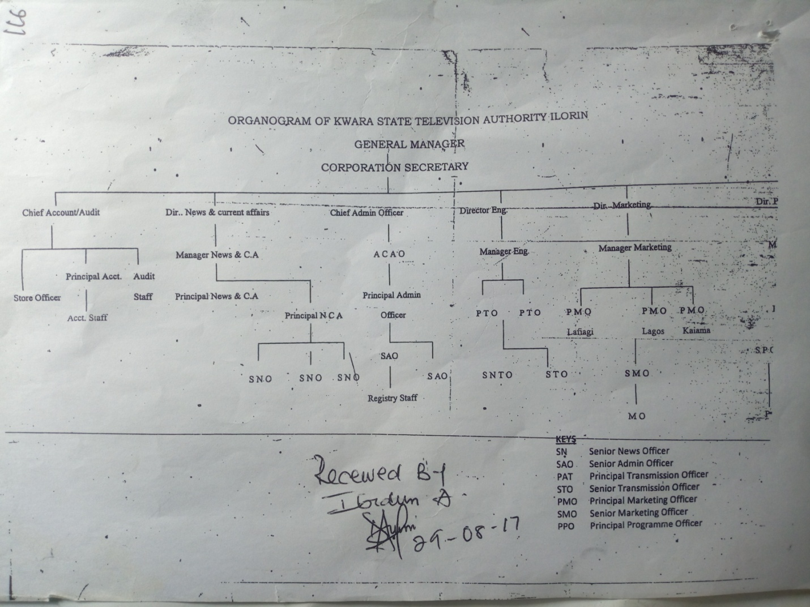
2.4 VISION STATEMENT
The vision statement for kwara tv is “to be the medium transforming the world through broadcasting by upholding our heritage using global best practice”.
2.5 MISSION STATEMENT
To build and sustain a television station that promotes stakeholders relationship through professionalism and innovative quality programming.
2.6 CORE VALUE
K- Knowledge of the job
W- Wealth of experience
A- Awareness
R- Respect for individual
A- Ability
T- Total commitment
E- Excellence
L- Lively entertainment
E- Enriching societal values
V- Viewer satisfaction
I- Innovation
S- Service
I- Insight
O- Objective
N- Newness

CHAPTER THREE
3.1. SIWES EXPERIENCE
I started my siwes program at kwara state television on the 5th of August 2024 in the new and current affairs department under the supervision of Mr. Emmanuel
3.2. Experience at News and Current affairs department
The news and current affairs department is where news is processed, produced and given to a caster to read to the public. In news and current affairs department theirs is what is called editorial meeting, editorial meeting is held every Monday it is the time where all staff come together to discussed and address serious issues concerning the department and how it can be improved.
During my stay at kwara tv news department i was taught what production table is all about production table is divided into four segment the first and second segment is for translation. third segment is for editing while the fourth segment is divided into three stages, the first stages is for home and top stories, second stages is for stories within Nigeria. A third stage is also divided into five unit, business, sport, entertainment, world and weather.
I went out with some reporters to cover some events and so as to learn how to gather news and write report from events, I also search for news online and it was used for the day bulletin and I also participated in writing news line up.

CHAPTER FOUR
4.1. SIWES EXPERIENCE
After completing the required period in the news and current affairs department I was posted to programs department under the supervision of Mr. Kamaldeen who was the presenter of morning show.
4.2. Experience at Programs department)
I was taught who the producer and a presenter is, I was made to know that a producer can also be a presenter in as far he or she is capable of holding the program.
Programs department is where various programs of the tv station are packaged and prepared for airing The department comprises various units such as editing suite, film unit, graphic and master control room(M.C.R) among other.
I was made known the function of the MCR and the equipment in it which are video mixer, audio mixer, monitor, black magic, montage.
- Video mixer: Is a device use to select or assemble the video or programs. It is also used to input background.
- Monitor: Is a device use for displaying.
- Montage: It is use to create awareness for the next program.
Lot was learn during my industrial program which include how programs are being run in the organization and many more.

CHAPTER FIVE
5.1 CONCLUSION
There is every need to appreciate and recognize the advent of SIWES program and agree it has brought about dynamism into learning system. The SIWES program brings new learning services and practical interactivity on the side of the students.
My SIWES report findings my experience and all I learned during my SIWES program at the KWARA STATE TELEVISION AUTHORITY.
My report also revealed the history of my SIWES placement and the aims and important of SIWES. However, my report is detailed with my experience and what I learned during the period.
5.2 RECOMMENDATION
It is been recommended that organizations or company owners who accept SIWES students should endeavor to fully digitize their organization.
It is also been suggested to organizations to make the SIWES student fully involve in the way the organization are been run or operated.
Federal government of Nigeria and state government should provide infrastructure that would help organization owners to fully digitize their companies.
Also institution management should also organize supervisors to inspect students in their vary SIWES placement.

