
A
TECHNICAL REPORT
ON
STUDENT INDUSTRIAL WORK EXPERIENCE SCHEME (SIWES)
HELD AT
OSUN STATE BROADCASTING CORPORATION (OSBC),
OKE-BAALE, ALONG IBOKUN ROAD, OSOGBO

PREPARED BY
ABDULRAHMON QUADIR OLAWALE
ND/23/MAC/PT/0735
SUBMITTED TO
DEPARTMENT OF MASS COMMUNICATION
INSTITUTE OF INFORMATION AND COMMUNICATION TECHNOLOGY
KWARA STATE POLYTECHNIC, ILORIN

IN PARTIAL FULFILLMENT OF THE REQUIREMENT FOR THE AWARD OF NATIONAL DIPLOMA IN MASS COMMUNICATION

SEPTEMBER- DECEMBER, 2023.
REPORT OVERVIEW
This report provides a detailed account of my Student Industrial Work Experience Scheme (SIWES) at Osun State Broadcasting Corporation (OSBC). The training spanned twelve weeks, during which I gained practical experience in broadcast media operations, including news reporting, scriptwriting, video editing, program production, and studio management.

TABLE OF CONTENTS
Title Page
Report Overview
Chapter One: Introduction
  - Background
  - Objectives
Chapter Two: Description of the Establishment
2.1 Location and Brief History of the Establishment
2.2 Objectives of the Establishment
2.3 Organizational Structure (Including Organogram)
2.4 Various Departments/Units and Their Functions
Chapter Three: Work Done and Experiences Gained
3.1 Orientation and Reporting on Program Monitoring
3.2 Understanding the Role of Different Units in Program Production
3.3 Scriptwriting and Presentation Training
3.4 Video Editing and Background Design Training
3.5 Studio Recording and Graphics Designing
3.6 Training on Live and Recorded Program Production
3.7 Caption Editing and Studio Setup for Live Programs
3.8 Practical Exposure to Broadcasting Library Management
3.9 Impact of Social Media on Broadcast Media
3.10 Structure of Broadcast Media and Program Monitoring
3.11 Departmental Meetings and News Caption Writing
3.12 Final Training on Program Background Design
Chapter Four: Challenges and Lessons Learned
4.1 Problems Encountered During the Program
4.2 Skills and Knowledge Gained
Chapter Five: Summary, Conclusion, and Recommendations
5.1 Summary of Attachment Activities
5.2 Problems Encountered During the Program
5.3 Suggestions for the Improvement of the Scheme

CHAPTER ONE
INTRODUCTION
1.1 Background
The Student Industrial Work Experience Scheme (SIWES) is a program designed to bridge the gap between theoretical knowledge and practical application in various fields of study. It is an initiative of the Industrial Training Fund (ITF), established to provide students with hands-on experience in real-world industrial and professional settings.
The importance of SIWES cannot be overstated, as it equips students with the necessary skills, technical know-how, and exposure required for effective participation in the workforce. The program allows students to apply classroom theories to practical scenarios, thereby enhancing their understanding of industry operations.
As part of this program, I was attached to the Osun State Broadcasting Corporation (OSBC) for my industrial training. The OSBC is a government-owned media organization responsible for radio and television broadcasting within Osun State and beyond. The corporation plays a crucial role in information dissemination, education, entertainment, and cultural preservation through its various channels.
During my internship at OSBC, I was exposed to different aspects of broadcasting, including news reporting, program production, technical operations, and corporate administration. This experience provided me with a deeper understanding of the media industry and enhanced my skills in communication, teamwork, and problem-solving.
1.2 Objectives
The primary objectives of my SIWES training at OSBC include:
- Gaining Practical Experience: To apply theoretical knowledge acquired in school to real-world broadcasting operations.
- Understanding Media Operations: To learn about the processes involved in radio and television broadcasting.
- Enhancing Technical Skills: To develop proficiency in media production, editing, and equipment handling.
- Improving Communication Skills: To gain experience in professional communication, news reporting, and public relations.
- Exposure to Workplace Ethics: To understand corporate culture, teamwork, and ethical standards in the media industry.
- Developing Problem-Solving Abilities: To learn how to handle challenges in broadcasting and media management.
- Contributing to OSBC Operations: To actively participate in various tasks and assignments during the training period.

CHAPTER TWO
DESCRIPTION OF THE ESTABLISHMENT ATTACHMENT
2.1 Location and Brief History of the Establishment
The Osun State Broadcasting Corporation (OSBC) is the official media organization of Osun State, Nigeria. It is headquartered at Oke-Baale, along Ibokun Road, Osogbo, with additional transmission stations across the state.
OSBC was established shortly after the creation of Osun State on August 27, 1991. The pioneer staff consisted mainly of former employees of the Broadcasting Corporation of Oyo State (BCOS) who were Osun indigenes. Chief John ArolagbadeFademi, the then-General Manager of BCOS, became the first General Manager of OSBC.
The corporation launched Radio Osun on November 25, 1991, at the OkeItase, Ile-Ife booster station, which previously belonged to BCOS. The administrative and operational departments initially operated from Presidential Hotel, Osogbo, before relocating to a three-floor complex at King’s Square, Ikirun Road, Osogbo in 1992.
The Television arm of OSBC commenced operations on August 27, 1992, in Ibokun, 17 km from Osogbo, broadcasting on Channel 22 UHF.
Subsequent developments included:
1993: Relocation of the radio station from Ile-Ife to Ita-Akogun, Osogbo.
1995: Laying of the foundation for OSBC’s permanent headquarters at Oke-Baale, Ibokun Road.
1999: Official relocation of both the radio and television services to the new headquarters.
2000: Merger of the radio and television services under a single General Manager.
2003-2008: Expansion into a conglomerate, with additional services such as Orisun 89.5 FM, Living-Spring FM 104.5, and Reality RadioVision Iwo.
In 2023, Governor AdemolaNurudeen Jackson Adeleke elevated the status of OSBC’s Director General to Permanent Secretary.
OSBC’s official motto is “Voice of the West”.

2.2 Objective of the Establishment
OSBC serves as the voice of Osun State, ensuring the dissemination of vital information through its radio and television platforms. The primary objectives include:
- Information Dissemination: Providing accurate, timely, and objective news.
- Education: Offering programs that enlighten and empower citizens.
- Public Awareness: Broadcasting government policies and public service announcements.
- Cultural Promotion: Showcasing and preserving Osun State’s rich cultural heritage.
- Entertainment: Delivering engaging content, including music, drama, and sports.
- Developmental Communication: Supporting social, economic, and political progress.
- Balanced Reporting: Upholding journalistic integrity and fairness.
2.3 Organizational Structure
The Osun State Broadcasting Corporation operates under a hierarchical structure to ensure efficiency. The chain of command includes:
- Board of Directors : Oversees policies and strategic direction.
- Director-General (DG)/Permanent Secretary: Chief Executive Officer responsible for overall management.
- Executive Directors: Oversee various operational divisions.
- Departmental Heads: Lead key functional areas.
- Managers & Supervisors: Oversee specific units within departments.
- Operational Staff: Journalists, broadcasters, engineers, and other support personnel.

ORGANOGRAM OF OSBC
Board of Directors

Permanent Secretary
Director General

Accurate Director

Engineering & Technical Service Depatment
Program & Production Department
Directive & Accounts Department
News & Current Affairs Department
Administration & Human Resources Department
Audit Compliance Unit
Finance & Account Department
Public Relations & Corporate Affairs Unit
2.4 Various Departments and Their Functions
OSBC is structured into multiple departments to ensure smooth broadcasting operations:
- Office of the Director-General (DG)
- Oversees the corporation’s entire operations.
- Implements policies set by the Board of Directors.
- Ensures compliance with government regulations and broadcasting standards.

- News & Current Affairs Department
- Gathers, edits, and broadcasts timely news.
- Covers local, national, and international events.
- Conducts interviews and investigative journalism.
- Produces news bulletins and current affairs programs.

- Programs & Production Department
- Develops, plans, and schedules radio and TV programs.
- Produces entertainment, educational, and cultural content.
- Oversees scriptwriting, editing, and directing of programs.
- Coordinates live broadcasts and special events.

- Engineering & Technical Services Department
- Maintains and repairs broadcasting equipment and transmitters.
- Ensures uninterrupted signal transmission.
- Upgrades technology and oversees digital broadcasting systems.
- Provides IT support for operations.

- Marketing & Commercial Services Department
- Generates revenue through advertisements and sponsorships.
- Develops marketing strategies to attract clients.
- Manages customer relations and public relations activities.

- Administration & Human Resources Department
- Handles staff recruitment, training, and welfare.
- Manages records, policies, and internal affairs.
- Oversees workplace discipline and compliance with labor laws.

- Finance & Accounts Department
- Manages the corporation’s budget and expenditures.
- Prepares financial reports and audits.
- Handles payroll and employee salaries.

- Public Relations & Corporate Affairs Unit
- Manages communication between OSBC and the public.
- Organizes corporate events and media relations.
- Enhances the corporation’s public image.

- Audit & Compliance Unit
- Ensures financial accountability and transparency.
- Conducts internal audits and risk assessments.
- Enforces compliance with regulations and procedures.

- Security & Logistics Unit
- Safeguards OSBC premises, equipment, and personnel.
- Manages transportation and logistics for field reporting.
- Coordinates emergency response and safety measures.

Chapter 3
Work Carried Out
3.1 Orientation and Introduction to Broadcasting Operations
During the first week, I was introduced to the broadcasting environment at OSBC. This included orientation sessions where I learned about the organization’s structure, the role of different departments, and the basics of media production. Additionally, I was assigned to monitor programs to understand the flow of broadcasting operations.
3.2 Understanding the Role of Different Units in Program Production
I observed how various units within the corporation work together to achieve seamless program production. These units include News & Current Affairs, Engineering & Technical Services, and Program Production. Understanding their functions helped me appreciate the collaborative effort required in broadcasting.
3.3 Monitoring and Reporting of Assigned Programs
One of my key responsibilities was to monitor assigned programs in the Video Transmitting Room (VTR). This involved tracking program schedules, ensuring seamless transitions between segments, and reporting any technical or content-related issues.
3.4 Practical Training in Script Writing and Presentation
I was trained in scriptwriting, where I learned how to structure scripts for different types of programs. Additionally, I had the opportunity to present a scripted program, which helped me improve my communication and broadcasting skills.
3.5 Studio Setup, Equipment Handling, and Live/Recorded Production
During my attachment, I was assigned tasks related to setting up the studio for different programs. This included arranging backgrounds, positioning cameras, and preparing the set for live and recorded programs. I also learned about the different types of equipment used in broadcasting and their applications.

3.6 Hands-on Training in Video Editing and Graphic Design
I received training on video editing techniques, including linear and non-linear editing. I also learned the difference between live and post-production editing. Additionally, I worked on designing program backgrounds using graphic design software.
3.7 Caption Editing and Program Background Design
I was introduced to caption editing using software like Vmix. I learned how to open applications, locate running orders, and edit text blocks. I also assisted in designing backgrounds for programs, such as ‘Ladies Chat.’
3.8 Fieldwork:
Recording and Coverage of External Events I participated in field recording sessions at the Secretariat, covering government-related events. This experience provided insight into how outdoor programs are recorded and later edited for broadcast.
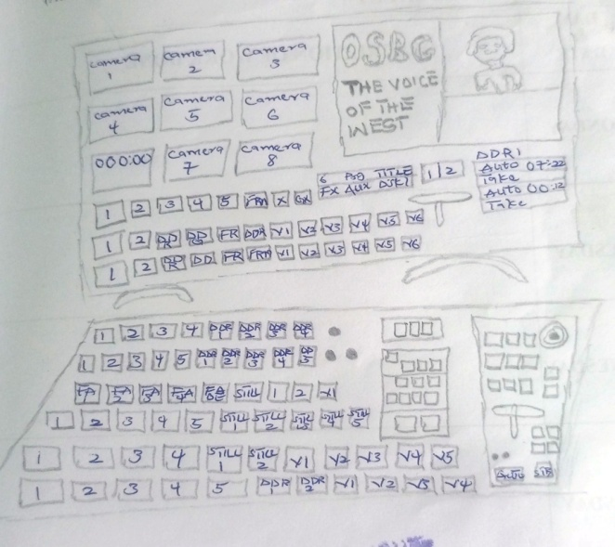
DIAGRAMS
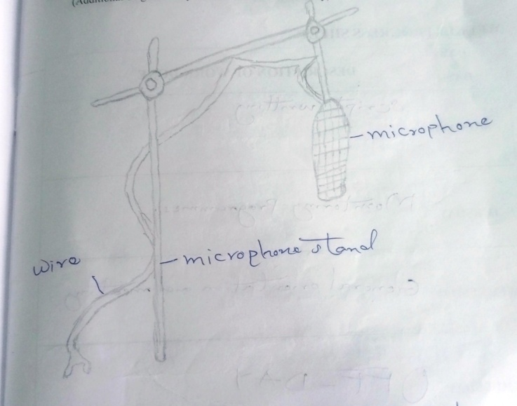
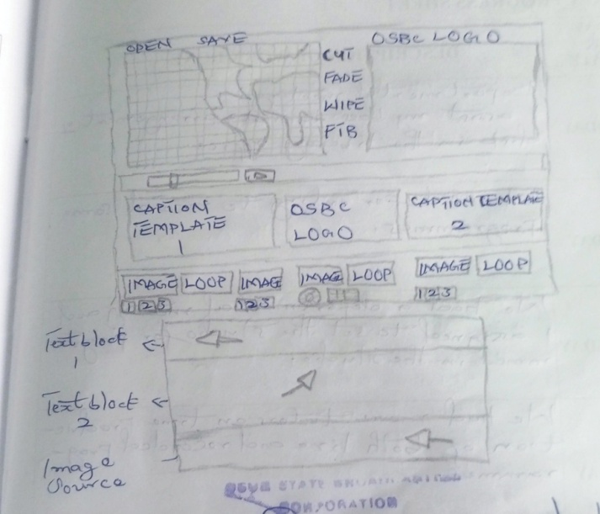
Chapter 4:
Experiences Gained
4.1 Skills Acquired in Program Production and Presentation
Through my attachment, I developed skills in program production, from scriptwriting to final broadcast. I also improved my presentation skills by participating in live and recorded programs.
4.2 Practical Knowledge in Video Editing and Broadcasting Techniques
I gained hands-on experience in video editing, learning different techniques used in both linear and non-linear editing processes. This knowledge enhanced my ability to edit and compile quality video content.
4.3 Understanding the Use of Social Media in Modern Broadcasting
I learned how social media has transformed broadcasting by enabling real-time interaction with audiences. This knowledge is crucial for adapting to the evolving media landscape.
4.4 Exposure to News Production and Caption Writing
I was trained in news production, where I learned about the structure of broadcast news and how to write captions for different segments.
4.5 Challenges and Problem-Solving During the Training
Despite some challenges, such as limited access to equipment and occasional technical difficulties, I developed problem-solving skills by adapting to various situations and finding alternative ways to complete my assignments.
This experience has provided me with practical knowledge and skills that will be beneficial in my future career in the broadcasting industry.

Chapter 5
Summary, Conclusion, and Recommendations
5.1 Summary of Attachment Activities
During my Students Industrial Work Experience Scheme (SIWES) at Osun State Broadcasting Corporation (OSBC), I was exposed to various aspects of television and radio broadcasting. My activities included program monitoring, scriptwriting, program background design, video editing, studio setup, and live and recorded program production. Additionally, I learned about different departments within the broadcasting corporation, such as the News & Current Affairs, Engineering & Technical Services, and Graphics & Design departments.
Over the twelve-week period, I actively participated in the production process, gaining hands-on experience in video editing, program presentation, studio setup, and graphics designing. I also assisted in setting up captions for news programs and worked closely with professionals to understand the dynamics of media broadcasting.
5.2 Problems Encountered During the Program
While my SIWES experience was insightful, there were some challenges, including:
- Limited access to equipment: Due to the high number of interns, access to production tools and equipment was sometimes restricted.
- Inadequate hands-on training: In some cases, theoretical explanations were given without sufficient practical demonstrations.
- Technical difficulties: Occasional power failures and network issues disrupted some training sessions.
- Limited time for in-depth learning: The duration of the attachment was relatively short to master all aspects of broadcasting.
5.3 Suggestions for the Improvement of the Scheme
- To enhance the effectiveness of the SIWES program, the following recommendations are suggested:
- Increase hands-on experience: Interns should have more practical sessions with broadcasting equipment to gain better technical skills.
- Improve access to resources: OSBC and similar organizations should provide more workstations and equipment for interns to use.
- Extend the duration of training: A longer internship period would allow for better learning and understanding of key broadcasting concepts.
- Organize more structured training sessions: Interns should have scheduled training programs with experts in various broadcasting fields.
- Enhance infrastructure: Provision of uninterrupted power supply and reliable internet access would improve training efficiency.
In conclusion, my SIWES experience at OSBC was valuable and provided me with an in-depth understanding of media production and broadcasting. Despite the challenges faced, the knowledge and skills gained during this period will greatly benefit my future career endeavors in the media industry.

