
TECHNICAL REPORT ON THE STUDENT
INDUSTRIAL WORK EXPERIENCE SCHEME
(SIWES)

HELD AT
ABDULFATAI AUTOMOBILE WORK
No 5, Apalara Area, Behind Shathex Filling Station Ilorin Kwara State

PRESENTED BY:

ALAO ABDULHAMEED
ND/23/MEC/PT/0187

SUBMITTED TO
DEPARTMENT OF ELECTRICAL/ELECTRONICS ENGINEERING
INSTITUTE OF TECHNOLOGY (I.O.T) KWARA STATE POLYTECHNIC ILORIN, KWARA STATE.
P.M.B. 1375, ILORIN, KWARA STATE.

IN PARTIAL FULFILMENT OF THE REQUIREMENT FOR AWARD OF NATIONAL DIPLOMA (ND) CERTIFICATION IN ELECTRICAL/ELECTRONICS ENGINEERING

MARCH - APRIL, 2025

PREFACE
This report contains all experience gained during the time of my student industrial work experience scheme (SIWES). Thus it vividly gives a comprehensive summary report of the engaged and experience gained at the company.

DEDICATION
I am delight to dedicate this report to Almighty ALLAH who gave me the grace and opportunity to complete this program.
I also dedicate it to my lovely parent Mr. and Mrs. ALAO. Who gave me the grace and opportunity for the period of my industrial training, and throughout my ND Program, may God Almighty be with you forever.

ACKNOWLEDGEMENT
All praises, adoration and gratitude are all due to Almighty ALLAH. My gratitude also goes to my industrial supervisors who devoted his time for me throughout my stay in the company to make sure I attained maximum knowledge during my program.
My special thanks to my lovely caring and hearted parents, my Mr. and Mrs. ALAO who stood by me that do not let me fall also for their moral and financial assistance rendered throughout my ND program.
Also to my unforgettable siblings, may God Almighty ALLAH be with you all.
Also to my always hardworking engineers in the department of Mineral Resources and Petroleum Engineeringstarting from my HOD of the Department, the Exam coordinator, and all the entire lectures in the great department for their effort and knowledge they impacted on us throughout the ND program may God Almighty be with you all.
And also to all my amiable friends in the department and in the school entirely, may how friendship leads us all to janatu-l-firidaos Amin.
ABSTRACT
This technical report is based on four months compressive industrial training exercise.
The report comprises of five chapters, chapter one: focuses on general introduction to work, chapter two; gives the description of establishment, chapter three and four explain the experience gain and gathered during the programme, chapter five gives the summary conclusion of the report and recommendation needed to the organization and to the polytechnic and development of student’s industrial work experience scheme (SIWES).

TABLE OF CONTENT
Title page
Prefacei
Dedication ii
Acknowledgment iii
Abstract iv
Table of content v
Chapter One
- Introduction 1
1.1 Aims And Objectives Of Siwes 2
1.2 Statement Of Problem 3
1.3 Scope Of The Study 4
1.4 Justification 4
Chapter Two
- Historical Background Of The Organization 5
2.1 Organization Chat 5
Chapter Three
- Workshop tool and machines 6
3.1 General safety rules and regulation 9

Chapter Four

4.0 Types Of Dredging Projects 23

4.1 Purposes Of Dredging 24

4.2 Types Of Dredgers 24
4.3 Challenges During Dredging 24
Chapter Five
5.0 Concussion 25
5.1 Personal impression About The Organization 25
5.2.1 Recommendations To The Polytechnic Concerning The Siwes Programme. 25

CHAPTER ONE
- INTRODUCTION
Student industrial work experience scheme (SIWES is a skill training program designed to expose and prepare students of institution of higher learning for the industrial work situation they are likely to meet after graduation, the scheme was designed to expose students to industrial environment and enable them develop occupational competencies so that they can readily contribute to the growth of national economic and technological development after graduation.
The student industrial work experience scheme (SIWES) was established by the Industrial Training Fund (ITF) in 1978.
  - OBJECTIVES OF SIWES
According to federal government in its gazette of April 1978, the objectives of the student industrial work scheme (SIWES) are to:
- To extend the knowledge of student and wilding their interest as well as to improve their technical skills.
- Provide student with an opportunity to apply their knowledge in real work situation thereby bridging the gap between theory and practical.
- Provide student the opportunity to relate what have been taught in the class with the actual knowledge obtained in the field.
- To build entrepreneurship on the student
- To learn how to manage the operation of a company

  - HISTORICAL BACKGROUND OF THE COMPANY
The company was established with the aim and objective of improving and broadcasting Nigeria engineering and mores to make engineering work easier to human being.
However, this company was owned and controlled by an individual private controller and management.
As at starting, started with an average worker of five (5) working and by now, being an automatic pen, they convert by operating various departments in which each department consist of two constant workers.
These departments are:
- Mechanical department
- Electrical department
- Security department
- Industrial training unit

1.3 ORGANIZATION CHART OF THE AUTOMOBILE COMPANY
PROJECT MANAGER
ADMIN OFFICER
MANAGING DIRECTOR
GENERAL MANAGER
SECRETARY
FINACIAL OFFICER
THE ENGINEER
SUPERVISING ENGINEER
TECHNICAL OFFICER
FOREMAN

CHAPTER TWO
2.1 SECTIONS OF THE ORGANIZATION AND THEIR SPECIFIC FUNCTION
The sections of the organization include:
- Fabrication section
- Production section
- Automobile section
  - FABRICATION SECTION
This section deals with cutting, bending and assembling of metal to form a given structure. Different methods are used in doing this, this include: grooving, welding, casting, machining, forming etc. Various machines such as: Roller, Electrical Furnace, Drilling Machine, Arc Welding Machine, Guillotine Machine, Bending Machine, Power Hacksaw can be found in the fabrication section
  - THE PRODUCTION SECTION
The Production Section makes use of machines tools such as Lathe Machine, Milling Machine, Drilling Machine, and Shaping Machine e.t.c in producing parts of an objects with desired and good surface finish.
The machine tools in production sections can perform various machining operation due to their versatility, operations like: Drilling, Boring, Reaming, Counter Sinking, Counter Boring Turning, Parting-off, Knurling, Drilling, Facing, Boring, Threading, , Keyways, Plain surfaces etc
  - AUTOMOBILE SECTION
This is the section where repairing, servicing and maintenance of a automotives such as Motor vehicle, Motorcycle, Tricycle is been done.

CHAPTER THREE
- WORKSHOP TOOLS AND MACHINES
Every workshop has specific tools and machine that are associated with the service rendered. Therefore the tools and machines that are associated with the servicing and repairing of vehicle includes:
RADIATOR: A car radiator is a critical component of a vehicle's cooling system, responsible for dissipating heat generated by the engine.
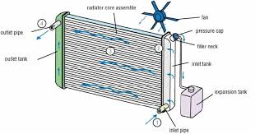


OIL FITTER: An oil filter is a device that removes contaminants and impurities from engine oil in internal combustion engines. Its primary function is to protect the engine from damage caused by dirt, dust, and other particles that can be present in the oil.

SHOCK ABSORBER: A shock absorber is a device designed to absorb and dissipate energy from sudden shocks, vibrations, or oscillations. In vehicles, shock absorbers are an essential part of the suspension system, helping to, smooth out bumps and irregularities, maintain tire contact with the road, reduce vibrations and oscillations, improve ride comfort and stability and enhance handling and control.
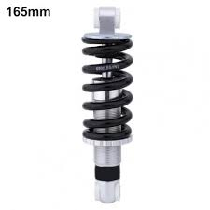

BRAIN BOX: A brain box, also known as an Engine Control Unit (ECU), is a computerized system that controls and monitors various aspects of a vehicle's engine and other critical systems. The brain box receives input from various sensors and sends output signals to actuators, which control the engine and other systems. It's essentially the "brain" of the vehicle, making decisions and adjustments in real-time to optimize performance, efficiency, and safety.
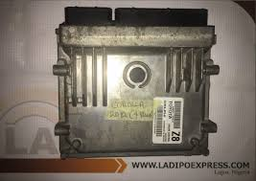

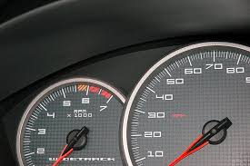
GUAGE AND METERS: Gauges and meters are measuring instruments used to display various parameters and readings in vehicles, industrial settings, and other applications.


FUSE: A fuse is a safety device designed to protect electrical circuits from excessive current flow, which can cause damage, fires, or electrical shocks.

ENGINE COOLANT RESERVOIR: An engine coolant reservoir, also known as an overflow tank, is a container that holds excess engine coolant (antifreeze) that has expanded due to heat or has been displaced by the cooling system.
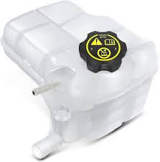

BRAKE FLUID RESERVOIR: A brake fluid reservoir is a container that holds the brake fluid used in a vehicle's hydraulic braking system.
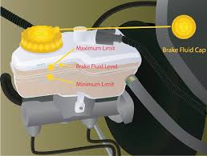

OIL LEVEL DIPSTICK: An oil level dipstick is a tool used to check the engine oil level in a vehicle. It's typically a long, thin rod with markings or holes indicating the oil level.
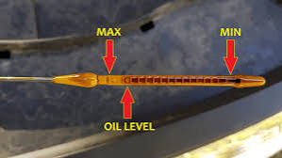

FAN BLADES: Fan blades are the flat, curved, or angled components of a fan that rotate to create airflow. They are typically attached to a hub or motor and are designed to: Move air, Increase airflow, Reduce noise.
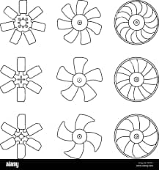

Types of fan blades:
- Axial fan blades: straight or curved blades that move air parallel to the axis.
- Centrifugal fan blades: curved or angled blades that move air perpendicular to the axis.
- Radial fan blades: straight or curved blades that move air radially outward.
COMPRESSOR: A compressor is a mechanical device that increases the pressure of a gas or air by reducing its volume.
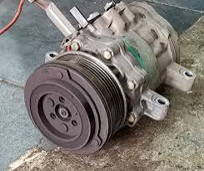

ROLLER: A roller is a cylindrical or rounded component that rotates or moves to facilitate movement, reduce friction, or transfer loads.
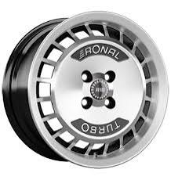

3.1 GENERAL SAFETY RULES AND REGULATION IN THE WORKSHOP
- Ensure tidiness of the workshop
- Ensure you properly wear your gloves, apron and boot
- Do not put on lose clothing in the workshop.
- Always use the right tool for the right job.
- Do not touch naked wire in the factory
- Do not put your bare hands on sharp tool without using glove
- After working always check if the tools or machine used are not faulty.

CHAPTER FOUR
- SERVICING OF MOTOR VEHICLE
There are two ways of servicing motor vehicle in the automobile aspects this include; normal servicing and comprehensive servicing. We shall take them one after the other.
4.1 NORMAL SERVICING:
Is a series of maintenance procedure carried out at a set time interval or after the vehicle has travelled a certain distance. The service intervals are specified by the vehicle manufacturer in a service schedule and some modern cars display the due date for the next service electronically on the instrument panel.
4.1.1 STEPS FOR NORMAL SERVICING
Step 1: Ensure the vehicle engine is cold before taking the servicing procedure to avoid smoking of engine.
Step 2: Litter the old engine oil from the sump
Step 3: loose the filter with oil filter chain and replace it with a new one.
Step 4: Tighten the sump and make sure that it is well tightened
Step 5: Pouring of the new engine oil.
Step 6: Remove the fuel filter and replace with new one make sure that it is fixed in a correct place to avoid incomplete work of motor vehicle.

4.2 COMPREHENSIVE SERVICING
This servicing has 16 names which implore it more to be comprehensive than the normal servicing, although, it is also just like normal servicing but it has further steps in the process which is not involved in the normal servicing.
Comprehensive servicing also under goes the steps of that normal servicing but the only changes is listed below:
- Change of spark plug
- Changing of the brake pad.
- Changing of engine oil
- Change of oil filter.
- Change of alternator belt
- Flushing of radiator
- Servicing of nozzle

4.3 CHANGING OF TOP GASKET
Step 1: Disconnection of wires
Step 2: Loose the cylinder cover
Step 3: Set the timing marks of the engine
Step 4: Loose the cylinder bolt and bring out the cylinder.

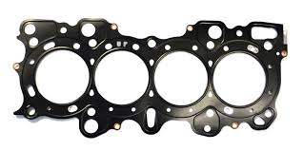

  - MOTOR VEHICLE BRAKE
Brake is a mechanical device which inhibits motion, slowing or stopping a moving object or preventing its motion. Most commonly brake use friction between two surface pressed together to convert the kinetic energy of moving object to heat, though other method of energy conversion may be employed.
4.4.1 CAUSES OF BRAKE FAILURE
- Grease or oil on brake causes brake failure because it interferes with friction. If oil leaks, it may indicate that an oil seal has failed.
- When the brake over heat to a great degree, the metal in the brake rotors or drum develops hard spots. These are known as hot spots. The spots resist the friction from the brake shoes and pads, because the shoes or pad have rutting they can grasp there’s no friction. Consequently, braking power is lost.

4.4.2 BRAKE BLEEDING
Brake bleeding is the procedure performed on hydraulic brake system whereby the brake lines (the pipes and hoses containing the brake fluid) are purged of any air bubbles. This is necessary because, while the brake fluid is an incompressible liquid air bubbles are compressible gas and their presence in the brake system greatly reduces the hydraulic pressure that can be developed within the system. The same methods used for bleeding are also used for purging, where the old fluid is replaced with new fluid which is necessary maintenance.
The brake fluid capacity of a typical automobile is around 500ml. Brake fluid is toxic, and must be handled carefully and disposed of properly. There are 5 methods of bleeding.
- Pump and Hold (2 variation)
- Vacuum
- Pressure
- Bench
- Reverse

4.5 Motor Shaft
The shaft in a motor is a cylindrical component that extrudes out from the motor and its housing. The purpose of the shaft is to convert energy from the motor into the end use application. Precision pins and shafts operate as a function of speed vs torque.
A shaft is a long piece of metal, usually circular in cross section, in an engine or machine that turns and transmits power or movement to another part of the machine. They are used for transmitting rotary motion and torque from one point to another.

4.5.1 Repairing of shaft
Worn and damaged shafts are conventionally repaired using a hot process (welding/machining or hot metal spray/machining). If not carefully controlled, these conventional methods will cause residual damage to the shaft. They also require the disassembly of the machine

4.5.2 Shaft Wear and Damage
Shafts are a critical component of rotating equipment. Shafts are used to transmit power from one part to another or from a machine that produces power to a machine that absorbs power. Shafts are usually operated in immersed or semi-immersed conditions and are subject to damage by corrosion or chemical attack. In the mining industry, shafts can become worn or damaged due to vibration, friction and abrasive media. In the marine industry, gland packing and bushing damage to the shaft together with sand abrasion and sea water exposure can lead to erosion-corrosion on shafts. Additionally, oversized keyways, a crucial component that connects the rotating equipment to the shaft, may cause shaft dysfunction. Worn and damaged shafts can shut down the entire machine. Therefore, worn shafts may hamper or halt production and result in revenue loss.

4.5.3 Conventional Repair Methods of a Worn Shaft
Worn and damaged shafts are conventionally repaired using a hot process (welding/machining or hot metal spray/machining). If not carefully controlled, these conventional methods will cause residual damage to the shaft. They also require the disassembly of the machine. There are problems associated with welding and thermal spraying. Welding can create heat stresses that will tamper and distort the metal, lowering its load bearing capacity. Metal spraying can only be used to repair damage up to a few 1000s of an inch.

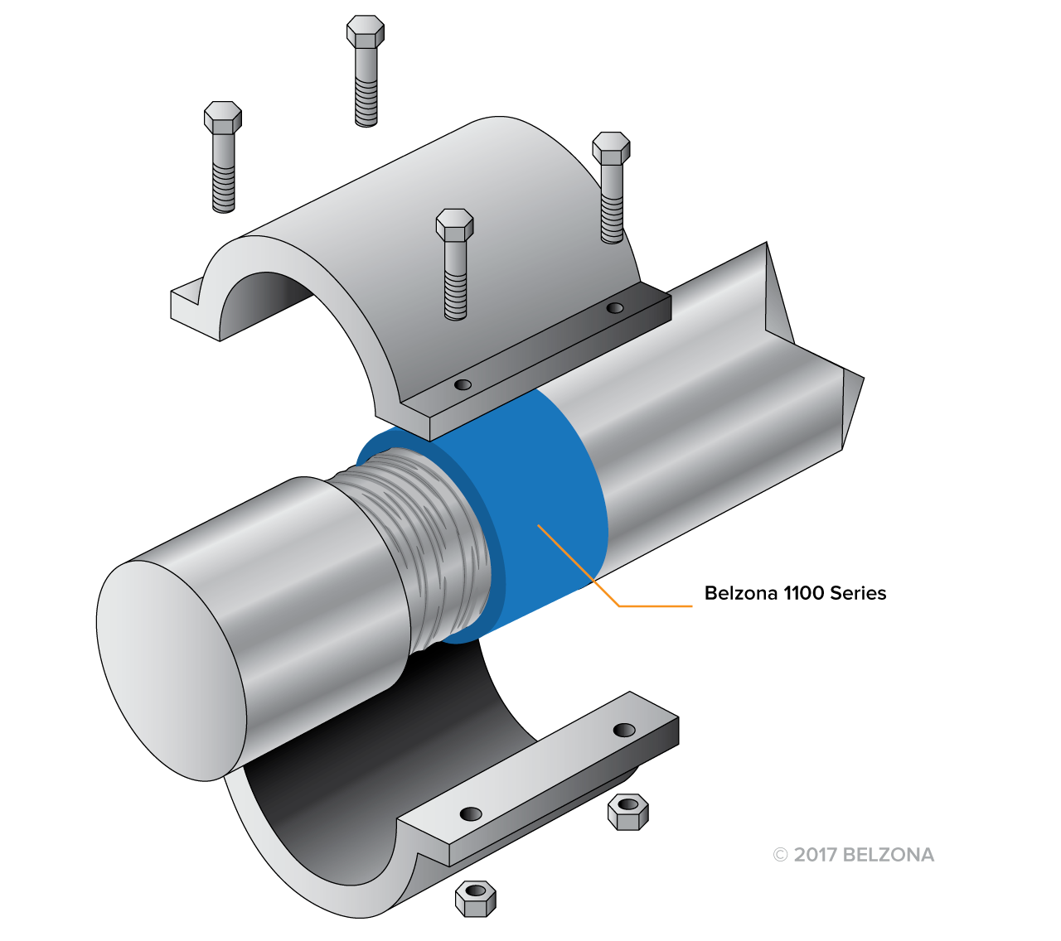

Worn Shaft Repair Drawing

CHAPTER FIVE
5.0 CONCLUSION
The student industrial work experience scheme (SIWES) had contributed to my exposure and training in the field of mechanical engineering.
The program had also enabled me to put into practice the knowledge gained in classroom with actual industrial experience and to develop a critical and realistic approach to problems and the solution in the mechanical field.
This company gave good practical knowledge about my course of study. Also all their staff are so friendly and kind, to the extent that one cannot distinguish one person from the others.

  - RECOMMENDATION
I want to use this medium to advice the polytechnic and industrial training fund (ITF) official to take time to visit the student regularly during their SIWES program, this will enable the student to put more seriousness into the program likewise the supervisor will also be fully aware of the challenges face by the student in their place of attachment.
More so, the student industrial training program is a very important program in which every student should pass through before graduating from their institution as it broadens their knowledge and develop their skills as well as technical know-how.

