
TECHNICAL REPORT ON THE STUDENT
INDUSTRIAL WORK EXPERIENCE SCHEME
(SIWES)

HELD AT
HASBUNALLAHI ELECTRICAL COMPANY
Iwo Road Ibadan, Oyo State

PRESENTED BY:

ABDULWAHEED ROKEEB AKANDE
ND/23/EEE/PT/0077

SUBMITTED TO
DEPARTMENT OF ELECTRICAL/ELECTRONICS ENGINEERING
INSTITUTE OF TECHNOLOGY (I.O.T) KWARA STATE POLYTECHNIC ILORIN, KWARA STATE.
P.M.B. 1375, ILORIN, KWARA STATE.

IN PARTIAL FULFILMENT OF THE REQUIREMENT FOR AWARD OF NATIONAL DIPLOMA (ND) CERTIFICATION IN ELECTRICAL/ELECTRONICS ENGINEERING

MARCH - APRIL, 2025

PREFACE
This report contains all experience gained during the time of my student industrial work experience scheme (SIWES). Thus it vividly gives a comprehensive summary report of the engaged and experience gained at the company.

DEDICATION
I am delight to dedicate this report to Almighty ALLAH who gave me the grace and opportunity to complete this program.
I also dedicate it to my lovely parent Mr. and Mrs. ABDULWAHEED. Who gave me the grace and opportunity for the period of my industrial training, and throughout my ND Program, may God Almighty be with you forever.

ACKNOWLEDGEMENT
All praises, adoration and gratitude are all due to Almighty ALLAH. My gratitude also goes to my industrial supervisors who devoted his time for me throughout my stay in the company to make sure I attained maximum knowledge during my program.
My special thanks to my lovely caring and hearted parents, my Mr. and Mrs. ABDULWAHEED who stood by me that do not let me fall also for their moral and financial assistance rendered throughout my ND program.
Also to my unforgettable siblings, may God Almighty ALLAH be with you all.
Also to my always hardworking engineers in the department of Mineral Resources and Petroleum Engineeringstarting from my HOD of the Department, the Exam coordinator, and all the entire lectures in the great department for their effort and knowledge they impacted on us throughout the ND program may God Almighty be with you all.
And also to all my amiable friends in the department and in the school entirely, may how friendship leads us all to janatu-l-firidaos Amin.
ABSTRACT
This technical report is based on four months compressive industrial training exercise.
The report comprises of five chapters, chapter one: focuses on general introduction to work, chapter two; gives the description of establishment, chapter three and four explain the experience gain and gathered during the programme, chapter five gives the summary conclusion of the report and recommendation needed to the organization and to the polytechnic and development of student’s industrial work experience scheme (SIWES).

TABLE OF CONTENT
Title page
Prefacei
Dedication ii
Acknowledgment iii
Abstract iv
Table of content v
Chapter One
- Introduction 1
1.1 Aims And Objectives Of Siwes 2
1.2 Statement Of Problem 3
1.3 Scope Of The Study 4
1.4 Justification 4
Chapter Two
- Historical Background Of The Organization 5
2.1 Organization Chat 5
Chapter Three
- Experienced Gained 6
3.1 Dredging 9

3.2 Dredging Of Sand With Site Dredger Only 10

Chapter Four

4.0 Types Of Dredging Projects 12

4.1 Purposes Of Dredging 13

4.2 Types Of Dredgers 14
4.3 Challenges During Dredging 14
Chapter Five
5.0 Concussion 15
5.1 Personal impression About The Organization 15
5.2.1 Recommendations To The Polytechnic Concerning The Siwes Programme. 15

CHAPTER ONE
1.0 INTRODUCTION
SIWES was established by ITE in 1973 to solve the problem of lack of adequate practical skills preparatory for employment in industries by Nigerian graduates of tertiary institution.
The scheme exposes students to industry based skills necessary for a smooth transition from the classroom to the world of work. It affords students of tertiary institution the opportunity of being familiarized and exposed to the needed experience in handling machinery and equipment’s which are usually not available in the educational institutions.
The student Industrial Work Experience Scheme (SIWES) was established for Nigerian Higher institution especially Polytechnics and Universities, in order to bring all what they have been taught in the lecture room into practical. Therefore, Polytechnics Universities education will be incomplete if it ends in the lecture room, It is highly experience for student particularly science student to put the lecture room theory into practical.
The Student Industrial Work Experience Scheme (SIWES) is the accepted skills training programme, which form part of the approved minimum academic standards in various degree programme for all the gap existing between theory and practical of Engineering and Technology, Science, Agriculture, Medical, Management and other professional work methods and ways of safeguarding the work areas and workers in industries and other organizations. The minimum duration of the SIWES should normally be 24 weeks except for Engineering and Technology programmes. The programme involving the students, the university and the industries (employers) is found by the federal government of Nigeria and jointly coordinated by the Industrial Training Fund (ITF) and National Universities.
1.1 DEFINITION OF SIWES
SIWES is an acronym of the student industrial work experience scheme. It is a practical skill program developed and designed to prepare student to gain more practical experience and for transition and enhancement of the theory lecturing in the classroom experience to practical experience.
1.2 AIMS AND OBJECTIVES OF SIWES
SIWES programme is therefore aimed at giving the student the opportunity to relate and translate their theoretical knowledge to the real world of work.
The specific objectives of SIWES as summarized by the federal government Gazette of April 1978 are listed below....
1. SIWES provide avenue for student in an institution of higher learning to acquire industrial skills and experience in their course of study.
2. Help student to gain increased maturity and understanding of the workplace.
3. The program teaches the student on how to interact with other workers and supervisors under various conditions in the organization.
4. The student will have chance to evaluate companies for which they might wish to work.
5. It exposes student to the work methods and techniques in handling equipment and machines that might not be available in educational institution.
6. It makes the transaction from school to the world of work easier.
1.3 HISTORICAL BACKGROUND OF THE ORGANIZATION
The company was established with the aim and objective of improving and broadcasting Nigeria engineering and mores to make Electrical Engineering work easier to human being.
However, this company was owned and controlled by an individual private controller and management.
As at starting, started with an average worker of five (5) working and by now, being an automatic pen, they convert by operating various departments in which each department consist of two constant workers.
1.4 ORGANIZATION CHART OF THE ORGANIZATION
ENGINEER
PROJECT MANAGER
ADMIN OFFICER
SECRETARY
MANAGING DIRECTOR
GENERAL MANAGER
SUPERVISING ENGINEER
FINACIAL OFFICER
TECHNICAL OFFICER
LABOURER
FOREMAN

CHAPTER TWO
2.0 SECTIONS / UNITS OF THE ORGANIZATION AND THEIR SPECIFIC FUNCTION
- Electrical section
- Auditing section
2.2 ELECTRICAL DEPARTMENT
This section foresees the proper maintenance and efficiency of the organization, electrification project and also electronics. This section is coordinate by the Director of Electrical Engineering Department.
2.3 AUDITING DEPARTMENT
This section has overall responsible to audit all financial transaction carryout in their organization such as amount spent on labor amount spent on purchasing of equipment’s etc

CHAPTER THREE
3.0 STUDENT INVOLVEMENT AT VARIOUS SECTIONS
This organization has many units, but I was not involving in all the units, I was able to participate in the unit provided in accordance with my course of study which is the electrical section.
This section is where we deal with the installation of electrical fittings, maintenance of different transformers.
SOLAR PANEL: Solar panels, also known as photovoltaic (PV) panels, are devices that convert sunlight into electrical energy. They are a key component of solar power systems, which provide a clean, renewable, and sustainable source of energy.
How Solar Panels Work
- Sunlight hits the panels: Solar panels are exposed to sunlight, which excites the electrons in the panel's photovoltaic cells.
- Electrons are energized: The energized electrons flow through the material, creating an electrical current.
- Direct Current (DC) is generated: The solar panels produce DC electricity, which is then converted to Alternating Current (AC) electricity using an inverter.
- Electricity is fed into the grid: The AC electricity is fed into the electrical grid, where it can power electrical devices, or be stored in a battery for later use.

Types of Solar Panels
- Monocrystalline silicon panels: High-efficiency panels made from single-crystal silicon.
- Polycrystalline silicon panels: Less expensive panels made from multiple-crystal silicon.
- Thin-film solar panels: Low-cost panels made from thin layers of photovoltaic material.
Benefits of Solar Panels
- Renewable energy source: Solar energy is a sustainable and renewable source of energy.
- Zero emissions: Solar panels produce no greenhouse gas emissions or pollution.
- Energy independence: Solar panels can provide energy independence, especially for remote or off-grid locations.
- Low maintenance: Solar panels require minimal maintenance and have a long lifespan.
Common Applications
- Residential solar power: Solar panels are used to power homes and residential buildings.
- Commercial solar power: Solar panels are used to power businesses, offices, and commercial buildings.
- Industrial solar power: Solar panels are used to power industrial processes and manufacturing facilities.
- Solar farms: Large-scale solar farms generate electricity for the grid.
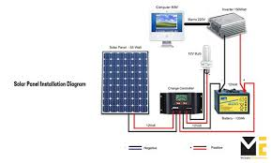

PLIER: A Plier is a handheld tool used to grip, bend, or shape various objects. Pliers are typically used for: Gripping small objects (Holding tiny objects, such as wires, nails, or small parts), Bending or shaping (Forming or bending objects, like wire, metal rods, or pipes), Tightening or loosening (Gripping and twisting objects, such as nuts, bolts, or fittings).
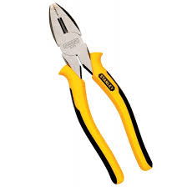

ELECTRIC POLE: An electric pole, also known as a utility pole or power pole, is a tall, sturdy structure used to support overhead power lines, communication cables, and other electrical infrastructure.

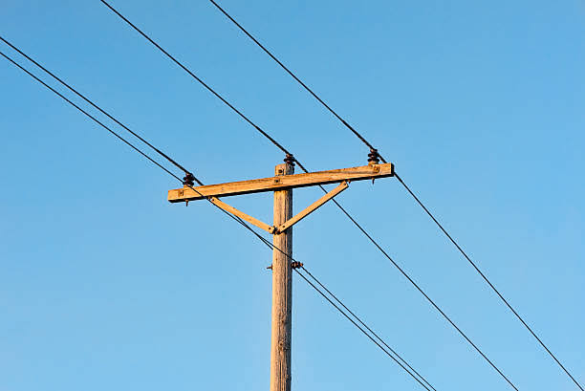

DOUBLE SOCKET AND BULB: A double socket with bulb, also known as a socket with integral lighting or a socket with built-in lamp, is a type of electrical outlet that combines: Two socket outlets (Providing two separate connection points for devices or appliances), A built-in light source (Typically a bulb or LED light, which provides illumination).
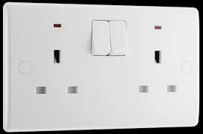

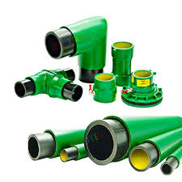
FUEL CONDUIT: A fuel conduit, also known as a fuel line or fuel hose, is a tube or pipe that carries fuel from a storage tank to an engine, furnace, or other device that uses fuel.

3-PHASE SUPPLY: A three-phase supply is a type of electrical power distribution that uses three alternating currents (AC) to transmit power. It is commonly used in industrial and commercial applications, as well as in power generation and distribution.
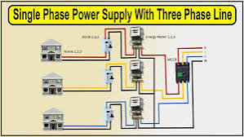

STREETLIGHTS: Streetlights, also known as street lamps or light standards, are outdoor lighting fixtures designed to illuminate public roads, streets, and highways. They provide safety, security, and visibility for: Pedestrians, Drivers, and Cyclists.
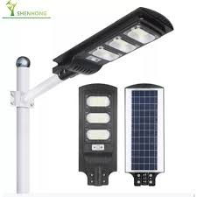

CHANGE OVER: A changeover refers to the process of switching from one system, process, or setup to another.
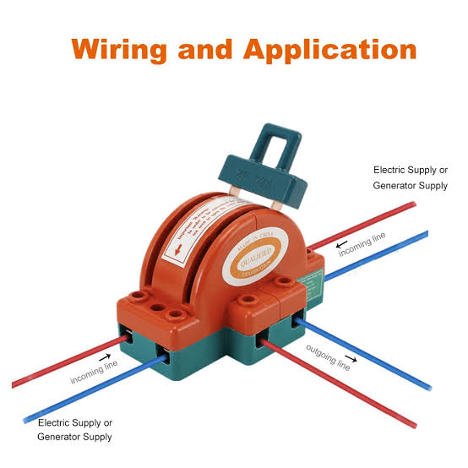

WIRING: The wiring of a house refers to the electrical wiring system that distributes power throughout the building, providing electricity to various appliances, lighting, and devices.
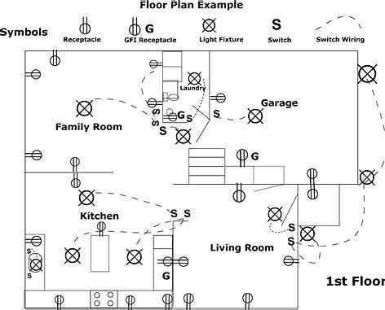

3.1 SAFETY PRECAUTIONS IN ELECTRICAL WORKS
If you’re taking electrician training, or about to begin an apprenticeship, these are 8 essential safety measures to know and respect.
1. Don’t touch someone who’s been electrocuted!
2. Know your Electrical Code
3. Always use GFCIs in damp or wet work areas
4. Inspect & maintain your electrical tools

CHARTER FOUR
DEPARTMENT (EMD)
The tools and equipment mainly utilized in this department during work are:
- Tools Box: As described earlier, this is a box containing various work tools.
- Gas Kit: This contains gas pipes and nozzles, used when refilling gas circuit breakers.
- Insulation Resistance Tester (Megger): This is an instrument used to measure the electrical resistance of an insulator, and the insulation on a conductor.
Grounding Lead and Stick: This tool is used to provide a temporal ground for conductors that may be partially charged4.0 TOOLS AND EQUIPMENT
- 4.1 TOOLS AND EQUIPMENT USED AT ELECTRICAL MAINTENANCE, due to induction, around the working site, so as to prevent electrocution.
- Multimeter: It is particularly used in this department for measuring battery voltage values during maintenance. However, it can also be used to measure current and resistance values.
- Hydrometer: This instrument is used to measure the specific gravity or density of electrolyte in a wet cell. The higher the concentration of sulfuric acid, the denser the electrolyte.
- Oil Pump: This is used for pumping oil from an oil drum to the necessary equipment (e.g. conservator tanks of power transformers, oil circuit breaker, instrument transformer, e.t.c.)
- Hose: This is usually connected to the hand pumps during oil pumping jobs.
- Funnel and Bucket: These are used during works that involve oil or adding of mineralized water to battery electrolyte.
- Oil dielectric test set
5. Follow proper lockout/tag out procedures
6. Wear the right safety gear

7. Choose the right ladder

8. Avoid power lines

CHAPTER FIVE
5.0 PERSONAL IMPRESSION ABOUT THE ORGARNIZATION
- They are well organized
- They provide allowance to the SIWES student
- They are cheerful in the organization
- They evince all necessary things that is need to know by the SIWES and IT student.
5.1 SUGGESTION AND RECOMMENDATION TO THE ORGANIZATION BASED ON SIWES PROGRAM
I suggested to the organization that they should maintain their effort on practical knowledge giving to IT students and the SIWES student.
5.2 SUGGESTION AND RECOMMENDATION TO THE POLYTECHNIC
The polytechnic should try to send departmental lecturer who has Experience about the course of study. Finally, during the visitation, the supervisor should ask the Coordinator at the organization about the performance of the Student.
5.3 CONCLUSION
I was absolutely impressed on how they carried out their day-today activities in the organization, they work with time and highly discipline and accommodative.
In a nutshell, I have gained a lot from the organization relating to my course of study in practical ways.

