

A TECHNICAL REPORT
ON
STUDENT INDUSTRIAL WORK EXPERIENCE SCHEME
(SIWES)

HELD AT
MINISTRY OF AGRICULTURE AND RURAL DEVELOPMENT
OLD JEBBA ROAD, ILORIN, KWARA STATE
BY
SALAWUDEEN AMIDAT AYOMIDE
ND/23/ABE/PT/0003

SUBMITTED TO:
THE DEPARTMENT OF AGRICULTURAL ENGINEERING
(INSTITUTE OF TECHNOLOGY) KWARA STATE POLYTECHNIC
IN PARTIAL FULFILMENT OF THE REQUIREMENT FOR THE AWARD OF NATIONAL DIPLOMA (ND) IN AGRICULTURAL ENGINEERING

AUGUST - DECEMBER 2024
DEDICATION
This Siwes is dedicated to Almighty God for his protection, kindness, strength over my life and also to my parents for their financial support and moral care towards me. Also to my lecturers for the academic advice they often gives to me.
May Almighty God shield them from the peril of this world and bless their entire endeavor Amen.

ACKNOWLEDGEMENT
I acknowledge with gratitude to Almighty GOD for the successful completion of this Siwes.
My Appreciation goes to all staffs and H.O.D of Agric Engineering Department who has contributed in one way or the other to the completion of this Siwes.
I also appreciate the effort of my parent in person of Mr. and Mrs. Salawudeen for their morally, spiritually and financially support, i pray that almighty God should be with them.

PREFACE
The student industrial work experience scheme (SIWES) helps in exposing students to the practical application of their course and to get used to equipment and machines used in the factory. The SIWES was established to promote student skills in industrial practice and pre-expose them to working experience in industrial setting.
The SIWES program covered a period of four months from August to December 2024 and it is a partial fulfilment of a two years academic program to obtain an OND certification in Engineering. The report explains the description of the work done.

TABLE OF CONTENTS
Title Page
Dedication i
Acknowledgements ii
Table of contents iii
CHAPTER ONE: INTRODUCTION ON STUDENTS INDUSTRIAL WORK EXPERIENCE SCHEME (SIWES)
  - Background on SIWES
  - Aim and Objectives of SIWES

CHAPTER TWO: DESCRIPTION OF THE ESTABLISHMENT OF ATTACHMENT
2.1 Location and brief history of establishment
2.2 Objectives of establishment
2.3 Organization structure (including organogram)
2.4 The various departments/unit in the establishment and their functions

CHAPTER THREE: WORK DONE AND EXPERIENCE GAINED AT THE PLACE OF ATTACHMENT
3.1 Brief introduction on the Greenhouse at Ministry of Agriculture and Rural Development
3.2 Operation of a plough machine
3.3 Making of Plant Beds in the Greenhouse kits
3.4 Installation of Trunk and Drip Lines for Irrigation
3.5 Staking of plants in the Greenhouse kits

CHAPTER FOUR: SUMMARY, CONCLUSION AND RECOMMENDATION
5.1 Summary of attachment activities
5.2 Problems encountered during the program
5.3 Conclusion
5.4 Recommendation

CHAPTER ONE
1.1. INTRODUCTION/MEANING OF SIWES
The Students' Industrial Work Experience Scheme (SIWES) was founded to be a skill training program to help expose and prepare students of universities, Polytechnics and colleges of education for the industrial work situation to be met after graduation. The Scheme affords Students the opportunity of familiarizing and exposing themselves handling equipment and machinery that are usually not available in their institutions
Before the establishment of the Scheme, there was a growing concern that graduates of our Institutions of higher learning lacked adequate practical knowledge and that the theoretical education in Higher Institutions was not responsive to the needs of the Employers ‘of Labour.

1.2. BRIEF HISTORY OF SIWES
SIWES was founded in 1973 by ITF (Industrial Training Funds) to address the problem of tertiary institution graduates' lack of appropriate skills for employment in Nigerian industries.
The ITF (Industrial Training Fund) organization decided to aid all interested Nigerian students and created the SIWES program. The federal government officially approved and presented it in 1974. During its early years, the scheme was entirely supported by the ITF, but as the financial commitment became too much for the fund, it withdrew in 1978. The National Universities Commission (NUC) and the National Board for Technical Education (NBTE) were given control of the scheme by the federal government in 1979. The federal government handed over supervision and implementation of the scheme to ITF in November 1984. It was taken over by the Industrial Training Fund (ITF) in July 1985, with the federal government bearing entire responsibility for funding.

1.3. AIMS/OBJECTIVES OF SIWES
The Industrial Training Fund’s Policy Document No. 1 of 1973 which established SIWES outlined the objectives of the scheme as:
- Provide an avenue for students in Institutions of higher learning to acquire
industrial skills and experience in their respective courses of study.
- Prepare students for the Industrial Work situation they are likely to experience
after graduation.
- Expose students to work methods and techniques of handling equipment and
machinery that may not be available in their
Institutions.
- Make the transition from school to the world of work easier; and enhance
students’ networks for later job placements.
- Provide students with an opportunity to apply their knowledge to real work
situations, thereby bridging the gap between theory and practice; and
- Enlist and strengthen Employers’ involvement in the entire educational
process; thereby preparing the students for employment in Industry and Commerce.

CHAPTER 2
2.0 Description of the establishment of attachment
2.1 Location and brief history of establishment
Kwara State Ministry of Agriculture and Rural Development, Ilorin is a parastate under the state affairs and been controlled by the state.
The Department is located at Fate Roundabout Area, Along Sango Area, Ilorin, Kwara State.
The main objectives of the establishment among many are:
- Improving Food security.
- Ensure access to fresh and healthy vegetables all year round.
- To create employment opportunities.
2.3 Organogram
SECURITIES
FA
FS
DDS
FASS
GHM
GOM
MD

CHAPTER 3
3.0 EXPERIENCE GAINED
3.1 BRIEF INTRODUCTION ON THE GREENHOUSE AT MINISTRY OF AGRICULTURE AND RURAL DEVELOPMENT
The Irrigation materials that are attached to each greenhouse structures are:
- A pair of Storex tank
- Trunk lines Pipes
- Drip line Pipes
- Tank stand
All these equipment’s are what makes up a complete greenhouse structure and keeps the greenhouse system running.
After the construction of a greenhouse structure and before the installation of the irrigation equipment into the greenhouse, the land preparation in each greenhouse kits needs to be done first and this is carried out by the Plough Machine.
3.2 Operation of a Plough Machine
Description: The typical plough machine used at Ministry of Agriculture and Rural Development is automated operated, uses Petrol and has the grinding machine engine. The plough is chiseled with very sharp edges.
3.2.1 My Experience in Operation:
- To start the Machine:
I started the machine by drawing the starting rope. This is done after I had switch on the start button and shifted the choke
- To move the Machine forward:
I pressed my hand on the clutch lever which is below the left handle of the machine and simultaneously shifted the gear lever in the gear box to the far right hand side [this I done without releasing the clutch]. After, I pushed forward the throttle lever and then then the machine began to move forward at an average speed with me providing the direction through the Horizontal steering [Handles].
- To halt the Movement of the Machine:
I pulled the throttle lever backwards and then the machine stopped moving.
- To move the Machine Backward:
I pressed my hand on the clutch lever which is below the left handle of the machine and simultaneously shifted the gear lever in the gear box to the far left hand side [this I done without releasing the clutch]. After, I pushed forward the throttle lever and then then the machine began to move backward at a slow speed with me providing the direction through the Horizontal steering [Handles].

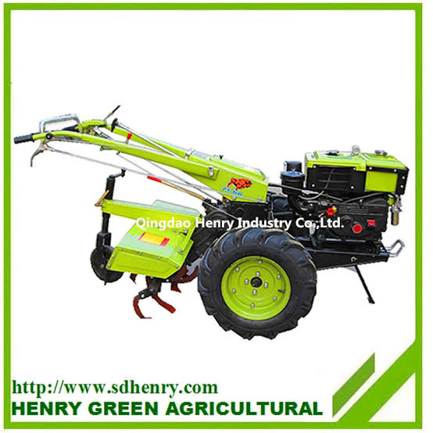
A background picture of the Plough machine used at Ministry of Agriculture and Rural Development
3.3 Making of Plant Beds in the Greenhouse kits
After the operation of the plough machine, beds needs to be make in the GH kits to aid planting and since the ground has been tilled and soften by the operation of the plough what is needed is for attendants to go to the farm store to gather the equipment needed for the bed making.
3.3.1 My Experience in making Plant beds
The method of making beds employed at Ministry of Agriculture and Rural Development is the manual method carried out by the use of shovels or spades. Below are my experiences in this:
- The bed widths and length are determined by the farm supervisor and he does this by fixing a pair of iron, one on one side of the bed and the other on the other side after which he ties a rope to both irons stretching it down to the designated end of the bed and tying it to the other pair of iron. This way, a space has been created between the two ropes showing the length and the width of the bed
- Each GH kits contain 12 beds, six beds at the upward part i.e. first half of the kit [divided by the trunk lines] while the other six are at the downward part i.e. at the second half of the kit.
- We are each handed a shovel and positioned at the middle of two plant beds where we can lift the soil with the shovel into the space that has been created by the ropes on both plant beds thus, the beds are formed.
Other Equipment used are:
- Watering Can: This farm tool is used for the light irrigation of crops in the dry season to prevent them from wilting and dying. It is also used to apply liquid fertilizer, wetting of cement blocks with water during construction of farm structures, and application of water to seedlings in the nursery.
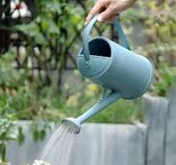

- Pumping Machine: An irrigation pump is a type of water pumping machine or water pump used for the pumping of water from the source of water to the irrigation system. Irrigation pumps are usually used in agriculture to pass water to crops. Without an irrigation pump, most irrigation systems will not work properly.
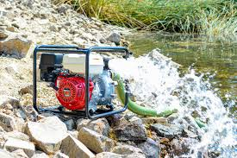
- Seed Drill: A seed drill is a farm implement that plants seeds in rows at a specific depth and spacing, ensuring uniform seed distribution and covering them with soil, which improves crop yield and reduces wastage compared to manual methods.
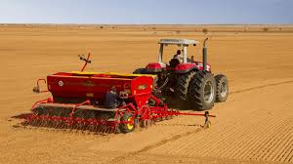

- De-Stoning Machine: It is used for separation of pebbles from paddy,wheat,rice,soybean,corn,sesame,rapeseed,malt ect. It can also do the same to other granular materials. It is a advanced equipment for the modern grain processing enterprises.
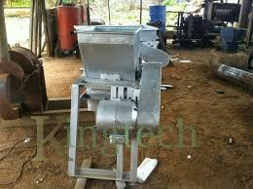
3.4 My Experience in Installation:
- I collected all the Materials needed for the installation from the farm supervisor.
Note: Installation is done by three or more people with the farm supervisor leading the operation.
- Moderate size holes are bored into the left and right side of the greenhouse covering [Net] at the middle and at the end of the greenhouse kit to allow the passage of the trunk line pipe in the GH kit.
- The trunk lines are passed into the bored holes from the tank side to the other side of which accurate measurement of the trunk line are taken and cut to avoid excesses.
- The end of the trunk line are covered to prevent the flowing out of water while the other end are connected [fixed] to the storex tank
- Holes are bored on the trunk line inside the GH kit with a plastic G-clamp to allow the connection of each drip line pipes.
- One end of the drip lines are connected to the bored holes through a small tap switch which is fixed to the trunk line serving as intermediary between the drip and trunk lines
- The other end of the drip line is tightly covered to avoid the flowing out of water.
- After all these, the water can now be switched on from the storex to allow the irrigation of the Plants.

CHAPTER 4
4.0 Summary, Conclusion and Recommendation
4.1 Summary of attachment activities
The farm as stated in chapter two is greenhouse based and involved the growing of vegetable crops such as cucumbers, tomatoes, green and yellow pepper, chili pepper and habanero pepper. The method of growing all these aside from cucumber is through the nursery, that is, treated seeds that have been worked upon are bought and are planted in a crate[nursery bed] containing planting medium.
The nursery are watered and monitored for 2-3 weeks before transplanting to the intended GH kit which had earlier been cultivated. The method of cultivating the GH kit in Ministry of Agriculture and Rural Development is through the use of automated plough machine. As stated in the preceding chapters, the plough machine is made up of a petrol engine and contains a sharp chiseled mouth at the bottom of the machine for breaking the soil structure and turning the soil.it has a big strong tire which also help in turning the soil.
After the first round of breaking the soil with the plough machine, large quantities of farmyard manures [8 bag sacks per kit] are then spread on the soil for the plough machine to mix together when ploughed again for the second time. Then the farm beds are made employing the use of Shovels.
4.2 Problems encountered during the program
The major problems encountered during my stay at the greenhouse farm are the longevity of working hours, working from 8am to 5pm with only one hour rest. Also, the lack of storage and processing facilities is a major setback for the farm leading to an average decrease in the spoilage and preservation of peppers.
4.3 Conclusion
Greenhouse system of Farming is a modern farming system that enhance the all year round production of vegetable crops using artificial irrigations and improved seedlings as well as the use of chemicals such as pesticides, insecticides, fungicides and Bonus to control and improve the growth rate of crops.
4.4 Recommendation
The greenhouse farming is a lucrative farming system needed in this country to improve and stabilize the economy and to improve consistent supply of food production in the country. Therefore I recommend this report to anyone who is willing to learn the basically of greenhouse farming.

