TECHNICAL REPORT ON THE STUDENT INDUSTRIAL WORK EXPERIENCE SCHEME (SIWES)

HELD AT
OBAFEMI AWOLOWO UNIVERSITY MATERIAL SCIENCE AND ENGINEERING (MSE)
MSE Obafemi Awolowo University Material Science and Enineering Oke-Ogbo Iye Zone 3 Ile-Ife Osun State

BY

ADEMIJU OLUWASEUN OLUWATIMILEYIN
ND/23/MET/PT/0010

SUBMITTED TO:
DEPARTMENT OF METALLURGICAL ENGINEERING
KWARA STATE POLYTECHNIC,
INSTITUTE OF TECHNOLOGY (I.O.T)
P.M.B 1375, ILORIN KWARA STATE

SEPTEMBER – DECEMBER, 2024

DEDICATION
I dedicated this report of my SIWES program to Almighty God that made it a successful one for me.
Also to my lovely parents in person of MR. & MRS. ADEMIJU for their support both morally and financially they gave me, may Almighty GOD reward them abundantly with long life and good health.
Also to my SIWES coordinator who didn’t make the Twelve weeks program went in vain and also to the school authority who accepted me in school for the program.

ii
ACKNOWLEDGEMENT
I wish to express my profound gratitude and sincere appreciation to my lovely and caring parents in persons of MR and MRS ADEMIJU may GOD bless you. I also appreciate the effort of my Brother and Sister may God help you all.
Also to my amiable SIWES coordinator and to all my lecturers at Kwara State Polytechnic, Institute of Technology (I.O.T).

iii

TABLE OF CONTENT
Title page i
Dedication ii
Acknowledgment iii
Table of content iv
CHAPTER ONE
1.0 Introduction 1
1.1 Definition of SIWES 1
1.2 Aims and Objectives of SIWES 1
CHAPTER TWO
2.0 Historical Background of the Organization Attachment 2
2.1 Organization Chart of the Organization 2
CHAPTER THREE
3.0 Material Selection And Samples Preparation 3
3.1 Mechanical Test 3
3.2 Compression Parallel to Grain 4
3.3 Venier Scale 5
3.4 Function 8
CHAPTER FOUR
4.0 Turning Machine (LATHE) 9
4.1 Grinding Machines 10
CHAPTER FIVE
5.0 Interpersonal Relationship within the Organization 11
5.1 Suggestion for Improvement of the Programme 11

iv
CHAPTER ONE
- INTRODUCTION
The student industrial works experience scheme (SIWES) was established by the industrial training fund (I.T.F) in 1973 and control by the national board for technical education (NBTE). The aims and objectives is to develop student skill and to expose students in the school of engineering, technology, environment, science and agriculture and medical science to the working experience in which they will found themselves in future.
It is integral part of degree and National Diploma programme institute of higher learning in Nigeria. This privilege programme would definitely broaden student chance of learning and would empower his/her academic efficiency.
During my four months Industrial Working Experience Scheme (SIWES) at Federal Ministry of Agricultural and Rural Development, the usefulness of maintenance in Tractor was proved and lot of experience was gained.
1.1 DEFINITION OF SIWES
Student industrial Working Experience (SIWES) is a skill acquisition training programme set up by the Federal and State government across the Nation in collaboration with the body known as Industrial Training Fund (I.T.F) for student to have a working experience and a feel of what it takes to be genius in one discipline before challenges ahead.
1.2 AIMS AND OBJECTIVES OF SIWES
1. It exposes the prepare students of higher institution for the industrial working situation they can likely to meet in the future.
2. It enables student to apply what they have learn theoretically in class into practice in the real world.
3. It makes student to understand the technical implication of their profession.
4. It helps student to express their initiatives, competence and standard in task they have chosen.
5. It enable student to be technically and morally oriented
6. It helps to make transition from school to the working environment easier and to enhance students contact for later job placement
CHAPTER TWO
2.0 HISTORICAL BACKGROUND OF THE ORGANIZATION ATTACHMENT
MSE Obafemi Awolowo University Material Science and Enineering Oke-Ogbo Iye Zone 3 Ile-Ife Osun State
The company also engages in other activities which differ from its academics activities, this includes:
- Preparation of Wood Sample
- The Venier Scale
- The production of a product
2.1 ORGANIZATION CHART OF THE ORGANIZATION

OBAFEMI AWOLOWO UNIVERSITY MATERIAL SCIENCE AND ENGINEERING (MSE)
Manager
Engineers
Apprentice
Surface Finishing & Dressing
Casting Section
Moulding Section

CHAPTER THREE
3.0 MATERIAL SELECTION AND SAMPLES PREPARATION
The studied wood samples were obtained from a clonal test of interspecific hybrids of Eucalyptus clones. 29 Eucalyptus clones were randomly selected in a planted forest located in southern Brazil following the ASTM D5536 (2010). 8 seven-year-old trees by clone were felled, totalling 232 trees. The selected trees had straight trunks, an absence of bifurcation, good phytosanitary conditions and a low presence of defects. Boards were cut from the 1,2 m long baseline logs, which presented a diameter at breast height of around 21 cm.
The boards were air-dried and their thicknesses were reduced from 8 cm to 6 cm using a thinner plane. For each test, 54 samples were cut according to the requirements of ASTM D143 (2021), as shown in Figure 1, avoiding the presence of growth defects, such as knots, splits, etc. Before the mechanical tests, the samples were placed into a climatic chamber (20 ºC and 65 % relative humidity) until reaching an equilibrium humidity of approximately 12 %. Weight and dimensions (measured in the sample centre) were determined using an analytical scale and a digital calliper, respectively.
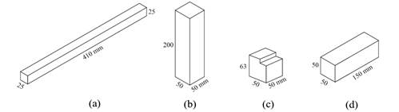

Three-point static bending (a), Compression parallel to grain (b), shear parallel to grain (c) and Janka hardness (d) samples geometry for the mechanical tests.

3.1 MECHANICAL TESTS
THREE POINTS STATIC BENDING
The three points static bending tests were performed according to ASTM D143 (2021). The wood samples were cut with dimensions of 25 × 25 × 410 mm³ (radial × tangential × longitudinal) and a span length of 360 mm was adjusted, keeping a minimum span-to-depth ratio of 14. An Emic DL 30000 universal testing machine was used for applying the load continuously in the centre of the beam throughout the test at a rate of motion of 1,3 mm/min. The load was applied at the tangential plane of the samples and the mid-span deflection was determined by the crosshead position.
Flexural strength (σ_{f}) was calculated using the relationship between the applied load and the measurements of mid-span deflection of the test sample in accordance with Equation 1. Modulus of elasticity E_{f} was calculated by Equation 2 using the gradient (∇m) obtained from the ratio of the load vs. deflection curve in the elastic region. These samples presented an equilibrium moisture content mean of 14,05 % with a standard deviation of 0,63 %.
(1)
(2)
Where: b, h, and L are the width and height of the specimen, and support span length, respectively.

3.2 COMPRESSION PARALLEL TO GRAIN
Compressive modulus and compressive strength were determined using compression parallel to grain tests in samples with dimensions of 50 x 50 x 200 mm³ (radial × tangential × longitudinal directions). These samples were cut assuring that the end grain surfaces were parallel to each other and at right angles to the longitudinal axis. A crosshead speed of 0,6 mm/min was applied using an Emic DL 30000 universal testing machine, following ASTM D143 (2021).
The compressive strength parallel to grain (σ_{c}) was obtained by the relation of the maximum achieved load (F_{max}) and the cross-sectional dimension at the middle of the specimen (A) according to Equation 3. Compressive modulus (E_{c}) was the ratio obtained from the stress (σ_{c}) vs. deformation (ɛ_{c}) curve in the elastic region (Equation 4). These samples presented an equilibrium moisture content mean of 12,82 % with a standard deviation of 0,75 %.
(3)
SHEAR PARALLEL TO GRAIN
The shear parallel to grain tests were performed to determine shear strength. Specimens with the dimensions of 50 x 50 x 63 mm³ (radial × tangential × longitudinal directions) were cut and tested according to ASTM D143 (2021). A shear tool was used to provide a 3 mm offset between the inner edge of the supporting surface and the plane of its adjacent edge. The load was continuously applied at a rate of motion of 0,6 mm/min in an Emic DL 30000 universal testing machine. The ultimate shear stress was calculated according to Equation 5. Using the maximum load (F_{max}) and the shear cross-section (A). These samples presented an equilibrium moisture content mean of 13,04 % with a standard deviation of 1,22 %.
(4)

3.3 VERNIER SCALE
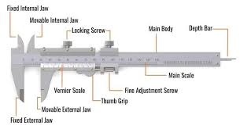
The vernier is a subsidiary scale replacing a single measured-value pointer, and has for instance ten divisions equal in distance to nine divisions on the main scale. The interpolated reading is obtained by observing which of the vernier scale graduations is coincident with a graduation on the main scale, which is easier to perceive than visual estimation between two points. Such an arrangement can go to a higher resolution by using a higher scale ratio, known as the vernier constant. A vernier may be used on circular or straight scales where a simple linear mechanism is adequate. Examples are calipers and micrometers to measure to fine tolerances, on sextants for navigation, on theodolites in surveying, and generally on scientific instruments. The Vernier principle of interpolation is also used for electronic displacement sensors such as absolute encoders to measure linear or rotational movement, as part of an electronic measuring system.

VENIER SCALE

3.4 FUNCTIONING
The vernier scale is constructed so that it is spaced at a constant fraction of the fixed main scale. So for a vernier with a constant of 0.1, each mark on the vernier is spaced 9/10 of those on the main scale. If you put the two scales together with zero points aligned, the first mark on the vernier scale is 1/10 short of the first main scale mark, the second is 2/10 short, and so on up to the ninth mark, which is misaligned by 9/10. Only when a full ten marks are counted, is there alignment, because the tenth mark is 10/10—a whole main scale unit—short, and therefore aligns with the ninth mark on the main scale. (In simple words, each VSD = 0.9 MSD, so each decrement of length 0.1 adds 10 times to make one MSD only in 9 divisions of vernier scale division).
Now if you move the vernier by a small amount, say, 1/10 of its fixed main scale, the only pair of marks that come into alignment are the first pair, since these were the only ones originally misaligned by 1/10. If we move it 2/10, the second pair aligns, since these are the only ones originally misaligned by that amount. If we move it 5/10, the fifth pair aligns—and so on. For any movement, only one pair of marks aligns and that pair shows the value between the marks on the fixed scale.

CHAPTER FOUR
4.0 TURNING MACHINES (LATHE)
The engine lathe, as the horizontal metal-turning machine is commonly called, is the most important of all the machine tools. It is usually considered the father of all other machine tools because many of its fundamental mechanical elements are incorporated into the design of other machine tools.
The engine lathe is a basic machine tool that can be used for a variety of turning, facing, and drilling operations. It uses a single-point cutting tool for turning and boring. Turning operations involve cutting excess metal, in the form of chips, from the external diameter of a workpiece and include turning straight or tapered cylindrical shapes, grooves, shoulders, and screw threads and facing flat surfaces on the ends of cylindrical parts. Internal cylindrical operations include most of the common hole-machining operations, such as drilling, boring, reaming, counter boring, countersinking, and threading with a single-point tool or tap.
Boring involves enlarging and finishing a hole that has been cored or drilled. Bored holes are more accurate in roundness, concentricity, and parallelism than drilled holes. A hole is bored with a single-point cutting tool that feeds along the inside of the workpiece. Boring mills have circular horizontal tables that rotate about a vertical axis, and they are designed for boring and turning operations on parts that are too large to be mounted on a lathe.
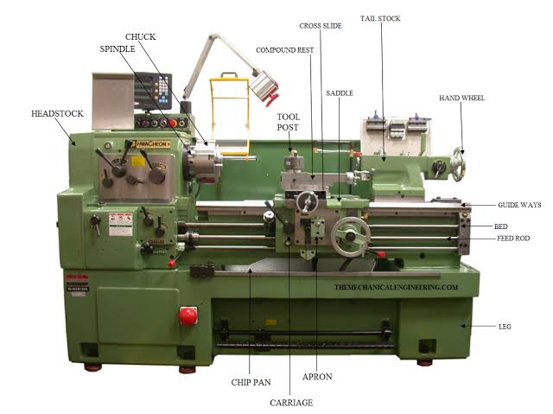

TURNING MACHINE (LATHE)

4.1 GRINDING MACHINES
Grinding machines remove small chips from metal parts that are brought into contact with a rotating abrasive wheel called a grinding wheel or an abrasive belt. Grinding is the most accurate of all of the basic machining processes. Modern grinding machines grind hard or soft parts to tolerances of plus or minus 0.0001 inch (0.0025 millimetre).
The common types of grinding machines include the following:
(1) plain cylindrical
(2) internal cylindrical
(3) centreless
(4) surface
(5) off-hand
(6) special and abrasive-belt.
Power saws
Metal-cutting power saws are of three basic types:
(1) power hacksaws,
(2) band saws
(3) circular disk saws. Vertical band saws are used for cutting shapes in metal plate, for internal and external contours, and for angular cuts.
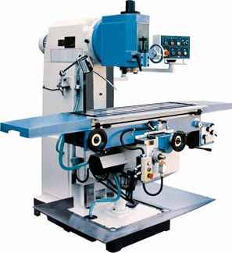

CHAPTER FIVE
5.0 INTERPERSONAL RELATIONSHIP WITHIN THE ORGANIZATION
My four months SIWES program has equipped me the knowledge of metallurgical engineering design in terms of fabrication and production of a particular project.
During the course of staying with the coordinators in the various sections has turn a new moment in my course of study in fabrication and automobile respectively.
5.1 SUGGESTION FOR IMPROVEMENT OF THE PROGRAMME
The industrial training fund should have up and hold committee on inspecting the student in their various organizations that they are attached to as this will improve the level of seriousness of the student to the program. Also, the federal government in collaboration with the industrial training fund (ITF) to increase the student allowance for the program as this will encourage them in active participation.

