

TECHNICAL REPORT ON STUDENT INDUSTRIAL WORK EXPERIENCE SCHEME (SIWES)

SIWES REPORT
UNDERTAKEN AT

BALOGUN GAMBARI MICROFINANCE BANK
NO 1, OJAGBORO, BALOGUN FULANI ROAD, ILORIN KWARA STATE

By:
AKINSANYA OLALEKAN DAVID
ND/23/BAM/PT/0392

SUBMITTED TO:
DEPARTMENT OF BUSINESS ADMINISTRATION AND MANAGEMENT,
INSTITUTE OF FINANCE AND MANAGEMENT STUDIES (IFMS),
KWARA STATE POLYTECHNIC, ILORIN

IN PARTIAL FULFILMENT OF THE REQUIREMENT FOR THE AWARD OF NATIONAL DIPLOMA (ND) IN BUSINESS ADMINISTRATION

AUGUST – NOVEMBER, 2024

CERTIFICATION
This is to certify that this SIWES was carried out by AKINSANYA OLALEKAN DAVID with Matric Number ND/23/BAM/PT/0394 in the Department of Business Administration, Institute of Finance and Management Studies (IFMS), Kwara State Polytechnic, Ilorin.

DEDICATION
I dedicate this report to the Almighty God for his guidance, strength, and protection throughout and protection throughout my industrial training. I also dedicate it to my parents for their constant support and encouragement, as well as to my mentors and supervisors whose guidance helped me succeed during this period.

ACKNOWLEDGEMENTS
First and foremost, I appreciate Almighty Allah for giving me the privilege to partake in the Students Industrial Work Experience Scheme (SIWES).
I acknowledge my amiable and dynamic parents MR AND MRS AKINSANYA, for their financial, moral and spiritual caring and support during the course of my SIWES program.
I also appreciate my Industrial based supervisor for their patient, endurance, courage and kind support during the course of my stayed in BALOGUN GAMBARI MICROFINANCE BANK
I wish to also acknowledge my school based supervisor, for their support, encouragement and kind during their visitation to BALOGUN GAMBARI MICROFINANCE BANK
Finally, I appreciate my colleagues in the same industrial based training; I pray Almighty Allah will grant us success in our entire endeavor (Amin).

TABLE OF CONTENT
Title page Dedication Acknowledgment Table of contents
Chapter One:
Introduction & History of SIWES Objectives of SIWES

Chapter Two:
Description of the Establishment Location
Brief History Objectives of the Establishment
Organizational Structure
Various Department And Their Functions
Chapter Three Works Carried out
Actual work done and Experience gained

Chapter Four:
Recommendations
Challenges Faced In the Industry

CHAPTER ONE

1.1 Introduction to SIWES
The Student Industrial Work Experience Scheme (SIWES) exposes students to industry based skills necessary for a smooth transition from the classroom to the world of work. It affords students of tertiary institutions the opportunity of being familiarized and exposed to the needed experience in handling machinery and equipment which are usually not available in the educational institutions and seeing firsthand the practical experience of some theoretical knowledge gained in the course of study.
Participation in SIWES has become a necessary pre-condition for the award of Diploma and Degree certificates in specific disciplines in most institutions of higher learning in the country, in accordance with the education policy of government.

1.2 Background to the SIWES
The Student Industrial Work Experience Scheme (SIWES) is an initiative which was established in 1973 by the Industrial Training Fund (ITF) to help bridge the gap between acquired classroom education and skills necessary for work in the industry.
Before the inception of the scheme in 1973, there was glaring evidence that inadequate practical exposure of students in tertiary institutions posed serious challenges to both the quality and standard of engineering and technological education in our nation. This resulted in half-baked engineering graduates who needed to undergo a form of training (Industrial Training) to be suitable for employment in industries and firms.
In order to forestall this threat that could bring about industrial regression, the Federal Government through the Industrial Training Fund (ITF) which was established by decree 47 of 1971 introduced the Student Industrial Work Experience Scheme (SIWES) in 1973.
SIWES exposes students to machines and equipment, professional work methods and ways of safe guarding the work areas and workers in industries and other organizations. It helps the student to know the link between what is learnt in the university and what is actually practiced on site. It further helps students to appreciate their field of study better, thereby also determining which area of specialization to go into to contribute to technological development of this nation.
The scheme involves the students, the universities and the industry (employers). It is funded by the Federal Government of Nigeria and jointly coordinated by the National Universities Commission (NUC) and the ITF.
SIWES orientation is usually done to intimate students with the rudiments of industrial training before they are being employed. At the end of the industrial training (IT), successful students whose log books were verified and approved by ITF officials are paid SIWES severance allowance.

1.3 Objectives of SIWES
- Provides the student with an opportunity to apply their theoretical knowledge in real work situation thereby bridging the gap between theory and Practical.
- Provides an avenue for students in tertiary institutions to acquire industrial skills and experience in their course of study.
- Expose students to work methods and techniques in handling equipment and machinery that may not be available in universities.
- Familiarizing the student for the working conditions they are likely to meet after graduation; and
- Make the transition from the university to the world of work easier and thus enhance student’s contacts for later job placement.

CHAPTER TWO

2.1 History of the Organization
The Bank then was established and incorporated under the Company and Allied Matters Act 1990 as a Limited Liability Company and commenced banking operation on the 28th of June, 1994 at her registered office located at 1 Ojagboro junction, Balogun Gambari Road, Ilorin.
Balogun Gambari Microfinance Bank Limited is licensed by the Central Bank of Nigeria (CBN) to operate as a Microfinance Bank. Balogun Gambari Microfinance Bank is focused on Small and Medium Scale Enterprises, Traders, Farmers, the underserved and those with a flair for true High Returns On Investments. Balogun Gambari Microfinance Bank Limited is endowed with an Active Board made up of Men and Women who have distinguished themselves in Banking, Insurance, Law, the Public Service and Entrepreneurship, and they bring strong competencies to the management of the bank. We are strategically positioned to provide excellent services to our customers and exceed all service expectations.

2.2 Vision and Mission Statement

Vision: BALOGUN GAMBARI MICROFINANCE BANK PRIOTIZE, ENCOURAGE AND REWARD SAVINGS BECAUSE, SAVING MONEY CAN HELP YOU BECOME FINANCIALLY SECURE AND PROVIDE A SAFETY NET IN CASE OF AN EMERGENCY.

Mission: WE ENCOURAGE SAVINGS, BASICALLY, BECAUSE WE CAN'T PREDICT THE FUTUREWE SAVE, BASICALLY, BECAUSE WE CAN'T PREDICT THE FUTURE

2.3 ORGANOGRAM OF BALOGUN GAMBARI MICROFINANCE BANK
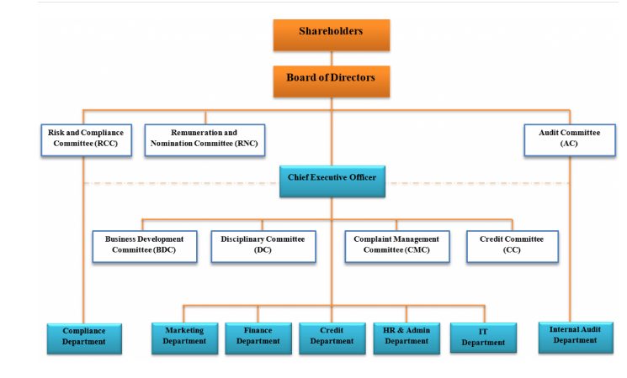
Balogun Gambari Microfinance Bank has seven departments namely: Administration & FINANCE, Operations, Credit/ Risk Management, Marketing, Transactional Support Services, Audit and Information Technology. The bank has the following type of Accounts: Personal, Sole Proprietor, Corporate Account, Salary Account, Joint Account, faculty/Departmental/Unit Account, Special Account, Student saving scheme, Student registration fees, Government Account. It also has products like Savings Account, Call Account, Fixed Deposits, Temporary overdraft and Term loans.

CHAPTER THREE
3.0 EXPERIENCE GAINED AND ACTUAL WORK DONE
Thus, microfinance enables credit-deprived households and MSMEs to access loans, streamline cash flows, and fuel growth, while also serving as a crutch to cope and rebuild during a financial crisis.
During the period of my SIWES program, I was taught about roles and important of an Administrator in microfinance banking sector. I realized that administrators oversee that the accounting operations of businesses and organizations run smoothly. They require a variety of technical skills related to business, finance, accounting and economics, alongside soft skills related to organization, communication and problem-solving.
- Also, I was taught that administrators ensure the accuracy of records. So, paying close attention to detail allows them to notice and correct errors and inconsistencies.
- Moreso, as an administrator, I was enable to liaise with a wide variety of people daily, including junior financial and business assistants, senior managers, external contractors, customers, accountants, bankers and stakeholders. Even when not in management positions, financial administrators can benefit by having leadership skills that help them assert themselves in liaising with different departments to collect financial data or implement new financial processes.
- Also, I was taught about improvement in financial processes continually to optimize profits and help secure the future financial success of the organization. It's important to be analytical and logical when interpreting data to give accurate analyses of the organization’s financial status and determine opportunities for improvement

CHAPTER FOUR

CHALLENGES ENCOUNTERED AND RECOMMENDATION

4.1 Challenges Encountered
There is nothing on earth that is free on challenges; life itself is full with different kinds of challenges
Firstly, there are many insults been placed on it’s by some of the staff in the organization. In the first week of observing the finance unit where I was posted to, some of the staff in the microfinance bank do ask us if we can make use of excel or MS word and if not, they will see us as an incompetent in the field or an unserious element. And at that time, they belittle us by not teaching us anything.
Another challenge was that, there were many students from different school doing their SIWES programme also. And we needed to shift period for each other which they divided us into groups.

4.2 Recommendation
SIWES is an important program that needs to be encouraged because, it provides from for practical knowledge to students in their areas of discipline.
It is important to ensure that student takes the programme seriously and the government is to ensure strict supervision and monitoring of both the student and the school and the industry based supervision for better results.

