

a TECHNICAL reporton student industrial work experience scheme
(SIWES)

held at
mR. OLAIYA TECH

written by
oyelade dorcas damilola
nd/23/MET/Pt/00011

submitted to
department of agricultural and bio-environmental engineering technology, institute of technology (iot), Kwara state polytechnic, p.m.b 1375, ilorin, kwara state, nigeria

In partial fulfillment for the award of national diploma (ND) in agricultural ENGINEERING

AUGUST – December, 2024

DEDICATION
This report is dedicated to the Lord God Almighty.

ACKNOWLEDGEMENT
My profound appreciation goes to Almighty God, whom with His grace gave me the opportunity to complete my industrial training exercise safely.
I would also like to express my deepest appreciation to

TABLE OF CONTENTS
CHAPTER ONE
1.0 Introduction
1.1 Aims and Objectives
1.2 Names of Companies
1.3 Location of the Companies
1.4 Brief Summary of the Companies’ Activities
1.5 Organization Chart
CHAPTER TWO
2.0 Workdone
2.1 Various tools & equipment and their function in welding
2.2 Measuring tools (calipers, squares, and measuring tapes)
2.3 Welding machines
2.3.1 Hydraulic folding or bending machine
2.3.2 Drilling machine
2.3.3 A Vice machine
2.3.4 Cutting machine
2.3.5 Lathe machine
CHAPTER THREE
3.0 Special Operations and Procedures
3.1 Boring Operation
3.2 Shaping of tools using beach grindes
3.3 Facing and Drilling of a solid rod
3.4 Drilling Operation
3.5 Turning Operation
3.6 Grooving Operation
CHAPTER FOUR
4.0 Recommendation and Conclusion
4.1 Recommendation
4.2 Conclusion
CHAPTER ONE
1.0 INTRODUCTION
The student's industrial work experience scheme (SIWES) is a program designed for student of tertiary institutions with the aim of exposing students that have acquired theoretical knowledge in the classrooms to the practical exposure and experience.
The scheme is a Program involving the students, the university and the industry. Participation in SIWES has become a necessary precondition for the award of diploma and degree certificate in specific discipline in most institution of higher learning in the country in accordance with the educational policy of the government.
The bodies involved are the federal Government, the industrial training fund (ITF). Other supervisory agency is the National council for college of education (NCCE). The success of, or otherwise; the SIWES, depends on these bodies and the general public involved in articulation and management of the program.
1.1 AIMS AND OBJECTIVES OF SIWES
- To provide students with the opportunity to apply their theoretical knowledge in real work situation, thereby bridging the gap between university work and actual work
- To provide an avenue for students in Nigeria universities to acquire industrial skills and experience in their course of study.
- To enlist and strengthen employers in the entire educational process of preparing university graduates for employment in industries.
- To help students prepare for the corporate world and enhance their curriculum vitae.
- To improve interpersonal relationship skills of the students.
- To make the transition from university world of work easier; and enhance contact for job placement.
- To expose students to work methods and techniques in handling equipment and machinery that may not be available in their institutions.
1.2 NAME OF THE COMPANY
MR. OLAIYA TECH
1.3 LOCATION OF THE COMPANY
      - MR. OLAIYA TECH is located at road 5 House 9 Alafia Estate along Akobo Ojurin Ibadan.
1.4 BRIEF SUMMARY OF COMPANIES ACTIVITIES
- MR. OLAIYA TECH is an …
1.5 ORGANIZATION CHART
DIRECTOR OF WORKS

TECHNICAL OFFICERS

AUTOMOBILE TECHNICIANS

SUPERVISORS

STUDENTS WORKERS SIWES

CHAPTER TWO
2.0 WORKDONE
2.1 VARIOUS TOOLS & EQUIPMENT AND THEIR FUNCTION IN WELDING
Welding is a fundamental process in many industries, from construction and manufacturing to automotive repairs and metalworking. Welding tools and equipment include measuring tools, welding machines, safety gear, and cleaning tools. For any workshop to perform welding tasks efficiently and safely, having the right tools and equipment is essential.
2.2 MEASURING TOOLS (CALIPERS, SQUARES, AND MEASURING TAPES)
Calipers, squares, and measuring tapes help ensure that your metal pieces are aligned properly and the welds are placed where they should be. These tools are particularly important when working on projects that require tight tolerances.
2.3 WELDING MACHINES
A welding machine is a machine that helps to assemble or remove metal parts by melting them with thermal energy. A welding machine is a useful tool for people in the welding industry. It produces heat that helps dissolve the metal to give it a different shape or combine metal with any other metal or metal.

2.3.1 HYDRAULIC FOLDING OR BENDING MACHINE
A hydraulic bending machine is a more advanced sheet metal bending tool. This machine contains a hydraulic system that can bend thicker and larger sheets. It is also equipped with a digital control system that allows different types of bends to be programmed and performed automatically. It is ideal for large manufacturing companies that need to produce large quantities of sheet metal parts.
2.3.2 DRILLING MACHINE
A drilling machine, called a drill press, is used to cut holes into or through metal, wood, or other materials. Drilling machines use a drilling tool that has cutting edges at its point. This cutting tool is held in the drill press by a chuck or Morse taper and is rotated and fed into the work at variable speeds. Drilling machines may be used to perform other operations. They can perform countersinking, boring, counterboring, spot facing, reaming, and tapping. A drilling machine comes in many shapes and sizes, from small hand-held power drills to bench mounted and finally floor-mounted models.
Drill press operators must know how to set up the work, set speed and feed, and provide for coolant to get an acceptable finished product. The size or capacity of the drilling machine is usually determined by the largest piece of stock that can be center-drilled.
There are two types of drilling machines used by maintenance personnel for repairing and fabricating needed parts: hand-feed or power-feed. Other types of drilling machines, such as the radial drill press, numerically controlled drilling machine, multiple spindle drilling machine, gang drilling machine, and turret drill press, are all variations of the basic hand and power-feed drilling machines. They are designed for high-speed production and industrial shops.
2.3.3 A VICE MACHINE
A vise or vice is a mechanical apparatus used to secure an object to allow work to be performed on it. Vises have two parallel jaws, one fixed and the other movable, threaded in and out by a screw and lever. The jaws are often flat but may have grooves, adapt to the shape of the workpiece or be custom made. A vice or bench vice can be clamped or bolted to a workbench. A vice allows workpieces to be quickly and easily clamped - in a vertical plane for the vice pictured - others may hold items horizontally. Some vices are quite small and portable. Vices are ideal for tasks such as sawing, drilling and filing. The vice jaws can be adjusted to securely hold the object into place. A vise grip is not a vise but a pair of lever-actuated locking pliers.
A vice or bench vice can be clamped or bolted to a workbench. A vice allows workpieces to be quickly and easily clamped - in a vertical plane for the vice pictured - others may hold items horizontally. Some vices are quite small and portable. Vices are ideal for tasks such as sawing, drilling and filing.
2.3.4 CUTTING MACHINE
A cutting machine is a device used in industries like cardboard box construction to cut rectangles from a strip based on specific cutting process constraints. Cutters use heat from an electric arc, a stream of ionized gas called plasma, or burning gases to cut and trim metal objects to specific dimensions. They also dismantle large objects, such as ships, railroad cars, and buildings. Cutters are designed to cut materials of different kinds of products such as wires, cables (electrical, coax, multi-strand), wire ropes, fencing, bolts, rods, pre-stressed concrete wires, and strapping.
2.3.5 LATHE MACHINE
A lathe is a machine that rotates a piece of wood or metal to shape it into a desired form. It's used in many industries, including woodworking, metalworking, and glass processing.
A lathe is a machine tool that specializes in processing cylindrical shapes. It is mainly used to process cylinders and cones. In addition, it can also perform drilling and screw machining. To give you an idea of what kind of parts lathes are used to process, most of the products we are familiar with use parts processed by lathes.
Automotive parts, aircraft parts, construction machinery parts, medical parts, energy-related parts, home appliance parts, semiconductor manufacturing equipment parts, etc. are mostly assembled products using parts processed using lathes. We can process all kinds of materials, including iron, aluminum, stainless steel, brass, castings, and resin.
A lathe consists of four main parts: the bed, spindle, turret, and tailstock. Briefly, the main spindle holds the material and rotates it. The turret, where the tool is attached, moves to shape the part to be machined. The tailstock supports the long workpiece. Finally, the bed is the base on which the three platforms are mounted.

Headstock
The headstock is a critical component of the lathe, located at the machine’s left end. It houses the main spindle, gears, and often the motor that drives the spindle. The primary function of the headstock is to hold and rotate the workpiece. The speed at which the spindle turns can often be adjusted, providing control over the cutting speed. This part of the lathe is essential for maintaining precision and stability during the machining process.

Tailstock
Function: Positioned opposite the headstock, the tailstock supports the other end of the workpiece.
Role: It’s commonly used to hold tools like drills or reamers for operations such as drilling. The tailstock can be moved along the lathe bed and clamped in position, providing additional support for longer workpieces. It’s adjustable, allowing it to be set to the required length, ensuring that the workpiece is held securely and accurately.

Bed
Function: The bed of the lathe serves as a robust base that supports the major components of the machine, including the headstock, tailstock, and carriage.
Role: It ensures alignment and precision by holding these components in place. The bed must be extremely stable and rigid to prevent any movement or vibration during operation, which could affect the accuracy of the work.

Carriage
Function: The carriage slides along the bed and is responsible for carrying the cutting tool.
Role: It facilitates precise lateral (side to side) and longitudinal (back and forth) movements for cutting. The carriage is typically controlled by a handwheel or a motor, allowing for smooth and accurate positioning of the cutting tool against the workpiece.

Lead Screw
Function: A long threaded shaft that runs parallel to the bed.
Role: The lead screw is crucial for precise threading operations and movement of the carriage. It works in conjunction with the carriage’s feed mechanism, allowing for controlled and precise cuts, especially in threading operations.

Feed Rod
Function: The feed rod, often running alongside the lead screw, also runs parallel to the bed.
Role: It powers the carriage movement for non-threading operations. This rod is essential for the consistent movement of the carriage during turning operations, ensuring smooth and even cuts.

Spindle
Function: Located inside the headstock, the spindle is rotated by the motor.
Role: It holds and rotates the workpiece or chuck. The spindle is the primary rotating component on which the workpiece is mounted, and its speed and rotation can be controlled to suit various machining tasks.

Chuck
Function: Attached to the spindle, the chuck grips and holds the workpiece in place.
Role: Chucks can be a three-jaw (self-centering) or four-jaw (independently adjustable) type, allowing for different shapes and sizes of workpieces to be securely held during the machining process.

Tool Post
Function: Mounted on the carriage, the tool post holds the cutting tool.
Role: It allows the tool to be positioned and secured at various angles, providing the flexibility to perform a range of cutting operations. The tool post is an adjustable part of the lathe that enables precise control over the cutting tool’s position and orientation.

Cross Slide
Function: Mounted on the carriage, the cross slide moves perpendicular to the bed.
Role: This component provides movement towards or away from the workpiece, crucial for depth control in cutting operations. It allows for precise adjustments in the position of the cutting tool, enabling it to make accurate depth cuts.

Compound Rest
Function: The compound rest sits atop the cross slide and allows for angled cuts and fine tool adjustments.
Role: It is used for precise cutting angles and finishing work, providing the ability to make precise angular cuts and adjustments for complex machining tasks.

Apron
Function: The apron is part of the carriage that houses the control mechanisms.
Role: It contains gears, clutches, and levers used to control the movement of the carriage and the cross slide. The apron is essential for the operator to control and adjust the carriage’s position and motion during machining operations.
The most common lathe operations are turning, facing, grooving, parting, threading, drilling, boring, knurling, and tapping.

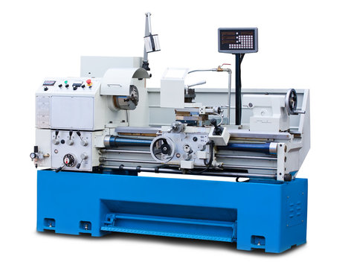
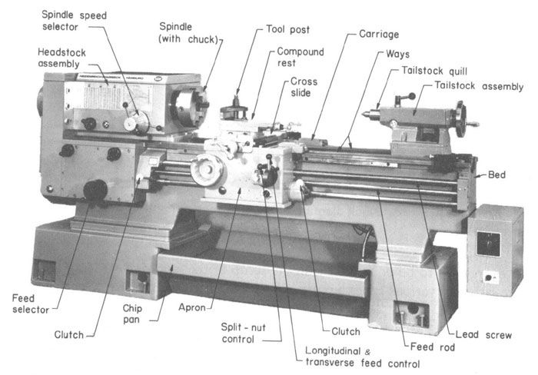
CHAPTERTHREE
SPECIAL OPERATION AND PROCEDURES
3.0 Special Operation and procedures carried out at MR. OLAIYA TECH.
3.1 Boring Operation
A "boring operation" in welding refers to the process of using a specialized machine to weld material inside a cylindrical hole (bore) to repair worn or damaged areas, essentially "filling in" the bore to restore its original size and shape, often done with a technique called "bore welding" and typically followed by a precision machining step to achieve the exact dimensions needed; this is commonly used in industrial applications to repair machinery components like cylinder bores or large bearings.
In boring operation, a tool enters the workpiece axially and removes material along the internal surface to either create different shapes or to enlarge an existing hole.
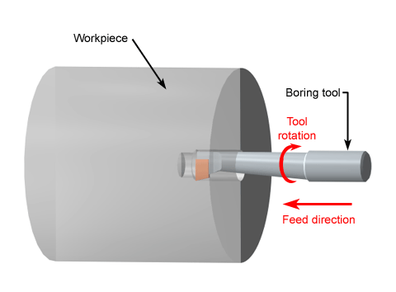
3.2 Shaping of tools using beach grindes
A bench grinder can be used to "shape" tools by grinding down metal to achieve a desired contour or profile, primarily by utilizing the rotating abrasive wheel to carefully remove material from the tool's edge or surface, allowing for adjustments to the bevel angle, curvature, and overall shape depending on the tool and desired function; this is commonly done with chisels, knives, plane blades, and other cutting tools where precise shaping is needed.
Procedure:
      - Creating a bevel on a chisel: By holding the chisel at the desired angle against the wheel and carefully grinding the edge.
      - Rounding the edge of a knife blade: Using the side of the grinding wheel to gradually smooth out sharp corners.
      - Creating a concave or convex curve on a woodworking tool: By carefully manipulating the tool's angle and movement across the wheel.
Safety Precaution:
- Eye protection: Always wear safety goggles when using a bench grinder.
- Proper guarding: Ensure the grinder has a working wheel guard to prevent sparks and debris from flying out.
- Secure grip: Maintain a firm grip on the tool to avoid losing control during grinding.

3.3 Facing and Drilling of a solid rod
Facing and drilling a solid rod" refers to a machining process where the end face of a solid rod is first flattened and smoothed using a lathe operation called "facing," and then a hole is drilled through the center of the rod using a drill bit, typically done on the same lathe machine; essentially creating a flat, even surface on one end of the rod before drilling a hole through it.
Facing:
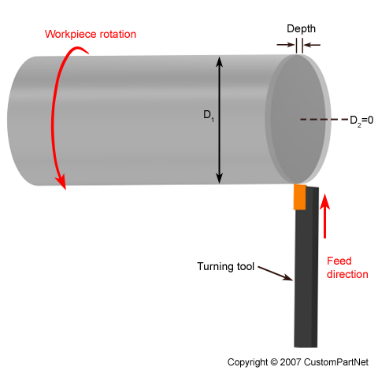
During the machining, the length of the workpieces is slightly longer than the final part should be. Facing is an operation of machining the end of a workpiece that is perpendicular to the rotating axis. During the facing, the tool moves along the radius of the workpiece to produce the desired part length and a smooth face surface by removing a thin layer of material.
- Uses a facing tool mounted on the lathe carriage to cut a flat surface perpendicular to the rod's axis.
- Removes any irregularities or rough edges from the end of the rod.
- Important for ensuring proper alignment when drilling the hole.
Drilling:
- Once the rod is faced, the drill bit is mounted in the lathe's tailstock and positioned to drill a hole through the center of the rod.
- Requires precise centering to achieve a straight, accurate hole.
- May involve using a center drill to create a small pilot hole for guiding the main drill bit.
3.4 Drilling Operation
Drilling on a lathe machine is the process of making a cylindrical hole in a workpiece. It's done by rotating the workpiece while holding a drill in the tailstock.
Steps
- Secure the workpiece in a chuck or on a faceplate
- Attach the drill to the tailstock
- Position the drill near the workpiece
- Rotate the tailstock handle clockwise to feed the tool against the workpiece
- Rotate the tailstock handle counterclockwise to withdraw the tool
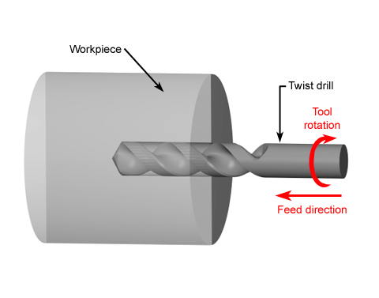
3.5 Turning Operation
Turning is the most common lathe machining operation. During the turning process, a cutting tool removes material from the outer diameter of a rotating workpiece. The main objective of turning is to reduce the workpiece diameter to the desired dimension. There are two types of turning operations, rough and finish.
Rough turning operation aims to machine a piece to within a predefined thickness, by removing the maximum amount of material in the shortest possible time, disregarding the accuracy and surface finish. Finish turning produces a smooth surface finish and the workpiece with final accurate dimensions.
Different sections of the turned parts may have different outer dimensions. The transition between the surfaces with two different diameters can have several topological features, namely step, taper, chamfer, and contour. To produce these features, multiple passes at a small radial depth of cut may be necessary.
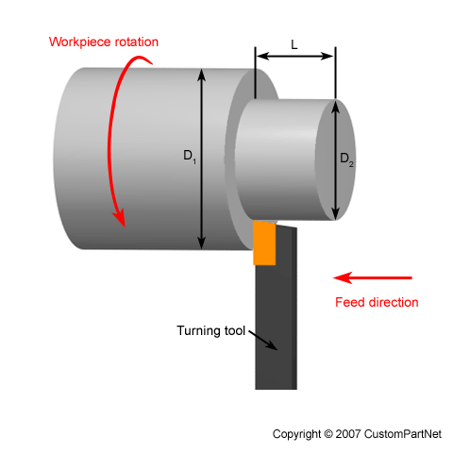

Step Turning
Step turning creates two surfaces with an abrupt change in diameters between them. The final feature resembles a step.
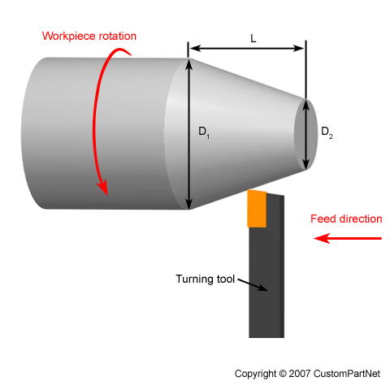

Taper Turning
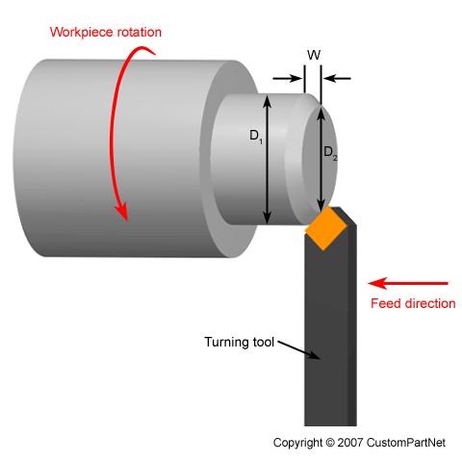
Taper turning produces a ramp transition between the two surfaces with different diameters due to the angled motion between the workpiece and a cutting tool.

Chamfer Turning
Similar to the step turning, chamfer turning creates angled transition of an otherwise square edge between two surfaces with different turned diameters.
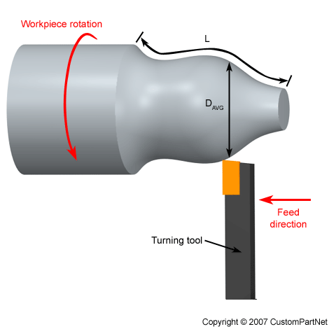

Contour Turning
In contour turning operation, the cutting tool axially follows the path with a predefined geometry. Multiple passes of a contouring tool are necessary to create desired contours in the workpiece. However, form tools can produce the same contour shape is a single pass.
3.6 Grooving Operation
Grooving is a turning operation that creates a narrow cut, a "groove" in the workpiece. The size of the cut depends on the width of a cutting tool. Multiple tool passes are necessary to machine wider grooves. There are two types of grooving operations, external and face grooving. In external grooving, a tool moves radially into the side of the workpiece and removes the material along the cutting direction. In face grooving, the tool machines groove in the face of the workpiece.
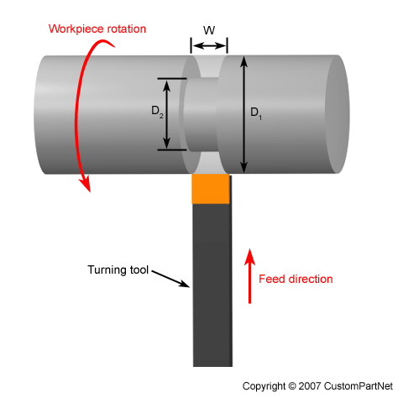

CHAPTER FOUR
OBSERVATIONS, CONCLUSION AND RECOMMENDATION
4.1 OBSERVATION
The SIWES programme undergone at MR. OLAIYA TECH afforded me an in-depth exposure to some of the practical industrial aspects of Agricultural branches. I was opportuned to have known the feed formulation. Experience was also garnered in the handling of layer birds especially when they started laying eggs.
Besides, knowledge and skills were acquired in both section of the farm (piggery and poultry section). The programme has been highly enlightening, beneficial, interesting and successful. The objective of which the scheme was undergone was however achieved.
4.2 CONCLUSION
The SIWES programme for me is educative and has empowered me with various opportunities to be self employed and in fact to be able to establish a farm based on many of all that have been practicalized. With the help of God the programme has enable a kind of workable opportunity to perform theories in a practical way, to see many of the equipment/tools used in the farm (birds, battery cage, deep litters etc.)
4.3 RECOMMENDATION
Although SIWES undergone did achieve quite a lot of its stated objectives, nevertheless, the following recommendations are suggested to improve the qualitative context of the programme:
- SIWES Students should endeavour to participate actively and positiviely during the SIWES progrogramme (i.e try to be hardworking) and see the industry where the programme is taking place as a research place where all that he/she has been taught in the class can be practicalized.
- The Industry should not see SIWES students as casual workers but as professionals in the making.
- Participation of private corporate organization to minimize the problem of low funding as recently complained by the director of ITF.
- Sending students specifically to establishment where the stipulated aims and objectives of SIWES would be achieved.
- Payment of befitting student allowance to assist in students finances during the period of training.

