TECHNICAL REPORT ON STUDENT INDUSTRIAL WORK
EXPERIENCE SCHEME (SIWES)
HELD AT
KWARA STATE MINISTRY OF WORKS AND TRANSPORT
AHMADU BELLO WAY P.M.B 1342, ILORIN KWARA STATE

WRITTEN BY

JAMIU HABEEB ABIODUN
ND/23/CEC/PT/0064

SUBMITTED TO
DEPARTMENT OF CIVIL ENGINEERING TECHNOLOGY,
INSTITUTE OF TECHNOLOGY,
KWARA STATE POLYTECHNIC, ILORIN

IN PARTIAL FULFILLMENT OF THE REQUIREMENT FOR THE
AWARD OF NATIONAL DIPLOMA (ND) IN TECHNOLOGY

SEPTEMBER –DECEMBER 2024

DEDICATION
This report is dedicated to Almighty Allah, the creator of the whole universe for protecting my life throughout the programme and to my loving parents for their morally and financially support.

ACKNOWLEDGEMENT
All glory and adoration to Almighty God, the Lord of the universe, may his peace and blessings be on mankind, I testify that there is no other God worthy of worship except God Almighty.
Glory is to God Almighty who bestowed upon me the wisdom and knowledge to write this report. My sincere and unquantifiable appreciation goes to my father and my mother MR. & MRS. JAMIU
My gratitude also goes to my industrial based supervisors for their effort and knowledge impart to me during my industrial attachment and their support

TABLE OF CONTENTS
Title Page i
Dedication iii
Acknowledgement iv
Table of Content vi
CHAPTER ONE
1.0 Introduction 1
1.1 Definition of SIWES 1
1.2 Aim and Objectives of Siwes 1
1.3 Historical Background of the Organization 2
1.4 Organization Chart 2
CHAPTER TWO
2.0 Section /Unit of the Organization and their Specific Function 3
CHAPTER THREE
3.1 Drainage 5
3.2 Types of Drainage 5
3.3 Block Drainage 5
3.4 Reinforced Concrete Drainage 5
3.5 The Important of Drainage 6
3.6 Culvert 6
3.7 Types of Culvert 6
3.8 Pipe Culvert 7
3.9 Box Culvert 7
3.10 Steps/Procedure of Constructing Culvert 7
CHAPTER FOUR
4.1 Roads Construction 8

4.2 Asphalt 8

4.3 Bituminous surface 9
4.4 Pavement Construction 9
4.5 Types of pavements 10
CHAPTER FIVE
5.0 Conclusion 13
5.1 Personal Impression about the Organization 13
5.2 Recommendation to the Organization Concerning the Siwes Programme 13
5.3 Recommendation To The Polytechnic Concerning The Siwes Programme 13
CHAPTER ONE
1.0 INTRODUCTION
The student Industrial Works Experience Scheme [SIWES] was established by the National Board for Technical Education [NBTE]. The aims and objective is to develop student’s skill and to expose student in the school of engineering, technology, environmental, science, agriculture and medical science to the Working experience in which they will found themselves in future. SIWES was established by ITF in 1973 to solve the problem of lack of adequate practical skills preparatory by Nigerian graduates of tertiary it is an integral part of degree and national diploma programme in institute of higher learning in Nigeria. This priviledge programme would definitely broaden student chance of learning and would also empower his/her academic efficiency. One of the primary goals of the SIWES is to help students integrate leadership development into the experiential learning process.
1.1 DEFINITION OF SIWES
Student industrial Working Experience Scheme [SIWES] is a skill acquisition training programme set up by the federal and state government across the nation in collaboration with the body known as Industrial Training Fund [ITF] for student to have a working experience and a feel what it takes to be genius in one discipline before challenges ahead.
1.2 AIM AND OBJECTIVES OF SIWES
The Student Industrial Work Experience Scheme is very important for the academic performance of the students, the main purpose of this ‘National Programme i.e. the main purpose of the SIWES to the students is as follow:
1. It exposes and prepare student of higher institution for the industrial working situation they are likely to meet in the future
2. It enables student to apply what they have learnt theoretically in class into practices in the real world problem.
3. It makes student to understand the technical implication of their profession.
4. To provide wide and comprehensive practical for the students.
5. To encourage the spirit of self-reliance in the part of the student for their field of study.
6. To give inspiration commitment and dedication to the student.
7. To expose student to various aspect of their specialized field of study.
8. To complete the practical work done by the student in their various field of studies.
1.3 HISTORICAL BACKGROUND OF THE ORGANIZATION
Kwara State Ministry of Works and Transport is situated along Ahmadu Bello way G.R.A, Ilorin. It was set up by the Kwara State Government. to control some specific activities in rural and urban settlement in terms of routes and other external works in the state. The organization was formally called PUBLIC WORKS COOPERATION. However, since the creation of the state in 1967, not until some years back when it was changed to present name, known as “ Ministry of Works and Transport” with the headquarters located in Ilorin Kwara State Capital of Nigeria.
As the name implied, the organization set up is meant for construction of road network, drainage, building construction, electric installation and other public utilities within the state.
1.4 Organization chart
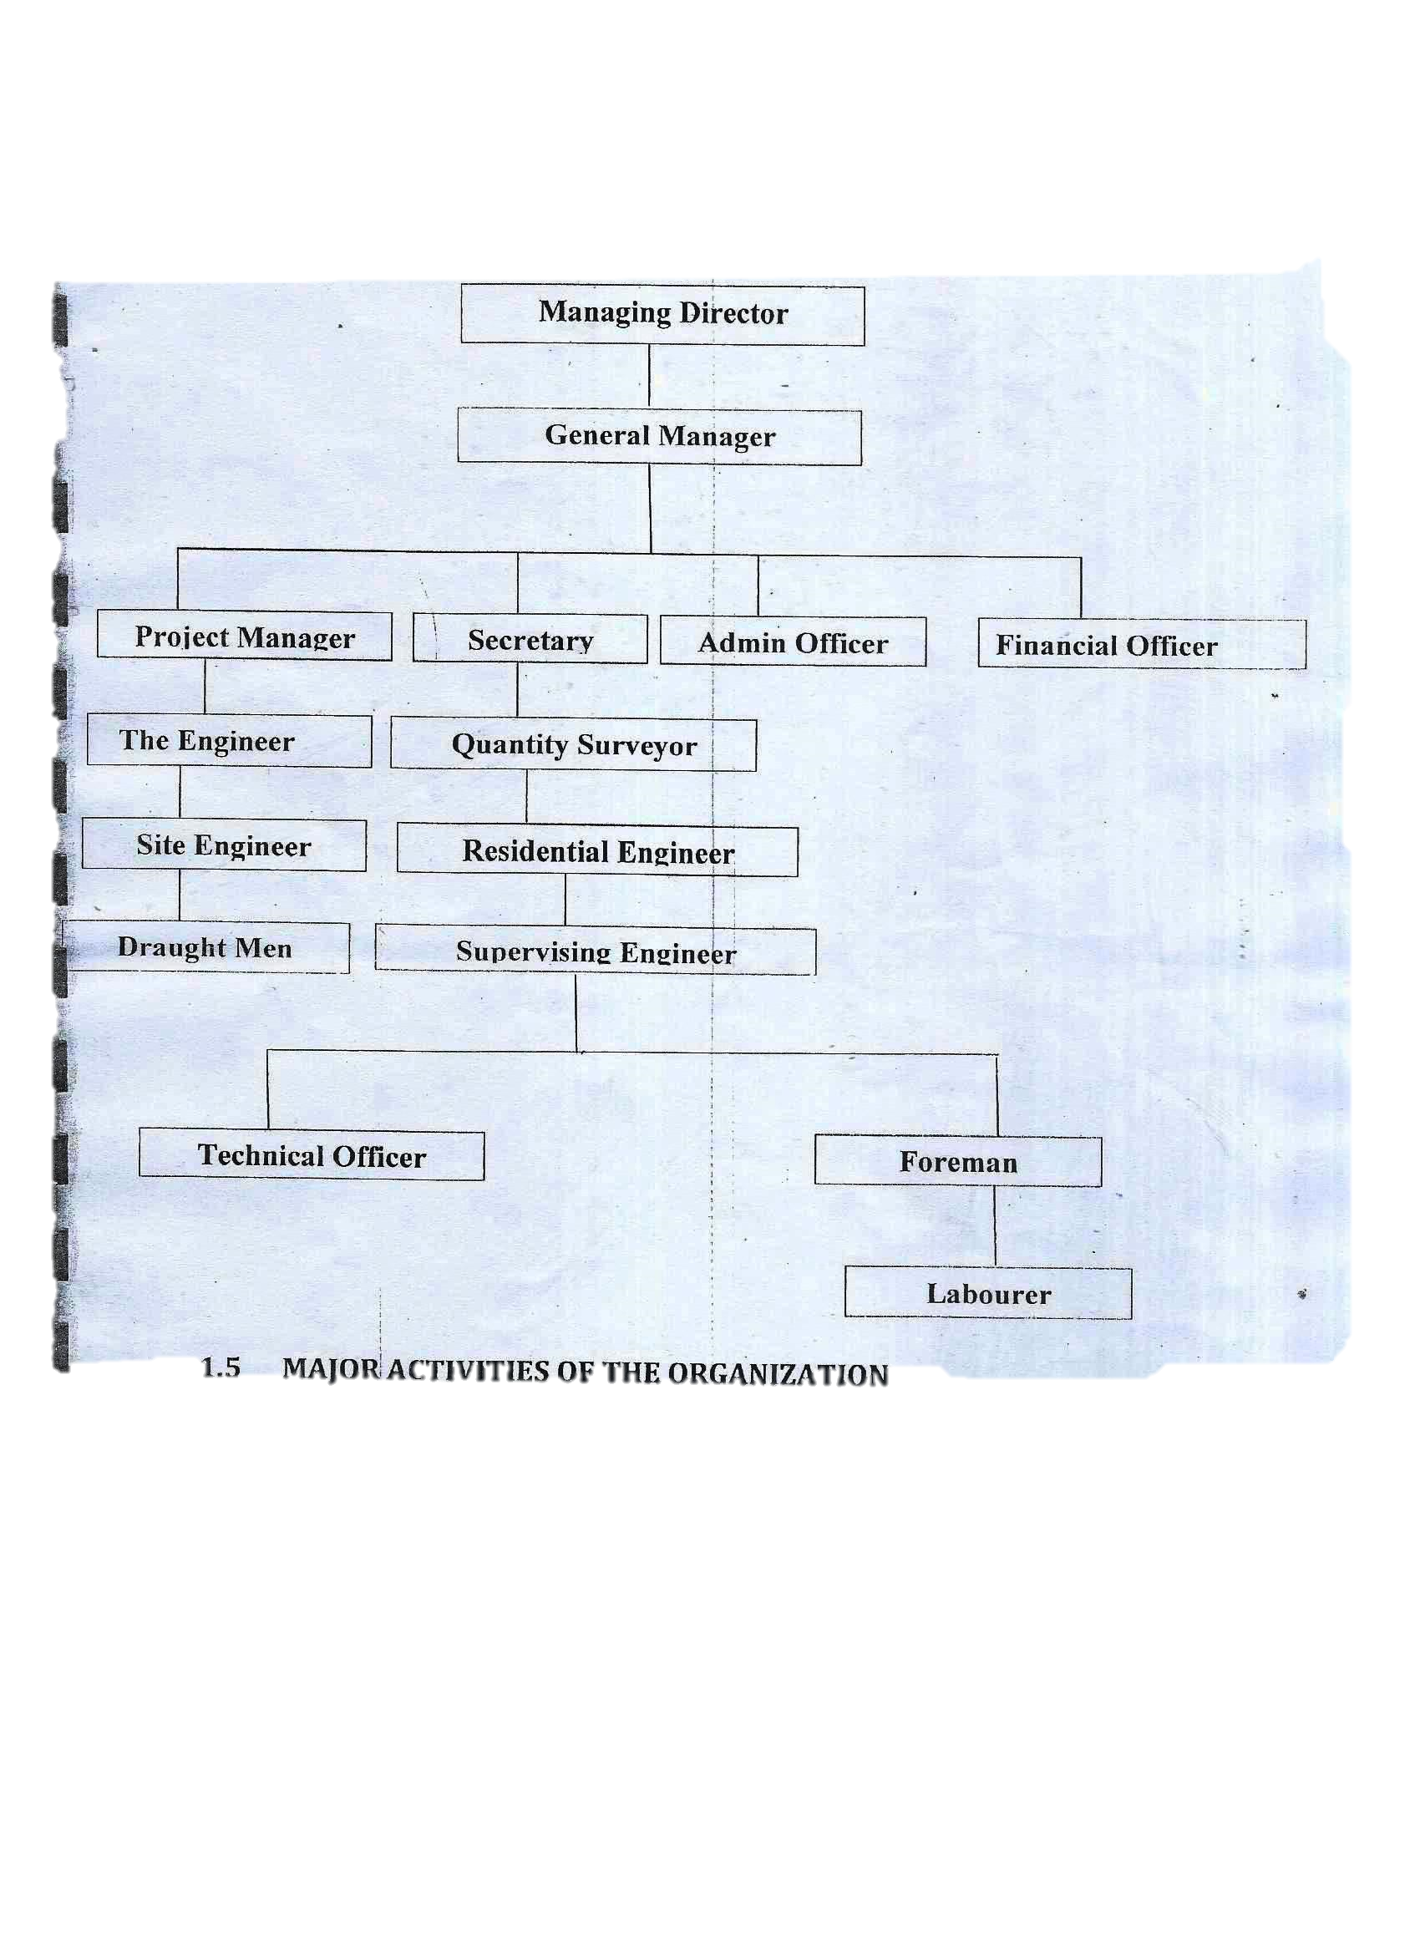
CHAPTER TWO
2.0 SECTION /UNIT OF THE ORGANIZATION AND THEIR SPECIFIC FUNCTION
The section of Kwara State Ministry of Works and Transport is divided into eight sections, namely are:
- Financial section
- Administrative section
- Secretariat section
- Security section
- Mechanical section
- Electrical section
- Civil section
- Maintenance section [KWARMA]
- FINANCIAL SECTION: This section is in charge of financial aspect of the organization, it issue out money for project execution and audit the outcome of any executed project and keep the account.
- ADMINISTRATIVE SECTION: This section foresees and ensures the smooth running of the organization. The section make sure that administrative setup of organization is in good order.
- SECRETARIAT SECTION: This section is keeping the necessary record of organization and file them for the reference and issue out letter to the state government if need arise and this section is headed by permanent secretary through the appointment.
- SECURITY SECTION: The security section is in charge of protection and ensures the well-being of an organization through proper security and the section is headed by the chief security officer.
- MECHANICAL SECTION: The mechanical section is responsible for the mechanical project of the organization and also to take proper maintenance of the engines available in the organization premises. Also, the section take charge of any state mechanical project and the section is coordinated by the Director of Mechanical department.
- ELECTRICAL SECTION: This section foresees the proper maintenance and efficiency of the organization, electrification project and also electronics. This section is coordinated by the Director of Electrical Engineering Department.
- CIVIL ENGINEERING SECTION: The civil engineering section is in charge of road network construction, bridges, building and in supervision of the organization project pertaining to civil work.
- MECHANICAL SECTION: The Kwara State Road Maintenance agency {KWARMA] was established by the state government to monitor road project, renovation of expiring point on the carriage across the state. KWARMA is embarking by the State Ministry of Works.

CHAPTER THREE
3.1 DRAINAGE
Drainage is the construction of drain line in order to allow water to flow off and away from the carriage way, to remove water through the roadways, prevent water from reaching the road and controlled movement of water along and under the road.
3.2 TYPES OF DRAINAGE
There are different types of drainage construction, but the most common ones constructed nowadays are:
1. Block drainage
2. Reinforced concrete drainage
3.3 BLOCK DRAINAGE
This is a type of drainage which is constructed using block, concrete and plaster with cement mortar. In this type of drainage, concrete prepared will be poured into the holes of the block for it to be able to withstand pressure heavy load and prevent porosity.
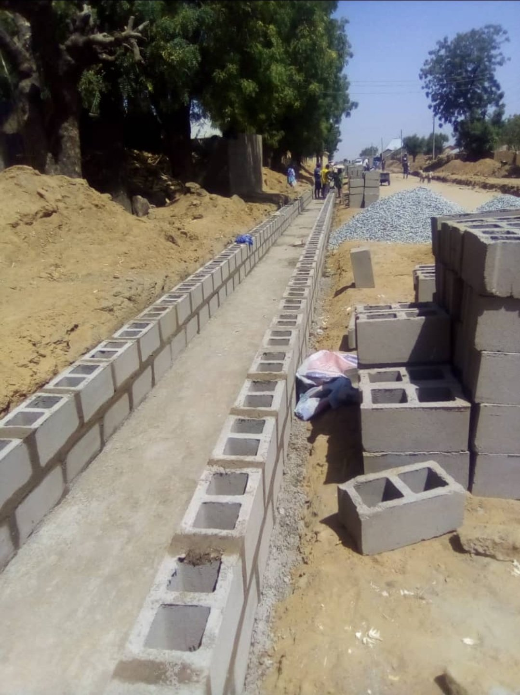
3.4 REINFORCED CONCRETE DRAINAGE
This is a type of drainage which is constructed using reinforcement bar and concrete. This type of drainage is stronger than the block drainage because of the reinforcement bar which makes it to gain strength and withstand external loadings.
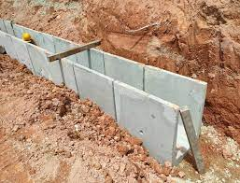
3.5 THE IMPORTANT OF DRAINAGE
i. It serves as channel to discharge excess water during reining period
ii. It prevent damage of road constructed
iii. It provide direction for water flowing
iv. It prevent wearing the soil erosion
3.6 CULVERT
A culvert in road construction is a hoe or pipe water which goes under a road and allows easy flow of water flowing through the drain. Culvert in another form of road drainage which is arises when a lying area or a steam or river, crosses.
The alignment of road at this point a culvert bridge has to be constructed to that the water of river as steam is made pass on the other side of the wad through them. Such culvert or structure is known as cross drainage work or simple drainage work. A culvert can be built in different from of Ring culvert
This can be practice by using of a concrete wood ring to construct culvert in other to allow the flow of water beneath the road pavement.
3.7 TYPES OF CULVERT
1. Pipe single or multiple culverts.
2. Pipe arch single or multiple culverts.
3. Box culvert single or multiple culverts.
4. Bridge culvert.
5. Arch culvert.
3.8 PIPE CULVERT
Pipe culvert is made of smooth steel, corrugated metal, or concrete material. Their primarily purpose is to convey water under roads, although a variety of wildlife uses them as passageways.
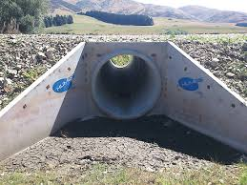
3.9 BOX CULVERT
Box culvert ate used to transmit water during brief runoff periods. These are usually used by wildlife because they remain dry most of the year. Box culvert are usually made up of reinforced concrete (RCC)
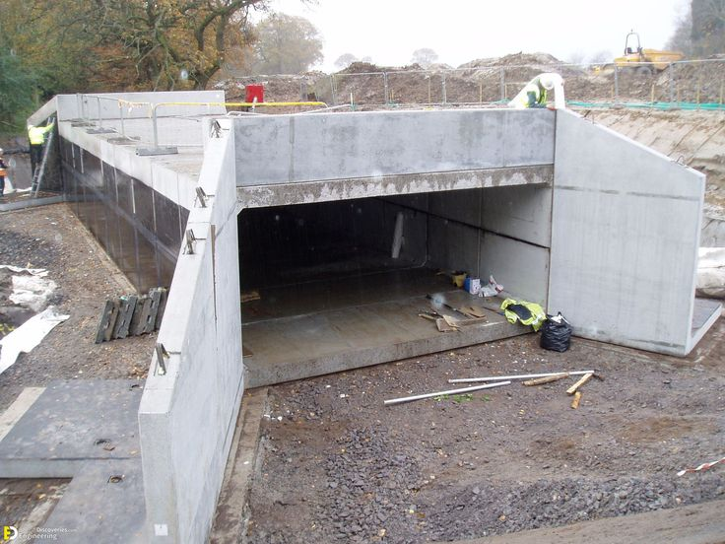
3.10 STEPS/PROCEDURE OF CONSTRUCTING CULVERT
i. Excavation of the trench to the acquired depth and width
ii. Setting of the concrete inside the trench
iii. Construction as the earthwork
iv. Filling the trench with concrete and allow to dry
CHAPTER FOUR
4.1 ROADS CONSTRUCTION
Road surface or pavement is the durable surface material laid down on an area intended to sustain vehicular or foot traffic, such as a road or walkway. In the past, gravel road surfaces, cobblestone and granite setts were extensively used, but these surfaces have mostly been replaced by asphalt or concrete laid on a compacted base course. Road surfaces are frequently marked to guide traffic. Today, permeable paving methods are beginning to be used for low-impact roadways and walkways.
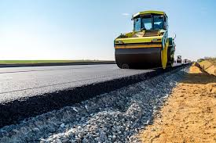

4.2 Asphalt
Asphalt (specifically, asphalt concrete), sometimes called flexible pavement due to the nature in which it distributes loads, has been widely used since the 1920s. The viscous nature of the bitumen binder allows asphalt concrete to sustain significant plastic deformation, although fatigue from repeated loading over time is the most common failure mechanism. Most asphalt surfaces are laid on a gravel base, which is generally at least as thick as the asphalt layer, although some 'full depth' asphalt surfaces are laid directly on the native subgrade. In areas with very soft or expansive subgrades such as clay or peat, thick gravel bases or stabilization of the subgrade with Portland cement or lime may be required. Polypropylene and polyester geosynthetics have also been used for this purpose.

4.3 Bituminous surface
Bituminous surface treatment (BST) or chipseal is used mainly on low-traffic roads, but also as a sealing coat to rejuvenate an asphalt concrete pavement. It generally consists of aggregate spread over a sprayed-on asphalt emulsion or cut-back asphalt cement. The aggregate is then embedded into the asphalt by rolling it, typically with a rubber-tired roller. Pavers (or paviours), generally in the form of pre-cast concrete blocks, are often used for aesthetic purposes, or sometimes at port facilities that see long-duration pavement loading. Pavers are rarely used in areas that see high-speed vehicle traffic.

Markings
Road surface markings are used on paved roadways to provide guidance and information to drivers and pedestrians. It can be in the form of mechanical markers such as cat's eyes, botts' dots and rumble strips, or non-mechanical markers such as paints, thermoplastic, plastic and epoxy.
4.4 Pavement Construction
A highway pavement is a structure consisting of superimposed layers of processed materials above the natural soil sub-grade, whose primary function is to distribute the applied vehicle loads to the sub-grade. The pavement structure should be able to provide a surface of acceptable riding quality, adequate skid resistance, favourable light reflecting characteristics, and low noise pollution. The ultimate aim is to ensure that the transmitted stresses due to wheel load are sufficiently reduced, so that they will not exceed bearing capacity of the sub-grade.
Requirements of a pavement
An ideal pavement should meet the following requirements:
- Sufficient thickness to distribute the wheel load stresses to a safe value on the sub-grade soil.
- Structurally strong to withstand all types of stresses imposed upon it.
- Adequate coefficient of friction to prevent skidding of vehicles,
- Smooth surface to provide comfort to road users even at high speed.
- Dust proof surface so that traffic safety is not impaired by reducing visibility
- Impervious surface, so that sub-grade soil is well protected.
- Long design life with low maintenance cost.
4.5 Types of pavements
Flexible pavements
Flexible pavements will transmit wheel load stresses to the lower layers by grain-to-grain transfer through the points of contact in the granular structure best quality to sustain maximum compressive stress, in addition to wear and tear. The lower layers will experience lesser magnitude of stress and low quality material can be used. Flexible pavements are constructed using bituminous materials. These can be either in the form of surface treatments (such as bituminous surface treatments generally found on low volume roads) or, asphalt concrete surface courses (generally used on high volume roads such as national highways).
Types of Flexible Pavements
- The following types of construction have been used in flexible pavement:
- Conventional layered flexible pavement,
- Full - depth asphalt pavement, and
- Contained rock asphalt mat (CRAM).
Rigid pavements
Rigid pavements have sufficient flexural strength to transmit the wheel load stresses to a wider area below. Compared to flexible pavement, rigid pavements are placed either directly on the prepared sub-grade or on a single layer of granular or stabilized material. Since there is only one layer of material between the concrete and the sub-grade, this layer can be called as base or sub-base course.
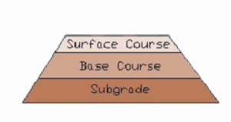
Pictorial Representation of Discussions
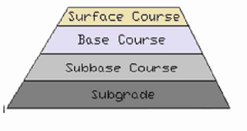

Fig 1. Section of Flexible Pavement Fig 2. Section of Rigid Pavement

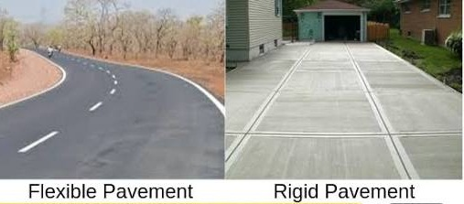

ROAD CONSTRUCTION EQUIPMENT AND THEIR USES
1. Bulldozer is used to clear the area required for work.
2. Grader is used to level the surface of the earth of the area to work upon.
3. Scrapper is used to cut up all high places and used to fill the low land.
4. Dump truck is used to transfer sand and laterite to required destination.
5. Tipper is used in transferring fine and coarse aggregate to site.
6. Bitumen tanker is used for storing bitumen and keeps the bitumen boiling so as not to get cold and stiff.
7. Water tanker is used to carry water to places needed on site for mixture of mortar and wetting the soil surface.
8. Excavator is used to dig the earth surface of the area needed.
9. Concrete mixer is used to transfer concrete from a particular place to another keeping the concrete mixed.
10. Pale loader is used to heap amount of sand, laterite, gravel or Stone dust to a particular container or back fills.
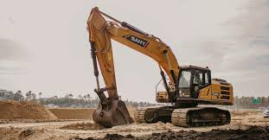
EXCAVATOR MACHINE
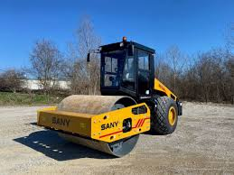
ROLLER MACHINE

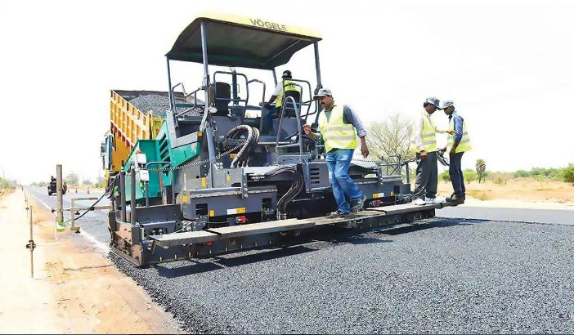
ASPHALT PAVER MACHINE
CHAPTER FIVE
5.0 CONCLUSION
The SIWES programme is an efficient an effective program which has bring much improvement to my field of study. I have gained a lot of experience from the various works done on field such as Drainage, Culvert and Road Construction. It is a programme that bridges the gap between theory and practical aspect, so therefore it has made me to have technical knowledge about what I have learnt theoretically in class.
It is a unique privilege for me to undergo this training, for its enables me to know the service to render as a agricultural and bio system engineer. I here appreciate the effort to the Federal Government and Industrial Training Fund (I.T.F) for improving the technological development of this country.
5.1 PERSONAL IMPRESSION ABOUT THE ORGANIZATION
I was highly impressed about the organization towards the acceptance of my SIWES letter in their organization. Also what impressed me most about the organization is the experience gained during my training under Civil Engineering Department at the Ministry of Work and Transport Ilorin. This will help me facing the future challenges that may likely to occur in my field of study.
5.2 RECOMMENDATION TO THE ORGANIZATION CONCERNING THE SIWES PROGRAMME
I will like to implore the organization to continue in their well accommodative standard.
I would recommend that the organization should provide transport facilities for SIWES students so as to move/carry them from the office to the site off construction.
5.3 RECOMMENDATION TO THE POLYTECHNIC CONCERNING THE SIWES PROGRAMME
I would recommend that the polytechnic should try to get a placement for the student by contacting all engineering organization to admit any student for their SIWES programme.
I would recommend that the polytechnic should try to give adequate supervision to the student in their place of attachment for student assessment before the completion of the programme.

