

A TECHNICAL REPORT
STUDENT INDUSTRIAL WORKING EXPERIENCE SCHEME
(SIWES)

HELD AT
SPECIAL ROYAL FARM
Obbo Ile/Ora road, Obbo-Ile, Ekiti LGA, Kwara State

Prepared by:
AKEEM YUSUF OLAWALE
ND/23/ABE/FT/0020

SUBMITTED TO

DEPARTMENT OF AGRICULTURAL AND BIO-ENVIRONMENTAL ENGINEERING TECHNOLOGY
INSTITUTE OF TECHNOLOGY
KWARA STATE POLYTECHNIC, ILORIN
INPARTIAL FULFILLMENT OF THE AWARD OF THE REQUIREMENT OF THE AWARD OF NATIONAL DIPLOMA IN AGRICULTURAL AND BIO-ENVIRONMENTAL ENGINEERING TECHNOLOGY

DEDICATION
I dedicate this report to Almighty God, who has been all in all from the beginning of my attachment to the end of the SIWES program all glory belongs to Him.
I also dedicate the SIWES report to my lovely family for their financial support and spiritual advice during the period of attachment.

ACKNOWLEDGEMENT
My sincere gratitude goes to Almighty God who has made things easy for me and for his unfailing love over my life, and my sincere gratitude goes to my parents Mr and Mrs AKEEM I pray May Almighty God continue to bless you and enrich your pocket.
Also my appreciation goes to the entire SPECIAL ROYAL FARM and the manager for his warm hand of love he has shown to us during the period.

PREFACE
The Students industrial Work Experience Scheme (SIWES) is a course which help the vocational technology students to become self employed in any aspect of their life.
The SIWES now serve as a big advantage to every student who participate in the program and also know how to make use of his/her time within the program.
As an Agricultural Engineering student, writing this report has become a personal experience in which what had been taught in school are put into practical aspect.
This SIWES program have positive influence in the growth and development of my field practical experience.

TABLE OF CONTENTS
Title page i
Dedication ii
Acknowledgement iii
Preface iv
Table Of Contents v
CHAPTER ONE
1.1 Introduction 1
1.2 Background of SIWES 1
1.1 Aim and Objective of SIWES 1
CHAPTER TWO
2.1 Brief History of Establishment 2
2.2 Objectives of Establishment 2
2.3 Organizational Structure 2
CHAPTER THREE
3.1 Significance of the SIWES experience 3
3.2 Farm Machinery and Farm Tools 3
CHAPTER FOUR
4.1 Livestock Farming 8
4.2 Crop Farming 12
4.3 Maintenance and Repairing of Farm Machinery 12
CHAPTER FIVE
5.1 Summary of Attachment activities 14
5.2 Challenges Encountered 14
5.3 Conclusion 14
5.4 Recommendation 14
CHAPTER ONE
  - INTRODUCTION
In October 1971, the federal government established the Industrial Training Fund (I.T.F). In its policy statement no.1 published in 1973, a clause was inserted dealing with the issue of practical skills among the locally trained professionals in the tertiary institutions especially the Universities of Technology, Monotechnics, Polytechnics, Colleges of Education and Technical Colleges. Section 15 of the policy statement states clearly that “Great emphasis will be placed on assisting certain products of the post-secondary school system to adapt or orientate easily to their possible post-graduation job environments”, subsequently leading to the launch of a scheme known as the Student’s Industrial Work Experience Scheme(SIWES).

1.2 BACKGROUND OF SIWES
The S.I.W.E.S. was launched in 1973 by the Industrial Training Fund (I.T.F) as a programme designed to impart the undergraduate of the nation’s tertiary institutions studying various professional courses with the practical methods of performing professional functions to real life situations on site, in the office or even the factory and how they apply themselves mentally, intellectually and physically in relation to what they have been taught in the classrooms theoretically. It works with the following professional bodies to function effectively across the tertiary institutions nationwide. These are the Nigeria University Commission (N.U.C), National Board for Technical Education (N.B.T.E.) and the National Commission for Colleges of Education (N.C.C.E.). Thus, equipping the students with the necessary skills and technical knowledge to make them highly competitive and professional individuals in the Labour Market.

1.3 AIM AND OBJECTIVES OF SIWES
The aim of SIWES is to bridge the gap between the level of knowledge acquired in tertiary institutions and the practical application of such knowledge in the field of work.
The Objectives of SIWES are as follows:
- To provide an avenue for students in industries of higher learning to acquire industrials skills and experience in their course of study.
- To expose students to work methods and techniques in handling equipment and machinery that may not available in the educational institution.
- To make transition from school to the world of work easier and enhance students contact for later job placements.
- To improve student’s interpersonal relationship with others in their field.
- To prove students an opportunity to apply his/her knowledge in real work situation, thereby bridging the gap between college work and actual practice.

CHAPTER TWO
2.1 BRIEF HISTORY OF ESTABLISHMENT
The name of the company is SPECIAL ROYAL FARM situated at Obbo Ile/Ora Road, Obbo Ile, Ekiti State which was established in the year 2016, it is constructed basically for crop farming and raising animals like poultry farming and Pig farming. The company also engage in construction of pig house and vegetable farming.

2.2 OBJECTIVES OF ESTABLISHMENT
The primary mission of SPECIAL ROYAL FARM is to contribute to food security and economic development by employing innovative and environmentally friendly farming methods. The farm strives to achieve the following objectives:
- Enhance agricultural productivity through the adoption of modern technologies.
- Promote sustainable and organic farming practices.
- Serve as an educational hub for students and professionals interested in agriculture.
- Contribute to the local economy by generating employment opportunities.

2.3 SPECIAL FARM NIGERIA LTD ORGANIZATIONAL STRUCTURE

Farm Director

Equipment Manager
Crop Manager
Diary Manager

Forage Supervisor
Maintenance Supervisor
Feeding Supervisor

Maintenance Team
Forage Team
Feeding Team

CHAPTER THREE
3.1 SIGNIFICANCE OF THE SIWES EXPERIENCE
The experience gained at SPECIAL ROYAL FARM holds significant implications for both academic and professional development. It not only deepened my understanding of agricultural concepts but also provided valuable exposure to the practical challenges faced by the agricultural sector. This report aims to chronicle the lessons learned, skills acquired, and the overall impact of the SIWES placement on my academic and career trajectory.

3.2 FARM MACHINERY AND FARM TOOLS USED ON THE FARM
Farm machinery plays a crucial role in modern agriculture, enhancing efficiency, productivity, and overall farm management. These machines are designed to perform various tasks, ranging from soil preparation to harvesting, and they significantly reduce the labor required for agricultural operations. Here's an overview of some common types of farm machinery used on the farm:
- Tractors: Tractors are essential vehicles in modern agriculture, performing a wide range of tasks to enhance efficiency and productivity on the farm. The type of tractor used depends on the specific tasks and requirements of the farm. They can be equipped with different attachments such as ploughs, harrows, seeders, and mowers. Tractors are used for tasks like ploughing fields, planting crops, cultivating, and pulling implements for various operations.
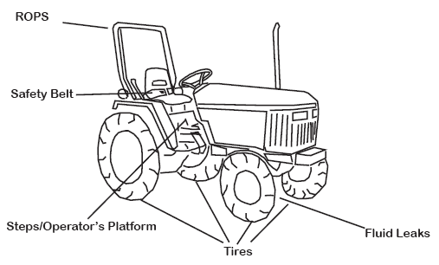

Fig 1. A Tractor

- Ploughs: Ploughs are used to turn over and break up the soil, preparing it for planting. Modern ploughs can be attached to tractors and come in various types, including moldboard ploughs, disc ploughs, and chisel ploughs.
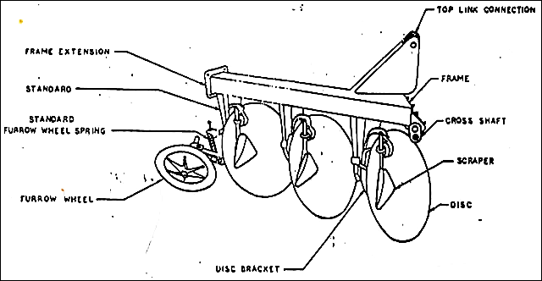

Fig 2. A Disc Plough

- Seeders and Planters: Seeders and planters are used for precise and efficient planting of seeds. They can be attached to tractors and are designed to place seeds at the desired depth and spacing.

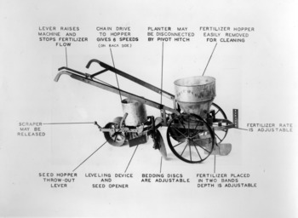

Fig 3. A Planter

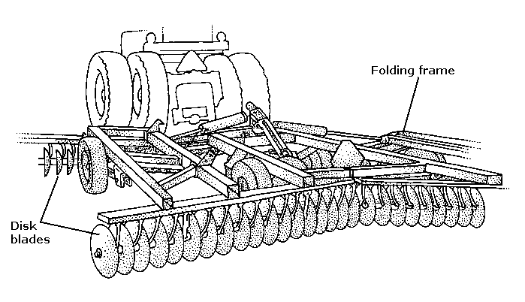
- Harrows: Harrows are used to break up clods of soil, smooth the surface, and incorporate crop residues. There are different types of harrows, such as disc harrows and tine harrows, each serving specific purposes in soil preparation.

Fig 4. Harrow


- Weighing Scale: A weighing scale is a device used to measure the weight or mass of objects, commonly employed in farms for weighing produce, livestock, feed, and fertilizers. It ensures accuracy in harvest measurement, helping farmers determine yield, set fair market prices, and manage inventory efficiently. In livestock farming, weighing scales are essential for monitoring animal growth, health, and feed intake, which aids in proper nutrition management. Accurate weight measurements also help in maintaining records, optimizing resource allocation, and reducing wastage, ultimately improving farm productivity and profitability.

Fig 5. Weighing Scale

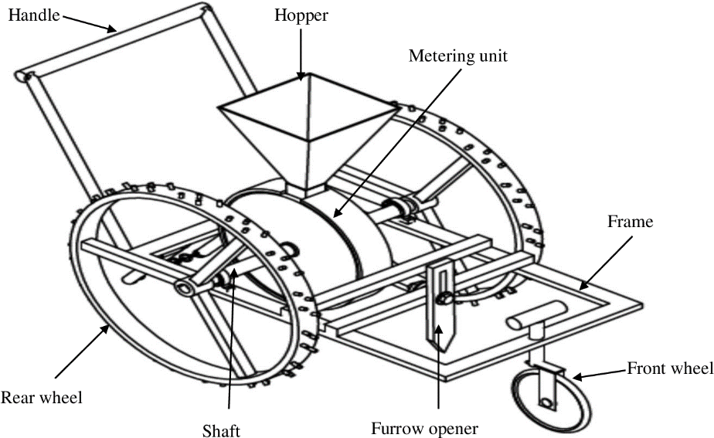
- Grain Planter: A grain planter is an agricultural machine designed to efficiently plant seeds, such as maize, rice, wheat, and other grains, at the correct depth and spacing in the soil. It ensures uniform seed distribution, reducing wastage and improving crop yield. Grain planters can be manual, mechanical, or automated, depending on the scale of farming. Their importance in agriculture includes increasing planting efficiency, saving time and labor, promoting even germination, and enhancing overall farm productivity. By ensuring precise seed placement, grain planters contribute to better crop management and higher agricultural output.

Fig 6. Grain Planter

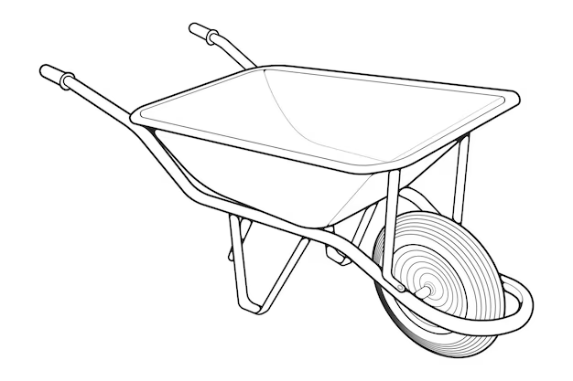
- Wheelbarrow: A wheelbarrow is a simple yet essential farm tool used for transporting materials such as soil, manure, animal feed, harvested crops, and farming equipment. It consists of a shallow basin mounted on a single wheel, with two supporting handles for easy maneuverability. The importance of a wheelbarrow in farming includes reducing manual labor, improving efficiency in material handling, and enabling farmers to move heavy loads with minimal effort. It is particularly useful in small-scale and large-scale farming operations, construction, and gardening, making it a versatile tool for various agricultural tasks.

Fig 7. Wheelbarrow
- Gardening Tool: A gardening tool is any equipment or implement used to assist in various gardening tasks such as planting, weeding, pruning, watering, and soil preparation. Common gardening tools include hoes, rakes, shovels, trowels, pruners, and watering cans. These tools are essential for maintaining healthy crops, improving soil conditions, and ensuring efficient farm management. Gardening tools help reduce manual labor, increase productivity, and contribute to better crop growth and farm maintenance.
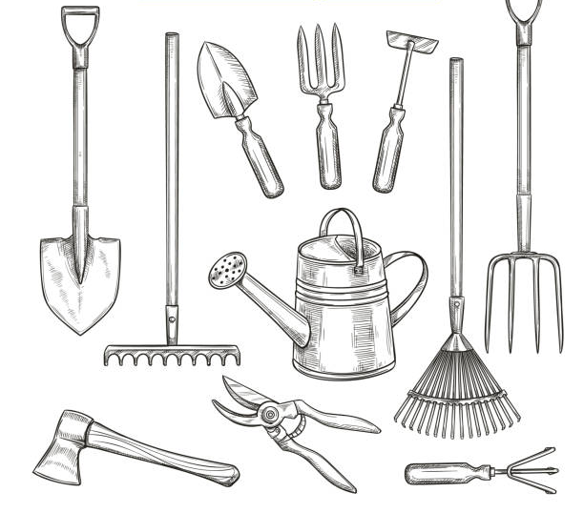

Fig 8. Gardening Tool

CHAPTER FOUR
4.1 LIVESTOCK FARMING
Livestock farming, also known as animal husbandry, involves the breeding and raising of animals for various purposes, including food production, fiber, labor, and other by-products. Livestock can include animals such as cattle, sheep, goats, poultry, and more. Here's an overview of key aspects of livestock farming:

TYPES OF LIVESTOCK FARMING
1. Poultry Farming
Poultry farming involves the raising of domesticated birds, such as chickens, ducks, turkeys, and geese, for various purposes such as meat and egg production. It is a significant aspect of agriculture and plays a crucial role in providing a sustainable source of protein for human consumption. Here is an overview of key aspects of poultry farming:
Types of Poultry Farming
- Broiler Farming: Involves raising chickens specifically for meat production.
- Layer Farming: Focuses on raising hens for the production of eggs.
- Dual-Purpose Farming: Combines both meat and egg production.

Key Aspects of Livestock Farming
- Housing and Infrastructure: Designing and maintaining appropriate shelters and facilities for different types of livestock.
- Feeding and Nutrition: Developing balanced and nutritious diets to meet the specific needs of each type of livestock.
- Breeding and Reproduction: Managing breeding programs to improve desirable traits in the herd or flock.
- Health Management: Implementing vaccination programs and preventive measures to control diseases.
- Waste Management: Proper disposal of animal waste to minimize environmental impact.
- Grazing and Forage Management: Efficient use of pasture and forage resources to provide natural grazing for animals.
- Record Keeping: Maintaining detailed records of breeding, health, and production parameters for each animal.
- Sustainable Practices: Implementing practices that promote environmental sustainability and animal welfare.
- Market Access and Marketing: Identifying market trends, pricing, and ensuring efficient marketing of livestock products.

2. Pig Farming
Pig farming, also known as piggery, is the practice of rearing domesticated pigs for meat (pork), breeding, and other by-products such as leather, bristles, and manure. It is one of the most profitable aspects of livestock farming due to the high reproductive rate, fast growth, and high feed conversion efficiency of pigs. Pigs are omnivorous animals that can be raised on a variety of feed sources, including grains, vegetables, and agricultural by-products, making pig farming a viable business in different farming systems.
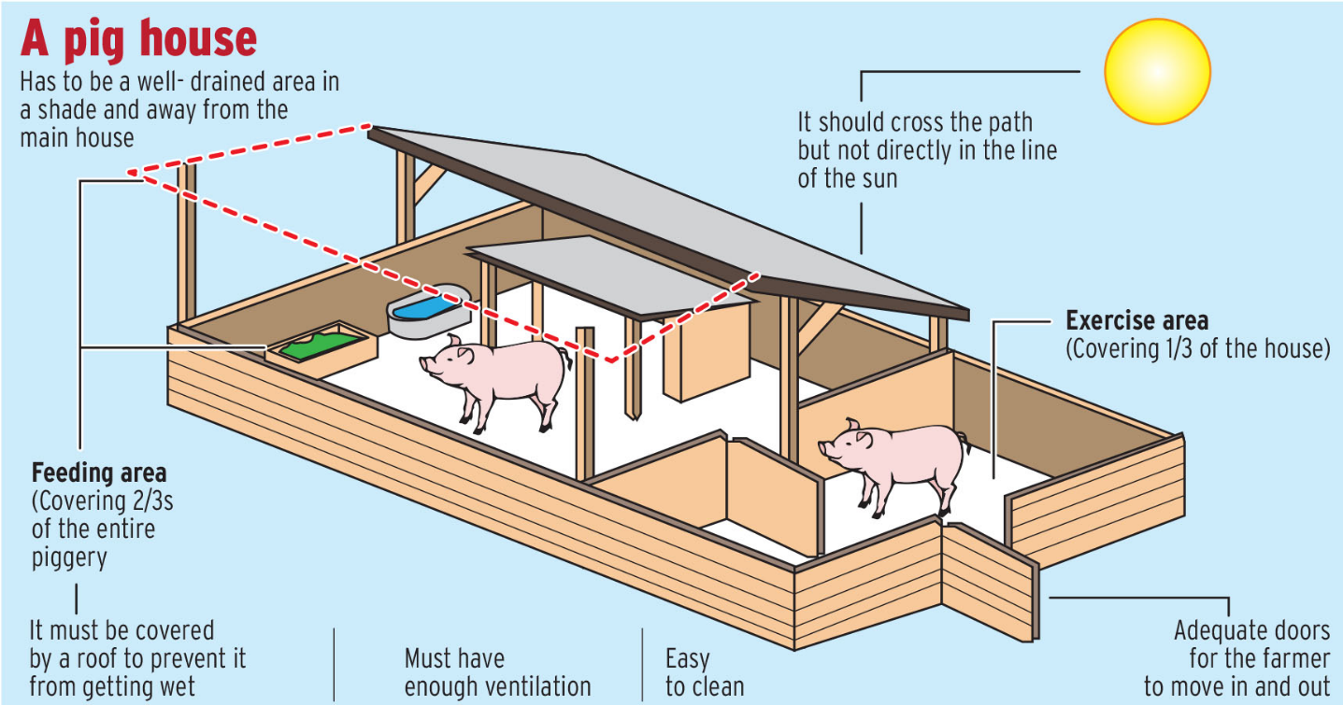

Fig 7 A pig house

Types of Pig Farming
Pig farming can be classified based on the scale of production and purpose:
- Commercial Pig Farming – Large-scale intensive farming focused on high meat production for commercial purposes.
- Backyard Pig Farming – Small-scale farming where pigs are raised alongside other livestock for family consumption or local markets.
- Breeding Farms – Specially managed farms focused on producing high-quality pig breeds for sale to other farmers.

Requirements for Successful Pig Farming
To ensure a profitable pig farming venture, certain factors must be considered:
- Housing and Management
  - Pigs require well-ventilated, clean, and spacious housing to prevent diseases and ensure comfort.
  - Proper waste management systems should be in place to prevent environmental pollution.
  - Housing should provide protection from harsh weather conditions.
- Feeding and Nutrition
  - Pigs need a balanced diet containing protein, carbohydrates, vitamins, and minerals for healthy growth.
  - Feed efficiency is crucial in pig farming, as it directly affects the growth rate and meat quality.
  - Common feed ingredients include maize, soybeans, cassava peels, kitchen scraps, and formulated pig feed.
- Breeding and Reproduction
  - Pigs have a high reproductive rate, with a single sow producing 8–12 piglets per litter.
  - Good breeding stock selection improves growth rate, disease resistance, and overall farm productivity.
  - Artificial insemination and controlled mating systems can improve genetic quality.
- Health and Disease Management
  - Common pig diseases include African Swine Fever, Foot-and-Mouth Disease, and Swine Influenza.
  - Vaccination, proper hygiene, and veterinary care are essential to prevent disease outbreaks.
  - Quarantine measures should be taken when introducing new pigs into a farm to prevent infections.
- Market and Profitability
  - Pork has a high demand in both local and international markets, making pig farming a profitable business.
  - Proper marketing strategies, such as selling to local butchers, supermarkets, hotels, and direct consumers, can increase profits.
  - Value addition, such as processing pork into sausages, bacon, or smoked meat, can enhance profitability.

Importance of Pig Farming
- Economic Benefits: Provides employment and income for farmers, traders, and processors.
- Food Security: Pork is a major source of protein and essential nutrients.
- Waste Recycling: Pigs can be fed with agricultural by-products, reducing waste.
- Manure Production: Pig manure is a valuable organic fertilizer that enhances soil fertility.
In conclusion, pig farming is a highly rewarding venture when managed properly. With the right housing, feeding, health care, and marketing strategies, pig farmers can achieve high productivity and profitability.

4.2 CROP FARMING
Crop farming is the cultivation of crops for food, fiber, biofuel, and other products used to sustain and enhance human life. It is a fundamental component of agriculture and plays a crucial role in providing food for the growing global population. Here are some key aspects of crop farming:
- Crop Selection: Farmers choose specific crops based on factors such as climate, soil type, water availability, market demand, and their own expertise. Common crops include cereals (such as rice and maize), legumes (like beans) and oilseeds (such as soybeans).
- Land Preparation: Farmers prepare the land for planting by ploughing, harrowing, and leveling. This helps create a suitable seedbed for planting and improves soil structure.
- Planting: Seeds are sown or planted in the prepared soil. The method and timing of planting depend on the type of crop, local climate, and agricultural practices. Some crops are directly seeded, while others are transplanted as seedlings.
- Harvesting: When the crops reach maturity, they are harvested. The timing of harvesting is critical to ensure optimal yield and quality. Harvesting methods vary depending on the crop; for example, grains are often harvested with combines, while fruits and vegetables may be picked by hand.
- Marketing and Distribution: Farmers sell their crops through various channels, such as local markets, wholesalers, and, increasingly, through online platforms. The distribution chain involves transportation, storage, and processing to make the crops available to consumers.
- Crop Rotation and Diversification: To maintain soil health and prevent the buildup of pests and diseases, farmers often practice crop rotation. This involves growing different crops in a sequence on the same piece of land. Crop diversification is another strategy where farmers cultivate a variety of crops to spread risk and enhance resilience.

4.3 MAINTENANCE AND REPAIRING OF FARM MACHINERY
Repairing and maintaining machinery is crucial to ensure the optimal performance, longevity, and safety of equipment in various industries. Whether it's agricultural machinery, construction equipment, manufacturing tools, or any other type of machinery, a well-executed maintenance and repair program can prevent breakdowns, reduce downtime, and extend the lifespan of the equipment. Here are key aspects of repairing and maintaining machinery:
- Regular Inspections
- Conduct routine inspections to identify wear and tear, loose parts, leaks, and other issues.
- Inspect critical components, such as belts, chains, bearings, and hydraulic systems.
- Scheduled Maintenance
- Develop a maintenance schedule based on manufacturer recommendations and equipment usage.
- Perform regular tasks like oil changes, filter replacements, lubrication, and belt adjustments.
- Cleaning and Lubrication
- Keep machinery clean to prevent the buildup of dirt, debris, and corrosive substances.
- Lubricate moving parts to reduce friction and wear. Use appropriate lubricants as specified by the manufacturer.
- Replacement of Wear Parts
- Identify and replace worn-out or damaged components, such as belts, blades, filters, and seals.
- Keep an inventory of spare parts to facilitate quick replacements

CHAPTER FIVE
5.1 SUMMARY OF ATTACHMENT ACTIVITIES
The SIWES program at Special Royal Farm provided valuable hands-on experience in various aspects of agricultural operations. I was introduced to farm machinery and tools, learning their functions, usage, and basic maintenance to ensure efficiency. My training also covered livestock farming, including poultry and pig farming, where I gained insights into animal care, feeding, and management practices. Additionally, I was exposed to crop farming techniques, including planting, weeding, and harvesting processes. The experience in farm machinery maintenance further enhanced my understanding of the importance of equipment upkeep for sustainable farm productivity. Overall, the training broadened my practical knowledge of modern agricultural practices.

5.2 CHALLENGES ENCOUNTERED DURING THE PROGRAMME
The main problem I encountered was getting placement and transportation.

5.3 CONCLUSION
In conclusion, SIWES programme is of great importance to every student as it exposes them to get acquainted to work experience. It provides an avenue for student to understand the practical aspect of the theories taught in school, exposing them to machines, equipment, professional work methods and ways to safeguard the work environment in industries and various organization. My four months’ industrial attachment with SPECIAL ROYAL FARM has been one of the most interesting, productive, instructive and educative experience in my life. Through this training, I have gained new insight and more comprehensive understanding about the real farming practices and has greatly improved my interpersonal skill. And from what I have undergone, I am sure that the industrial training programme has achieved its primary objective.

5.4 RECOMMENDATION
I suggest that all institutions or bodies involve in Student Industrial Working Experience Scheme, should provide places for industrial attachment for Student Industrial Training Fund and also pay some allowances to students and the company should provide more safety equipment to prevent further environmental and health hazards. Also, to students that are to undergo the training, I recommend that they should take it very seriously, because it is one of the most important parts of their studies which will help them build a very significant and effective meaning in their career.

