

A TECHNICAL REPORT
STUDENT INDUSTRIAL WORKING EXPERIENCE SCHEME
(SIWES)

HELD AT:
TOWN HALL LIBRARY NO. 719 OWOLAWO STREET IKORODU, LAGOS STATE, IKORODU

PREPARED BY:
JIMOH MONSURA MORENIKEJI
ND/23/LIS/FT/0050

SUBMITTED TO:

DEPARTMENT OF LIBRARY AND INFORMATION SCIENCE
KWARA STATE POLYTECHNIC, ILORIN

IN PARTIAL FULFILLMENT OF THE REQUIREMENTS FOR THE AWARD OF NATIONAL DIPLOMA (ND) IN LIBRARY AND INFORMATION SCIENCE

Sept., – Nov., 2024
DEDICATION
I dedicate this technical report to the Almighty GOD, the giver of knowledge, wisdom and who is rich in mercy.

ACKNOWLEDGEMENT
I take this opportunity to express my profound gratitude and deep regards to the creator of heaven and earth, the one who knows the beginning and the end, the alpha and the omega. my sincere gratitude also goes to my guidance MR. & MRS. JIMOH for their financial support and word of encouragement during my SIWES Programme and also to those who stood by me during my SIWES programme, thank you all. I also take this opportunity to express a deep sense of gratitude to compliment my supervisor at my place of attachment for taking his time for my practical knowledge and for his cordially support, valuable information and guidance which helped me in completing my SIWES through various stages may Almighty God bless you abundantly.
TABLE OF CONTENT
Dedication
Acknowledgement
CHAPTER ONE
  - Introduction to SIWES
  - History of SIWES
  - Objectives of the Programme
  - Objectives of Establishment
CHAPTER TWO
2.1 Activities of place of Attachment
2.2. Precaution Taken in the Place of Attachment
2.3 Organizational Product and Benefits
CHAPTER THREE
Reporting on Work Carried Out
3.1 Reporting on Daily Work Carried Out
CHAPTER FOUR
Challenges Encounter In Place of Attachment
CHAPTER FIVE
Summary, Conclusion and Recommendations
5.1 Summary
5.2 Conclusion
5.3 Recommendations
CHAPTER ONE
  - INTRODUCTION TO SIWES
Students Industrial Work Experience Scheme (SIWES) is a Skills Training Program designed to prepare and expose Students of Universities, Polytechnics, Colleges of Technology, Colleges of Agriculture and Colleges of Education for the Industrial Work situation they are likely to meet after graduation. The Scheme affords Students the opportunity of familiarizing and exposing themselves handling equipment and machinery that are usually not available in their institutions.

1.2 HISTORY OF SIWES
The Students’ Industrial Work Experience Scheme (SIWES) was initiated in 1973 by the Federal Government of Nigeria under the Industrial Training Fund (ITF) to bridge the gap between theory and practice among products of our tertiary Institutions. It was designed to provide practical training that will expose and prepare students of Universities, Polytechnics, and Colleges of Education for work situation they are likely to meet after graduation.
Before the establishment of the scheme, there was a growing concern among the industrialists that graduates of institutions of higher learning lacked adequate practical background studies preparatory for employment in industries. Thus the employers were of the opinion that the theoretical education going on in higher institutions was not responsive to the needs of the employers of labour.
As a result of the increasing number of students’ enrolment in higher institutions of learning, the administration of this function of funding the scheme became enormous, hence ITF withdrew from the scheme in 1978 and was taken over by the Federal Government and handed to National Universities commission (NUC), National Board for Technical Education (NBTE) and National Commission for Colleges of Education (NCCE). In 1984, the Federal Government reverted back to ITF which took over the scheme officially in 1985 with funding provided by the Federal Government.
1.3 OBJECTIVES OF THE PROGRAMME
The specific objectives of SIWES are to:
- To provide students with hands-on experience in their field of study, allowing them to apply theoretical knowledge in real-world scenarios.
- To enhance students' technical and soft skills, including problem-solving, teamwork, and communication, which are crucial for their professional development.
- To familiarize students with the working environment and culture of the industry, helping them understand the dynamics of professional settings.
- To enable students to build relationships with industry professionals, which can be beneficial for future job placements and career guidance.
- To prepare students for their future careers by exposing them to the challenges and expectations of the workplace.
- To encourage students to engage in research and innovative projects that may contribute to the advancement of their respective fields.
- To provide a platform for students to receive feedback on their performance, which can help them improve and grow professionally.
1.4 OBJECTIVES OF ESTABLISHMENT
The specific objectives of establishment are to:
- Libraries aim to offer a wide range of resources, including books, journals, digital media, and databases, to meet the information needs of their users.
- Libraries support learning by providing resources and services that facilitate education, research, and lifelong learning.
- Libraries encourage reading and literacy through programs, events, and access to diverse reading materials.
- Libraries often serve as community hubs, offering services, programs, and resources that meet the needs of their local populations.
- Libraries work to preserve historical documents, local heritage, and cultural materials for future generations.
- Libraries teach users how to find, evaluate, and use information effectively, fostering critical thinking skills.
- Many libraries provide spaces and resources for creative projects, innovation, and technology exploration.
- Libraries strive to eliminate barriers to information access, ensuring that all community members can benefit from their services.
- Libraries often collaborate with schools, community organizations, and other institutions to enhance their services and reach.
- Libraries aim to stay current with technological advancements to provide relevant and up-to-date resources and services.

CHAPTER TWO
2.1 ACTIVITIES OF PLACE OF ATTACHMENT
The experience, knowledge, skills and exposure acquired during the period of attachment in the industrial exercise cannot be over emphasized. I was exposed to certain areas in my course of study, such as:
- Books
- Journals and Magazines
- eBooks and Audiobooks
- Databases
- Reference Services
- Study Rooms
- Public Programs
- Children's Programs
- Digital Media
- Interlibrary Loan Services
- Research Assistance:
- Technology Access
- Archives and Special Collections
- Community Outreach
- Online Resources
2.2. PRECAUTION TAKEN IN THE PLACE OF ATTACHMENT
- Installation of security systems, including surveillance cameras and alarm systems, to prevent theft and ensure safety.
- Policies to maintain a quiet atmosphere, such as designated quiet areas and noise guidelines.
- Regular cleaning and sanitization of spaces, especially in light of health concerns (e.g., during a pandemic).
- Adherence to fire safety regulations, including accessible exits, fire alarms, and safety drills.
- Supervision policies for children's areas to ensure their safety and well-being.
- Clear procedures for emergencies, including evacuation plans and first aid training for staff.
- Guidelines for acceptable behavior within the library to ensure a respectful and safe environment.
- Protecting user privacy regarding borrowing records and personal information.
- Monitoring access to certain areas, such as special collections or staff-only zones.
- Ensuring cybersecurity measures are in place for public computers and Wi-Fi access.

2.3 USES OF ORGANIZATIONAL EQUIPMENT
- Computers: Provide access to digital resources, research databases, and the internet for information retrieval and online learning.
- Printers and Scanners: Allow users to print documents, scan materials, and create digital copies of physical items.
- Microform Readers: Enable users to view and print documents stored in microfilm or microfiche formats, often used for archival research.
- Projectors and Screens: Used for presentations, workshops, and community events, facilitating visual learning and engagement.
- Audiovisual Equipment: Includes DVD players, sound systems, and recording devices for multimedia projects and programs.
- Study Carrels and Desks: Provide individual study spaces equipped with power outlets and lighting for focused work.
- Meeting Rooms: Furnished with tables, chairs, and technology for group studies, community meetings, and events.
- Bookmobiles and Outreach Vans: Mobile libraries that bring resources to underserved communities and promote library services.
- Self-Checkout Stations: Allow patrons to borrow materials independently, streamlining the checkout process.
- Digital Kiosks: Provide access to library catalogs, databases, and information about library services.
- Furniture: Comfortable seating and tables that create inviting spaces for reading, studying, and collaboration.
- Assistive Technology: Tools such as screen readers and magnifiers to support users with disabilities.

ORGANIZATION STRUCTURE/ORGANOGRAM

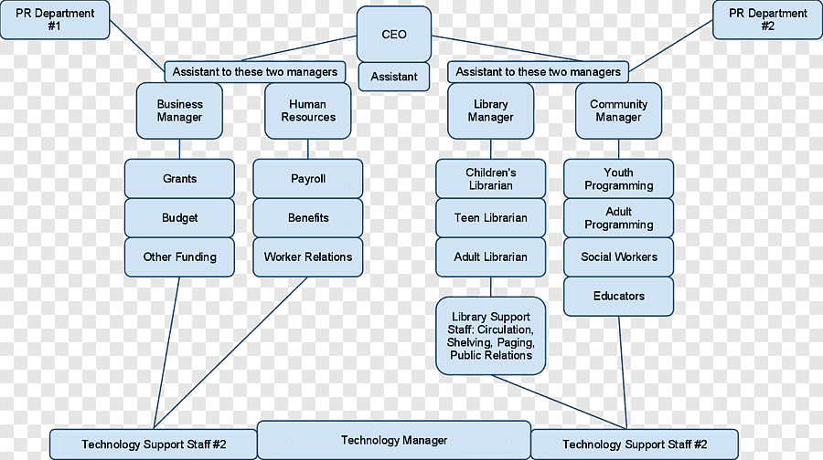

CHAPTER THREE
REPORTING ON WORK CARRIED OUT
3.1 Reporting on Daily Work Carried Out
WEEK 1: I was introduced to all members in the organization and I was given rules and regulation of the organization.
WEEK 2: I worked on the acquisition of books in the library. I also clean material in the library
WEEK 3: I leant on how to compute data in the library and also ensure that all books are neat
WEEK 4: I prepare proper registration for the new library user
WEEK 5: I did a shelving and networking in the library
WEEK 6: I practice on how to display newly acquired book to the library according to the classification
WEEK 7: I ensure that all books are clean and accounted for the proper sense in the library
WEEK 8 : I did reading section in the library to the student from different school
CHAPTER FOUR
CHALLENGES AND GAIN ENCOUNTER IN PLACE OF ATTACHMENT
GAIN
- Practical Experience: Hands-on exposure to library operations, management, and services that enhances theoretical knowledge.
- Skill Development: Opportunities to develop skills in information retrieval, cataloging, and customer service.
- Networking Opportunities: Building professional relationships with librarians, staff, and other professionals in the field.
- Understanding Library Technology: Familiarity with library management systems, digital resources, and emerging technologies.
- Enhanced Research Skills: Improved ability to conduct research and locate information efficiently using library resources.
- Exposure to Library Programs: Participation in community outreach programs, workshops, and events that broaden knowledge of library functions.
- Time Management: Learning to balance responsibilities and deadlines within a professional setting.

CHALLENGES
- Limited Experience: Initial difficulties in navigating library systems or handling equipment may arise due to lack of prior exposure.
- Adapting to Policies: Adjusting to library policies and procedures can be challenging, especially regarding user privacy and resource management.
- Technical Issues: Encountering problems with library software or hardware can be frustrating and may require troubleshooting skills.
- Customer Service Demands: Dealing with diverse patron inquiries and managing difficult interactions may test communication skills.
- Workload Management: Balancing project responsibilities with routine library tasks can be overwhelming at times.
- Changing Technology: Keeping up with rapidly evolving library technologies and digital resources may pose a learning curve.
- Limited Resources: In some cases, lack of access to certain tools or materials can hinder learning opportunities.

CHAPTER FIVE
SUMMARY, CONCLUSION AND RECOMMENDATIONS
5.1 SUMMARY
Libraries engage in numerous activities that support education, promote literacy, and foster community engagement. They provide access to a vast collection of resources, including books, journals, eBooks, and digital media, facilitating research and lifelong learning. In addition to collecting and preserving information, libraries offer programs such as workshops, author talks, and storytimes for children, encouraging participation and enhancing literacy skills. They also provide research assistance, helping patrons navigate information effectively.
Moreover, libraries serve as community spaces, hosting events and meetings that bring people together and promote collaboration. They often embrace technology by offering access to computers, online databases, and digital resources, ensuring users can engage with contemporary tools and information.
5.2 CONCLUSION
libraries are essential institutions that provide invaluable resources, services, and programs to foster learning, literacy, and community engagement. They not only offer access to a wide range of information but also serve as safe spaces for individuals to explore ideas, collaborate, and engage with their communities. Despite facing challenges such as adapting to technological advancements and meeting diverse user needs, libraries continue to evolve and play a crucial role in supporting education and cultural preservation.
5.3 RECOMMENDATIONS
- SIWES supervisors should make sure they visit the students in their place of attachment for proper monitoring, improvement and progress for the benefit of the societies as a whole.
- Employees should seek ongoing training and education to stay updated on industry trends and technological advancements.
- Regularly update your knowledge of industry trends, consumer preferences, and regulatory changes to stay ahead of the competition.
- Libraries should invest in expanding their digital collections and improving access to eBooks, online databases, and multimedia resources to meet the growing demand for digital information.
- Implementing outreach programs and partnerships with local schools, organizations, and businesses can help libraries better serve their communities and attract new users.

