

A TECHNICAL REPORT
ON
STUDENTS’ INDUSTRIAL WORK EXPERIENCE SCHEME (SIWES)

HELD AT:
KWARA STATE MINISTRY OF WORK AND TRANSPORT
AHMADU BELLO WAY, P.M.B 1384, ILORIN, KWARA STATE, NIGERIA

BY
ABDULGANIYU ALIYAH OMOBOLANLE
ND/23/PAD/PT/0389

SUBMITTED TO THE DEPARTMENT OF PUBLIC ADMINISTRATION,
INSTITUTE OF FINANCE AND MANAGEMENT STUDIES,
KWARA STATE POLYTECHNIC, ILORIN

2024/2025 ACADEMIC SESSION
DEDICATION
This seminar work is dedicated to Almighty God for its successful completion

ACKNOWLEDGEMENTS
Foremost, my appreciation goes to Almighty God for the successful completion of this SIWES report.
My sincere appreciation goes to Industrial Training and Management of kwara State polytechnic for the opportunities given in having practical idea of what’s learnt in the four wall of a class room.
Lastly, my appreciation goes to all those who were supportive in one way or the other in the success of this work.
Thanks to you all.

TABLE OF CONTENTS
Title Page i
Dedication ii
Acknowledgements iii
Table of Contents
CHAPTER ONE: INTRODUCTION
1.1 Background to SIWES
1.2 Objectives of SIWES
CHAPTER TWO
2.1 Description of the Organization
2.2 Organogram
CHAPTER THREE
3.1 Activities Carried Out During SIWES
3.2 Lessons Learned
CHAPTER FOUR
4.1 Conclusion
4.2 Recommendations

CHAPTER ONE
INTRODUCTION
1.1 Background to SIWES
The Student Industrial Work Experience Scheme (SIWES) was established to bridge the gap between classroom knowledge and real-world practical experience. Many students graduate with theoretical knowledge but lack the hands-on skills required to thrive in their respective industries. To address this, SIWES was introduced as a means to provide students with firsthand exposure to real working environments, ensuring they develop the necessary skills, confidence, and adaptability needed for their careers.
The scheme was initiated by the Industrial Training Fund (ITF) in 1973 to cater to students in technical, vocational, and administrative disciplines. It was observed that fresh graduates often faced difficulties in securing jobs because they lacked relevant work experience. SIWES, therefore, serves as a preparatory platform where students acquire job-related skills, interact with industry professionals, and gain insights into workplace dynamics before officially joining the labor market.
One of the key objectives of SIWES is to prepare students for the challenges of professional life by exposing them to real-life job responsibilities. Unlike the structured learning environment of a classroom, workplaces present unexpected challenges that require quick thinking, problem-solving, and teamwork. Through this scheme, students learn how to adapt to different work cultures, manage tasks efficiently, and contribute meaningfully to their assigned roles.
For students of Public Administration, SIWES is particularly significant because it provides an opportunity to experience how government institutions operate on a daily basis. Public administration is not just about policies and regulations—it involves real interactions with citizens, managing public resources, and ensuring that government services are effectively delivered. Through SIWES, students get to understand the inner workings of local government, state agencies, and other public service institutions.
At the heart of SIWES is the need to create a competent and work-ready graduate population. Industries and organizations today seek employees who can immediately add value without requiring extensive training. By participating in SIWES, students develop professionalism, discipline, and an understanding of workplace ethics. They also gain exposure to practical tools, processes, and technologies relevant to their field, making them more competitive in the job market.
Beyond technical skills, SIWES also fosters interpersonal and communication skills. Since students work closely with professionals, clients, and colleagues, they learn how to communicate effectively, handle conflicts, and build productive working relationships. These soft skills are essential for career success, as they determine how well an individual can navigate the complexities of a work environment.
The impact of SIWES extends beyond the individual student—it also benefits industries and the economy at large. Organizations hosting SIWES students get additional support for their operations, while students bring in fresh perspectives and enthusiasm. Furthermore, by exposing students to workplace realities early, SIWES helps reduce the burden of unemployment, as many students secure job placements or business opportunities through the networks they build during their training.
By and large, SIWES is not just a requirement for academic fulfillment but a crucial experience that shapes students' professional growth. It serves as a bridge between academic theories and real-world applications, ensuring that students graduate with the knowledge, skills, and experience necessary to excel in their chosen careers. By the end of the program, students are expected to have a clearer career direction, a stronger professional network, and the confidence to tackle future challenges in the workforce.
1.2 Objectives of SIWES
The followings are some of the objectives of SIWES program:
- To provide students with practical experience in their field of study.
- To expose students to real-world work environments and professional ethics.
- To bridge the gap between theoretical knowledge and practical application.
- To develop students’ technical and administrative skills for future careers.
- To familiarize students with modern tools, equipment, and workplace technologies.
- To enhance students’ problem-solving, teamwork, and decision-making abilities.
- To help students understand workplace culture and communication dynamics.
- To prepare students for employment by improving their job readiness.
- To gain practical experience in public administration and management.
- To understand the role and functions of the Ministry of Works and Transport in Kwara State.
- To develop skills in policy implementation, project management, and public service delivery.

CHAPTER TWO
2.1 Description of the Organization
The Kwara State Ministry of Works and Transport has experienced several structural changes over the years to improve governance and service delivery:
December 2019: The state government reduced the number of ministries from 19 to 16. This restructuring led to the merger of certain ministries, including the consolidation of the Ministry of Housing and Urban Development into the Ministry of Works and Transport.
February 2025: To enhance efficiency and address specific developmental priorities, the state government created two new ministries: the Ministry of Transportation and the Ministry of Livestock Development. This decision involved separating the transportation functions from the Ministry of Works and Transport to form the standalone Ministry of Transportation. Consequently, the Kwara State Road Traffic Management Agency (KWARTMA) was reassigned to the new Ministry of Transportation.
Ministry of Works:
The Ministry of Works is responsible for the planning, design, construction, and maintenance of public infrastructure within Kwara State. Its key functions include:
- Roads and Drainage Maintenance: Overseeing the upkeep of municipal roads and sidewalks, managing storm water systems, and maintaining bridges and related structures.
- Water Utility Management: Ensuring the distribution of high-quality drinking water to residents and businesses, maintaining water mains, valves, pump stations, and fire hydrants, and responding to water-related emergencies.
- Sanitary Sewer Services: Managing the construction and maintenance of sanitary sewer infrastructure, including sewer mains and pump stations, to ensure effective wastewater management.
- Solid Waste Collection: Coordinating the collection of garbage, recycling, and organic waste from residential areas, and implementing sustainable waste management practices.
Recent achievements include the completion of 75 road projects in the third quarter of 2024, such as the rehabilitation of critical roads and the expansion of the Kwara State Road Traffic Management Authority (KWARTMA) operations to enhance traffic control.
Ministry of Transportation:
Established to create a more effective transportation management system, the Ministry of Transportation focuses on:
- Transportation Policy Development: Formulating and implementing policies to improve transportation infrastructure and services within the state.
- Traffic Management: Overseeing agencies like KWARTMA to ensure effective traffic control, road safety, and compliance with transportation regulations.
- Urban Mobility Planning: Developing strategies to enhance urban mobility, reduce congestion, and promote sustainable transportation options.
This restructuring aims to enhance efficiency, improve coordination, and align governance with the state's developmental priorities, ensuring seamless mobility for residents and optimizing Kwara State's expanding infrastructure network.

2.2 Organogram of Kwara State Ministry of Works and Transportation
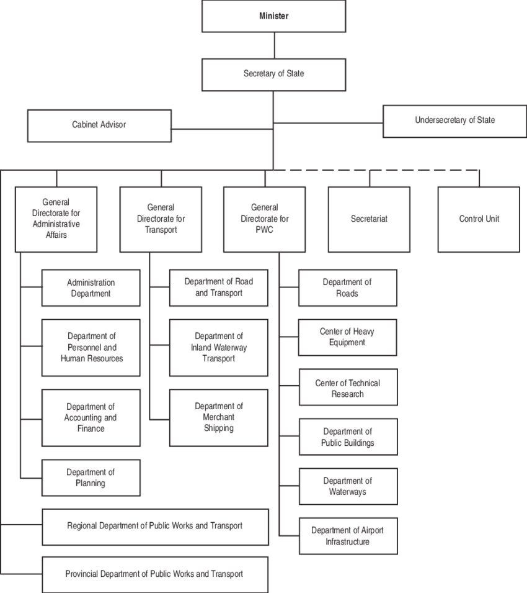

CHAPTER THREE
3.1 Activities Carried Out During SIWES
The Student Industrial Work Experience Scheme (SIWES) provides students with the opportunity to gain practical experience in their field of study. During my SIWES training at Kwara State Ministry of Work and Transport, I was actively engaged in various tasks that exposed me to real-world applications of public administration, governance, and community service. My responsibilities covered a wide range of activities, including administrative duties, public service and community engagement, digital and technical tasks, educational and social programs, supervisory and developmental roles, accounting and reporting, and community celebrations. Each of these categories played a crucial role in my professional development, enhancing my understanding of public sector operations and improving my practical skills. Below is a detailed account of the activities I carried out during the training.
Activities and Experiences:
During my SIWES, I was assigned to various departments within the Ministry, including:
1. Policy and Planning Department: I assisted in the development of policy briefs and strategic plans for the Ministry.
2. Project Management Department: I participated in the monitoring and evaluation of ongoing projects, including road construction and maintenance.
3. Public Service Department: I helped in the provision of services to the public, including responding to inquiries and resolving complaints.
Some of the specific activities I performed include:
-Attending meetings and seminars with Ministry officials and stakeholders.
- Conducting field visits to project sites and inspecting ongoing works.
- Analyzing data and preparing reports on project progress and performance.
- Interacting with members of the public and providing information on Ministry services.
Achievements:
Some of my achievements during the SIWES program include:
- Developing a policy brief on the "Role of the Ministry of Works and Transport in Promoting Economic Development in Kwara State".
- Assisting in the preparation of a project proposal for the construction of a new road in Kwara State.
- Improving my skills in project management, policy analysis, and public service delivery.
Administrative Duties
A significant portion of my SIWES training involved administrative tasks that are essential for the smooth operation of the local government. My duties included the arrangement and sorting of official files, ensuring that documents were properly classified and stored in their respective categories. This process helped streamline workflow and made information retrieval easier for the staff.
I was also responsible for receiving and dispatching official mails. This task required attention to detail, as it involved recording incoming and outgoing correspondence into the appropriate ledger. Ensuring that these documents were accurately logged and sent to the correct departments was crucial for efficient communication within the local government.
Additionally, I assisted in writing records of service for retired staff members, a task that involved documenting the employment history and contributions of these individuals. This experience gave me insights into the importance of record-keeping in public administration. I also numbered personal and policy files for easy tracking, an exercise that reinforced the value of proper documentation in government institutions.
Public Service and Community Engagement
Public administration is not only about paperwork but also about serving the people. During my training, I was actively involved in engaging with local government staff on ways to improve social amenities in the community. These discussions provided valuable insights into the challenges of public service delivery and the efforts required to address them.
One of the key responsibilities I handled was providing essential services to the local population. This included responding to citizen inquiries, assisting with birth, death, and marriage registrations, and ensuring that collected government data was securely stored. These activities highlighted the importance of maintaining accurate public records, which play a crucial role in planning and development.
Digital and Technical Tasks
Technology plays a crucial role in modern governance, and my SIWES training exposed me to various digital and technical tasks. One of the most exciting aspects was learning how to operate a digital printing press for large-format printing. This skill was useful in the production of posters, banners, and other government communication materials.
I was also introduced to basic design principles, including an understanding of color theory, which is essential in producing visually appealing official documents. In addition, I assisted in filing personal information using computer systems, ensuring that data was accurately recorded and stored for future reference.
Accounting and Reporting
Proper financial management is crucial for any government institution, and during my SIWES training, I had the opportunity to observe and participate in some accounting and reporting activities. I assisted in the preparation of administrative and annual year accounting reports, which provided insights into how government budgets are planned, allocated, and monitored.
Recording information related to retired and deceased staff was another key task I handled. This involved updating pension records and ensuring that all necessary documentation was in place for processing benefits.
In addition, I learned how to manage government expenditure records, track financial transactions, and verify invoices. This experience gave me a foundational understanding of public sector accounting and financial management principles.
3.2 Lessons Learned
My SIWES training at Kwara State Ministry of Work and Transport provided me with invaluable lessons that enhanced my understanding of public administration, governance, and community service. The experience exposed me to real-world challenges and practical solutions in a government setting. From administrative tasks to community engagement, I gained firsthand knowledge of how to organize files. Through this training, I developed essential professional skills and a deeper appreciation for the role of government institutions in societal development.
One of the most important lessons I learned was the significance of effective record-keeping and documentation. Handling files, registering births, deaths, and marriages, and recording information for retired staff taught me the importance of maintaining accurate and well-organized records. I realized that proper documentation is crucial for government accountability, decision-making, and efficient service delivery. Without a systematic approach to record-keeping, administrative processes would be disorganized, leading to inefficiencies and delays.
Another valuable lesson was the importance of teamwork and collaboration in the workplace. Working closely with local government staff, I observed how different departments coordinate their activities to achieve common goals. Whether in project supervision, event planning, or public service delivery, teamwork played a key role in ensuring success. I learned that effective communication and cooperation among colleagues are essential for achieving organizational objectives and maintaining a positive work environment.
Furthermore, my training reinforced my understanding of public service ethics and professionalism. Government employees are expected to uphold integrity, transparency, and dedication in their duties. Observing how civil servants handled citizen inquiries, processed official documents, and managed community projects, I realized that professionalism and ethical conduct are crucial in building trust between the government and the people. This lesson has inspired me to always prioritize honesty, diligence, and responsibility in my future career.
Lastly, I gained a deeper appreciation of community engagement and social responsibility. Participating in educational programs, cultural events, and developmental projects showed me the impact of government policies on people's lives. I learned that governance is not just about making policies but also about actively involving the community in decision-making and implementation. This experience has motivated me to be more socially responsible and contribute positively to my community, knowing that even small efforts can lead to meaningful change.
- The importance of effective communication and teamwork in achieving organizational goals.
- The need for proper planning, monitoring, and evaluation in project management.
- The role of public administration in promoting economic development and improving the quality of life for citizens.
Challenges:
Some of the challenges I faced during my SIWES include:
- Limited access to resources and information, particularly in the early stages of the program.
- Difficulty in adapting to the Ministry's bureaucratic structure and procedures.
- Balancing the demands of the SIWES program with other academic responsibilities.
CHAPTER FOUR
CONCLUSION AND RECOMMENDATIONS
4.1 Conclusion
In conclusion, my SIWES experience at the Kwara State Ministry of Works and Transport was valuable and enriching, reinforcing the theoretical knowledge I had acquired in the classroom. I gained practical experience in public administration and management, developed new skills, and learned valuable lessons about the importance of effective communication, teamwork, and planning. I am grateful for the opportunity to have participated in the SIWES program and look forward to applying the knowledge and skills I acquired in my future career. The training also deepened my appreciation for teamwork, professionalism, and the importance of effective governance in improving society. Overall, SIWES has significantly shaped my understanding of the public sector and strengthened my passion for contributing to societal development.
4.6 Recommendations
At the end of the program, the following recommendations are made:
Based on my experiences, I recommend that:
- The Ministry of Works and Transport should provide more resources and support for SIWES students, including access to relevant documents and equipment.
- The Ministry should also provide more opportunities for SIWES students to participate in decision-making and policy implementation.
- Students should be encouraged to take the initiative in seeking out opportunities and experiences during the SIWES program.
- The government should improve record-keeping systems for better efficiency and data management.
- Training programs should be provided to staff to enhance professionalism and service delivery.
- Digitalization of administrative processes should be encouraged to reduce paperwork and delays.
- Regular workshops should be organized to educate staff on ethical public service conduct.

