

TECHNICAL REPORT

ON
STUDENT INDUSTRIAL WORK EXPERIENCE SCHEME (SIWES)

HELD AT
KWARA STATE BROADCASTING CORPORATION
NO 2, BROADCASTING HOUSE, POLICE ROAD, G.R.A, ILORIN

BY

OYEBANJI ELIZABETH ERIOLUWA
ND/23/MAC/PT/1180

KWARA STATE POLYTECHNIC, ILORIN
DEPARTMENT OF MASS COMMUNICATION, KWARA STATE

IN PARTIAL FULFILMENT FOR THE AWARD OF NATIONAL
DIPLOMA (ND) IN MASS COMMUNICATION, KWARA STATE

AUGUST – DECEMBER, 2024
DEDICATION
This report is dedicated to Almighty GOD for seeing me through, and my wonderful parent, Mr. and Mrs. OYEBANJI for their love, guidance and support.

ACKNOWL DGEMENT
My Special appreciation goes to God Almighty the giver of life, my Parents, Mr. & Mrs. OYEBANJI for their love and care. I thank them for their financial, moral and spiritual support and for giving the privilege and right guidance among others.
A big thank you to all my colleagues from different institutions that formed the group members during my training, they made me appreciate and believe in team work.

TABLE OFCONTENTS
Title
Dedication
Acknowledgement
Table of Contents
Chapter One: Introduction
Chapter Two: Description of Place of Attachment
Chapter Three and Four: Two Chapter reporting on work actually carried out with clear Statement on experience gained
Chapter Five: Summary, Conclusions and Recommendation
CHAPT R ONE
INTRODUCTION
1.1 BACKGROUND
The Student Industrial Work-Experience Scheme (SIWES) is a government planned and supervised training intervention for specific learning and career objectives, aimed at developing the occupational competencies of the participants and exposing them to practical training as well as on the job tutelage.
SIWES is expected to be undertaken by all students of tertiary institutions undergoing courses in specialized fields such as engineering, technical, business, applied sciences and applied arts and Mass Communication.
It is worthy of note that the Federal Government on the 8th of October 1971 established the Industrial Training Fund (ITF) with offices in each State of the Federation to acquaint the students on the industrial work method.
The Students during this period are exposed to practical training in areas of their disciplines to enhance their mental and creative minds.
1.2 IMPORTANCE AND OBJECTIVES OF SIWES
The Students Industrial Work Experience Scheme (SIWES) is the accepted skills training programme, which forms part of the approved Minimum Academic Standards in the various degree programmes for all the Nigerian universities and Polytechnics.
It is an effort to bridge the existing gap between theory and practical of engineering and technology, science, agriculture, medial, management and other professional educational and Mass Communications programmes in the Nigerian tertiary institutions.
It is aimed at exposing students to machines and equipment, professional work methods and ways of safe-guarding the work areas and workers in industries and other organization.
1.3 OBJECTIVES OF SIWES
Specifically, the objectives of the Students Industrial Work Experience Scheme are to
- Prepare students for the work situation they are likely to meet after graduation.
- Provide an avenue for Students in the Nigerian Universities to acquire industrial skills and experience in their course of study.
- Make the transition from the university to the World of work easier, and thus enhance students contacts for later job placements.
- Enlist and strengthen employers involvement in the entire educational process of preparing university graduates for employment in industry.
- Provide students with an opportunity to apply their theoretical knowledge in real work situation, thereby bridging the gap between university work and actual practices; and Expose students to work methods and techniques in handling equipment and machinery that may not be available in the universities.
1.4 IMPORTANCE OF SIWES
i.) It provides students with an opportunity to apply their theoretical knowledge in real life situations.
ii.) It exposes students to more practical work methods and techniques.
iii.) It strengthens links between the employers, universities and Industrial Training Fund (ITF).

CHAPTER TWO
DESCRIPTION RADIO KWARA
2.1 LOCATION AND BRIEF HISTORY
Kwara State Broadcasting Corporation is the corporate name of Radio Kwara, Ilorin, it's remains the Station's Identity. Radio Kwara, Ilorin, is one of the public owned broadcast media in the Country which started as a rally Station of the then Radio Nigeria.
The Station Broadcasts on Medium Wave Meter Band, popularly known Frequency Modulation, (FM) Meter Band on Ninety-nine- Dot-One Midland FM. The Broadcasting House and Corporate Headquarters of the Corporation is located at Number Two, Police Road, GRA, Ilorin.
COVERAGE CAPACITY
Radio Kwara, Midland FM station covers more than twenty-three states and remains the most heard broadcast station in the entire North-Central region of the Country.
INDEPTH
Radio Kwara, Ilorin operates within the confines of the operational guidelines and ethical regulations as entrenched by relevant monitoring and supervising agencies. The station hinges its services on protecting and projecting indigenous values. It serves as a link between the government and the governed through effective tracking of the performances of government towards addressing the aspirations of the masses. Similarly, the station performs other relevant social responsibility services, like promoting good governance and equitable distribution of dividends of democracy. Above all, Radio Kwara encourages inter-cultural, inter-religious and exchange of useful ideas to accelerate socio economic lives of the people.
However, the station is always mindful of ownership and control, without compromising its social responsibility to its numerous audience.
CORE VALUES OF THE STATION
RADIO ACRONYM CONNOTES THE FOLLOWING AS CORE VALUES
- Responsive to Dynamic Environment
- Adaptive to New Environment
- Diligence to Work
- Integrity and Innovation
- Outstanding Performance
- Knowledge of the Job
- Wealth of Experience
- Awareness
- Respect for Individuals
- Ability
VISION STATEMENT
To be the preferred medium operating in a uniquely professional environment for world class broadcast.
MISSION STATEMENT
To build a broadcast giant promoting societal values and human development through performance driven innovative and quality services
Radio Kwara is managed by a team of competent Management team under the General Manager as the head of the Corporation.
There are (5) Directorates in Radio Kwara with all the Directors responsible to the General Manager.
These Directorates include Director General Administration, Director Programmes, Director News and Current Affairs Department, Director Marketing and Director Engineering Services.
Other departments are the Accounting department and Audit department.
2.2 OBJECTIVE OF RADIO KWARA
The main objectives of Broadcasting are to inform, educate and entertain. In carrying out these functions, Broadcasting organizations are guided by certain codes, ethics and practice.
These are the dos and donts of broadcasting which cover and protect the rights of the audiences. They also take account and cater to the nature, interest and sensibilities of groups, like the women and children.
- Respect the culture, norms, traditions and religions of societies and environments.
- Ensure peaceful co-existence
3 Information Dissemination to the entire State.
Here in Nigeria Broadcasting is regulated by the National Broadcasting Commission (NBC) which grants licenses to the operators and monitors their output to ensure adherence to professionalism.
There is Broadcasting Organizations of Nigeria (BON), a voluntary association of radio and television stations which came into existence in 1973. The Society of Nigeria Broadcasters (SNB) formed in 1979 caters to the welfare of practitioners, while BON is involved in training and exchange of ideas and programmes and Nigeria Union of Journalists for Journalists and Media Practitioners.
BON, in addition, engages in joint coverage of important events like the National Sports Festivals, the 2nd All Africa Games of 1973, first West African Games of 1977 and the 2nd World Black Festival of Arts and Culture, (Festac 77). There is also FIBAN (the Freelance and Independent Broadcasters Association of Nigeria) formed in 2002 to cater for the welfare of its members.
2.3 ORGANIZATIONAL STRUCTURE OF KWARA STATE
BROADCASTING CORPORATION, RADIO KWARA
DEPARTMENTS AND FUNCTIONS
General Organization of Radio Kwara
General Administration
General Administration division is headed by the General Manager or Station Manager, assisted by other Staff including the Business Manager, the Accountants, the Secretaries, and other administrative and office staff.
These employees serve various duties such as the payment of wages and salaries, membership fees and subscriptions for industry information, license and other government-imposed fees, taxes, insurance, legal and auditing fees, and contributions to charitable organizations.
In addition, maintenance of the building and of equipment, utilities, office supplies, computers, station automobiles, and other administrative services and supplies are also provided by the general administrative department.
It is not surprising, then, that this department consumes one-third of the total operating expenses of a station, although only about 13 percent of the total staff may be in administration.
Marketing/Commercial
The Sales Department at Radio Kwara is responsible for generating the revenue for the Station to survive. This Department is headed by a Director while on the other hands has general sales managers that lead a team that is comprised of a national/regional sales manager, a local sales manager, account executives, and at times, a traffic manager.
In most cases, the national/regional sales manager will be a liaison from an outside organization that wins advertising contracts from regional and national advertisers. The local sales manager, then, is charged with securing advertising accounts with local businesses and organizations.
A staff of Account Executives helps the local sales manager sell advertising time to local businesses employing solicitation tactics similar to other sales businesses. However, the sales people of television must negotiate advertising sales using a rate card, a definitive list of airtime costs during the various time periods and television programs.
Furthermore, the television account executive can also offer to create the advertisement for a client if the client so chooses, in which case the sales department cooperates with the production and programming departments for this venture.
Programmes
The Programmes department, in conjunction with the production and News Departments, acquires and schedules the product that the audience consumes, which in turn allows the sales department to create revenue, which allows the General Administration Department to facilitate station operations.
The Programmes department is responsible for filling the entire broadcast day with programmes and is therefore saddled with the most challenging job. Consequently, this department also works closely with the traffic department in structuring the daily programmes schedule.
Programmes is second only to general administration in terms of operating expenses. Programmes Department may consist of a Director, a videotape librarian, a ratings researcher, an acquisitions staff, a continuity standards staff, and on-camera personalities for use in locally originated programs.
The Programmes Director, helped by the acquisitions personnel, may obtain the majority of the programming of a station from syndicators and other program suppliers.
It also generate programmes through Conference conducted quarterly with Community feedback aids in planning decisions. However, all decisions concerning programme acquisition are ultimately controlled by the amount of revenue gained from sales and the resulting budget allotted the programmes division.

CHAPTER THREE
3.0 ACTUAL WORK DONE
3.1 Introduction to News
Introduction to news refers to the initial segment or presentation of news content within a media outlet, whether it's a newspaper, radio broadcast, or online news platform. It serves as the gateway to informing audiences about current events, developments, and issues of relevance. The introduction typically outlines the major headlines and stories that will be covered, providing a brief overview to grab the audience's attention and set the tone for the news program. It may include key highlights, breaking news updates, and teasers to encourage viewers or listeners to engage further with the news content. The effectiveness of the introduction is crucial in capturing the audience's interest and establishing the credibility of the news source.
Various sources of News
Newspapers: Traditional print publications offering in-depth reporting on local, national, and international news.
Radio: News radio stations deliver updates and reports throughout the day, covering a wide range of topics.
Online News Websites: Digital platforms operated by news organizations provide articles, videos, and multimedia content on breaking news and in-depth reporting.
Social Media: Platforms like Twitter, Facebook, and Instagram serve as sources of news through posts, tweets, and live streams shared by individuals, news outlets, and organizations.
Press Releases: Organizations issue press releases to share announcements, updates, and information with the media and the public.
Academic Research: Studies and reports from universities and research institutions provide data and analysis on various topics covered in the news.
Interviews and Expert Commentary: News outlets interview experts, analysts, and stakeholders to provide context and insight into news stories.
Citizen Journalism: Individuals use digital tools and platforms to report on events and share firsthand accounts, photos, and videos, contributing to news coverage from diverse perspectives.
3.2 News Writing and News reporting
News writing and news reporting are integral components of journalism, each playing a distinct role in the dissemination of information to the public.
News writing involves crafting articles, reports, or stories that convey factual information in a clear, concise, and engaging manner. Journalists who specialize in news writing strive to present the facts objectively, without bias or personal opinion, adhering to the principles of accuracy, fairness, and balance. They carefully research their topics, gather relevant data and quotes from credible sources, and organize their content in a way that is easy for readers to understand and follow. Whether it's breaking news, investigative pieces, or feature stories, news writing serves as the foundation for informing and educating the public about current events, issues, and developments in society.
3.3. Some equipment available at the place of attachment.
Equipment include:
- Reel to reel audio tape recording:
is a form of magnetic tape audio recording in which the recording medium is held on a reel, rather than being securely contained within a cassette. In use, the supply reel or feed reel containing the tape is mounted on a spindle; the end of the tape is manually pulled out of the reel, threaded through mechanical guides and a tape head assembly, and attached by friction to the hub of a second, initially empty take-up reel.
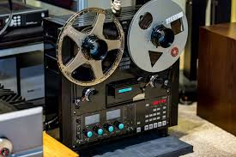

- Long grammar phone (Micro-Phone)
A microphone is a device that translates sound vibrations in the air into electronic signals or scribes them to a recording medium. Microphones enable many types of audio recording devices for purposes including communications of many kinds, as well as music and speech recording.


- Sound mixing board
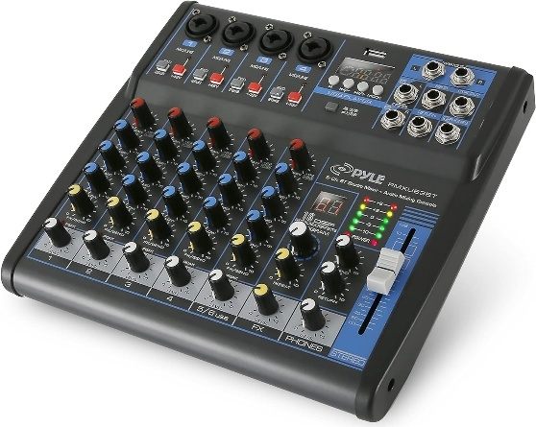
The sound mixing board, also known as an audio mixer, plays a crucial role in a radio station by allowing operators to control and balance various audio inputs. It enables the blending of different sound sources such as microphones, music players, and pre-recorded segments, ensuring smooth transitions between them. Operators can adjust volume levels, apply equalization for clarity, add effects if needed, and monitor audio quality in real-time. Additionally, the mixer facilitates communication between hosts, guests, and technical staff by providing features like talkback systems and headphone monitoring. Overall, the sound mixing board is the central hub for managing audio content and ensuring broadcast quality in a radio station.
- Headphone
In the radio station, headphones are essential tools for various tasks such as monitoring audio quality during live broadcasts, editing recorded segments, conducting interviews, and communicating with other staff members. They enable DJs and producers to cue up music, listen to caller feedback, and ensure smooth transitions between songs. Additionally, headphones facilitate communication between hosts, producers, and technical staff, allowing for seamless coordination during broadcasts. Overall, headphones play a crucial role in maintaining the professionalism and quality of the station's programming.


- Deck to the Cassette
A cassette deck is a type of tape machine for playing and recording audio compact cassettes. Consumer electronics formerly used the term deck to distinguish them from a tape recorder, the "deck" being part of a stereo component system, while a "tape recorder" was more portable and usually had a self-contained power amplifier (and often speakers). Other software’s include the audibling and Nero software

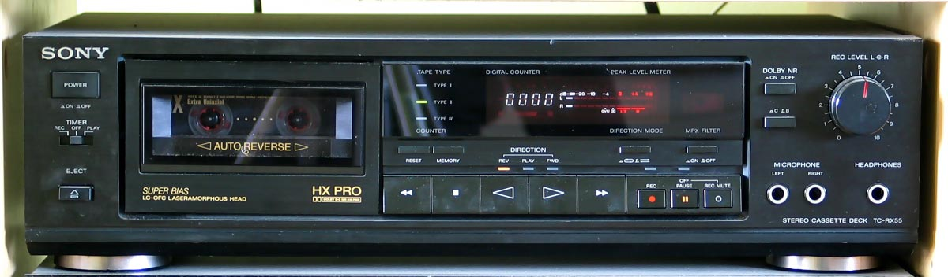

- Studio monitor

Studio monitors are precision speakers used in recording studios for accurate audio reproduction. They provide a flat frequency response, avoiding any bias towards specific frequencies. This neutrality allows engineers to make precise adjustments to recordings and mixes. Studio monitors ensure consistency and quality across different playback systems.

CHAPTER FOUR
4.0 RELEVANCE OF THE EXPERIENCE GAINED
In summary, this program has exposed me to some practical aspect in relation to my course of study (Mass Communication) and I benefitted greatly from the program, involves the following:
- I leant about the two studio every radio station has which is Live studio and recording studio.
- Theoretical aspect about the radio station equipment’s and machineries i.e microphone, audio console, computer system, headphone etc.
- Also leant on how to source for local news and foreign news by using platform such as BBC, Aljazeera and CNN.
- On how to use jingle to promote the radio and the basic radio styles.

CHAPTER FIVE
CONCLUSION
Coordinators and Organizers of the SIWES programme must in earnest compel tertiary institutions to adhere strictly to the duration for SIWES attachment in any industry if they really want to bridge the gap between the theoretical knowledge acquired in tertiary institutions and the practical skills required in todays workplace. SIWES coordinators should take note that there are some companies or industries in the country who don't allow industrial attachments, such companies should be penalized under section 8A (2) of Decree No. 47 of 1971 as amended in 2011. By doing this more credence would be given to the Programme.
I urge undergraduates to seize the opportunity given by the SIWES programme to develop their skills and prioritize practical development over theories in their academic pursuit in various field of study.
SIWES has made me to see the other side of my course of study and also afforded me the opportunity to make use and link what I have learnt in the lecture room in the practical field.
PROBLEMS ENCOUNTERED
Getting used to the working environment at first was challenging, meeting professionals at different levels who are at different locations within the city, imbibing good working ethics needed as a journalist, exhibiting the core values of the station at all times during my training period.
My reading ability was put to test to determine my fluency in English language, to ascertain if I have a broadcast voice and also to know if I can read within a given time.
In the news room, I faced another challenge of contributing on general issues or topics being discussed where I have to debate either for or against with proven fact. I am not allowed to keep mute in the news room when issues are been discussed I have to contribute, reason being that as a Mass Communication students; one must know something about everything.
My in-house supervisor prioritized individual and intellectual development over going to the Broadcast Studio just to look and keep mute while programmes are been aired.
RECOMMENDATIONS/SUGGESTIONS
Although SIWES undergone did achieve quite a lot of its stated objectives, nevertheless, the following recommendations are suggested to improve the qualitative context of the programme:
- Participation of private corporate organization to minimize the problem of low funding as recently complained by the director of ITF.
- Sending students specifically to establishment where the stipulated aims and objectives of SIWES would be achieved.
iii Payment of befitting student allowance to assist in students finances during the period of training.
iv. The station should have a method of recognizing its SIWES students through issuance of recommendation letter in addition to letter of completion to enable the students secure job placement in both public and private sectors.

