

A TECHNICAL REPORT ON
STUDENT INDUSTRIAL WORK EXPERIENCE SCHEME
(SIWES)

HELD AT
KULTURE MULTIVENTURE
NO. 1, Kulture plaza, Itapopo junction Off Idi-Araba road, Ogbomoso, Oyo State

WRITTEN BY

IKUDIASI YUSUF OLAMIPOSI
ND/23/ACC/PT/0252

SUBMITTED TO
DEPARTMENT OF ACCOUNTANCY, INSTITUTE OF I.F.M.S,
ILORIN

IN PARTIAL FULFILLMENT OF THE REQUIREMENTS FOR THE
AWARD OF NATIONAL DIPLOMA (ND) IN BUILDING TECHNOLOGY

AUGUST - NOVEMBER, 2024

PREFACE
This report contains all experience gained during the time of my student industrial work experience scheme (SIWES).Thus, it vividly gives a comprehensive summary report of the engaged and experience gained at KULTURE MULTIVENTURE

DEDICATION
I dedicate this report to Almighty Allah, the source of my strength and ability. Also to my dearest parents Mr and Mrs Ikudiasi whom through their advices, love, care and financial assistance has made me to be where I am today. I pray the good God will continue to keep and guide them for me. Amen.

ACKNOWLEDGEMENT
My sincere thanks and praises are to Almighty Allah; the uncreated creator who within His mercy I’m able to begin and end this programme successfully. He is forever worthy of my appreciation “ALHAMDULILLAH ROBILL ALAMEEN”. My gratitude also goes to my parents Mr and Mrs Ikudiasi for their care and passion into my future. May Allah keep you both to reap the good fruit of your labour, Amen
I have learnt a lot both in academic and life as a whole. May Allah keep protecting you and your families with lot of goodness and also to my supervisor thank you so much
To everyone who has in one way contributed to the success of this programme, you are all acknowledged. “JAZAKUMULLAHU KAIRAN JAZZA”ii

ABSTRACT
This technical report is based on four months compressive industrial training exercise.
The report comprises of five chapters, chapter one: focuses on general introduction to work, chapter two; gives the description of establishment, chapter three and four explain the experience gain and gathered during the programme, chapter five gives the summary conclusion of the report and recommendation needed to the organization and to the polytechnic and development of students industrial work experience scheme (SIWES).
TABLE OF CONTENT
Title page i
Certification ii
Dedication iii
Acknowledgement iv
Abstract v
Table of content vi
CHAPTER ONE
1.0 INTRODUCTION 8
1.1 Background of SIWES 8
1.2 Aim and objective of SIWES 8
1.3 Benefit of SIWES 9
1.4 The Bodies involved in the management of SIWES 9
2.0 CHAPTER TWO
2.1Introduction to all Workers 10
2.2 Team Work Collaboration 11
2.3 Diagram of the tools 12
3.0 CHAPTER THREE
3.0 Developed and Implemented Process Improvement 14
3.1 Importance of Control Quality 14
4.0 CHAPTER FOUR
4.1 Experience gained during the SIWES training and their relevance to my course of study 15
4.2 Problems Encounter during the Programme 15
5.0 CHAPTER FIVE
5.1 Conclusion 16
5.2 Recommendations 17
CHAPTER ONE
1.0 INTRODUCTION
I had my four (4) months Student Industrial Work Experience Scheme at Reynolds Construction Company Limited, a Road construction company and I partake on; the company is located at KULTURE MULTIVENTURE

The period of my attachment was from October to November, 2024.
This report is a comprehensive summary of my Two months training which was completed at the above mentioned organization and also contains information about the organization.
I officially started my SIWES training on 26th of October, 2024, and worked on both construction sites and in the office. The task carried out present in the company include, equipment or machine used in the company, taking measurement of work done to know the quantity of material used, checking the component made off site.
The office task and responsibilities include taking off, preparation of bill of quantities, estimation for the material used on site/Road, preparation of daily production report e.t.c. The task carried out, works observed and experiences gained are fully explained in the later chapters of this report.
I also took part in some Laboratory work which include Slump test, Aterberg limit test, and Concrete cube test.
1.1 Background of Students’ Industrial Work Experience Scheme (Siwes)
The Students Industrial Work Experience Scheme (SIEWS) is a Skills Training Programme designed to expose and prepare Students of Universities, Polytechnics, and Colleges of Education for the Industrial Work situation they are likely to meet after graduation.
The Industrial Training Fund (ITF) solely funded the scheme during its formative years. However, due to financial constraints, the Fund withdrew from the scheme in 1978. The Federal Government, noting the significance of the skills training, handed the management of the Scheme to both National Board for Technical Education (NBTE) and National Universities Commission (NUC) in 1979.
1.2 Aim and Objectives of SIWES Programme
The aim is to provide an enabling environment for the practical application of theoretical knowledge in actual real work situation and also to enable practical establishment of theoretical facts that had been learnt is school.
Specifically, the objectives of the Students of the Industrial Work Experience Scheme (SIWES) are to:
a) Provide an avenue for Students in Institutions of higher learning to acquire industrial skills and experience in their course of study.
b) Prepare students for the industrial work situation they are to meet after graduation.
c) Expose students to work methods and techniques in handling equipment and machinery that may not be available in their institutions.
d) Make the transition from school to the world of work easier, and enhance students contact for later job placement.
1.3 Benefits of SIWES Programme
There are many benefits derived from SIWES, some of which are:
a) The opportunity for the students to boost the theoretical knowledge gained in the classroom with practical knowledge in the Industry.
b) The opportunity for the students to be in direct contact with Junior, intermediate and senior professional staff in the industry.
c) It provides opportunities for students to handle equipment and machine that they may not have access to in their academic institutes.
d) It serves as an avenue for students to understand the technicalities and realities used in the business world that relate to their various field of study thus exposing them to practical levels and advanced level of learning.
1.4 The Bodies involved in the Management of Siwes
In Nigeria, there are five bodies that are involved in the smooth operation of SIWES. They are:
i. Educational Institutions
ii. Employers
iii. Students
iv. National University Commissions (NUC)
v. Industrial Training Fund (ITF)
Employers
The employers are to work out relevant industrial attachment programmes with institutions; ensuring that attachment programme exposes students to real life working situations; and inspect and countersign students logbooks on weekly basis and make comments where necessary. They are to pay students allowances and when due for every month completed and submit to the ITF monthly returns of actual amounts disbursed, and complete the end of the programme evaluation form (ITF FORM 8) in respect of all students who served in the organization.
Students
Students on Industrial training are expected to keep logbooks (obtained from their respective schools) in which daily activities and other assignments are recorded. They must equally be present regularly at the respective organizations to which they have been attached.

Industrial Training Fund
The ITF was established upon promulgation of the ITF decree of 1971. It publishes the rules and guidelines for the Student Industrial Work Experience Scheme (SIWES), identifies and prepares list of suitable industries for placement and assist institutions of learning in facilitating placements for their students.
CHAPTER TWO
2.0 INTRODUCTION TO ALL WORKERS
We discuss about present in the company about the equipment or machine used in the company some of the machinery are;
i. Scale
ii. Punch card machine
iii. Calculator machine
iv. Sack machine
They teach us how to used some of them and their usefulness continuation on how to use the tools.
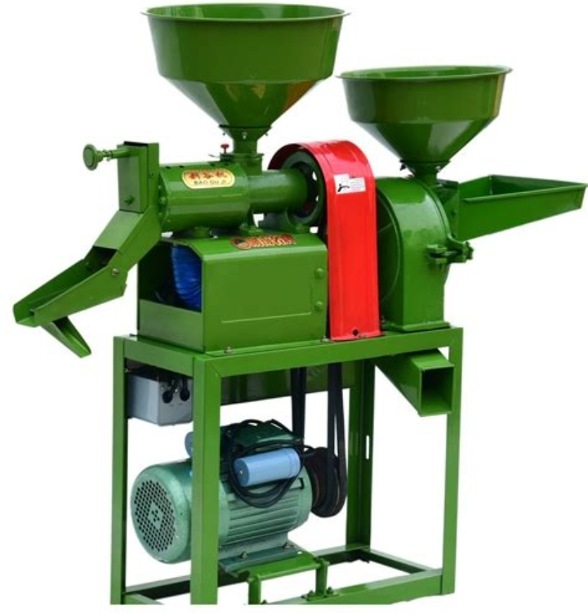
RICE POLISHER MACHINE WITH ELECTRIC MOTOR
They teach us how to distribute goods to the customer and they make us understand the rate on each produces and the gain we talked about the lust of goods name and the person that bought the goods we discussed about the process and how to do the estimate of the product we talked about the record of goods we sell in a day to the book for future purpose.
S/N | NAME OF THE PERSON | NAME OF THE GOODS | DATE | TOTAL NUMBER OF THE GOODS
1. | Alhaji Baba | Rice | 05/09/2024 | 20 Bags
2. | Alhaji Toyin | Semovita | 06/09/2024 | 15 Bags
3. | Mummy | Garri | 06/09/2024 | 3 Bags
4. | Oga Soja | Rice | 07/09/2024 | 10 Bags
5. | Oga Layi | Beans | 08/09/2024 | 2 Bags
6. | Abdullahi | Wheat | 08/09/2024 | 11 Bags
7. | Alfa | Beans | 08/09/2024 | 12 Bags
8. | Iya Hikmat | Semovita | 09/09/2024 | 30 Bags
9. | Abiodun | Semovita | 10/09/2024 | 8 Bags

We all take to store to know how the store suppose to look like and how to arrange the goods in the store and they taught us how to arrange the each product in the store we were show how to sticks I introduce to operated rice polishing machines I introduce to monitoring production process I conducted quality control check we all maintained equipment cleanliness I assisted in production planning.

A CALCULATOR
I learned about rice processing stages learned and understood rice polishing techniques familiarized with quality standards gained knowledge of food safety protocols discuss industry challenge.

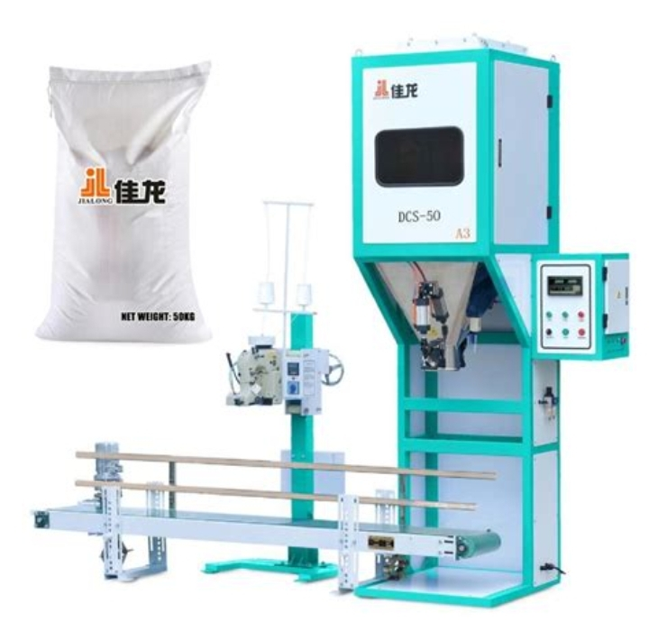
RICE BAG WEIGHING SCALE
2.1 Team work and Collaboration
I communicate with colleagues and supervisor time management and punctuality problem solving and adaptability attention to detail.
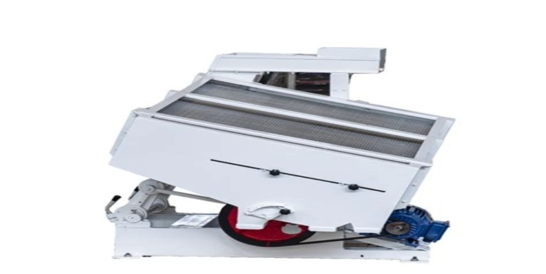
SEPARATOR MACHINE FOR RICE
I assisted in bagging and packaging conducted inventory management I participated in maintenance activities observed supply chain operation I contributed to production optimization.
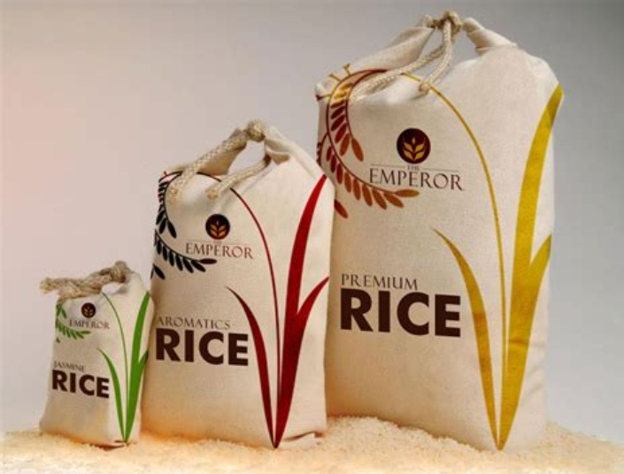
A BAG OF SEMOVITA
Solved mechanical issue improved efficiency and productivity adjusted to industrial environment I manage work hood and pressure enhanced problem solving skills.
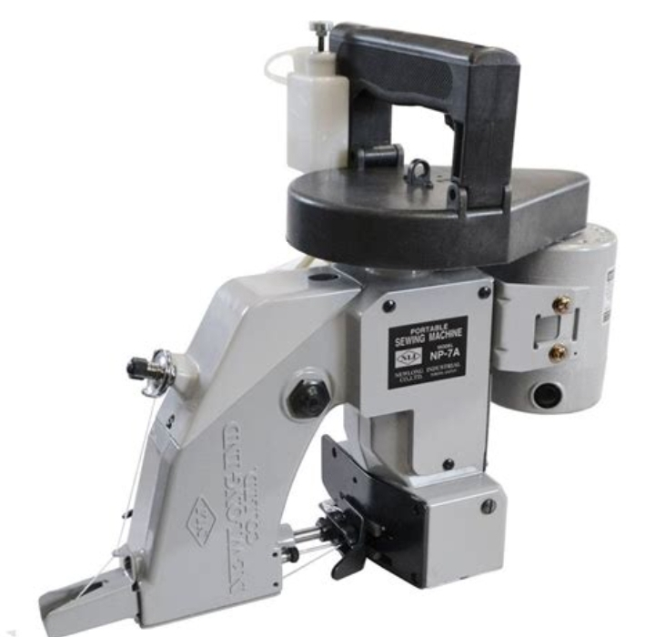
RICE SEWING MACHINE

I was introduced to show analytical skills it was introduced to show analytical skills it was introduced to show problem solving skill team work skills communication skills time management skills

CHAPTER THREE
3.0 Developed and Implemented Process Improvement
Optimized production work flows assist in training new staff members I conducted regular equipment inspections collaboration with production team to meet daily targets. Documented production record and reports participate in quality improvement initiatives conducted sensory evaluation of plastic rice mentioned production process for efficiency assisted in production planning and scheduling assisted in maintenance activities (e.g) equipment (A Libration). I monitored diction process for efficiency operated rice postings to active desired quality standard manage raw materials and inputs
3.1 Importance of Control Quality
i. I learned role of technology in production
ii. I learned how to value of team work
iii. I learned about industrial best practices
iv. Adapt ability dynamic environment
v. I implemented cost-saving measure

CHAPTER FOUR
4.1 Experience gained during the SIWES training and their relevance to my course of study
Student Industrial Working Scheme (SIWES) is a programme that exposes students to practical aspect of their discipline or their different courses of studies.
During my SIWES program at the Global Fleet Group, Elemere Town Idofian, Kwara State, I was able to identify different tools that are used to carry out simple maintenance tasks on Equipment or machine used in the company. I also learnt periodic maintenance of a tractor and implement for tillage operation.
I learnt propagation methods of different crops (both food and cash crop), their nursing requirements, harvesting, processing, packing and marketing.
4.2 Problems Encounter during the Programme.
Transportation problem
Far distance of farm locations.
Suggestion
All institutes should make proper arrangement with the ITF in sending students to certain Company/Industry which is allied with his/her course of study. ITF should try to pay the students at the appropriate time since the school and company are not paying with the belief that so far that ITF is paying them.

CHAPTER FIVE

5.0 Summary, Conclusions and Recommendation
The whole experience gained during the attachment at The Global Fleet Group was very enlightening. The practical skills we were exposed to and the opportunity to relate with typical situations relating to computer engineering industry.
The program gave me the privilege to relate with senior professionals and other students from different institutions and this experience made me appreciate the nature, benefits, and intricacies of my chosen field of study both in the classroom and in the society at large while also gives me the opportunity to put into practice the theoretical knowledge acquired throughout my stay in school.

5.1 Recommendations
Based on the experience and knowledge acquired at the course of the SIWES training, I hereby give the following recommendation based on my observations.
1. Proper orientation should be given to the students by the university before they go on SIWES at least before mid-semester break of first semester.
2. The placement letter should be given to students early enough so as to avoid attachment in irrelevant organization.
3. I recommend that substantial percent of the National budget should go into the development, improvement and sustenance of the power sector. Doing this would help improve Electricity production and in turn improve development and industrialization and subsequently, the income the country generates.
4. Student should avoid prioritizing money over work and experience and should develop a good attitude, good work ethics and be a good ambassador of the university they are representing.
5. Institution and ITF should ensure that students are attached at relevant establishment for effective training, experience and exposure related to their course of study in the university.

