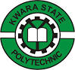
TECHNICAL REPORT
ON
STUDENT INDUSTRIAL WORK EXPERIENCE SCHEME (SIWES)
UNDERTAKEN AT

GREEN AND WHITE OPTIMUM HOTEL
NO 4 TEMIDIRE STREET OFF JEBBA ROAD, BEHIND SCHOOL OF SPECIALIST,OYUN.ILORIN KWARA STATE

FROM SEPT, 2024 TO NOVEMBER, 2024
BY
OSUNJIDE MODINAT TOYIN
ND/23/HMT/FT/0036

IN PARTIAL FULFILLMENT OF NATIONAL DIPLOMA IN HOSPITALITY MANAGEMENT FOR THE AWARD OF NATIONAL DIPLOMA, IN HOSPITALITY MANAGEMENT
SUBMITTED TO

THE SIWES COORDINATOR,
DEPARTMENT OF HOSPITALITY MANAGEMENT,
INSTITUTE OF APPLIED SCIENCE, KWARA STATE POLYTECHNIC

APRIL 2025
DEDICATION
This report is dedicated to Almighty God for His divine mercy on me and my family who has given me the strength, wisdom, knowledge and understanding in working toward my success.

ACKNOWLEDGEMENT
To God who owns life, I wish to express my sincere appreciation and gratitude for seeing me throughout my duration in Kwara State Polytechnic and for making my vision come to reality, also for His Goodness, Mercy, Provision and Grace upon my life.
My profound gratitude goes to my sincere appreciation goes to My family may God be with you.
Finally, my sincere gratitude also goes to my lovely friend both within and outside the institution,

ABSTRACT
This report gives a good account of the training and experience which exposed student during the student industrial work experience (SIWES) at GREEN AND WHITE OPTIMUM HOTEL.

TABLE OF CONTENT
Title page
Dedication
Acknowledgement
Abstract
CHAPTRE ONE
  - Introduction
  - Aims and objectives of SIWES (Definition of SIWES)
  - Historical background of the organization
  - Organization chart
  - Major activities of the organization
CHAPTRE TWO
2.1 Specific function of various section/units of the organization
2.2 Student involvement at various section/ unit
2.3 Interpersonal relationship with the organization
CHAPTER THREE
3.1 Discussion
3.2 Relevance experience gained to the student field study
CHAPTER FOUR
4.2 Personal Impression about the organization
CHAPTER FIVE
5.1 Conclusion
5.2 Recommendation

CHAPTER ONE
INTRODUCTION
Siwes is acronyms for student industrial wore experience such. Siwes is an infusive instrument used for exposing student to the realities of the work environment in Nigeria especially, and the world in general, in their various professions so as to achieve the needed technological advancement for the nation, some of the aims of Siwes are:
- To provide for the students opportunities to be involved in the practical aspects of their respective discipline, this bridging the gap between the theatrical aspects thought in the class and the real world sudations
- To expose students to latest development and technological innovation in their chosen professions.
- To prepare students for industrial working environment, they are likely to meet often graduation.
BRIEF HISTORY OF SIWES
The students industrial work experience (Siwes) is a skill training designed to expose and prepare students of universities polytechnics, colleges of technology and others for the industrial work experience, they are likely to meet after graduation.
The scheme also offered students the opportunities of familiarizing and exposing themselves to the needed experiences in handing equipment and machines that are usually not available in their institutions. The industrial training and (ITF) funded the schemes during its formative year in 1973/74. But, as the financial involvement became unbearable to the fund, it withdrawn from the scheme in 1978.
The federal government handed over the scheme in 1979 to both the national universities commission (NVC) and the national board for technical education (NBTE). Later, the federal government in November 1984 revert the management and implementation of the Siwes program to (ITF) and it was effectively taken over by the industrial training fund in July 1985 with the funding being solely borne by the federal government.
IMPORTANCE AND OBJECTIVE OF SIWES
In regards to the Siwes handwork the specific objectives and importance of the Views are to:
- Provide an avenue for students in institutions of higher learning to acquire industrial skills and experience in their course of study.
- Prepare students for the industrial work experience they are to undergo after graduation.
- To provide students with an opportunity to apply their knowledge in real work solution thereby bridging the gap between they and practice.
- To satisfy accreditation requirements set by NBTE
- To provide students and opportunity to see the real world of their discipline and consequently bridge gap between the classroom and real work situation.
- To enable students assess interest suitable for their chosen profession.

CHAPTER TWO
OBJECTIVE AND VALUES OF THE ESTABLISHMENT
The core of the organization is to give sell perishable comfort food -- sweet and tempting offerings that appeal to a broad target market. Daily Goals products are also extremely perishable; many customers have grown to expect management businesses to offer product that is undiluted to the hotel customer, making it challenging to meet demand without wasting inventory. Business objectives for a Hotel should include building a broad and committed customer base and developing a business model that brings in enough income to cover your expenses despite a potentially high level of waste
The objectives and core values of GREEN AND WHITE OPTIMUM HOTEL is as follows:
- REVENUE GOALS AND REPEAT BUSINESS
A bakery can increase its revenue through advertising and promotions such as offering deals on specific items on different days of the week. You can add to sales totals by carefully monitoring and adapting to demand, paying attention customer flow as well as sales patterns.
- Margin Goals
Because the bakery business model of selling optimally fresh offerings creates so much potential for waste, bakeries should closely monitor profit margins, or the percentage of sales that exceeds operating expenses
ORGANIZATIONAL STRUCTURE OF ESTABLISHMENT
THE VARIOUS DEPARTMENTS
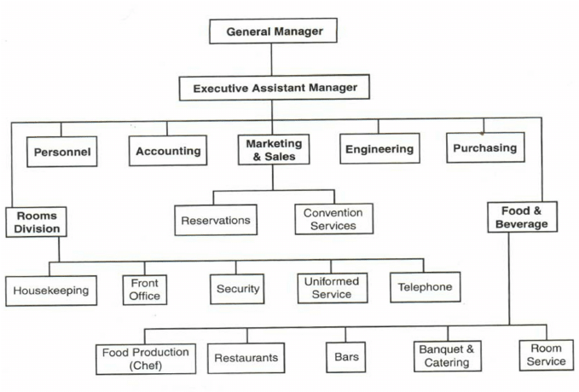

RECEPTIONIST (Front Office Department)
Front office department Is regarded as the life of an hotel or as the window of the hotel and these lobby of the is the public, entrance area that give access to the guest room, restaurant, bar, shops, household items and other bodies are in the hotel
These are some section, which consist from front office department e.g., reception billing and exchange in the telephone room. Reception office under each office department deals with receiving and welcoming guests. Chart all reservation deal with the telephone communication.
Handling incoming and outgoing mail, deal with advance reservations, handle queries or complain and provide information etc. all these points are the function of reception (front office area).
Therefore, reception section is considered as a center of activities in the hotel, the efficiency and personality display by the receptionist of permanent importance to the hotel because is the first and last person to be seen among workers (staffs) and the section deals directly with the guest and any information concern about the hotel services.

Westbro receptionist (MISS OMOWUNMI)
FUNCTIONS OF RECEPTIONIST
- Greeting the customer as they enter the establishment and offering assistance to
- receptionist will also keep accounts al the funds received and make note of a balance payment. Book keeping is part and parcel of the profession as the job involves taking payments from diets.
- QUALITIES OF A GOOD RECEPTIONIST
1. Patience: he/she must be patient in carrying out his or her function {duty}.
2. Tactfulness: a good receptionist must be tolerant, diplomatic in
Handling guest.
3. Courtesy: a good receptionist should be able to use such a word as in good morning sir or ma {i.e. words of respect).
4. Humility: this humility is very important thing to be considered by receptionist and to every staffs.
5. Pleasure manner: as a good receptionist one have to maintain hygiene, it means to be hygienic i.e. to dress property, neatness, maintain body balance with accurate proving uniform etc. in order to impress the concerning guests.
These are the books used on reception desk:
> Tariff
- • Reservation book
- • Guest registration form
- > Checkout book
- • Bill
- > Daily guest register
- > Daily chart
Arrival and departure notification
Arrival and departure list Mem
Uses of the books listed above:
Tariff: this is giving to the guest checking into the hotel to itsode the type of room and their prices and deposit of each of the room.
Reservation book: its used to record the reservation, the reservation booking transaction made by customers.
Guest registration form: is the form that is been given to the guests immediately he/she arrives before to fill before checking in into the hotel.
Check out book: its used for recording the names of the guests that has checked out in the hotel.
Bill: it's used to write the guests payment.
Daily guest register: it's used to record the names of the guests residing in the hotel daily.
Daily chart: this is a large chart which contain the names of the guest that are in the hotel that day.
Arrival and departure list: it's a form that use to record the day and date of guest arrival and departure.
Arrival and departure notification: it's a form that uses to tell some other department the arrival and departure day and date of the guests.
Memo: it's a form is used to pass information around in the hotel.
DOCUMENT USED IN THE RECEPTION
Then following materials are used in the front office:
a. Guest registration form
b. Reservation form
c. Key card
d. Master card
e. Drawer
f. Bill
g. Reception desk
h. Telephone desk
1. Telephone
j. Computer
k. Pen
1. Files
m. Staple.

FOOD AND BEVERAGE DEPARTMENT
The food and beverage department is the outlet for the pa services of food and beverages to the hotel guest. It is regarded the most important aspect of hospitality industry. This department of three sections in the Westbro hotel which are kitchen, and bar
FOOD AND BEVERAGE DEPARTMENT
The food and beverage department is the cutter for the productions and services al food and beverages to the hotel guest. This department consists of three categories which are kitchen, restaurant and bar.
KITCHEN
Kitchen is the one of the section under food and beverage department in reason to the production of food and beverage. Al the food served and sold in the hotel b prepared in the Kitchen. Cook and Kitchen department are also involved in the daily adilty of the kitchen.
In this case, the kitchen cooperation and work hand in hand with the bar restaurant and room serves for efficient and prompt services of food to resident, and non- resident guests.
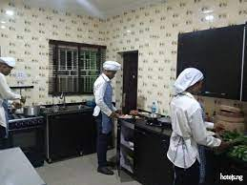
SOMEWATT hotel & Suites
METHOD OF COOKING IN THE KITCHEN
a. Boiling
* b." Frying
c. Baking
d. Roasting
e. Braising
f. Poaching
g. Stewing
h. Frozen Steaming
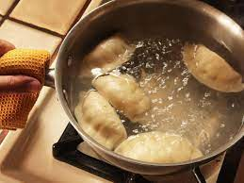
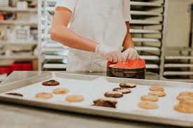
BAKING SEGMENT FROZEN STEAMING
These are the equipment used in the kitchen.
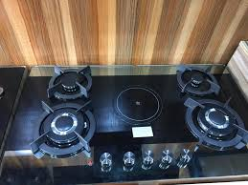
- Gas

2. Pot
3. Fridge
4. Spoon
5. Drawer for flatware and cutlery
6. Bowl
7. Turning stick
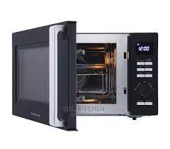
8. Microwave

9. Frying pan
10.Grater
11.Chopping board
12.Whisk
13.Toasting machine
14.Water dispenser
15.Working table
16.Sieve
17.Knife
18.Plate basket
19.Oven
HOUSE KEPING DEPARTMENT.
Mite a room it and vacant contain. the Houston, a equipment used in the house keeping:
a) Bucket
b) Sweeper or broom
c) Tissue paper
d) Waste bin
e) Doves cover

f) Bed spread

g) Towel
h) Iron sponge
i) Toilet brush


j) Mopping bucket
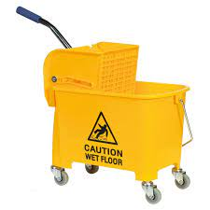

k) Mopping stick
I) Sponge

DETERGENT, SOAP, AND STAIN REMOVER:
1. Harpic
2. Indolence
3. Scouring powder
4. Liquid soap
Room freshener
6. Air freshener
7. Raid (anti losectic acy
8. Jodaf bleach
9. Toilet soap (sephan)
Function of The Housekeeping Department
1) They clean the guest room
2) They clean the surrounding and premises.
3) They report damage in the room to the porter and the sets regret, to the maintenance department.
Function of the steward
a) They take out dirty lines for clearing
b) They clean the numbers of room given to them,
c) Tiding of rooms.
d) Put things in order in the room.
> House keeping room repo

FOODS FOR REGULARS
Fried Rice
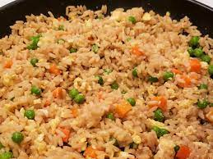
Goat meat pepper soup
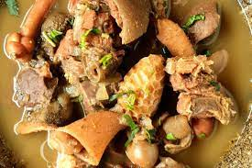
Semo with Egusi
MEAL AND DRINKS IN THE RESTAURANT
In our Hotel, when the services going on in the restaurant the gust is welcome and sit them down by the reception head vasa. Guest can order what he/she wants or what he/she will like to take.
EQUIPMENT USED IN THE RESTAURANT
The following are used in order to carry out efficient services
1. Side board
2. Table and chair
3. Cutlery e.g knife
4. Flat ware e.g. fork and spoon
5. Hollow ware e.g teapot, sugar bowl, milk jug etc
6. Napkin and serviette
7. Hot plate
8. Glassware e.g water glass, wine glass
9. Table accompaniment (ash tray, table number, flower pot, cruet)
Plate (side plate, joint plate, fish plate)
10. Stationeries: food check, order bill, pen, pencil which are used by the cashier.
MINERAL
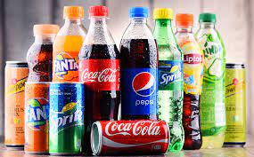
1. Coke
2. Gold sport
3. Limca
4. Pepsi
5. Mirinda
6. Maltina
7. Schwepps
Juice
1. Dangote juice
2. Fruita juice
3. Fuman juice
4. Boosta juice
5. Chivita juice
6. Five alive
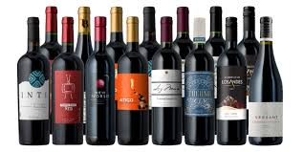
WINE
1. Red wine
2. Red label
3. Rose wine
4. Blue cocktail
5. Champagne
6. Bacchus
7. Barleys
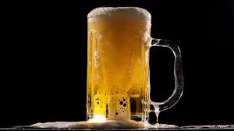
BEER
1. Gulder
2. Harp
3. Small stout
4. Heineken
5. Big stout
SPIRIT
1. Campary
2. Dry gin
3. Chelsea
4. Golden dry gin
5. Ponche
6. Bull

CHAPTER THREE
`ACTUAL WORKDONE WITH EXPERIENCE GAINED
During my Students Industrial Working Experience Scheme (SIWES) at the GREEN AND WHITE HOTEL, we were able to learn and gain a lot of industrial and organizational experience as goes:
MEANING OF FOODS
Food variety is the number and types of different foods that are available to eat. It is important for a person to have a variety of foods in their diet to get the nutrients they need. A person's diet should include fruits, vegetables, whole grains, low-fat proteins, and also healthy fats
Food is the basic necessity of every organism. Food is a substance that we consume in order to derive energy to run our body and nutrition to grow. All living organisms must have food to survive. It provides nourishment to our body system and makes sure that it works smoothly. It aids many biological processes inside the body and helps us grow
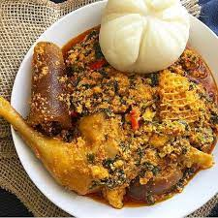
bar.

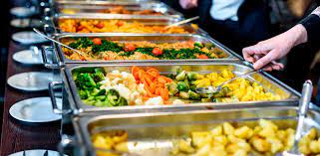
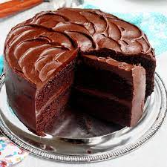
Chocolate Cake

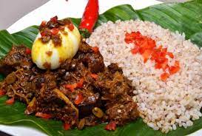
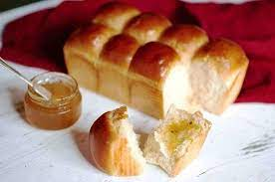
Buttered bread Ofada rice
KITCHEN
Kitchen is the one of the section under food and beverage department in reason to the production of food and beverage. Al the food served and sold in the hotel b prepared in the Kitchen. In the kitchen we have the tread the superies, sho supervised the activities. Cook and Kitchen derk are also involved in the daily adity of the kitchen.


These are the equipment used in the kitchen.
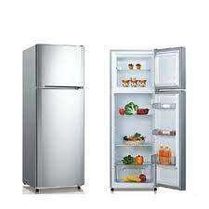
1. Gas
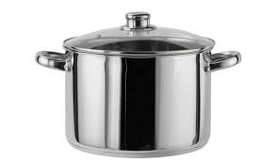

GAS COOKER

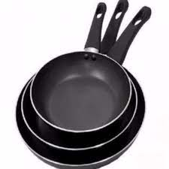
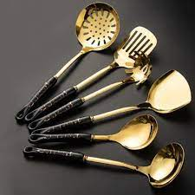

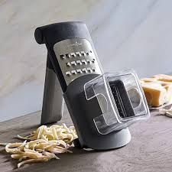
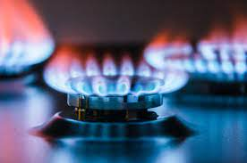

METHOD OF COOKING IN THE KITCHEN
a. Boiling
* b." Frying
c. Baking
d. Roasting
e. Braising
f. Poaching
g. Stewing
h. Frozen Steaming
2. Pot
3. Fridge
4. Spoon
5. Drawer for flatware and cutlery
6. Bowl
7. Turning stick
8. Microwave
9. Frying pan
10.Grater
11.Chopping board
12.Whisk
13.Toasting machine
14.Water dispenser
15.Working table
16.Sieve
17.Knife
18.Plate basket
19.Oven

CHAPTER FOUR
BAR STOCK BOOK
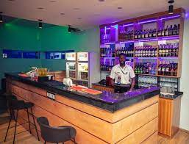
This book shows the numbers and quantity of all drink which are available in the bar and it shows the number of drinks sold at bar dam, and each drink. the opening stock

BAR
THINGS AVAILABLE AT ADIYAT BAR
Juice
1. Dangote juice
2. Fruita juice
3. Fuman juice
4. Boosta juice
5. Chivita juice
6. Five alive
WINE
1. Red wine
2. Red label
3. Rose wine
4. Blue cocktail
5. Champagne
6. Bacchus
7. Barleys
MINERAL
1. Coke
2. Gold sport
3. Limca
4. Pepsi
5. Mirinda
6. Maltina
7. Schwepps

CHAPTER FIVE
SUMMARY OF ATTACHMENT ACTIVITIES
This is a complete report of an industrial training program carried out during my SIWES (2023/2024) GREEN AND WHITE HOTEL , @ NO 4 TEMIDIRE STREET OFF JEBBA ROAD, BEHIND SCHOOL OF SPECIALIST,OYUN.ILORIN KWARA STATE. Activities including field work such as news writing and report, different types of interview, news editing, photo news and caption and so on.
The experience gained has given me a sound knowledge on Hospitality management and Hotel management in general which has helped prepare me for the future use.
PROBLEMS ENCOUNTERED
The success of my training is undisputed, but it was not devoid of rough edges. I experienced some challenges, among these are:
- The issue of expensive transportation: I have to pay an average of 800 naira every day for transport without remuneration.
- Every member of staff was now depending on me to carry out assignments when there were other hands. This made me work overtime sometimes & it was favorable coming back late to a family house.
- The bureaucratic system is rigid and before things are done its takes so much time. This affected the conducive working environment for the members of staff in that whenever machines are bad and need repairs it takes so much time before it gets attended to. This system made work so tedious and cumbersome.
SUGGESTIONS FOR IMPROVEMENT OF THE SCHEME
- Visiting of students during the program should be ensured by the ITF
- Students should be paid their allowance on time to ensure motivation
- Selection of placement should not be left to students. Polytechnics should make a means of allocating students to related companies
- Seminars should be organized for establishments to acquaint them with their roles towards students on training
- Government should participate fully in the provision of equipment in the placement centers
CONCLUSION
The period has contributed immensely to my academic experience. Students Industrial Working Experience Scheme (SIWES) is an important program for all students. It helps in tackling the issue of unemployment amongst youth as it teaches us way to be independent. The exercise made me understood part of what is expected as a journalist in the practice. It helped groom my relationship skills especially in areas where team work are required and communicating with the staffs and students alike. It has exposed me to work ethics and routines.
The problems, if not tackled, will make it lose its usefulness and vitality notwithstanding the benefits of it.

