

A TECHNICAL REPORT

A TECHNICAL REPORT OF THE STUDENTS
INDUSTRIAL WORK EXPEREINCE SCHEME (SIWES)

HELD AT
KWARA STATE MINISTRY OF LAND
WARAH ALONG LUBCON ROAD

BY

ILUYEMI TITILOPE ESTHER
ND/23/ETM/PT/0043

SUBMITTED TO:

THE DEPARTMENT OF ESTATE MANAGEMENT
INSTITUTE OF ENVIRONMENTAL STUDIES (I.E.S)

FROM AUGUST- DECEMBER, 2024
DEDICATION
We dedicate to Almighty God, the most beneficent and the most merciful, the beginning and the end, who made this possible for me

ACKNOWLEDGEMENT
Special thanks to Almighty Allah for his love and protection, during and after the SIWES programme.
Also a profound gratitude to our all staff and lecturer of Estate Management Department.

PREFACE
SIWES was established by ITF to find solution to the problems of lack of practical skills preparatory for employment in industry by Nigeria graduates of tertiary institution. The scheme enlighten student to industry based skill necessary for a smooth transition from the class room to field work. It help student of tertiary institution the opportunity of being familiarized and epode to the needed experienced in handing machineries and equipment which are usually not available in the education institution.
- Institute of applied science: including science laboratory technology, hospitably management leisure and tourism, and agricultural technology.
- Institute of environment studies: including estate management urban and regional planning architectural techno logy, building technology.
- Institution of information and communication technology: including computer science, mathematics and statistic and officer technology management.
- Institute of technology: including electronic electricity, metallurgical engineering technology, civil engineering electricity, metallurgical engineering, technology civil engineering, agriculture engineering technology and mineral resources engineering.

TABLE OF CONTENT
TITLE PAGE -------------------------------------------------------------------------------- i
PREFACE ----------------------------------------------------------------------------------- ii
DEDICATION ------------------------------------------------------------------------------ iii
ACKNOWLEDGEMENT -------------------------------------------------------------------- iv
TABLE OF CONTENTS ---------------------------------------------------------------------v
CHAPTER ONE
1.0 INTRODUCTION --------------------------------------------------------------------- 1
1.1 DEFINATION OF SIWES ------------------------------------------------------------ 1
1.2 AIM AND OBJECTIVE OF SIWES -------------------------------------------------- 1
1.3 HISTORICAL BACKGROUND OF PLACE OF ATTACHMENT -------------------- 2
1.4 THE ORGANIZATION OF THE ORGANIZATIONAL CHART --------------------- 3
1.5 MAJOR ACTIVITIES OF THE ORGANIZATION ----------------------------------- 4
CHAPTER TWO
2.0 SECTION/UNITY OF THE ORGANIZATION AND THEIR FUNCTION ---------- 5
2.1 FUNCTION RERFORMED BY VARIOUS DEPARMENT DEVENTCONTROL
DEPARTMENT ----------------------------------------------------------------------------- 5
CHAPTER THREE
30. STUDENT’ SPECIF INVOLEMENT IN VARIOUS SECTION/UNIT --------------- 8
CHAPTER FOUR
4.0 RELEVANT EXPERIENCE GAINED BY STUDENT IN THE FIELD OF STUDY --- 10
4.1 INTEROERSONAL RELATION WITH N THE ORGANIZATION ------------------ 13
CHAPTER FIVE
5.0 CONCLUSION ------------------------------------------------------------------------ 14
5.1 PRESONAL IMPREESSION ABOUT THE ORGANIZATION ---------------------- 14
5.2 SUGGESTION AND RECOMMENDATION TO THE COMPANY ------------------ 14
5.3 RECOMMEDATION TO THE POLYTECHNIC CONCERNINR THE SIWES
PROGRAMME ---------------------------------------------------------------------------- 14
CHAPTER ONE
1.0 INTRODUCTION
This program called (SIWES) student industry work experience scheme is compulsory to all ND 1 student who offer science course or any other practicable course it enables student to have the experience of the aspect which have been taught in school it is a program that takes up to four month in which student expected to able to practice what they are taught.
1.1 DEFINITION OF THE SIWES
The student industrial work experience scheme (SIWES) is the accepted skills training program, which from parts of the approved minimum academic standard in the various degree programs for all the Nigeria universities and polytechnics. It is an effort to bridge the gap existing between theory and practices of engineering, sciences, agriculture, medical, and management and other and professional education programs in the Nigeria tertiary institution, it is aimed exposing student to machines and equipment professionals work method and way of safe guarding the work area and work area and workers in industries and other organization.
1.2 AIMS AND OBJECTIVES OF SIWES
The student industrial work experience scheme (SIWES) can be define as a technical skills and acquisition of knowledge from the organization, industrial sector. It is also serving as the complement of the learning which student have acquired in the classroom of theoretically
The objective of the industrial work experience scheme is as follow.
• It also enlighten student to various study division of industrial of Organization of work in which the course of study can be radicalize
• To enable student to defend his of herself in any where he or she found Itself.
‘. It relate the student to the labor market and how it being operated.
• It enables the student to practically different test from what they learnt theoretically in the classroom.
1.3 HISTORICAL BACKGROUND OF THE ORGANIZATION
The kwara state town planning and development authority was established by edict no 7 of 1996 it stated full operation in 1968 and the first board of the authority as prostate organization was in December 1968
It had its name change to Ministry of Land and development authority in 1991 to reflect the true perspective of the authority in their roles and function in the edict establish it.
The organization is divided into department namely
- Works
- Development control
- Administration
- Schemes
- Financial and supply
- Planning research statistics
The units under works department
• Building
• Country survey
• Civil engineering
• Estate management
• Architecture
• Survey e.t.c

ORGANIZATION STRUCTURE OF KWARA STATE MINISTRY OF LAND
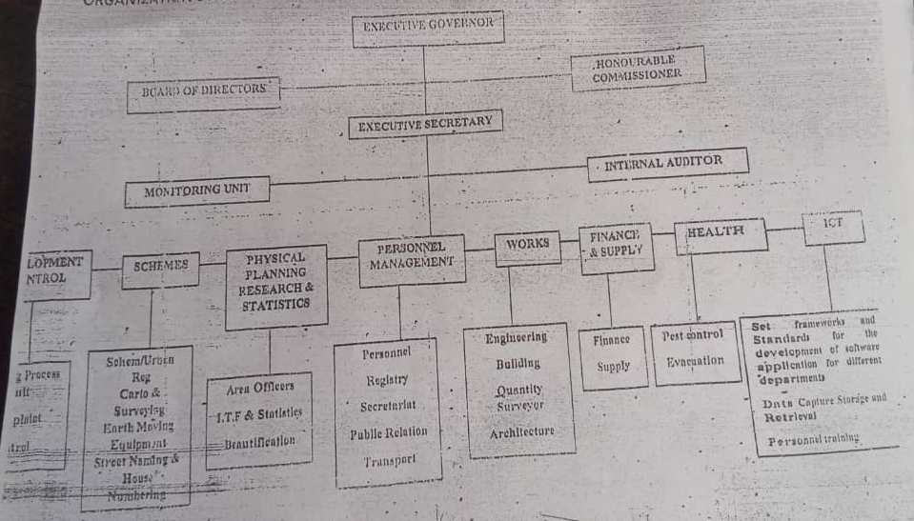

1.5 MAJOR ACTIVITIES OF THE ORGANIZATION
Kwara state town planning and development authority ability is to administration execute and enforce the provision of the town and country planning.
The following are the major of the organization
• To plan, promote and secure the physical and environment improvement of the estate through orderly control over the development and use of land in the state.
• To provide, maintain and constructs roads and other proper infrastructure of Urban development e.t.c.
• To frame, establish, publish and approve within certain period as it may be
Specified by the commissioner, a planning schemes for a town of village within the estate.
Other activities that organization deals with are as follows:
• House numbering
• Building approval
• Industrial estate
- SCHEME DEPARTMENT
The department in charge of preparation of new residential scheme in various parts of new residential scheme in various parts of kwara state. The preparation of these scheme improved the orderly development and service the environment improvement of the kwara state.
It also organized the land use patter in the area evolved adequate linkages within the scheme area with adjacent properties and community.
It open roads and route for adequate circulation within the scheme and interrogation with adjacent development through the use of earth moving equipment and also control density and orientation of building.
- PHYSICAL PLANNING RESEARCH AND STATISTICS:
The department in charge of collection organization and storage of data and record on approved development plans. It is in charge of data base operation in urban and regional planning including traffic, transportation, urbanization, waste, management and population, all technical and social infrastructures.
It prepares and submits the annual progress report on the operation of the national physical plans as it affects kwara state
Finally it reviews the annual report of the local planning authority in charge of publicity and enlightens activities and help the authority to train student on industrial attachment programme.
- PERSONNEL MANAGEMENT DEPARTMENT
The department is in charge of providing the necessary human and material resources require to enabling the authority by function efficiently.
It coordinates the activities or other department and help to train and manpower politics and detailed studies of financial incentive programmers.

CHAPTER TWO
2.0 SECTIONS! UNITS OF THE ORGANIZATION AND THEIR
SPECIFIC FUNCTIONS
- Also the board of director of the authority, who formulate the principle and guidelines for the authority programs and policies, is constituted by the executive governor
- The executive secretary and chief executive of the authority is a member of board of direct. He is the head of management team of the authority we have the internal auditor who is direct under the executives secretary
- The department are those of development control schemes, physical research and statistics personnel management, work finance and supply and health department
- At the apes of the organization in the kwara state town planning and development authority, Ilorin is the executive governor of the state who has the final approval to all form of policies and programs the authority
- Apart from the estate governor, there is the parent ministry that is the ministry of the land and house who supervise and coordinates the activities of the authority.
2.1 FUNCTION PERFORMED BY VARIOUS DEPARTMENTS DEVELOPMENT CONTROL
- The department is in charge of issuing of approval building plans, faces in renovation or development on estate land with a view to initiating necessary action to control such patter. It investigate all petitions and complaints on physical development in the state it also collaborates with kwara state environmental protection agency, on assessment of grating planning approval and control of outdoor advertisement on all state.

- FINANCE AND SUPPLY DEPARTMENT
The department is in charge of internal funding of the authority it is in the responsibility of the department to ensure that all revenue accruable to the authorities are collected as well as proper custody of this monies and control.
On expenditure it ensure that staff salaries and other allowance are paid as at when due.
Finally, they store unit under the department ensure proper custody of store item and also advise the authority from time to time on the stocks on warehouse and need of the established.
- WORK DEPARTMENT
The department helps the authority to preserve please of architecture and historical interest and beauty. The department help to authority to prepare architecture and engineering design in reading for any project embark upon by the authority. It also prepares bills of quantities for a project in the authority.
It is the duties of the department to cross-check all the building plans submitted to the authority for approval to ensure the building regulation and conformity.
- HEALTH DEPARTMENT
The department provides and maintains proper sanitary facilities amenities and conveniences.

CHAPTER THREE
3.1 SPECIFIC INVOLVEMENT AT THE VARIOUS SPECTATORS! DEPARTMENT IN THE ORGANIZATION
We are assigned to different department/ unit during our four month programme at the town planning development authority.
Students are involves in various units such as:
i. Development
ii. Scheming department
iii. Physical planning research and statics
iv. Complain and litigation
v. Administration department
vi. Planning processing unit
vii. Patrol unit (patrol A, patrol B, patrol C)
viii. Planning approval office
ix. Work department
x. Finance and supply department
- The kwara state town planning and development authority edit and the Nigerian urban and regional planning law of 1992 was amended in 1999 and 2003 stipulated that approval of the authority shall be required for any development.
If any person unlawfully obstructs molest any staff of the authority, or remove any mark set up for the purpose in indicating any level or direct necessary for the execution of the work of the authority of any premises, such person shall be guilty of an offence and liable on conviction of a fine to be determine by authority or imprisonment to be determined by the court of law
Any expenses incurred by the authority in the removal attention of any work will be recovered as a debt from any person upon whom such notice has been said.
Items/ materials seizes and collected within 14 days for felt the authority.
- Red mark (x) shall only be ascribed on ant development the suggest imminent punitive measure.
- Any development that contravenes this law embarks on the construction of illegal structures shall be liable to charge 100% of the assessment fee among other possible sanction as contained in the edicts.
VALIDATION OF DEVELOPMENT
A development permit, granted in respect of any development on a land shall deemed valid for two years from the date of commencement of this a applicant were the holder of the permit fails to commence complete development within 2 years it shall therefore be subject to revalidation or renewal

CHAPTER FOUR
3.0 RELEVANT EXPERIENCED GAINED BY STUDENT IN THE FIELD OF STUDY
The experience we gained during the duration of our SIWES is relevant to my field study [estate management] the core course of my field of study was treated which are property valuation and property taxation and some other relevant course and some other practice work which enlighten us about the field of study in the polytechnic.
We get to what the word VALUATION really means that is not just to determine the monetary worth of a property alone to estimate the future benefit which is to enjoy from the owner of a fee holder or a lease holder interest in land and landed property which the future benefit are express in present worth, also valuation is a process of ascertaining the monetary worth of an interest in land and laded property for a specific purpose at a specific period of time.
Why valuation is a process
It is because is an art and science of ascertaining the monetary worth of an interest in land and landed property.
Been art means ours
1. Personal skills
2. Knowledge and assumption
3. Experienced
Mathematical determination of worth of an interest and to be able to predicted the future constrains of a particular property

1. It involve calculation research
2. Government policy which include;
A. Taxation
B. Rate control and building regulation
3. Physical attribute [that is the feature the property]
Also I knew different method used involving properties which are
- Investment method
- Comparism method
- Residual method
- Profit or account method
- Cost or contractor method
INVESTMENT METHOD
Investment method of valuation is used to value properties which are held as generating income flow which are rent income producing investment, therefore freehold and leasehold interest where there is an evidence of income yielding.
COST OR CONTRACT METHOD
This method is used for property as seldom chances hand in a property marks such as school, town hail and other public properties of non-profit making
PROFIT OR ACCOUNT METHOD
This method is usually adopted for the value of commercial or profit making properties such as hotel, cinema, theater, filling station e.t.c where comparable are not frequently available.
Also I learnt different valuation tables, the valuation table are as follow
I. Amount of one naira
II. Present value of one naira
III. Amount of one naira per annual
IV. Annual sinking fund
V. V.P dual rate
VI. V.P single rate
VII. V.P dual rate adjust for tax annuity one naira will purchase
4.1 INTERPERSONAL RELATION WITH THE ORGANIZATION
The relationship between individual in the organization is very cordial, they interact together, pray and even chat together to make the ministry attains their common goals. We really enjoy their parental relationship with us as a big family and working for a brighter future.

CHAPTER FIVE
5.0 CONCLUTION
Conclusively, the student industrial work experienced scheme [SIWES] has really helped us in developing our academic skill in such a way that we are able to combine our theoretical knowledge in school with the practical work in place of attachment.
There, we will implore the gout to continue intensifying their effort toward the programs.
5.1 OUR PERSONAL IMPRESSION ABOUT THE ORGANIZATION
We are highly impressed about the practice work because we have been given the privilege to participate in every activities going on in various unit, more knowledge were gained which really motivated us to continue the profession.
5.2 SUGGESTION AND RECOMMENDATION TO THE COMPANY
• The object of the scheme could be better achieved if the industrial unit can help student in getting placement by posting them to establishment. This will go a long way in reducing the difficulties usually encountered by student in securing placement
• The program should not be exercised because of allowance and grade but also to student’s skills and technical knowledge to become professional in their field of study.
• Also the government should review the scheme so that student allowance can be paid promptly and adequately.
• In each place of attachment, there should be proper monitoring of students who really donates their selves in the training rather than bribing in other to sign.

5.3 Recommendation to the polytechnic concerning the SIWES programme
Our regard goes to the management of the polytechnic for organizing and scheduling this program which really help because it has really improve our knowledge as a student to the required standard
The ITF in collaboration with institution should evolve minimum standards in respects of SIWES and develop, monitor and review job specification to guide the, training of student.
To guarantee quality assurance of the scheme there is need for through supervision of SIWES participation by the institution and then ITF
- The organization should make adequate provision in the annual budget of proper funding of SIWIES in view of the potential of the quality of the poor technical Vskills available.

