

A TECHNICAL REPORT
STUDENT INDUSTRIAL WORKING EXPERIENCE SCHEME
(SIWES)

Held at
FIRST CLASS ENTERPRISES,
12, POST OFFICE ROAD MUSHIN LAGOS STATE

Prepared by:
JIMOH NURUDEEN OLAMIDE
ND/23/BAM/PT/0016

SUBMITTED TO

DEPARTMENT OF BUSINESS ADMINISTRATION
INSTITUTE OF FINANCE AND MANAGEMENT STUDIES
KWARA STATE POLYTECHNIC, ILORIN

INPARTIAL FULFILLMENT OF THE AWARD OF THE REQUIREMENT OF THE AWARD OF NATIONAL DIPLOMA IN BUSINESS ADMINISTRATION AND MANAGEMENT STUDIES

DEDICATION
I dedicate this technical report to the Almighty GOD, the giver of knowledge, wisdom and who is rich in mercy.

ACKNOWLEDGEMENT
I take this opportunity to express my profound gratitude and deep regards to the creator of heaven and earth, the one who knows the beginning and the end, the alpha and the omega, the Almighty Allah and also to my guides (MR & MRS JIMOH, and to all those who has helped me during my SIWES programme. The blessings, help and guidance given by them, time to time has carry me so this far and shall carry on the journey of life on which I am about to embark. I also take this opportunity to express a deep sense of gratitude to compliment my mentor for his cordial support valuable information and guidance which helped me in completing my SIWES through various stages.

TABLE OF CONTENT
Title page i
Table of content ii
Dedication iii
Acknowledgements iv
CHAPTER ONE
  - Background of SIWES 1
  - History of SIWES 1
  - Objectives of SIWES 2
  - Objectives of Establishment 3
CHAPTER TWO
2.1. Store Room 4
2.2. 'Product' 4
CHAPTER THREE
3.1 Some Goods Sell In Funmi Stores 6
CHAPTER FOUR
4.0 Conclusion and Recommendation 12
4.1 conclusion 12
4.2 Recommendation 13

CHAPTER ONE
  - INTRODUCTION TO SIWES
Students Industrial Work Experience Scheme (SIWES) is a Skills Training Program designed to prepare and expose Students of Universities, Polytechnics, Colleges of Technology, Colleges of Agriculture and Colleges of Education for the Industrial Work situation they are likely to meet after graduation. The Scheme affords Students the opportunity of familiarizing and exposing themselves handling equipment and machinery that are usually not available in their institutions.

1.2 HISTORY OF SIWES
The Students’ Industrial Work Experience Scheme (SIWES) was initiated in 1973 by the Federal Government of Nigeria under the Industrial Training Fund (ITF) to bridge the gap between theory and practice among products of our tertiary Institutions. It was designed to provide practical training that will expose and prepare students of Universities, Polytechnics, and Colleges of Education for work situation they are likely to meet after graduation.
Before the establishment of the scheme, there was a growing concern among the industrialists that graduates of institutions of higher learning lacked adequate practical background studies preparatory for employment in industries. Thus the employers were of the opinion that the theoretical education going on in higher institutions was not responsive to the needs of the employers of labour.
As a result of the increasing number of students’ enrolment in higher institutions of learning, the administration of this function of funding the scheme became enormous, hence ITF withdrew from the scheme in 1978 and was taken over by the Federal Government and handed to National Universities commission (NUC), National Board for Technical Education (NBTE) and National Commission for Colleges of Education (NCCE). In 1984, the Federal Government reverted back to ITF which took over the scheme officially in 1985 with funding provided by the Federal Government.

1.3 OBJECTIVES OF THE PROGRAMME
The specific objectives of SIWES are to:
- Provide placements in industries for students of higher institutions of learning approved by relevant regulatory authorities (NUC, NBTE, NCCE) to acquire work experience and skills relevant to their course of study
- Prepare students for real work situation they will meet after graduation.
- Expose students to work methods and techniques in the handling of equipment and machinery that may not be available in schools.
- Make transition from school to the labour market smooth and enhance students’ conduct for later job placement
- Provide students with the opportunity to apply their knowledge in real life work situation thereby bridging the gap between theory and practice
- Strengthen employer involvement in the entire educational process and prepare students for employment in industry
Promote the desired technological knowhow required for the advancement of the nation.
1.4 OBJECTIVES OF ESTABLISHMENT
To provide innovative and effective solutions
➢ To deliver exceptional customer service
➢ To drive business growth and expansion
➢ To build a strong brand reputation
➢ To develop and maintain a skilled workforce
➢ To promote a culture of innovation and continuous improvement
➢ To maintain high-quality standards and best practices
➢ To foster strategic partnerships and collaborations

CHAPTER TWO
2.1. HOW TO PRODUCE 40 LEAVES BOOK
Producing a 40-page book involves several steps, from planning and designing to printing and binding. Here's a step-by-step guide to help you produce a 40-page book:
Planning and Designing (Steps 1-5)
1. Define the book's purpose and content: Determine the book's genre, target audience, and content.
2. Create a layout and design concept: Plan the book's layout, including font styles, sizes, and margins.
3. Write and edit the content: Write and edit the book's content, ensuring it fits within the 40-page limit.
4. Add images and graphics: Incorporate relevant images and graphics to enhance the book's visual appeal.
5. Design the cover: Create an eye-catching cover design that reflects the book's content and genre.
Typesetting and Formatting (Steps 6-8)
6. Choose a typesetting software: Select a suitable typesetting software, such as Adobe InDesign or Microsoft Word.
7. Format the text and images: Format the text and images according to the design concept, ensuring consistency throughout the book.
8. Check for errors and inconsistencies: Proofread the book for errors, inconsistencies, and formatting issues.
Printing and Binding (Steps 9-11)
9. Choose a printing method: Select a suitable printing method, such as offset printing, digital printing, or print-on-demand.
10. Print the book: Print the book according to the chosen printing method, ensuring high-quality output.
11. Bind the book: Bind the book using a suitable binding method, such as perfect binding, saddle-stitching, or hardcover binding.
Finishing Touches (Steps 12-13)
12. Add finishing touches: Add any finishing touches, such as laminating the cover or adding a dust jacket.
13. Inspect and package the book: Inspect the book for quality and package it for distribution or sale.
Timeline and Budget
- Timeline: The production timeline will depend on the complexity of the book, the printing method, and the binding process. A typical timeline can range from a few weeks to several months.
- Budget: The budget will depend on the printing method, binding process, and quantity of books. A rough estimate for producing a 40-page book can range from $500 to $5,000 or more, depending on the specifications..
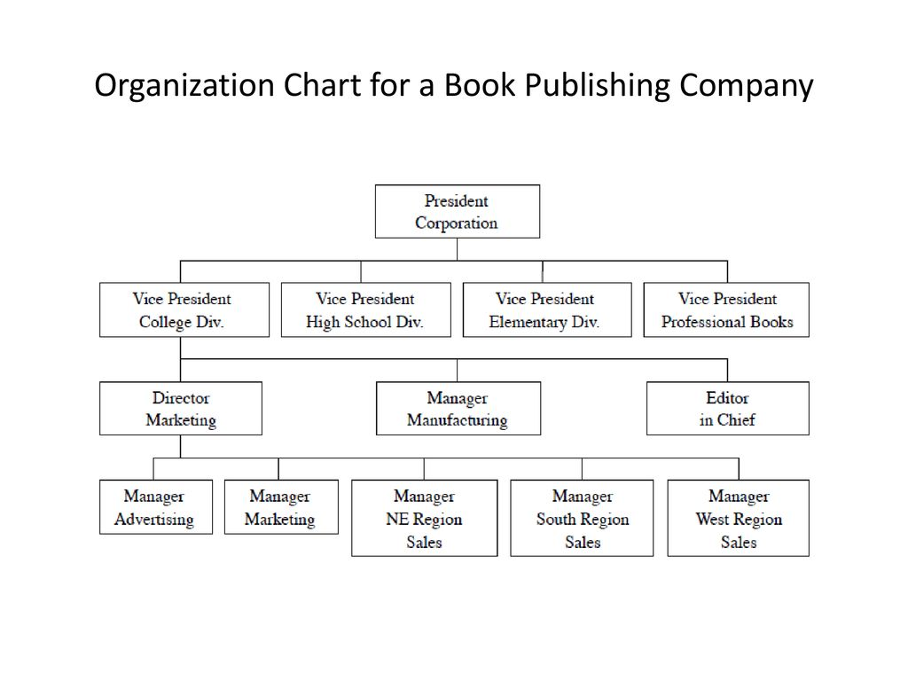

2.2 DIFFERENT EQUIPMENT INVOLVE IN BOOK ACTIVITIES PRODUCTION

Pre-Press Equipment

1. Computers: Used for designing, editing, and formatting book content.

2. Software: Such as Adobe In Design, Illustrator, and Photoshop.

3. Scanners: For digitizing images and artwork.

4. Printers: For printing proofs and test copies.

Printing Equipment

1. Offset Printing Presses: For large-scale printing of books.

2. Digital Printing Presses: For short-run printing and print-on-demand.

3. Inkjet Printers: For printing high-quality images and text.

4. Toner-Based Printers: For printing black and white text.

Binding and Finishing Equipment

1. Perfect Binders: For binding books with a glue-based adhesive.

2. Saddle-Stitchers: For binding books with staples.

3. Hardcover Binders: For binding books with a hardcover.

4. Folded and Gathered Machines: For folding and gathering book signatures.

5. Trimmers: For trimming book edges.

6. Laminators: For laminating book covers.

Quality Control Equipment

1. Proofreaders: For checking text for errors.

2. Color Calibrators: For ensuring color accuracy.

3. Density Meters: For measuring ink density.

4. Register Control Systems: For ensuring accurate registration.

Packaging and Shipping Equipment

1. Boxing Machines: For packaging books in boxes.

2. Shrink Wrap Machines: For wrapping books in shrink wrap.

3. Palletizers: For stacking books onto pallets.

4. Strapping Machines: For securing books onto pallets.

Other Equipment

1. Paper Cutters: For cutting paper to size.

2. Drill Presses: For drilling holes in books.

3. Rounding Machines: For rounding book corners.

4. Gilding Machines: For applying metallic foil to book edges

2.3 DIFFERENT EQUIPMENT INVOLVE IN PRODUCING NOTE BOOK ACTIVITIES
Paper Production
1. Paper Machines: For producing paper from pulp.
2. Cutting Machines: For cutting paper into desired sizes.
3. Folding Machines: For folding paper into notebook pages.
Notebook Binding
1. Saddle-Stitchers: For binding notebooks with staples.
2. Perfect Binders: For binding notebooks with a glue-based adhesive.
3. Spiral Binders: For binding notebooks with a spiral coil.
4. Case Binders: For binding notebooks with a hardcover.
Printing and Decorating
1. Offset Printing Presses: For large-scale printing of notebook covers.
2. Digital Printing Presses: For short-run printing and print-on-demand.
3. Screen Printing Machines: For printing notebook covers with specialized designs.
4. Embossing Machines: For adding raised designs to notebook covers.
Notebook Assembly
1. Assembly Lines: For assembling notebook components, such as pages and covers.
2. Glue Machines: For applying adhesive to notebook pages and covers.
3. Stitching Machines: For stitching notebook pages together.
4. Quality Control Machines: For inspecting notebooks for defects.
Packaging and Shipping
1. Boxing Machines: For packaging notebooks in boxes.
2. Shrink Wrap Machines: For wrapping notebooks in shrink wrap.
3. Palletizers: For stacking notebooks onto pallets.
4. Shipping Containers: For transporting notebooks to customers.
Other Equipment
1. Cutting Dies: For cutting out notebook pages and covers.
2. Foil Stamping Machines: For adding metallic foil to notebook covers.
3. Debossing Machines: For adding depressed designs to notebook covers.

4. Notebook Testing Machines: For testing notebook quality and performance.

CHAPTER THREE
3.1 HOW TO PRODUCE EXERCISE BOOK USING WOOD
Producing an exercise book using wood is a unique and creative project. Here's a step-by-step guide to help you make a wooden exercise book:
Materials Needed:
- Wood (e.g., birch, cedar, or reclaimed wood)
- Woodworking tools (e.g., table saw, drill press, sandpaper)
- Hinges and screws
- Wood glue
- Wood finish (e.g., varnish, stain)
- Paper (for the exercise book pages)
- Binding materials (e.g., thread, glue)
Step-by-Step Instructions:
Step 1: Design and Plan the Book
1. Determine the size and shape of your wooden exercise book.
2. Plan the layout and design of the book, including the number of pages and any additional features (e.g., pockets, elastic closures).
Step 2: Cut the Wood
1. Cut the wood into the required pieces for the book's cover, pages, and any additional features.
2. Use a table saw or circular saw to make precise cuts.
Step 3: Assemble the Book Cover
1. Use wood glue and screws to assemble the book cover.
2. Attach the hinges to the cover, allowing it to open and close.

Step 4: Create the Pages
1. Cut the paper into the required size for the exercise book pages.
2. Use a binding technique (e.g., saddle-stitching, perfect binding) to attach the pages to the book cover.
Step 5: Add Additional Features (Optional)
1. Add pockets, elastic closures, or other features to the book as desired.
2. Use wood glue and screws to attach these features to the book cover.
Step 6: Finish and Protect the Wood
1. Apply a wood finish (e.g., varnish, stain) to protect the wood and enhance its appearance.
2. Allow the finish to dry according to the manufacturer's instructions.
Step 7: Final Assembly and Quality Check
1. Assemble all the components of the exercise book.
2. Check the book for quality and functionality, making any necessary adjustments.
Tips and Variations:
- Use reclaimed or sustainable wood to create a unique and eco-friendly exercise book.
- Add decorative elements (e.g., engravings, carvings) to the book cover for a personalized touch.
- Experiment with different binding techniques and materials to create a distinctive exercise book.
3.2 EQUIPMENT AND TOOLS USE FOR PRODUCING EXERCISE BOOK
Paper Production
1. Paper Machines: For producing paper from pulp.
2. Cutting Machines: For cutting paper into desired sizes.
3. Folding Machines: For folding paper into exercise book pages.
Printing
1. Offset Printing Presses: For large-scale printing of exercise book covers and pages.
2. Digital Printing Presses: For short-run printing and print-on-demand.
3. Screen Printing Machines: For printing exercise book covers with specialized designs.
Binding
1. Saddle-Stitchers: For binding exercise books with staples.
2. Perfect Binders: For binding exercise books with a glue-based adhesive.
3. Spiral Binders: For binding exercise books with a spiral coil.
Finishing
1. Trimmers: For trimming exercise book edges.
2. Laminators: For laminating exercise book covers.
3. Embossing Machines: For adding raised designs to exercise book covers.
Quality Control
1. Quality Control Machines: For inspecting exercise books for defects.
2. Proofreaders: For checking exercise book content for errors.
Packaging and Shipping
1. Boxing Machines: For packaging exercise books in boxes.
2. Shrink Wrap Machines: For wrapping exercise books in shrink wrap.
3. Palletizers: For stacking exercise books onto pallets.
Other Equipment
1. Cutting Dies: For cutting out exercise book pages and covers.
2. Foil Stamping Machines: For adding metallic foil to exercise book covers.
3. Debossing Machines: For adding depressed designs to exercise book covers.
4. Exercise Book Testing Machines: For testing exercise book quality and performance.

CHAPTER FOUR
4.1 CONCLUSION
The Student Industrial Work Experience Scheme (SIWES) plays a significant role in human resource development, it helps students develop new skills and enlightens them of what the present society holds for them after graduation and helps them adapt accordingly. As a result of the programme, I am now more confident to build my future, My four (4) months industrial attachment with Radio Kwara has been one of the most interesting, productive and instructive experience in my life. Through this training, I have gained new insight and more comprehensive understanding.

4.2 RECOMMENDATION
The following are the suggested recommendation for the program
i. The company should remain friendly and accommodating to future IT student.
ii. The SIWES coordinator and school should where organized enlightenment program for IT student in order to know the important of SIWES.
iii. The school (Polytechnics) should consider the four months mandatory SIWES while drafting the calendar for a successive session in a way that will affect the returning IT Student.

