A TECHNICAL REPORT ON
STUDENT’S INDUSTRIAL WORK EXPERIENCE SCHEME
(SIWES)

HELD AT
KWARA STATE POLYTECHNIC LIBRARY
ILORIN, KWARA STATE

PREPARED BY:
ADEGBOLA BLESSING YETUNDE
ND/23/LIS/FT/0140

SUBMITTED TO:
THE DEPARTMENT OF LIBRARY AND INFORMATION SCIENCE,
INSTITUTE OF INFORMATION AND COMMUNICATION TECHNOLOGY,
KWARA STATE POLYTECHNIC, ILORIN.

IN PARTIAL FULFILMENT OF PART OF THE REQUIREMENT FOR THE AWARD OF NATIONAL DIPLOMA (ND) IN LIBRARY AND INFORMATION SCIENCE

NOVEMBER, 2024
TABLE OF CONTENT
Title page i
Table of content ii
Dedication iii
Acknowledgements iv
TABLE OF CONTENTS
CHAPTER ONE
- Introduction 1
  - History of SIWES 1-2
1.2 Aims and Objectives of SIWES 3
1.3 Relevance and Justification of SIWES 3
CHAPTER TWO
2.1 Description of Organization 4
2.2 Location of organization 5
2.3 Objective of Organization 5-6
2.4 Organizational Structure of Organization 6
2.5 Departments and Functions 6
CHAPTER THREE
3.1 Work Carried out during SIWES 7-10
CHAPTER FOUR
4.1 Work Done and Experience Gained 11-12
CHAPTER FIVE
5.1 Summary 13
5.2 Conclusion 13-14
5.3 Recommendations 14-15

DEDICATION
I dedicate this technical report to the Almighty God, the giver of knowledge, wisdom and who is rich in mercy.

ACKNOWLEDGEMENT
I use this opportunity to express my profound gratitude and deep regards to the creator of heaven and earth, the one who knows the beginning and the end, the alpha and the omega, the Almighty Allah. Thank You for seeing me through this SIWES programme.
Also, to my parents MR. and MRS. ADEGBOLA for their blessings, help and guidance given by them, time to time has carry me so far and shall carry on the journey of life on which I am about to embark. I, also take this opportunity to express a deep sense of gratitude to compliment my mentor for his cordial support valuable information and guidance which helped me in completing my SIWES through various stages.

CHAPTER ONE
- INTRODUCTION
SIWES stands for Students Industrial Work Experience Scheme. It is the accepted skills training program, which forms part of the approved minimum Academic standards in the various degree program for all Nigerian tertiary Universities (N.U.C 1996). SIWES goes a long way inputting to test the level of knowledge a student has acquired during the industrial training program.
The student industrial work experience scheme {SIWES} is an appreciable skills/training which is included as part of the minimum academic standard in Nigeria tertiary institution. The scheme is a participatory program involving universities, polytechnics and technical colleges for student of various institutions in Nigeria. It is run jointly by the Industrial Training Fund (I.T.F). The SIWES was established as a result of realization by the Federal Government in 1971, of the need to introduce a new dimension to the quality and standard of education obtained in the country in order to achieve the much-needed technology advancement, because it has been shown that a correlation exist a country level of economic, technological development and its level of investment in manpower (oniyide; 2000).
SIWES goes a long way inputting to test the level of knowledge a student has acquired during the industrial training program. It is an effort to bridge the gap existing between theory and other practice of architecture, engineering and technology, sciences, agriculture and other professional educational programs in the Nigerian tertiary institutions. It is aimed at exposing students to machines and equipment and professional work methods in industries and other organizations. The scheme is a tripartite program, involving the students, the universities and the industries (employers of labor). It affords students the opportunity to familiarize and expose themselves to the knowledge and experience needed in handling equipment that is not readily available in their various institutions. Before the establishment of this scheme, employers believed that the theoretical education in tertiary institutions were not adequate enough to meet most of the needs of employers of labor.
  - HISTORY AND BACKGROUND OF SIWES
In the early stages of education development in Nigeria, there was a problem with the gap between students' theory and practical skills. Therefore, there was a need to allow students to get real work experience. The program was created to give students experience in addition to theoretical learning. The industrial training policy was introduced by the Federal Government of Nigeria in 1973. Therefore, this project was necessary to improve the practical skills of students.
SIWES was established by ITF (Industrial Training Funds) in the year 1973 to solve the problem of lack of adequate proper skills for employment of tertiary institution graduates by Nigerian Industries. The Students’ Industrial Work Experience Scheme (SIWES) was founded to be a skill training programme to help expose and prepare students of universities, polytechnics and colleges of education for the industrial work situation to be met after graduation. This scheme serves as a smooth transition from the classroom to the world of work and further helps in the application of knowledge. The scheme provides students with the opportunity of acquainting and exposing themselves to the experience required in handling and managing of equipment and machinery that are usually not made available in their institutions. Before this scheme was established, there was a growing concern and trend noticed by industrialists that graduates of higher institutions lacked sufficient practical background for employment. It used to be that students who got into Nigerian institutions to study science and technology were not trained in the practical know-how of their various fields of study. As a result, they could not easily find jobs due to the lack of working experience.
Therefore, the employers thought that theoretical education going on in higher institutions was not responsive to the needs of the employers of labour. This was a huge problem for thousands of Nigerians until 1973. It is against this background that the fundamental reason for initiating and designing the scheme by the fund in 1973/74 was introduced.
The ITF organization (Industrial Training Fund) made a decision to help all interested Nigerian students and established the SIWES program. It was officially approved and presented by the Federal Government in 1974. The scheme was solely funded by the ITF during its formative years but as the financial involvement became unbearable to the fund, it withdrew from the scheme in 1978. In 1979, the federal government handed over the management of the scheme to both the National Universities Commission (NUC) and the National Board for Technical Education (NBTE).Later, in November 1984, the federal government reverted the management and implementation of the scheme to ITF. In July 1985, it was taken over by the Industrial Training Fund (ITF) while the funding was solely borne by the federal government. (Culled from Job Specifications on Students Industrial Work Experience Scheme).

  - AIMS AND OBJECTIVES OF SIWES
In the early stages of education development in Nigeria, there was a problem with the gap between students' theory and practical skills. Therefore, there was a need to allow students to get real work experience. The program was created to give students experience in addition to theoretical learning. The industrial training policy was introduced by the Federal Government of Nigeria in 1973. Therefore, this project was necessary to improve the practical skills of students.
- To provide an avenue for students in the Nigerian Universities to acquire industrial skills and experience in their various field of study.
- To prepare students for the work situation they are likely to meet after graduation.
- To expose students to work methods and techniques in handling equipment and machinery that may not be readily available in the universities.
- To make transition from the university to the world of work and thus enhance student’s contacts for future job placements.
- To provide students with the opportunity to apply the theoretical knowledge they had gain in school to real-life work situation, thereby bridging the gap between university work and actual practice.
- To enlist and strengthen employers’ involvement in the entire education process of preparing university undergraduate for employment in the industry.
- To provide students with an opportunity to apply their theoretical knowledge in real work situation, thereby bridging the gap between university work and actual practice.
- To serve as opportunity for self- actualization for students thus making positive and commendable contribution within the scope of his/her knowledge.
CHAPTER TWO
  - DESCRIPTION OF KWARA STATE POLYTECHNIC LIBRARY
The Kwara State Polytechnic Library is a modern, well-equipped library located within the campus of Kwara State Polytechnic, Ilorin, Nigeria. The library is designed to support the academic and research needs of students, staff, and faculty members of the polytechnic. The library provides a conducive environment for learning, teaching, and research, and offers a wide range of resources and services to support the academic success of its users.
The library building complex has a conducive and spacious environment for students. The building is designed to provide a comfortable and conducive reading environment, with ample natural lighting and ventilation. The library has a diverse collection of printed and electronic resources, including one million plus (1,000,000) books and a thousand plus researches of textbooks, reference books, and other publications covering various fields of study.
The library provided services to support the academic and research needs of users, including lending Services: Books and other materials are lendable to registered library users. Reference Services such as library staff provide assistance with research, information retrieval, and referencing. Information Literacy which involves training and workshops on information literacy, research skills, and library usage. Interlibrary Loan such as arrangements with other libraries for borrowing and lending materials. The library operates from Monday to Friday, 8:00 am to 6:00 pm, and on Saturdays from 9:00 am to 1:00 pm. The library is closed on Sundays and public holidays.
Overall, the Kwara State Polytechnic Library is a vibrant and supportive learning environment that provides access to a wide range of resources and services to support the academic success of students and staff.
Mission Statement
“to provide access to relevant and timely information, support teaching, learning, and research, and foster a culture of literacy and lifelong learning among the polytechnic community.
Vision Statement
“To be a leading library in Nigeria, providing innovative and excellent library services, and supporting the polytechnic's vision to be a center of excellence in education, research, and innovation.

2.2 LOCATION OF KWARA STATE POLYTECHNIC LIBRARY
The Kwara State Polytechnic Library is located within the campus of Kwara State Polytechnic, Ilorin, Nigeria. The library is situated near the administrative block and is easily accessible from all parts of the campus. Its postal code is P.M.B 1375, Ilorin, Kwara State, Nigeria.
2.3 OBJECTIVES OF KWARA STATE POLYTECHNIC LIBRARY
The objectives of the Kwara State Polytechnic Library are:
1. To provide access to relevant and timely information to support teaching, learning, and research.
2. To foster a culture of literacy and lifelong learning among the polytechnic community.
3. To develop and maintain a comprehensive collection of print and electronic resources.
4. To provide training and support to users in the use of library resources and services.
5. To collaborate with other libraries and institutions to enhance the library's collections and services.
2.4 DEPARTMENTS AND THEIR FUNCTIONS OF KWARA STATE POLYTECHNIC LIBRARY
The Kwara State Polytechnic Library is organized into the following departments:
1. Acquisitions Department:
Responsible for selecting, acquiring, and processing new library materials.
Develops and maintains the library's collection development policy.
2. Cataloging and Classification Department:
Responsible for cataloging and classifying library materials.
Maintains the library's online public access catalog (OPAC).
3. Circulation Department:
Responsible for lending library materials to users.
Maintains user records and resolves circulation-related issues.
4. Reference Department:
Provides research assistance and instruction to users.
Develops and maintains the library's reference collection.
5. Serials Department:
Responsible for acquiring, processing, and maintaining the library's serials collection.
Maintains the library's serials database.
6. Systems and Technology Department:
Responsible for maintaining the library's computer systems and networks.
Develops and implements new technologies to enhance library services.
7. User Services Department:
Provides support and assistance to users.
Develops and implements user education programs.
2.5 ORGANOGRAM OF KWARA STATE POLYTECHNIC LIBRARY
LIBRARIAN
LIBRARY ATTENDANTS
LIBRARY ASSISTANTS

LIBRARIANS

SYSTEMS AND TECHNOLOGY DEPARTMENT
REFERENCE DEPARTMENT
USER SERVICES DEPARTMENT
CATALOGING AND CLASSIFICATION DEPARTMENT
ACQUISITIONS DEPARTMENT
CIRCULATION DEPARTMENT
DEPARTMENTAL HEADS
DEPUTY LIBRARIAN

CHAPTER THREE
  - WORK CARRID OUT DURING THE SIWES
As a student in Kwara State Polytechnic Library, I was exposed to the various units and processes involved in the management and maintenance of the library. My journey began with an orientation and introduction to the library staff, where I was briefed on the importance of the library and its role in supporting the academic and research needs of students and faculty members.
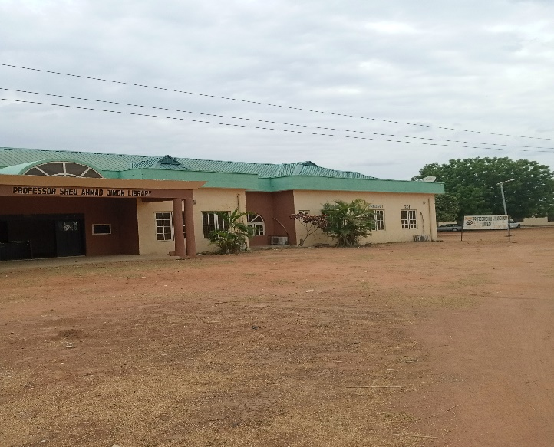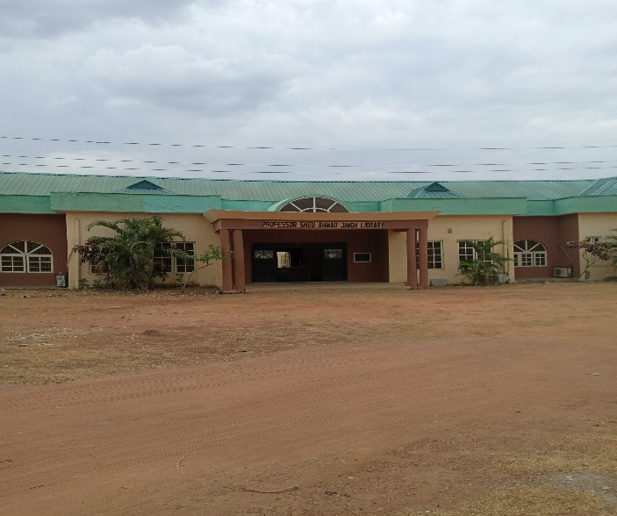
One of the first tasks assigned to me was in the Classification Unit, where I learned about the organization and arrangement of books on the shelves. I was introduced to the Dewey Decimal Classification (DDC) system, which is used to categorize books based on their subject matter. I was also trained on how to use headings, indexes, and cutter tables to locate books on the shelves. For example, I learned how to use the cutter table to determine the specific shelf location of a book based on its author's name. I also learned about the importance of consistency in classification and the need to follow established guidelines and standards.
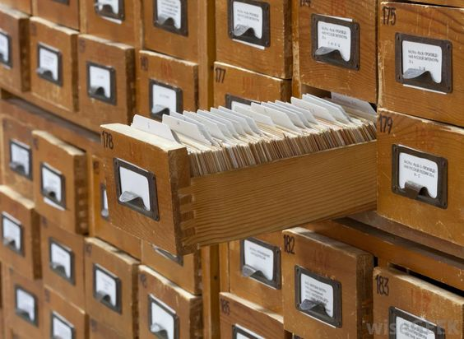
INDEXES
From the Classification Unit, I moved to the Acquisition Unit, where I was involved in the selection and purchasing of materials and resources for the library. I assisted the librarian in evaluating book reviews, publisher's catalogs, and other sources to identify relevant and useful materials for the library's collection. I also learned about the importance of considering factors such as relevance, accuracy, and currency when selecting materials for the library. Once the materials were acquired, I was responsible for stamping and gumming them, which involved applying a library stamp and gum to the book to indicate ownership and to prevent theft.
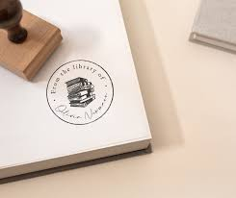
LIBRARY STAMP
Next, I worked in the Circulation Unit, which is responsible for the registration, charging, and discharging of library materials. I assisted in registering new users, issuing library cards, and explaining the library's policies and procedures to them. I also learned about the importance of maintaining accurate records of library materials, including circulation statistics and user data. I was responsible for checking out materials to users, collecting fines and fees, and shelving returned materials. I also assisted in compiling statistics on library usage, which helped to identify trends and patterns in user behavior and to inform library decision-making.
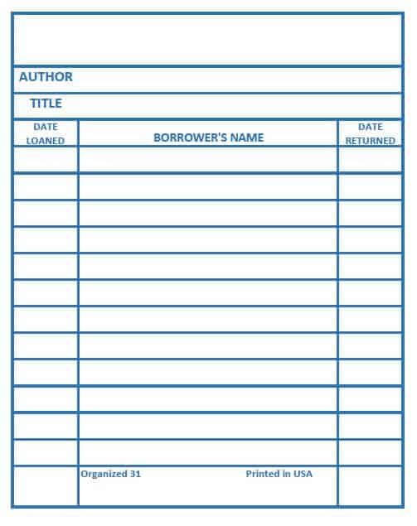
LIBRARY CARDS
Another unit I worked in was the Catalogue Unit, which is responsible for creating and maintaining the library's catalog. I learned about the different types of cataloging, including manual cards for single and double authors, edited books, and title access points. I also learned about the rules for cataloging, including the Anglo-American Cataloging Rules (AACR1 and AACR2), which provide guidelines for describing and accessing library materials. I assisted in creating manual cards for new materials, which involved entering bibliographic data, subject headings, and other relevant information into the catalog.
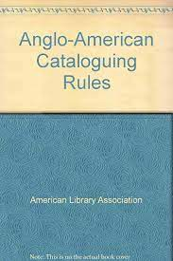
I also worked in the Serial Unit, where I was responsible for indexing and cataloging newspapers and other serial publications. I learned about the importance of maintaining accurate and up-to-date records of serial publications, which are often used by researchers and students. I assisted in creating indexes for newspapers, which involved identifying and recording relevant articles, editorials, and other content.

NEWSPAPER INDEXING
In addition to working in these units, I also had the opportunity to use the library's e-library, which provides access to electronic resources such as e-books, online journals, and databases. I learned about the different types of e-resources available, including subscription-based databases, open-access journals, and digital libraries. I also learned about the importance of evaluating online sources for credibility, accuracy, and relevance.
Finally, I worked in the Reference and Binding Unit, where I was involved in the binding and preservation of library materials. I learned about the different types of binding, including perfect binding, case binding, and Braille binding. I also learned about the materials used in binding, such as paper, glue, and thread, and the techniques involved in binding, such as sewing, gluing, and trimming. I assisted in binding and preserving rare and fragile materials, which required careful handling and attention to detail.
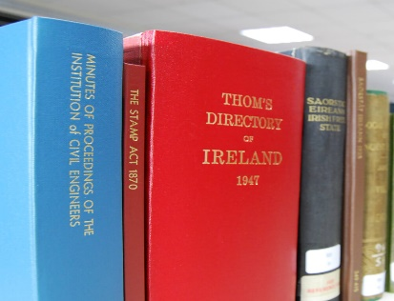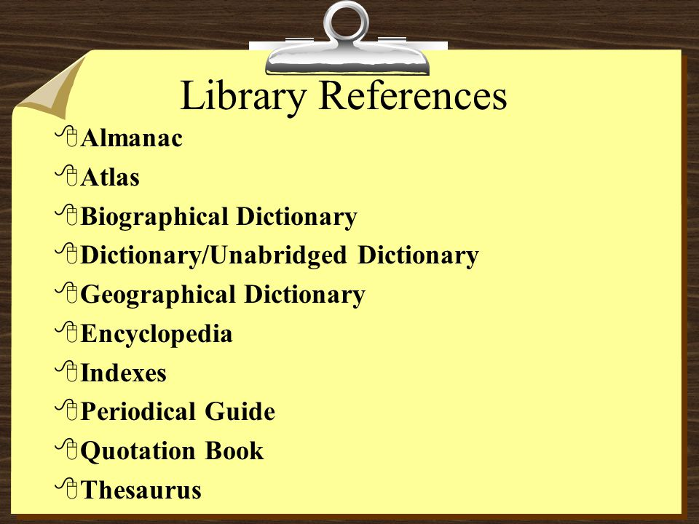
BINDED BOOKS REFERENCE FORMAT
Throughout my experience in the library, I gained a deeper understanding of the importance of libraries in supporting academic and research endeavors. I learned about the different units and processes involved in library management, from classification and acquisition to circulation and cataloging. I also gained hands-on experience in using library resources and services, including the e-library and reference materials. Overall, my experience in the Kwara State Polytechnic Library was highly rewarding and has prepared me for a career in librarianship or a related field.
In conclusion, my experience in the Kwara State Polytechnic Library was a valuable learning opportunity that provided me with a comprehensive understanding of library operations and management. I gained experience in various units, including classification, acquisition, circulation, cataloging, serials, e-library, and reference and binding. I also learned about the importance of attention to detail, consistency, and adherence to established guidelines and standards in library work. I am confident that the skills and knowledge I acquired will serve me well in my future career, and I am grateful for the opportunity to have worked in such a dynamic and supportive library environment.

CHAPTER FOUR
  - DESCRIPTION OF WORK DONE AND EXPERIENCE GAINED
Throughout my experience in the Kwara State Polytechnic Library, I gained a wealth of knowledge and skills that have prepared me for a career in librarianship and beyond. One of the most significant experiences I gained was in the classification unit, where I learned about the organization and arrangement of books on the shelves. I was introduced to the Dewey Decimal Classification (DDC) system, which is used to categorize books based on their subject matter. I also learned about the importance of consistency in classification and the need to follow established guidelines and standards. For instance, I gained hands-on experience in using headings, indexes, and cutter tables to locate books on the shelves. This experience has taught me the importance of attention to detail and the need to be meticulous in my work.
Another valuable experience I gained was in the acquisition unit, where I was involved in the selection and purchasing of materials and resources for the library. I learned about the importance of evaluating book reviews, publisher's catalogs, and other sources to identify relevant and useful materials for the library's collection. I also gained experience in considering factors such as relevance, accuracy, and currency when selecting materials for the library. This experience has taught me the importance of being discerning and critical in my selection of resources, and the need to consider the needs and preferences of the library's users.
My experience in the circulation unit was also highly rewarding. I assisted in registering new users, issuing library cards, and explaining the library's policies and procedures to them. I also learned about the importance of maintaining accurate records of library materials, including circulation statistics and user data. I gained hands-on experience in checking out materials to users, collecting fines and fees, and shelving returned materials. This experience has taught me the importance of providing excellent customer service and the need to be efficient and organized in my work.
In addition to these experiences, I also gained valuable skills in the cataloging unit. I learned about the different types of cataloging, including manual cards for single and double authors, edited books, and title access points. I also learned about the rules for cataloging, including the Anglo-American Cataloging Rules (AACR1 and AACR2), which provide guidelines for describing and accessing library materials. I gained hands-on experience in creating manual cards for new materials, which involved entering bibliographic data, subject headings, and other relevant information into the catalog. This experience has taught me the importance of accuracy and attention to detail in cataloging, and the need to follow established guidelines and standards.
My experience in the serials unit was also highly valuable. I learned about the importance of maintaining accurate and up-to-date records of serial publications, which are often used by researchers and students. I gained hands-on experience in indexing and cataloging newspapers and other serial publications, which involved identifying and recording relevant articles, editorials, and other content. This experience has taught me the importance of being thorough and meticulous in my work, and the need to consider the needs and preferences of the library's users.
Furthermore, my experience in the e-library was highly rewarding. I learned about the different types of e-resources available, including subscription-based databases, open-access journals, and digital libraries. I gained hands-on experience in using these resources, which involved searching, browsing, and retrieving information from online databases and digital libraries. This experience has taught me the importance of being tech-savvy and the need to stay up-to-date with the latest developments in technology and online resources.
Finally, my experience in the reference and binding unit was highly valuable. I learned about the different types of binding, including perfect binding, case binding, and Braille binding. I also learned about the materials used in binding, such as paper, glue, and thread, and the techniques involved in binding, such as sewing, gluing, and trimming. I gained hands-on experience in binding and preserving rare and fragile materials, which required careful handling and attention to detail. This experience has taught me the importance of being gentle and careful in my handling of materials, and the need to consider the long-term preservation and conservation of library materials.
In conclusion, my experience in the Kwara State Polytechnic Library has provided me with a wealth of knowledge and skills that have prepared me for a career in librarianship and beyond. I have gained hands-on experience in classification, acquisition, circulation, cataloging, serials, e-library, and reference and binding. I have learned about the importance of attention to detail, consistency, and adherence to established guidelines and standards in library work. I am confident that the skills and knowledge I acquired will serve me well in my future career, and I am grateful for the opportunity to have worked in such a dynamic and supportive library environment.

CHAPTER FIVE
- SUMMARY, CONCLUSION AND RECOMMENDATIONS
  - SUMMARY OF ATTACHMENT ACTIVITIES
The Student's Industrial Work Experience Scheme (SIWES) is a vital program that bridges the gap between theory and practice in various fields of study. As part of the approved minimum academic standards in Nigerian tertiary institutions, SIWES provides students with an opportunity to acquire industrial skills and experience in their field of study. This report highlights my as a student of the National Diploma (ND) program in Library and Information Science, who underwent the SIWES program at the Kwara State Polytechnic Library, Ilorin, Kwara State.
Throughout the program, I was exposed to various units and processes involved in the management and maintenance of the library. I received training in the Classification Unit, where I learned about the Dewey Decimal Classification (DDC) system and how to use headings, indexes, and cutter tables to locate books on the shelves. Additionally, I worked in the Acquisition Unit, where I assisted in selecting and purchasing materials and resources for the library. These experiences provided me with a deeper understanding of the theoretical concepts learned in the classroom and enabled me to apply their knowledge in real-life work situations.
The SIWES program also allowed me to interact with library staff and gain insight into the day-to-day operations of a library. I observed how the library provides a conducive environment for learning, teaching, and research, and how the library staff work together to ensure the smooth operation of the library. This experience helped mee developed essential skills such as communication, teamwork, and problem-solving, which are crucial for success in the library and information science profession.
5.2 CONCLUSION
In conclusion, the SIWES program is an essential component of the library and information science curriculum, as it provides students with the opportunity to acquire practical skills and experience in their field of study. The program enables students to bridge the gap between theory and practice, and to develop essential skills that are necessary for success in the profession. The experiences gained during the SIWES program have prepared me to take on the challenges of working in a library and information science environment, and have provided me with a deeper understanding of the importance of libraries in supporting the academic success of students and faculty.
The SIWES program has also highlighted the importance of collaboration between academic institutions and industrial organizations in providing students with practical experience and training. The program has demonstrated that libraries can play a critical role in providing students with hands-on experience and training, and that library staff can serve as mentors and role models for students. Overall, the SIWES program has been a valuable and enriching experience for the student, and has provided them with the skills, knowledge, and confidence necessary to succeed in the library and information science profession.
5.3 RECOMMENDATIONS
Based on the experiences gained during the SIWES program, several recommendations can be made to improve the program and to enhance the practical skills and experience of students in the library and information science profession. These are;
- I recommend that academic institutions and industrial organizations continue to collaborate in providing students with practical experience and training. This can be achieved through the establishment of partnerships and agreements that allow students to work in libraries and other information organizations, and to gain hands-on experience and training.
- I recommend that libraries and other information organizations provide students with a variety of tasks and responsibilities that allow them to develop a range of skills and competencies. This can include tasks such as cataloging and classification, collection development, reference services, and programming and outreach.
- I recommend that academic institutions and libraries provide students with opportunities for feedback and reflection throughout the SIWES program. This can be achieved through regular meetings and evaluations, as well as through the use of reflective journals and other tools.
- I recommend that academic institutions and libraries continue to emphasize the importance of practical experience and training in the library and information science curriculum. This can be achieved through the development of courses and programs that focus on practical skills and experience, as well as through the use of hands-on training and simulation exercises.
- I also recommend that libraries and other information organizations consider providing students with stipends or other forms of compensation for their work during the SIWES program. This can help to recognize the value and importance of the work that students do during the program, and to provide them with a sense of appreciation and motivation.
- Lastly, I recommend that academic institutions and libraries consider establishing mentorship programs that pair students with experienced library professionals. This can provide students with guidance, support, and advice throughout the SIWES program, and can help them to navigate the challenges and opportunities of the library and information science profession.

