

A TECHNICAL REPORT
STUDENT INDUSTRIAL WORKING EXPERIENCE SCHEME
(SIWES)

Held at

KWARA STATE TEACHING HOSPITAL, ILORIN
Prepared by:
ADETUTU GLORY VICTORIA
ND/23/NAD/FT/0010

SUBMITTED TO

DEPARTMENT OF NUTRITION AND DIETETICS
INSTITUTE OF APPLIED SCIENCE
KWARA STATE POLYTECHNIC, ILORIN

IN PARTIAL FULFILLMENT OF THE AWARD OF THE REQUIREMENT OF THE AWARD OF NATIONAL DIPLOMA IN NUTRITION AND DIETETICS

AUGUST – NOVEMBER 2024

DEDICATION
I dedicate this technical report to the Almighty God, the giver of knowledge, wisdom and understanding.

ACKNOWLEDGEMENT
I take this opportunity to express my profound gratitude and deep regards to the creator of heaven and earth, the one who knows the beginning and the end, the alpha and the omega, the Almighty God and also to my parents MR & MRS ADETUTU, and to all those who helped me during my SIWES programme. May Almighty God bless, protect, keep, nourish and guide you all… AMEN

ABSTRACTS
The Students Industrial Work Experience Scheme (SIWES) is an accepted skills acquisition programme which forms part of the approved academic standard in the degree programme for Nigeria University. In 1974, the federal government of Nigeria introduced the national policy on industrial training, called the Students Industrial Work Experience Scheme (SIWES).This programmes is under the umbrella of the ministry of education through the industrial training fund (ITF), was designed to help students acquire the necessary practical education/experience in their field of study and other related professions. This is an effort which was created on order to bridge the existing gap between the theory taught in the classroom and practice of science, agriculture, medicine, engineering, technology and other professional programmes in the Nigeria tertiary institution. The programme was established basically to impact elaborate practical understanding to students with respect to their various disciplines. This report is a summary of the experience I acquired during my Students' Industrial Work Experience Scheme (SIWES)

TABLE OF CONTENT
Title page i
Dedication ii
Acknowledgements iii
Abstract iv
Table of content v-vi
TABLE OF CONTENTS
CHAPTER ONE
  - Background of SIWES 1
  - History of SIWES 1-2
  - Objectives of SIWES 2-3
  - Objectives of Establishment 3
1.5 BRIEF HISTORY OF KWARA STATE TEACHING HOSPITAL 3
CHAPTER TWO
2.1. Kitchen Equipment 4-6
2.2. How to Calculate BMI 6-7
2.3. Concept and Significance Of Early Life Nutrition 7-8
2.4. Fruits Diabetes Patient Should Avoid 8-10
CHAPTER THREE
3.1. Job Description 11
3.2. Achievements 11
3.3. Challenges 11
3.4. Lessons Learned 12
CHAPTER FOUR
4.1 Conclusion 13
4.2 Recommendations 13-14

CHAPTER ONE
  - INTRODUCTION TO SIWES
Students Industrial Work Experience Scheme (SIWES) is a Skills Training Program designed to prepare and expose Students of Universities, Polytechnics, Colleges of Technology, Colleges of Agriculture and Colleges of Education for the Industrial Work situation they are likely to meet after graduation. The Scheme affords Students the opportunity of familiarizing and exposing themselves handling equipment and machinery that are usually not available in their institutions.

1.2 HISTORY OF SIWES
The Students’ Industrial Work Experience Scheme (SIWES) was initiated in 1973 by the Federal Government of Nigeria under the Industrial Training Fund (ITF) to bridge the gap between theory and practice among products of our tertiary Institutions. It was designed to provide practical training that will expose and prepare students of Universities, Polytechnics, and Colleges of Education for work situation they are likely to meet after graduation.
Before the establishment of the scheme, there was a growing concern among the industrialists that graduates of institutions of higher learning lacked adequate practical background studies preparatory for employment in industries. Thus the employers were of the opinion that the theoretical education going on in higher institutions was not responsive to the needs of the employers of labour.
As a result of the increasing number of students’ enrolment in higher institutions of learning, the administration of this function of funding the scheme became enormous, hence ITF withdrew from the scheme in 1978 and was taken over by the Federal Government and handed to National Universities commission (NUC), National Board for Technical Education (NBTE) and National Commission for Colleges of Education (NCCE). In 1984, the Federal Government reverted back to ITF which took over the scheme officially in 1985 with funding provided by the Federal Government.

1.3 OBJECTIVES OF THE PROGRAMME
The specific objectives of SIWES are to:
- Provide placements in industries for students of higher institutions of learning approved by relevant regulatory authorities (NUC, NBTE, NCCE) to acquire work experience and skills relevant to their course of study
- Prepare students for real work situation they will meet after graduation.
- Expose students to work methods and techniques in the handling of equipment and machinery that may not be available in schools.
- Make transition from school to the labour market smooth and enhance students’ conduct for later job placement
- Provide students with the opportunity to apply their knowledge in real life work situation thereby bridging the gap between theory and practice
- Strengthen employer involvement in the entire educational process and prepare students for employment in industry
Promote the desired technological knowhow required for the advancement of the nation.
1.4 OBJECTIVES OF ESTABLISHMENT
- To provide optimum and individual care to patients.
- To develop recognition for patients needs for privacy and preservation of dignity.
- To maintain good relationship with patients, relations and the community through health education.
- To carry out diagnosis and intervention.
- To provide training for students.
- To maintain sufficient hospital supply of equipment and promote their utilization and maintenance.
- To treat and control diseases.

1.5 BRIEF HISTORY OF KWARA STATE TEACHING HOSPITAL, ILORIN
Kwara State Teaching Hospital, Ilorin, is a tertiary healthcare institution that provides comprehensive medical services to patients. The hospital has a Dietetics Department that provides nutritional services to patients.

CHAPTER TWO
2.1 KITCHEN EQUIPMENT
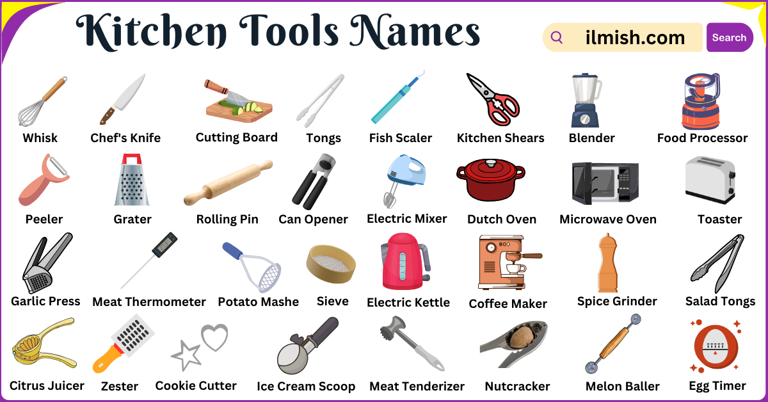
Kitchen equipment encompasses the tools and appliances used for preparing, cooking, and storing food, including cooking equipment, food preparation tools, storage containers, and cleaning tools.

COOKING EQUIPMENT:
- Ovens: For baking, roasting, and cooking a variety of dishes.
- Stoves/Cooktops: Provide heat for cooking on the stovetop.
- Grills: Used for grilling meat, vegetables, and other foods.
- Microwaves: For quick heating and cooking.
- Pots and Pans: Various sizes and types for different cooking needs.
- Stockpots: Large pots for boiling and simmering.
- Double boilers: Used for gently heating food.
- Pasta cookers: Designed specifically for cooking pasta.
- Sauce pots: Smaller pots for sauces and other liquids.
- Food pans: For baking, roasting, or holding food.
- Baking trays: For baking cookies, cakes, and other items.
- Oven dishes: For baking casseroles, lasagnes, and other dishes.
- Muffin trays and cake tins: For baking muffins and cakes.
- Wire racks: For cooling baked goods.
- Griddles: Used for cooking pancakes, flatbreads, and grilling meat.

FOOD PREPARATION TOOLS:
- Knives: Essential for cutting, slicing, and chopping.
- Cutting Boards: Provide a surface for cutting and chopping.
- Mixers: For mixing ingredients, such as batter or dough.
- Blenders: For blending, pureeing, and liquefying ingredients.
- Food processors: For chopping, slicing, and shredding food.
- Choppers: Similar to food processors, but smaller and simpler.
- Measuring cups and spoons: For accurate measurements.
- Mixing bowls: For mixing ingredients.
- Whisks: For incorporating air into ingredients.
- Spatulas: For flipping, stirring, and spreading.
- Tongs: For handling food while cooking.
- Can opener: For opening cans.
- Grater: For grating cheese, vegetables, and other foods.
- Colander: For draining pasta, vegetables, and other foods.
- Sieve: For sifting dry ingredients.
- Rolling pin: For rolling out dough.
- Mortar and pestle: For grinding spices and other ingredients.
- Salad tongs: For serving salads.
- Lemon squeezer: For squeezing lemons.
- Oil bottle: For storing and dispensing oil.
- Ladle: For serving soup and other liquids.
- Water jug: For storing and dispensing water.
- Bottle opener: For opening bottles.

STORAGE:
- Refrigerators: For storing perishable foods.
- Freezers: For long-term storage of foods.
- Food containers: For storing leftovers and other foods.

CLEANING TOOLS:
- Dishwashers: For washing dishes.
- Sinks: For washing dishes and cleaning up.
- Sanitizers: For cleaning and disinfecting surfaces.

2.2 HOW TO CALCULATE BMI
To calculate Body Mass Index (BMI), divide your weight in kilograms by your height in meters squared (BMI = weight (kg) / [height (m)]^2).

BREAKDOWN ON HOW TO CALCULATE BMI
- Metric Units:
  - Weight: Measure your weight in kilograms (kg).
  - Height: Measure your height in meters (m).
  - Calculation: Square your height (height x height), then divide your weight by the squared height.
  - Example: If you weigh 70 kg and are 1.70 m tall: 70 kg / (1.70 m * 1.70 m) = 24.22.

- US Customary Units:
  - Weight: Measure your weight in pounds (lbs).
  - Height: Measure your height in inches (in).
  - Calculation: Multiply your weight in pounds by 703, then divide that answer by your height in inches squared.
  - Example: If you weigh 180 lbs. and are 5 feet and 5 inches tall (65 inches total): (180 lbs * 703) / (65 in * 65 in) = 29.95.

- BMI CATEGORIES:
- Underweight: Below 18.5
- Healthy weight: 18.5 to 24.9
- Overweight: 25 to 29.9
- Obese: 30 or higher

2.3 CONCEPT AND SIGNIFICANCE OF EARLY LIFE NUTRITION
Early-life nutrition, encompassing the first 1000 days from conception to a child's second birthday, is crucial for establishing a foundation for lifelong health and development, with lasting impacts on growth, brain development, and disease prevention.
Concept of Early-Life Nutrition:
- The "First 1000 Days":
This period, from conception to a child's second birthday, is a critical window for growth and development, where nutrition plays a vital role in shaping long-term health outcomes.
- Nutritional Programming:
Early-life nutrition can influence the development of tissues and organs, potentially leading to irreversible changes and increasing the risk of chronic diseases later in life.
- Breastfeeding:
Breastfeeding is considered the gold standard of infant nutrition, providing essential nutrients and immune protection, and is recommended for the first six months, with continued breastfeeding alongside complementary foods until two years of age or beyond.
- Complementary Feeding:
At 6 months, infants need to start eating complementary foods, ensuring a variety of nutrient-rich foods are introduced in adequate quantities.
- Importance of Early Childhood Nutrition:
What, when, and how children eat before age 2 is more important than at any other time in life, impacting their physical and cognitive development, and setting the stage for future health.
Significance of Early-Life Nutrition:
- Optimal Growth and Development:
Adequate nutrition during the first 1000 days is essential for supporting healthy growth, brain development, and the development of other vital organs and systems.
- Reduced Risk of Chronic Diseases:
Poor nutrition in early life can increase the risk of developing chronic diseases like obesity, type 2 diabetes, cardiovascular disease, and other metabolic disorders later in life.
- Improved Cognitive Function:
Good nutrition during the first 1000 days is linked to improved cognitive function, learning abilities, and overall academic performance.
- Stronger Immune System:
Breastfeeding and proper nutrition during infancy help build a strong immune system, protecting children from infections and diseases.
- Long-Term Health Outcomes:
Early-life nutrition has lasting effects on an individual's health and well-being, influencing their lifespan and quality of life

2.4 FRUITS DIABETES PATIENT SHOULD AVOID
While fruits are generally healthy, individuals with diabetes should be mindful of their sugar content and choose fruits in moderation, with some like mangoes, bananas, and pineapple being higher in natural sugars and potentially causing blood sugar spikes.

FRUITS TO LIMIT OR AVOID, AND WHY:

- Mangoes:
High in natural sugars and carbohydrates, leading to a rapid increase in blood sugar.
- Bananas:
While a good source of nutrients, overly ripe bananas have a high glycemic index and can cause a rapid rise in blood sugar.
- Pineapple:
Contains a fair amount of sugar and has a moderate glycemic index, so it's best to consume in moderation.
- Watermelon:
Despite being refreshing, watermelon is high in sugar and can cause a rapid spike in blood sugar.
- Grapes:
High in natural sugars and can lead to quick spikes in blood sugar levels.

- Dried Fruits:
While nutritious, dried fruits are concentrated in sugar and should be eaten in smaller portions.
- Cherries:
While they have health benefits, cherries are high in sugar and can cause blood sugar spikes if consumed in large quantities.
- Jackfruit:
Similar to mangoes, jackfruit is high in sugar and carbohydrates, so it should be consumed in moderation.
- Chikku:
This fruit is also high in sugar and should be consumed in moderation.
- Figs:
People with diabetes should be cautious when consuming figs, as they can affect glucose levels in the blood.

Fruits to Include in Moderation:
- Apples:
A good source of fiber and nutrients, apples are a healthy choice for people with diabetes.
- Berries (Blueberries, Strawberries, Raspberries):
These fruits are lower in sugar and higher in fiber, making them a good choice for people with diabetes.
- Oranges:
A good source of vitamin C and fiber, oranges can be part of a balanced diet.
- Prunes:
Prunes are a good source of fiber and can be a healthy snack.
- Avocados:
Avocados are a good source of healthy fats and fiber, which can help regulate blood sugar levels.

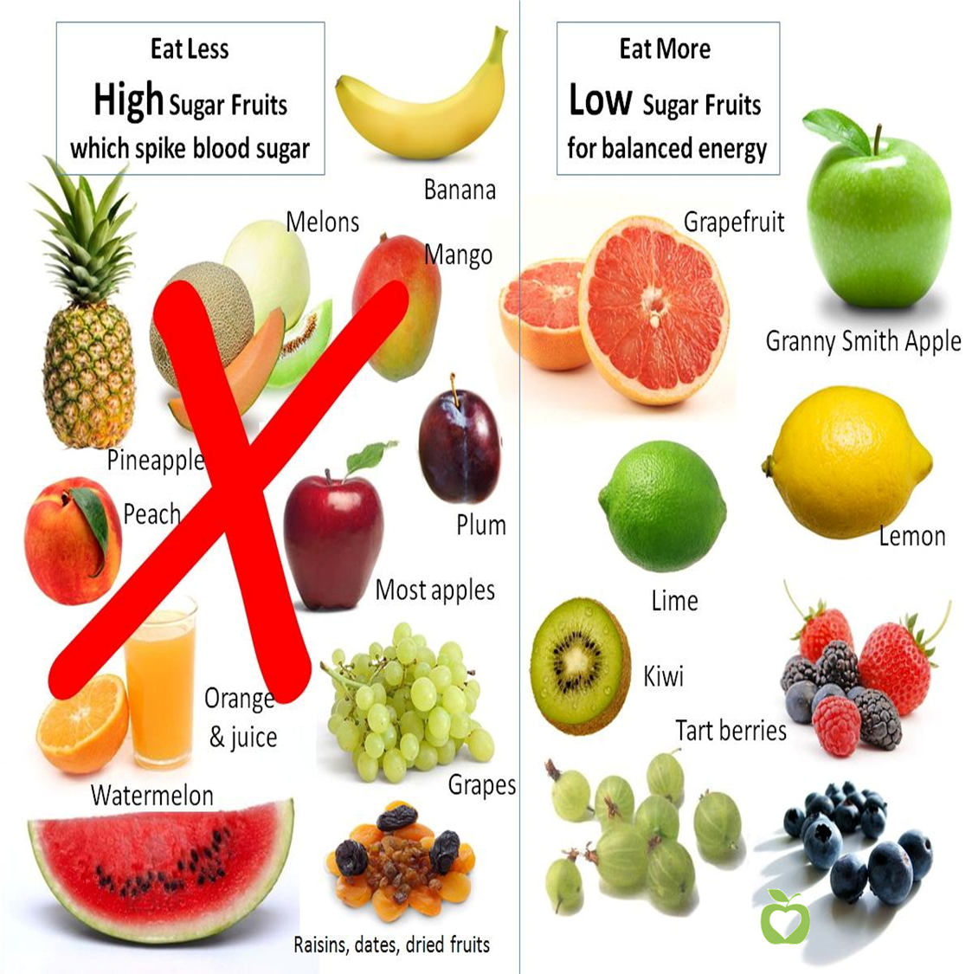

CHAPTER THREE
3.1 JOB DESCRIPTION
During my SIWES program, I worked closely with the dietitians and other healthcare professionals to gain practical experience in nutrition and dietetics. My duties included:
- Conducting nutritional assessments of patients
- Assisting in diet planning and education
- Participating in ward rounds and patient care conferences
- Assisting in the preparation of dietary menus and meal plans
3.2 ACHIEVEMENTS
During my SIWES program, I achieved the following:
- Gained practical experience in nutritional assessment, diet planning, and education
- Developed skills in communication and interpersonal relationships
- Contributed to the delivery of quality healthcare services
- Built relationships with healthcare professionals and patients
3.3 CHALLENGES
During my SIWES program, I faced the following challenges:
- Limited access to some patient information due to confidentiality agreements
- Difficulty in communicating with patients who spoke different languages
- Limited opportunities for hands-on experience in some areas of nutrition and dietetics.
3.4 LESSONS LEARNED
During my SIWES program, I learned the following:
- The importance of effective communication and interpersonal relationships in healthcare
- The need for cultural competence in healthcare delivery
- The value of teamwork and collaboration in achieving healthcare goals
- The importance of continuous learning and professional development in nutrition and dietetics

CHAPTER FOUR
4.1 CONCLUSION
The Student Industrial Work Experience Scheme (SIWES) plays a significant role in human resource development, it helps students develop new skills and enlightens them of what the present society holds for them after graduation and helps them adapt accordingly. In conclusion, my SIWES program at Kwara State Teaching Hospital, Ilorin, was a valuable learning experience that provided me with practical skills and knowledge in nutrition and dietetics. I am grateful to the hospital and the Dietetics Department for the opportunity to work with them. My SIWES program at Kwara State Teaching Hospital, Ilorin, was a valuable learning experience that provided me with practical skills and knowledge in nutrition and dietetics. I am grateful to the hospital and the Dietetics Department for the opportunity to work with them.
4.2 RECOMMENDATIONS
I put forward the following recommendations for future improvement of the scheme;
- That students of nutrition and dietetics be given more opportunities for hands-on experience in clinical settings
- That healthcare institutions provide more resources and support for nutrition and dietetics services
- Those healthcare professionals be trained in cultural competence and effective communication skills The scheme should also try to enforce the act guiding the establishment of the scheme, to serve as a deterrent to those establishments who reject student for IT.
- School Curriculum should be organized in such a way that the SIWES exercise be carried out at a stretch of six months and not the intermittent arrangement of three months twice.
- Be proactive and take initiative to seek out learning opportunities
- Develop good communication and teamwork skills
- Be flexible and adaptable in the face of challenges and changes

