

a TECHNICAL reporton student industrial
work experience scheme
(SIWES)
held at
DORMAN LONG ENGINEERING LIMITED,
Was established in 1949, managing director, CEO
Engineer Chris ijeli .
written by
MUSTAPHA NIMOTALLAHI MOJISOLA
nd/23/MET/Pt/0005

submitted to
department of agricultural and bio-environmental engineering technology, institute of technology (iot), Kwara state polytechnic, p.m.b 1375, ilorin, kwara state, nigeria

In partial fulfillment for the award of national diploma (ND) in agricult
ural ENGINEERING

AUGUST – December, 2024

DEDICATION
This report is dedicated to the Lord God Almighty.

ACKNOWLEDGEMENT
My profound appreciation goes to Almighty God, whom with His grace gave me the opportunity to complete my industrial training exercise safely.
I would also like to express my deepest appreciation to

TABLE OF CONTENTS
CHAPTER ONE
1.0 Introduction
1.1 Aims and Objectives
1.2 Names of Companies
1.3 Location of the Companies
1.4 Brief Summary of the Companies’ Activities
1.5 Organization Chart
CHAPTER TWO
2.0 Workdone
2.1 H-Beam
2.2 Flat bar
2.3 Angular Irons
2.4 Galvanized items
2.5 Beam structure
2.6 Drilling machine
2.7 How to drill hole using CAD files
CHAPTER THREE
3.0 Special Operations and Procedures
3.1 Dimension check
3.2 Dimension check on Camber beams
3.3 Dimension check on Angular bracing
3.4 Pipe bracing
CHAPTER FOUR
4.0 Recommendation and Conclusion
4.1 Recommendation
4.2 Conclusion
CHAPTER ONE
1.0 INTRODUCTION
The student's industrial work experience scheme (SIWES) is a program designed for student of tertiary institutions with the aim of exposing students that have acquired theoretical knowledge in the classrooms to the practical exposure and experience.
The scheme is a Program involving the students, the university and the industry. Participation in SIWES has become a necessary precondition for the award of diploma and degree certificate in specific discipline in most institution of higher learning in the country in accordance with the educational policy of the government.
The bodies involved are the federal Government, the industrial training fund (ITF). Other supervisory agency is the National council for college of education (NCCE). The success of, or otherwise; the SIWES, depends on these bodies and the general public involved in articulation and management of the program.
1.1 AIMS AND OBJECTIVES OF SIWES
- To provide students with the opportunity to apply their theoretical knowledge in real work situation, thereby bridging the gap between university work and actual work
- To provide an avenue for students in Nigeria universities to acquire industrial skills and experience in their course of study.
- To enlist and strengthen employers in the entire educational process of preparing university graduates for employment in industries.
- To help students prepare for the corporate world and enhance their curriculum vitae.
- To improve interpersonal relationship skills of the students.
- To make the transition from university world of work easier; and enhance contact for job placement.
- To expose students to work methods and techniques in handling equipment and machinery that may not be available in their institutions.
1.2 NAME OF THE COMPANY
DORMAN LONG ENGINEERING LIMITED
1.3 LOCATION OF THE COMPANY
      - DORMAN LONG ENGINEERING LIMITED is located at 371, OID Abeokuta Expressway Oko-Oba Agege, Lagos State.
1.4 BRIEF SUMMARY OF COMPANIES ACTIVITIES
- DORMAN LONG ENGINEERING LIMITED is an …
1.5 ORGANIZATION CHART
DIRECTOR OF WORKS

TECHNICAL OFFICERS

AUTOMOBILE TECHNICIANS

SUPERVISORS

STUDENTS WORKERS SIWES

CHAPTER TWO
2.0 WORKDONE
2.1 H – Beam
The H beam platform welding process is a process that connects H-shaped steel (a steel with a cross-sectional shape similar to the English letter H) through welding technology. Common H beam classifications include hot-rolled and welded H beam. It has the advantages of high structural strength, good stability, strong load-bearing capacity, and convenient construction. It is widely used in bridges, buildings, ships, machinery manufacturing and other fields.
Application fields
- Bridge construction such as bridge decks, piers and other parts of large bridges.
- Building structure: The beams, columns and other parts of high-rise buildings, long-span structures and other buildings often use H -shaped steel platform welding technology.
- Ship manufacturing: The hull structure, deck and other parts of the ship need to bear large loads, and the H beam platform welding process can provide sufficient structural strength and stability.
- Machinery manufacturing: In the manufacturing of large mechanical equipment, the H-shaped steel platform welding process is often used in the support structure, frame and other parts of the equipment.
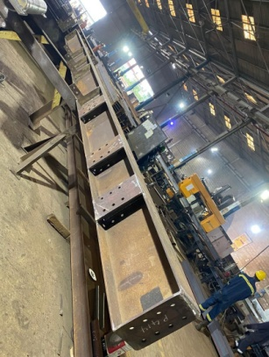
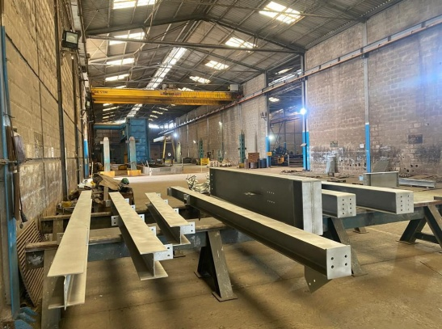
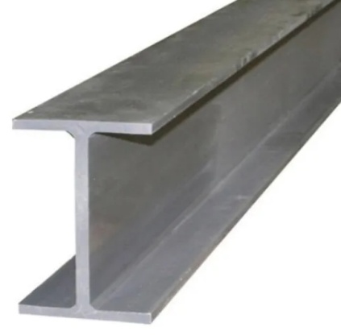

2.2 FLAT BARS
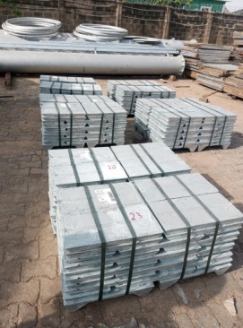
Flat bars refer to long, rectangular pieces of metal (usually steel) that are commonly used for fabrication and structural support due to their ease of welding, cutting, and drilling, making them ideal for building frameworks and creating complex structures in various applications like construction, machinery, and art installations.

2.3 ANGLE IRONS
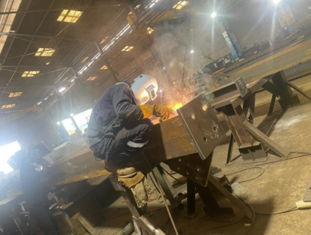
Angle iron, a metal bar with an L-shaped cross-section, is a commonly used material in fabrication work due to its exceptional strength, versatility, and ability to provide structural support for various projects by creating stable corners and frames; it's ideal for building machine bases, shelving units, brackets, trusses, tool holders, and more, making it a key component in constructing sturdy and reliable structures.

2.4 GALVANIZED ITEMS
Galvanized items are refer to metal components that have been coated with a layer of zinc, typically steel, which are considered challenging to weld due to the zinc coating that can create harmful fumes when exposed to high welding heat, often requiring special precautions and techniques to weld properly; ideally, the zinc coating should be removed from the weld area before welding. Examples of galvanized items typically include: galvanized steel pipes, structural steel beams, fence posts, metal building components, car body parts, handrails, ladder rungs, and even some smaller hardware like nuts, bolts, and screws, as these are commonly galvanized to enhance corrosion resistance

2.3 BEAM STRUCTURE
Beam structures are widely used in many engineering fields, for example, mechanical, civil, and aerospace engineering areas. A beam is another simple but commonly used structural component. Geometrically, it is usually a slender straight bar of an arbitrary cross-section, but it deforms only in directions perpendicular to its axis.
Welding structural beams is essential in construction and fabrication, and various methods are used depending on the materials, design requirements, and project specifications. Here are some common welding methods employed for structural beams:
1. Shielded Metal Arc Welding (SMAW)
- Description: Also known as stick welding, SMAW uses a consumable electrode coated in flux to lay the weld.
- Applications: Suitable for steel and iron; often used in construction and repair work.
2. Gas Metal Arc Welding (GMAW)
- Description: Commonly referred to as MIG (Metal Inert Gas) welding, GMAW uses a continuous wire feed as an electrode and an inert gas to shield the weld pool.
- Applications: Effective for thin to medium thickness materials; used in manufacturing and construction.
3. Gas Tungsten Arc Welding (GTAW)
- Description: Known as TIG (Tungsten Inert Gas) welding, GTAW uses a non-consumable tungsten electrode and requires a filler material. The weld area is protected by an inert gas.
- Applications: Ideal for stainless steel and non-ferrous metals; provides high-quality welds.
4. Flux-Cored Arc Welding (FCAW)
- Description: Similar to GMAW, FCAW uses a tubular wire filled with flux. It can be used with or without shielding gas.
- Applications: Effective for thick materials and outdoor applications due to its high deposition rate.
5. Submerged Arc Welding (SAW)
- Description: In SAW, the weld is submerged under a blanket of granular flux, which protects the weld from contamination.
- Applications: High-speed welding of thick sections; commonly used in shipbuilding and heavy equipment manufacturing.
6. Electron Beam Welding (EBW)
- Description: A fusion welding process that uses a beam of high-velocity electrons to melt the workpieces.
- Applications: Suitable for precision welding of thick materials; used in aerospace and high-tech industries.
7. Laser Beam Welding (LBW)
- Description: Uses a laser to melt the materials together, offering high precision and speed.
- Applications: Common in automotive and electronics industries; effective for thin materials.
8. Resistance Spot Welding (RSW)
- Description: Involves the application of heat generated by resistance to electric current to join overlapping metal surfaces.
- Applications: Widely used in the automotive industry for sheet metal assembly.
When selecting a welding method for structural beams, the following factors are to be considered:
- Material Type: Different methods are suitable for different materials (e.g., steel, aluminum).
- Thickness of Material: Some methods are better for thicker materials.
- Positioning: The ease of welding in different orientations (flat, vertical, overhead).
- Cost and Equipment Availability: Some methods require specialized equipment and training.
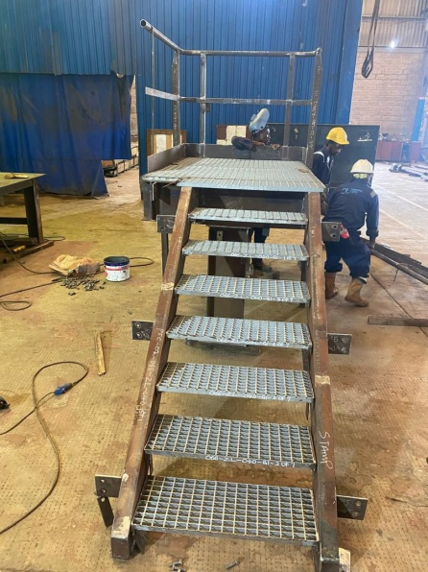
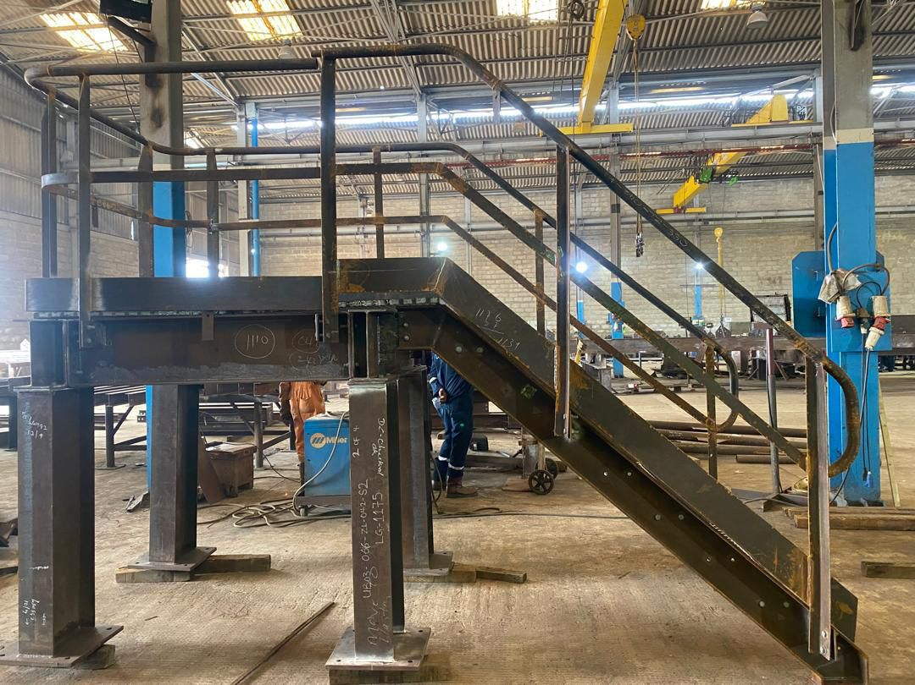
2.4 DRILLING MACHINE
A drilling machine, called a drill press, is used to cut holes into or through metal, wood, or other materials. Drilling machines use a drilling tool that has cutting edges at its point. This cutting tool is held in the drill press by a chuck or Morse taper and is rotated and fed into the work at variable speeds. Drilling machines may be used to perform other operations. They can perform countersinking, boring, counterboring, spot facing, reaming, and tapping. A drilling machine comes in many shapes and sizes, from small hand-held power drills to bench mounted and finally floor-mounted models.
Drill press operators must know how to set up the work, set speed and feed, and provide for coolant to get an acceptable finished product. The size or capacity of the drilling machine is usually determined by the largest piece of stock that can be center-drilled.
There are two types of drilling machines used by maintenance personnel for repairing and fabricating needed parts: hand-feed or power-feed. Other types of drilling machines, such as the radial drill press, numerically controlled drilling machine, multiple spindle drilling machine, gang drilling machine, and turret drill press, are all variations of the basic hand and power-feed drilling machines. They are designed for high-speed production and industrial shops.
Drilling Operation
Drilling on a lathe machine is the process of making a cylindrical hole in a workpiece. It's done by rotating the workpiece while holding a drill in the tailstock.
Steps
- Secure the workpiece in a chuck or on a faceplate
- Attach the drill to the tailstock
- Position the drill near the workpiece
- Rotate the tailstock handle clockwise to feed the tool against the workpiece
- Rotate the tailstock handle counterclockwise to withdraw the tool
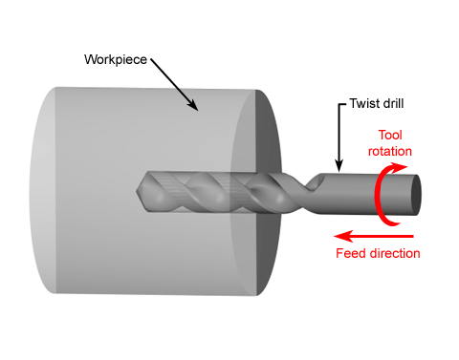

2.5 How to Drill Holes Using CAD Files

Step 1: Converting the CAD file to G-Code.
The engineers wanted to make the process as simple and straightforward as possible. A problem that we encountered was that when you import a .dxf file into the PAC, it generates all of the G-Code for that file automatically. See Figure 3.
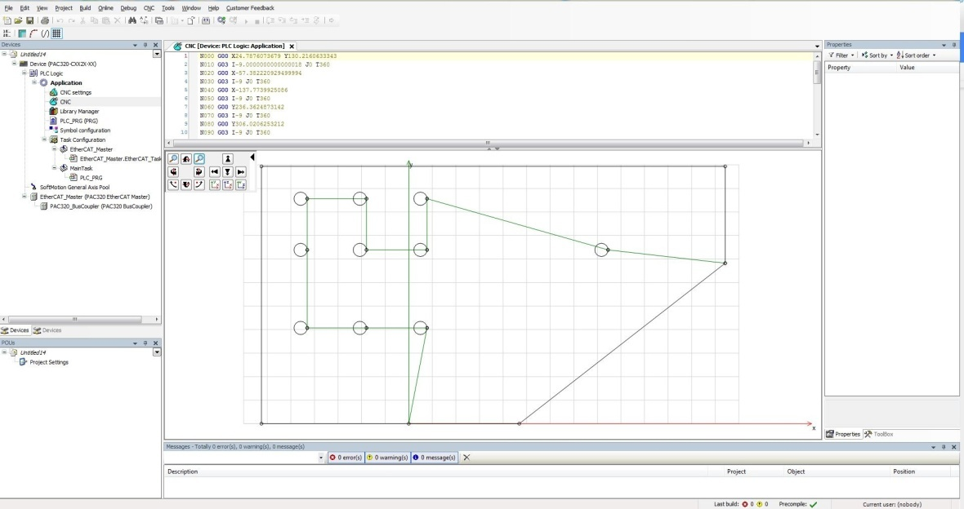
This is an example of what it would look like to import just the .dxf file. The image shows the path that the drill heads will take. We don’t want it to follow the outer edge of the part. We want it to go to the center of each hole location and then drill.
The problem with this is that the PAC will use the entire object as its path. For example, if this .dxf file were to be used, the tool would follow the path with its drill head. It would outline the outside edge of the object and then circle all of the holes. This is not what we want.
The solution was a simple fix. CAD software has the ability to ‘layer’ drawings on top of an existing drawing. All the engineers had to do was make lines from hole center to hole center as a separate layer. Once that was done, the whole .dxf file can be imported into the PAC. The PAC has built-in functionality to select which layer the programmer wants to use. See Figure 4.
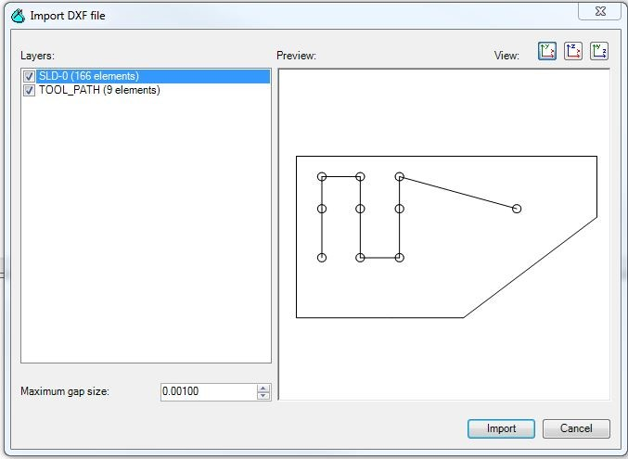
Figure 4: This is an example of what it looks like to import a .dxf file with multiple layers. All of the layers all selected in this import, but it is easy to select only 1 layer by unchecking or checking the boxes under the Layers section.
The ending result can be seen in Figure 5 and 6. With this step, the path for the tools is generated very simply and all of the hole locations are known. The ability to use the engineer’s existing drawings to get hole locations was huge because it saved them hours and hours of programming time. Essentially, we took what they already had and made it work for them.
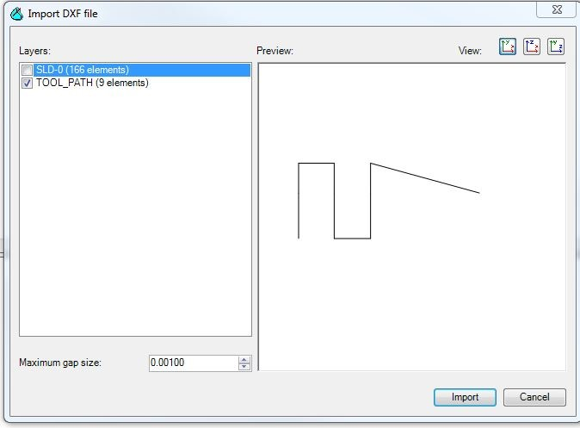
Figure 5: Tool Path Layer.
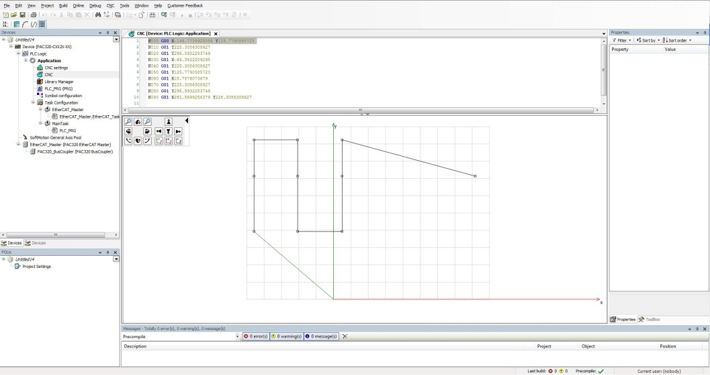
Figure 6: This is the what the .dxf file looks like after it has been imported into the controller.

Step 2: Editing the G-Code.

So, we have all hole locations or target positions where we need to drill, but how do we drill? If the .dxf file were to be run as is, the drill head would go to that position, stop, then continue to the next hole position.
CNC machines are programmed using M-Code. M-Codes are much like sub-functions; they can do whatever the programmer creates it for. When the controller reads an M-Code, it stops path following and executes the sub function. In our case, that sub-function would be to drill. See Figure 7 for an example of what the code would look like. This process can easily be done by using something as simple as an excel sheet to enter all of the drilling commands into the G-Code. See Figure 8 for entering all of the M-Codes by hand. By doing this step, we have essentially created a very basic CNC machine.
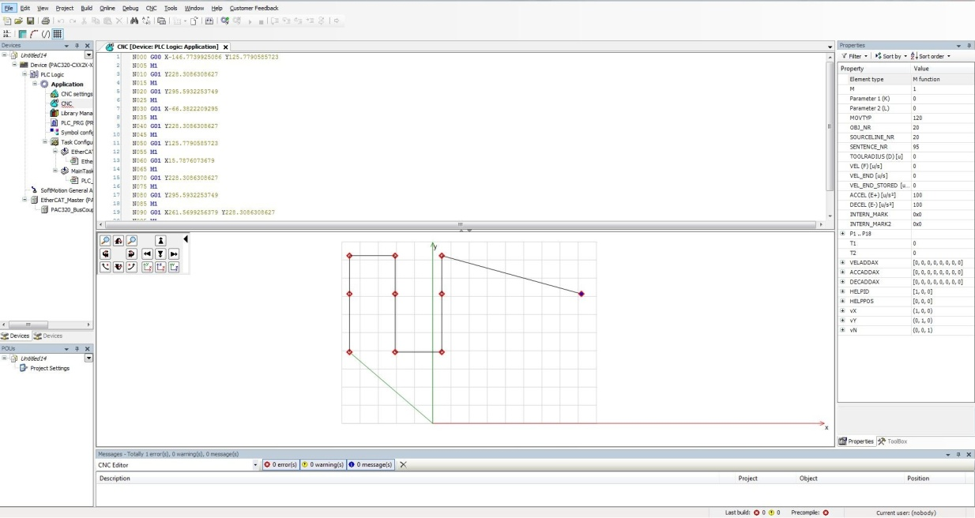
Figure 7: DXF File with M-Code commands.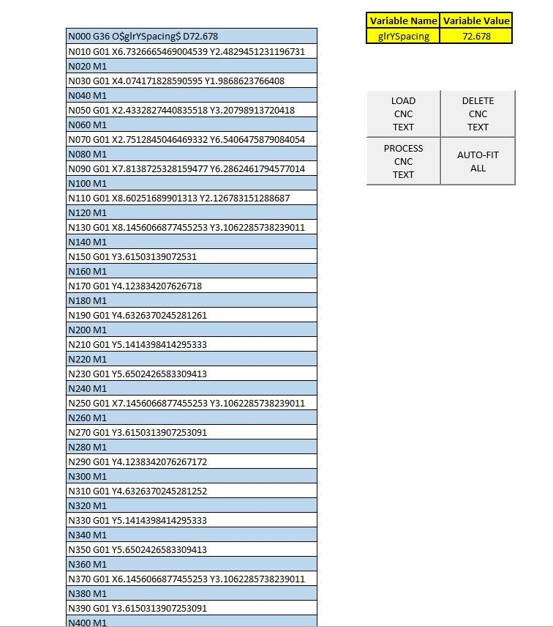
Figure 8: Excel App created by Cross Motion Solution App Engineer Ben Bishop. Automatically creates the desired CNC file to run the controller.

Step 3: Embedded Variables
A tricky part of this application was having to program for two independent drill heads. If both drill heads are going to be drilling at the same time, then the spacing between them has to correlate to the spacing between the holes. It just so happens that we can save variables in the G-Code that will be used to determine the spacing between the Z1 and Z2 axes. The G36 command is what we used to change the spacing between the Z1 and Z2 axes.

Step 4: Send CAD File to Controller
Now we have the ability to generate hole positions from existing CAD drawings, drill based off of the M-Code commands, and set the spacing between Z1 and Z2 axes. So, how do we get the modified ‘CNC’ file to the PAC? The PAC has a very useful tool built in it to communicate using FTP. FTP stands for File Transfer Protocol, and it is a standard network protocol used to transfer computer files between a client and server on a computer network.
The engineers wanted the ability to load new ‘CNC’ files into the PAC remotely and easily. By using their existing network, we were able to do that. The FTP site for the PAC is built-in. This allowed the engineer to transfer their modified file into the PAC and use it for every different part that they have. By doing this, the engineer can simply connect to the PAC over their network and send the file to the PAC using FTP. This way, there is no programming change. All the engineer has to do is load the ‘CNC’ file into the controller.

CHAPTERTHREE
SPECIAL OPERATION AND PROCEDURES
3.0 Special Operation and procedures carried out at MR. OLAIYA TECH.
3.1 Dimension check
Dimension checks are critical to ensure that welded components meet specified tolerances and fit within the required assembly. Accurate measurements are vital for structural integrity and functionality. Dimension checks help identify potential issues early in the process, preventing costly rework and delays.
Types of Dimension Checks
- Linear Measurements: This involves measuring the length, width, height, and diagonal dimensions of components. Accurate linear measurements ensure that parts will fit together properly.
- Angular Measurements: These checks assess the angles formed by joints or connections. Correct angles are crucial for maintaining alignment and structural performance.
- Spacing Checks: Ensure proper distance between components, which can affect load distribution and overall strength.
- Alignment Checks: Verify that components are aligned correctly during assembly and after welding to prevent misalignment issues that could lead to structural failure.
Measurement Tools and Techniques
Various tools are used for dimension checks which including
- Calipers: For measuring internal and external dimensions and depths. Micrometers: For precise measurement of small dimensions.
- Levels: To ensure that surfaces are flat and aligned.
- Gauges: To check tolerances and fit.
3.2 Dimension check on Camber beams
In the simplest terms, camber refers to curving. In rolled metal, camber is a curve across the plane of the sheet, whether down the middle or along one or both edges. Camber is measured by putting a straight edge next to the sheet. The greatest distance between the straight line and the sheet’s curve is the camber. A cambered sheet might be slightly thinner in the middle than on the edges (concave), thicker in the middle (convex), or thinner on one side (triangular). Any one of these can lead to costly machine malfunctions later on.
Camber in sheet metal is caused by roll deflection, perforating, or cutting. Rolling direction and variations in the thickness of coiled steel can create problems. Improper camber in a sheet of metal makes it difficult to roll the sheet into a coil. And camber in a rolled coil makes it difficult to cut or shape the roll into pieces. Processing machines depend on consistent thickness for cutting, punching, and custom shaping or roll forming, so precision is key.
Camber is a curve in the vertical plane or strong axis (hardway bending) of a metal beam or sheet. Imagine you’re looking at a beam from one end. The beam would be positioned like a capital “I.” Camber can, however, be anticipated and corrected. Processers can use a corrective leveler to straighten a coil as it unrolls. With a series of horizontal and vertical rollers, the straightening machine creates a more uniform sheet before further processing. Since its vital to control the degree of camber for precision stamping and precision deep drawing applications, it’s important to obtain alloys from a metal expert that you can trust.
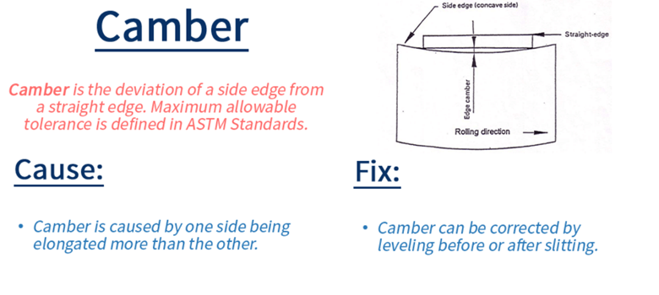3.3 Dimension check on Angular bracing
Angular distortion in welding refers to the bending or warping of a welded joint that occurs due to the heat applied during the welding process. This distortion can affect the alignment and overall geometry of the welded components.
Causes of Angular Distortion:
- Thermal Expansion and Contraction: When metal is heated during welding, it expands. As it cools, it contracts. If different parts of the joint cool at different rates, it can lead to angular distortion.
- Uneven Heating: Variations in heat input can cause certain areas to expand more than others, leading to uneven stresses in the material.
- Weld Pool Dynamics: The shape and movement of the molten weld pool can influence how the surrounding material reacts, contributing to distortion.
Effects of Angular Distortion:
- Misalignment: Components may not fit together as intended, leading to issues in assembly and function.
- Increased Stress: Distortion can introduce residual stresses in the welded joint, which may affect the structural integrity.
- Aesthetic Issues: For visible welds, angular distortion can lead to an unsightly appearance.
Mitigation Techniques:
- Preheating: Heating the base metal before welding can help reduce the temperature gradient and minimize distortion.
- Welding Sequence: Planning the order of welds can help distribute heat more evenly and reduce the risk of distortion.
- Clamping and Fixturing: Using clamps or fixtures to hold parts in place during welding can help maintain alignment.
- Post-Weld Treatment: Techniques such as stress relieving or heat treatment can be used to minimize residual stresses and distortion after welding.
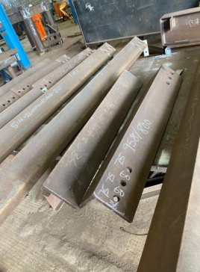
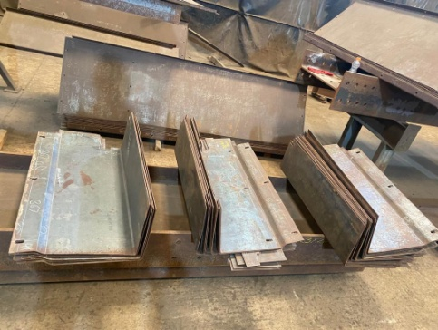

3.4 Pipe bracing
Pipe bracing" in welding refers to the practice of using additional pieces of pipe, often welded to the main pipe run, to provide structural support and prevent distortion or movement during the welding process, particularly on long or complex pipe sections; essentially acting as a temporary brace to maintain alignment and stability while welding takes place.
Braces are typically positioned strategically along the pipe run, often at points where significant stress is expected, like bends or intersections.
Types of braces:
- Lateral braces: Placed perpendicular to the main pipe to prevent sideways movement.
- Vertical braces: Used to support the pipe from above or below, preventing sagging.
- Diagonal braces: Provide additional stability by creating a triangular support system.
Material:
Braces are usually made from the same pipe material as the main pipe run, allowing for easy welding.
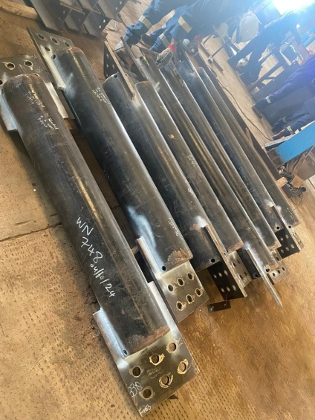
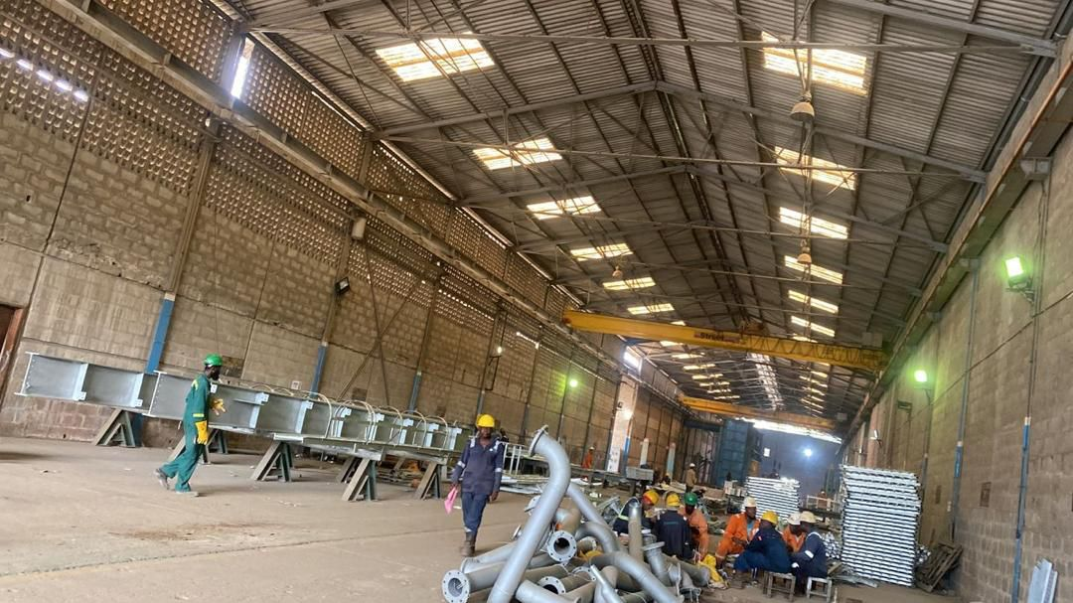
CHAPTER FOUR
OBSERVATIONS, CONCLUSION AND RECOMMENDATION
4.1 OBSERVATION
The SIWES programme undergone at DORMAN LONG ENGINEERING LIMITED afforded me an in-depth exposure to some of the practical industrial aspects of Agricultural branches. I was opportuned to have known the feed formulation. Experience was also garnered in the handling of layer birds especially when they started laying eggs.
Besides, knowledge and skills were acquired in both section of the farm (piggery and poultry section). The programme has been highly enlightening, beneficial, interesting and successful. The objective of which the scheme was undergone was however achieved.
4.2 CONCLUSION
The SIWES programme for me is educative and has empowered me with various opportunities to be self employed and in fact to be able to establish a farm based on many of all that have been practicalized. With the help of God the programme has enable a kind of workable opportunity to perform theories in a practical way, to see many of the equipment/tools used in the farm (birds, battery cage, deep litters etc.)
4.3 RECOMMENDATION
Although SIWES undergone did achieve quite a lot of its stated objectives, nevertheless, the following recommendations are suggested to improve the qualitative context of the programme:
- SIWES Students should endeavour to participate actively and positively during the SIWES programme (i.e try to be hardworking) and see the industry where the programme is taking place as a research place where all that he/she has been taught in the class can be practicalized.
- The Industry should not see SIWES students as casual workers but as professionals in the making.
- Participation of private corporate organization to minimize the problem of low funding as recently complained by the director of ITF.
- Sending students specifically to establishment where the stipulated aims and objectives of SIWES would be achieved.
- Payment of befitting student allowance to assist in students finances during the period of training.

