

A TECHNICAL REPORT
ON

STUDENT INDUSTRIAL WORK EXPERIENCE SCHEME (SIWES)

HELDAT

BRO AJOBI FARM
ALONG SOBI ROAD CAMIC ESTATE, ILORIN, KWARA STATE.

COMPILED BY:
John Isaac ugbede
ND/23/AGT/PT/0085

SUBMITTED TO

DEPARTMENT OF AGRICULTURAL TECHNOLOGY INSTITUTE OF APPLIED SCIENCES, (I.A.S) KWARA STATE POLYTHENIC P.M.B. 1375 ILORIN

AUGUST-NOVEMBER, 2024

DEDICATION
This technical report is dedicated to Almighty God, the king of the whole Universe. Glory be to him for giving me the grace and ability to work as a student in order to achieve a set goal. Also to my parents for their word of encouragement that serve as backbone for me, I really say big thanks to you all.

ACKNOWLEDGMENT
My special thanks go to Almighty God for his provision, protection, mercy and love upon my life, right from my birth till this present moment. May his name be praised forever.
My appreciation goes to my lovely parents for their love, care and support on my career. May God continue to bless and strengthening and the entire member of the class for their immense contribution.
1 also want to use this medium to appreciate my SIWES supervisor from Kwara state polytechnic my prayer for you is that you will live long to eat the fruit of your labour (Amen).

PREFACE
This report will help the upcoming agricultural technology student, especially those that are interested in post harvest. I sincerely believe and hope that it will improve their skills both in term of objectives and practical aspect.

TABLE OF CONTENT
Title page
Dedication
Acknowledgement
Preface
Table of content
CHAPTER ONE
1.0 Introduction
1.1 Background of SIWES
1.2 Objectives of Siwes
CHAPTER TWO
2.0 Specific function of various section/ units of organization
2.1 Student specific involvement in various units
2.2 Interpersonal relationship with the organization
2.3 Organizational Chart
CHAPTER THREE
3.0 Work-down
CHAPTER FOUR
4.0 Experience Gained
CHAPTER FIVE
5.0 Recommendation
5.1 Suggestion

CHAPTER ONE
1.0 INTRODUCTION
The Student Industrial Work Experience Scheme (SIWES) was introduced by Nigerian University Commission (NTJC) to augment student’s class room work. It is being co-ordinate by the Federal Government in 1973 in association with the Nigerian University Commission (NUC).
1.1 BACKGROUND
Sequel to the beginning of SIWES in 1973, there was obvious evidence that Inadequate practical exposure of students in Universities and Polytechnics posed serious challenges to both the quality and standard of Engineering and Technological Education in our Country. This inadequacy became a threat to the industrial and technological growth of the country as industries found graduates unsuitable for employments without undertaking the industrial training.
1.2 THE OBJECTIVES OF SIWES
* To breach the gap between theoretical classroom learning and practical industrial experience.
* To get students exposed to methods of handling standard tools and equipments.
* To create job opportunity for students after school.
* To enlist and strengthen employees involvement in the entire educational process.

CHAPTER TWO
2.0 SPECIFIC FUNCTION OF THE VARIOUS SECTION / UNITS
OF THE ORGANIZATION
These are the various unit of the organization and their specific function:
DIRECTOR: They are the head of management and he is also in charge of the organization affairs.
SECURITY: the person in charge of monitoring the area and well safe of the farm.
2.1 STUDENT SPECIFIC INVOLVEMENT IN VARIOUS SECTION/ UNITS
Since the major aims and objectives of SIWES programme is to enlighten students more with the practical aspect in respect to the theoretical aspect that they have been taught in class, I was attached to the training section where I was introducing to feeding of goats, cow, operating of planter machine in the crop farming section and other machine uses in the following department:
- Livestock Section: Rearing and management of cattle and goats.
- Crop Production Section: Cultivation and harvesting of maize and beans
- Feed Production Unit: Preparation of animal feed using farm-grown maize and beans
- Marketing and Sales Unit: Distribution and sales of farm products.
2.2 OBJECTIVES OF ESTABLISHMENT
- To produce high-quality cattle and goats for meat and dairy purposes.
- To cultivate and supply maize for human consumption and animal feed.
- To contribute to agricultural development and food security.
2.3 ORGANIZATION
Farm Manager
Secretary
Livestock Supervisor

Crop Production Supervisor

Siwes Student
Farm Workers

Administrative Staff

CHAPTER THREE
3.0 WORK-DONE
During my industrial attachment, I actively participated in various farm activities, including:
Livestock Management:
- Feeding and watering of cattle and goats to ensure proper nutrition and hydration.
- Cleaning and disinfecting animal pens to maintain hygiene and prevent disease outbreaks.
- Assisting in disease prevention and treatment, including vaccination and deworming of livestock.
- Monitoring the health of animals and reporting any unusual behavior to the farm supervisor.
- Assisting in artificial insemination and natural breeding programs to improve livestock quality.
- Learning how to identify and manage common livestock diseases.

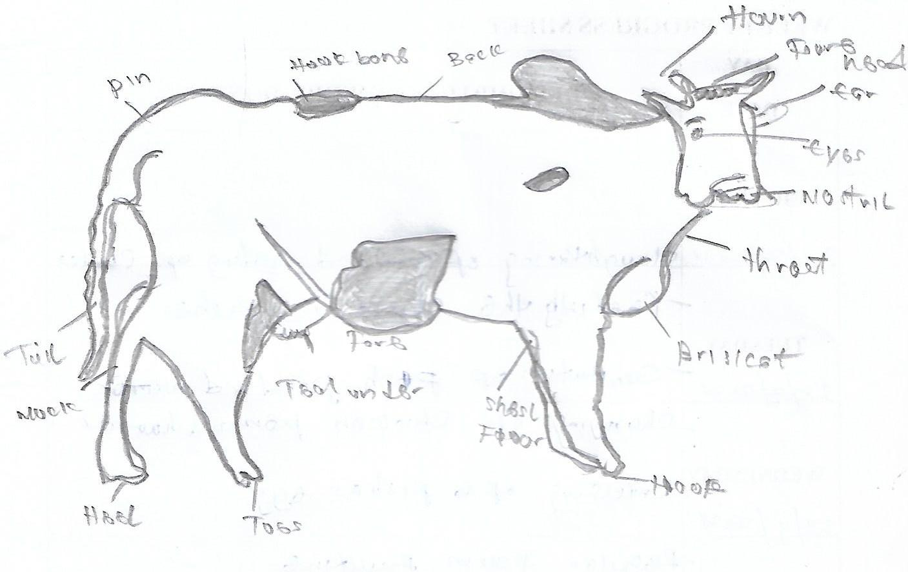

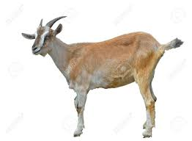

Crop Farming Activities:
- Land preparation, including plowing, harrowing, and ridging for maize and beans cultivation.
- Planting maize seeds using proper spacing techniques to maximize yield.
- Regular weeding and application of fertilizers and pesticides to promote healthy growth.
- Irrigation management to ensure adequate water supply for crops.
- Harvesting maize at maturity and proper storage to prevent post-harvest losses.

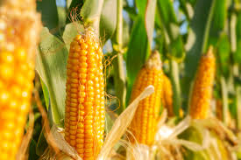
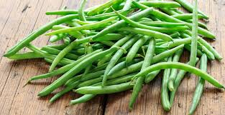

Farm Machinery and Equipment Operation:
- Exposure to different farm machinery such as tractors, planter, plows, and harvesters.
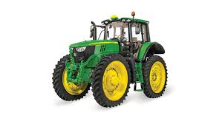
- Learning basic maintenance and troubleshooting of farm equipment.
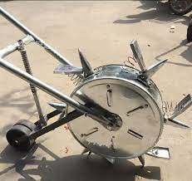
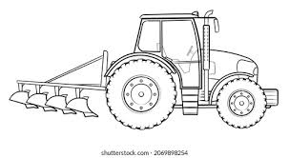

Feed Production:
- Processing and storage of maize for both human consumption and animal feed.
- Preparing feed mixtures for cattle and goats to ensure balanced nutrition.
Farm Records and Administration:
- Assisting in keeping records of animal health, feed consumption, and farm expenses.
- Participating in farm sales activities, including marketing livestock and maize products.

CHAPTER FOUR
4.1 RELEVANCE OF THE EXPERIENCE GAINED
In summary, this program has exposed me to some practical aspect in relation to my course of study and I benefitted greatly from the program, involves the following:
- Improved knowledge of livestock nutrition, disease management, and breeding techniques.
- Practical understanding of maize farming techniques, from soil preparation to harvesting.
- Hands-on experience in operating and maintaining farm machinery such as tractors, plows, and irrigation systems.
- Enhanced skills in farm record-keeping and sales management, understanding the financial aspects of farming operations.
- Gained insights into farm labor management, learning how to delegate tasks efficiently among workers.
- Developed problem-solving skills related to agricultural challenges such as pest control, unpredictable weather conditions, and disease outbreaks.
- Learned how to diagnose and treat common livestock diseases under the guidance of veterinary staff.
- Understood the importance of biosecurity measures in livestock farming to prevent disease transmission.
- Improved knowledge of sustainable farming practices, including crop rotation, organic farming, and waste management.
- Gained experience in customer relations and marketing strategies used in selling farm products.
- Learned the importance of teamwork and communication in a farm setting to ensure smooth operations and efficiency.
- Acquired practical skills in identifying and selecting quality maize seeds for planting to achieve high yields.

CHAPTER FIVE
5.0 CONCLUSION AND RECOMMENDATION
5.1 CONCLUSION
Keeping animals and crop farming is not easy. It is a learning process. You should start slowly and expand as you gain experience. You may have set backs but you must persevere and seek advice when you have problems and need help. If you are kind to your animals and treat well they will respond.
5.2 RECOMMENDATION
Although SIWES undergone did achieve quite a lot of its stated objectives, nevertheless, the following recommendations are suggest to improve the qualitative context of the programme.
1. Posting students specifically to establishment where the stipulated aims and objectives of SIWES would be achieved.
2. Participated of various professional, regulatory and statutory bodies such as COREN, NSE in the supervision of students.
3. Payment of befitting student allowance to assist in students finances during the period of training.
5.3 SUGGESTION
4. I would suggest that the program should be encouraged in all tertiary
institution, and make sure the students achieve what they should know
within the period. I would also like to suggest that the period for the
Industrial Training should be restructured in such a way that the students resume back to school when other students are resuming. This will enable them to fully prepare for the new session.
5. The period should be restricted in such a way that the student Resume back to school when other student are resuming. This will enable them to fully prepare for the new session.
6. I cannot overlook the stress the student went through in getting/sourcing for I.T placement for themselves, so I am using this opportunity to implore the I.T.F to come to the aid of students by getting a placement for them, in order to save them from the rigorous process that they go through in sourcing for placement for themselves.

