

A TECHNICAL REPORT

STUDENT INDUSTRIAL WORK EXPERIENCE SCHEME (SIWES)

HELD AT

ONIYANGI ARCHI-GLOBAL CONSULT SERVICE

WRITTEN BY

ABUBAKAR MUH’D TOHIR

MATRIC NO:

ND/23/ARC/PT/0056

SUBMITTED TO

DEPARTMENT OF ARCHITECHTURAL TECHNOLOGY

INSTITUTE OF ENVIRONMENTAL STUDIES (I.E.S) KWARA STATE POLYTECHNIC, P.M.B 1375 ILORIN, KWARA STATE. NIGERIA

IN PARTIAL FULFILMENT FOR THE AWARD OF NATIONAL DIPLOMA (ND) ARCHITECHTURAL TECHNOLOGY

NOVEMBER, 2024

DEDICATION
I Dedicate This Siwes Report To Almighty Allah And My Parents

ACKNOWLEDGEMENTS
I would like to express my gratitude to the management of Kwara State Polytechnic, Ilorin, and Oniyangi Archi-Global Consult Services for providing me with the opportunity to participate in the SIWES program. Special thanks to my industrial supervisor, [Supervisor's Name], and my academic supervisor, [Academic Supervisor's Name], for their guidance and support throughout the program.

TABLE OF CONTENTS
- Introduction
- Brief History of SIWES
- Overview of Kwara State Polytechnic and Host Organization
- Objectives of SIWES
- Activities Undertaken
- Skills Acquired
- Challenges Faced
- Recommendations
- Conclusion

CHAPTER ONE
1. INTRODUCTION
The Student Industrial Work Experience Scheme (SIWES) is a mandatory program for students in tertiary institutions in Nigeria, designed to bridge the gap between theoretical knowledge and practical skills. As an Architectural Technology student at Kwara State Polytechnic, Ilorin, I undertook my SIWES at Oniyangi Archi-Global Consult Services, a reputable architectural firm in Ilorin, Kwara State. This report outlines my experiences, activities, and the knowledge gained during the six-month industrial training.
Students Industrial Work Experience Scheme (SIWES) is a Skills Training Program designed to prepare and expose Students of Universities, Polytechnics, Colleges of Technology, Colleges of Agriculture and Colleges of Education for the Industrial Work situation they are likely to meet after graduation. The Scheme affords Students the opportunity of familiarizing and exposing themselves handling equipment and machinery that are usually not available in their institutions. Before the establishment of the Scheme, there was a growing concern that graduates of our Institutions of higher learning lacked adequate practical knowledge and that the theoretical education in Higher Institutions was not responsive to the needs of the Employers ‘of Labour. It is against this background that the Industrial Training Fund (ITF) initiated, designed and introduced SIWES Scheme in 1973 to acquaint Students with the skills of handling Industrial equipment and machinery. The Industrial Training Fund (ITF) solely funded the Scheme during its formative years. However, due to finance constraints, the Fund withdrew from the Scheme in 1978. The Federal Government noting the significance of the skills training, handed the management of the Scheme to the National Universities Commission (NUC) and the National Board for Technical Education (NBTE) in 1979. In November 1984, management and implementation of the Scheme was again reverted to the ITF with the funding to be solely borne by the Federal Government
1.2. BRIEF HISTORY OF SIWES
SIWES was introduced in 1973 by the Industrial Training Fund (ITF) to equip Nigerian students with technical skills relevant to their fields. It aims to prepare students for the workforce by integrating academic learning with industrial practice. For engineering students, SIWES is critical for understanding modern tools, safety standards, and industry workflows.

1.3. Background & Establishment
- Origin: Launched under the ITF Act of 1971, SIWES emerged from concerns about graduates lacking practical skills needed by Nigerian industries.
- Objective: To expose students to real-world work environments, enhance employability, and align education with industry demands.

CHAPTER TWO
2. OBJECTIVES OF SIWES
The aim of SIWES is to prepare and expose students of higher institutions to machine and equipment handling and professional work ethics/methods in Industries.
The primary objectives of the SIWES program are:
- To expose students to real-world practices in their field of study.
- To develop practical skills and competencies in architectural technology.
- To familiarize students with the use of modern tools, software, and equipment in the architectural industry.
- To enhance students' understanding of the roles and responsibilities of architectural technologists in construction projects.
- To prepare students for future employment by providing hands-on experience.

CHAPTER THREE
3. COMPANY PROFILE
Oniyangi Archi-Global Consult Services is a leading architectural firm in Ilorin, Kwara State, specializing in architectural design, project management, and construction consultancy. The firm is known for its innovative designs and commitment to delivering high-quality projects. Services offered include:
- Architectural design and drafting.
Architectural drafting is a crucial aspect of the architectural design and construction process. It involves creating detailed technical drawings and plans that serve as a visual representation of architectural designs. These drawings are essential for communication between architects, engineers, contractors, and other professionals involved in the construction project. In this article, we will explore various aspects of architectural drafting, including its purpose, tools used, and the skills required for this profession.
- Building construction supervision.
This is the process of providing continuous guidance and monitoring to construction projects. It involves overseeing all on-site activities, ensuring that they adhere to approved plans, specifications, and regulations. Key responsibilities include inspecting work progress, coordinating different contractors, and verifying compliance with construction and contract documents.
- Feasibility studies and site analysis.
Why is a feasibility study so important in project management? For one, the feasibility study or feasibility analysis is the foundation upon which your project plan resides. That’s because the feasibility analysis determines the viability of your project. Now that you know the importance, read on to learn what you need to know about feasibility studies.
- Interior and exterior design.
Interior design is the art and science of creating beautiful, functional spaces within buildings. It involves not only choosing furniture and décor, but also planning the layout and flow of each room in order to create a harmonious, stylish whole.
Exterior design is concerned with the overall look and feel of a building's exterior. This includes everything from choosing appropriate materials and finishes to ensure the structure compliments its surroundings, to designing eye-catching features that make it stand out from the rest.
- Project management and consultancy.
Project management consultancy refers to the services provided by specialized professionals or consulting firms who assist organizations in managing their projects more effectively. These consultants possess extensive knowledge of project management methodologies, tools, and best practices.

CHAPTER FOUR
4. ACTIVITIES UNDERTAKEN DURING SIWES
During my six-month industrial training, I was involved in various activities, which included:
4.1. ARCHITECHTURAL INSTRUMENTS
Introduction of instruments such as T-square, Set square, Scale, Table, Pencil etc
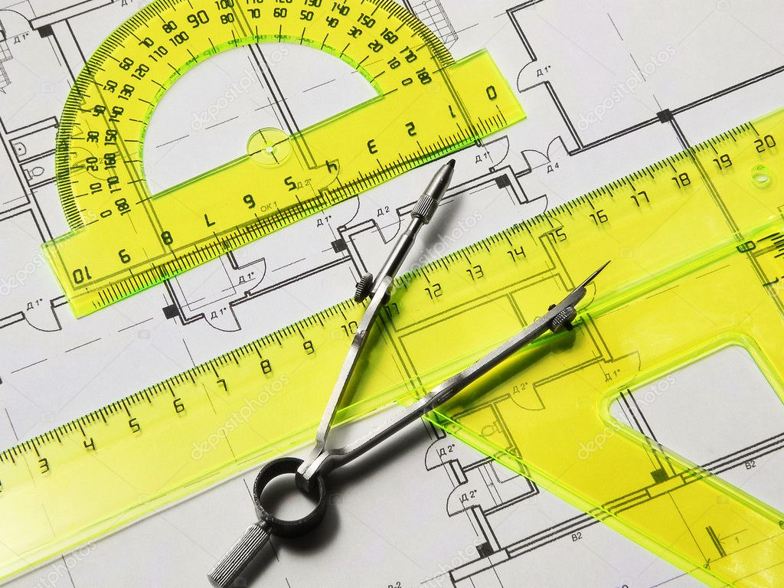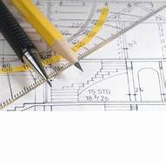

4.2 Architectural Drafting and Design
- Assisted in the preparation of architectural drawings using AutoCAD and Revit.
- Participated in the design development of residential and commercial buildings.
- Learned how to create floor plans, elevations, sections, and detailed drawings.

4.2. Site Visits and Supervision
- Visited construction sites to observe and understand the implementation of architectural designs.
- Assisted in site supervision, ensuring that construction work adhered to the approved plans and specifications.
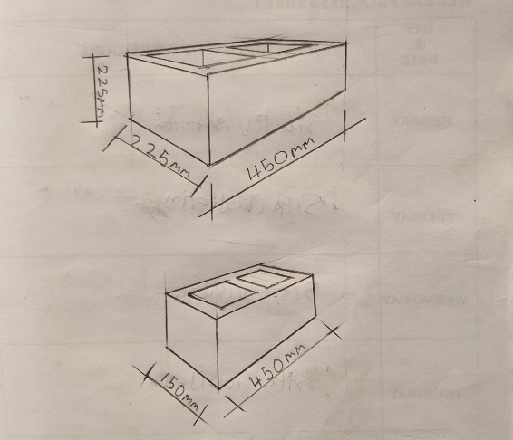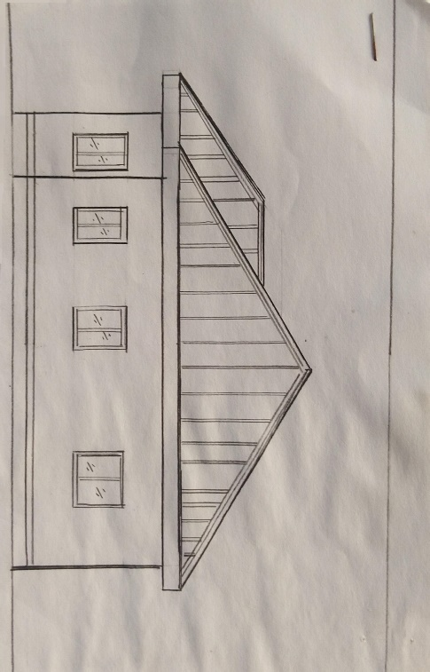
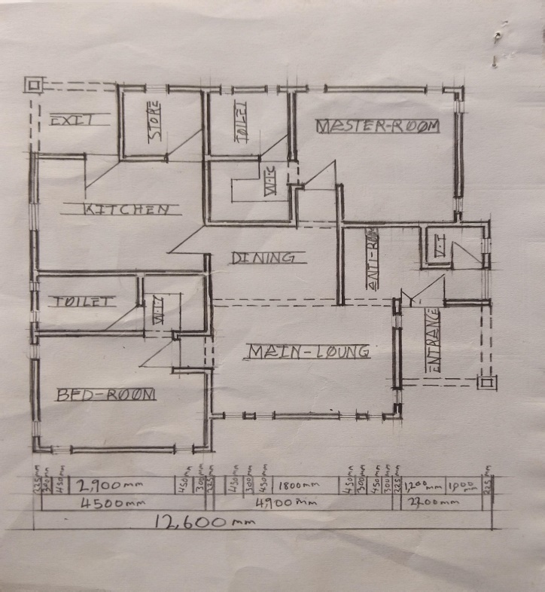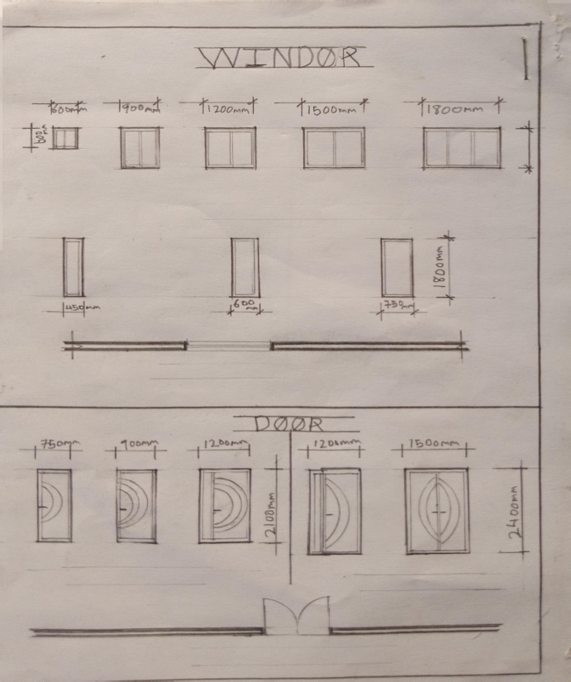

4.3. Use of Architectural Software
- Gained proficiency in using software such as AutoCAD, Revit, and SketchUp for 2D and 3D modeling.
- Learned how to render architectural designs to produce realistic visualizations.
4.4. Project Documentation
- Assisted in the preparation of project documents, including bills of quantities, specifications, and contract documents.
- Learned how to organize and maintain project files for easy reference.
4.5. Team Collaboration
- Worked closely with architects, engineers, and other professionals on various projects.
- Participated in team meetings and contributed ideas during design discussions.

CHAPTER FIVE
5. SKILLS ACQUIRED
During my SIWES program, I acquired the following skills:
- Proficiency in architectural drafting and design using AutoCAD and Revit.
- Ability to interpret architectural drawings and specifications.
- Knowledge of construction processes and site management.
- Improved communication and teamwork skills.
- Enhanced problem-solving and critical thinking abilities.
5.1 CHALLENGES ENCOUNTERED
Some of the challenges I faced during the program included:
- Initial difficulty in adapting to the fast-paced work environment.
- Limited access to some advanced software and tools due to licensing restrictions.
- Balancing work responsibilities with academic commitments.
However, these challenges were overcome through perseverance, guidance from supervisors, and continuous learning.
5.2 CONCLUSION
The SIWES program at Oniyangi Archi-Global Consult Services was a transformative experience that provided me with invaluable practical knowledge and skills in architectural technology. The exposure to real-world projects and the opportunity to work with experienced professionals have significantly enhanced my understanding of the architectural profession. I am confident that the skills and experiences gained during this program will greatly contribute to my future career as an architectural technologist.
5.3 RECOMMENDATIONS
To improve the SIWES program, the following recommendations are proposed:
- Increased collaboration between institutions and industry partners to ensure students are placed in relevant organizations.
- Provision of training on advanced architectural software and tools before the commencement of the program.
- Regular monitoring and evaluation of students' progress by both the institution and the industry supervisor.
REFERENCES
- Kwara State Polytechnic, Ilorin SIWES Handbook.
- Oniyangi Archi-Global Consult Services Company Profile.
- AutoCAD and Revit User Manuals.

