

a TECHNICAL reporton student industrial work experience scheme
(SIWES)
held at
ALLAH’S WILL STEEL SOKA BUS STOP IBADAN
written by
RASAQ MARIAM OLUWATOBILOLBA
nd/23/MET/Pt/0009

submitted to
department of agricultural and bio-environmental engineering technology, institute of technology (iot), Kwara state polytechnic, p.m.b 1375, ilorin, kwara state, nigeria

In partial fulfillment for the award of national diploma (ND) in agricultural ENGINEERING

AUGUST – December, 2024

DEDICATION
This report is dedicated to the Lord God Almighty.

ACKNOWLEDGEMENT
My profound appreciation goes to Almighty God, whom with His grace gave me the opportunity to complete my industrial training exercise safely.
I would also like to express my deepest appreciation to

TABLE OF CONTENTS
CHAPTER ONE
1.0 Introduction
1.1 Aims and Objectives
1.2 Names of Companies
1.3 Location of the Companies
1.4 Brief Summary of the Companies’ Activities
1.5 Organization Chart
CHAPTER TWO
2.0 Workdone
2.1 Construction and Fabrication
2.2 Pipe
2.3 Bending machine
2.3.1 Manual Bending Machine
2.3.2 Thermal cutting machine
2.4 Welding electrodes
2.5 Angle irons
2.6 Flange and web
2.7 Flat bars
CHAPTER THREE
3.0 Special Operations and Procedures
3.1 Operation of rolling machine

CHAPTER FOUR
4.0 Recommendation and Conclusion
4.1 Recommendation
4.2 Conclusion

CHAPTER ONE
1.0 INTRODUCTION
The student's industrial work experience scheme (SIWES) is a program designed for student of tertiary institutions with the aim of exposing students that have acquired theoretical knowledge in the classrooms to the practical exposure and experience.
The scheme is a Program involving the students, the university and the industry. Participation in SIWES has become a necessary precondition for the award of diploma and degree certificate in specific discipline in most institution of higher learning in the country in accordance with the educational policy of the government.
The bodies involved are the federal Government, the industrial training fund (ITF). Other supervisory agency is the National council for college of education (NCCE). The success of, or otherwise; the SIWES, depends on these bodies and the general public involved in articulation and management of the program.
1.1 AIMS AND OBJECTIVES OF SIWES
- To provide students with the opportunity to apply their theoretical knowledge in real work situation, thereby bridging the gap between university work and actual work
- To provide an avenue for students in Nigeria universities to acquire industrial skills and experience in their course of study.
- To enlist and strengthen employers in the entire educational process of preparing university graduates for employment in industries.
- To help students prepare for the corporate world and enhance their curriculum vitae.
- To improve interpersonal relationship skills of the students.
- To make the transition from university world of work easier; and enhance contact for job placement.
- To expose students to work methods and techniques in handling equipment and machinery that may not be available in their institutions.
1.2 NAME OF THE COMPANY
ALLAH’S WILL STEEL SOKA BUS STOP IBADAN
1.3 LOCATION OF THE COMPANY
      - ALLAH’S WILL STEEL located at Soka Bus Stop Ibadan.
1.4 BRIEF SUMMARY OF COMPANIES ACTIVITIES
- ALLAH’S WILL STEEL is an …
1.5 ORGANIZATION CHART
DIRECTOR OF WORKS

TECHNICAL OFFICERS

AUTOMOBILE TECHNICIANS

SUPERVISORS

STUDENTS WORKERS SIWES

CHAPTER TWO
2.0 WORKDONE
2.1 CONSTRUCTION AND FABRICATION
Welding is a fundamental process in many industries, from construction and manufacturing to automotive repairs and metalworking. Welding tools and equipment include measuring tools, welding machines, safety gear, and cleaning tools. For any workshop to perform welding tasks efficiently and safely, having the right tools and equipment is essential.
Welding is crucial in the construction industry, serving as a critical fabrication process in creating robust and secure structures. This process involves the fusion of materials, typically metals or thermoplastics, by utilizing high heat to melt the parts together.
Fabrication is the process of taking raw stock material and creating an end product, which often involves welding. The fabrication process includes steps such as design, forming, cutting, machining, casting, stamping and punching.
2.2 Pipe
Pipes are essential components in many industries, transporting various liquids and gases over long distances through complex networks. Pipe welding is a crucial process that ensures the longevity and safety of piping systems.

Pipe Types
The required thickness of a pipe is affected by the type of pipe selected. There are three main pipe types:
- Seamless – a pipe with no weld lines.
- Longitudinally welded – a pipe with one or more longitudinal weld lines.
- Spiral welded – spiral shaped weld.
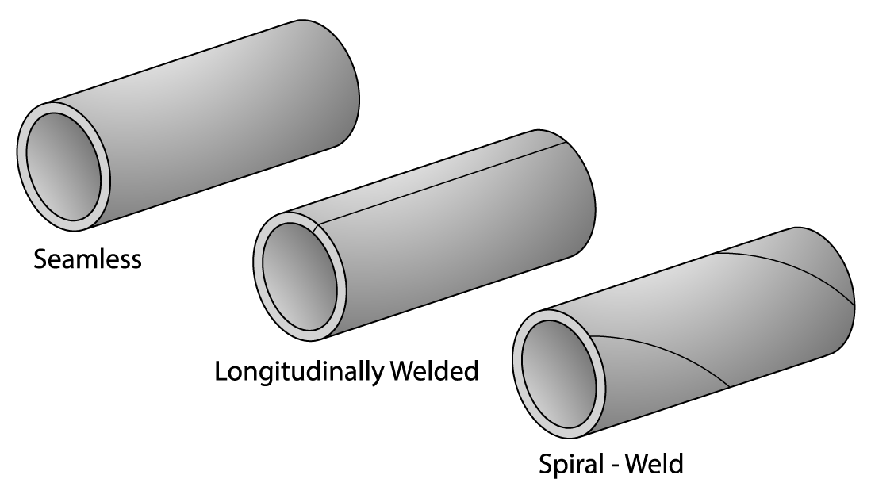
Pipe Types: Seamless, Longitudinally Welded, Spiral Welded
Seamless
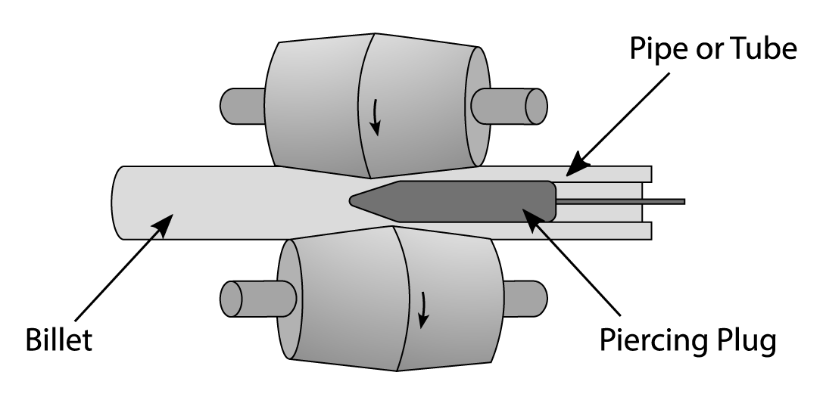
This pipe is formed by thrusting a piercing plug through a metal billet whilst it is retained between rollers, or, by pressing a mandrel into a billet that is held within a die. The result of both operations is a pipe with no weld lines (it is seamless).

Seamless Pipe Manufacturing Process

Longitudinally Welded
Flat metal plate can be hot rolled to produce the circular shape of a pipe. It is then necessary to weld the two ends of the plate together to complete the pipe shape in its entirety. Longitudinally welded pipes may have one weld, or multiple welds. As a rough guide, pipes up to approximately 1,000mm in diameter will have only a single weld, whilst larger pipes will require more than one weld.
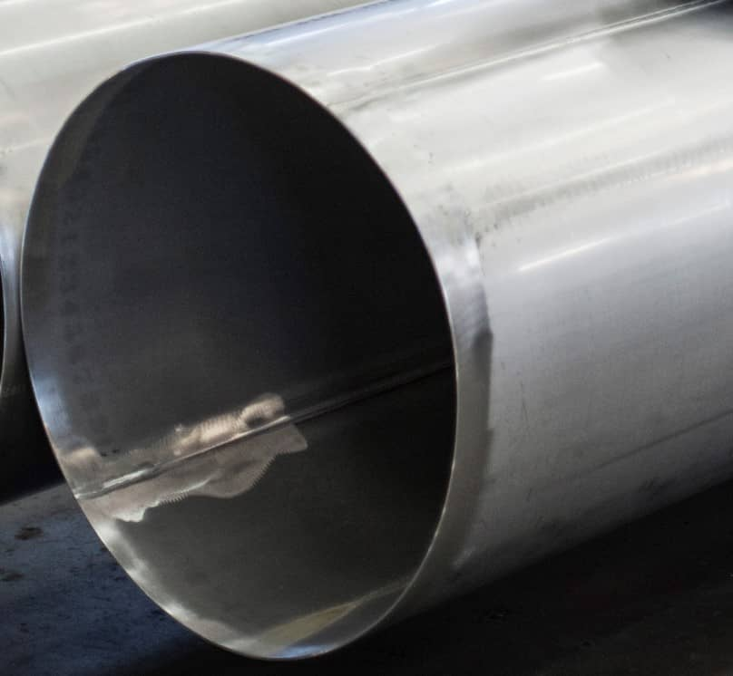
Single Weld Longitudinally Welded Pipe
Longitudinally welded pipes are not preferred for critical systems if seamless welded pipes can be used. There are several reasons for this:
- The weld must be proven before its integrity can approach/near that of a seamless pipe. For critical systems, the aim is always to make the piping system as reliable as possible.
- Proving of a weld takes time and adds financial cost.
- The use of longitudinally welded pipe creates additional stresses within the piping system (during the design stage, stress calculations are performed extensively).
Tip – if the manufacturing process for a longitudinally welded pipe is hard to visualise, take a piece of paper in two hands and bend it lengthwise into a circular tube shape, then place tape along the joining edges to maintain the tube shape. Now imagine that the paper is metal plate and the tape is the weld, that is generally how longitudinally welded pipe is manufactured.
Spiral Welded
For systems operating with very high volumes and low pressures, a spiral welded pipe may be used. The manufacturing method is similar to that of a longitudinally welded pipe, but the metal plate is rolled at an angle which gives the pipe its spiral shape. Although this type of piping is the cheapest to manufacture, it is the least popular of the three. A typical application for spiral welded pipe would be for power station cooling water systems (non-toxic, high volume, low pressure).
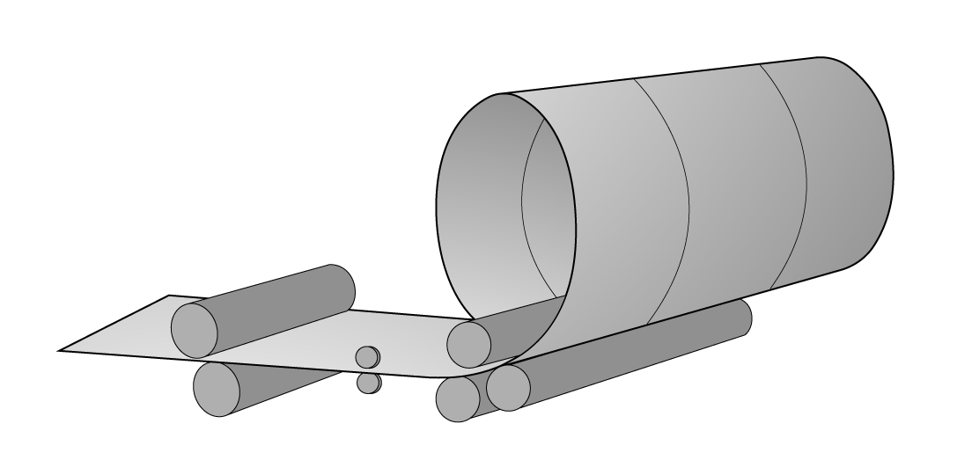
Spiral Welded Pipe Manufacturing Process
Because spiral welded pipes are welded, they are also not favoured for critical systems for the same reasons as mentioned previously when discussing longitudinal welded pipes (weld integrity must be proven, cost of proving the weld, stress raising characteristics within the piping system).
2.3 BENDING MACHINE
A bending machine is referred to as a primarily used machine which is mainly used to form a bend on any required work piece. The machine is used to make use of the bending tool which is present in it and is responsible for the process.
There are different types of bending machines catering to various metal shapes, such as small pipes, large tubes, rebar, thick metal plates, or regular sheet metal, covering a wide variety of applications.
Each bending machine serves particular functions involving various metal fabrication processes. Here is a brief overview of how bending machines function in modern industry.

2.3.1 MANUAL BENDING MACHINE

A manual bending machine is a tool used to bend metal sheets manually into various shapes, angles, and curves. This machine comprises several parts that work together to bend the metal sheets. The main parts of the manual bending machine are the bending blade, the clamping bar, and the handle.

Manual bending machines are suitable for one-off use or for the production of parts in small batches, where a high level of precision is not required. With a manual bending machine, bending accuracy and repeatability depend on the operator’s experience.
Manual bending machines can be mechanical or hydraulic:
- Mechanical bending machines are generally used for small-diameter tubes. They are equipped with a crank that drives the roller, which in turn moves the tube, bar, or profile.
- Hydraulic bending machines are used to bend larger diameter tubes. They are equipped with a hydraulic cylinder that exerts an even thrust on the bending roller.
2.3.2 THERMAL CUTTING MACHINE
Thermal cutting machines are devices that use heat to cut through materials. They are mainly used for shape cutting of cold and hot-rolled steel, but they can also work on aluminum and stainless steel with varying degrees of success. Thermal cutting machines can exploit the feature of thermal fracture, which causes cracks in brittle materials such as glass when they are heated and expanded. Cutters use heat from an electric arc, a stream of ionized gas called plasma, or burning gases to cut and trim metal objects to specific dimensions. They also dismantle large objects, such as ships, railroad cars, and buildings. Cutters are designed to cut materials of different kinds of products such as wires, cables (electrical, coax, multi-strand), wire ropes, fencing, bolts, rods, pre-stressed concrete wires, and strapping.
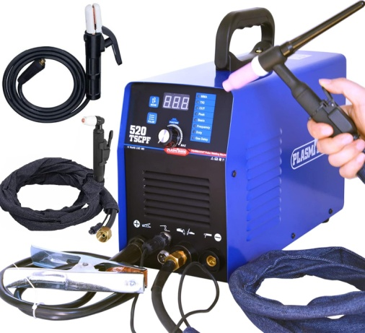
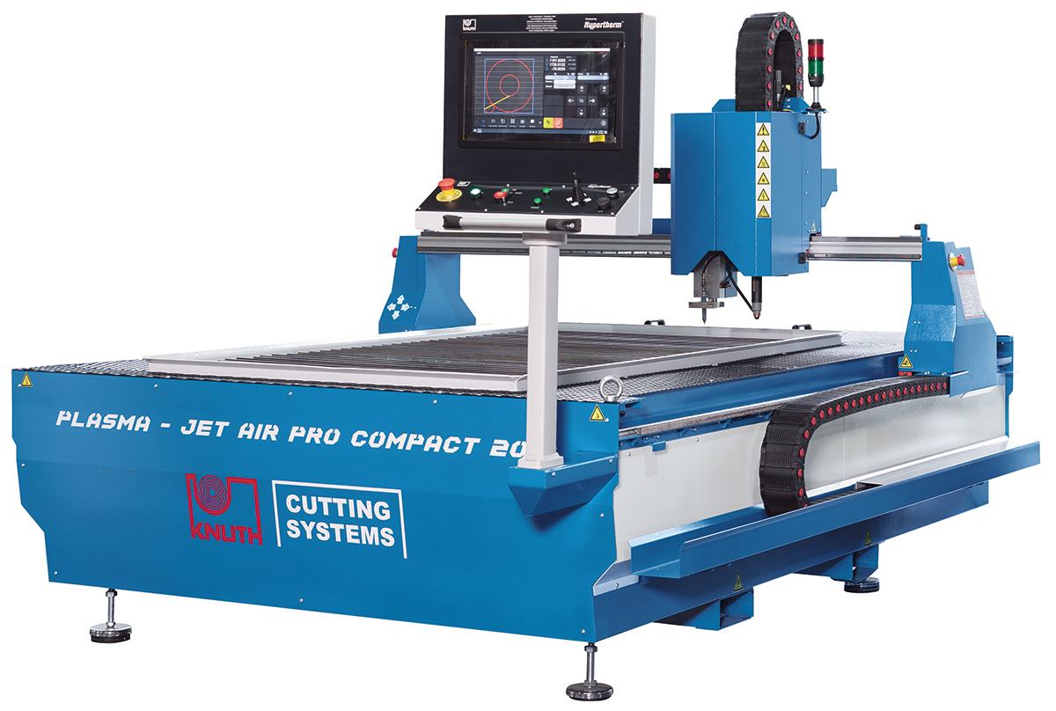

2.3.3 ROLLING MACHINE
A rolling machine, also known as a rolling mill or roller mill, is a device used in metalworking to shape and form metal by passing it between two or more rotating rollers. This process is known as rolling and is one of the most common methods of metal forming, allowing the creation of uniform sheets, plates, bars, or other shapes from metal stock. Rolling machines are essential in industries such as automotive, construction, aerospace, and manufacturing.
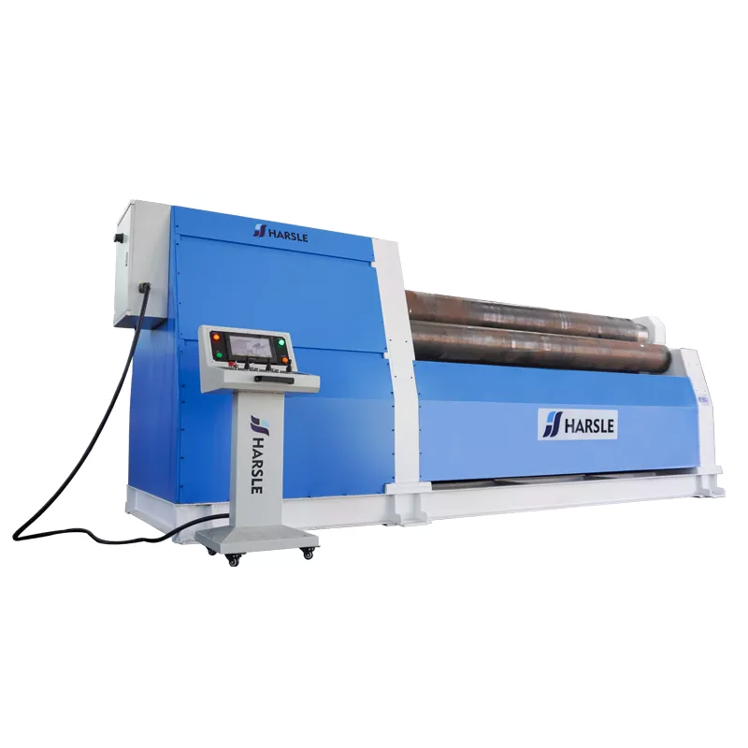
2.4 WELDING ELECTRODES
An electrode is a coated metal wire made of similar materials to the base metal. Welding electrodes are wire lengths connected to your welding machine to create an electric arc when an electrical current passes through them, and the arc generates enough heat to melt and fuse the metals.
There are two main welding electrode types: consumable and non-consumable. In stick welding, a.k.a. shield metal arc welding (SMAW), the electrodes are consumable, used during welding, and melt into the weld. On the other hand, tungsten inert gas welding (TIG) electrodes, typically made of tungsten, are non-consumable and do not melt into the weld.
Consumable electrodes are used in stick, MIG, and flux-cored arc welding, and the stick electrodes are further divided into heavy-coated (shielded arc) and light-coated electrodes.
Heavy-coated electrodes: As the name suggests, these electrodes have a thicker coating applied by dipping or extrusion. They are manufactured in three types: those cellulose coatings, mineral coatings, or a combination. Cellulose-coated electrodes protect the molten metal with a gaseous zone around the weld zone, while mineral-coated electrodes form a slag deposit. Heavy-coated electrodes are recommended for welding steels, cast iron, and hard surfacing.
Light-coated electrodes: The light coatings reduce impurities, help make the metal more uniform, increase arc stability, and produce a thin slag.

Selecting the Right Electrode
Choosing an electrode is determined by the requirements of the welding job. These include:
- Strength: Ensures the electrode meets the required joint strength.
- Welding position: You have fewer choices of electrodes, depending on your welding position: overhead, horizontal, vertical, and flat.
- Power Supply: You can’t use a rod that doesn’t run on your power supply.
- Joint Type: Factors include penetration, joint access for slag removal, material thickness, and surface cleanliness.
Material: stick welding electrodes come in cast iron, high carbon steel, mild steel, iron-free (nonferrous), and special alloys.
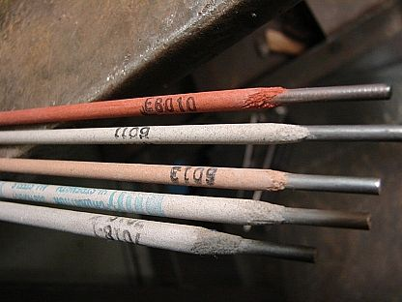

2.3 BEAM FABRICATION

In welding construction and fabrication, "beams" refer to structural components, typically made of steel plates welded together, used to support heavy loads in buildings and structures, often designed with specific shapes like I-beams or H-beams to optimize their load-bearing capacity, and can be custom-fabricated through welding to suit specific project requirements; essentially, a welded beam is a constructed beam made by joining multiple steel plates using welding techniques to create a strong, unified structural element.

Welded beams are assembled from steel plates and customized according to the specific requirements of various construction projects, with a variety of sizes. The production of welded beams is quite straightforward, involving cutting steel plates, automatic welding, straightening beams, welding stiffeners and connection plates, surface cleaning, painting, and packaging.

2.5 ANGLE IRONS

Angle iron, a metal bar with an L-shaped cross-section, is a commonly used material in fabrication work due to its exceptional strength, versatility, and ability to provide structural support for various projects by creating stable corners and frames; it's ideal for building machine bases, shelving units, brackets, trusses, tool holders, and more, making it a key component in constructing sturdy and reliable structures.

2.6 FLANGE AND WEB

In welding, a "flange" refers to the horizontal, flat plate sections at the top and bottom of a beam, while the "web" is the vertical plate connecting those flanges, essentially forming the "I" shape of a typical steel beam; when welding a beam, the connection between the flange and web is a critical point where the welds must properly resist both bending and shear forces depending on the load applied to the beam.

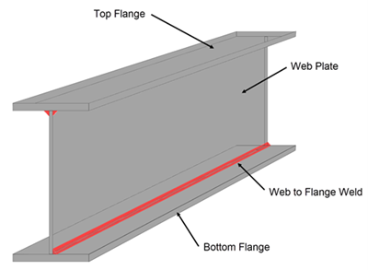

2.7 FLAT BARS

Flat bars refer to long, rectangular pieces of metal (usually steel) that are commonly used for fabrication and structural support due to their ease of welding, cutting, and drilling, making them ideal for building frameworks and creating complex structures in various applications like construction, machinery, and art installations.

CHAPTERTHREE
SPECIAL OPERATION AND PROCEDURES
3.0 Special Operation and procedures carried out at ALLAH’S WILL STEEL
3.1 Operation of rolling machine
The steps to operate the three-axis rolling machine are as follows: first, raise the upper roller and adjust the distance between the lower rollers according to the thickness of the blank. The distance between the lower rollers should be as small as possible when the bending force of the upper roller is permitted. Generally, it is reasonably fixed according to the thickness of the blank. When the thickness is 4mm, the spacing is 90~100mm, and when the thickness is 4~6mm, the spacing is 110~120mm. Place the blank on the lower roller, cover the two lower rollers, and then lower the upper roller according to the bending radius requirements, and bend the blank locally, and then turn on the roller bed to rotate the roller, and the blank is automatically sent to bend and form. Lift, go up the rollers, and finally remove the parts.
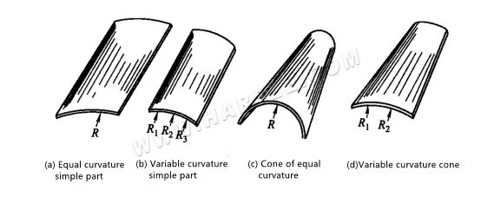On the symmetrical three-axis rolling machine, by changing the mutual position of the three rollers, four typical parts of equal curvature simple shape, variable curvature simple shape, equal curvature cone, and variable curvature cone can be rolled, as shown in the following figure show. When bending, one-time forming should be avoided as much as possible to prevent excessive bending. It will cause difficulties in repeated operations. After each bending, the lowering distance of the upper roller is generally about 5~10mm. The main points of various shapes of roll bending operations are as follows.

1. When rolling cylindrical (cylindrical) parts with equal curvature, it can be achieved as long as the upper roller does not move up and down during the bending process, and the three rollers are parallel to each other. The curvature needs to go through several trial rolls from small to ground before finally reaching the requirements. It is worth noting that the blank must be placed upright when it is fed, otherwise, the rolled-out parts will be distorted, as shown in figure (b). It is best to draw a reference line when bending. When bending, make the reference line coincide with the axis of the upper roller before starting the bending, as shown in figure (a). This is particularly important for the bending of large thick sheets. Because the repair of this kind of parts afterward is not only large but also quite difficult.
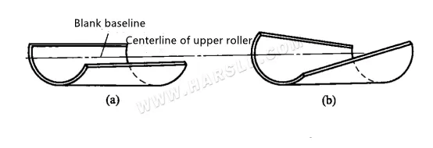
2. During the rolling process, the three rollers remain parallel to each other, and the up and down positions of the upper rollers can be changed at any time to roll out parts with varying degrees of curvature. For the cylindrical part shown in the rolling diagram, R1>R2>R3>R4>Rs in the figure. The method used in the production is to approximate this part as consisting of several cylindrical shapes with different radii R, press The radius R is divided into sections, which are rolled successively according to the bending radius from large to small. The steps of the whole operation are as follows.
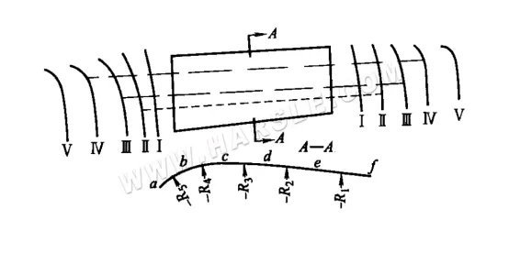
The process I: Adjust the position of the upper roller with R1, and roll the blank from end a to end f, so that the bending radius of section ef meets the requirements.
The process Ⅱ: Adjust the lower roller with R2, roll from end a to e, so that the bending radius of section de meets the requirements. When the upper roller approaches point e, it rises slowly and moderately to make a smooth transition to prevent edges and corners from appearing between R1 and R2.
From a to d, from a to c, from a to b to complete the other process III to process V.
For mass production, to improve efficiency, after the procedures of the entire batch of workpieces are completed, the subsequent procedures are carried out. It is best to inspect each part of each process according to the template or mold tire, so as not to affect the subsequent process.
3. Rolling of tapered parts Theoretically speaking, during the bending process, the two lower roller shafts are kept parallel, and the upper roller shaft is inclined and does not move up and down so that the tapered parts with equal curvature can be rolled out. The two lower roller shafts are kept parallel, and the upper roller shaft is inclined and moved up and down to roll out tapered parts with varying degrees of curvature. It is necessary to make the two ends of the blank feed between the rollers at different speeds to roll out the conical parts with equal or variable curvature that meets the requirements. This is because the curvature of the two ends of this kind of part is different, and the unfolding length is also different. Therefore, when bending, it is required to have different bending speeds at both ends. The speed at the end with the larger curvature should be slower, and the speed at the end with the smaller curvature should be faster. Since the sheet material is subjected to the rolling pressure of three rollers at the same time during the bending, and the rollers are generally cylindrical, it is impossible to obtain several different speeds at the same time. To solve this problem, the blank is required to be in the bending direction Divide into several areas, carry out segmental bending.
The commonly used methods of rolling tapered parts in production mainly include the rectangular feeding method, partitioned rolling method and rotary feeding method, smallmouth deceleration method, and so on. The figure below shows the rectangular feed roll bending method for tapered parts. During operation: First, feed the material according to the AEFD rectangular center line OH shown in Figure (b) and roll out the cylindrical shape on both sides, so that the middle section rolls out of the straightness of the bus bar. At this time, the four corners are expanded, especially the two places A and D. To highlight, as shown in figure (c). Then roll both sides with AB and CD positioning and feeding, so that the two sides are rolled in, and the straightness of the generatrix is rolled out so that the tapered part is rolled out, as shown in Figure (d). In essence, it is rolled in three areas. When rolling this kind of part, the blank should be placed at the same position as the length of the roller. If it moves left and right, the curvature of the rolled part will not meet the requirements.
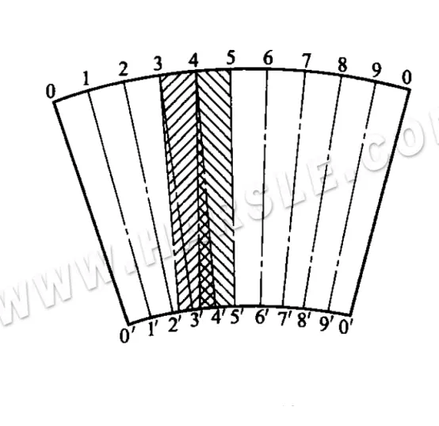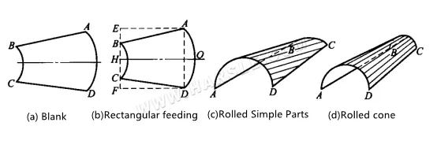

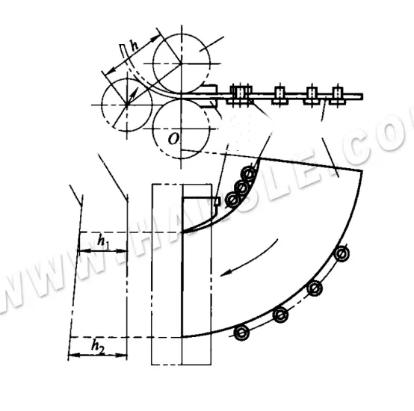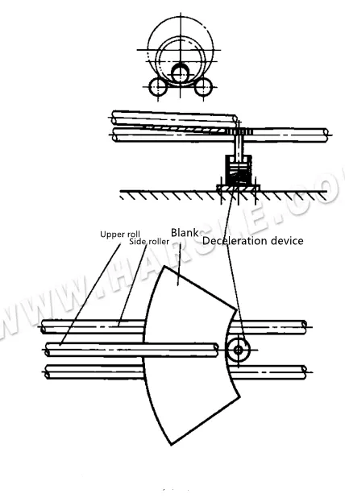4. The figure below shows the device for rolling a conical surface by the rotary feeding method. To roll the fan-shaped blank material into a conical surface, the blank must be rotated and fed around 0 o’clock, and the centerline of the side rollers must be adjusted to tilt it. For this reason, in the T-shaped groove of the additional worktable in front of the plate bending machine, a guide wheel arranged in an arc shape is installed to force the fan-shaped material to rotate around the O point. The function of the end guide wheel is to make the end part of the material detach from the front guide wheel and still be able to rotate and feed in and roll into a cone.

5. The rolling of parts with a small radius of curvature affects the parts with a relatively small radius of section curvature, and sometimes it cannot be completely roll-formed on a three-axis rolling machine. This kind of part generally requires two processes to bend, as shown in the figure. First, roll out the required curvature on the three-axis rolling bed to make the two sides meet the requirements, and then use the bending die to bend the middle curvature on the press brake to make it finally meet the requirements.

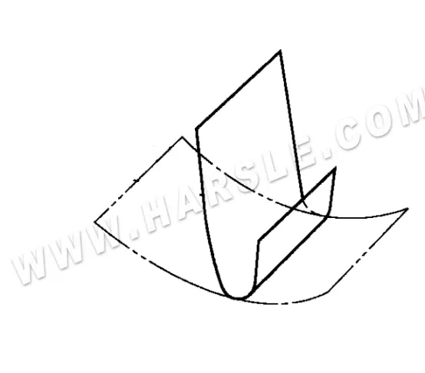

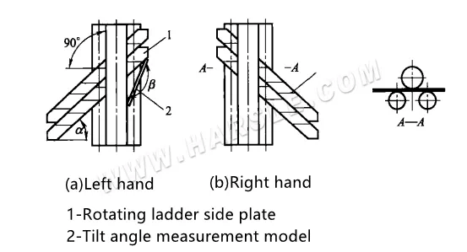6. The rolling spiral staircase side plate of the spiral staircase side plate is a part of the cylindrical shape, and its rolling method is the same as that of the cylinder, but the angle between the placement of the roll on the plate and the roll of the plate before crimping should be the spiral of the spiral staircase. The angle of the rise and the angle of placement during rolling can be measured with a model. The model angle β≈180°-a°, as shown in the figure.

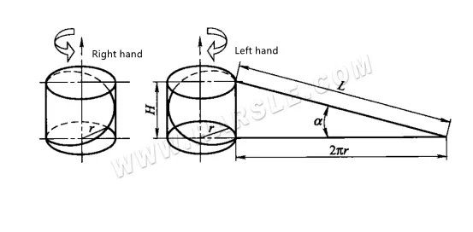When rolling, depending on the length of the side plate of the spiral ladder and the specific conditions of the plate rolling machine, it can be carried out in a single block H or multiple blocks at the same time. The helix angle a is calculated according to a=arctan H/2πr, and the meaning of each symbol in the formula is shown in the figure.

CHAPTER FOUR
OBSERVATIONS, CONCLUSION AND RECOMMENDATION
4.1 OBSERVATION
The SIWES programme undergone at MR. OLAIYA TECH afforded me an in-depth exposure to some of the practical industrial aspects of Agricultural branches. I was opportuned to have known the feed formulation. Experience was also garnered in the handling of layer birds especially when they started laying eggs.
Besides, knowledge and skills were acquired in both section of the farm (piggery and poultry section). The programme has been highly enlightening, beneficial, interesting and successful. The objective of which the scheme was undergone was however achieved.
4.2 CONCLUSION
The SIWES programme for me is educative and has empowered me with various opportunities to be self employed and in fact to be able to establish a farm based on many of all that have been practicalized. With the help of God the programme has enable a kind of workable opportunity to perform theories in a practical way, to see many of the equipment/tools used in the farm (birds, battery cage, deep litters etc.)
4.3 RECOMMENDATION
Although SIWES undergone did achieve quite a lot of its stated objectives, nevertheless, the following recommendations are suggested to improve the qualitative context of the programme:
- SIWES Students should endeavour to participate actively and positiviely during the SIWES progrogramme (i.e try to be hardworking) and see the industry where the programme is taking place as a research place where all that he/she has been taught in the class can be practicalized.
- The Industry should not see SIWES students as casual workers but as professionals in the making.
- Participation of private corporate organization to minimize the problem of low funding as recently complained by the director of ITF.
- Sending students specifically to establishment where the stipulated aims and objectives of SIWES would be achieved.
- Payment of befitting student allowance to assist in students finances during the period of training.

