
REPORT ON
STUDENT INDUSTRIAL WORK EXPERIENCE SCHEME (SIWES)

HELD AT;
SECRETARIAT MORO LOCAL GOVERNMENT, OLORUN SOGO AREA BODE SAADU, KWARA STATE.

BY
AGBAJE OMOTAYO SHUKURAT
ND/23/STA/FT/0071

SUBMITED TO
DEPARTMENT OF STATISTICS,
INSTITUTE OF APPLIED SCIENCES,
KWARA STATE POLYTECHNIC, ILORIN.

IN PARTIAL FULFILMENT OF THE REQUIREMENTS
FOR THE AWARD OF NATIONAL DIPLOMA (ND) IN STATISTICS.

AUGUST – NOVEMBER, 2024

DEDICATION
This report is dedicated to almighty God, the Supreme Being, the beneficent, the merciful, and the foundation of wisdom, knowledge and understanding to the prudent.

OUTLINE
Title Page 1
Dedication 2
Outline 3
Introduction to SIWES 4
Definition of SIWES 4
Aim and Objectives of SIWES 4
Introduction of Industrial Placement 5
Organogram of Industrial placement 6
Departments and their function 6
Statistical Work Done 8
Experiences Gained in the Industrial Place 10
Conclusion 11
Recommendation 11

INTRODUCTION TO SIWES
Student industrial work experience scheme (SIWES) was established by Industrial Training Fund (ITF) in 1973/1974 to solve the problem of lack of adequate practical skills preparatory for employment in industries by Nigerian graduate of tertiary institutions.
Prior to the establishment of the schemes, there was a concern among our institution of higher learning lacked practical background studies preparation for employment in the industries.
The student industrial work experience scheme (SIWES) is a skill training program designe to expose and prepare student of agriculture technology, environmental science, medical science and pure & applied science for the industrial work situation one is likely to meet after graduation.
The program was established with various coordinating agencies respect to each tertiary institution in the country. These agencies are:
- NBTE (National Broad for Technical Education)
- NUC (National University Commission) for University
- NCCE (National Commission of College of Education) for colleges of education.
DEFINITION OF SIWES
Student industrial work experience which is a program established by I.T.F (Industrial Training Fund) in 1976 to bridge the gap between theory and practical aspect of learning in a tertiary institutions in Nigeria.
SIWES was established in Nigeria to help student develop on their practical aspect of learning expose them to various techniques in the industry and also help them to know the ways of handling equipment and machineries.
AIM AND OBJECTIVES OF SIWES
The aim and objectives of SIWES are as follows;
- Provide an avenue for students in institution of higher learning to acquire industrial skills and experience in their approved courses of study.
- Prepare students for the industrial work situation which they are likely to meet after graduation.
- Expose students to work methods and techniques in handling equipment and machinery not available in their institution.
- Provide students which they are likely to meet after graduation.
- Expose students to work methods and techniques in handling equipment and machinery not available in their various institutions.
INTRODUCTION OF INDUSTRIAL PLACEMENT
Moro Local Government Secretariat is the administrative headquarters of Moro Local Government Area (LGA) in Kwara State, Nigeria. Moro LGA was created from Ilorin East and is one of the sixteen local government areas in the state.

Brief History
Moro Local Government was established as part of Nigeria’s local government reforms to enhance governance at the grassroots level. It is predominantly inhabited by the Yoruba and Nupe ethnic groups, with farming and trading as the primary economic activities. The secretariat serves as the hub for government administration, policy implementation, and community development in the region.

Key Features of Moro LGA
- Headquarters: Bode Saadu
- Major Towns: Bode Saadu, Jebba, Shao, Lanwa, Olooru
- Economic Activities: Agriculture (cassava, maize, rice), fishing, and commerce
- Notable Landmark: Jebba Hydroelectric Dam

ORGANOGRAM OF INDUSTRIAL PLACEMENT

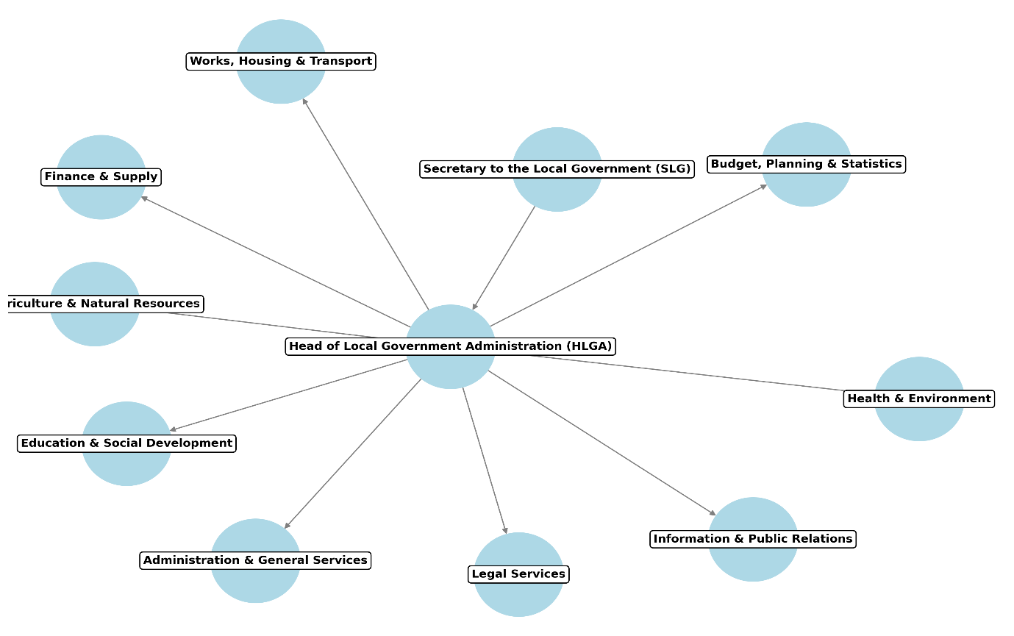

DEPARTMENT IN THE PLACEMENT AND THEIR FUNCTION

1. Administration & General Services Department
Functions:
- Handles personnel management and staff welfare.
- Oversees recruitment, training, and promotion of staff.
- Manages records and official correspondence.
- Ensures smooth administrative operations of the local government.

2. Finance & Supply Department
Functions:
- Manages the local government’s finances, budget, and expenditures.
- Prepares financial statements and ensures proper auditing.
- Collects revenue from local businesses, taxes, and levies.
- Oversees procurement and supply of government assets.

3. Budget, Planning & Statistics Department
Functions:
- Prepares annual budgets and financial plans for the LGA.
- Collects and analyzes statistical data for development planning.
- Monitors and evaluates local government projects.
- Advises on economic development initiatives.

4. Works, Housing & Transport Department

Functions:
- Oversees construction and maintenance of roads, bridges, and public buildings.
- Supervises urban planning and land allocation.
- Manages transportation infrastructure within the LGA.
- Ensures proper maintenance of government vehicles and properties.

5. Health & Environment Department

Functions:
- Oversees public health services, including local clinics and hospitals.
- Implements environmental sanitation programs.
- Regulates waste management and pollution control.
- Conducts health education and disease prevention campaigns.

6. Education & Social Development Department

Functions:
- Manages public primary schools within the local government.
- Promotes adult literacy programs.
- Supports social welfare services for vulnerable groups.
- Oversees sports, culture, and youth empowerment initiatives.

7. Agriculture & Natural Resources Department

Functions:
- Supports farmers with improved seedlings, fertilizers, and modern farming techniques.
- Implements rural agricultural development programs.
- Manages forest resources and environmental conservation.
- Oversees livestock farming and fisheries development.

8. Legal Services Department

Functions:
- Provides legal advice to the local government.
- Drafts local laws, by-laws, and policies.
- Represents the local government in legal matters.
- Handles dispute resolution and regulatory compliance.

9. Information & Public Relations Department

Functions:
- Handles communication between the local government and the public.
- Manages public enlightenment and community engagement programs.
- Oversees media relations and government publications.
- Monitors public feedback and reports to the local government.
STATISTICAL WORK-DONE
Statistics can be said to be about collecting, organizing, summarizing, presenting and analysis of data and there are various method or techniques in which data can be analyze to make a valid and valid conclusion or interpretation of the analyzed data. During my stay at Local Government, I was placed in several departments (Treasury, Research, Secretariat Café, and Agriculture department) in which I work using MS Excel and MS Word.
During my stay at Agriculture department, I was taken to a poultry to keep records of livestock (hen) production (eggs laid) in which there are 500 hens in the poultry.

The dataset below consist of total number of eggs laid including both good and defective for 10 days
Day | Total Eggs Laid | Good Eggs | Defective Eggs
Day 1 | 451 | 390 | 61
Day 2 | 492 | 438 | 54
Day 3 | 414 | 364 | 50
Day 4 | 471 | 447 | 24
Day 5 | 460 | 393 | 67
Day 6 | 420 | 365 | 55
Day 7 | 482 | 448 | 34
Day 8 | 486 | 453 | 33
Day 9 | 474 | 442 | 32
Day 10 | 474 | 436 | 38
Bar chart is used to show the difference between the good and defective eggs
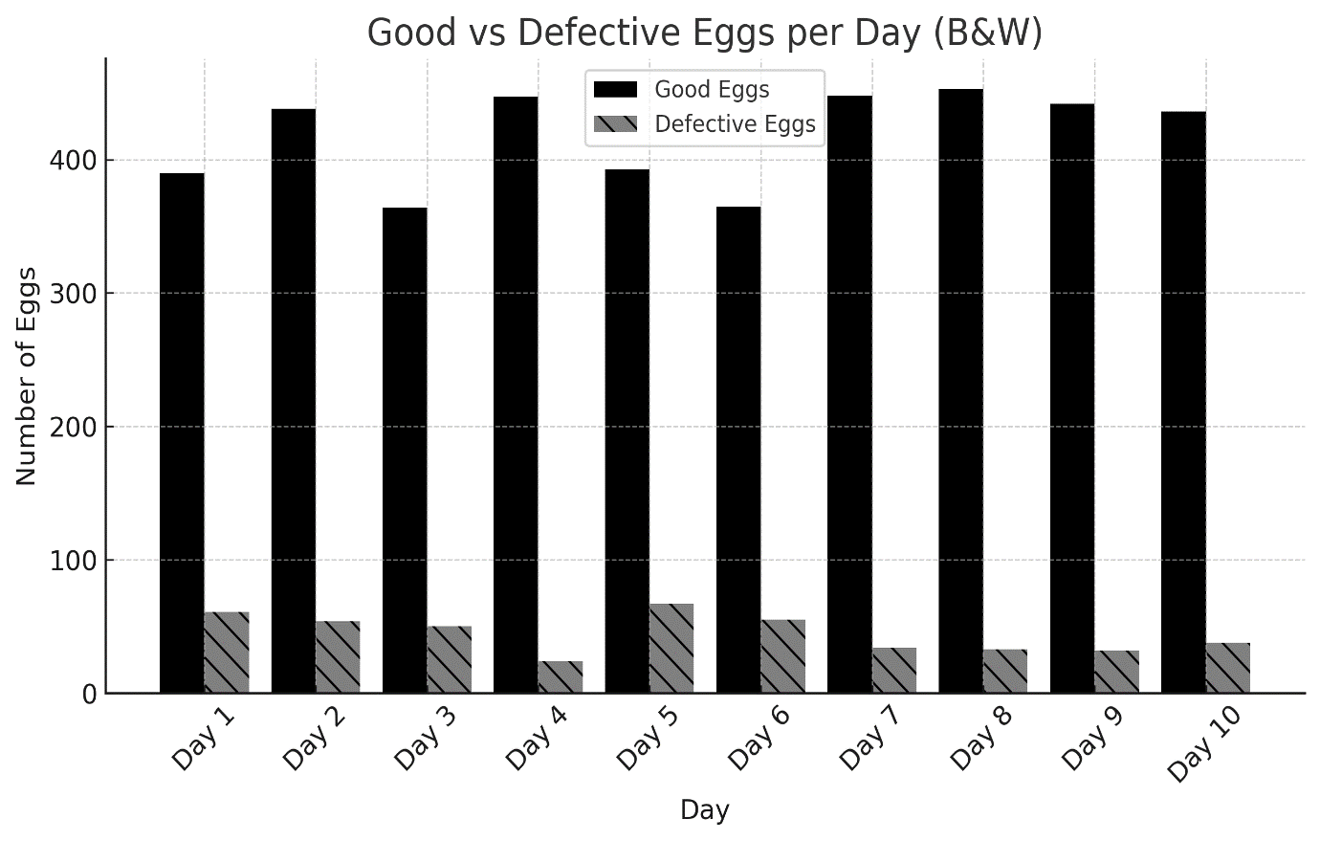
Observation:
- Stable Production:
- The total number of eggs laid per day remains fairly consistent, ranging between 414 and 492 eggs.
- The average daily production is 462 eggs, showing a relatively steady pattern.
- Good vs. Defective Egg Trend:
- Good eggs consistently outnumber defective eggs, but some days show a noticeable increase in defects 50 and above.
- The variation in defective eggs indicates possible inefficiencies in egg collection or storage conditions.
Recommendation:
- Investigate factors causing defective eggs (e.g., hen nutrition, environmental conditions).
- Monitor trends over a longer period to identify patterns and take corrective actions.
EXPERIENCE GAINED IN SIWES PLACEMENT
During my SIWES at placement, the following experience was gained and work done.
I was assigned to the treasury department to learn about the financial planning and budgeting and how works are being done in the above sector.
I learnt that tax and revenue are a compulsory financial contribution or levy imposed by the government to fund public spending e.g. provision of good roads and hospitals.
I learnt from the expenditure officer on how to process and pay invoices, salaries and benefits, I also learn how to manage cash flow and ensure timely payment of bills.
I was introduced to tax avoidance and tax evasion.
- Tax avoidance is the act of minimizing the tax payable by the taxable cavity by exploring the loopholes in the tax laws to reduce the tax payable.
- Tax evasion is the deliberate and outright refusal to pay tax at all. It is a criminal act to reduce, deduct and remit tax to the relevant tax authority.
I was introduced to the research officer to learn how to conduct research on local government issues and trends. I learnt about analyzing data and information to inform policy decisions and identify best practice and innovative solution.
I was called for help at the Secretariat Cafe and I helped in typing and printing of Bio data for SUBEB required by the NCE holder, different NCE holder with different course of study [Social studies (12), Islamic studies (4), Christian Religion study (8), Computer (10), Agriculture (15), Mathematics (1), and English (6)] are those we type and print out.
I typed the collated individual file record for each workers in the Health department, PRS department, Education department, Agriculture department.
I was taken to Agriculture department to learn how livestock grows. I was taken to poultry to witness how hens lay eggs, there are about 500 hens in the poultry, and I took record of each hen and the eggs they laid daily.
CONCLUSION
After my stay at the SIWES placement, which I was placed in the records department in which I input the daily record in the system, and I was able to carry-out some statistical work by practical, I understand that solving the problem of skill acquisition by graduates of Nigerian technical / vocational education is a reason for the establishment of SIWES. It was planned to be a bridge between educational institutions and industrial employers with the latter providing general and specific occupational skills and knowledge. If the scheme is not adequately implemented it becomes difficult for graduates of the system to secure proper understanding of their choice of study and implementing into occupations or make smooth transition to the labor market world.
Incompetence in workplace is related to the kind or quality of training in the school. To improve on the scheme’s implementation students should be placed in industries relevant to their field s of study. There is need for greater cooperation between industries and educational institutions on how best to implement SIWES programme. It can thus be concluded that SIWES offers the students learning experiences which cannot be directly gained in the class room.
RECOMMENDATION
- All the institutions involved should be organizing orientation courses in collaboration with the ITF for their students prior to their attachment with the attendance made mandatory for the students accepted for SIWES and ITF staff.
- ITF should ensure the regular visitation of the ITF officers to supervising Agencies institutions, employers and students on attachment.
- ITF should be providing insurance cover to students on attachment and improve on paying students and supervisors allowances for motivation.
- The Banks should speed up their action at clearing of cheque issued to avoid nnecessary delay.

