
REPORT ON
STUDENT INDUSTRIAL WORK EXPERIENCE SCHEME (SIWES)

HELD AT;
ALADE PROFESSIONAL SERVICES CHARTERED ACCOUNTANT, SUITE C1 AMORI COMPLEX, ORELOPE STREET, ORELOPRE BUSSTOP EGBEDE, LAGOS STATE.

BY
AYINDE SAIDAT AJOKE
ND/23/STA/FT/0073

SUBMITED TO
DEPARTMENT OF STATISTICS,
INSTITUTE OF APPLIED SCIENCES,
KWARA STATE POLYTECHNIC, ILORIN.

IN PARTIAL FULFILMENT OF THE REQUIREMENTS
FOR THE AWARD OF NATIONAL DIPLOMA (ND) IN STATISTICS.

DEDICATION
This report is dedicated to almighty God, the Supreme Being, the beneficent, the merciful, and the foundation of wisdom, knowledge and understanding to the prudent.

OUTLINE
Title Page 1
Dedication 2
Outline 3
Introduction to SIWES 4
Definition of SIWES 4
Aim and Objectives of SIWES 5
Introduction of Industrial Placement 5
Organization structure/Organogram 6
Departments and their function 6
Statistical Work Done 7
Experiences Gained in the Industrial Place 9
Conclusion 10
Recommendation 11

INTRODUCTION TO SIWES
Student industrial work experience scheme (SIWES) was established by Industrial Training Fund (ITF) in 1973/1974 to solve the problem of lack of adequate practical skills preparatory for employment in industries by Nigerian graduate of tertiary institutions.
Prior to the establishment of the schemes, there was a concern among our institution of higher learning lacked practical background studies preparation for employment in the industries.
The student industrial work experience scheme (SIWES) is a skill training program designed to expose and prepare student of agriculture technology, environmental science, medical science and pure & applied science for the industrial work situation one is likely to meet after graduation.
The program was established with various coordinating agencies respect to each tertiary institution in the country. These agencies are:
- NBTE (National Broad for Technical Education)
- NUC (National University Commission) for University
- NCCE (National Commission of College of Education) for colleges of education.
DEFINITION OF SIWES
Student industrial work experience which is a program established by I.T.F (Industrial Training Fund) in 1976 to bridge the gap between theory and practical aspect of learning in a tertiary institutions in Nigeria.
SIWES was established in Nigeria to help student develop on their practical aspect of learning expose them to various techniques in the industry and also help them to know the ways of handling equipment and machineries.
AIM AND OBJECTIVES OF SIWES
The aim and objectives of SIWES are as follows;
- Provide an avenue for students in institution of higher learning to acquire industrial skills and experience in their approved courses of study.
- Prepare students for the industrial work situation which they are likely to meet after graduation.
- Expose students to work methods and techniques in handling equipment and machinery not available in their institution.
- Provide students which they are likely to meet after graduation.
- Expose students to work methods and techniques in handling equipment and machinery not available in their various institutions.

INTRODUCTION OF INDUSTRIAL PLACEMENT
Alade Professional Services (APS) is a firm specializing in accounting and auditing services. Founded in 2012, it is based in Lagos, Nigeria, and operates as a chartered accounting firm that aims to add value to its clients’ businesses. The firm offers services such as bookkeeping, auditing, and investment advisory.

The company is located at Suite C1 Amori Complex, Orelope St, Egbeda, Lagos, Nigeria, and provides round-the-clock services to its clients​. it provides bookkeeping, auditing, tax advisory, and investment consulting services. APS aims to support businesses with financial management solutions to enhance efficiency and compliance.

ORGANIZATION CHART/ORGANOGRAM
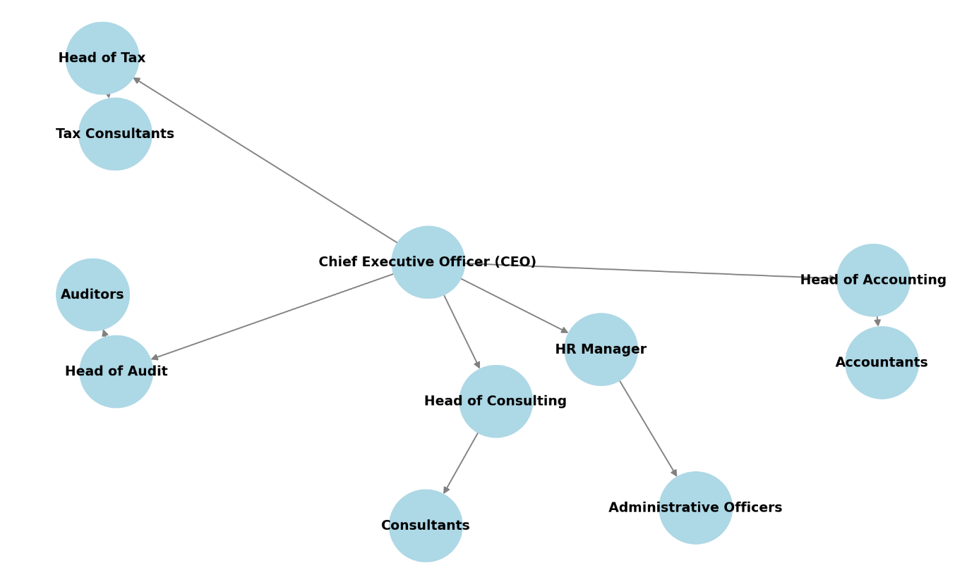
DEPARTMENT IN THE PLACEMENT AND THEIR FUNCTION
Alade Professional Services (APS) is a chartered accounting firm in Lagos, Nigeria, offering services such as bookkeeping, auditing, and financial advisory. The firm's main department functions include:
- Executive Management – Led by the Chief Executive Officer, responsible for overall strategy and decision-making.
- Accounting & Bookkeeping – Handles financial record-keeping, financial reporting, and compliance.
- Audit & Assurance – Conducts independent reviews of financial statements to ensure accuracy and compliance.
- Tax Advisory & Compliance – Assists clients in tax planning, filing, and regulatory compliance.
- Consulting & Advisory – Provides business, investment, and financial consulting services.
- Human Resources & Administration – Manages recruitment, employee welfare, and internal operations.
STATISTICAL WORK-DONE
Statistics can be said to be about collecting, organizing, summarizing, presenting and analysis of data and there are various method or techniques in which data can be analyze to make a valid and valid conclusion or interpretation of the analyzed data. During my stay at APS, I was assigned FINE Venture which they deals with the sale of office equipment and I helped in auditing and record the daily sales of goods in the system using MS Excel and MS Word, and I was able to carry-out some statistical work of the recorded sales of goods.
The data below is record of all the items sold during September, 2024.
Items | Week 1 | Week 2 | Week 3 | Week 4
Blue plastic chair | 280 | 300 | 200 | 420
Amber Chairman | 45 | 70 | 35 | 50
Supra | 15 | 10 | 11 | 19
Honor | 40 | 50 | 25 | 45
Elephant table | 110 | 95 | 72 | 60
Symphony | 90 | 120 | 90 | 75
Baby elephant | 78 | 85 | 100 | 75
Step bin | 90 | 105 | 70 | 69

Sales Report – September 2024
1. Total Sales Per Item
Item | Total Sales
Blue plastic chair | 1,200
Amber Chairman | 200
Supra | 55
Honor | 160
Elephant table | 337
Symphony | 375
Baby elephant | 338
Step bin | 334

Bar chart is use to show the total sales of each items sold.

2. Weekly Sales Trends
- Highest-selling item: Blue plastic chair (1,200 units) – peaked in Week 4 (420 units).
- Lowest-selling item: Supra (55 units) – lowest sales in Week 2 (10 units).
- Most consistent item: Symphony – sales ranged between 75 and 120 per week.
- Biggest weekly increase: Blue plastic chair (Week 3 to Week 4: +220 units).
- Biggest weekly drop: Elephant table (Week 1 to Week 4: -50 units).

3. Observations & Recommendations
- The Blue plastic chair had the highest sales and should be prioritized for stock replenishment.
- Supra had the lowest sales and may require promotional efforts to boost demand.
- Elephant table sales declined steadily, indicating possible market saturation or seasonal demand changes.
- Future strategies can include targeted advertising, discounts on low-performing items, and inventory adjustments based on these trends.

EXPERIENCE GAINED IN SIWES PLACEMENT
- Learning how to collect, organize, and manage data.
- Exposure to data entry, cleaning, and validation using spreadsheets and statistical software.
- Applying statistical methods to analyze trade trends.
- Using statistical tools like Excel, to perform calculations and visualize data.
- Learning how to forecast sales/expenses trends using historical data.
- Assisting in predicting peak operational periods to optimize logistics.
- Supporting decision-making through trend analysis and performance evaluation.
- Understanding how data influences financial decisions and resource allocation.
- Assisting in the preparation of management reports for improving operational efficiency.
- Learning how statistical models help in reducing delays and improving service delivery.
- Working with professionals in operations, finance, and business development.
- Developing problem-solving skills by applying statistics to real-world challenges.
- Learning professional ethics, time management, and corporate communication.

CONCLUSION
After my stay at the SIWES placement, which I was placed in the records department in which I input the daily record in the system, and I was able to carry-out some statistical work by practical, I understand that solving the problem of skill acquisition by graduates of Nigerian technical / vocational education is a reason for the establishment of SIWES. It was planned to be a bridge between educational institutions and industrial employers with the latter providing general and specific occupational skills and knowledge. If the scheme is not adequately implemented it becomes difficult for graduates of the system to secure proper understanding of their choice of study and implementing into occupations or make smooth transition to the labor market world.
Incompetence in workplace is related to the kind or quality of training in the school. To improve on the scheme’s implementation students should be placed in industries relevant to their field s of study. There is need for greater cooperation between industries and educational institutions on how best to implement SIWES programme. It can thus be concluded that SIWES offers the students learning experiences which cannot be directly gained in the class room.
RECOMMENDATION
- All the institutions involved should be organizing orientation courses in collaboration with the ITF for their students prior to their attachment with the attendance made mandatory for the students accepted for SIWES and ITF staff.
- ITF should ensure the regular visitation of the ITF officers to supervising Agencies institutions, employers and students on attachment.
- ITF should be providing insurance cover to students on attachment and improve on paying students and supervisors allowances for motivation.
- The Banks should speed up their action at clearing of cheque issued to avoid unnecessary delay.

