
TECHNICAL REPORT ON THE STUDENTS' INDUSTRIAL WORK EXPERIENCE SCHEME (SIWES)
HELD AT
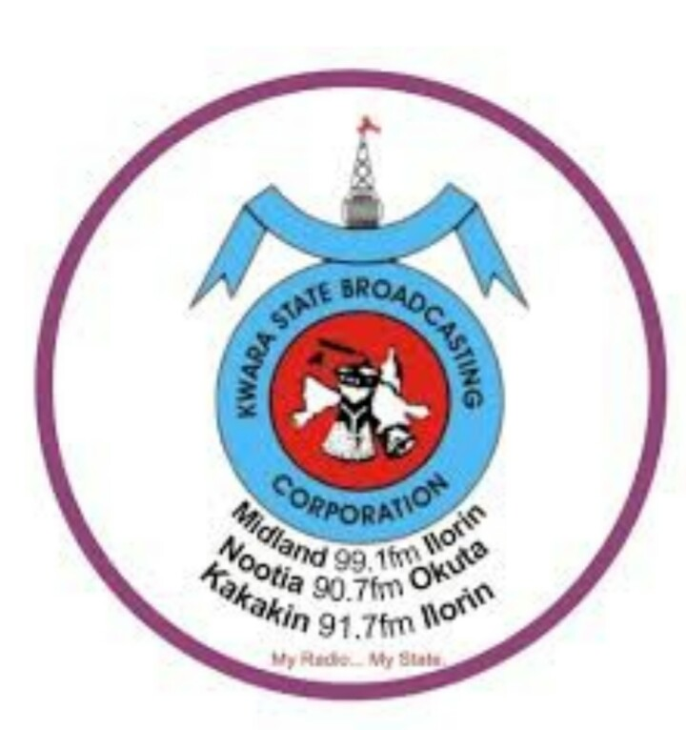
POLICE ROAD, GRA, ILORIN, KWARA STATE.
BY

ABDULKAREEM KAREEMAH OPEYEMI
ND/23/ MAC/ PT/ 0349

SUBMITTED TO
THE DEPARTMENT OF MASS COMMUNICATION,
KWARA STATE POLYTECHNIC,
INSTITUTE OF INFORMATION AND COMMUNICATION TECHNOLOGY ( IICT).
P.M.B 1375, ILORIN NIGERIA.

IN PARTIAL FULFILMENT FOR THE AWARD OF NATIONAL DIPLOMA (ND) IN MASS COMMUNICATION

5TH AUGUST - 29TH NOVEMBER 2024.
TABLE OF CONTENT
Dedication
Acknowledgement
Chapter One: Introduction
1.1 Background
1.2 Objectives
Chapter Two: Description of the Establishment of Attachment
2.1 Location and brief history of the Establishment
2.2 Objectives of the Establishment
2.3 Organization Structure
2.4 Various department in the Establishment and their Functions
Chapter Three: Work Experience
3.1 Introduction
3.2 Tasks and Responsibilities
3.3 Skills and Knowledge Acquired
Chapter Four: Experience Gained and Challenges Faced
4.1 Introduction
4.2 Experience Gained
4.3 Challenge Faced
4.4 Overcoming Challenges
Chapter Five: Summary, Conclusion and Recommendations
5.1 Summary
5.2 Conclusion
5.3 Recommendations
Some of the events covered and report written while at Radio Kwara.

DEDICATION
To Almighty Allah, who has been my superior and over linger throughout this journey.

ACKNOWLEDGEMENT
I wish to express my sincere gratitude to my family for their unwavering support and encouragement.
And to my Supervisor at Radio Kwara, in person of Mrs Aminah Adediji- Soladoye. I appreciate the guidance, support and encouragement provided.
I am grateful for the opportunity given by the school to enhance theoretical knowledge with practical experience.

CHAPTER ONE
INTRODUCTION:
The Students' Industrial Work Experience Scheme (SIWES) is a mandatory program designed by the Industrial Training Fund (ITF) to provide Students in Nigerian Universities and Polytechnics with practical work experiences in their chosen fields. As a mass communication student of Kwara State Polytechnic Ilorin, I was required to participate in this program to gain hands-on-experience and develop skills relevant to my future career.
I completed my SIWES program successfully at Radio Kwara Broadcasting Corporation, located at No 2, Police Road, GRA- Ilorin, Kwara State, from August 5th to November 29th 2024. During this period, I worked at the News and Current Affairs Department where I was despoiled to various aspects of broadcasting. This report provides a detailed account of my experience, achievements and lesson learned during my SIWES program.

1.1 BACKGROUND
The Students' Industrial Work Experience Scheme (SIWES) is a program established by Industrial Training Fund (ITF) in 1973. The program is designed to bridge the gap between theoretical knowledge acquired in the classroom and practical skills required in the workplace.
As a student of Kwara State Polytechnic Ilorin, studying Mass Communication, I am required to participate in the SIWES program to gain hands-on- experience and develop skills and develop skills relevant to my future career. The program is a mandatory requirement for student in Nigerian Universities and Polytechnics, and is expected to provide students with the opportunity to apply theoretical knowledge in a practical setting.
The SIWES program is usually undertaken during the long vacation period, and it last for a minimum of 6 months. During the period, students are expected to work in a reputable or organization in their chosen field, where they will be exposed to various aspects of the industry.

1.2 OBJECTIVES
The objective of the SIWES program includes:
1. To provide students with practical work experience in their chosen fields.
2. To develop skills relevant to the student's future careers.
3. To bridge the gap between theoretical knowledge acquired in the classroom and practical skills required in the workplace.
4. To provide students with the opportunity to apply theoretical knowledge in a practical settings.
In line with these objectives, I undertook my SIWES program at Radio Kwara Broadcasting Corporation; Midland FM, located at No 2, Police Road, GRA-Ilorin, Kwara state, from 5th August to 29th November 2024. The corporation is a leading broadcasting organization in Kwara State and it provided me with the opportunity to gain practical work experience and develop skills relevant to my future career.

CHAPTER TWO
DESCRIPTION OF THE ESTABLISHMENT OF ATTACHMENT:
The Kwara State broadcasting Corporation Ilorin, is a state government owned media house located in Ilorin, Kwara State. With broadcasting identification, Radio Kwara started broadcasting service in Ilorin in 1956 as a relay station. It was then known as Provincial Broadcasting House.

LOCATION AND BRIEF HISTORY OF ESTABLISHMENT.
Ilorin was the location in kwara state where broadcasting service were provided by the Kwara State Broadcasting Corporation (also known as "Radio Kwara"). These services began in 1956 as a relay station.
The one quarter Kilowatt (KW) medium wave transmitter that was employed at that time could only reach an area within an eight kilometer radius of Ilorin.
However, the Kwara State Broadcasting Corporation as it is now was not one of the beneficial byproducts of the first state to be created in Nigeria. It came into existence by the adoption of the first Kwara Edict No.3 of 1979, but it took effect back on April 10th 1978. As a result of a directive from the federal government, the short wave transmitter was shut down in 1976. Instruction work began in 1974 in the modern studio /broadcasting house at the 10kw short wave and 20kw medium wave transmitting station sites. On April 1st 1978, a decrees was issued in camphene with the federal governments that transfers all radio Nigeria stations on the state to their respective host states.
On September 5, 1978, Mr. Horation Agedoti of Radio Corporation in Lagos reframed the formal handling over the station by the NBA to the Kwara State Governments. In spite of the past efforts made by the administration of Alhaji Mohammed Lawal and the government of Dr. Bukola Saraki of immediate renovations of the station which awarded a contract for the provision of contemporary studio equipment and an additional 50kw Harris transmission, brings the total cost of nearly #300,000,000.
Due to this one of a kind breakthrough "Radio Kwara" has become not only one of the first radio stations in Nigeria with digital studio installed,but also one of the first stations Nigeria to comply with the global directive converting from analogue to digital broadcasting.

OBJECTIVES OF THE ESTABLISHMENT.
1.To provide high-quality of entertainment, education and information to the public.
2.To promote cultural, social and economic development through broadcasting.
3.To serve as a platform for the public discourse, debate and discussion.
4.To produce and broadcast educational programs that promotes knowledge, skills and values.
5.To provide accurate, timely and reliable information to the public on local, national and international issues.

ORGANIZATION STRUCTURE.
Radio Kwara Broadcasting Corporation operates under the Kwara State Government Authority.The station is headed by a Managing Director, who is responsible for the overseeing the overall operations of the station.

VARIOUS DEPARTMENT IN THE ESTABLISHMENT AND THEIR FUNCTIONS.
1. News and Current Affairs: Responsible for gathering and broadcasting news and current affairs programmes.
2. Programmes: Responsible for producing and acquiring programs for broadcast
3. Engineering: Responsible for maintaining and operating the station's technical equipment.
4. Administrative: Responsible for providing administrative support services to the station.

CHAPTER THREE
INTRODUCTION:
During my Four-month SIWES programme at Radio Kwara Broadcasting Corporation (Midland FM) Ilorin, I became visible to various aspects of radio broadcasting. This chapter highlights the specific tasks and responsibilities I was assigned to, as well as the skills and knowledge I acquired during my attachment.
TASKS AND RESPONSIBILITIES:
My tasks and responsibilities at Radio Kwara Broadcasting Corporation includes:
1. Assisting in News Productions: I assisted producers in the department in researching and scripting of News and coordinating logistics for live broadcasts.
2. Participating in the Compilation of News: I participated in the compilation of the National News Bulletins.
3. Operating Studio Equipment: I was introduced and trained on how to operate studio cameras, lighting, computer systems and sound equipment during broadcasts.
4. Conducting of Interviews: I was trained to conduct interviews in and outside the organization.
5. Coverage of News-Worthy Events: I was assigned to cover-up events and write it as news stories.
6. Monitoring Live Programmes: I monitored live programmes and wrote the discussion programmes into news stories.
SKILLS AND KNOWLEDGE ACQUIRED:
Through my attachment at Radio Kwara Ilorin, I acquired the following skills and knowledge:
1. Radio Production Techniques: I gained the experience in broadcast production including proofreading, camera operation and editing.
2. Broadcasting Ethics: I learned the various ethical consideration that involves in broadcasting which includes accuracy, fairness and respect for diversity.
3. Communication and Team works: I developed communication skills and teammates by working hands-in-hands with the producers and colleagues in other to deliver high-quality broadcast.
4. Technical Skills: I acquired technical skills in operating the studio equipment, editing soft wares and other broadcasting tools.
5. Time Management and Organization: I learned and practiced how to manage my time effectively, prioritizing tasks and meeting up to deadline in a fast paced broadcast environment.

CHAPTER FOUR
EXPERIENCE GAINED AND CHALLENGE FACED.
This chapter highlights the experience i gained during my SIWES attachment at Radio Kwara Broadcasting Corporation, Ilorin; as well as the challenges I faced and how I surmounted them.
EXPERIENCE GAINED.
My SIWES attachment at Radio Kwara provided me with invaluable experience in radio broadcasting. I gained:
1. Confidence and Self-esteem: I gained confidence and self-esteem engaging in live interviews with the publics and contributing to the production of high quality programs.
2. Practical Experience: I gained hands on experience in news writing and production, including events coverage and how news stories are edited.
3. Organizational Insight: I gained insight into the radio broadcasting organization including the latest trends and technologies.
CHALLENGES FACED.
During my attachment, I faced some challenges including;
1. Adapting to New Environment: I had to adapt to a new environment, working with different set of people and equipment which required adaptability and flexibility.
2. Communication Challenges: I had to communicate effectively with team members, my supervisor and producers, which required strong interpersonal skills.
3. Time Constraints: I had to work under time restrictions and tight deadlines, succeed my time effectively to do deliver assigned works.
OVERCAME CHALLENGES:
To overcome these challenges, I;
1. Sought Guidance: I sought guidance from my supervisor and colleagues, who provide valuable supports and advice.
2. Development of Problem Solving Skills: I developed my problems solving skills and overcame such problems technically and logistically.
3. Improved in Communicating Skills: I improved in my communication skills, learned how to express myself clearly and effectively.

CHAPTER FIVE
SUMMARY, CONCLUSION, RECOMMENDATIONS.
SUMMARY:
This report summarizes my four months Students’ Industrial Work Experience Scheme (SIWES) attachment at the Radio Kwara Broadcasting Corporation (Midland FM) Ilorin. During my SIWES, I gained practical experience in radio broadcasting, which includes news gathering, news production, proofreading and news editing.
I worked with a team of professionals in order to deliver high quality of news and current affairs and developed skills in teamwork, communication and time management.

CONCLUSION:
In conclusion, my SIWES attachment at Radio Kwara was a valuable learning experience that provided me with practical skills and knowledge in news broadcastings. The experience proclaim me to develop my skills in news production, editing and gathering news, and I achieved a deeper understanding of the organization concerning broadcast productions. I am grateful and thankful for the opportunity to have worked with a team of professionals and I claim that such experience gained will be beneficial to my future career.

RECOMMENDATIONS:
Based on my experience, I recommend the followings:
1. Improve facilities and equipment: Radio Kwara Broadcasting Corporation should invest in modern facilities and equipment to enhance programs production and news gathering.
2. Internship Programs: The Organization should continue to provide internship opportunities for students to gain practical experience in broadcastings.
3. Training and Development Program: Radio Kwara should provide regular training and development programs for staffs to enhance their skills and knowledge.
4. Industry Partnership: Radio Kwara should establish partnership with other media organization in terms to share resources and expertise.
5. Feedback Mechanism: Radio Kwara should establish feedback mechanism to receive feedbacks from viewers and improvement of programme contents.
For Students undertaking SIWES:
1. Be proactive: Taking the step of initiative to learn and seek feedback from colleagues and supervisors.
2. Develop teamwork skills: learning how to work effectively with others to achieve common goals.
3. Seek mentorship: seeking guidance from experienced professionals in the industry.
4. Keep a reflective journal: keep a record of your experience to help in learning and growing you.
5. Development of problem-solving skills: learning of how to think critically and development of creative solutions to problems.

SOME OF THE EVENTS COVERED DURING MY SIWES

