

TECHNICAL REPORT

ON
STUDENTS INDUSTRIAL WORK EXPERIENCE SCHEME (SIWES)

HELD AT:
SUPER FLASH ALUMINIUM
3/4 BAYO AYENI STREET DOPEMU AGEGE LAGOS STATE

By
ATANDA FATIA ADEFOLAKE
ND/23/BAM/PT/0818

SUBMITTED TO:
THE DEPARTMENT OF BUSINESS ADMINISTRATION, INSTITUTE OF FINANCE AND MANAGEMENT STUDIES (IFMS), KWARA STATE POLYTECHNIC, ILORIN.

IN PARTIAL FULFILLMENT FOR THE AWARD OF NATIONAL DIPLOMA IN BUSINESS ADMINISTRATION.

AUGUST-DECEMBER, 2024

DEDICATION
I dedicate my Industrial Training report to Almighty God, who has given me the grace to participate in the SIWES program, to my Parents and as many that have contributed greatly to the success of my Industrial Training.

ACKNOWLEDGEMENT
I thank God who has seen me throughout my SIWES program and also thank my Industrial based supervisor who guided me through My Industrial training. I also send out my appreciation to my lecturers, friends and Coworkers for their moral support.
My special thanks to my wonderful and lovely parents Mr. & Mrs. ATANDA who were there for me in terms of care, prayers, financial support.

TABLE OF CONTENT
Title Pages
Dedication
Acknowledgement
Table of content
CHAPTER ONE
1.0 Introduction
1.1 About SIWES
1.2 Brief history of SIWES
1.3 Aim and objectives of SIWES
1.4 Role of student during SIWES
1.5 Objectives of the report
1.6 The logbook
CHAPTER TWO
2.1 Brief history of the establishment
CHAPTER THREE
3.0 knowledge gained during the SIWES exercise
CHAPTER FOUR
4.1 Equipment used and their uses
CHAPTER FIVE
5.1 Conclusion
5.2 Recommendation
CHAPTER ONE
1.0 INTRODUCTION
This chapter gives a brief history of SIWES, its aims and objectives, as well as a short narrative on my application and posting. It also introduces intelligent solution providers (ISP) of Computer, where I had my SIWES training.
1.1 ABOUT STUDENTS INDUSTRIAL WORK EXPERIENCE SCHEME
The student work experience scheme (SIWES) is a worldwide program practiced in countries like Japan, Australia, USA, Europe, and in African countries too. It is popularly known as co-operative education and referred to as sandwich in Europe. It is a six (6) months students industrial work experience scheme (SIWES) taken in the third year of the degree program, where the students go to various establishments related to their course of study.
The program was initially introduced in Nigeria by the Industrial Training Fund (I.T.F.) which was established under Decree 47 of 1972 by the Supreme Military Council, headed by General Yakubu Gowon. The Decree was billed to take effect from 31st March, 1974 and had as its core objective, the gradual reduction of the percentage of foreign participation in most of Nigeria’s economic activities, accompanied by a systematic cooperation of locally oriented skilled manpower into the vast economic sector.
1.2 BRIEF HISTORY OF SIWES
The word SIWES (Student Industrial Work Experience Scheme) was introduce by the federal government in the year 1973 to develop the technological, physical and social skill of our nation, through this, adequate and intelligent student are provide the department involved the actual challenge various discipline before they can be awarded as am National Diploma (ND) graduate.
1.3 AIMS AND OBJECTIVES OF SIWES
- Provide an avenue for students in institutions of higher learning to acquire industrial skills and experience in their approved course of study and also by interacting with people with more experience in the field under consideration.
- Prepare students for the industrial work situation which they are likely to meet after graduation.
- Expose students to work methods and techniques in handling equipment and machinery that are mostly not available in their various institutions.
- Provide students with an opportunity to apply their knowledge in real world situation thereby reducing the gap between theoretical knowledge and practical work.
- Enlist and strengthen employers’ involvement in the entire educational process and prepare students for employment in Industry and Commerce.

1.4 OBJECTIVES OF THE REPORT
The objectives of the SIWES report are;
- To make through explanation of the work done during my four month industrial training.
- To fulfill the requirement for national diploma in computer science.
- To contribute to the body of knowledge and to enhance the understanding of the writer about a similar or same job.

CHAPTER TWO
2.0 BRIEF HISTORY OF THE ESTABLISHMENT
SUPER FLASH ALUMINIUM LIMITED
SUPER FLASH ALUMINIUM LIMITED was incorporated in DOPEMU, Nigeria with Registration Number 913152. It was registered on 24 Sep 2010 and it's current status is unknown. Company's registered office address is NO. 4, BAYO AYENI STREET, ALUMINIUM VILLAGE DOPEMU , DOPEMU , LAGOS.
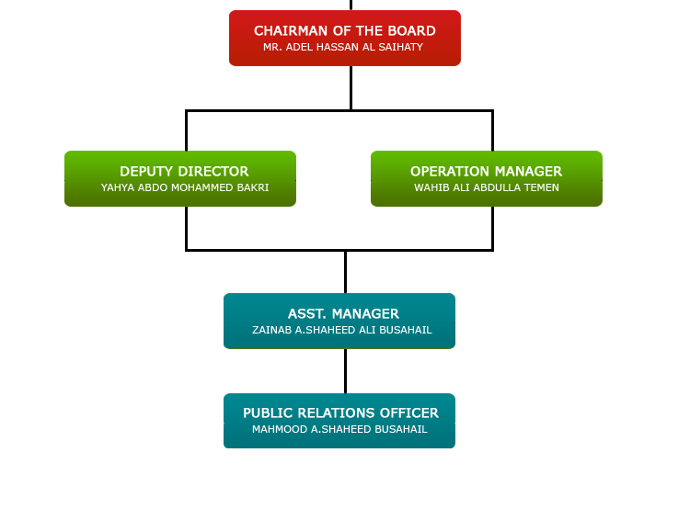
Organizational Chart

CHAPTER THREE
EXPERIENCED GAINED DURING THE SIWES EXERCISE
During the Student Industrial Work Experience Scheme (SIWES), I had the opportunity to gain hands-on experience in various aspects of aluminum fabrication, including cutting, welding, assembling, and understanding different aluminum alloys. The period of industrial training exposed me to the practical applications of my theoretical knowledge and helped me develop essential skills that will be beneficial in my future career. The following are the key areas in which I gained valuable experience:

3.1 Learning Aluminum Cutting, Welding, and Assembling Techniques
One of the fundamental skills I developed during my industrial training was aluminum cutting. I learned different cutting techniques such as shearing, sawing, and plasma cutting. Each method has specific applications depending on the thickness and type of aluminum being used. I was trained in handling cutting tools safely and accurately to achieve precise dimensions as required by design specifications.
In addition to cutting, I was introduced to aluminum welding. Welding aluminum requires specialized techniques due to its low melting point and high thermal conductivity. I was taught how to use Tungsten Inert Gas (TIG) welding and Metal Inert Gas (MIG) welding for joining aluminum parts. I practiced welding under the guidance of experienced welders, improving my ability to create strong and durable weld joints.
Assembling aluminum structures was another critical aspect of my training. I learned how to read engineering drawings and assemble components accurately. I also acquired knowledge of using fasteners such as rivets and bolts, as well as adhesive bonding techniques for aluminum structures. This experience helped me understand the importance of precision and alignment in fabrication work.

3.2 Understanding Different Aluminum Alloys and Their Applications
During my training, I became familiar with various aluminum alloys and their specific applications in different industries. Aluminum alloys are categorized into series based on their chemical composition and mechanical properties. For example:
- 1000 series: High purity aluminum used in electrical and chemical applications.
- 2000 series: Aluminum-copper alloys used in aerospace applications due to their high strength.
- 3000 series: Aluminum-manganese alloys used in roofing sheets and beverage cans.
- 5000 series: Aluminum-magnesium alloys used in marine and structural applications.
- 6000 series: Aluminum-silicon-magnesium alloys used in automotive and construction industries.
- 7000 series: Aluminum-zinc alloys used in aerospace and military applications.
Understanding these alloys enabled me to make informed decisions regarding material selection for different projects, considering factors such as corrosion resistance, weight, and strength.

3.3 Operating Various Fabrication Machines
The industrial training also provided me with practical exposure to operating different fabrication machines. Some of the machines I worked with included:
- Shearing Machine: Used for cutting aluminum sheets to specific sizes.
- CNC Router: Used for precision cutting and engraving of aluminum.
- Bending Machine: Used for shaping aluminum sheets and profiles.
- Drilling Machine: Used for making precise holes in aluminum components.
- Grinding Machine: Used for finishing and smoothing aluminum surfaces.
Learning how to operate these machines improved my technical competence and understanding of fabrication processes. I also learned about machine maintenance and troubleshooting, which is essential for ensuring smooth operations in a manufacturing environment.

3.4 Practicing Safety Measures in the Workshop
Safety is a crucial aspect of any industrial environment, and during my SIWES training, I was trained in various safety protocols to prevent accidents and injuries. Some of the key safety measures I practiced included:
- Wearing Personal Protective Equipment (PPE) such as gloves, safety goggles, helmets, and protective clothing.
- Ensuring proper ventilation while welding to prevent inhalation of harmful fumes.
- Using fire-resistant materials and fire extinguishers to handle potential fire hazards.
- Maintaining a clean and organized workspace to prevent tripping hazards.
- Following machine safety protocols, including proper shutdown procedures and regular equipment inspections.
By adhering to these safety measures, I developed a strong sense of responsibility for workplace safety and learned how to respond effectively to emergency situations.

3.5 Gaining Teamwork and Problem-Solving Skills
The SIWES experience also helped me enhance my teamwork and problem-solving skills. In an industrial setting, collaboration is essential to ensure the success of projects. I worked alongside experienced fabricators, welders, and engineers, learning how to communicate effectively and contribute to team efforts. I participated in group discussions, shared ideas, and resolved challenges that arose during fabrication processes.
Problem-solving was another critical skill I developed. I encountered various challenges, such as material defects, incorrect measurements, and welding distortions. Through critical thinking and guidance from my supervisors, I learned how to analyze problems, identify root causes, and implement effective solutions. This experience boosted my confidence and ability to handle real-world technical challenges.

Conclusion
Overall, my SIWES training was an invaluable learning experience that provided me with practical skills in aluminum fabrication. From mastering cutting, welding, and assembling techniques to understanding different aluminum alloys, operating fabrication machines, practicing safety measures, and enhancing teamwork and problem-solving abilities, I gained a wealth of knowledge that will contribute significantly to my professional development. The experience strengthened my interest in the field and prepared me for future challenges in the industry.

CHAPTER FOUR
EQUIPMENTS USED AND THEIR USES
- Cutting Machine - Used for shaping aluminum sheets.

- Welding Machine - Joins aluminum parts together.
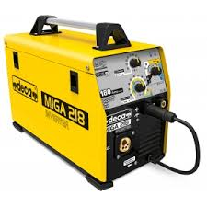

- Drilling Machine - Makes holes in aluminum sheets.
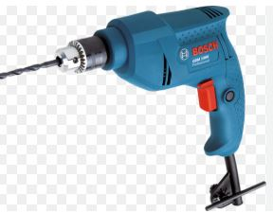
- Measuring Tape - Ensures precision in cutting and assembly.


CHAPTER FIVE
CONCLUSION AND RECOMMENDATIONS
The SIWES experience was invaluable, providing practical exposure to real-world applications of theoretical concepts. It has prepared me for future career challenges and improved my technical and professional skills.

RECOMMENDATIONS
To enhance the effectiveness of the SIWES program, the following recommendations are proposed:
Extended Duration: The duration of SIWES should be extended to allow students more time to fully immerse themselves in industrial practices.
Adequate Funding: The government and institutions should provide adequate funding to support students during their industrial training, covering transportation and necessary materials.
Better Supervision: Organizations should assign dedicated supervisors to students, ensuring they receive proper guidance and relevant work experience.
Modern Equipment and Facilities: Companies should invest in updated technologies and equipment to ensure students are trained with industry-relevant tools.
Collaboration Between Institutions and Industries: Stronger partnerships between educational institutions and industries should be fostered to create more opportunities for industrial training placements.
Structured Evaluation System: A well-defined assessment system should be established to evaluate students' performance and provide constructive feedback.

