KWARA STATE POLYTECHNIC, ILORIN
KWARA STATE.
STUDENT INDUSTRIAL WORK EXPERIENCE SCHEME,
(S.I.W.E.S),
REPORT ON MY EXPERIENCE,
FOR FOUR (4) MONTHS,
TRAINING.

AT

SHEGNET KONSULT (TRUE MESSAGE CYBER KONSULT),
NO. 25, DANTORO ROAD, NEW-BUSSA,
NIGER STATE.

BY

OKE ABIDEMI STEPHEN,
ND/23/COM/PT/0102
DEPARTMENT OF COMPUTER SCIENCE.
INSTITUTE OF INFORMATION AND COMMUNICATION TECHNOLOGY

REPORT OVERVIEW
This report presents an account details of the Student Industrial Work Experience Scheme (SIWES) undertaken at Shegnet Konsult technology. Driven organization specializing in software development, IT consultancy, and data base management. The training lasted for four [4] months, during which the student was exposed to practical applications of theoretical knowledge gained in the classroom. The primary focus of the training was website development, data base management, where I undertook so many classes and did some practical works. Tasks included (developing a website with html and PHP and by using html links, forms and soon.) which significantly enhanced technical and problem-solving skills. Additionally, I gained hands-one experience with (some software tools in data base management e.g., MySQL, HTML, PHP], improving proficiency in website development and some project writing skills.

TABLE OF CONTENT.
- CHAPTER 1 INTRODUCTION..............................................................
- CHAPTER 2 DESCRIBITION OF THE ESTABLISHMENT OF ATTACHMENT ................................
- CHAPTER 3 MY SIWES EXPERIENCE ...........................................................................
- CHAPTER 4 MY SIWES EXPERIENCE.................................................
- CHAPTER 5 SUMMARY, CONCLUSION AND RECOMMENDATION ................................................

INTRODUCTION
This report presents an account details of the Student Industrial Work Experience Scheme (SIWES) undertaken at Shegnet Konsult technology. Driven organization specializing in software development, IT consultancy, and data base management. The training lasted for four [4] months, during which the student was exposed to practical applications of theoretical knowledge gained in the classroom. The primary focus of the training was website developme1nt, data base management, where I undertook so many classes and did some practical works. Tasks included (developing a website with html and PHP and by using html links, forms and soon.) which significantly enhanced technical and problem-solving skills. Additionally, I gained hands-one experience with (some software tools in data base management e.g., MySQL, HTML, PHP], improving proficiency in website development and some project writing skills.

- 1 BACKGROUND
Shegnet Konsult started in 2007 in Ogbomoso when the CEO or visioner (Mr. Joseph O. ADIGUN) as a student of Ladoke Akintola University of Technology [LAUTECH] and some friends started developing what they called Slum CD (a kind of Photo CD album that plays music in background) which is for secondary school, (rincipally Federal Government College, Ogbomoso students.

In 2017, Shegnet Konsult was restarted in New Bussa, Niger state as a Cyber training Center. In 2019 Shegnet Konsult started full stack Software/Website Development and have developed website for FCWM, Kambel and some proprietary web applications for schools and cooperative societies

Recently, Shegnet Konsult is known as Nik ShegNet Konsult with Olanike OLUSEGUN as CEO. Shegnet Konsult is permanently located in Block 15, Flat22, Ayetoro Scheme, Oyo, Oyo state and currently has a branch in No 25, Dantoro road, New-Bussa, Niger State.

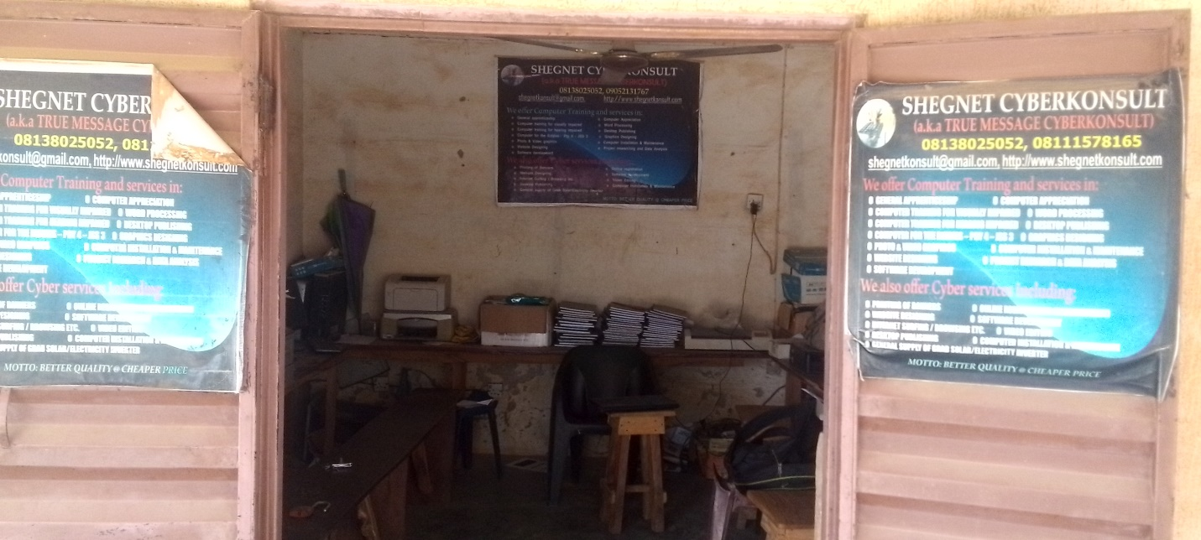

- 2 OBJECTIVE
The goals I intended to gain in my siwes experienced is to learn how to develop a website, create a websites for an organization and for my self.

CHAPTER 2 DESCRIPTION OF THE ESTABLISHMENT OF ATTACHMENT
2.1 LOCATION AND BRIEF HISTORY OF THE ESTABLISHMENT
Shegnet Konsult is permanently located in Block 15, Flat22, Ayetoro Scheme, Oyo, Oyo state and currently has a branch in No 25, Dantoro road, New-Bussa, Niger State.
Shegnet Konsult started in 2007 in Ogbomoso when the CEO or visioner (Mr. Joseph O. ADIGUN) as a student of Ladoke Akintola University of Technology [LAUTECH] and some friends started developing what they called Slum CD (a kind of Photo CD album that plays music in background) which is for secondary school, (rincipally Federal Government College, Ogbomoso students.
In 2017, Shegnet Konsult was restarted in New Bussa, Niger state as a Cyber training Center. In 2019 Shegnet Konsult started full stack Software/Website Development and have developed website for FCWM, Kambel and some proprietary web applications for schools and cooperative societies
2.2 OBJECTIVE OF ESTABLISHMENT
The establishment is a web development company that specialize in designing and developing dynamic website, web application, and mobile application. The company utilizes various programming languages such as HTML, CSS, JAVASCRIPT, PHP and PHYTHON to deliver innovative and effective digital solution. The team consist of experienced web developers, designers, and programmers who work collaboratively to provide high-quality services to client.

2.3 ORGANIZATION STRUCTURE ( INCLUDING ORGANOGRAM)
Shegnet Konsult (True Message Cyber Konsult )Division’s and Unit’s.

NOTE: Shegnet Konsult is structured into several specialized divisions, each focusing on distinct services:

- Nik Sheg Net Cyber Konsult: This division offers cyber consulting services, including:

- Software development forsmal land medium-scale businesses.

- Website development to support and market businesses.

- Conversion of websites to Android applications.

- Design of magazines, book publishing, flyers, banners, and posters.

- Nik Sheg Net Edu Konsult: Focused one ducational consulting, this division provides:

- Data analysis for research papers and final year projects.

- JAMB CBT practice.

- Access to fully referenced final year projects for various academic levels (NCE, ND, HND, BSc, PGDE).

- Final year project software development.

- Sales of WAEC/NECO/NABTEB result checkers.

- Free download of computer training resources.

- Nik Sheg Net Advert Konsult: This division handles advertising services, allowing clients to:

- Advertise products and services on their website.

- Promote through applications developed for general use.

- Nik Sheg Net Media Konsult: Specializing in media consulting, this division offers:

- Photo CD albums (on DVD and website), year books, and photo and video production.
- Photo albums and video production for ceremonies such as weddings, funerals, and birthdays.

Additionally, Shegnet Konsult has develop dreadily available web applications, including:

A secondary school result processing app.

A cooperative management app.

The Division I worked in is Nik Sheg Net Edu Konsult and the Unit is under Training unit, I worked there as a student and received training under the supervision of Division Nik Sheg Net Edu Konsult.
2.4 THE VARIOUS DEPARTMENT/UNIT OF THE ESTABLISHMENT AND THEIR FUNCTION
SHEGNET KONSULT COMPUTER CENTER
CEO/MANAGER

STAFF 2/SUPPORT STAFF
STAFF 1/TECHNICAL STAFF

CEO/MANAGER
- Strategic Planning and Vision.
- Decision Making.
- Financial Oversight.
- Leadership and Management.
- Company Representative.
- Innovation and Growth.

STAFF1/TECHNICALSTAFF
- Cybersecurity.
- System Maintenance.
- Technical Support.
- Software Development.
- Software Maintenance.
- Network Administration.
- Technology Research and Upgrades.
- Hardware Installation and Repair.

STAFF2/SUPPORT STAFF
- Customer Service.
- Record Keeping.
- Administrative Support.
- Data Entry and Management.
- Office Maintenance.

CHAPTER 3 MY SIWES EXPERIENCE
My Student Industrial Work Experience Scheme (SIWES) took place at Shegnet Konsult Organization. The organization is a system which enhances student with various equipment in different aspect of sections in the organization, during these four (4) month program which took place on Shegnet Konsult, more over the organization is a multi faceted enterprise which specializes in cyber consulting, multimedia production, educational services and also software development. The organization is permanently located at Block15, Flat22, Ayetoro scheme, Oyo, Oyo State with a branch which is located at No. 25, Dantoro Road, New-Bussa, Niger State. The branch which is located at No. 25, Dantoro Road, New-Bussa, Niger State is where my SIWES program actually took place.
On First day up on joining which was on 1^{s t}of august 2024, I under went an orientation program that familiarized me with the company’s operations, including their services in website development, data analysis and soon, I was also asked which section I would like to functioning, so many sections was laid down but I choose website development, Because I know upon choosing these section it will help me in my project in National Diploma Two,(ND2).
Actually on the first day we did nothing much but we were taught on how to write our project easily in an extensive way, and I was briefly introduced to what web development is and it was said to be the process of creating, building and maintaining websites, in other words web site is a collection of web pages that are interconnected together through hyperlinks. Moreover, we were taught there sources needed to build a website.
We were introduced to Html, PHP and Database.

Html Experience.
Hyper text Mark-up Language (HTML) is A system for Marking up document with tags. It is just like a structure for website development were others will be added, some popular HTML tags and it syntax will be shown below:

Tag | Name | Description | The Browser View
<strong> | Boldentext | <strong>It helps bolden a text</strong> | Makes a text bold in the browser
<!-- | Comment | <!—These helps the developer to remember his code after sometime--> | Shows nothing or have not affect in the browser.
<h1> | heading | <h1>The biggest heading size</h1> | Puts the header a text in the bigger form.
<p> | paragraph | <p>Makes a text in a paragraph</p> | Gives a text a paragraph.
<br> | Breakline | <br>it an empty tag that break a text to then textline. | Goes to then textline.
<a> | For Hyperlinks | <ahref=””>Creationoflinktodifferentwebpagesbytheuseoftheattributehrefwhichmeansheaderreference. | Display a link for navigation
<input> | inputting | <input type=”text”>It is also an empty tag that allows a user to input either a text, date and soon. | Display a text box for inputtinginformation.

HTMLSYNTAX

<!Doctypehtml>
<htmllang="en">
<head>
<title></title>
</head>
<body>
</body>
</html>

These syntax is a basic html structure where the “lang=en” in the html opening tag is an attribute which adds additional information about HTML element. An example of an image which describes or explains how html looks like will be shown below or an image of an html describing a html with a heading and hyperlink.
CODE FOR THE HTML WHICH DESCRIBES HEADING, LINK, TABLE
<!Doctypehtml>
<html lang="en">
<head>
<title>
My Website
</title>
</head>
<bodybgcolor="grey">
<h1align="center">MyFirstWebsite</h1>
<tablealign="center"width="80%">
<tr>
<tdwidth="25%"><ahref="index.html">Home</a></td>
<tdwidth="25%"><ahref="service.html">Services</a></td>
<tdwidth="30%"><ahref="about.html">About</a></td>
<tdwidth="20%"><ahref="gallery.html">Gallery</a></td>
</tr>
</table>
<p>
<tablewidth="80%"border="1">
<tr>
<tdcolspan="4"align="center">ComputerStudentsInformation</td>
</tr>
<tr>
<tdwidth="25%">Names</td>
<tdwidth="25%">MatricNo</td>
<tdwidth="30%">CourseCode</td>
<tdwidth="20%">CourseTitle</td>
</tr>
<tr>
<tdwidth="25%">Okeabidemistephen</td>
<tdwidth="25%">ND/23/COM/PT/0102</td>
<tdwidth="30%">COM125</td>
<tdwidth="20%">ComputerApplicationPackages1</td>
</tr>
<tr>
<tdwidth="25%">BobbeShuaibKelvin</td>
<tdwidth="25%">ND/23/C0M/PT/0109</td>
<tdwidth="30%">COM113</td>
<tdwidth="20%">IntroductionToProgramming</td>
</tr>
</table>
</p>
</body>
</html>
OUTPUT FOR THE HTML CODE ABOVE
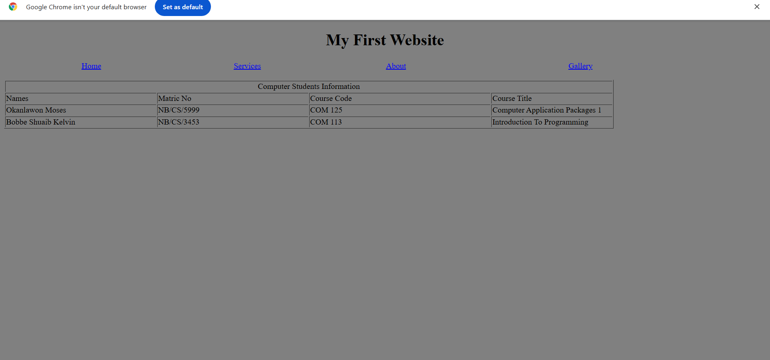
PHP Experience
My experience with Hyper text Pre-processor (PHP) is very wide.
What is PHP?
- It is a server side scripting language i.e executed on the server before sending the output to browser.
- It is an open Source Language.
- It enhances in Database Connectivity.
- It is used for Web Development.
- It has Security Features.
Basic PHP Syntax
PHP ( Hyper text Pre-processor) also has a syntax which must be generally used or must be used if also the PHP would not work. The syntax is just as HTML has opening and closing tag.
PHP Syntax starts with<?phpandendswith?>.

Division Of PHP
- Code Mixing.
- Code Switching.

Below is an example of a PHP code calculation for distance with the formula:
S=u*t*(t*½*a*t²).
<html>
<head>
<title>PHPCalculation</title>
</head>
<bodyalign="center">
<h1align="center">YOUAREWELCOMETOPHPCALCULATION</h1>

<?php
$u=12.0;
$t=4.12; $a=29.8;
$S=$u*$t*(1/2)*$a*$t*$t;
Echo"
<h2>TheAnswer:=$S
</body>
</html>
";
?>
OUTPUTFORTHEPHPCODEABOVE
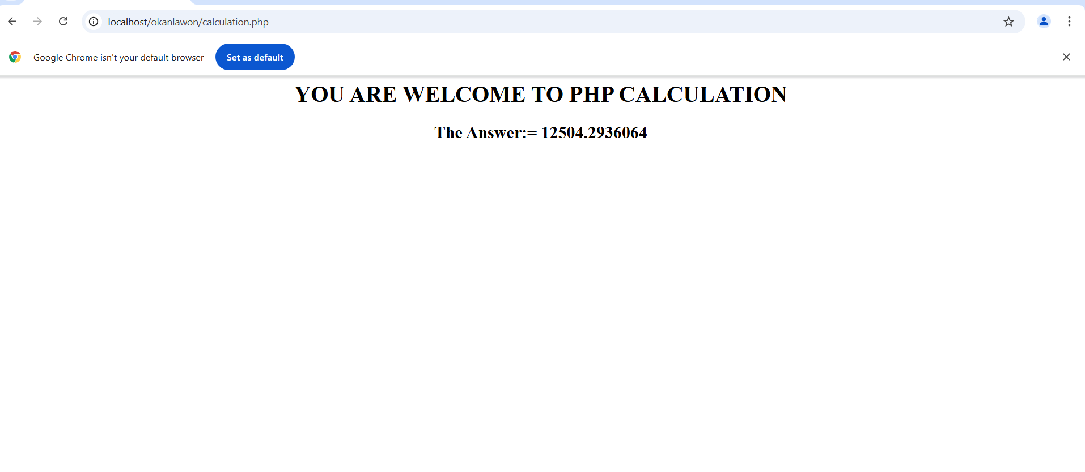
Experience With Data base And MySQL

CHAPTER 4 WHAT IS DATABASE?
- Collection of Interrelated Data’s and Information.
- It is used for Data Management.
- It is good in terms of Scalability and Maintenance.
- It enhances Security and Integrity.
- It is used in case of User Authentication.

SQL(Structured Query Language)
Moreover,structuredquerylanguage(SQL)isaStandardizedlanguageusedtomanageandmanipulatedatabases.
SQL is basically used for:
- Data Querying.
- Data Manipulation.
- Data Definition.
- Data Control.

Some Operations In Database
- Create database with MySQL, PostreSql, PHP My Admin and soon.
- Create table where your data’s will be stored.
- Basic working Database are: Insertion, Update, Deletion, Fetch and soon.

Below is an example of a Database:
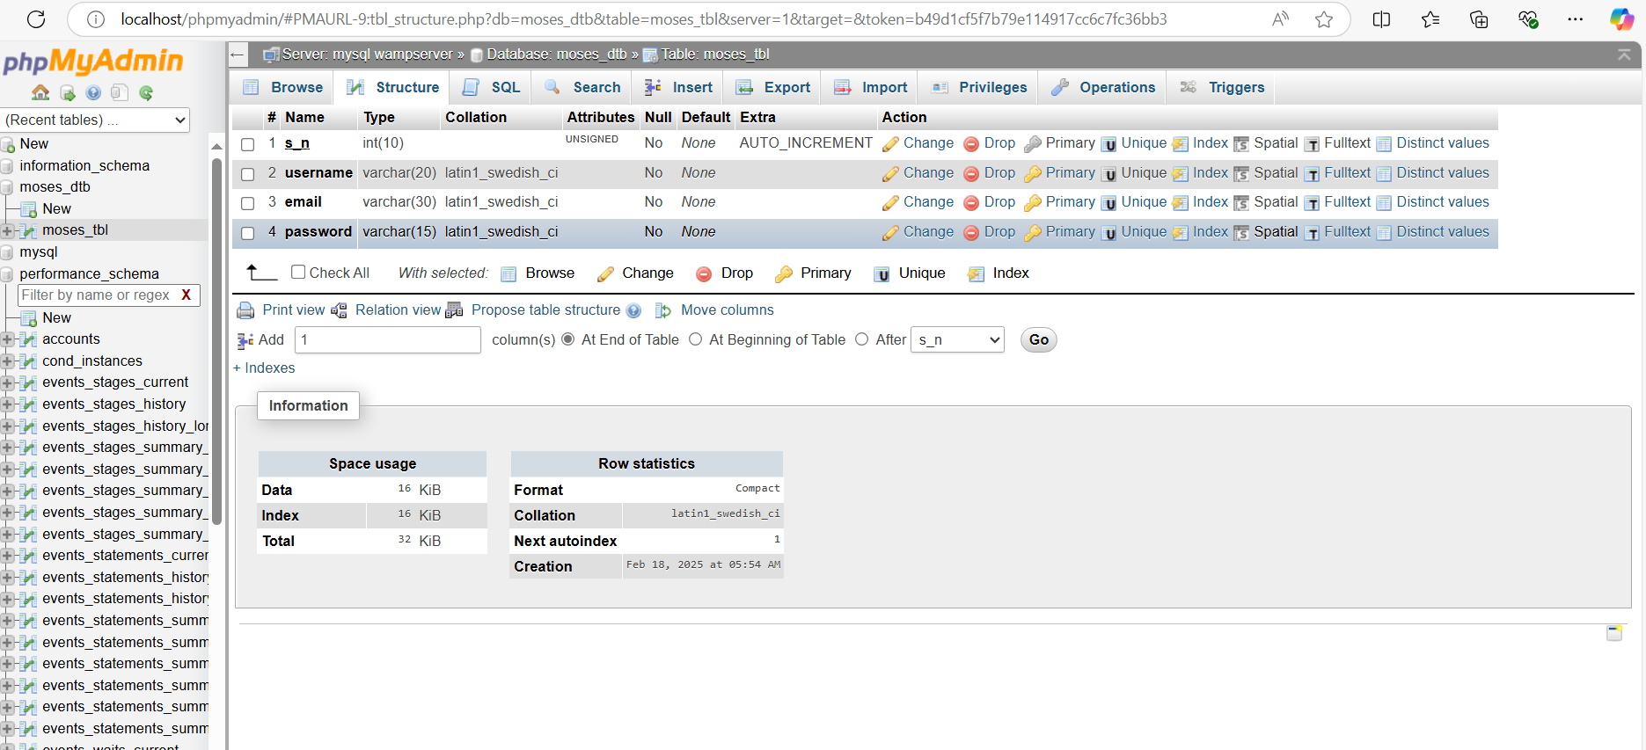

NOTE: Before you can start working with data base as a web developer, you must be able to connect or interact your database with HTML and PHP. So, what you can do is that I use the Connection String Code below:
<?php
$host='';//Changeasperyour database
$dbname='';//Your database name
$username='';//YourMySQLusername
$password='';//Your MySQL password

try{
$pdo=newPDO("mysql:host=$host;dbname=$dbname",$username,$password);
$pdo->setAttribute(PDO::ATTR_ERRMODE,PDO::ERRMODE_EXCEPTION);
}catch(PDOException$e){
die("Error:Couldnotconnecttothedatabase.".$e->getMessage());
}
?>

CHAPTER 5 SUMMARY, CONCLUSION AND RECOMMENDATION
5.1 Summary of attachment activities
- Web Designing.
- Resources To Develop a Website.
- Necessary Installation for Web Development e.g local hosting.
- Hypertext Mark-Up Language (HTML) Teaching or Lecture.
HTML Tags
HTML Forms
HTML Lists
HTML Tables
Inline CSS

- PHP (Hyper text Pre-processor).
PHP Syntax
PHP Calculation
PHP Interaction with database

- Database Management System(MySQL)
Database Creation
Data base Table’s
Data base Connection String with PHP

5 .2 Problems encountered during the program
- Lack of Electricity: we encountered so many problems in decence of power electricity there is no light some times we have to wait for NEPA to restore light some times we close even without doing anything
- Absentism of attachment siwes coordinator: due to lack of the company owner the person is a lecturer of FEDERAL COLLEGE OF WILDLIFE MANAGEMENT he is not that available to teach us very well but with this my little time spent with him I tried my best to learn somethings even though am not capable of everything I tried my best
- Financial problems: This point is the first and fore most among my challenges faced during the four (4) month program. It was very hard to transport my self to the organization where my SIWES took place hence making learning difficult.

5.3 Suggestion improvement of the scheme
I suggested that the siwes organization should keep there promise in terms of paying the student there levies by doing that student will be encouraged to do siwes and learn alot

