
TECHNICAL REPORT ON
STUDENT INDUSTRIAL WORKS EXPERIENCE SCHEME (SIWES)
HELD AT
UNIVERSITY OF ILORIN WORKS DEPARTMENT
PRESENTED BY
DUROJAIYE MUSIBAU TUNDE
ND/23/MEC/PT/0118
SUBMITTED TO:
DEPARTMENT OF MECHANICAL ENGINEERING, INSTITUTE OF TECHNOLOGY (IOT)
KWARA STATE POLYTECHNIC, P.M.B 1375, ILORIN
KWARA STATE
IN PARTIAL FULFILMENT OF THE REQUIREMENT FOR THE AWARD OF NATIONAL DIPLOMA (ND) IN MECHANICAL ENGINEERING DEPARTMENT
KWARA STATE POLYTECHNIC, ILORIN, KWARA STATE.

AUGUST – DECEMBER, 2024

DEDICATION
I wholeheartedly dedicate the success of this work to my beloved wife, whose unwavering support and steadfast encouragement have been my greatest strength through it all.
To my wonderful children, your words of encouragement have been a constant source of motivation, and for that, I am truly grateful.
Finally, I extend my heartfelt appreciation to every single person who has contributed, in one way or another, to the success of this work. Your support and efforts have not gone unnoticed.

ACKNOWLEDGEMENT
I would like to express my deepest gratitude to Engineer S.O. Aloga and Engineer Mumeen for their unwavering encouragement and immense support throughout this journey. Their guidance and belief in me played a vital role in making this work possible.
A special appreciation also goes to my supervisor, Engineer Adeshina Dayo, for his invaluable tutoring, mentorship, and guidance. His insights and dedication made the completion of this work a smooth and enriching experience.
PREFACE
The Student Industrial Work Experience Scheme (SIWES) helps in exposing students to the practical application of their course and to get used to equipment and machines used in the factory. The SIWES was established to promote student skill in industrial practice and pre-expose them to working experience in industrial setting.
The SIWES programme covered a period of four months from August to December 2024 and it is a partial fulfilment of a two-year academic programme to obtain an OND certificate in Engineering. The report explains the description of work done.

Table of Contents
Title Page i
Dedication ii
Acknowledgement iii
Preface iv
Table of Contents v
CHAPTER 1: INTRODUCTION
1.1: Background 1
1.2: Objectives of SIWES 2

CHAPTER 2: DESCRIPTION OF THE ESTABLISHMENT OF ATTACHMENT
2.1: Location and Brief History of Establishment 3
2.2: Objectives of Establishment 3
2.3: Organization Structure (Including Organogram) 5
2.4: The Various Departments/Units in the Establishment and their Functions 5

CHAPTER 3: WORKDONE
3.1: Various Machines, Tools, and Equipment and their Functions in the Engineering Workshop7
3.2: Machine Tools and Equipment and their Functions in the Workshop 10
3.3: Metal Casting in the Fabrication Workshop 16

CHAPTER 4: EXPERIENCE GAINED
4.0: Summary of experience gained 21

CHAPTER 5: SUMMARY, CONCLUSION AND RECOMMENDATION
5.1: Summary of Attachment Activities 22
5.2: Problems Encountered during the Program 22
5.3: Suggestions for the Improvement of the Scheme 23

CHAPTER 1
1.0. INTRODUCTION
1.1. Background
SIWES stands for Students Industrial Work Experience Scheme. It is a mandatory internship program for students in Nigerian universities and polytechnics, particularly those in engineering, technology and other related fields.
The SIWES program was established by the Federal Government through the Industrial Training Fund (ITF) under the National Board of Technical Education (N.B.T.E.) in 1973, with the primary objective of bridging the gap between theoretical knowledge acquired in the classroom and practical experience in the industry.
1.1. Objectives of SIWES
The Students Industrial Work Experience Scheme is designed to achieve the following specific, measurable, achievable, relevant, and time-bound objectives:
- Primary Objectives
- Practical Skill Acquisition: To provide students with hands-on experience in their chosen field, enabling them to apply theoretical knowledge by equipping them with practical skills and competencies required in the industry in real-world setting.
- Industry-Academia Collaboration: To foster collaboration between educational institutions and industries, and facilitating the exchange of knowledge, expertise, and resources between academia and industry promoting mutual understanding and benefit.
- Career Preparation: To prepare students for the workforce by exposing them to industry practices, ethics, and expectations thereby enhancing students' employability and career prospects.

- Secondary Objectives
- Skill Development: To enhance students' skills, particularly in areas such as problem-solving, communication and teamwork while developing their critical thinking, creativity and innovation skills.
- Exposure to Industry Practices: To provide students with firsthand experience of industry practices, procedures, and standards.
- Entrepreneurial Skill Development: To encourage students to develop entrepreneurial skills and consider starting their own business.
- Expected Outcomes.
- Improved Employability: To improve the employability of graduates by providing them with relevant work experience and skills thereby enhancing their career prospects and opportunities.
- Enhanced Skill Competencies: To enhance student’s ability to apply theoretical knowledge and practical skills in real-world setting.

CHAPTER 2
2.0. DESCRIPTION OF THE ESTABLISHMENT OF ATTACHMENT
2.1. Location and Brief History of Establishment
UNIVERSITY OF ILORIN, P.M.B, 1515, ILORIN, KWARA STATE It was established in 1975 by a decree of the Federal Military Government. The University of Ilorin's Works Department is located at Old Jebba Road, Oke Ose, Ilorin, Kwara State, Nigeria. The department also provides technical support.
2.2. Objectives of Establishment
- Primary Objectives
- To provide high-quality technical and vocational education that meets the needs of the economy and society.
- To equip students with practical skills and competencies required in the industry
- To promote research and innovation in various fields, leading to the development of new technologies and products.

- Secondary Objectives
- To foster collaboration between academia and industry, leading to the exchange of knowledge, expertise, and resources.
- To provide a conducive learning environment that supports academic excellence and personal growth.
- To provide opportunities for lifelong learning and professional development.
- To promote entrepreneurship and self-employment among graduates.
- 2.3. Organization Structure.
DIRECTOR

DEPUTY DIRECTOR

COMPTROLLER

QUALITY CONTROL INSPECTOR
SAFETY OFFICER
ELECTRICAL SECTION SUPERVISOR
MECHANICAL SECTION SUPERVISOR
CIVIL SECTION SUPERVISOR

WELDING TECHNICIANS
FITTINGS TECHNICIANS
MACHINING TECHNICIANS

STUDENT TRAINEES (MACHINING)
STUDENT TRAINEES (WELDING)

STUDENT TRAINEES (FITTINGS)

2.4. The Various Departments or Units in the Establishment and their Functions.
- Mechanical Engineering Department
- Functions:
- Design and development of mechanical systems
- Thermodynamics and heat transfer
- Fluid mechanics and dynamics
- Materials science and metallurgy
- Welding and Fabrication Engineering Department
- Functions:
- Design welding processes
- Fabricate metal products
- Conduct quality control
- Develop new welding techniques
- Testing of welding equipment
- Inspect welded products
- Train welding personnel

- Automotive Engineering Unit
- Functions:
- Design vehicle systems
- Develop engine performance
- Test transmission systems
- Improve braking systems
- Develop safety features
- Validate vehicle performance
- Research new automotive technologies

CHAPTER 3
3.0. WORKDONE
3.1. Various Machines, Tools, and Equipment and their Functions in the Engineering Workshop.
Tools and equipment can be any items or apparatus that is used to achieve a goal or a specific objective either mechanical or non-mechanical. Also, tools are most component in engineering workshops.
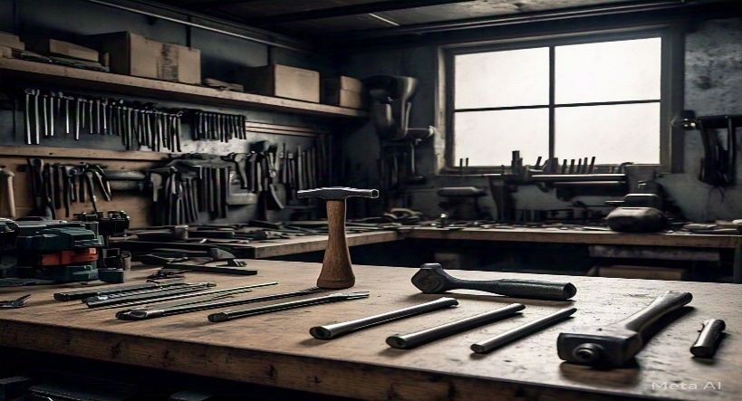

- Different Hand Tools in the Engineering Workshop
- Cutting Tools
- Hacksaw: A hacksaw is a handheld saw used to cut metal pipes, rods, and other metal objects. It consists of a frame, a blade, and a handle.
- Bolt cutters: Bolt cutters are used to cut chains, bolts, and wires. They consist of two handles and a cutting jaw.
- Pliers: Pliers are handheld tools used to grip, bend, and cut objects. There are various types of pliers, including needle-nose pliers, slip-joint pliers, and locking pliers.
- Utility knife: A utility knife is a handheld tool used to cut various materials like wood, plastic, and drywall. It consists of a blade and a handle.
- Scissors: Scissors are handheld tools used to cut paper, fabric, and other lightweight materials.

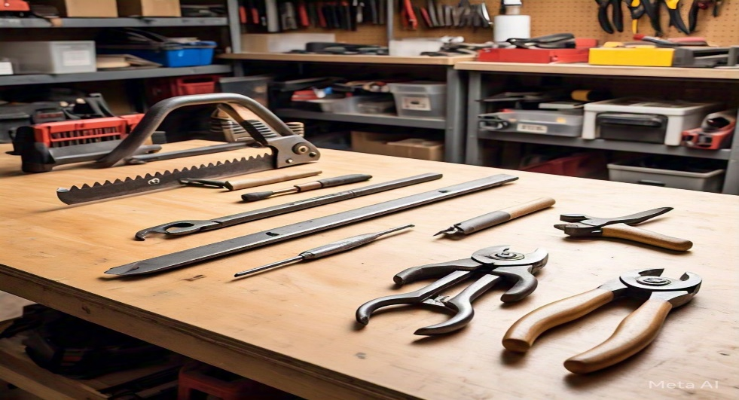

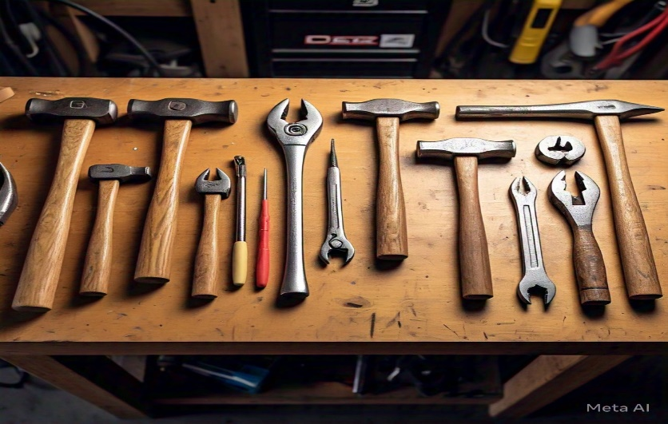

- Fastening Tools
- Hammer: A hammer is a handheld tool used to drive nails, fit parts together, and break apart objects. There are various types of hammers, including claw hammers, ball-peen hammers, and sledgehammers.
- Screwdrivers: Screwdrivers are handheld tools used to drive screws and other fasteners. There are various types of screwdrivers, including flathead screwdrivers, Phillips-head screwdrivers, and Torx screwdrivers.
- Pliers: Pliers are also used as fastening tools to grip and twist objects.
- Wrenches: Wrenches are handheld tools used to tighten and loosen bolts and nuts. There are various types of wrenches, including adjustable wrenches, socket wrenches, and box-end wrenches.
- Tape measure: A tape measure is a handheld tool used to measure distances and sizes.


- Measuring Tools
- Calipers: Calipers are handheld tools used to measure internal and external dimensions. There are various types of calipers, including digital calipers and dial calipers.
- Micrometer: A micrometer is a handheld tool used to measure precise dimensions. There are various types of micrometers, including digital micrometers and analog micrometers.
- Level: a level is a handheld tool used to ensure surfaces are level and plumb.
- Square: A square is a handheld tool used to ensure accurate right angles.
- Protractor: A protractor is a handheld tool used to measure angles.

- Holding Tools
- Clamps: Clamps are handheld tools used to hold objects in place. There are various types of clamps, including bar clamps, pipe clamps, and C-clamps.
- Vises: Vises are handheld tools used to hold objects firmly in place. There are various types of vises, including bench vises and hand vises.
- Gripping pliers: Gripping pliers are handheld tools used to hold small objects.
- Magnetic bases: Magnetic bases are handheld tools used to hold metal objects.
- Bench stops: Bench stops are handheld tools used to hold objects against a bench.
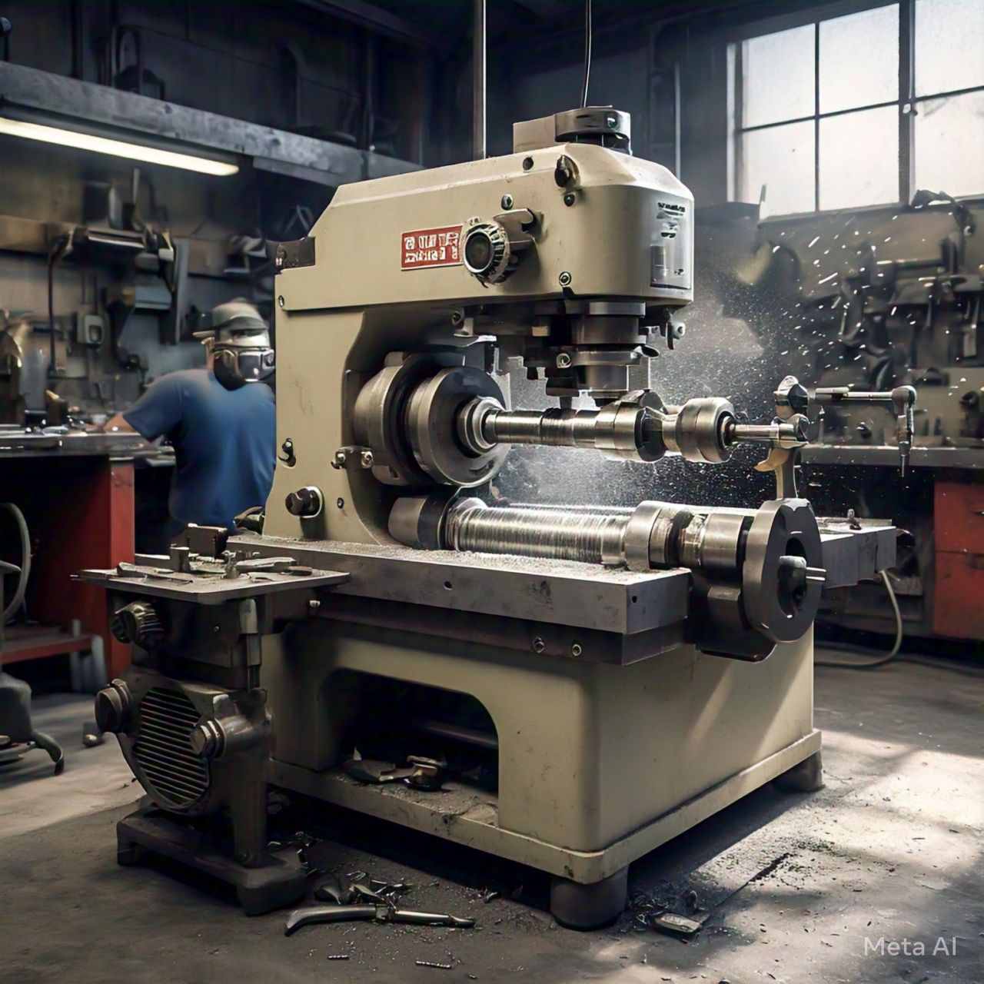

3.2. Machine Tools and Equipments and their Functions in the Workshop
- Lathe Machine
The lathe machine is a machine tool used to shape and form cylindrical workpieces by rotating them against a cutting tool. It consists of a bed, a headstock, a tailstock, and a carriage. The headstock holds the spindle, which rotates the workpiece. The tailstock provides support for the workpiece, while the carriage moves along the bed to position the cutting tool.
- Main Components of Lathe Machine
- Bed: The bed is the base of the lathe machine, providing support for the other components.
- Headstock: The headstock is located at one end of the bed and holds the spindle, which rotates the workpiece.
- Tailstock: The tailstock is located at the other end of the bed and provides support for the workpiece.
- Carriage: The carriage moves along the bed and holds the cutting tool.
- Cross-slide: The cross-slide moves perpendicular to the bed and holds the cutting tool.
- Compound rest: The compound rest is a swiveling table that holds the cutting tool.

- Functions of Lathe Machine
- Turning: The lathe machine is used to turn cylindrical workpieces to precise dimensions.
- Facing: The lathe machine is used to face cylindrical workpieces to create flat surfaces.
- Threading: The lathe machine is used to thread cylindrical workpieces to create screw threads.
- Knurling: The lathe machine is used to knurl cylindrical workpieces to create textured surfaces.
- Drilling: The lathe machine can be used to drill holes in cylindrical workpieces.
- Reaming: The lathe machine can be used to ream holes in cylindrical workpieces.
- Tapping: The lathe machine can be used to tap holes in cylindrical workpieces.
- Boring: The lathe machine can be used to bore holes in cylindrical work pieces.

- Work done or Operations Performed on Lathe Machine
- Rough turning: Rough turning involves turning a cylindrical workpiece to remove excess material.
- Finish turning: Finish turning involves turning a cylindrical workpiece to precise dimensions.
- Facing: Facing involves creating a flat surface on a cylindrical workpiece.
- Threading: Threading involves creating screw threads on a cylindrical workpiece.
- Knurling: Knurling involves creating a textured surface on a cylindrical work piece.

- Common Lathe Machine Problems and Solutions
- Vibration:
- Causes: Unbalanced workpiece, worn bearings, misaligned spindle.
- Solutions: Balance the workpiece, replace worn bearings, and align the spindle.
- Inaccurate Turning:
- Causes: Worn or damaged cutting tool, incorrect cutting tool geometry, insufficient cutting tool pressure.
- Solutions: Replace worn or damaged cutting tool, adjust cutting tool geometry, and adjust cutting tool pressure.
- Overheating:
- Causes: Insufficient coolant, clogged coolant lines, incorrect cutting tool material.
- Solutions: Ensure sufficient coolant, clean clogged coolant lines, select correct cutting tool material.
- Chuck or Workpiece Damage:
- Causes: Excessive tightening or loosening, incorrect chuck or workpiece alignment, insufficient cutting tool pressure.
- Solutions: Tighten or loosen the chuck correctly, align the chuck and workpiece correctly, adjust cutting tool pressure.
- Preventative Maintenance
- Regular Cleaning: Clean the machine and its components regularly to prevent dirt and debris buildup.
- Lubrication: Apply lubricants to moving parts and components to reduce friction and wear.
- Inspections: Perform regular inspections to identify potential problems before they become major issues.
- Operator Training: Ensure operators are properly trained and follow correct operating procedures to prevent machine damage and optimize performance.

- CNC Machine
A CNC (Computer Numerical Control) machine is a computer-controlled machine tool that uses programmed instructions to execute precise movements and actions. The machine consists of a computer control system, machine tool, drive system, sensors, and feedback systems. The computer control system is the brain of the CNC machine, interpreting programmed instructions and controlling the machine's movements. The machine tool is the physical machine that performs the desired operation, such as cutting, drilling, or milling.
The drive system is the mechanism that moves the machine tool along the desired path, using motors, gears, and ball screws. Sensors and feedback systems monitor the machine's movements and provide feedback to the control system, ensuring accuracy and precision. CNC machines can perform various operations, including movement along multiple axes, cutting, drilling, milling, turning, grinding, and engraving.
There are several types of CNC machines, including milling machines, lathes, grinding machines, drilling machines, and router machines. Milling machines are used for milling, drilling, and tapping operations. Lathes are used for turning, facing, and boring operations. Grinding machines are used for grinding and polishing operations. Drilling machines are used for drilling and tapping operations. Router machines are used for routing and engraving operations.
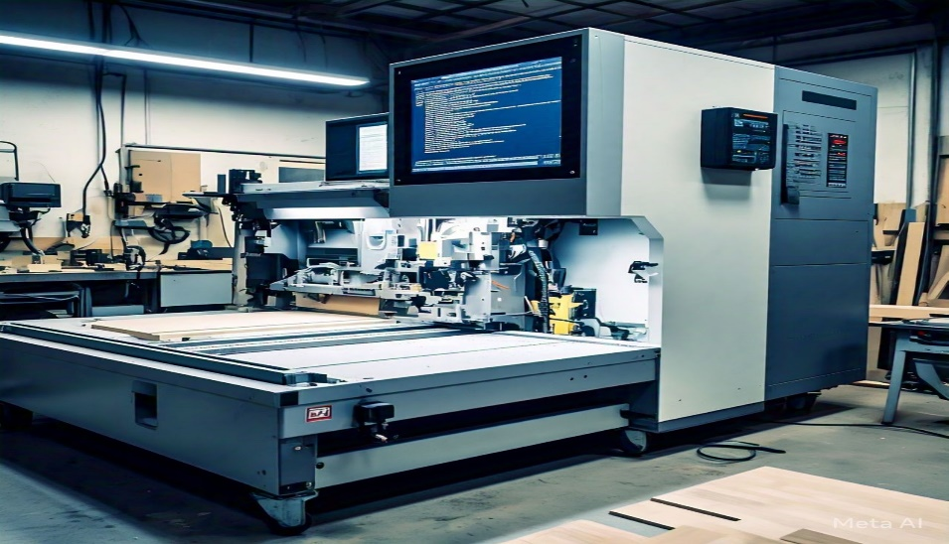

- Main Components of a CNC Machine
- Computer Numerical Control (CNC) System: The brain of the machine, responsible for interpreting programs and controlling machine movements.
- Machine Tool: The physical part of the machine that performs the desired operation, such as cutting, drilling, or milling.
- Spindle: The rotating shaft that holds the cutting tool in place.
- Axes: The mechanical components that move the spindle and cutting tool along specific paths.
- Drive System: The motors, gears, and ball screws that power the axes and spindle.
- Control Panel: The interface where operators input programs, monitor machine status, and adjust settings.

- Common CNC Machine Problems and Solutions
- Inaccurate Machining:
- Causes: Inaccurate machining can occur due to incorrect programming, worn-out cutting tools, or improper machine calibration.
- Solution: Verify programming accuracy, check machine calibration, and use precision cutting tools.

- Machine Vibration:
- Causes: Machine vibration can cause inaccurate machining, reduce tool life, and lead to machine damage.
- Solution: Check machine mounts and foundations, balance rotating components, and use vibration-dampening materials.
- Tool Breakage:
- Causes: Tool breakage can occur due to incorrect tool selection, improper tool setup, or excessive cutting forces.
- Solution: Select correct cutting tools, set up tools correctly, and monitor cutting forces.
- Spindle Overheating:
- Causes: Spindle overheating can occur due to excessive cutting forces, incorrect coolant usage, or malfunctioning spindle components.
- Solution: Monitor coolant usage, check spindle components, and reduce cutting forces.
- Program Errors:
- Causes: Program errors can occur due to incorrect programming, syntax errors, or incompatible program formats.
- Solution: Verify program syntax, check program compatibility, and use program simulation software.

- Axis Slippage:
- Causes: Axis slippage can occur due to worn-out bearings, incorrect axis alignment, or excessive cutting forces.
- Solution: Check axis alignment, replace worn-out bearings, and reduce cutting forces.
- Coolant Leaks:
- Causes: Coolant leaks can occur due to damaged hoses, loose connections, or clogged coolant nozzles.
- Solution: Inspect hoses and connections, replace damaged components, and clean coolant nozzles.
- Motor Overload:
- Causes: Motor overload can occur due to excessive cutting forces, incorrect motor sizing, or malfunctioning motor components.
- Solution: Reduce cutting forces, check motor sizing, and replace malfunctioning motor components.

3.3. Arc Welding
Arc welding is a fabrication process that let you join materials like metals by using heat at high temperatures. Welding uses high temperature to join the materials, whereas soldering and brazing do not allow the base metal to melt. After cooling the base metal and the filler metal gets attached.
The welding process comes to light when there was a search for a technique for developing iron into useful shapes. Welded blades were the first result of welding in the early years, the carburization of iron produced hard steel that was very brittle for usage, later interlaying the rigid and soft iron with high-carbon material and hammer forging resulted in a tough and durable blade.
The process of welding uses filler material. The filler material is the pool of molten material that aids in the formation of a strong link between the base metal. The shielding process after welding the metal protects both the base and filler components from being oxidized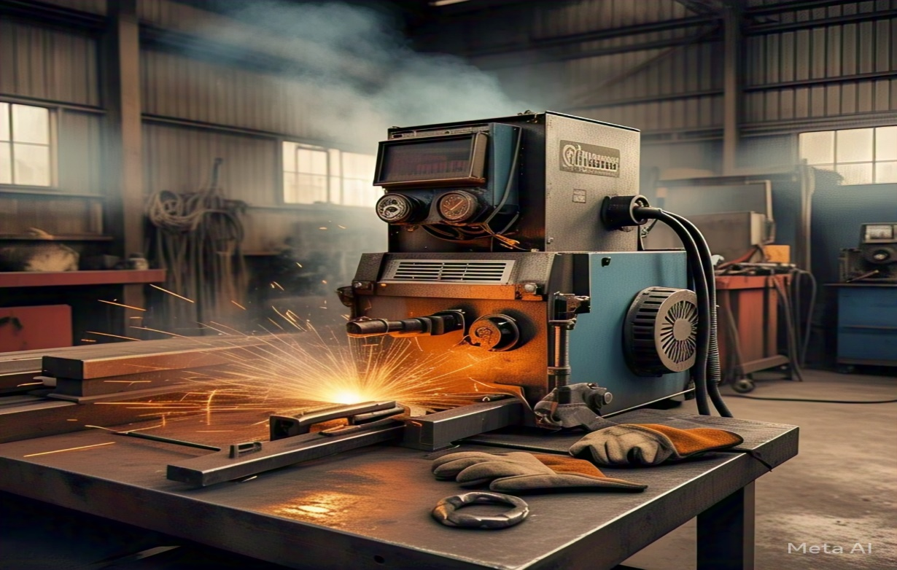
- Types of Welding
There are many types of welding uses for various purposes under different situations. They are:
- Forge welding
- Arc welding
- Shielded metal arc welding
- Gas metal arc welding
- Submerged arc welding
- Flux-cored arc welding
- Electroslag welding
- Forge Welding
Forge welding is the early version of welding where it was used to join the small iron pieces to make larger valuable pieces. It is the simplest welding method where two metals are heated and joined, and later hammered for the finishing purpose.
- Arc Welding
Arc welding is the common type of welding seen today. Arc welding is a type of welding in which an electric arc is created to heat and join metals. Tiny globules of molten metal are transferred from the molten electrode to the weld joint.
- Oxy-fuel Welding
Oxy-fuel welding is oxy welding, gas welding or oxy acetylene welding. This process uses the combustion of fuel gases like acetylene and oxygen to weld or cuts the metal. Edmond Fouché and Charles Picard, French Engineers in 1903, developed Oxy-fuel welding.
When acetylene and oxygen are mixed in proper measures inside the hand held-torch or blowpipe the hot flame is produced in the hand-held torch measuring 3200 degrees Celsius. The flame's intensity can be manipulated by altering the proportion of the volume of oxygen in acetylene. Welding can be done using this flame.
- Shielded Metal Arc Welding
Various names like flux shielded arc welding manual metal arc welding or stick welding are known as shielded metal arc welding. It is a manual welding process that uses an electrode covered with flux to perform welding.
- Gas Metal Arc Welding
Gas metal arc welding is a welding in which an electric arc is formed between a consumable metal inert gas wire electrode and the workpiece metal. The generated heat melts the workpiece metal and is then joined. It is a semi-automatic or automatic process which uses AC or DC from the power supply.
- Submerged Arc Welding
Submerged arc welding is a type of welding process that involves forming an arc between the electrode and the workpiece. A blanket of granular fusible material shields the arc on the work.
- Flux-cored Arc Welding
This is a semi-automatic or automatic arc welding process. Flux-cored arc welding is similar to the metal active gas welding process. It uses a continuous wire fed electrode and a constant-voltage welding power supply.
- Electroslag Welding
Electroslag welding is the most effective welding used to weld materials more significant than 25mm up to about 300mm. In Electroslag welding, heat is generated by passing electricity between the filler metal and the workpiece through a molten slag covering the weld surface.
- Advantages
- Welding establishes strong, durable and permanent joint links
- It is a simple process that results in a great finish
- The technique, when used with filler material, produces a stronger weld than the base material
- It can be performed at any place
- It is an economical and affordable process
- It is used in various sectors like construction, automobile and many other industries
- Disadvantages
- It is hazardous when performed outside safety and security guidance
- It is a difficult task to dismantle the joined material through welding
- Requires skilled labor and electrical supply
3.4. Drilling Machine
A drilling machine is a machine tool used in the drilling machining process to create round holes in various materials, such as metals, woods and plastics. These machines function by rotating a drill bit at high speeds and applying pressure to drive it into the workpiece resulting in precise and clean holes. Drilling machines are essential in a machine workshop for tasks ranging from simple holes to complex drilling operations, including deep hole drilling and counterboring. Their versatility and precision make them indispensable tools in manufacturing and construction, with different types of drilling machines suited for specific applications.
- Drilling Machine Operation
A drilling machine operates through a precise sequence of actions that transform rotational motion into a vertical drilling process. This operation begins when the machine is powered on, activating the electric motor. The motor generates rotational force, which is transmitted to the spindle via a series of gears and pulleys. The spindle holds the drill bit, and its speed can be adjusted according to the material being drilled and the size of the bit used.
- Main Stages
- Workpiece Preparation: Before beginning the drilling process, ensure the workpiece is securely clamped onto the worktable. Proper clamping prevents movements during drilling, maintaining accuracy and safety.
- Tool Selection: Choose the appropriate drill bit based on the material and hole diameter required. For example, a rotary drill bit is ideal for metal, while a different type might be better suited for wood or plastic.
- Spindle Adjustment: Adjust the spindle and feed mechanism to match the material and desired hole depth. Higher speeds are suitable for softer materials, while lower speeds are necessary for harder ones to avoid excessive heat and wear on the drill bit.
- Positioning: Align the drill bit with the intended drilling spot on the workpiece. Use a pilot hole if necessary to guide the bit and reduce the risk of slipping.
- Drilling: Begin the drilling process by lowering the spindle and applying pressure, the drill bit will penetrate the material, creating a round hole. The operator should monitor the process to ensure proper chip removal and prevent overheating.
- Completion and Inspection: Once the desired depth is reached, retract the drill bit and inspect the hole for accuracy and finish. Remove any rough edges if necessary.
- What are the Core Components of a Drilling Machine
The core components of a drilling machine include the base, column and radial arm. These parts are fundamental to the machine's operation and stability, providing the necessary support and movement for the drilling process.
Each component has a specific role that contributes to the overall functionality of the machine.
- Base: The base is the foundation of the drilling machine, providing stability and support. It absorbs vibrations and ensure the machines remains steady during the operations.
- Column: This vertical support structure holds the radial arm and spindle, allowing for precise alignment and movement. It also contributes to the rigidity needed for accurate drilling.
- Radial Arm: Attached to the column, the radial arm can be adjusted for different drilling positions. It allows the drill head to move horizontally, accommodating various workpiece sizes.
- Drill Head: The drill head houses the spindle and drill bit, controlling their rotation and movement. It is responsible for the actual drilling action.
- Worktable: The worktable supports the workpiece and can be adjusted for height and angle. It is crucial for positioning the workpiece correctly.
- Feed Mechanism: This system controls the advancement of the drill bit into the material, ensuring consistent pressure and speed during drilling.
- Spindle: The spindle is a rotating shaft that holds the drill bit. It transfers rotational motion from the motor to the bit, enabling the drilling process.
- Chuck: The chuck is a clamping device that secures the drill bit in place on the spindle. It allows for quick bit changes and precise alignment.
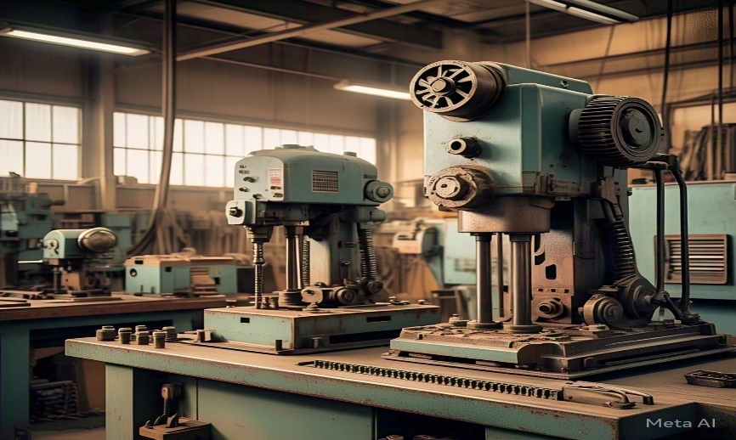
CHAPTER 4
4.0. Experiences Gained
The 4-months SIWES program has exposed me to technical skills as in, practical application of theoretical knowledge, familiarity with industry-standard equipment and software, and hands-on experience with projects and tasks in relation to my course of study and my view of knowledge is broadened through the experience gained at various units which involves the following:
- Familiarizing with the knowledge of different types of hand tools used in the workshop
- How to operate the lathe machine in regards to tasks given in the workshop
- Identification of different components of the lathe machine and common lathe machine problems and their solutions
- How to operate the CNC machine in regards to operations to be carried out
- Identification of different components, functions and common CNC machine problems and their solutions
- How to operate the different types of drilling machines in the workshop
- Identification of different components of drilling machine and hands on learning on operating the drilling machine

CHPATER 5
5.0. Summary, Conclusion and Recommendation
5.1. Summary of Attachment Activities
- Familiarization and Training
- Familiarized with common hand tools used in workshops.
- Underwent training on safety protocols and best practices.
- Machine Operation
- Received training on operating the lathe machine.
- Learned about CNC machines and their programming.
- Practiced operating CNC machines and gained familiarity with their controls.
- Explored other machine tools and equipment used in workshops.
- Received training on operating different types of drilling machines.
5.2. Problems Encountered during the Program
- Time constraints due to multiple ongoing projects
- Unlimited access due to electricity supply
- Occasional delays due to equipment malfunction
5.3. Suggestions for the Improvement of the Scheme
- Ensure that SIWES programs are aligned with the student’s academic curriculum to maximize learning outcomes
- Establish clear learning objectives for SIWES programs to help students understand what they need to achieve
- Ensure that students receive effective supervision and guidance during their SIWES program
- Provide regular feedback to students to help them improve and adjust to the work environment

