

REPORT ON STUDENT INDUSTRIAL WORK EXPERIENCE SCHEME (SIWES) TRAINING PROGRAMME
HELD AT

PRIMACY laundry and dry cleaning services
The herald area, 69 Offa Rd, GRA, Ilorin 240212, Kwara
PRESENTED BY:

DAMAS OLUWASEYI EMMANUEL
ND/23/BAM/PT/0580

SUBMITTED TO:
THE DEPARTMENT OF BUSINESS ADMINISTRATION
INSTITUTE OF FINANCEAND MANAGEMENT STUDIES,
KWARA STATE POLYTECHNIC, ILORIN.

IN PARTIAL FULFILMENT OF THE REQUIREMENT FOR THE AWARD ON NATIONAL DIPLOMA (ND) IN BUSINESS ADMINISTRATION

Aug-Nov, 2024

CERTIFICATION
We certify that this students industrial work experience scheme training log book and report writing was carried out by DAMAS OLUWASEYI EMMANUEL, with matric no: (ND/23/BAM/PT/0580) at the Department of Business Administration, Institute of Finance and Management Studies Ilorin, kwara state. In fulfillment of the requirement of Ordinary National Diploma (OND).

…………………….. ……………………
SIWES SUPERVISOR DATE AND SIGNATURE

……………………… ………………………
SIWES CO-ORDINATOR DATE AND SIGNATURE

DEDICATION
I dedicate this technical report to the Almighty God, the giver of knowledge, wisdom and who is rich in mercy.

ACKNOWLEDGEMENT
I would like to begin by expressing my heartfelt gratitude to the Creator of heaven and earth, the One who knows the beginning and the end, the Alpha and the Omega, the Almighty Allah for His guidance and blessings throughout this journey.
I am deeply grateful to my beloved parents, Mr. and Mrs. DAMAS, whose unwavering support and prayers have been my foundation. To my brothers and dear friends, your encouragement and companionship have meant the world to me.
My special thanks go to my SIWES supervisor for her guidance, mentorship, and invaluable insights during this program. I also extend my profound appreciation to everyone who supported me during my SIWES experience. May the Almighty God bless, protect, sustain, and guide you through all of life’s journeys.
Lastly, I wish to express my sincere regards to the school’s Board of Trustees and the entire staff of the business administration department for their dedication and support. Once again, a big thank you to everyone who contributed to making this experience a memorable and successful one.

TABLE OF CONTENT
Title page i
Table of content ii
Dedication iii
Acknowledgements iv
TABLE OF CONTENTS

CHAPTER ONE
  - Background of SIWES 1
  - Objectives of SIWES 2

CHAPTER TWO
2.1. Organizational Background 3
2.2. Departments in primacy laundry services 3
2.3. Organogram of the Organization 4
CHAPTER THREE
3.0 Key Projects and Assignments 5

CHAPTER FOUR
4.0 Key Knowledge Gained from the Siwes Training Programme 7
CHAPTER FIVE
5.1 Challenges 11
5.2 Conclusion 11
5.2 Recommendation 12
CHAPTER ONE
INTRODUCTION
1.1 Industrial Training Fund (ITF) and SIWES
SIWES was founded by ITF in 1973 to address the issue of Nigerian tertiary school graduates lacking sufficient practical skills to prepare them for employment in industries. The program exposes students to industry-based skills that are essential for a seamless transition from the classroom to the workplace. It gives tertiary institution students the chance to become acquainted with and exposed to the necessary experience in operating machinery and equipment, which is typically not available in educational institutions.
Participation in industrial training is a well-known educational strategy. Classroom studies are integrated with learning through hands-on work experiences in a field related to the students’ academic major and career goals. Successful internships foster an experiential learning process that not only promotes career preparation, but provides opportunities for learning to develop skills necessary to become leaders in their chosen professions.
One of the primary goals of the SIWES is to help students integrate leadership development into the experiential learning process. Students are expected to learn and develop basic non-profit leadership skills through a mentoring relationship with innovative non-profit leaders. By integrating leadership development activities into the industrial training experience, we hope to encourage students to actively engage in non-profit managements as professional career objectives. However, the effectiveness of the SIWES experience will have varying outcomes based upon the individual student, the work assignment, and the supervisor/mentor requirements. It is vital that each internship position description includes specific, written learning objectivities to ensure leadership skill development is incorporated.
Participation in SIWES has become a necessary pre-condition for the award of diplona and degrees certificates in specific practical-oriented disciplines in most institutions of higher learning in the country, in accordance with the education
policy of government operators-the ITF, the coordinating agencies (NUC, NCCE and NBTE), employers of labor and the institutions.
1.2 Objectives of the Students Industrial Work Experience Scheme (SIWES)
1. To provide students the opportunity to test their interest in a particular career before permanent commitments are made.
2. To provide an avenue for students in institutions of higher learning, acquire industrial skills and experience in their course of study.
3. To provide and prepare students for the industrial work situation they are to meet after school.
4. To aid students in adjusting from college to full-time employments
5. To provide students the opportunity to develop attitudes conducive to effective interpersonal relationships.
6. to increase students’ sense of responsibility.
7. To make students acquire good work habits.
8. To provide students with an opportunity to apply their knowledge in real work situation thereby bridging the gap between theory and practice.

CHAPTER TWO
INTRODUCTION
2.1 Organizational Background
PRIMACY laundry and dry cleaning services, THE HERALD AREA, 69 Offa Rd, GRA, Ilorin 240212, Kwara.
The primary purpose of a Primacy laundry service is to provide a convenient and efficient solution for washing, drying, and often ironing clothes and other textiles, saving customers time and effort while ensuring their garments are properly cared for.
Here's a more detailed breakdown:
- Convenience and Time-Saving:
Laundry services offer a hassle-free way to handle laundry, allowing individuals to reclaim time by outsourcing the sorting, washing, drying, and folding tasks.
- Expert Care and Quality:
Professional laundry services are equipped with the right tools and expertise to handle various fabrics and stains, ensuring that garments are treated with care and their quality is maintained.
- Specialized Services:
Some laundry services offer specialized services, such as stain removal, dry cleaning, and even pickup and delivery options, catering to a wider range of needs.
- Hygiene and Sanitation:
Laundry services play a crucial role in maintaining hygiene and sanitation, especially in settings like hospitals and hotels, where clean linens and textiles are essential.
- Cost-Effectiveness:
While there's a cost associated with using a laundry service, it can be a cost-effective option, particularly for individuals who value their time and prefer not to handle laundry themselves.
Primacy laundry department, typically involves collecting, sorting, washing, drying, and distributing clean linen and clothing to various users, while also maintaining hygiene standards and managing inventory.
Here's a more detailed breakdown of the functions and objectives of a Primacy laundry department:
Core Functions:
- Collection: Gathering soiled linen and laundry from various locations.
- Sorting: Separating items by type, fabric, and level of contamination.
- Washing: Operating washing machines and using appropriate detergents and water temperatures for different types of fabrics.
- Drying: Using dryers or other drying methods to properly dry the laundered items.
- Ironing/Folding: Ironing and folding clean linen and clothing, as needed.
- Inspection and Repair: Inspecting items for damage and repairing or replacing them as necessary.
- Distribution: Delivering clean linen and clothing to the designated user departments.
- Inventory Management: Maintaining records of linen and clothing stock levels.
- Cleaning and Maintenance: Ensuring the laundry area and equipment are clean and well-maintained.
- Hygiene Standards: Maintaining high standards of hygiene throughout the laundry process.

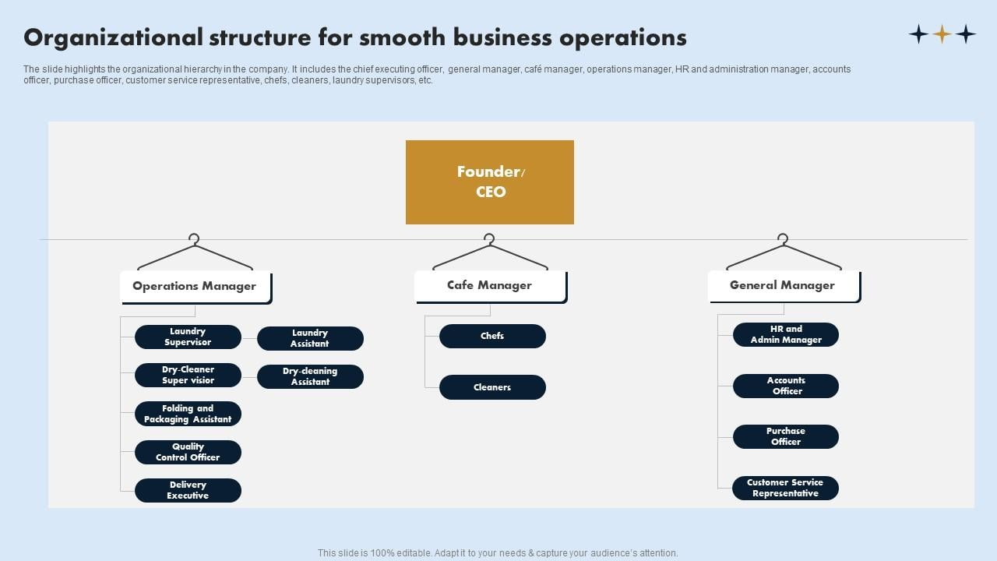
PRIMACY ORGANIZATIONAL STRUCTURE

CHAPTER THREE
KEY PROJECTS AND ASSIGNMENTS

3.1 Key Projects / Assignments and Achievements
During the Student Industrial Work Experience Scheme (SIWES) at Primacy Laundry services multiple projects, assignments, and responsibilities were undertaken, significantly contributing to the store's operational efficiency. The practical experience gained aligns with key business administration principles, inventory control methodologies, and customer service management, reinforcing theoretical knowledge acquired in an academic setting.

1. Inventory and Stock Management Optimization: Inventory control is a critical aspect of supply chain management, ensuring seamless operations in the fashion store. Key achievements include:
- Application of Microsoft Excel in Inventory Management:
  - Developed proficiency in using Excel spreadsheets for stock monitoring by applying fundamental formulas such as SUM, COUNTIF, and IFERROR, which are crucial in data validation and error handling.
  - Assisted in maintaining real-time stock records, ensuring an efficient tracking system that prevents understocking and overstocking.
- Physical Stock Auditing and Verification:
  - Conducted manual stock reconciliation by cross-checking system records with physical inventory, ensuring accuracy in documentation.
  - Participated in weekly stock-taking exercise, ensuring that discrepancies were promptly identified and corrected, a practice essential for maintaining optimal inventory levels.
- Customer Relations and Front Desk Operations: Customer service excellence is fundamental in retail businesses, particularly in the fashion industry, where client satisfaction drives revenue growth. Major contributions include:

- Order Processing and Invoice Documentation:
  - Managed front desk operations, handling customer inquiries, order placements, and invoice generation using a structured order-tracking system.
  - Processed electronic and cash transactions using Point-of-Sale (POS) terminals, ensuring proper financial documentation and reconciliation.
- Customer Relationship Management (CRM):
  - Engaged in customer interaction training, enhancing skills in handling complaints, addressing inquiries, and providing after-sales support.
  - Implemented strategies in customer persuasion and retention, ensuring client satisfaction and repeat patronage.

3. Payroll and Administrative Responsibilities
Financial management, particularly payroll administration, plays a vital role in employee satisfaction and business stability. Key tasks included:
- Introduction to Payroll Systems:
  - Observed and assisted in payroll preparation, learning salary computationtechniques, including deductions, bonuses, and statutory contributions (e.g., pensions and taxes).
  - Gained insight into how payroll systems integrate with financial reporting, ensuring compliance with accounting principles.
- Digitization of Business Records:
  - I assisted in scanning and archiving transactional documents, contributing to an efficient document management system that ensures quick access to historical financial records.
  - Ensured data integrity and security by properly categorizing and storing documents in computerized databases, aligning with best practices in administrative record-keeping.

- Laundry services
  - A typical laundry service organization structure often features a Laundry Manager overseeing operations, with Supervisors managing specific areas like washing, drying, and folding, and Attendants performing the task

CHAPTER FOUR

4.1 KEY KNOWLEDGE GAINED FROM THE SIWES TRAINING PROGRAMME
During my Student Industrial Work Experience Scheme (SIWES) at Primacy Laundry services, I gained practical knowledge and hands-on experience in various aspects of Office Equipment, business administration, inventory management, customer service, and fashion retail operations.Key experience gained included:
- Identification Of Office Equipment and Their Functions

I get to know more about Various office equipment utilized to enhance administrative efficiency, record-keeping, customer service, and sales processing. These devices play crucial roles in streamlining business operations, ensuring smooth communication, and improving overall workflow. Below arelist of Office Equipment and Their Functions:
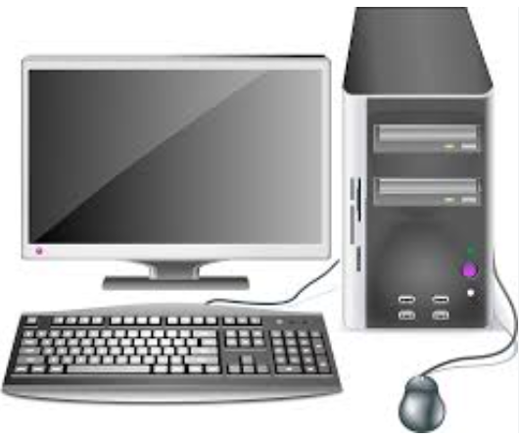
Computer: Used for processing business data, managing inventory using Microsoft Excel, writing invoices, scanning and storing documents, and handling payroll records.

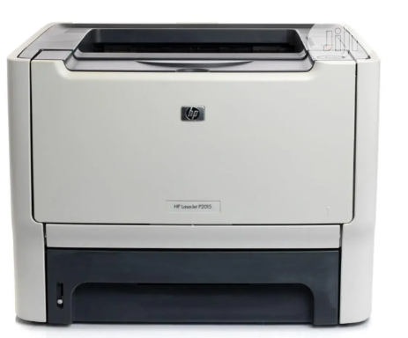
Printer: Used to produce hard copies of invoices, receipts, payroll documents, and other business records required for customer and administrative use.

Photocopier Machine: Duplicates essential business documents such as receipts, invoices, staff records, and sales reports for record-keeping.
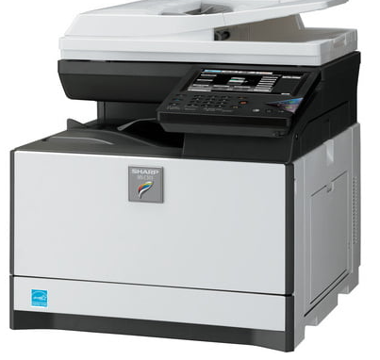


Point-of-Sale (POS): Machine Processes customer transactions, allowing for secure and efficient payment via credit/debit cards, reducing reliance on cash payments.

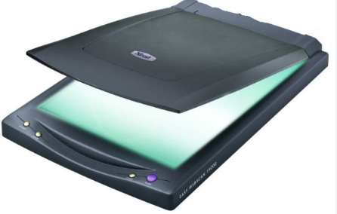
Scanner: Converts physical documents into digital files for secure storage, record-keeping, and easy retrieval.


Telephone (Landline and Mobile): Facilitates communication with customers, suppliers, and employees, ensuring seamless business operations.

Binding Machine: Used to assemble and organize hard copies of business reports, invoices, and other important documents for easy reference.
Laminating Machine: Protects important documents (e.g., business licenses, certifications, and ID cards) by sealing them in a plastic covering to prevent damage.
Cash Register: Records sales transactions, providing printed receipts and keeping track of daily revenue.

2. Inventory and Stock Management
Inventory management involves tracking, ordering, storing, and controlling business materials, goods, and supplies to ensure there is enough stock to meet customer demand without excessive overstocking. I acquired valuable hands-on experience in tracking and managing inventory, ensuring stock records were up to date and accurately recorded. I also learned how to use Microsoft Excel for stock control and reporting, an essential tool for inventory management. Proper inventory management prevents stock shortages, reduces waste, and optimizes financial resources. By keeping an accurate record of stock levels, businesses can forecast demand, reduce unnecessary costs, and ensure customer satisfaction.

3. Financial Documentation and Payroll Processing
Financial documentation involves recording, storing, and managing financial transactions such as invoices, sales records, payroll, and expenses. Payroll processing refers to calculating and distributing employee salaries, including deductions and benefits. I gained in-depth knowledge of preparing invoices, handling payroll records, and maintaining financial accuracy. Observing payroll management processes gave me insights into salary calculations, tax deductions, and employee benefits. Accurate financial documentation ensures compliance with financial regulations, minimizes errors, and enhances transparency in business operations. Payroll processing is essential for employee satisfaction and legal compliance regarding wages and tax obligations.

4. Customer Relations and Front Desk Operations
Customer relations refers to the strategies and processes a business uses to interact with and satisfy its customers. Front desk operations involve handling inquiries, issuing invoices, processing transactions, and addressing customer concerns. Interacting with customers taught me effective communication, problem-solving, and the importance of professionalism. I learned how to process transactions, issue invoices, and address customer concerns politely and efficiently.Good customer relations increase customer retention, enhance brand loyalty, and drive business growth. Front desk operations ensure efficient service delivery, professional communication, and streamlined business transactions.

5. Digital Record-Keeping and Administrative Efficiency
Digital record-keeping involves scanning, storing, and managing business records electronically for quick access and long-term storage. It replaces manual filing systems with computerized data management tools. I was trained in scanning, organizing, and securing digital business records, reducing reliance on manual filing systems. I also learned how to retrieve and manage customer and financial records digitally.Digital documentation improves accuracy, enhances security, and allows easy retrieval of important business records. It reduces paperwork, saves time, and ensures compliance with data protection regulations.
In one word, My SIWES experience at Dolafaja Fashion Store provided me with comprehensive exposure to business administration functions. I developed practical skills in inventory management, financial documentation, customer relations, digital operations, and supply chain management. These competencies are essential for ensuring business efficiency, optimizing resources, and driving sustainable growth.
This training has equipped me with the ability to analyze business challenges, propose effective solutions, and implement best practices for operational success. The hands-on experience has bridged the gap between theoretical knowledge and real-world business applications, making me better prepared for a future career in business administration.

CHAPTER FIVE

CHALLENGES, RECOMMENDATIONS, AND CONCLUSION

5.1 Challenges
During my Student Industrial Work Experience Scheme (SIWES) at Primacy laundry services, I encountered several challenges that tested my ability to adapt, learn, and apply my knowledge of business administration in a real-world setting. These challenges, while demanding, significantly contributed to my professional growth.
Limited Initial Experience in Business Administrative Processes: At the start of my internship, I faced difficulties understanding core business administration tasks such as inventory management, payroll processing, and financial documentation. However, through continuous practice and guidance from my supervisor, I developed proficiency in these essential business functions.
Lack of Financial Incentives for SIWES Students: While SIWES provided invaluable practical knowledge, the lack of financial compensation posed a challenge, especially for students who had to cover transportation and other expenses. A small stipend for interns could serve as motivation and enhance productivity.
Technical Challenges with Office Equipment: The photocopier, scanner, POS machine, and other office equipment occasionally developed technical faults, causing delays in administrative processes. Learning basic troubleshooting and maintenance techniques became necessary to ensure smooth workflow and prevent operational inefficiencies.

5.2 Conclusion
The Student Industrial Work Experience Scheme (SIWES) at Dolafaja Fashion Store provided me with invaluable hands-on experience in business administration, enhancing my understanding of key administrative functions such as inventory management, financial documentation, payroll processing, and customer relations. Through practical engagement in these tasks, I developed essential workplace skills, including effective communication, problem-solving, multitasking, and digital proficiency in business tools like Microsoft Excel.
Despite the challenges encountered, such as handling customer complaints, managing high workloads, and adapting to technical and inventory-related issues, these obstacles ultimately contributed to my professional growth, resilience, and adaptability in a real-world business environment. Additionally, my exposure to various administrative duties deepened my knowledge of business operations, stock control, and financial record-keeping, which are vital components of any successful organization.
The insights gained from this experience have reinforced my passion for business administration and have equipped me with the necessary skills to navigate the corporate world with confidence. Moving forward, I believe that implementing the recommendations proposed—such as structured departmental exposure, investment in modern business tools, financial support for interns, and digital skills training—will further enhance the SIWES program, ensuring that future students gain even greater practical knowledge and professional competence.
Overall, this experience has been a significant stepping stone in my academic and career journey, preparing me for future roles in business administration and corporate management. The lessons learned will remain invaluable as I continue to develop my expertise and contribute meaningfully to any organization I become a part of.
5.3 Recommendations
Based on my industrial work experience, I propose the following recommendations to improve the SIWES program and enhance its benefits for future students:
- Comprehensive Departmental Exposure: All students undergoing SIWES, especially in business-related organizations, should be given the opportunity to work across various departments, such as inventory management, financial records, sales, and customer service. This will ensure a holistic learning experience and allow students to discover areas where they excel.
- Investment in Modern Business Tools and Equipment: Private organizations should invest in modern office equipment to facilitate administrative efficiency. Upgraded computers, payroll software, efficient POS systems, and stock management applications will help streamline operations, reduce errors, and enhance productivity.
- Provision of Financial Support for SIWES Students: Given that students actively contribute to business operations, organizations should consider offering stipends or transportation allowances. This will motivate students, enhance commitment, and reduce financial strain, particularly for those who live far from their place of primary assignment (PPA).
- Incorporation of Digital Skills Training:Business organizations should provide training on digital tools such as Microsoft Excel, accounting software, and customer management systems. These digital skills are essential in modern business administration and will significantly benefit students beyond their internship period.
- Structured Feedback and Evaluation: Companies should implement structured feedback sessions for SIWES students, allowing them to identify their strengths and areas for improvement. Regular evaluations from supervisors will help students develop professional competencies and enhance their future career prospects.

