

REPORT OF STUDENT INDUSTRIAL WORK EXPERIENCE SCHEME (SIWES)

AT

WINDOW BLIND INDUSTRY
NO. 1 SHOP 6 ESTATE JUNCTION SANGO ILORIN, KWARA STATE

BY

ISHOLA KEHINDE ABDULLAHI
MATRIC NO: ND/23/PAD/PT/0275

SUBMITTED TO
THE DEPARTMENT OF PUBLIC ADMINISTRATION,
INSTITUTE OF FINANCE AND MANAGEMENT STUDIES
KWARA STATE POLYTECHNIC ILORIN

IN PARTIAL FULFILLMENT OF THE REQUIREMENT FOR THE AWARD OF NATIONAL DIPLOMA (ND) IN PUBLIC ADMINISTRATION

MARCH, 2025
CERTIFICATION
This is to certify that this SIWES report was written by ISHOLA KEHINDE ABDULLAHI with Matric No: ND/23/PAD/PT/0275 of the Department of Public Administration. The report has been read and approved as meeting the requirement for the award of National Diploma in Public Administration Kwara State Polytechnic, Ilorin.

………………………….. ………………………..
Date
(SIWES Coordinator)

DEDICATION
I dedicate this SIWES report first and foremost to Almighty God who has been there right from the beginning to this very point. Special dedication also to my ever supportive parents MR & MRS ISHOLA for their relentless support and compassion towards me during the course of my SIWES training.

ACKNOWLEDGEMENT
Have taken efforts in this report. However, it would not have been possible without the kind support and help of many individuals. I would like to extend my sincere thanks to all of them. It has been great honour and priviledge to undergo training at Window Blind Industry, Ilorin South LGA, Kwara State. I am highly indebted to the Director of the company for his guidance and constant supervision as well as for providing necessary information regarding the report. His constant guidance and willingness to share his vast knowledge made me understand this SIWES and its manifestations in great depths had helped me to complete the assigned tasks on time. I would like to express my gratitude towards my parents MR & MRS ISHOLA and Staff of Window Blind Industry for their kind cooperation and encouragement which help me in completion of this report. My thanks and appreciations also go to my colleagues in developing the report and people who have willingly helped me out with their abilities.

TABLE OF CONTENT
Title Page i
Certification ii
Dedication iii
Acknowledgement iv
Table of Content v
Abstract vi

Chapter One
1.0 Historical Background of SIWES 1
1.2 Objectives of SIWES 1
Chapter Two
2.1 Description of Window Blind Industry 2
2.2 Objectives of Window Blind Industry 2
2.3 Mission of Window Blind Industry 2
2.4 Vision of Window Blind Industry 2
2.5 Organisational Structure of Window Blind Industry 3
2.6 Department / Units In Window Blind Industry 3
Chapter Three
3.0 Work Done During The SIWES 4-5
Chapter Four
4.0 Experience Gained 6
4.1 Images 6-7
4.2 Lesson Learnt 8
4.4 Major Skills and Competencies Acquired 8
4.5 Industrial Standard, Protocols And Guildlines 8
Chapter Five
5.1 Challenges Encountered 9
5.2 Conclusion 9
6.2 Recommendation 9
ABSTRACT
Student Industrial Work Experience Scheme (SIWES) is a mandatory programme which exposes students to practical aspect of their chosen career/field. This report is divided into five chapters, and this is highlighted below: Chapter One talks about the Historical Background of SIWES as well as its Objectives, Chapter Two described the Organization, the Department / Units and their duties, Chapter Three explained in details the activities carried out in the company, Chapter Four is on experienced gained, Chapter Five is on problems encountered and how it is been handled, the conclusion and recommendation.

CHAPTER ONE
1.0 HISTORICAL BACKGROUND OF SIWES
The Student’s Industrial Work Experience Scheme (SIWES) is a program that is coordinated by the Industrial Training Fund (ITF) in conjunction with National University Commission (NUC). This is a program engaged by students in various degree programs in order to provide the student with practical experience on various field of studies and to expose them to actual working experience. This is a program involving the ITF, the students and the industries. It is meant to bridge the gap between the theory and practical work in order to sharpen student’s skills and understanding of physical planning and practices on the various fields. The industrial training fund National Conference held in Jos in the year 1988 mandated all collaborating agencies include NCCE, NBTE and NUC to draw up job specifications for all degree programs including the student’s industrial work experience scheme (SIWES). As at that time the specification of the job was to guide the industrialist and institutional supervisors in the industrial placement of students in order to meet the expected requirement of minimum industrial exposure preparatory for employment. The final job specification for the program was organized into the following four parts: the Introduction, Objectives, Physiology and Job schedule.
1.2 OBJECTIVES OF SIWES
The main objectives of SIWES include the following:
- To provide an avenue for students to acquire industrial skills and experience in their various field of study.
- To provide students the chance to apply knowledge in real work situation thereby bridging the gap between theory and practical.
- To expose students to work, methods and techniques in handling equipments and machines that may not be available in their institutions.
- To enlist and strengthen industries involvement in polytechnics education.
- To enable polytechnics educators access the effectiveness of their curriculum and make modification where necessary.
CHAPTER TWO
2.1 DESCRIPTION OF WINDOW BLIND INDUSTRY
Window Blind Industry is a company that deals with production of different types of window blind which brings out the interior beauty of a building. The company is location in Estate Junction Kulende Sango Ilorin, Kwara State. It was established in the year 2020 by Mr. Bello Kareem. K and fully registered under CAC in the year 2021. The company is well known in Kwara State due to the quality of their product. The company is divided into two major department which include Administrative and Operation department.
2.2 OBJECTIVES OF WINDOW BLIND INDUSTRY
Window Blind Industry been one of a leading and well known window blind supplier in Ilorin South Local Government Area, in Kwara State exist for many purpose, which one of it is to provide good quality window curtain to people and organization. While others include:
i. To be among the leading window blind supplier in Kwara State and Nigeria as a whole.
ii. To impact window blind production knowledge into young determine youth.
iii. To provide the cheapest window blind production to the people
2.3 MISSION OF WINDOW BLIND INDUSTRY
The mission is to provide a continuous services to the people and cooperate organization within and outside the State.

2.4 VISION OF WINDOW BLIND INDUSTRY
The vision is to be recognized as the preferred window blind Centre, providing a continuous, excellent, efficient, integrated and improving the services rendered to people and organization.
2.5 ORGANISATIONAL STRUCTURE OF WINDOW BLIND INDUSTRY
The day to day operation of the WINDOW BLIND INDUSTRY is ruled by a team of dedicated professional made up of Director, Secretary and an Accountant. This is headed by Director with substantial experiences . The organizational structure of the company can be illustrated below;
WINDOW BLIND INDUSTRY ORGANOGRAM
DIRECTOR
INSTALLER

SECRETARY
ACCOUNTANT

2.6 DEPARTMENT / UNITS IN WINDOW BLIND INDUSTRY
i. Administrative Department
The department is responsible for setting the organization goals, overseeing finances and developing schedules and budgets. Ensuring the organization's policies and procedures align with current laws. Communicating with management as well as a board of directors.

ii. Operation Department
The operation department is responsible for managing the day-to-day operations of the company, these include production, packaging and distribution of company products, and ensuring that the company runs efficiently.
CHAPTER THREE
3.0 WORK DONE DURING THE SIWES
INRODUCTION TO WINDOW BLIND
In first week, we were told the genesis of window blind. Window blind is a type of window covering, typically made of slats (horizontal or vertical), that can be adjusted to control light and privacy. Window blinds offer the ability to adjust the amount of light entering a room and provide privacy by covering the window.
TYPES OF WINDOW BLIND
- Horizontal blinds (Venetian blinds): Consist of horizontal slats that can be raised and lowered, and the slats can be tilted to control light.
- Vertical blinds: Feature vertical slats that can be moved horizontally to open or close and can also be tilted to adjust light.
- Other types: There are also other types of blinds, such as zebra blinds, cellular shades, and roller blinds.

FABRICS USED IN WINDOW BLIND
Window blinds can be made from various fabrics, including polyester, PVC, vinyl, and polycotton blends, with polyester being a popular choice for its durability and versatility.
- Polyester:
A synthetic fabric known for its durability, resistance to fading, and ease of cleaning, making it a popular choice for roller blinds and other types of window coverings.
- PVC (Polyvinyl Chloride):
A durable and waterproof material that is often used in vinyl blinds, offering a good balance of affordability and performance.
- Vinyl:
Similar to PVC, vinyl is a durable and waterproof material often used in blinds, offering a good balance of affordability and performance.
- Polycotton Blends:
Combinations of polyester and cotton, often used for roller blinds, providing a blend of durability and a softer feel.
EQUIPMENT USED IN WINDOW BLIND
- Tape Measure: For accurate measurements of window width and height.
- Spirit Level: To ensure brackets are installed horizontally and the blinds are properly aligned.
- Pencil: For marking where to drill holes for brackets.
- Drill and Bits: Essential for creating holes in walls or window frames to install brackets.
- Hacksaw or Utility Knife: For cutting blinds to the correct width, especially for metal or wooden blinds, or trimming fabric blinds.
- Scissors: For cutting fabric or lightweight materials.
- Screwdrivers (Phillips or flathead): To secure brackets and other components.
- Hammer: For hammering in rawl plugs (if needed).
- Step Ladder: For reaching higher windows.
CHAPTER FOUR
4.0 EXPERIENCE GAINED
During my SIWES programme at Window Blind Industry, I gained a lot, I never knew the important of SIWES not until I experienced it. During the training exercise, I learnt; the mode of operation and the working principle of different departments in the company, I was opportune to take part in series of activities out there thereby acquiring more knowledge and applying it to my field of study. The SIWES programme has really exposed me to various activities: and bridged the gap of my theoretical knowledge with practical. I was able to acquire more knowledge as regards window blinds. All procedure and methods are strictly followed as written in this report at their appropriate place. Part of what I gained are as follows
i. How to install window blind.
ii. How to identify types of window blind
iii. How to operate tools used in window blind

4.1 IMAGES
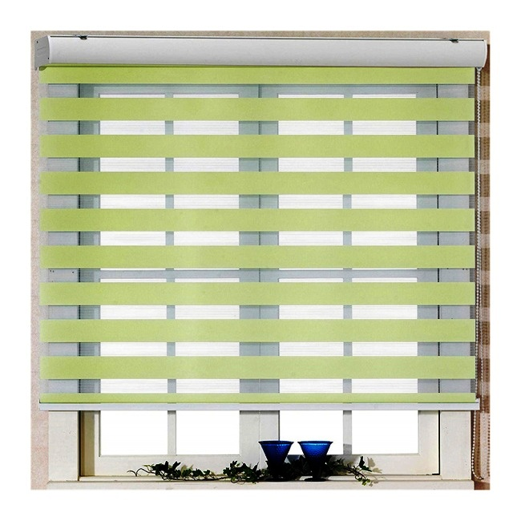
i. Window Blind

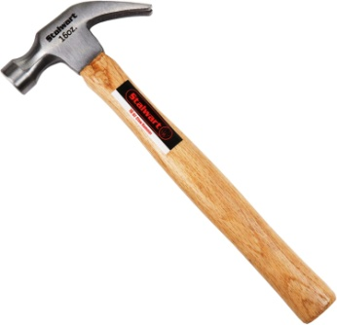
ii. Hammer

iii. Scissor:
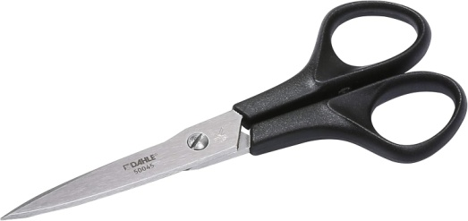

iv. Hacksaw:


v. Drill and Bits

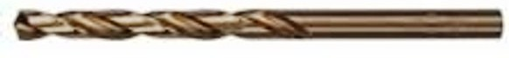

4.2 LESSON LEARNT
I learnt how to make window blind, how to operate each tools as well as installation of different types of window blind.

4.4 MAJOR SKILLS AND COMPETENCIES ACQUIRED
The major skills I acquired include:
i. How to identify types and installation of window blinds.
4.5 INDUSTRIAL STANDARD, PROTOCOLS AND GUILDLINES
Punctuality as they say is the soul of business, this is one of the habit inculcated by all staff of Window Blind Industry. All staff resumes to work very early and discharge their duties as expected in line with the organization protocol and guidelines. Cleanliness is another standard been practice in the organization, all staff are always well dress and they also ensure that the organization environment are well kept.

CHAPTER FIVE
5.1 CHALLENGES ENCOUNTERED
The major problem encountered during the programme was the transportation aspect as the organization location is far within reach and means of transportation are very hard to be gotten. Also, the financial aspect (for feedings and transportation) is a challenge. All other minor challenges are negligible as the main aim of this programme is to acquire more knowledge and industrial experiences.

5.2 CONCLUSION
SIWES as it is called has come to stay, it will be more meaningful if the programme can be extended beyond the stipulated four months so as for students to gained more practical knowledge and experience in their field of studies. My SIWES with Window Blind Industry has been one of the most interesting, productive and instructive experience in my life. Through this training, I have gained new insight and more comprehensive understanding about the real industrial working condition and practice, it has also improved my soft and functional skills. All these valuable experiences and knowledge's that I have gained were not only acquired through the direct involvement in task but also through aspects of the training such as work observation, interaction with colleagues and superior. And from what I have undergone, I am sure that industrial training programme has achieved its primary objective. As a result of the program I am more confident to build my future career which I have already started with the company.
6.2 RECOMMENDATION
Considering the importance of the SIWES programme and its advantages to students, I will recommend that the duration of the SIWES should be extended to enable more knowledge to be acquired by the students. I will also suggest that there should be more mutual relationship between SIWES and industries of attachment. Also, the ITF should endeavor to make the training allowance available to students during the course of their training. These will be highly beneficial to the students and will be highly appreciated into consideration.

