
A TECHNICAL REPORT
STUDENT INDUSTRIAL WORKING EXPERIENCE SCHEME
(SIWES)

Held at

AL HAMAD BUILDING CONTRACTING COMPANY
ALONG MANDATE AREA, ILORIN KWARA STATE

Prepared by:
SALAUDEEN YUSUFF OLATUNJI
ND/23/CEC/PT/0041

SUBMITTED TO

DEPARTMENT OF CIVIL ENGINEERING

INSTITUTE OF TECHNOLOGY
KWARA STATE POLYTECHNIC, ILORIN
INPARTIAL FULFILLMENT OF THE AWARD OF THE REQUIREMENT OF THE AWARD OF NATIONAL DIPLOMA IN CIVIL ENGINEERING

Sept., – Dec., 2024

TABLE OF CONTENTS

TITLE PAGE ………….......………………………………………….. I

CERTIFICATION …...………………………………………….…… II

DEDICATION ………………..……………………………………… III

ACKNOWLEDGEMENT…..……………………………………..... IV

TABLE OF CONTENT….…………………………………………… 5

CHAPTERONE
1.1 BACKGROUNDOFSIWES
1.2 AIMANDOBJECTIVESOF SIWES
1.3 BODIESINVOLVEDINTHEMANAGEMENTOFSIWES
1.4 ROLESOFSTUDENT
1.5 OBJECTIVESOFTHEREPORT
1.6 BRIEFHISTORYOFAL-HAMAD CIVIL ENGINEERING CONSTRUCTION.
CHAPTERTWO
2.1 INTRODUCTIONTOAUTOCAD
2.1.1 UsesofAutoCAD
2.1.2 SomeBasicCommandsofAutoCAD
2.1.3 Basicdesigncarriedouton AutoCAD
2.2 PRINCIPLESOFARCHITECTURALDESIGN
2.3 BUILDINGWORK
2.3.1 Column
Fundamentally, columns can be categorised as:
Also,columnscanbeclassifiedbasedonitsendconditionsas:
Procedure for Construction Column Foundation
Super Structure
2.3.2 ConstructionofStairs
2.3.3 PlasteringWork
Tips
2.3.4 Construction/LayingofBlockWall
Procedure for laying of Blocks
CHAPTERTHREE
3.1 ContributiontoAl Hamad Building Contracting Company
3.2 Projectcarriedout
CHAPTER FOUR CONCLUSIONANDRECOMMENDATION
4.1 Conclusion
4.2 Recommendations
REFERENCES

CHAPTERONE

  - STUDENTSINDUSTRIALWORKEXPERIENCESCHEME(SIWES)

Students Industrial Work Experience Scheme (SIWES) was established by the Industrial Training Fund (ITF) in 1973 with the aim of bridging the gaps between the skills which the labour market required with that of those acquired by the graduate students. The Polytechnic and College of Technology students for National Diploma programs will have four months’ industrialattachmentattheendoftheirfirstyearwhilestudentsintheuniversitywillhavesix months’ attachment at the end of 200, 300, or 400 level. The scheme has over the years contributed immensely to the personal development and motivation of students to be able to understand the important connection between the taught and learnt content of their academic programmes and what knowledge and skill will be expected of them on professional practice after graduation.

BACKGROUNDOFSIWES

SIWES was established by ITF in the year 1973 to serve the problem of lack of adequate practical skills preparatory for employment in industries by Nigeria Tertiary Institutions graduates. The scheme educates students on Industrial based skills essential for a smooth transitionfromtheclassroomtotheworldofwork.Studentsoftertiaryinstitutionsisgiventhe opportunityofbeingfamiliarizedandexposedtotheneededexperienceinhandlingmachinery and equipment which are usually not available in the educational institutions.Partaking in SIWES training has become a crucial pre-condition for the award of diploma and degree certificatesinspecificdisciplinesinmostinstitutionsofhigherlearningin Nigeria in line with the government education policies. This scheme is to bridge the existing gap between the theory taught in the classroom and practice of science, agriculture, medicine, engineering, technology and other professional programs in the Nigerian tertiary institutions. This program is aimed at exposing the students to the use of various machines and equipment’s, professional work Methods and ways of safeguarding the work areas in industries as well as other organizations and parastatals.

AIMANDOBJECTIVESOF SIWES

The aim of SIWES is to bridge the gaps between the skills which the labour market required with that of those acquired by the graduate students.
TheobjectivesofSIWES includes;

    - Preparestudentsforthe worksituationtheyarelikelytomeetafter graduations.

    - ProvideanavenueforstudentstoacquireIndustrialschemeandexperienceintheir course of study.
    - MakethetransitionfromTertiaryinstitutiontotheworldofwork easier,andthese enhance student contact for the later job placement.
    - Enlistand strengthensemployer’s involvementin theentire educational processto

prepareagraduate foremployment intheindustries.

BODIESINVOLVEDINTHEMANAGEMENTOFSIWES

The bodies involved are: Federal Government, Industrial Training Fund (ITF). Other SupervisingAgenciesare:NationalUniversityCommission(NUC),NationalBoardfor Technical Education (NBTE) & National Council for Colleges of Education (NCCE). The functions of the above-mentioned agencies are to:
    - EnsureadequatefundingoftheSIWESscheme.

    - EstablishSIWESandaccreditSIWESunitintheapproved institutions.

    - Supervise students at their places of attachment and sign their log-books and ITF Forms.
    - Vetandprocessstudents’log-booksandforwardsameto ITFArea office.

    - Ensurepaymentof Allowancesforthestudentsand supervisors.

Therefore,thesuccessorotherwiseoftheSIWESdependsontheefficiencyoftheMinistries, ITF, Institutions, Employers of labour and the general public involved in articulation and management of the programme.

ROLESOFSTUDENT

    - AttendSIWESorientationprogrammebeforegoingonattachment.

    - Complywiththeestablishment’sruleandregulation.

    - Recordalltrainingactivitydoneandotherassignmentinthelogbook.

    - Complete SPEI fromITF,FORM8andgetitendorsed by the employer for submission to the ITF.

OBJECTIVESOFTHEREPORT

TheobjectivesoftheSIWESreportare;

    - Tomakethoroughexplanationoftheworkdoneduringthefour-month Industrial training.
    - TofulfiltherequirementforNationalDiplomainComputer Engineering.

    - Tocontributetothebodyofknowledgeandtoenhancetheunderstandingofthe writer about a similar or same job.

BRIEFHISTORYOFAL-HAMAD CIVIL ENGINEERING CONSTRUCTION.
Al Hamad Building Contracting Company has established a strong presence in Ilorin and Nigeria seas. The company adopts an Integrated Project Delivery (IPD) approach and client-focused delivery methods, ensuring excellence in commercial, residential, hospitality, industrial, and infrastructure projects. Committed to delivering high-quality, cost-effective projects on schedule, Al Hamad envisions becoming a pioneer in the construction and development industry

CHAPTERTWO

EXPERIENCE GAINED (SKILLS AND KNOWLEDGE ACQUIRED)

The knowledge gained during my attachment as a trainee of A story building Hostel at kwasu, was divided in to two segments which are listed as follows; Introduction to AutoCAD and Building Construction.

INTRODUCTION TO AUTOCAD

AutoCAD is globally used by surveyors, designers, engineers, drafters. Globally, AutoCAD has proven as an efficient and user-friendly program. AutoCAD software is recognized internationally for its remarkable editing capabilities, which make it likely to digitally draw building plans or recreate 3D images. This software was developed in the year 1982 by Autodesk. AutoCAD consist of some Drawing Commands such as Line, Polyline, Circle, Rectangle, Eclipse, Arc, Hatch, Construction line, etc. There are some Modification tools available to modify in existing drawing such as Extended, Trim, Offset, Mirror, move, Copy, Scale, Fillet, Rotate, Erase, Align, Break, etc.

Uses of AutoCAD

AutoCAD can be defined as the use of computer systems to assist in the creation, modification, optimization of a design. In this, we can create both 2D and 3D drawings used in construction and manufacturing. It was developed by John Walker in 1982 with the help of AUTODESK and maintained it successfully. It is most commonly used for creating and modifying 2D & 3D designs for professional drafting with detail measurement information about the conceptual design and layout of the product, also available in 14 different languages with respect to location. Users can customize the CAD software with available add-on apps as per project requirements. User specialized tool setting can be done to view and design product in wire frame and surface modelling. Widely preferred in the industries of mechanical, telecom, civil, architectural engineering. It stands on demand to students and industries because of its requirements

Some Basic Commands of AutoCAD

List of Commands are as follows;

      - Unit (UN): It can be used for controls coordinate and angle display formats and precision.
      - Line (L): It can be used for making simple lines in the drawing.

      - Circle(C):It is the command used for making a circle in AutoCAD.

      - Polyline (PL): This command can be used to make a Polyline in your drawing.

      - Rectangle (REC): This command will make a rectangle in AutoCAD.

      - Arc (ARC): As the name suggests, this command can be used to make a narcin AutoCAD.
      - Ellipse (EL): As the name suggests, this command can be used to make a nellipse with the major and minor axis.
      - Copy (CO): This command is used to copy object (s) in AutoCAD.

      - Trim (TR): This command is used for trimming a geometry.

      - Scale (SC): This command is used to change the scale of an object.

      - Block (B): This command is used for creating a block; the properties of the block can be defined using the block definition window.
      - Insert (I): This command can be used to insert an existing block or a drawing as a block in AutoCAD.
      - Test style (ST): Using this command you can open text style window which controls properties of the default AutoCAD text style.
      - Explode (X): This command can be used to explode objects like Polyline to simple lines, an array or a block to a simple geometry etc.

      - Fillet (F): This command can be used to add rounded corners to the sharp edges of the geometry; these round corners are also called fillets.
      - Layer(LA):Thiscommandcanbeusedtoopenlayerpropertiesmanagepalettewhich is a tool for creating and managing layers in a drawing.

Basic design carried out on AutoCAD

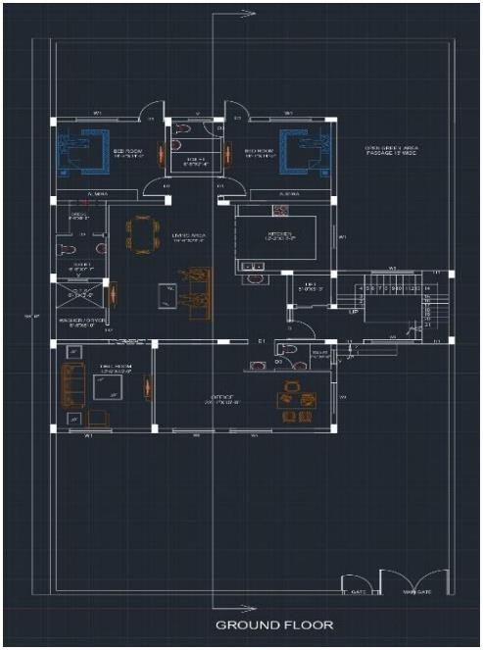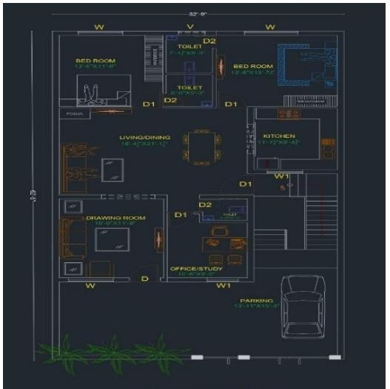

Figure2.1:Designing of Ground Floor Planusing AutoCAD software.

PRINCIPLES OF ARCHITECTURALDESIGN

Some of the Principles of Architectural Design is as follows;

- Emphasis: Emphasis is where the focal point of the design is and where the eye is drawn, using proportion, placement, shape, color, and materials.
- Axis: Axis is an abstract or well-defined linear progression, which can be used to organize other forms and spaces.

- Symmetry: Symmetry is using a well-defined center point, or line, to reflect and balance a design. In architecture, this concept is a formula-driven compositional structure that could be linear, radial, or bilateral (vertical vs. horizontal).
- Asymmetry: Asymmetry is a counter concept to symmetry, relying on abstract strategies rather than formula-driven strategies to provide balance. The end result is a design that is sequential, amorphous, or what could be considered non-rational, yet still in balance.
- Balance:Balanceistheartofmixingclassificationsofweights,colors,texture,andobjects to generate a sense of stability. Symmetry or asymmetry are often combined with balance to give more definition and character to a design.
- Space: Space is the defined volume between different elements. The manipulation of space can add or subtract from the design to create varying effects for aesthetic or functional purposes. This could include negative space or white space as well.
- Movement: Movement is how the design leads a viewer’s eyes through the exterior and interior of a building composition, guided by patterns or other design elements. Any element of design can be used to accomplish this, including direction, colors, value, and proportions.
- Rhythm: Rhythm is the intentional variation of design elements that of fertheviewerasense of repeating visuals. This can be expressed through intervals, random, or gradated inflections that may increase or decrease in proportion with each repetition.
- Material: Material includes the components of designs that engage the senses and form emotional responses to the way in which buildings are experienced and valued.

BUILDINGWORK

Column
Primarily, columns are compression members, although some may be subjected to bending either duet other slenderness or due to their a symmetric loading from beams (Oyenuga,op.

cit.).Reinforced concrete columns are generally either rectangular in cross-section with separate links, or circular – and, in some cases, polygonal.

Fundamentally, columns can be categorised as:
      - Axially loaded column: When it supports approximately symmetrical beam arrangement.
      - Uniaxial column: When it supports direct loading and bending in one direction.

      - Biaxial column: When it supports a concentric loading and bending acting about two axes that are mutually at right angles.

Also, column scan be classified based on its end conditions as:
- Braced column: When wall, bracing or buttressing, designed to resist all lateral forces in that plane, laterally supports it.
- Unbraced column: When it is not laterally supported by wall, bracing or buttressing.

Procedure for Construction Column Foundation
The construction process of foundation is as follows:

- Excavating the earth from foundation.

- Laying of cement concrete in foundation (blinding).

- Placing steel barnet in foot in gasper design and also placing vertical bars of column in footing on the steel bar net as per design.
- Laying form working footing.

- Laying cement concrete 1:1.5: 3or1:2:4 in footing up to required height as per design.
- Curing work and refilling of earth around footing.

Super Structure
Aftertheconstructionoffootingandpedestaltheconstructionofcolumnisstarted.The process of construction is following:

- Tieupallringsaroundandintoverticalsteelbarsaccordingtodesign.

- Fixformworkofrequiredsizewithverticalsteel bars.

- Laycementconcreteinformworkaccordingtodesign.

- TakepropercuringofRCCcolumn.

ConstructionofStairs

Procedure in the Construction of stairs

- CalculatetheStairs'DimensionsStairsconsistofariser,theverticalface,andthetread,the part you step on. Calculate the elevation, the height of one floor to the other. This number is the total riser to the stairs. Measure the horizontal distance the staircase will span. Measure the width of each step from left to right in the area where the staircase will go.
- DeterminetheDimensionsoftheStaircase'sFoundationWhenbuildingconcretesteps,you will need a foundation: a slab of concrete poured to a depth of several inches below the grade level (check local building codes). The dimensions are equal to that of the footprint ofthestairs.Tocalculateyournecessaryfootprint,takethetotalrunforlengthoftheslab, and total width of the stairs for the width of the slab.
- Build the Form, the form can be made with plywood or framing lumber. It can be made fromscraporlow-gradelumber.Thefirststepistocutthesideformsaccordingtothetread and riser calculations. This should look like the view of a staircase from the side. They must be securely adhered to the building's foundation. You want the new stairs to bond to the foundation seamlessly. Add wooden stakes as bracing against the outward movement of the poured concrete every 12 inches (30.5 cm) along the outside surface of the form. Next, install the boards that will form the face of the risers. These should have a width equaltotheheightoftheriser.Dependingonthewidthofthestairs,youmighthavetoadd bracing to the center of each riser. Make sure that the forms are plumb and level before proceeding further.

- Mix the Concrete For a staircase, you can mix the concrete by hand, or you can use a portable cement mixer. If the staircase is any larger than the short sunken living room staircase.Youcanuseready-mixedconcretethatonlyrequireswater,oryoucanobtainthe ingredients individually. Typically, with concrete you'll calculate 6 gallons of water per bag of cement.
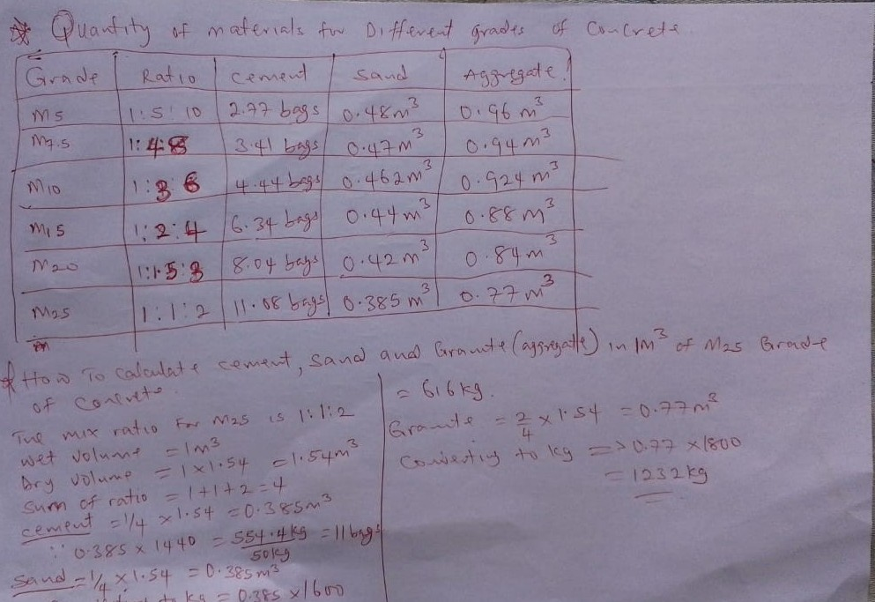
- Pour the Concrete, though it requires the least direction from me, this is the real meat of the project. Start at the bottom, and pour one step at a time. Once you pour it, it should be spread evenly. Use a spade or a rod to remove trapped air bubbles.
- Addthe Finishing Touches There are any number offinishing methods you can useto get a smooth surface while building concrete steps... A screed board is a piece of lumber somewhat longer than the width of the staircase that you'll gently work front to back and sidetosidetogettheexcessconcreteoffthetreads.Youcanusea2x4forasimplescreed board. Use a wood float to level the surface. A wood float is a small piece of flat lumber withahandleononeofthefaces.Toprovideafinerfinish,useasteeltrowel,whichisvery much like a wood float, only the finishing surface is very smooth steel which creates a smoother and less bubbly finish.
- Wait and Dampen Once you have the surfaces smoothed, keep the concrete wet or damp for up to one week while it cures. You can do this by covering the stairs with burlap and keepingtheburlapwet,oryoucancoverittightlywithplastic.Additionally,spraythestairs with curing compound. This step is essential. Left open to the atmosphere, the relative humidity of the concrete will drop rapidly. If it drops below 80%, the curing hydration reaction can stop. If this happens, the concrete may only achieve a fraction of its potential strength. After a week, the concrete will have attained its final shape, and you can remove theformlumber.Curingwillcontinuetotakeplaceoveraperiodofmonths.Ifafteryou've completedbuildingconcretestepsyouplanonstainingthem(apopularprocedurethese days),itisimportantthatyouallowtheconcretetocureforatleast30dayssothatthe staining will take properly.

Plastering Work

Procedure of Plastering
The very first step towards plastering a wall will comprise of mixing the chemicals, like aggregate, lime orgypsum and fiber. To do this, you need a bucket filled with clean, cold water. Add plaster to the water slowly, using a gauging trowel. With the help of a mixer drill, blend the plaster and water thoroughly. Make sure that the plaster is mixed to the appropriate consistency and is lump free.
The First Coat: The first coat, called the scratch coat, is applied to the walls at 3/8-inch thickness. It is called the scratch coat, because the surface is scratched with a comb, in order to give it a rough texture.
The Second Coat: The second coat, called the brown coat, is applied directly on the basecoat. In this case also, the thickness of 3/8-inch is maintained. The rough texture to the coat is lent by the sand mixed in it.
The Final Coat: The final coat, or the traditional lime finish coat, is applied at a thickness of 1/8-inch. The lime putty is prepared by blending it with water, in a mixing board. The final coat gives the wall a hard and shiny finish.

Tips

- Make sure to wet the surface at which you are applying plaster. This will ensure better sticking of the plaster.
- Don’t use dry cement over the plastic surface, as there are chances of it getting distorted.

- Usetheappropriateamountofwaterwhilemixingchemicalsorelse,therearechancesthat

It won’t set up to the brick wall.
- Wait for 24 hours after plastering the wall and splatter water over it for the next 3-4days.

The splattered water will ensure better set up of the plaster.

- If you are doing the patch up work in a smaller area, like in a room, make sure to keep newspaper pieces on the ground, so that if the plaster fall sover it, it can be removed. Once dried, it is difficult to remove the plaster.

Construction/Laying of Block Wall

Concrete blocks, commonly referred to as “CMUs”, are used for wall construction throughout residential and commercial building. From foundations to terraces and planters, concrete blocks offer an efficient and cost- effective alternative to the cost and elaborate forming of poured concrete. No matter the scope of your project, the basic procedure for laying block sets a pattern that ensures an accurate and structurally sound wall.
Procedure To Calculate The Total Blocks Needed For Block Work.
Determine the total wall area, subtract the area of openings (doors, windows), and then divide the remaining area by the area of a single block (including mortar).
Here's a more detailed breakdown:
1. Calculate Total Wall Area:
Measure Wall Lengths: Accurately measure the length of each wall (both external and internal).
Calculate Wall Area: Multiply the total wall length by the wall height to get the total wall area.
Example: If you have a 10-meter wall that is 3 meters high, the area is 10m * 3m = 30 square meters.
2. Subtract Openings:
Measure Openings: Determine the area of all openings (doors, windows, etc.).
Subtract from Total Area: Subtract the total area of openings from the total wall area to get the net area to be covered with blocks.
Example: If your wall has a 2-meter wide door and a 1.5-meter wide window, the total opening area is (2m * 2m) + (1.5m * 1.5m) = 6.25 square meters. Subtracting this from the 30 square meters leaves 23.75 square meters for block work.
3. Calculate Blocks Needed:
Determine Block Area:
Measure the length and height of a single block (including mortar) to find its area.
Divide Net Area by Block Area:
Divide the net wall area (after subtracting openings) by the area of one block to find the total number of blocks needed.
Example:
If your block is 450mm x 225mm (0.45m x 0.25m), the area is 0.45m * 0.25m = 0.1125 square meters. Dividing the 23.75 square meters by 0.1125 square meters per block gives you approximately 211.1 blocks.
Add for Waste:
Always add a percentage (e.g., 5-10%) to account for breakage and waste during construction.

Procedure for laying of Blocks
      - Installanappropriatelysizedandreinforcedpouredconcretefootingfortheblockwall.
The Dixieline ProBuild Home Centers website recommends a continuous level minimumfootingdimensionof8inchesdeepand12incheswideforthefulllengthof the wall.
      - Define the exterior wall line for the concrete block. Set a stake in line with the desired wall line roughly 3 to 4 feet beyond the wall length at both ends of the footing. Drive the stakes using a sledgehammer until they’re firmly held in place.
      - Tie a length of string line between the two stakes to use as a guideline for the outside walllinefortheconcreteblocks.Youcanadjustthestakes,asneeded,toalignthewall with the footing. Keep the string taut and unencumbered during the block laying.
      - Mark a wall in epoint on the top surface of the concrete footing at each end using a

builder’s level aligned with the string line set in step3. Connect the two marks using a
chalkline.Thisdefinesawallguidelineforthefirst“course”,orlayer,ofconcrete

block.

      - Mix cement mortar mix in a wheel barrow following the manufacturer’s label

directions.

      - Set up a mortar board and stand, within easy reach of the block wall, and place a small pile of mortar on the board. A piece of plywood and a couple of concrete blocks also makes a simple mortar board and stand, or the wheel barrow of mortar can be kept close by.
      - Spread a straight, even line of mortar using a trowel. Make the mortar line approximately 2 inches wide, ¾ inch thick and 24 inches long beside the chalked guideline you snapped in step 4. Spread a second matching a parallel mortar line 8 inches from the first on the same side of the guideline.
      - Lower a standard concrete block onto the mortar lines, aligned with the chalked guide line and the desired end of the wall, and the nuseatorpe do level to level the block. Tap the top of the block with a rubber mallet, as needed, to level it and maintain a minimum 3/8-inch mortar joint between the block and the footing surface. Collect the excess mortar mix that squeezes out from under the block and return it to the wheelbarrow or mortar board for reuse.
      - Repeat steps 7 and 8 to set the next concrete block in place, leveling the block and keeping the adjacent vertical joint tight. Use a builder’s level to keep the top surfaces level and side faces aligned.
      - Complete the first full course of concrete blocks by repeating the procedure described in step 7 and 8. When the first course has been completed, recheck each block for level and alignment with the chalked guideline.
      - Begin the next course of concrete blocks by spreading two parallel lines of mortar on the edge of the first blocks, again about ¾ inch thick and 24 inches long, and then starting the course with a CMU half block to offset the vertical joints from the proceeding couse of blocks. This method of starting alternating course with standard and half-blocks is to be used throughout the wall’s construction.
      - Repeatstep7and8tocompletetheconcreteblockinstallationfortheremainderofthe wall

CHAPTERTHREE

MAJORACTIVITIESANDPROJECTCARRIEDOUT

Contribution to Al Hamad Building Contracting Company

Overview In all, I have been trained as to be equipped in the consultancy and construction industry as. I was exposed to various facets of building profession and road constructions which eals with general site concept and contractor /consultant interface. Construction involves alot of professions like Quantity Surveying, Architecture, Structural Engineering, Electrical Engineering, Mechanical Engineering, Surveying, etc. I was exposed to all of this profession interfaces as far as building construction and Inspection which is basically act of the professionals on the project to check whether the conceived ideas put on paper are translated into real structure. However. I helped in carrying out some technical tasks which serves as positive addition to the organization and this is as follows;
    - Keeping records of daily activities

    - Attending to clients

    - Propagating the nature of the organization job

Project carried out
These are some of the activities carriedout:
- Participation in the inspection of Site inspection
- Carrying some designs on AutoCAD such as; designing of ground-flow Etc.
- Participation is carrying out some building work.
- Participation is carrying out the LIPOGA project at KWASU.

CHAPTER FOUR CONCLUSION AND RECOMMENDATION

Conclusion

My four (4) months industrial attachment as a traineeatAl Hamad Building Contracting Company was a huge success and a great time of acquisition of knowledge and skills. Because have been trained as to be equipped in the consultancy and construction industry as. I was exposed to various facets of building profession and road constructions which deals with general site concept and contractor/consultant interface. Hence, my training has given me a broader view to the importance and relevance of Architecture Technology in the immediate society and the world as a whole.

Recommendations

I use this medium to make the following recommendations concerning the training of student in industrial attachment.
    - This program should be continued for polytechnic students because it bridges up the gap up between the practical and the theoretical skill aspect in the course of study. Government should also ensure a proper supervision of SIWES student so that the purpose of the programme will be achieved.
    - This program enables us to be self-reliance and employer of labor instead of looking for white collar job after the ND graduation.

REFERENCES

Onyemauwa,M., (2019). How to easily write a good and presentable I.T/SIWES report.

Retrieved from https:// siwesbeginner.com/write-siwes-report.

Ibenegbu, G., (2018). How to write SIWES report. Retrieved from

https://www.legit.ng/amp/1147444-how-write-siwes-report.

Guide lines on How to Write SIWES Reports. From the SIWES Unit, The Federal Polytechnic Ile-Oluji.

