

A TECHNICAL REPORT
ON
STUDENT INDUSTRIAL WORK EXPERIENCE SCHEME
(SIWES)
HELD AT

LAND AND HOUSING EDU LOCAL GOVERNMENT
LAFIAGI KWARA STATE
PRESENTED BY
ESAN ISAAC TEMIDAYO
ND/23/MEC/PT/0045

SUBMITTED TO
DEPARTMENT OF MECHANINCAL ENGINEERING, INSTITUTE OF TECHNOLOGY (IOT), KWARA STATE POLYTECHNICS, ILORIN.
KWARA STATE
IN PARTIAL FULFILLMENT OF THE REQUIREMENT FOR THE AWARD OF NATIONAL DIPLOMA (ND)

2024 SESSION

CHAPTER ONE
INTRODUCTION
1.1 Background of SIWES
This program, Student industrial work experience scheme (SIWES) was introduced in year 1973 for the purpose of improving the technical knowledge of science student in all polytechnic and university, it is jointly co-operated and cared for by the Industrial Training Fond (ITF) and some other bodies like nation board for technical education (NBTE) and Nigerian University Commission (NUC).
1.1 PROFILE OF ITF
The industrial Training Fund Programe is essential in order for student to acquire practical and technical knowledge in various professions which is certainly different from theories. The ITF office are in various state with its head quarter in mango (Jos Plateau State )
1.2 FUNCTION OF MECHANICAL ENGINEERING DEVELOPMENT BOARD:-
Mechanical engineers design power-producing machines, such as electric generators, internal combustion engines, and steam and gas turbines, as well as power-using machines, such as refrigeration and air-conditioning systems. Mechanical engineers design other machines inside buildings, such as elevators and escalators.
1.3 ROLE OF ITF IN SIWES
1. The ITF give the student allowance through liaison office.
2. The ITF liaise with the siwes agencies to ensure prompt receive of replacement list.
2. The ITF co-operate direct and finance the programe
3. The ITF liaise with sister’s to ensure payment of student allowances.
1.3 OBJECTIVE OF THE SIWES
The siwes is aimed at improved the technical ability of science student in developing the nation the following are some of the objective
. To inspire and prepare student for work ahead of them after graduation.
. To expose them to what they might meet in future after school’
. To give student practical orientation relating to course of student
. To enable them practicalise what they have studied in theories

CHAPTER TWO
2.1 DESIGN
Mechanical engineers design machines that produce power, like engines, turbines, and generators, as well as machines that use power, like air conditioners and refrigeration systems. They also design machines for buildings, like elevators and escalators.
  - DEVELOP
Mechanical engineers develop products and systems, such as medical devices, robots, and sensors.
  - BUILD
Mechanical engineers build machines and systems, including aircraft engines, control systems, and prosthetic devices.
2.4 TEST
Mechanical engineers test machines and systems to ensure they function safely, efficiently, and reliably.
  - ANALYZE
Mechanical engineers analyze data from simulations, lab tests, and real-world operation to identify issues and improve designs.
  - MAINTAIN
Mechanical engineers plan, operate, and maintain products and power systems.
  - MANAGE
Mechanical engineers manage projects, costs, and people.
  - PROVIDE TECHNICAL ADVICE
Mechanical engineers provide technical advice and write reports and documentation.
Mechanical engineers use their analytical, technical, and problem-solving skills to create technologies that meet human needs.
CHAPTER THREE
WORK DONE AND EXPERIENCE GAINED
3.1 MILL HOUSE
Mill house is an industrial unit in sugar cane production company helps in extraction of juice from the sugar cane and produce bargas burning fuel
Bargas burning fuel is a fuel used to operate a boiler in an industry.
The Mill House is a critical section of a sugar manufacturing plant where the extraction of juice from sugarcane occurs. This process is essential for producing raw sugar, which can then be refined into white sugar. The equipment and processes utilized in the Mill House are designed to maximize efficiency and yield while minimizing waste and energy consumption.
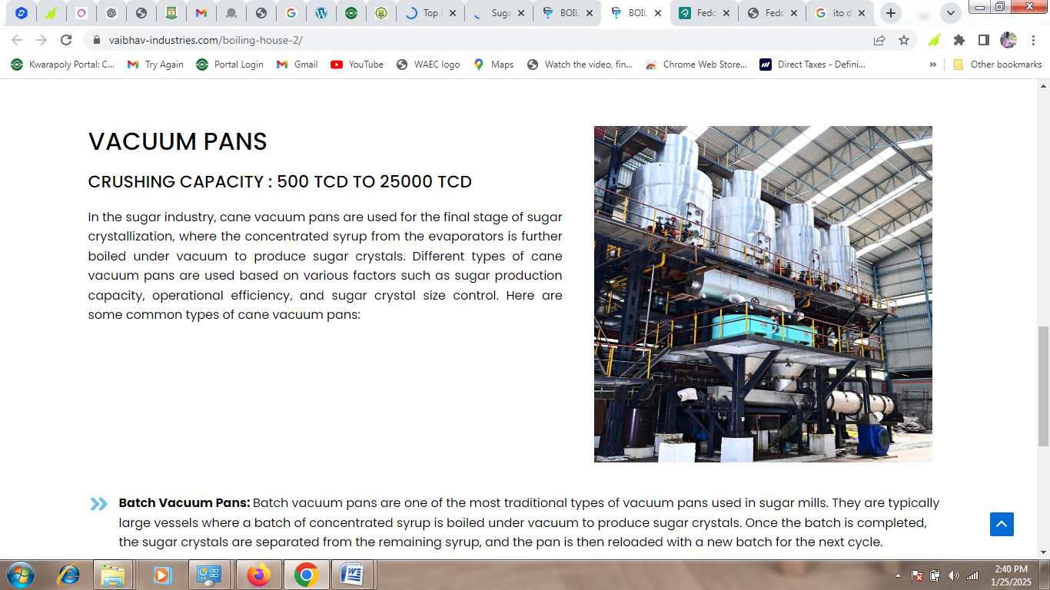
Equipment Utilized in the Mill House
- Milling Equipment: The primary function of the Mill House is to extract juice from crushed sugarcane. This is achieved using various types of milling equipment, such as tandem mills, which consist of multiple rollers that crush the cane under high pressure. These mills can range from three to six rolls and are often equipped with imbibition systems that introduce water to enhance juice extraction.
- Cane Preparation Equipment: Before the juice extraction process begins, the cane must be prepared. This involves cutting and shredding the cane using rotating knives or shredders, which open up the cells of the cane and facilitate better juice extraction during milling.
- Rake Elevators and Rake Carriers: These devices are used to transport crushed cane between different mills within the Mill House. They ensure a continuous feed of cane into the milling process, thereby optimizing production efficiency.
- Cane Choppers and Fibrizors: Cane choppers are designed to cut cane into smaller pieces for easier processing, while swing-type fibrizors help increase juice extraction rates by breaking down the cane fibers more effectively.
- Rotary Juice Screens: These screens play a vital role in separating solid materials from liquid juice after extraction. Modern rotary screens require less maintenance, have automated cleaning features, and operate efficiently even at lower crush rates.
- Crane Systems: Custom-designed cranes within the Mill House facilitate movement and handling of heavy equipment and materials, ensuring smooth operations throughout the facility.
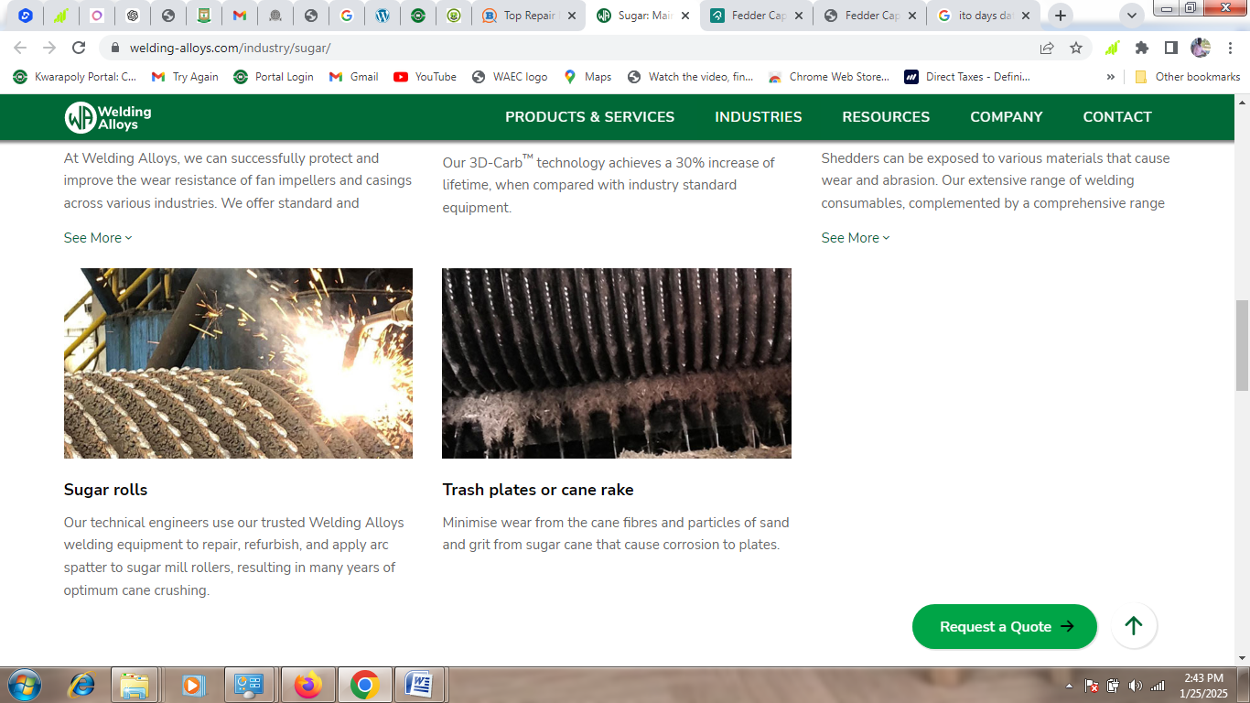
Process Flow in Mill House
- Juice Extraction: The initial step involves preparing the cane followed by its passage through tandem mills or diffusers for juice extraction.
- Purification: After extraction, the juice undergoes purification processes to remove impurities such as suspended solids (mud, waxes, fibers).
- Evaporation and Crystallization: The purified juice is then concentrated through evaporation before undergoing crystallization to form raw sugar crystals.
- Centrifugation: Finally, centrifugation separates sugar crystals from molasses (the mother liquor), resulting in raw sugar ready for storage or further refining.
- Storage: The extracted raw sugar is stored along with molasses until it is transported for further processing or sale.
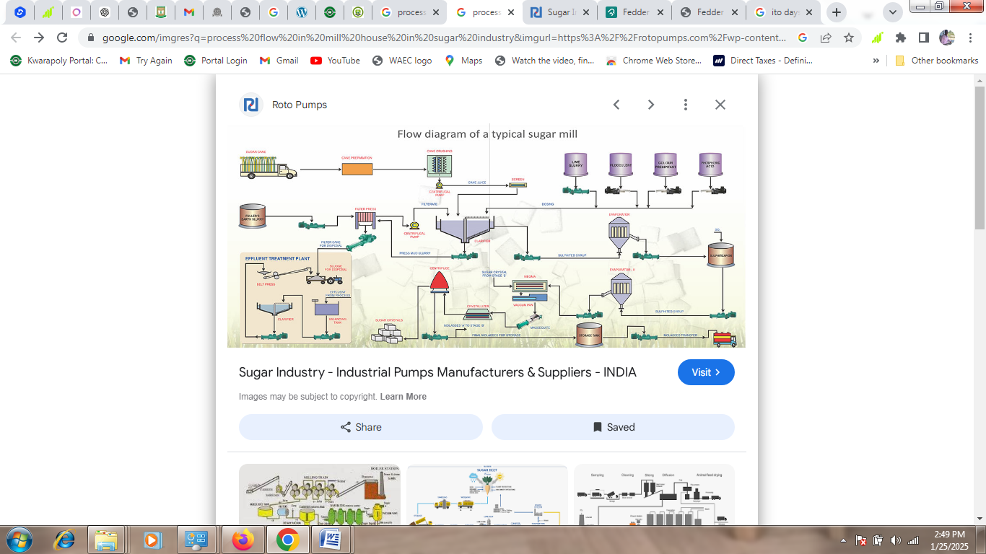
MAINTENANCE IN THE MILL HOUSE IN A SUGAR COMPANY
Maintenance in the mill house of a sugar company is crucial for ensuring efficient operation, maximizing production, and minimizing downtime. The mill house is where sugarcane is processed to extract juice, and it involves various mechanical components that require regular upkeep. Proper maintenance practices can significantly enhance the lifespan of equipment and improve overall productivity.
Maintenance Practices
Effective maintenance practices can be categorized into several types:
- Preventive Maintenance: This involves scheduled inspections and servicing of equipment to prevent breakdowns before they occur. It may include checking lubrication levels, inspecting belts for wear, and ensuring all safety devices are functional.
- Predictive Maintenance: Utilizing technology such as vibration analysis or thermal imaging to monitor equipment condition. This allows for identifying potential failures before they happen based on real-time data.
- Corrective Maintenance: Addressing issues after they have occurred. This may involve repairing or replacing broken components like bearings or rollers.
Key Areas of Focus
When maintaining a mill house, certain areas require particular attention:
- Roller Mills Maintenance: Regularly inspect rollers for wear patterns, replace worn-out parts, and ensure proper alignment to maximize crushing efficiency.
- Pump Maintenance: Check seals for leaks, monitor performance metrics (like flow rate), and clean filters regularly to prevent blockages.
- Lubrication Systems: Ensure that all moving parts are adequately lubricated according to manufacturer specifications to reduce friction-related damage.
Documentation and Training
Maintaining detailed records of maintenance activities is essential for tracking performance over time. Training staff on proper maintenance procedures ensures that everyone understands their role in keeping equipment running smoothly.
Safety Considerations
Safety should always be a priority during maintenance activities. Implementing lockout/tagout procedures when servicing machinery prevents accidental start-up during repairs.
FABRICATION
Fabrication is the process of constructing products by combining typically standardized parts using one or more individual processes. This term is often associated with metal fabrication, which involves the production of metal structures through various methods such as cutting, bending, and assembling. The goal of fabrication is to create a complete assembly made from smaller sub-assemblies that can be utilized in larger manufacturing processes.
One of the key aspects of modern fabrication is the use of technology, particularly computer-aided design (CAD) and computer numerical control (CNC). CAD allows designers to create detailed models and plans for the products being fabricated, while CNC technology enables machines on the factory floor to execute these designs with high precision. This integration of technology not only enhances the quality standards of production but also leads to quicker assembly times and better material utilization.
The fabrication process typically includes several steps:
- Design: The initial phase involves creating a design that outlines specifications for the product. This can be done using hand-drawn diagrams for simpler projects or advanced CAD software for more complex designs.
- Forming: After finalizing the design, raw materials are shaped into components through various methods such as cutting, bending, welding, and machining.
- Assembly: The formed parts are then assembled together to create a finished product or sub-assembly.
- Finishing: Once assembled, finishing processes may be applied to enhance durability and aesthetics. This could include painting, coating, or polishing.
- Installation and Maintenance: For larger projects, professional installation may be required. Additionally, routine maintenance is essential to ensure longevity and optimal performance of fabricated products.
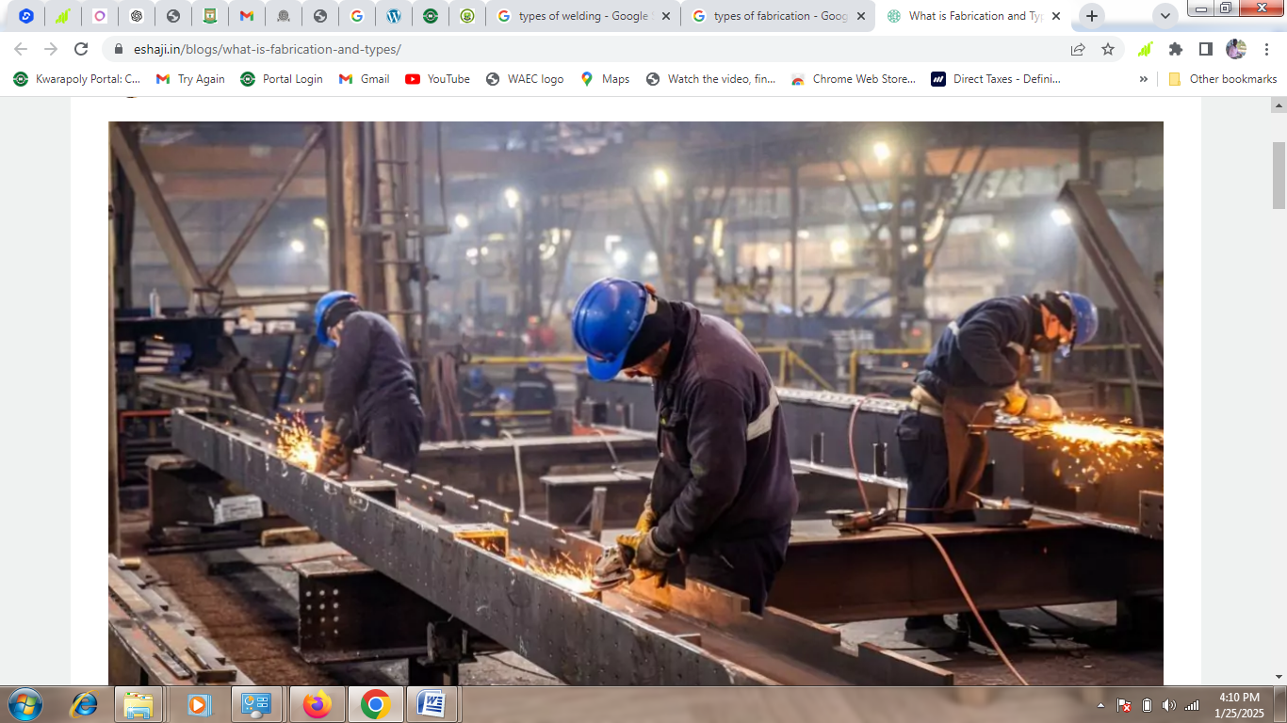
WELDING
Welding is a fabrication process that joins materials, primarily metals or thermoplastics, by using high temperatures to melt the parts together. This melting allows the materials to fuse as they cool, forming a strong joint known as a weldment. The process typically involves the addition of a filler material, which creates a molten pool (the weld pool) that solidifies to form a joint that can be stronger than the base materials themselves.
Types of Welding Processes
There are several welding processes, each utilizing different energy sources and techniques:
- Gas Metal Arc Welding (GMAW/MIG): This method uses a thin wire as an electrode and is commonly employed in construction and automotive applications. A shielding gas is used to protect the weld from contamination.
- Gas Tungsten Arc Welding (GTAW/TIG): Known for its precision, this technique uses a non-consumable tungsten electrode and is ideal for welding thin and non-ferrous metals such as aluminum.
- Shielded Metal Arc Welding (SMAW): Often referred to as stick welding, this manual technique employs a flux-coated electrode and is popular among home-shop welders due to its low cost.
- Flux Cored Arc Welding (FCAW): Similar to MIG welding but with variations that allow for outdoor use, FCAW involves continuously feeding a wire while welding.
- Submerged Arc Welding (SAW): This process involves covering the weld area with granular flux to protect it from contamination during welding.
- Other Methods: Additional techniques include gas welding/oxyacetylene welding, thermit welding, electron beam welding, plasma arc welding, and resistance welding.
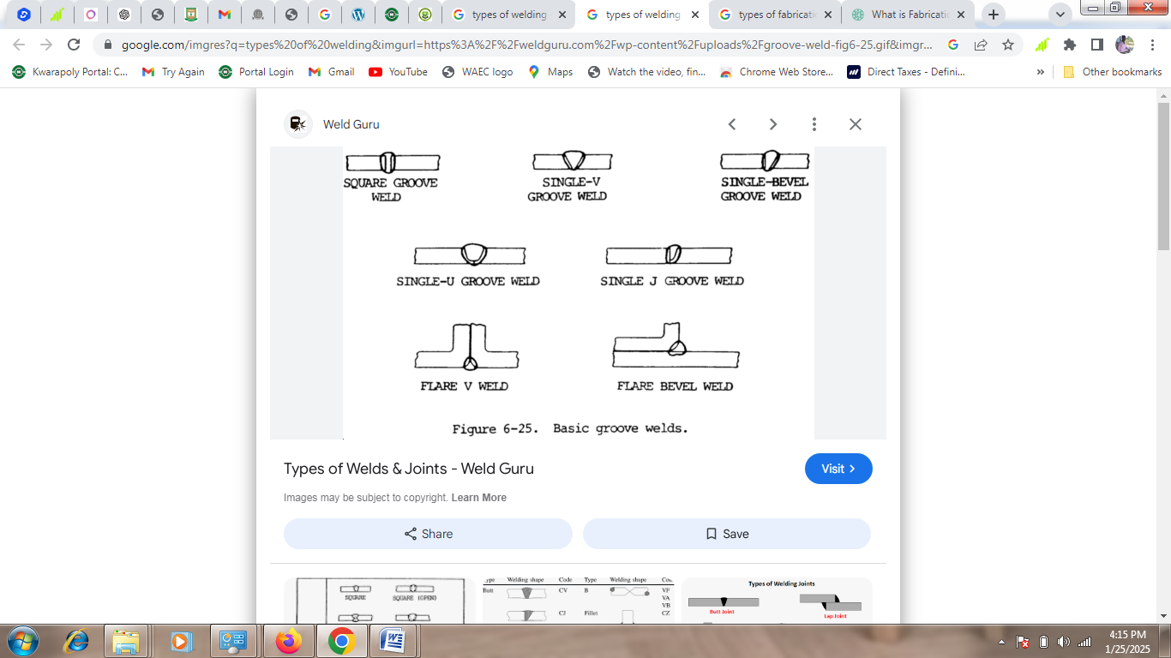

A feeder tablet is a small tablet that is used to add chemicals to water or wastewater. Tablet feeders are used in a variety of applications, including chlorination, dechlorination, and chemical treatment.
How are feeder tablets used?
- Wastewater treatment
Tablet feeders are used to add chlorine to wastewater to treat it. The tablets dissolve in the wastewater, releasing chlorine into the water.
- Water treatment
Tablet feeders can be used to add chemicals to water, such as for chlorination or dechlorination.
- Hot tubs
Tablet feeders can be used to add sanitizers to hot tubs to maintain clean water.
Types of feeder tablets
- Tri-Max
A dry chemical tablet feeder made from stainless steel that can be used for chlorination and dechlorination
- Bio-Dynamic
A self-contained dry chemical tablet feeder that is low maintenance and requires no electricity
- STS Tablet Feeder
A tablet feeder made from corrosion resistant polyethylene that can be used for wastewater chlorination
.

CHAPTER FOUR
PROBLEM ENCOUNTERED, CONCLUSION AND RECOMMENDATIONS
4.1 PROBLEM ENCOUNTERED
It is a critical clear that SIWES is an experience programme for all students because it is in this programme that student will be impact to withstand the challenges of life in the office after graduation.
But there are still some problems which encountered during the experience which are as follows:
• Inadequate facilities in the office
• Insufficient funding of the programme
• No allowance to the student.
4.2 CONCLUSION
The experience was a great one, and I have learnt a lot from the office.
I was exposed to many things like; Site plan, Site investigation, Building team, Concrete, Drainage system, Stair case, Specification, Scaffolding, Contract, Building maintenance.
4.3 RECOMMENDATION
Based on experience and achievement in SIWES programme I hereby recommend this programme for all serious and eligible students and urge them to take it serious, student should avail themselves for this tremendous opportunity to learn during the lecture room, but it during training that I was exposed to many things that I need to know in my discipline practically and I am so glad.

