

Technical Report
On
STUDENT INDUSTRIAL WORK EXPERIENCE SCHEME (SIWES)

HELD AT
KWARA STATE MINISTRY OF JUSTICE ILORIN
Ahmadu Bello Way GRA, Ilorin Kwara State
Presented by:
ENIOLA KEMI MARY
ND/23/ACC/FT/0017

Submitted to:
DEPARTMENT OF ACCOUNTANCY, INSTITUTE OF FINANCE AND MANAGEMENT STUDIES
KWARA STATE POLYTECHNIC
P.M.B. 1375, ILORIN

IN PARTIAL FULFILLMENT OF THE REQUIREMENT FOR THE AWARD OF NATIONAL DIPLOMA (ND) IN
ACCOUNTANCY, KWARA STATE
POLYTECHNICS, ILORIN

August – December, 2024

PREFACE
This technical report is written to situate the standard of experience gain by student in the industrial as awareness of continuity at the tertiary level of learning. The technical indulgence of training has been expressed formally in these report required by the constitution of the industrial training office of polytechnic.
This report is divided into five different parts which each part explains the meaning of siwes, major organization, work actually carried out and experienced gain. Even challenged faced, conclusion and recommendation are also involved.

DEDICATION
I dedicate this report to the Almighty God, for granting me the privilege to commence this course. Also to my reliable and respectful loving parents, Mr. & Mrs. Eniola for being there for me. I pray may the Almighty Allah reward you abundantly, Amen.

ACKNOWLEDGEMENT
I wish to express my sincere gratitude to Almighty God for spearing my life throughout my first year in Kwara State Polytechnic, Ilorin and for making my vision to come to reality. I also thank him for his goodness, mercy and joy throughout my life.
My greatest debt is to my indispensible parent Mr. and Mrs. Eniola for their moral and financial support throughout the duration of my training may Almighty God reward you abundantly.
My special thanks go to the head department and the entire staff of Accountancy department, Kwara State Polytechnic.
My appreciation also goes to the entire staffs of Kwara State Ministry of Justice
I also acknowledge the effort of my friends and siblings for their financial, moral and spiritual support throughout my academic pursuit. Also to my SIWES supervisor for his great work.

TABLE OF CONTENT
Title Page
Preface
Dedication
Acknowledgement
Table of content
CHAPTER ONE
1.1 Meaning of SIWES
1.2 Brief history of SIWES
1.3 Aims and Objectives of SIWES
CHAPTER TWO
2.1 History of the Organisation
2.2 The organizational Structure
2.3 Department in the organization
2.4 Interpersonal Relation with the organization
CHAPTER THREE
3.1 Work Actually Carried Out
CHAPTER FOUR
4.1 Experienced Gained
4.2 Challenges Faced
CHAPTER FIVE
5.1 Conclusion
5.2 Recommendation

CHAPTER ONE
1.1 MEANING OF SIWES
SIWES is skill development program designed to prepare students of all institutions for transition from the collage environment to work. Also to promote and encourage the acquisition of skills in industry and commerce with a view of generating a poll of indigenous trained manpower sufficient to meet the needs of the Nigeria economy
It is also described as work experience in a education program in while attending school, while the work experience gives student opportunity to be part of an actual work situation outside the classroom.
1.2 BRIEF HISTORY OF SIWES
The government decrees no 47 of 8th October, 1971 as amended in 1990 highlighted the capacity building resource in industry commerce and government through training and re-training of workers in order to effecting provide the much needed high quality goods and services in a dynamic economy as ours (Jemerigbo 2003) the decree led the establishment of Industrial Training Fund (ITF) in 1973/1974.
The growing concern among our industrialist that graduates of our institution lack adequate practical background studies preparatory for employment in industries, led to the information of student industrial work experience scheme (SIWES) by ITF 1993/1994
The student industrial work experience scheme (SIWES) is a skill training program designed to expose and prepare student of agriculture, technology, environmental science, medical science and applied science for the industrial work situation which they are likely to meet after graduating.

1.3 AIMS AND OBJECTIVES OF SIWES
1. The main aim is the exposing of students to work method and technologies in handing equipment and machinery that may not be available in educational institutions.
2. SIWES provide an avenue for students in institutions of higher learning to acquire industrial skills and experience in their course of study especially in engineering.
3. To strengthen employers involvement in the educational process of preparing students for past graduation work situation.
4. To make transition from school to the world of Work easier and to enhance student contact for later job placement.
5. To provide student an opportunity to apply their knowledge in actual practice
6. Provide opportunity for students to apply their knowledge in real work situation thereby bringing the gain between theory and practical.

CHAPTER TWO
ABOUT KWARA STATE MINISTRY OF JUSTICE
The Ministry of Justice is headed by the Attorney General and Commissioner for Justice. The Commissioner exercises general direction and control over the affairs of the Ministry. The Attorney General/Commissioner for Justice is assisted by the Solicitor General/Permanent Secretary who is responsible for the administration of the office and for the coordination and execution of approved policy and also ensures the efficiency of staff.
Next to the Permanent Secretary are the various departmental heads who are Directors. The professional staff of the Ministry comprising State Counsel of various grades are distributed across the departments depending on the volume of work of the departments. The State Counsel reports to their various departmental heads whilst the administrative staff report to the Director of Personnel, Finance and Supply. The Ministry has zonal offices across the State which include Omu-Aran, Offa, Lafiagi, Afon, Osi, Jebba, Igbaja and proposes to establish more zonal offices to make justice accessible to the citizens and residents of the state at the grassroots.

THE ORGANIZATION STRUCTURE AND CHART
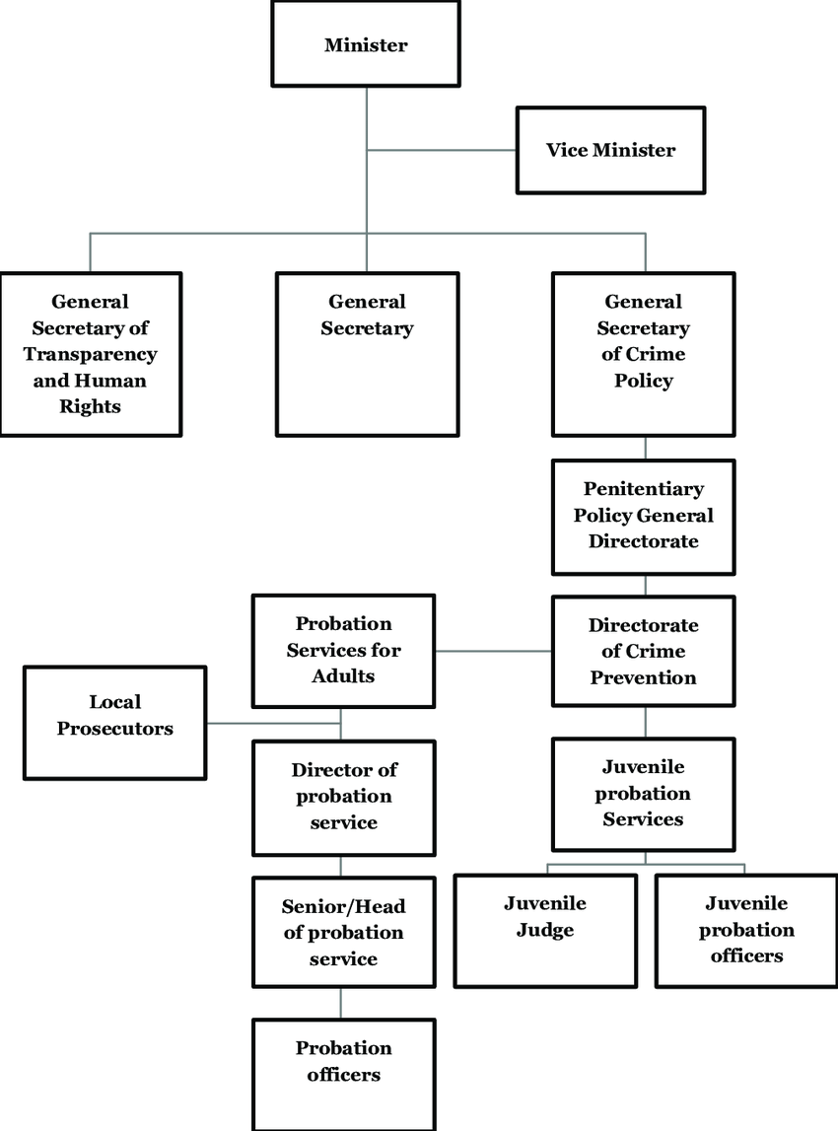
  - DIFFERENT DEPARTMENT IN THE ORGANIZATION
1. Legal Advisory Department
- Responsibilities: This department provides legal advice and opinions to the state government on various matters, including legislative proposals, contracts, and disputes. It ensures that the state's actions comply with the law.
2. Prosecution Department
- Responsibilities: This department is responsible for prosecuting criminal cases on behalf of the state government, ensuring that criminal offenders are brought to justice.
3. Civil Litigation Department
- Responsibilities: This department handles civil cases involving the state government, such as lawsuits filed against the government, or by the government, concerning issues like contracts, property disputes, and other legal claims.
4. Legislative Drafting and Law Reform Department
- Responsibilities: This department is in charge of drafting new laws, reviewing existing laws, and suggesting amendments or reforms where necessary to align with evolving legal standards.
5. Human Rights and Public Interest Department
- Responsibilities: This department focuses on protecting human rights and addressing public interest issues within the state, ensuring that the government's actions respect the rights of individuals.

6. Public Prosecution and Legal Aid Department
- Responsibilities: This department provides legal aid and representation to individuals who cannot afford legal services, ensuring access to justice for all citizens, regardless of their financial status.
7. Alternative Dispute Resolution (ADR) Department
- Responsibilities: This department focuses on resolving legal disputes outside of the formal court system, through mediation or arbitration, offering parties involved an alternative to traditional litigation.
8. Administration and Finance Department
- Responsibilities: This department manages the ministry’s internal administration and finances, ensuring proper budgeting, allocation of resources, and human resources management.
9. Corporate Affairs and Documentation Department
- Responsibilities: This department handles the ministry's corporate communications, including managing public relations and maintaining essential records and documentation.
10. Criminal Justice Reform and Monitoring Department
- Responsibilities: This department focuses on reforming the criminal justice system in the state, ensuring that the rights of individuals in the criminal justice system are protected.
2.4 INTERPERSONAL RELATION WITH THE ORGANIZATION
There was mutual understanding and love among the staff and the student that did their SIWES programme there because they took all the student like their own children, advising and guiding them to do the right thing at the right time.
High level of discipline was displayed among the student, even though the staffs a make sure that every problem encountered by the student are been tackled and solved out by both the student and staff all in the aspect of bringing about unity and peace.

CHAPTER THREE
3.1 WORK ACTUALLY CARRIED OUT
During my industrial training, I was assigned to the Accounts Department where I worked closely with the staff in ensuring that the financial activities of the Ministry were effectively managed. My tasks included:
- Budget Preparation: I assisted in the preparation of the Ministry’s annual budget by collecting data on projected expenses and revenues, and ensuring alignment with state financial regulations.
- Financial Record Keeping: I helped maintain proper financial records, ensuring that all financial transactions were accurately documented in the accounting system.
- Expenditure Monitoring: I worked on reviewing departmental expenditures and ensuring that spending was in line with approved budgets, providing recommendations for cost control where necessary.
- Reconciliation of Accounts: I assisted in reconciling various accounts, including bank accounts, to ensure accuracy and integrity of the Ministry’s financial data.
- Payroll Management: I was involved in verifying employee payroll data and ensuring that salaries, benefits, and deductions were processed accurately and timely.
- Taxation: I assisted in preparing tax documents and filing returns in compliance with relevant tax laws.
- Preparation of Financial Reports: I contributed to the preparation of periodic financial reports for internal use and for submission to the state government for auditing and evaluation purposes.

CHAPTER FOUR
4.1 EXPERIENCED GAINED
I can actually say I gained a lot from my SIWES Programme by having the opportunity to know my capability on the work I have been taught in school.
Throughout my time at the Kwara State Ministry of Justice, I was able to develop a variety of practical skills, including:
- Public Sector Accounting: Gained an understanding of how accounting is handled in government institutions, including budgetary controls, grant management, and financial reporting.
- Budgeting and Financial Planning: Learned the intricacies of preparing and managing government budgets, ensuring financial sustainability while adhering to statutory guidelines.
- Tax Compliance: Gained experience in preparing tax returns and ensuring that the Ministry complied with local tax laws.
- Use of Accounting Software: Familiarized myself with government accounting systems and software used in processing financial transactions and generating reports.
- Attention to Detail: Improved my ability to review and verify financial documents for accuracy and completeness.
4.2 CHALLENGES FACED
While at the Kwara State Ministry of Justice, I faced several challenges, including:
- Complex Government Regulations: Government financial regulations can be complex and require a thorough understanding of state-specific laws. Initially, it was difficult to fully grasp all the financial policies, but with the guidance of my supervisors, I was able to overcome this challenge.
- Data Entry and System Familiarity: The Ministry used specific financial management software that I was not previously familiar with. Learning to navigate this system took time, but I became more proficient as I continued using it.
- Time Constraints: The Ministry had strict deadlines for reporting and submitting financial documents. At times, balancing multiple tasks within tight deadlines proved challenging, but I learned to manage my time more efficiently.

CHAPTER FIVE
CONCLUSION AND RECOMMENDATION

5.1 CONCLUSION
Student Industrial Work Experience Scheme (SIWES) is a good programme for higher institution in the sense that it adds to one’s practical knowledge based on your course of study. As for me SIWES as a course has truly exposed me to face in a growing information world that depend on Business Administration and Management.
5.2 RECOMMENDATION
As a bonafide student of the department of Accountancy of Kwara State Polytechnic and who has undergo industrial training. I hereby make the recommendation that the government should continue funding this programme (SIWES) and pay directly to student after the completion of the programme due to the stress inclined to the programme, in order to serve as encouragement to student that want to increase their practical and technical knowledge.

