
A TECHNICAL REPORT
ON
STUDENT INDUSTRIAL WORK EXPERIENCED SCHEME
(SIWES)

HELD AT
OGO ILU, 89.3 FM
ALONG GBOMOSO - OSOGBO ROAD, OKO.

PRESENTED BY
LUKMAN FATHIA ADENIKE
ND/22/MAC/PT/1104
SUBMITED TO:
THE DEPARTMENT OF MASS COMMUNICATION
INSTITUTE OF INFORMATION AND COMMUNICATION TECHNOLOGY
KWARA STATE POLYTECHNIC, ILORIN
IN PARTIAL FULFILMEN OF AWARD ON NATIONAL DIPLOMA.

2023/2024 SESSION

DEDICATION
This technical report is dedicated to the almighty God who gave me the life, strength, ability to acquire the knowledge and practical experience for the period of my attachment of my SIWES on my field of study.

ACKNOWLEGEMENT
I’m indebted to several people who at various stages contributed towards making this industrial training programme a success. My special thanks first and foremost goes to Almighty God for the grace and enablement He gave to me during the period of my attachment and during the period of writing this technical report.
I also wish to appreciate my parent in persons of Mr. and Mrs. Taiwo who has helped me in all aspect of my life. You will reap the fruit of your labour. Thank you

TABLE OF CONTENT
Title page
Dedication
Acknowledgement
Table of content
CHAPTER ONE
1.0 Introduction to Siwes
1.1 Advent of Siwes
1.2 The objective
1.3 Mission |
1.4 Vision
1.5 Benefit of industrial Training
CHAPTER TWO
2.0 Background of the Organization
2.1 Crown 101.5 FM and its Objectives
2.2 Department in Crown 101.5 FM
2.3 Departments
CHAPTER THREE
3.0 News Writing
3.1 How to Write a News Article
3.2 On-Air Experience
3.3 Basic Technical Skills Development I Gained
CHAPTER FOUR
4.0 Challenges Faced During Siwes
4.1 Suggestions to Siwes Organizer
CHAPTER FIVE
5.0 Summary
5.1 Conclusion
5.2 Recommendation

CHAPTER ONE
INTRODUCTION OF STUDENT INDUSTRIAL WORK EXPERIENCE SCHEME (SIWES)
1.0 INTRODUCTION
Student Industrial Work Experience Scheme was established by the Industrial training Fund (ITF) in 1973 with the aim of bridging the gap between the skills which the labour market required with that of those acquired by the graduate students.
Since its introduction by the ITF in 1973 the Scheme has gone through series of reforms. its management, for instance, has changed hands from the ITF to the various regulatory AGENCIES SUCH AS National Universities Commission (NUC) National board for Technical Education (NBTE) and National Commission for college of Education (NCCE) and now back to the ITF again. These are the major stakeholders in (SIWES).
Consequently, SIWES Programme was introduced into the curriculum of tertiary institutions in the country as far back as 1974 with 748 students from 11 institutions of higher learning.
However, the scheme has over the years contributed immensely to the personal development and motivation of students to be able to understand the important connection between the taught and learnt content of their academic programmes and what knowledge and skill will be expected of them on professional practice after graduation.
Meanwhile, the need for students to possess adequate information on (SIWES) is further underlined by the fact that (SIWES) is a course of study that attract two, four and six credit units in Colleges of Education, Polytechnics and Universities respectively, depending on the need attached to it by the institutions.
The availability of required information therefore, enhances the capacity of students to work for and earn the credit units allotted for SIWES, rather than wobbling through the training intervention because of lack of pertinent information.

1.2 ADVENT OF SIWES
In recognition of the short courses and weakness in the formation of Set graduates, particularly with respect o acquisition of relevant production skills, the industrial training fund established the students Industrial Work Experience Scheme (SIWES) in 1973.
The Scheme was designed to exposed students to the industrial environment and enable them develop occupational experiences so that they can readily contribute their quota to national economic and technological development after graduation.
Consequently, SIWES is a planned and structured programme based on stated and specific career objectives, which are geared toward developing the occupational competencies of participants.
1.3 OBJEC TIVES OF SIWES
The Industrial training funds policy document no. 1 of 1973, which established SIWES outline the objectives of the scheme.
The objectives are to:
- Provide an avenue for students in institution of higher learning to acquire industrial skills and experience during their course of study.
- Prepare students for industrial work situation that they are likely to meet after graduation.
- Expose students to work methods and techniques in handling equipment and machinery that may not be available in their institutions.
- Make the transition from school to the world of work carrier and enhances students contacts for later job placements.
- Provide students with the opportunities to apply their educational knowledge in real work situations, thereby bridging the gap between theory and practical.

1.4 MISSION
SIWES: Is charged with the responsibility of promoting and encouraging the acquisition of skill, commerce and industry, with the view to generating a pool of trained indigenous manpower sufficient to meet the need of the economy.
SIWES, is aimed at developing the human resources of the nation. It builds the nation’s work force to promote the economy of a nation.
1.5 VISION
The vision of SIWES is to prepare students to contribute to the productivity of their nation.
1.6 BENEFITS OF INDUSTRIAL TRAINING TO STUDENTS
The major benefits accruing to students who participate conscientiously in industrial training are the skills and competencies they acquire. This is because the knowledge and skill acquired through training by students are internalized, and it becomes relevant, during job performances or functions.
Several other benefits include:
- Opportunity for students to blend theoretical knowledge acquired in the classroom with practical hand-on application of knowledge required to perform work in industry.
- Exposes students to the working environment, i.e. to enable them see how their professions are organized in practice.
- Prepares students to contribute to the productivity of their employers and nation’s economy.
- Provision of an enabling environment where students can develop and enhance personal attributes such as critical thinking, creativity, initiative, resourcefulness leadership, time management, presentation of skills and interpersonal skills.
- Prepares students for employment and makes transition from school to the work environment easier after graduation.
- Enables Students Bridge the gap between the acquired skills in the institutions and the relevant production skill required in the work organization.
- Enhances students’ contact with potential employers while on training.

CHAPTER TWO
2.0 BACKGROUND OF ORGANIZATION
The new station, OGO ILU 89.3 FM is situated in Oko Town, Oyo state. The inauguration crremony will be performed by the Minister of Information and Culture, Alhaji Lai Muhammed who is the Chief Host while the Chairman, House Committee on Information, National Orientation, Ethics and Values, Hon. Olusegun Odebunmi will be the chairman at the Occasion.
Governor Seyi Makinde Of Oyo State is expected to grace the occasion. FRCN Director General, Dr Mansur Liman is the host While The Zonal Director, Alhaji Mohammed Bello will lead Management and Staff of Ibadan National Station to the event.
Traditional rulers, Politicians and Residents of Oko Town are also expected to be part of the epoch making ceremony. The event is scheduled for ten o clock in the morning.
OGO ILU 89.3FM oko was added to the stable of Radio Nigeria ibadan alongside another new station, 88.5 fm, Saki on the 16th of October, 2020. With the latest addition, Radio Nigeria Ibadan now parades Nine fm stations namely, Premier 93.5 FM, Ibadan, Amuludun 99.1 F.M, Ibadan, Oyo State, Positive 102.5 F.M Akure, Ondo state, Progress 100.5 F.M Ado-Ekiti, Ekiti State
Others are Gold 95 5 F.M, Ilesha, Osun State, Paramount 94.5 F.M Abeokuta and Choice F.M Ota, Ogun state..

2.1 OGO ILU 89.3FM OKO AND ITS OBJECTIVES
OGO ILU has remained, and continues to broadcast effectively. Being a community radio, the station now has more audience than ever before as it strives to win the hearts of radio listeners and carve a niche for itself in the broadcast industry.
OGO ILU maintains the highest possible professional standards of programme content, presentation and technical quality within the broadcast industry.
The primary aim of establishing the radio station according to its management is to create employment opportunities for people and provide access for people to hear the truth about happenings in the state. It also aims at having a progressive radio station committed to social justice, focusing on public affairs issues and the arts. It seeks to assist the community to be a healthier and better place through professional broadcasting. It is established as a forum for many voices by providing an outlet for the expression of a wide spectrum of ideas, especially for those lacking media access. Part of the founding ideals is to provide a common resource for balanced news, music, entertainment, local features and all-round information.
The coverage areas of OGO ILU are Osun and other neighbouring states, including Ondo, Ekiti, Oyo and Kwara States.
However, through the power of the internet, Crown Radio is accessible in every part of the world. Listners can tune in through www.crownfmradio.com, or on the popular radio app, Radio Garden, as well as through the station’s Radio app, Crown FM Radio.
2.2 DEPARTMENTS IN OGO ILU 89.3 FM
Structurally, Management in Crown FM is not too different from what is obtained in other radio stations of its status.
The Station Management Structure goes thus:
Board of Directors

General Manager

Head of Departments

Admin| Accounting| Marketing| Enginering|Programmes|Production|News (Yor&Eng)

The station has the following departments:
Administrative Department
This department is headed by an Administrative Officer. It is the department that handles all administrative and personnel matters like keeping of files & documents, recruitments, placements, welfarism, organizing, & supervising. It has the personnel records of all the workers of the radio station. It also handles SIWES placements as prospective industrial trainees submit their letters of introduction/application to the Administrative Department and signs their log books there.
Accounts Department
This department is headed by an accountant. It handles all financial transactions which include receipt and lodgment of cash in the company’s bank account. It deals with budgeting, payment of staff salaries on monthly basis as well as reconciliation of income and expenditure. The department also makes recommendation to the station on fiancial issues.
Marketing Department
The department is in charge of income generation for the radio station and is headed by a Marketing Officer. It is one of the main hubs of the outfit. It serves as the link between the station and its various clients and presenters within and outside the state/town. Negotiation and payment for jingles, scripts, sponsored programmes, political broadcasts, adverts and public service announcements are made in the marketing department. The department also relate with advertising agencies to secure major sales of popular products, as well as the scheduling of such adverts and programmes for broadcast.
Engineering Department
Here we have the studio engineers and technicians that ensure that broadcast signals are transmitted to the audience. It is a very essential and sensitive section in any broadcast station. The department also oversees power related issue, and every other technical challenge, including audio production, outside broadcasting, among ohterss.
Programmes Department:
The Programmes & Production department is headed by a Programme Officer who is in charge of programme schedules. He/She determines what programmes goes on air at a particular time. He/She allocates air time for programmes. He/She coordinates the studio officers and supports the continuity announcer on duty. The programme department also ensured that the code of ethics as directed by the National Broadcasting Cooporation are followed during programmes to avoid sanctioning from the body.

News and Current Affairs Department
This department sees to the soughting, reporting, editing and presentation of news bulletins. The department are also in charge of all the current affairs programmes on the staion. The provide up-to-date information to listeners about day-to-day affairs on political matters, governance, govermental agencies and policies, educational, entertainment, foreign scene, business and fianacial updates, sports, among others. The newsroom has two news desks: English (which shields the pidgin news as well) and Yoruba news desks.

CHAPTER THREE
3.0 EQUIPMENT THAT WAS FOUND IN THE STUDIO
Audio Console
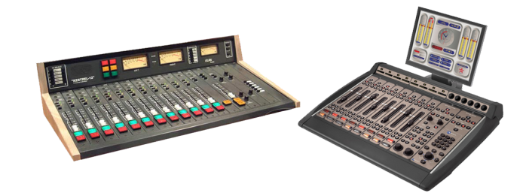
At the heart of any studio is the audio console (sometimes called a radio panel, sound panel, or sound desk). This is the interface the radio announcer (or panel operator) uses to control what’s heard on air. Every channel represents one “input”. The fader (slider) attenuates or amplifies the incoming signal.
Radio Audio Consoles are very different from a regular PA or Live Sound audio console, and are often more expensive than PA audio consoles as they are purpose-built for on-air talent ease of use. When you turn a microphone on or off, a radio console will mute any speakers and illuminate an “on air” light. When you turn a CD Player, Phone or Computer channel on, often it will “trigger” that input so it starts playing immediately.

Microphone

A microphone captures sounds from the studio and turn it into electrical impulses. Broadcast microphones are designed a little differently to PA microphones, as issues such as feedback (the squealing sound that can come through speakers) isn’t an issue in a studio.
Experienced audio announcers will often have a favourite microphone. Common microphones include ElectroVoie RE20, Sennheiser MD421, and Rode Broadcaster.
Microphone Arm
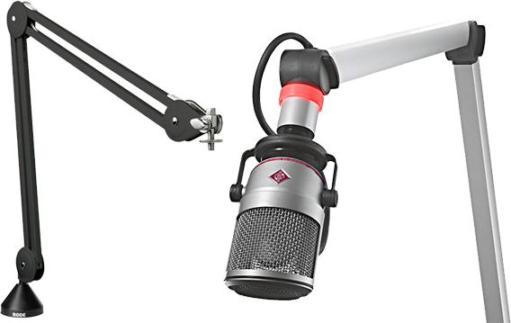
Studio microphones are often mounted on a special arm that keeps the microphone at the correct height. These arms often extend over the audio console, computer monitors, and other equipment – leaving plenty of table space free for equipment and paper.

Playout & Automation Software
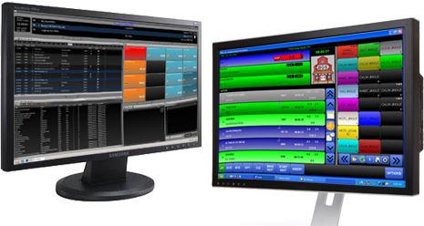
The computer system that plays back music, spots (ads, promos, etc.) and sweepers (the little voice-overs played between songs) is called a Playout System or Automation Software. These are specially designed computer programs that allow for continuous playback of audio, with a lot of granular control for Announcers and Programme Directors.
At the heart of any Automation System is the “log”. This is a sequential list of all audio files and commands that need to be played at certain times. All music played on a commercial radio station will be pre-programmed by the Music Director and loaded into the log. A separate person will often load all advertisements into the same log.
Most automation systems also contain a music database, hot keys (to play ad-hoc audio), an audio editor, segue editor (to change the mix between different elements), interfaces for website and RDS data, and a lot more.
Level Meters
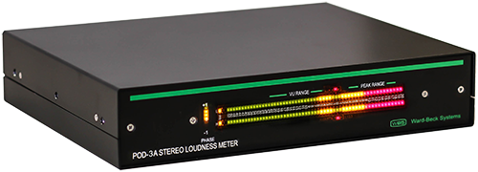
To ensure output of a station is somewhat consistent, radio studios contain different Level Meters. These allow the announcer or panel operator to see if their audio is too loud or too quiet at any given time. Often, you’ll have multiple meters showing the levels at different points in the signal chain.
Some radio stations also provide phase meters along side level meters. This helps you detect mono content, and spot any problems in source material that are likely to cause issues with the stereo image.
Studio Monitor Speakers

Studio Monitor Speakers provide an easy way to hear what’s going to air without headphones. Often, these are very high quality speakers so any abnormalities in sound quality can be detected.
Cue/Preview Speaker
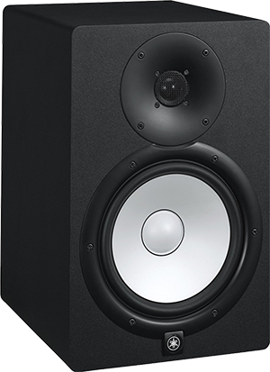
A separate speaker is often provided for the announcer hear all audio that isn’t going to air, such as the preview output from your audio console or the feed from your audio editor. By having a separate speaker for this, announcers can be sure their “preview” audio isn’t going to air.
Headphones
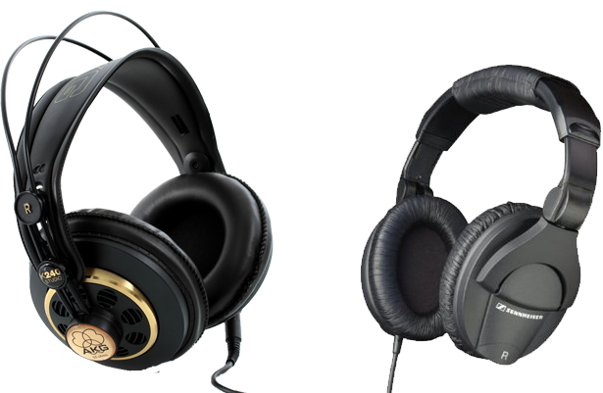
Studio Monitor Speakers are automatically muted whenever a microphone is turned on. As a result, anyone in a studio needs headphones to hear what is going to air. Headphone selection is often a very personal decision based on your preferences in comfort and frequency response.
Talent Panel
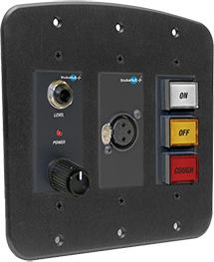
While the main announcer or panel operator can control everything via the audio console, guests often need their own individual control for headphone levels, a cough mute and mic on/off. These panels are generally mounted in front of each guest microphone, usually recessed into the table. Most panels include a headphone jack, and some also contain an XLR connector for the microphone.

On Air Light
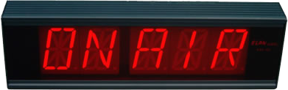
How do you know a mic in the studio is live? There’s a light especially for that! This light is automatically turned on/off by the audio console whenever a microphone channel is turned on. Usually you’d have at least one light inside the studio, and one outside.
Button Panel (GPIO)
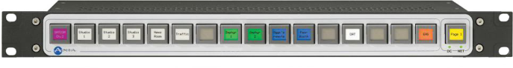
Sometimes you need to control settings not available from the audio console itself. This is why many consoles can have at least one row of configurable buttons. These can be physically wired to other equipment (in analog audio consoles), or configured via software (in digital audio consoles).
These buttons will often control studio delegation (which studio goes to air), phone systems, automation systems, or even remote triggering for networked radio stations.
P.S. GPIO stands for General Purpose Input/Output.

3.1 NEWS WRITING
News writing is a fundamental aspect of journalism, aimed at informing the public about current events, issues, and developments. It serves to provide timely, accurate, and relevant information to a diverse audience. The purpose of news writing is multifaceted:
- Informing the Public: News articles convey facts and details about events, allowing readers to stay informed about what is happening locally, nationally, and globally.
- Educating Readers: Through in-depth reporting and analysis, news writing helps readers understand complex issues, providing context and background information to facilitate comprehension.
- Promoting Accountability: Journalists hold individuals, organizations, and governments accountable by investigating and reporting on their actions, exposing corruption, inefficiency, and injustice.
- Facilitating Dialogue: News articles stimulate public discourse and debate by presenting different perspectives and viewpoints on contentious issues, fostering a more informed and engaged citizenry.
- Reflecting Society: News writing reflects the diversity of society, covering a wide range of topics, interests, and perspectives to mirror the experiences and concerns of various communities.
To achieve these objectives, news writing adheres to certain principles, including accuracy, fairness, impartiality, and objectivity. Journalists rely on thorough research, fact-checking, and verification to ensure the information they present is credible and reliable. They strive to represent different viewpoints fairly and avoid bias or sensationalism in their reporting.
In terms of structure, news articles typically follow the inverted pyramid style, with the most important information presented at the beginning, followed by supporting details in descending order of significance. This allows readers to grasp the main points quickly, even if they only read the headline and lead paragraph.
Overall, news writing plays a vital role in democracy by providing citizens with the information they need to make informed decisions, participate in civic life, and hold those in power accountable.
3.1 HOW TO WRITE A NEWS ARTICLE
Writing a news article requires careful planning, research, and attention to detail to ensure accuracy and clarity. Here's a step-by-step guide to help you write a news article:
1. Choose a Newsworthy Topic: Select a topic that is timely, relevant, and interesting to your audience. It could be a recent event, a development in a particular field, or a human interest story.
2. Research: Gather information from reliable sources such as interviews, press releases, official reports, and reputable news outlets. Ensure you have all the facts and background information necessary to present a comprehensive story.
3. Craft a Compelling Headline: Write a concise and attention-grabbing headline that summarizes the main point of your article and intrigues readers to continue reading.
4. Write the Lead: Begin your article with a strong lead paragraph that answers the who, what, when, where, why, and how questions. The lead should summarize the most important information and entice readers to delve further into the article.
5. Organize Information: Structure your article using the inverted pyramid style, with the most important information at the beginning followed by supporting details in descending order of significance. This allows readers to grasp the main points quickly.
6. Provide Context: Offer background information and context to help readers understand the significance of the story. Include relevant historical facts, statistics, or explanations to add depth to your reporting.
7. Quote Sources: Incorporate quotes from relevant sources such as eyewitnesses, experts, or officials to provide firsthand accounts and diverse perspectives. Attribute quotes accurately and ensure they enhance the credibility of your article.
8. Maintain Objectivity: Present the facts objectively without bias or opinion. Avoid injecting personal views or emotions into the reporting, and strive to provide a balanced portrayal of the topic.
9. Edit and Revise: Review your article for clarity, accuracy, grammar, and style. Eliminate unnecessary words, tighten sentences, and ensure a smooth flow of ideas. Fact-check all information to maintain credibility.
10. Add Multimedia Elements: Consider including visuals such as photographs, videos, or infographics to complement your article and engage readers visually.
11. Finalize and Publish: Once you're satisfied with the content, finalize your article and prepare it for publication. Follow any specific guidelines or formatting requirements of your chosen platform, whether it's a print publication, website, or social media.
By following these steps, you can effectively write a compelling and informative news article that informs and engages your audience.
3.2 ON-AIR EXPERIENCE
My personal on-air experience at Ogo Ilu 89.3, situated at Along Ogbomoso to OSogbo road Oyo State, was nothing short of exhilarating and enlightening. From the moment I stepped into the studio, I was greeted with the bustling energy of live radio production. The station's friendly staff members welcomed me warmly, setting the stage for what would be a memorable journey into the world of broadcasting.
As I shadowed experienced broadcasters during their shows, I was captivated by the seamless flow of on-air communication. From the smooth transitions between songs to the engaging banter with listeners, I witnessed firsthand the artistry and skill required to captivate an audience through the airwaves. It was inspiring to see how each presenter injected their unique personality and style into their programs, creating a vibrant atmosphere that resonated with listeners.
Under the guidance of mentors, I had the opportunity to contribute to on-air content in various capacities. Whether it was assisting with scriptwriting, conducting research for talk show topics, or even delivering live updates during broadcasts, every moment spent in the studio felt like a hands-on lesson in the craft of radio production. The thrill of hearing my voice on the airwaves and knowing that I was part of something bigger than myself was an experience I will always cherish.
Beyond the technical aspects of radio broadcasting, my time at Ogo Ilu 89.3 allowed me to forge meaningful connections with fellow enthusiasts and industry professionals. Collaborating with like-minded individuals who shared a passion for storytelling and communication enriched my learning experience and broadened my perspective on the power of radio as a medium for social impact and community engagement.
In retrospect, my on-air experience at Ogo Ilu 89.3fm was not just about learning the ropes of radio production—it was a journey of self-discovery and personal growth. It taught me the importance of creativity, resilience, and adaptability in the fast-paced world of broadcasting. As I bid farewell to the studio, I left with a newfound appreciation for the magic of radio and a determination to pursue my dreams in the field with passion and purpose.

3.3 BASIC TECHNICAL SKILLS DEVELOPMENT I GAINED
During my time at Ogo Ilu 89.3, situated at Along Ogbomoso to OSogbo road Oyo State, I had the opportunity to develop a range of technical skills essential for radio broadcasting. First and foremost, I gained proficiency in operating broadcasting equipment, including soundboards, microphones, and recording devices. Learning to navigate these tools allowed me to understand the technical intricacies involved in producing high-quality audio content for radio.
Additionally, I honed my skills in audio production and editing software, which are critical components of radio broadcasting. Through hands-on training sessions and practical exercises, I became familiar with editing techniques, such as trimming, fading, and mixing audio tracks. This technical knowledge empowered me to manipulate audio recordings effectively and enhance the overall quality of radio programs.
Furthermore, I acquired expertise in studio management and organization, learning how to set up and maintain a professional broadcasting environment. From ensuring proper microphone placement to managing audio levels and cues during live broadcasts, I gained a comprehensive understanding of the technical aspects of studio operations. These skills were invaluable in ensuring smooth and seamless radio productions.
Moreover, my experience at Ogo Ilu 89.3 fm provided me with insights into troubleshooting technical issues that arise during radio broadcasts. Whether it was addressing sound quality issues, resolving equipment malfunctions, or troubleshooting software glitches, I learned to remain calm under pressure and effectively resolve technical challenges to minimize disruptions to the broadcast.
My time at Ogo Ilu 89.3 FM equipped me with a solid foundation of technical skills essential for success in the field of radio broadcasting. From operating equipment and audio production software to studio management and problem-solving, the hands-on training and practical experience I gained have prepared me to pursue a career in radio with confidence and proficiency.

CHAPTER FOUR
4.0 CHALLENGES FACED DURING SIWES
One of the challenges encountered during the SIWES program at OGO ILU was the fast-paced nature of the radio broadcasting environment. Students often found it challenging to keep up with the demands of live broadcasts, especially when tasked with on-air responsibilities such as scripting segments or delivering live updates. Additionally, the technical complexities involved in operating broadcasting equipment and editing software posed a steep learning curve for some students, particularly those with limited prior experience in the field. Moreover, coordinating schedules and ensuring effective communication between students and mentors amidst the dynamic nature of radio production presented logistical challenges at times.
4.1 SUGGESTIONS TO SIWES ORGANIZER
To address these challenges and optimize the SIWES experience at OGO ILU 89.3 FM, several suggestions can be made to the SIWES organizer. Firstly, providing structured training sessions and workshops focused on key areas such as on-air presentation techniques, audio production, and studio management can help students build essential skills and confidence in their abilities. Additionally, implementing a mentorship program where each student is assigned a dedicated mentor from the station's staff can facilitate personalized guidance and support throughout the SIWES period. Furthermore, establishing clear communication channels and scheduling protocols can streamline coordination efforts and ensure that students have sufficient opportunities to actively participate in radio production activities while balancing academic commitments.

CHAPTER FIVE
5.0 SUMMARY
Undertaking the Student Industrial Work Experience Scheme (SIWES) at OGO ILU 89.3 FM in Oko Oyo State, provided a comprehensive and immersive learning experience in the field of radio broadcasting. Through hands-on training, observation, and active participation, students gained valuable insights into various aspects of radio production, including content creation, on-air presentation, technical operations, and studio management. Mentored by experienced professionals, students had the opportunity to develop practical skills, expand their knowledge, and gain exposure to the dynamic world of broadcasting.
5.1 CONCLUSION
In conclusion, the SIWES program at OGO ILU 89.3 FM has proven to be a rewarding and enriching experience for students interested in pursuing careers in radio broadcasting. By providing a conducive learning environment, hands-on training opportunities, and guidance from industry experts, the radio station has equipped students with the skills, confidence, and knowledge needed to excel in the field. The practical experience gained during SIWES at OGO ILU 89.3 FM has not only enhanced students' academic learning but also prepared them for the challenges and opportunities that lie ahead in their careers.
5.2 RECOMMENDATION
Based on the positive outcomes observed from the SIWES program at OGO ILU 89.3 FM, it is recommended that similar opportunities be extended to future students seeking industrial training in the field of radio broadcasting. To further enhance the effectiveness of the program, it would be beneficial to incorporate structured training modules, workshops, and seminars on relevant topics such as media ethics, digital broadcasting, and emerging trends in radio. Additionally, fostering closer collaboration between educational institutions and broadcasting organizations can facilitate seamless integration of theoretical knowledge with practical experience, thereby maximizing the learning outcomes for students participating in SIWES.

