TABLE OF CONTENTS
Title page - - - - - - - - - - i
Certification - - - - - - - - ii
Dedication - - - - - - - - - iii
Acknowledgement - - - - - - - - iv
Table of content - - - - - - - - v
CHAPTER ONE
1.0 Introduction - - - - - - - 1
1.1 Role and objectives of SIWES - - - - - 1
1.2 Major activities of the Organization - - - - 2
1.3 Historical Background of the Organization - - - 2
CHAPTER TWO
2.0 Aims and objective of the Organization - - - 3
2.1 The Organization Chart - - - - - - 3
CHAPTER THREE
3.0 Student special involvement at various sections - - 4
3.1 Welding - - - - - - - - 4
3.2 Electrical Arc Welding - - - - - - 5
3.3 Stretching the Arc - - - - - - - 6
3.4 Function of electrode coating - - - - - 6
3.5 Types of electrode - - - - - - - 7
3.6 Electrode Grade - - - - - - - 7
3.7 Ancillary equipment in Arc Welding - - - - 8
CHAPTER FOUR
4.0 Tools found in the Metallurgical Engineering workshop tool box-10
4.1 General rule for safety - - - - - - 11
4.2 Machine used at workshop - - - - - 12
4.3 Safety rules for machine operation - - - - 12
4.4 Petrol station pole construction - - - - - 13
4.5 Method of processing - - - - - - 13
4.6 Folding of plane sheet metal into the shape of an over head tank-14
4.7 Advantage of Steel Tank than Rubber Tank - - - 14
4.8 Method of Processing - - - - - - 14
CHAPTER FIVE
5.0 Conclusion - - - - - - - 16
5.1 Personal impression about the organization - - - 16
5.2 The polytechnic concerning the SIWES programme - 17
5.3 Recommendation- - - - - - - 17
CHAPTER ONE
1.0 INTRODUCTION
Student’s Industrial Work Experience Scheme (SIWES) is design to take care of the practical aspect of learning in science and engineering profession, it is important that students are allow to go out and learn how to put into practice of those theories and laws learnt in lecture rooms while still in course of study that is why engineering students of Kwara State Polytechnic are mandated to take part in different training programme. The training is applied for the student under Student Industrial Work Experience Scheme. Usually a four month programme which is sponsor by the Industrial Training Fund (ITF) and also supported by the Federal Government of Nigeria at the end of the Ordinary National Diploma (OND).
Student would had have experience of some practical aspect been taught while in school.
1.1 ROLE AND OBJECTIVE OF SIWES
- SIWES programme provides students with the experience that will enable then function professionally after graduation.
- It also enhance contact for future employment.
- It enable student to bridge the gap between lecture room and environment practical work.
4. It practically make student see and know those challenges, they are likely to encounter in their chose field.
5. It strengthens industrial involvement in higher institutional education with the objectives of the student and trainees relationship to foster good qualitative industrial training of the student
6. Finally, it expose the student to further psychomotor skill to improve in various field.

1.2 MAJOR ACTIVITIES OF THE AUTHORITY
- To undertake comprehensive development of both structural and reduced collapsed of house through providing good and standard service
- To construct door, water tank, roof sheet and pole etc.
- To produce a well standard and long lasting product to the customer
1.3 HISTORICAL BACKGROUND OF THE ORGANIZATION
Adebayo metal Worksstart with a man of passion and hopefully to create an Organization in a quiet and peace environment to render a good standard quality to the communitywith one man there after few years he moves on to established it own company at sango Ilorin after few years he then move to the present site at Agunbiade street sango,ilorin. The owner of the site is ChiefAdebayo.

CHAPTER TWO
2.0 AIMS AND OBJECTIVES OF THE ORGANIZATION
- To undertake comprehensive development of both structural and reduce collapsed of houses through providing good and standard services
- To construct and avoid of accident in society and written the organization through checks and balances of the product been produce.
- To improve quality of materials used for constructing purposes e.g door, tank and pole etc. through different technique used in the organization
- To produce a well standard and long lasting product to the customer
- To improve the trust of the customer and believe in the organization
2.1 THE ORGANIZATION CHART
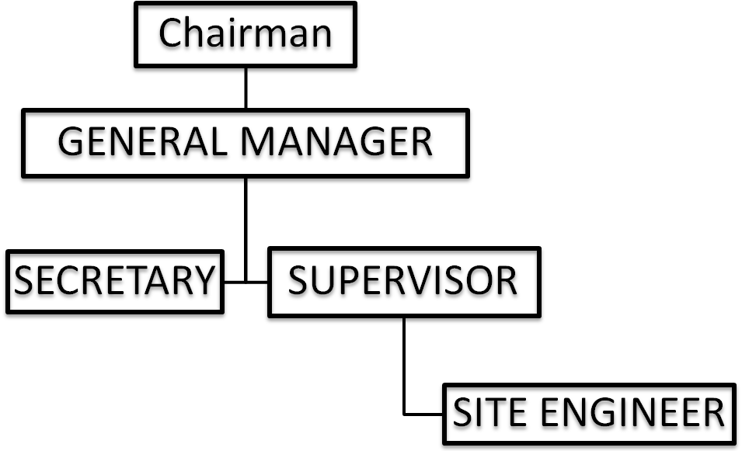
CHAPTER THREE
3.0 STUDENT SPECIFIC INVOLVEMENT AT THE VARIOUS SECTIONS
Student respect to this ITF programme. I have acquired more knowledge and view on the diverse engineering fields. I have also learnt more about the practical application of engineering to our everyday life.
The specific involvement in the various sections of the programme is to enable technological student of higher learnt theoretically at school and put it into practical use, which brighten their knowledge.
Here are the various experience that are derive from my place of assignment at Adebayo metal Works.
3.1 WELDING
Welding is a metal joining process in which coalescence is obtained by heat and (or pressure). It may also be defined as metallurgical bound accomplished by the attracting force between atoms. Before this atoms can be bounded together absorbed vapours and oxide on contacting surfaces must be overcome.
Temperature is added to pressure, the welding of two surfaces will be facilitated and the two metals are united. As temperature is increase the ductility of the base metal is increased and atomic diffusion progress move rapidly.
In any form of welding strengthen ofthe joint is improved by cleanliness of the surface to be welded. Surface oxide should be removed as they tend to become entrapped in the solidifying metal. In electric arc welding which I specialized, flux is coated on the electrode although there are other joining process like forged welding, soldering, resistance welding and gas welding.
3.2 ELECTRIC ARC WELDING
Electric Arc Welding is a process in which fusion is obtained by heat produced from electric arc between the work and an electrode. The electrode or filler metal is heated to liquid state and deposited into the joint to make the weld. Contact is the first method between the electrode and the work to create an electric circuit and then by separating the conductors slightly, an arc is formed. The electric energy is converted into intense heat in the arc, which attains a temperature around 5500⁰c.
There are two basic types of power source available for manual metal arc welding depending upon the type of electrical energy to be used. These are:
- AC transformer: is an alternative current is a current supply from main to a transformer.
- DC generator: is the direct current supply by a generator.
Either Direct or Alternative current can be used for arc welding. Direct current being preferred for mist purposes there should not be too great a current surge when the short circuit is made and the machine should compensate to some extent for varying length of arc. Direct current machines are built in capacities up to 1000amp having an open current voltage of 40 – 95 volts, while welding is going on the arc voltage is 18 – 40 volts in straight polarity the electrode is connected to the positive.
For ordinary welding, there is little different in the weld quality made by AC and DC equipment but polarity made great variation in the weld quality.
The AC machines consist principally of static transformers which arc simple pieces of equipment having no moving parts. There efficiency is high, their loss at no load is negligible and their maintenance and initial cost are low. The welding speed and the ease of welding DC and AC welders are comparatively the same however on heavy plate using large diameter rods since the polarity can be changed to the electrode.
3.3 STRIKING THE ARC
There are two different way to striking the arc. The first is by touching the working with the top of the electrode and raising it slightly to establish the arc. The second method is by scratching the tip of the electrode on the workpiece raise it slightly to establish the arc. The arc is maintained by uniformly moving the electrode towards the work at a rate that composite for that portion of it which has been molted and transferred to the weld. At the same time the electrode is generally move along the joint.
3.4 FUNCTION OF THE ELECTRODE COATING
Electrode coating with slagging or fluxing materials are particularly necessary in the welding of alloys and non-ferrous metal. Some of the elements in these alloys are not very stable and are lost if there is no protection against oxidation. Heavy coating also permits the use of large welding rods, higher current and greater welding speed. In summary the coating perform the following functions I arc welding:
- Provide a protection environment
- Facilitate overhead and position welding
- Stabilize the arc
- Add allowing element to the weld metal
- Reduce spatter of weld metal.
- Increase deposition efficiency
- Remove oxide and impurities
- Slow down the cooling rate of weld
- Influence the shape of the bead
- Perform metallurgical refining operation
3.5 TYPES OF ELECTRODE
- Copper electrode
- Milk steel electrode
- Stainless electrode
- Gold electrode

3.6 ELECTRODE GRADE
S/N | Diameter of Electrode (mm) | Grade | Current
1. | 2.0 | 14 | 55-70
2. | 2.50 | 12 | 40-90
3. | 3.00 | 10 | 80-130
4. | 4.00 | 8 | 120-130
5. | 5.00 | 6 | 150-260
6. | 6.00 | 4 | 190-350

3.7 ANCILLARY EQUIPMENT IN ARC WELDING
- Electrode holder -use to hold electrode and provide safe insulated handle for the welder
- Face shield and helmet-use to protect the eye effect of arc ray and heat
- Chipping hammer- use for removing slag and spatters
- Wire brush- use to remove small particles of slag remaining after deslagging

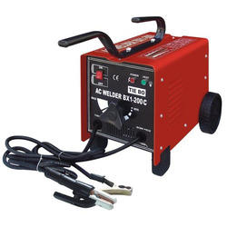
DIAGRAM OF TOOL USED IN THE WORKSHOP
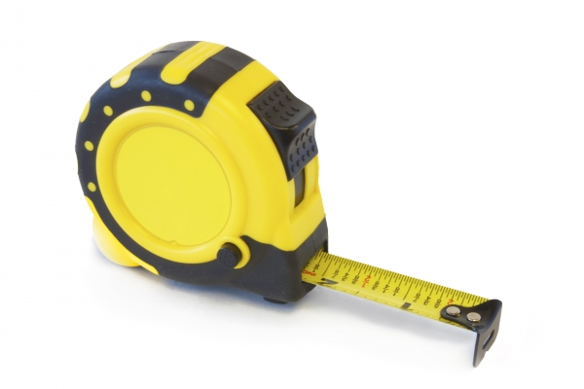
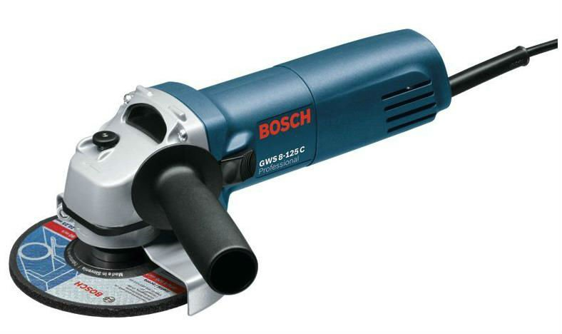
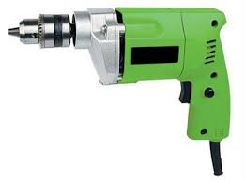
Steel Tape
Grinding Machine
Arc Welding Machine
Hand Drilling Machine
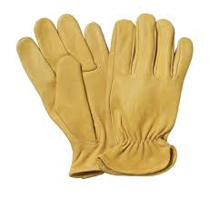
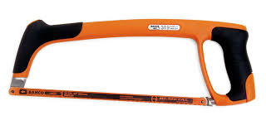
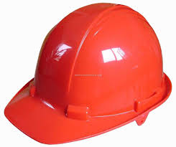
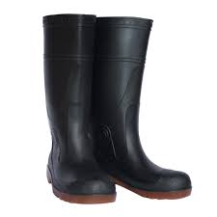

Hand Glove
Hack Saw

Safety Shoe

Helmet
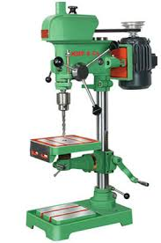
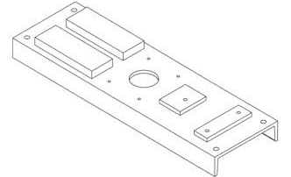
Drilling Machine
Base of Pumping Machine
CHAPTER FOUR
4.0 TOOLS FOUND IN METALLURGICAL WORKSHOP BOX
This are tools to be used when carrying out welding and manufacturing various operation or activities and maintenance of equipment in a workshop .
These are some tools and their functions
- Pliers: For gripping, cutting small flat and round workpiece and depressing of soft metal.
- Hacksaw: for metal cutting process
- Tin sips: For cutting metal, trimming inside curves and cylinders
- Hand files: For reducing and smoothing surfaces
- Centre punches: used for marking small indentation in the surface of metal for purpose of identifying location required for during work
- Veneer Caliper: used for measuring internal and external diameter of round object and thickness of a metal
- Veneer protractor: used for accurate measuring and marking out angles
- Dial Clock: used for rapidly checking of height, flatness and eccentricity of metal or object.
- Micrometer Gauge: used for measuring accurately round object or rod commonly small in size.
- Internal Caliper: is used for measuring inner diameter of round cylindrical pipe or gap between two wall of an object
- External Caliper: used for measuring external diameter of round cylinder pipe or thickness of work
- Engineer bevel: used for checking inclined face and marking out lines at given angles
- Mallet Hammer: for straighten a metal smoothly
- Spring Divider: used for marking arc or circle on work
- Tri Square: used for checking the squares to the other on a marking device or use as a guide to mark line parallel to square end or perpendicular to a straight edge
4.1 GENERAL RULES FOR SAFETY
- Always use the right tools for the right job and damaged tool should be repaired or do away with it.
- Appropriate workshop clothing should be worn with all loose part properly secured
- Loose clothing should not be worn to the workshop
- When preparing the pickle bath for cleaning copper and grinding metal, the acid must be added to water an not water to acid
- All injuries, no matter how slightly, should be reported immediately. Also breakages and all damaged to equipment should be reported.
- Always use protective goggle/shield in welding operations
- Always avoid oily floor to prevent slippery of the floor which may cause accident
- Strong leather boot is required in the workshop to prevent stepping on sharp or hot object
- Ensure proper illumination of the work environment for every operation to be properly visible.
- Always wear leather glove when handling sharp and hot metals and rubber glove when handling electrical installation or repairs
- Ventilation of work environment can be natural or artificial natural in the form of open walls like doors and windows or open roof. Artificial in form of electrical fans, air extractors of air condition.

4.2 MACHINE FOUND IN METALLURGICAL WORKSHOP
- Grinding machine- for grinding and smoothing weld part or spot
- Welding machine- for welding purpose of metal product
- Drilling machine – for making hole on material
- Bench shear – for cutting metal sheet
- Bending machine – for bending or folding metal sheet into a different shape and sizes
- Spirit level – for leveling machinery and also for setting up irregular work for marking out when some part of the work has to be horizontal
4.3 SAFETY RULES FOR MACHINE OPERATION
- A machine should never be set in motion until guards are securely in place
- Goggle should always be worn when using a grinding wheel machine for tool sharpening
- Only one person should operate the machine control
- Swarf should always be removed with a brush and never with the finger
- Work being machine should never be held in the finger but always secured in a chuck or vice or bolted to the drill table, face plate or angle plated
- When closing electric switched, use the insulated handle if available and avoid touching the metal part of the switch or switch box
4.4 PETROL STATION POLE CONSTRUCTION
Petrol Station Pole are made-up of carbon-steel iron which are so strong to withstand the structure at the top or roof, the sheet metal used is of guage of ranging 3mm to 6mm.
4.5 METHOD OF PROCESSING
- Measuring of the plane sheet metal usually 2 feet by 4 feet height.
- Cutting of the metal sheet into adequate denoted located on the sheet.
- Create a slightly curve at the 2 feet measured to each end for easy rolling on the ruling machine (manual)
- Rolling of the metal on the manual rolling machine
- Tightly the two end to give a corresponding little curves.
- Correcting of metal rolled if the edges if is not correspond or intact and at the same level by hammer.
- Spotting of the align or correspond part by welding and electrode of guage 14.
- Fill welding of the rolled metal.
- Joining of the finishing once, to make a longer once because usually it 16 to 24 feet in high.
- Grinding of the welding part for smoothing purpose.
- The output is usually 16.3 inches by 4ft height.
4.6 FOLDING OF PLANE METAL SHEET INTO SHAPE OF AN OVERHEAD TANK
Folding of plane metal sheet into the actual shape of an overhead tank before welding into desire size, it is an important and useful in the industry and other welfare organization because tank is used for storage of various thing usually in liquid form of state.
In generally, the two common uses of tank is to store water and petroleum product like kerosene petrol, diesel for either for sale or future purpose personally or collectively. Other hand there is a complex that has shape of tank used to store good in various depot too. Although they are serves different purpose but one similar thing in common is the shape.
4.7 ADVANTAGE OF STEEL TANK THAN RUBBER TANK
1. Good strength
2. Durability
3. It can withstand atmospheric attack
4. Long lifespan
5. Good ductility
6. It is very strong

4.8 METHOD OF PROCESSING
1. Measuring of the plane metal shoot depending on the customer and the purpose used for commonly the different size are:-
2 feet by 8 feet
4 feet by 8 feet
4 feet by 4 feet
4 feet by 2 feet
Usually the metal sheet gauging is from 2mm to 6mm.
2. Denoting the actual action either from the length or from the breath of the metal.
(A) Length
It will have many laps in a progressive form.
The measurement are 4”, 3”, 9”, 3”, 9”, 3”, 9”, 3”, 9”, 3”, 9”, 3”, 9”, 3”, 9”, 3”, 4” will be marked on the plane both surfaces.
(B) Breath
We measured and marked it differently from (A) we measured both surface.
Surface 1: 4”, 16”, 8”, 16”, 4”
Surface 2: 8”, 8”, 16”, 8”, 8”
3. Bending on the denoted plate on the bend machine that is been support will iron bar of 5mm

CHAPTER FIVE
CONCLUSION AND RECOMMENDATION
5.0 CONCLUSION
The Experience gained within the four months of the Student Industrial Work Experience Scheme (SIWES) programme remains one of the great challenges and experiences that impacted knowledge, skills and attitude in the field of Metallurgical and Material Engineering.
It has enhance my knowledge about the theoretical and practical through the industrial training period, I was able to achieve the objective of Students Industrial Work Experience Scheme (SIWES).
In fact, it really boosts my knowledge and made me to be courageous and confident in the field at Metallurgical, Mechanical, Electrical, and Material Engineering.
5.1 PERSONAL IMPRESSION ABOUT THEE ORGANIZATION
I was so much impressed about the organization because they expose the various section of their work concerning the same Metallurgical processes and welding.
And this practical knowledge acquired from the organization can also be useful for me in my field of study after leaving school. It can help student to know how to relate with workers and useful precaution for technical works and it improves the technological advancement.
5.2 THE POLYTECHNIC CONCERNING THE SIWES PROGRAMME
This programme (SIWES) was encouraged by Polytechnics, in other to improve the theoretical knowledge of the students and to enhance the practical knowledge of the student in their various field of study.
Also, the polytechnics want the improvement of all their students concerning the SIWES programme, so as to prove themselves comprehensively practically in the society.
5.3 RECOMMENDATION
Student Industrial Work Experience Scheme (SIWES) is a good programme for all student because it introduce student acquire relevant skill related to their field. So I wish the institution to continue this programme so that other student that are also coming for the training will also achieve a lot related to their field.

