

A TECHNICAL REPORT ON
STUDENT INDUSTRIAL WORK EXPERIENCE SCHEME (SIWES)

HELD AT

RADIO KWARA
THE KWARA STATE BROADCASTING CORPORATION, ILORIN.

BY

OKUNOLA MATTHEW OLUMIDE
MATRIC NO: ND/23/MAC/PT/0554

SUBMITTED TO
DEPARTMENT OF MASS COMMUNICATION,
INSTITUTE OF INFORMATION COMMUNICATION TECHNOLOGY (I.I.C.T)
KWARA STATE POLYTECHNIC, PMB 1375 ILORIN KWARA STATE

AUGUST – NOVEMBER, 2024.
DEDICATION
This report is dedicated to GOD ALMIGHTY for making everything easy for me throughout my Student Industrial Work Experience Scheme (SIWES) programme and to my parent Mr & Mrs OKUNOLA for their contribution to the success of this project. May Almighty GOD give you long life and prosperity (Amin).

ACKNOWLEDGEMENT
All praise, glory and honour to GOD ALMIGHTY, the author and the giver of wisdom, knowledge and understanding for the success of this programme.
I appreciate my parents which are my source to this world Mr & Mrs OKUNOLA for their parental and spiritual support because without their maximum understanding and support, this experience would have not come into existence including my brother and sister for their support.

PREFACE
The Student Industrial Work Experience Scheme (SIWES) is a National Diploma Curriculum of the Department of Mass Communication, Kwara State Polytechnic Ilorin. The programme was established by the Industrial Training Fund (ITF) in 1973 to 1974.
It is designed to acquire the student with life situation in industries as well as supplies in a more practical manner and their knowledge in practical activities and other practical field during their course of study.
CHAPTER ONE
INTRODUCTION
1.1 ABOUT SIWES
SIWES stands for acronym for Student Industrial Work Experience Scheme.
The Student Industrial Work-Experience Scheme (SIWES) is a planned and supervised training intervention based on stated and specific learning and career objectives, and geared towards developing the occupational competencies of the participants. It is a programme required to be undertaken by all students of tertiary institutions in Nigeria pursuing courses in “specialized engineering, technical, business, applied sciences and applied arts”. The federal government on 8th October 1971 established the industrial training (ITF) in order to acquaint the students on the industrial work method. The SIWES which is a subsidiary formed in 1973 was initiated to improve the students’ technical abilities to expose them to industrial culture thereby getting the acquainted with the role to play towards the technological advancement of the nation. It creates an avenue on environment in which the students are being exposed to areas of their various disciplines which enhances their mental and creative minds in the aspects of technology and development. It is therefore a practical aspect of the academic work, which students may not be opportune to carry out throughout their stay in the higher institution.
1.2 OBJECTIVES OF SIWES
Specifically, the objectives of the students’ industrial work experience scheme are to
- Prepare students for the work situation they are likely to meet after graduation.
- Provide an avenue for students in the Nigerian Universities to acquire industrial skills and experience in their course of study.
- Enlist and strengthen employers’ involvement in the entire educational process of preparing university graduates for employment in industry.
- Provide students with an opportunity to apply their theoretical knowledge in real work situation, thereby bridging the gap between university work and actual practices; and Expose students to work methods and techniques in handling equipment and machinery that may not be available in the universities.
1.3 IMPORTANCE OF SIWES
- It provides students with an opportunity to apply their theoretical knowledge in real life situations.
- It exposes students to more practical work methods and techniques.
- It strengthens links between the employers, universities and industrial training fund (ITF)
- It also prepares the students for the labour market after graduation.
CHAPTER TWO
INTRODUCTION
This study, as overview objectives of the SIWES and my experience after the completion of my training at Kwara State Broadcasting Corporation (Radio Kwara).
It expands basically the operation of broadcast media, most especially radio, its democratization and the challenges facing the private media in Nigeria.
HISTORICAL OF KWARA STATE BROADCASTING CORPORATION
The Kwara State Broadcasting Corporation, Ilorin, with broadcasting identification, Radio Kwara, started broadcasting service in Ilorin in 1995 as a relay station. It was then known as provincial Broadcasting house. The ¼ Kilowatt (KW) Medium Wave transmitter which has then used covered only about 8 Kilometer radius of Ilorin.
However, Kwara State Broadcasting Corporation as constituted today, formally came into being with the enactment of the Kwara Edict No 3 of 1979, but with retrospective effect from April 1st, 1978. This was one of the beneficial by product of the first state creation in Nigeria.
On the creation of the state in 1967, a master plan was drawn up and approved for the country as to the number and capacity of transmitter and mode of transmission to be sited in each location. Owing to the topography of Kwara State, it was decided that it should be covered with both medium and short wave transmitters.
In 1974, construction work started on the modern Studio/ Broadcasting House, the 10KW short wave, and 20KW medium wave transmitting station sites. These facilities were put in use from 19th December, 1976. However, following the directive of the Federal Government, the short wave transmitter was closed down in 1978.
On 1st April, 1978, in compliance with Federal Government’s directive which transferred all Radio Nigeria Station in the State to their respective host-states. The formal handling over of the Station by the NBC to the Kwara State Government was performed by Mr. Horation Agedeh of Federal Radio Corporation, Lagos on 15th September, 1978. All the existing Staff then was given option of either saying with the Corporation or going to the Federal Radio Corporation. Those who opted to stay were remained.
At the time of take-over by the State Government, this Station had a Broadcasting House situated at the present premises and transiting station located at Apata Yakuba, along Jebba Road, Ilorin. It then had two 10WK medium wave transmitters and 10KW short wave transmitter at then was working satisfactorily at the time of over in 1978.
In 1984, the Federal government boosted the transmitting capacity of Radio Kwara through the directive that transferred the Federal Radio Station in Ilorin to the Kwara State Government. The station then had two (2) 50KW medium wave transmitters at Budo Efo, with this development; the State Government approved the recommendation of the Corporation to install the four imported 10KW medium wave transmitters in the fringe areas of then Kwara State for effective coverage.
Two of them installed Egbe, one at Otite near Okene (both now in Kogi State) and the fourth at Koro in New Bussa (now in Niger State). All the three boosted stations were completed and commissioned.
In spite of the giant strides, in 1999 the transmitting station at Budo Efo witnessed a serious set-back when the 840 feet tower mast was truck and destroyed by thunder storm. This problem became a serious challenge to contend with; bearing in mind that the transmitting station had then become an integral part of Radio Kwara and a dependable ally in the performance of its statutory responsibility.
Effort to resuscitate the station between 2000 and 2002 resulted in the provision of a new tower mast and a 50KW Thomcast transmitter to restore normal transmission. In spite of the effort by Alhaji Mohammed Lawal’s Administration, the transmitter remained insufficient. However, the Government of Dr. Bukola Saraki, on assumption of office in May, 2003, set the ball rolling to renovate the station with award of contract for the provision of modern studio equipment and additional 50KW Harris transmitter for the transmission, totally over N300,000,000.
This singular development has made Radio Kwara not just one of the few Radio Stations with installed digital studios in Nigeria, but one of the first stations in Nigeria, to comply with the global directive on conversion from analogue broadcast to digital broadcast.
ORGANISATION STRUCTURE OF KSBC ILORIN AND ITS DEPARTMENT
Though Ministry of Information and Home Affairs is the Superintending Ministry of the Corporation, its function is to give Corporation directions of a great character or relating generally to particular matters (but not to any individual or case) with regard to the exercise by Corporation of its functions under the Edict, and it shall be the duty of the corporation to comply with such directions.
It should, however, be noted that the policy thrust of the station rests with the Board of Directors, the apex authority. The Board is to advise the Corporation (Management) on such matters arising under, on in execution of its function under the provision of the Edict and as provided for in existing circulars. It is also to approve such financial obligations or functions beyond the power of the management.
The General Manger who by the Edict of the corporation is member of the Board heads the Management. He is the Chief Executive Officer of the corporation, and responsible for the execution of the policy of the Corporation and its day-day business. He is by the provisions of the Edict, and service convention expected to be supported by a Corporation Secretary who shall be his Chief Adviser, and in charge of general administration, records and correspondence of the Corporation. He is also offer general advice to the Board and Management on statutory requirements and policy decisions of the Board; among others. Both are appointed by the Executive Governor, or as may be delegated in the case of the Corporation Secretary.
ORGANIZATIONAL CHART
GENERAL MANAGER
Director of New
& Current Affairs
Corporation Secretary
Director of Programmes
Chief Administrative Officer
Siwes Trainee
Programme Manager
Finance Controller
Engineering Manager
Marketing Manager
Auditor

ORGANIZATION CHART
DIRECTOR
NEW CURRENT AFFAIRS
CONTROLLER NEWS

CONTROLLER CURRENT AFFAIRS

PRINCIPAL REPORTER
PRINCIPAL EDITOR
PRINCIPAL CURRENT AFFAIR
SENIOR REPORTER
SENIOR
SENIOR CURRENT AFFAIR OFFICER
REPORTER
EDITOR
CURRENT AFFAIR OFFICER

`

VARIOUS DEPARTMENTS IN THE CORPORATION
Kwara State Broadcasting Corporation (Radio Kwara) has various departments through which it operates it day-to-day broadcasting activities.
The corporation is divided into six broad departments, where it carryout the smooth running of its programmes and coordinating all its activities. The available departments are;
- News & Current Affairs Department
- Administrative Department
- News and Current Affairs Department
- Programme Department
- Engineering Department
- Finance and Marketing department

1. NEWS & CURRENT AFFAIRS DEPARTMENT
This is an important department in the broadcasting organization that solely responsible for the day-to-day preparation of news story report, information and current affairs for the public audience.
In Radio Kwara Ilorin, this department is headed by a director and it is divided into two units viz: News unit and Current affairs unit.
- News Unit
This is the unit that solely responsible for the daily preparation of news, commentaries and broadcast it to the heterogeneous audience. They are in charge of news production and it comprise different staffs among whom the editors, reporter, proof reader, re-writers, desk-editor, news-caster and those that will align the news bulletin (from local to foreign), compu-graphist, typist, etc and it is being held by an Editor-in-Chief.
- Current Affairs Unit
This is the unit that specializes on current affairs programmes such as political talk, sport review, public enlightenment, environmental, highlight etc some of this programme are not live programme, they were recorded and played later, some of which guest were invited. After such recording, the programme is then edited by expert and producer before broadcasting.
The main objectives of this unit are to enlighten the audience more on the various issues of interest currently happening in the society.

2. PROGRAMME DEPARTMENT
This department consists of seasoned broadcasters, producers and presenters of high standard of productions. It is been divided into four different units viz: Audio Unit, Presentation Unit, Entertainment and Public enlightenment units.
- Audio Unit
This consists of Audio console operators, audio assistants, technicians, transmission directors and DJ’s who operates the audio-console and help in the smooth operation of the station programmes, either by laying jingles, public and personal paid announcement (PPA), commercial and adverts, recorded programmes, music etc. at the appropriate times and they also involved in the opening and closing of the station transmission at the end of the day programme in midnight. They usually operate and work in shifts.
- Presentation Units
This is the units that consists different skilled and seasoned presenters, announcers etc. that works in shifts.
They presented programmes, announcement etc
- Entertainment Units
This is the unit of notable entertainers, presenters, showbiz etc who organized and present entertainment programmes where music are played and sometimes audience can call in to make shout-out or greet their families and associates.
- Public Enlightenment Unit
This is the unit where public enlightenment and information where passed across to the audience by some skillful presenter and researchers who talk and discuss basically on public events and information an incident occurs in our societies to enlighten the audience.
3. MARKETING AND COMMERCIAL DEPARTMENT
As the soul of every organization, marketing and commercial department in Radio Kwara, Ilorin is the department where most of the station revenue is been generated through the selling of airtime on radio, receiving adverts and commercial etc.
4. RESEARCH PLANNING LOGIC AND STATISTIC DEPARTMENT
This is department that is in charge of the station statistical plans, logic and research projects. It stands responsible for the documentation and presentation of modern and digital information materials such as Audio Compact Disc (CD) both empty and recorded, cassettes, records, newspaper, journal, magazines etc.
The department also provides a standard internet service for the station especially in the studio and newsrooms where the presenters and reporter can browse through to grab recent information needed for smooth running and delivering of standard programme on radio.
5. ENGINEERING DEPARTMENT
This is another important department that consists of the station and studio engineer, installation engineering, technicians etc whose responsibility is to provide better services to the station machineries, maintain and repair the station equipment’s. The department stands to put all the equipment in good conditions for smooth and excellent transmission of the station.
Engineers in works in shift and their services round the clock rectify all fault discovered on any machineries needed for transmission and broadcasting. It is been divided into sub-unit of transmission, generating house, Radio workshop, Automobile and Air Conditioning Workshop units among others, each unit is head by a supervisor.
6. ADMINISTRATIVE DEPARTMENT
This is a newly created formed department that involves in organizing training for staffs, interview for new applicants and employees, conduct and recommends staffs for promotions, etc as well as perform corporate services.
It is also deals in maintaining standard welfare and well-being of the station managements and staffs. They works inter-dependent.
CHAPTER THREE
Radio
Radio is the radiation (wireless transmission) of electromagnetic energy through space. The biggest use of radio waves is to carry information, such as sound, by systematically changing (modulating) some property of the radiated waves, such as their amplitude, frequency, phase, or pulse width. When radio waves strike an electrical conductor, the oscillating fields induce an alternating current in the conductor.
A radio receiver receives its input from an antenna and converts it into a form usable for the consumer, such as sound, pictures, digital data, measurement values, navigational positions, etc. Radio frequencies occupy the range from a 3 kHz to 300 GHz, although commercially important uses of radio use only a small part of this spectrum.
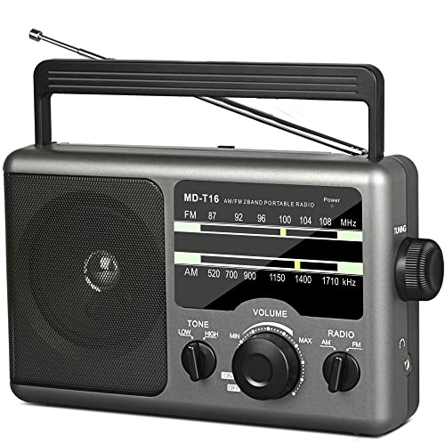
A radio communication system sends signals by radio. The radio equipment involved in communication systems includes a transmitter and a receiver, each having an antenna and appropriate terminal equipment such as a microphone at the transmitter and a loudspeaker at the receiver in the case of a voice-communication system.

Computer with an Automation Software.
This computer system makes it possible to play background music and commercials.
The software is called Automation Software or “Playout”, and it is designed to continually play music in the background.
The heart of these programs is the Playlist – which is a list with all the audio files that need to be played.
Most of the time these programs contain hotkeys, a music database, and a lot more.
They are computer programs especially designed to allow continuous audio playback, with exceptional granular control for Announcers and Programme Directors.
Most automation systems also contain a Music Database, Hot Keys (to play ad-hoc audio), an Audio Editor, a Segue Editor (to change the mix between the different elements), Interfaces for Website and RDS data, and a lot more.

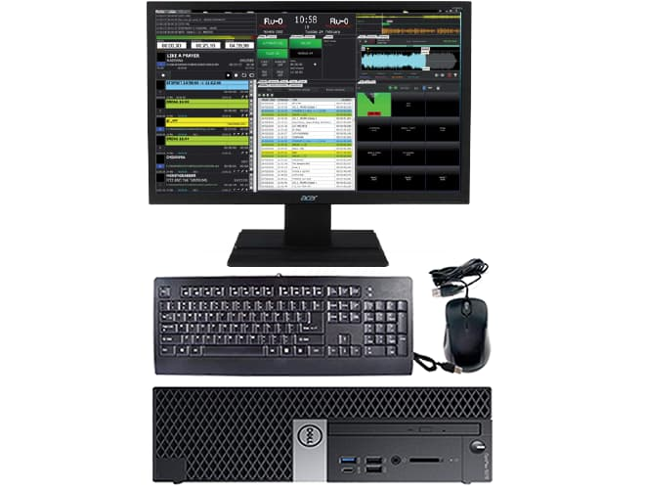

Processes
Radio communication. Information such as sound is converted by a transducer such as a microphone to an electrical signal, which modulates a radio wave sent from a transmitter. Radio systems used for communication have the following elements. With more than 100 years of development, each process is implemented by a wide range of methods, specialized for different communications purposes.
Transmitter and modulation
Each system contains a transmitter; this consists of a source of electrical energy, producing alternating current of a desired frequency of oscillation. The transmitter contains a system to modulate (change) some property of the energy produced to impress a signal on it. This modulation might be as simple as turning the energy on and off, or altering more subtle properties such as amplitude, frequency, phase, or combinations of these properties.
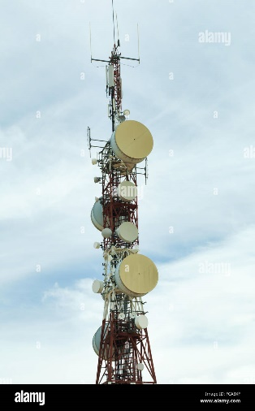
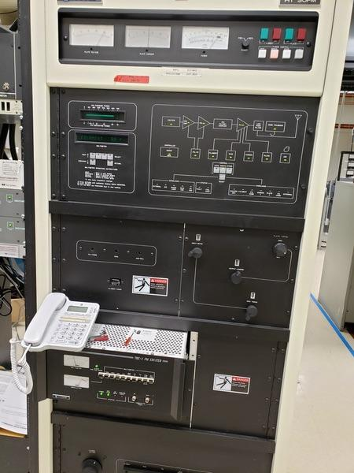

An audio signal (top) may be carried by an AM or FM radio wave.
Amplitude modulation of a carrier wave works by varying the strength of the transmitted signal in proportion to the information being sent. For example, changes in the signal strength can be used to reflect the sounds to be reproduced by a speaker, or to specify the light intensity of television pixels. It was the method used for the first audio radio transmissions, and remains in use today. "AM" is often used to refer to the medium wave broadcast band (AM radio), but it is used in various radiotelephone services such as the Citizen Band, amateur radio and especially in aviation, due to its ability to be received under very weak signal conditions and its immunity to capture effect, allowing more than one signal to be heard simultaneously.

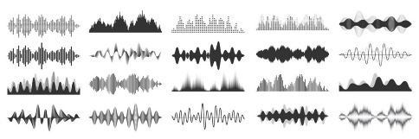
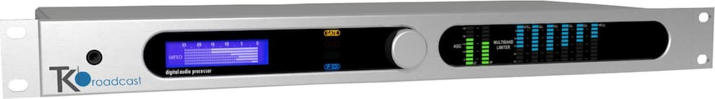

Frequency modulation varies the frequency of the carrier. The instantaneous frequency of the carrier is directly proportional to the instantaneous value of the input signal. FM has the "capture effect" whereby a receiver only receives the strongest signal, even when others are present. Digital data can be sent by shifting the carrier's frequency among a set of discrete values, a technique known as frequency-shift keying. FM is commonly used at Very high frequency (VHF) radio frequencies for high-fidelity broadcasts of music and speech (see FM broadcasting).

Analog TV sound is also broadcast using FM.
Angle modulation alters the instantaneous phase of the carrier wave to transmit a signal. It may be either FM or phase modulation (PM).
Antenna.
Rooftop television antennas. Yagi-Uda antennas like these six are widely used at VHF and UHF frequencies.
An antenna (or aerial) is an electrical device which converts electric currents into radio waves, and vice versa. It is usually used with a radio transmitter or radio receiver. In transmission, a radio transmitter supplies an electric current oscillating at radio frequency (i.e. high frequency AC) to the antenna's terminals, and the antenna radiates the energy from the current as electromagnetic waves (radio waves).

Propagation
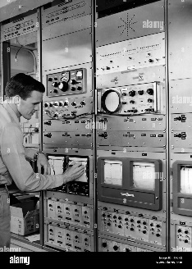
Once generated, electromagnetic waves travel through space either directly, or have their path altered by reflection, refraction or diffraction. The intensity of the waves diminishes due to geometric dispersion (the inverse-square law); some energy may also be absorbed by the intervening medium in some cases. Noise will generally alter the desired signal; this electromagnetic interference comes from natural sources, as well as from artificial sources such as other transmitters and accidental radiators.

Resonance
Electrical resonance of tuned circuits in radios allow individual stations to be selected. A resonant circuit will respond strongly to a particular frequency, and much less so to differing frequencies. This allows the radio receiver to discriminate between multiple signals differing in frequency.
Receiver and demodulation
A crystal receiver, consisting of an antenna, adjustable electromagnetic coil, crystal rectifier, capacitor, headphones and ground connection.
The electromagnetic wave is intercepted by a tuned receiving antenna; this structure captures some of the energy of the wave and returns it to the form of oscillating electrical currents. At the receiver, these currents are demodulated, which is conversion to a usable signal form by a detector sub-system. The receiver is "tuned" to respond preferentially to the desired signals, and reject undesired signals.
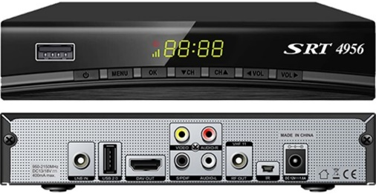
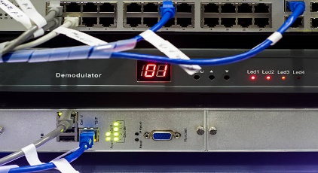

Early radio systems relied entirely on the energy collected by an antenna to produce signals for the operator. Radio became more useful after the invention of electronic devices such as the vacuum tube and later the transistor, which made it possible to amplify weak signals. Today radio systems are used for applications from walkie-talkie children's toys to the control of space vehicles, as well as for broadcasting, and many other applications.
A radio receiver receives its input from an antenna, uses electronic filters to separate a wanted radio signal from all other signals picked up by this antenna, amplifies it to a level suitable for further processing, and finally converts through demodulation and decoding the signal into a form usable for the consumer, such as sound, pictures, digital data, measurement values, navigational positions, etc.

Radio band

Light comparison
Name | Frequency
Gamma ray | > 30 EHz (0.01 nm) | 124 keV - 300+ GeV
X-Ray | 30 EHz - 30 PHz (0.01 nm - 10 nm) | 124 eV to 120 keV
Ultraviolet | 30 PHz - 750 THz (10 nm - 400 nm) | 3.1 eV to 124 eV
Visible | 750 THz - 428.5 THz (400 nm - 700 nm) | 1.7 eV - 3.1 eV
Infrared | 428.5 THz - 300 GHz (700 nm - 1 mm) | 1.24 meV - 1.7 eV
Microwave | 300 GHz - 300 MHz (1 mm - 1 m) | 1.24 µeV - 1.24 meV
Radio | 300 MHz - 3 kHz (1 m - 100 km) | 12.4 feV - 1.24 meV

Radio frequencies occupy the range from a 3 kHz to 300 GHz, although commercially important uses of radio use only a small part of this spectrum. Other types of electromagnetic radiation, with frequencies above the RF range, are infrared, visible light, ultraviolet, X-rays and gamma rays. Since the energy of an individual photon of radio frequency is too low to remove an electron from an atom, radio waves are classified as non-ionizing radiation.
Communication systems
A radio communication system sends signals by radio. Types of radio communication systems deployed depend on technology, standards, regulations, radio spectrum allocation, user requirements, service positioning, and investment.
The radio equipment involved in communication systems includes a transmitter and a receiver, each having an antenna and appropriate terminal equipment such as a microphone at the transmitter and a loudspeaker at the receiver in the case of a voice-communication system.
The power consumed in a transmitting station varies depending on the distance of communication and the transmission conditions. The power received at the receiving station is usually only a tiny fraction of the transmitter's output, since communication depends on receiving the information, not the energy, which was transmitted.
Classical radio communications systems use frequency-division multiplexing (FDM) as a strategy to split up and share the available radio-frequency bandwidth for use by different parties communications concurrently.
Coverage
There are several factors influencing the coverage area:
- Location of the transmitter in relation to the desired coverage area
- Type and ‘pattern’ of the transmitting aerial
- Height of the transmitting aerial
- Power of the transmitter (and this is regulated in most countries)
- Terrain (how hilly is the area to be covered).
Transmitters
Transmitters are available with powers of a few Watts to several thousand Watts. A 50W transmitter may cover a small village or town (if the aerial is high enough), whereas to cover a large city may require 5kW.
When selecting a transmitter the following parameters should be considered:
- Efficiency (there is no point paying for power which does not go into the aerial)
- Robustness (a modular design makes sense – a single failure will not render the whole unit inoperative)
- Remote control and diagnostics (often transmitters are sited in remote locations, difficult to get to)

CHAPTER FIVE
5.1 CONCLUSION
Simply with the above aforementioned events I’ve undergone in the Kwara State Broadcasting Corporation (KSBC) popularly identified as Radio Kwara in Ilorin during my training, I surely known and belief that you will reasoned with me that I’ve acquired all necessary practical and professional skill I needed to proceed in my study under this profession; contrary to the theoretical knowledge I took down to the training ground in the last four months before my trainee.
The training have exposed me to many practical areas of my profession, it is a worthwhile experience in life.
5.2 RECOMMENDATIONS
Though the corporation serves the audience satisfactorily in the area of modern infotainment broadcasting and educational development in our society through all its programmes and news delivery. I hereby recommend that the organization (KSBC) need to improve in employing skill and trained journalists, reporters and broadcasters that will assist the station news-gathering and presentation team to the better expectation of the audience/listeners.
5.3 EXPERIENCE AND OBSERVATION
Life experience is going on till the end of human life. An adage says “the more you leave the more you learn” when I started my media attachment at kwara state broadcasting corporation (radio kwara) Ilorin, I gain enormous experience
I observed how to interview people of dignitaries in political leaders, business man etc editorial in different newspaper (tribune, punch, herald e.t.c). I also visited the studio of the station and I realize how programme and news were been broadcast.
Finally, I gained the experience of house styles of Kwara state broadcasting corporation (Radio Kwara) Ilorin during my SIWES (IT Programmed)

