
TECHNICAL REPORT
ON
STUDENTS INDUSTRIAL WORKS EXPERIENCE SCHEMES
(SIWES)
HELD AT
AYEDUN FARM,
KM. 4, AYEDUN CLOSE, GASLINE SANGO OTA, OGUN STATE.
BY:
LATEEF RASHIDAT ASHANI
ND/23/PAD/FT/0037
SUBMITTED TO:
DEPARTMENT OF PUB LIC ADMINISTRATION,
INSTITUTE OF FINANCE AND MANAGEMENT STUDIES (IFMS), KWARA STATE POLYTECHNIC, KWARA STATE.
IN PARTIAL FULFILMENT OF THE REQUIREMENTS FOR THE AWARD OF NATIONAL DIPLOMA (ND) IN PUB LIC ADMINISTRATION, KWARA STATE POLYTECHNIC ILORIN, NIGERIA.

AUGUST — DECEMBER, 2024.

DEDICATION
DEDICATION
I dedicate this project to God Almighty my creator, my strong pillar, my source of inspiration,
wisdom, knowledge and understanding. He has been the source of my strength throughout this
program and on His wings only have I soared.
I also dedicate this to my parents and my loving sister who encouraged me all the way and whose
encouragement have made sure that I give it all it takes to finish that which I have started. May
the blessing of God be with them now and always “AmenDEDICATION
I dedicate this project to God Almighty my creator, my strong pillar, my source of inspiration, wisdom, knowledge and understanding. God has been the source of my strength throughout this program and on His wings only have I soared. I also dedicate this work to my parents who has encouraged me all the way and whose encouragement has made sure that I give it all it takes to finish that which I have started.

ACKNOWLEDGEMENT
This SIWES work has been a great journey for me and has helped me to understand an area of work that is vast and wonderful. It has been completed with months of hard work and dedication and would not have been possible if not for the blessing and guidance I have received from a number of people. For this I am particularly indebted to all staffs of Public Administration Department of Kwara Poly who had earlier thought me all the basics involved with workshop practice. Also, I appreciate the rigorous training and teaching from the company.

CHAPTER ONE
- INTRODUCTION
The student industrial works experience scheme (SIWES) was established by the industrial training fund (I.T.F) in 1973 and control by the national board for technical education (NBTE). The aims and objectives is to develop student skill and to expose students in the school of engineering, technology, environment, science and agriculture and medical science to the working experience in which they will found themselves in future.
It is integral part of degree and National Diploma programme institute of higher learning in Nigeria. This privilege programme would definitely broaden student chance of learning and would empower his/her academic efficiency.
During my four months Industrial Working Experience Scheme (SIWES) at Federal Ministry of Agricultural and Rural Development, the usefulness of maintenance in Tractor was proved and lot of experience was gained.
1.1 DEFINITION OF SIWES
Student industrial Working Experience (SIWES) is a skill acquisition training programme set up by the Federal and State government across the Nation in collaboration with the body known as Industrial Training Fund (I.T.F) for student to have a working experience and a feel of what it takes to be genius in one discipline before challenges ahead.

1.2 FUNCTION OF SIWES UNIT
By the directive of National Universities Commission (NUC) and IndustrialTraining Fund (ITF), the Unit is mandated to carry out the following functions.
i. Supervision of the students placed in the industries located within our ITFzone.
ii. Processing of students’ logbooks, ITF forms and industrial
attachment reports upon which is based on the Federal Government funding of supervision and
students’ allowances.
iii. Fostering of close links between the university and industries participating inSIWES programme.
iv.Provision of advisory guidance to participating students on careeremployment opportunities.
v. Monitoring of compliance with the requirements of SIWES on the part ofstudents in eligible disciplines as a condition for graduation.
1.3 AIMS AND OBJECTIVES OF SIWES
1. It exposes the prepare students of higher institution for the industrial working situation they can likely to meet in the future.
2. It enables student to apply what they have learn theoretically in class into practice in the real world.
3. It makes student to understand the technical implication of their profession.
4. It helps student to express their initiatives, competence and standard in task they have chosen.
5. It enable student to be technically and morally oriented
6. It helps to make transition from school to the working environment easier and to enhance students contact for later job placement.

CHAPTER TWO
- HISTORICAL BACKGROUND OF THE ORGANIZATION ATTACHMENT
My SIWES site, AYEDUN FARM, started in the year 1999 before it was purchased by the current managing director, Chief E.F. Ogunnaike in the year 2002 with about 3,000 layers.
Presently, the farm had increased tremendously and there are many sections in the farm. Operations like, poultry, hatchery, feedmill, piggery, ruminants, fishery, sales/marketing of Agricultural products and health care/services.
2.1 Geographical Location
AYEDUN FARM has her headquarter situated at KM. 4,Ayedun Close, Gasline Sango Ota, Ogun State.
MANAGING DIRECTOR

HEAD DOCTOR
ADMINISTRATIVE/ACCOUNT MANAGER
FARM MANAGER

VETERINARY DOCTORS
AUDITOR
UNITS SUPERVISORS

VETERINARY ASSISTANTS
UNITS ATTENDANTS

SALES CLERKS
SECURITY MEN
DRIVERS
CASHIERS

Figure 1.1 Organizational chart of Ayedun Farm.
2.2 Infrastructural Facilities on the Farm
There were several infrastructural facilities at AYEDUN FARM. These are; Farm building, administrative block, Poultry pens, Hatchery building, Pig pens, Fish ponds, Feed mill house, Stores, Generating plants, Lorries, Cars, Trucks, Vulcanizing machines, Pumping machines, Tankers e.t.c.
2.3 Sections on the site
The following are the different sections on the farm
- HATCHERY
- POULTRY
- FEED MILL

Hatchery Department
A Hatchery is a special building where fertile or hatchable eggs can be hatched into day old chicks.
Operations at Hatchery
- Collection of eggs from breeders’ farm.
- Eggs storage
- Selection and traying of Eggs
- Fumigation
- Incubation
- Eggs candling and transfer
- Chicks sorting, handling and boxing
- Chicks vaccination
- Cleaning and disinfection after hatching

CHAPTER THREE

3.0 WORK DONE AND EXPERIENCE GAINED

3.1 Collection of eggs from Breeders’ Farm
At AYEDUN FARM, the hatchable eggs were gotten from the breeders’ farm, from customers in other farms and sometimes imported hatchable eggs.
Eggs were transported in clean, disinfected and covered vehicle because hatchable eggs should not be exposed to direct sunlight, wind and dust during transportation.
Eggs were set carefully in clean egg trays and stacked together in egg case.

Eggs Storage
Eggs brought from the breeders’ farm were stored in egg storage room till the setting day. Because the number of eggs needed may not be attained at times. At AYEDUN FARM, eggs were usually set and hatched twice weekly (Monday and Wednesday) and Eggs were stored for maximum of five days at temperature of 18ºC.

Sorting and Traying of Eggs
Traying means setting of the eggs on incubator trays while handling involves sorting and setting of the eggs. When eggs were set on incubator trays, they were sorted to pick out suitable eggs for hatching and bad eggs were separated, because bad eggs will not hatch or may hatch to disabled chicks.

Factors considered when setting eggs
- Crack eggs and dirty eggs were avoided
- Extra large or extra small eggs were avoided (weight of a hatchable eggs is between 45-65g)
- The pointed ends of the eggs were faced vertically downward.
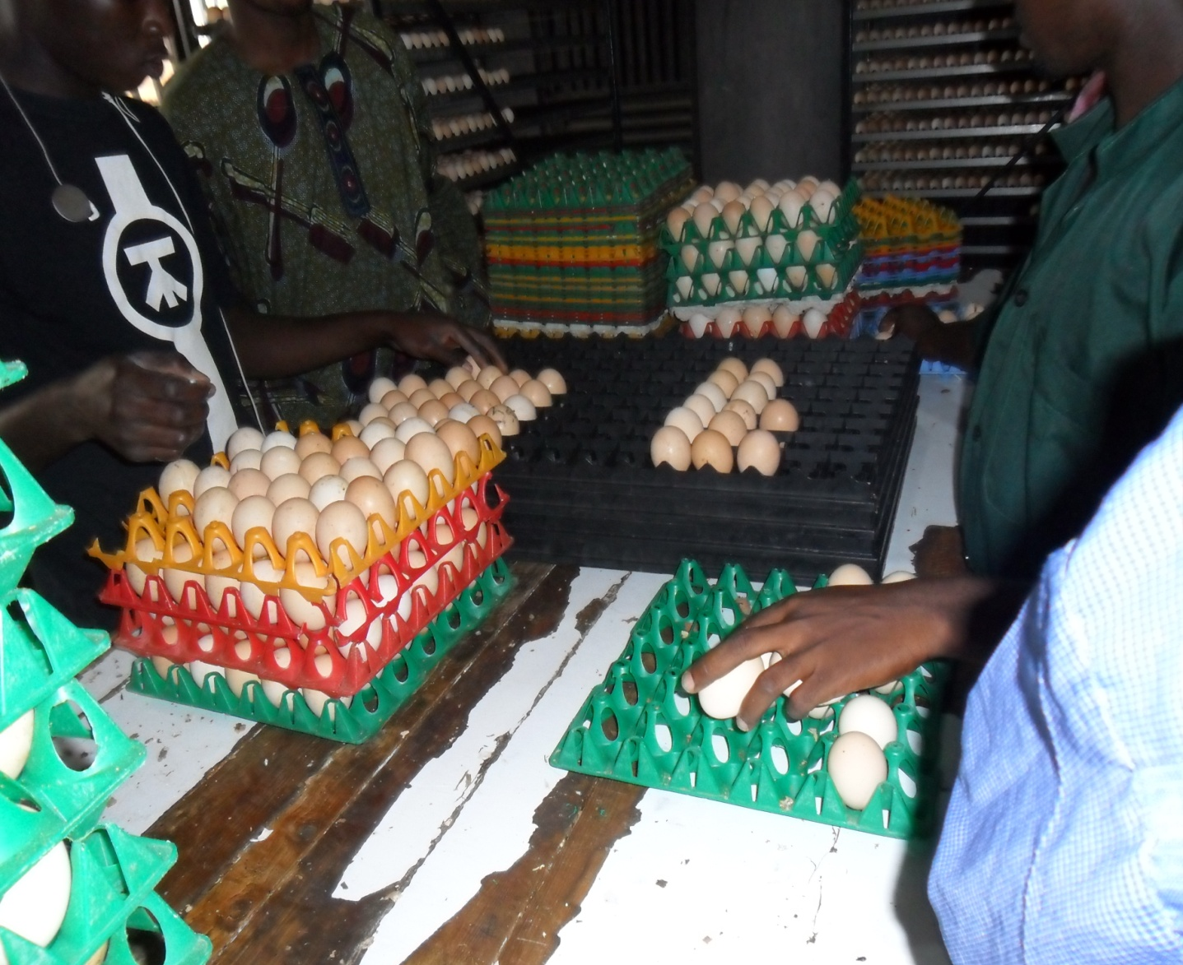
Figure 2.1 Setting of Eggs on Incubator Trays
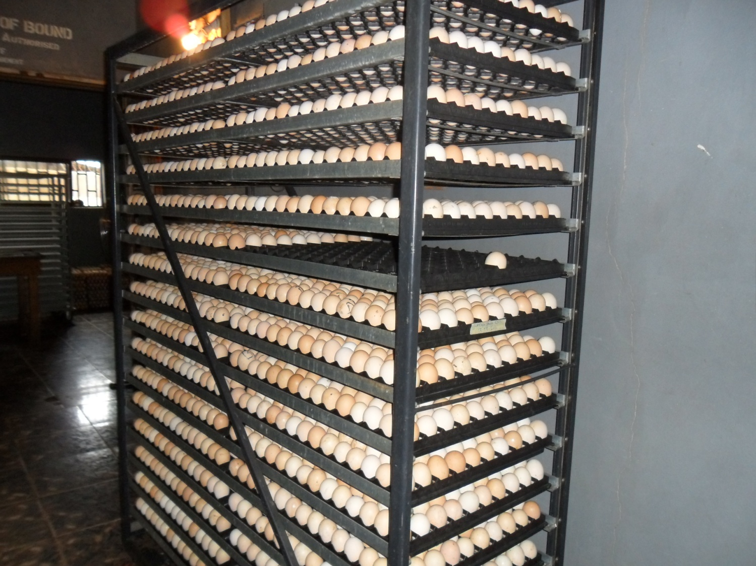
Figure 2.2 Eggs in an Incubator Trolley

3.2 Fumigation
Fumigation is the process through which pathogenic organisms on the eggs could be destroyed. The method of fumigation process that was used at Ayedun Farm was formalin solution and Potassium permanganate (KMnO₄).

Procedure for Fumigation at Ayedun Farm
- Hatchable eggs were clean with dry spongy (not iron spongy)
- Fumigation was done in the box after each collection
- 10g of potassium permanganate (KMnO₄) in 20ml of formalin solution for box of 4x8x4 feet cabinet for half an hour.
(This was not done in my presence but was given to me by the Hatchery manager Mr. Ademola).

3.3 Incubation
This is the artificial management practices of a fertile eggs to ensure that day old chicks are produced, these involves good temperature, better humidity, normal ventilation, good turning of eggs and quality of the hatching eggs. The machine used for these is called INCUBATOR.
There were two (2) types of INCUBATOR at AYEDUN FARM; these are Belgium type (Peterson) and USA type (Chick master).

Incubator Description

BELGIUM TYPE (PETERSON)
- The incubator is from Belgium
- It is a large Size incubator of 57,600 chicken egg setting capacity. It has a setter of 12 trolleys, 32 trays and 150 eggs in a tray.
- The egg chamber is a section type
- It is force draught with automatic egg turning device and hot air heat transfer
U.S.A TYPE (CHICKS MASTER)
- The incubator is from U.S.A
- It is mammon incubator of 101,400 chicken egg setting capacity. It has 2 setters of 50,700 eggs per each and 307 trays of 165 eggs in a tray.
- The egg chamber is a section type
- It is force draught with automatic egg turning device and hot air heat transfer

Candling and Transfer
This is the process by which a clear cut distinction is made between fertile and unfertile eggs i.e. it helps to determine the fertility of the incubated hatchable eggs. Candling was done at 18th day of incubation at AYEDUN FARM.

Processes of Candling
Eggs were subjected to direct beams of light. The fertile eggs will be opaque but the unfertile eggs will give colour like yellow e.t.c.

Egg transfer
The fertile eggs after candling were transferred into the hatcher at 18th day for the completion of the incubation for 72 hours (3 days).

Chicks Handling, Sorting and Boxing
Handling: After hatching, Chicks were handled with care to prevent injury and death of the chicks because improper handling will cause stress on the chicks.
Sorting: Chicks were removed from the midst of broken egg shells within the hatching trays, after which they were sorted to remove the undesirable ones and to grade the good ones. The undesirable ones were usually the runts, deformed chicks, very weak chicks, chicks with unhealed navel and dead chicks.
Boxing: After sorting, chicks were parked carefully into chick boxes. The chick boxes used at AYEDUN FARM, were paper type which is partitioned into two compartments, each compartment usually accommodates 25 chicks, all together making 50 chicks in a box.

Chicks Vaccination
After boxing, vaccinations of chicks were done and this was carried out by the veterinary doctors. The chicks were usually been vaccinated against Mareks and Newcastle diseases at day old. Mareks diseases vaccines were usually administered subcutaneously with the use of automatic syringe. The Newcastle disease vaccine (NDV La Sota) was usually administered intra-ocularly or intra-nasally with droppers.

Cleaning and Disinfection after Hatching
The hatcher, hatching trays and egg trolleys were usually been washed properly with detergent and disinfectant after each hatch. The equipment were allowed to dry and they were been fumigated.
Routine Management Practices in Hatchery
- Sweeping of the floor of hatchery, making sure the environment is kept clean.
- Putting of disinfectant in the tyre dip and foot dip.
- Collection of eggs from breeders’ farm
- Storage and fumigation of eggs
- Setting and traying of eggs
- Checking and regulation of the readings on the incubator control panel, readings like; temperature, humidity and egg turning counter.
- Checking of the effectiveness of the incubator gadgets, which are, heating system, cooling system, incubator fan, humidity bowl, ventilator, red light and alarm.
- Check and remove blown up, cracked or fallen eggs on the floor of the incubator.
- Candling and transfer of eggs at 18th day of incubation
- Washing and disinfecting of incubator equipment like; egg trays, egg trolleys, hatching trays after each hatch.
- Fumigate the hatcher and hatching room after each hatch.
- Packing, boxing and Vaccination of chicks.
- Servicing of incubator.

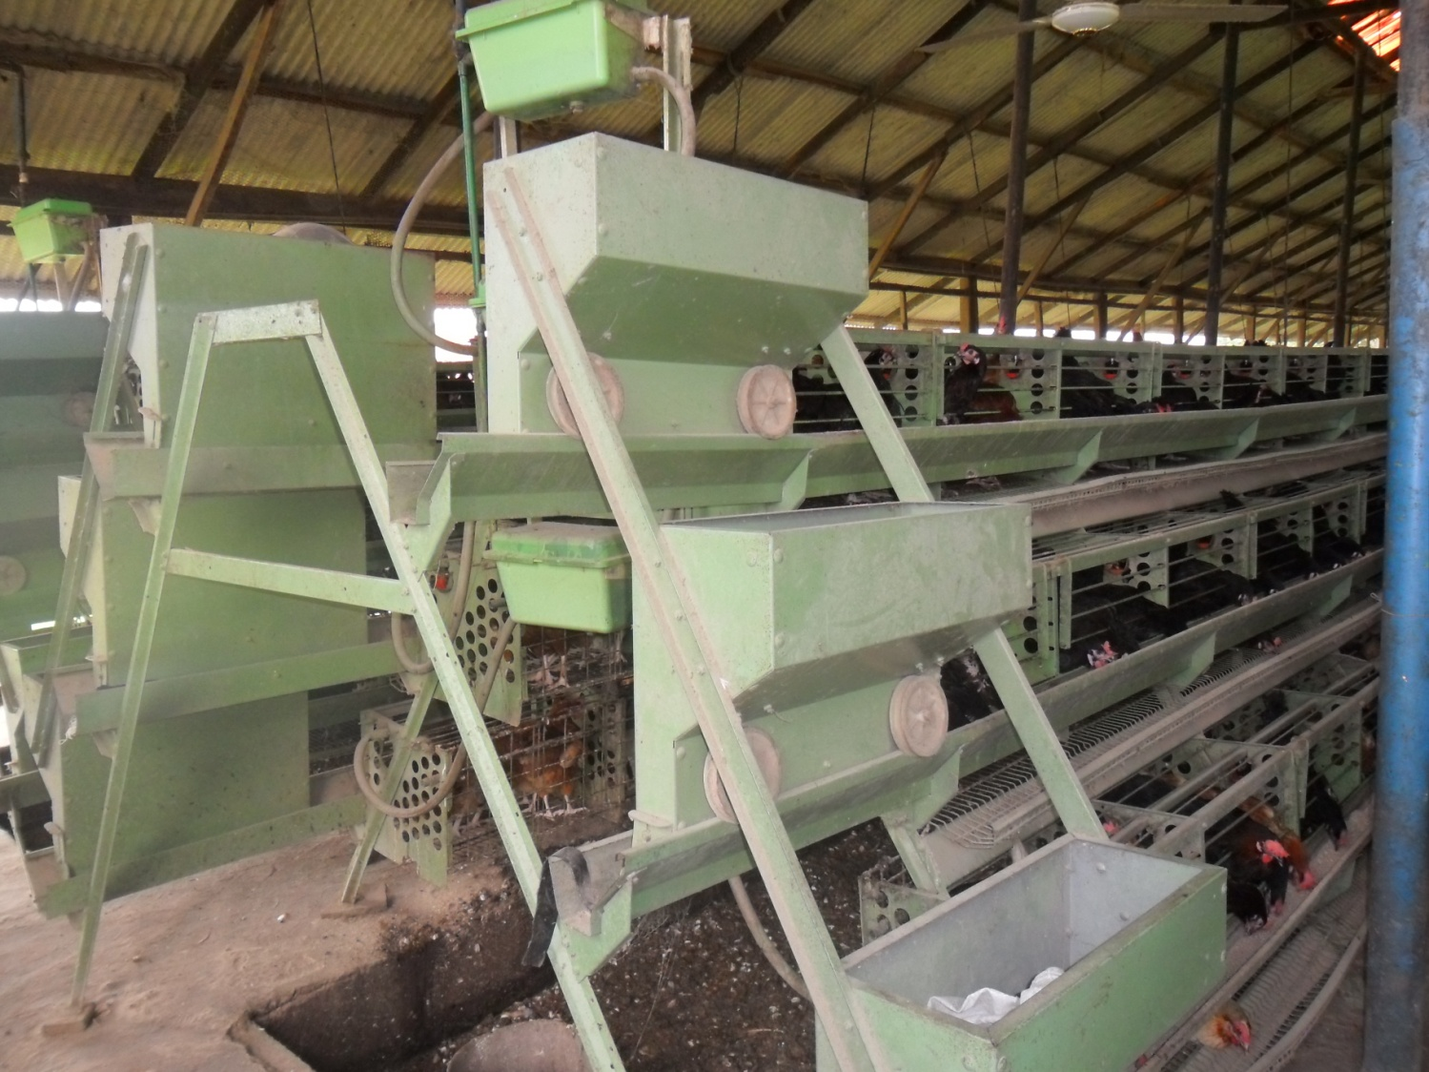
Figure 2.3 Laying Unit (3 Step battery cage with automatic feeder and drinker)

CHAPTER FOUR
4.0 RECOMMENDATION AND CONCLUSION
4.1 CHALLENGES ENCOUNTER
Despite the knowledge, experience and exposures acquires during this period. The following are some of the challenges encountered.
- Difficulty in findings a place for industrial training is a big problem for students on SIWES program.
- Another challenge is transport fare issues. After eventually getting a company for the SIWES program, to finance my transport fare to my place of work is a very difficult experience.
- The combination of the Industrial training together with the course work was so challenging and stressful.
4.2 RECOMMENDATION
I would recommend that the organization should appeal to the federal government to make provision for necessary equipment for the effectiveness of the programme.
I would recommend that the organization should provide transport facilities for SIWES students so as to ease their mobility.
4.3 CONCLUSION
The SIWES programe is an efficient an effective program which has bring much improvement to my field of study. I have gained a lot of experience from the various works done on field such as construction of sliding gate, solar street light and production of different set of burglary. It is a programe that bridges the gap between theory and practical aspect, so therefore it has made me to have technical knowledge about what I have learnt theoretically in class.
My four months SIWES program has equipped me the knowledge of fabrication and production of a project. I hereby appreciate the effort to the Federal Government and Industrial Training Fund (I.T.F) for improving the technological development of this country.

REFERENCE
www.google.com
www.wikipedia.com
My training log book

