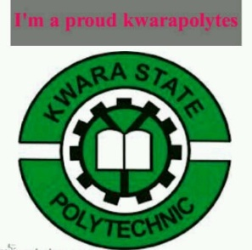

A TECHNICAL REPORT ON
STUDENT INDUSTRIAL WORK EXPERIENCE SCHEME (SIWES)

HELD AT
NIGERIAN TELEVISION AUTHORITY (NTA)
FATE ROAD, ILORIN KWARA STATE.

BY
ABDULRASAQ FATIMOH ONAOLAPO
MATRIC NO: ND/23/MAC/PT/0757

SUBMITTED TO
DEPARTMENT OF MASS COMMUNICATION,
INSTITUTE OF INFORMATION COMMUNICATION TECH. (I.I.C.T)
KWARA STATE POLYTECHNIC, PMB 1375 ILORIN KWARA STATE

AUGUST – NOVEMBER, 2024
DEDICATION
This report is dedicated to Almighty ALLAH for making everything easy for me throughout my Student Industrial Work Experience Scheme (SIWES) programme and to my parent Mr & Mrs ABDULRASAQ for their contribution to the success of this project. May Almighty God give you long life and prosperity (Amen)

ACKNOWLEDGEMENT
All praise, glory, honour and adoration to Almighty ALLAH, the author and the giver of wisdom, knowledge and understanding for the success of this programme.
I appreciate my parents which are my source to this world Mr & Mrs ABDULRASAQ for their parental and spiritual support because without their maximum understanding and support, this experience would have not come into existence including my brother and sister for their support.

PREFACE
The Student Industrial Work Experience Scheme (SIWES) is a National Diploma Curriculum of the Department of Mass Communication, Kwara State Polytechnic Ilorin.
The programme was established by the Industrial Training Fund (ITF) in 1973 to 1974.
It is designed to acquire the student with life situation in industries as well as supplies in a more practical manner and their knowledge in practical activities and other practical field during their course of study.

TABLE OF CONTENTS
Title Page i
Dedication ii
Acknowledgement iii
Preface iv
Table of Content v
CHAPTER ONE
1.0 INTRODUCTION
1.1 Background
1.2 Objectives of SIWES
CHAPTER TWO
2.0 HISTORY OF NIGERIAN TELEVISION AUTHORITY NTA ILORIN
2.1 Historical Background
2.3 Various Departments in NTA Ilorin
2.4 Mission and Objectives of Establishment
CHAPTER THREE
3.0 WORK EXPERIENCE
3.1 Introduction
3.1.1 Chains in TV production
3.2 Equipment’s Used at ATAR Communication
3.3 Structural Representation of Studio Signs
CHAPTER FOUR
4.0 RECOMMENDATION AND CONCLUSION
4.1 Recommendation
4.2 Conclusion

CHAPTER ONE
1.0 INTRODUCTION
1.1 Background
The Industrial Training fund established by decree 43 was introduced in 1971, vis-à-vis the birth of the Students Industrial Work Experience Scheme (SIWES) the same year by the Federal Government of Nigeria (FGN). It is against this background that the industrial training fund (ITF) initiated, designed and introduced SIWES Scheme in 1973 to acquaint students with the skills of handling employers’ equipment and machinery.
The Industrial Training Fund (ITF) solely funded the scheme during its formative years. However, due to financial constraints, the fund withdrew from the scheme in 1978. The Federal Government, noting the significance of the skills training, handed the management of the scheme to both the National Universities Commission (NUC), and the National Board for Technical Education (NBTE) in 1979. The management and implementation of the scheme was however, reverted to the ITF by the Federal Government in November, 1984 and the administration was effectively taken over by the industrial training fund in July 1985, with the funding solely boned by the Federal Government. It is an integral part of the requirements for the award of Certificates, Diplomas and Degrees in institutions of higher learning, e.g. Colleges of Education, Polytechnics, Universities, etc.
Student Industrial Work Experience Scheme (SIWES) exposes students to industry based skills necessary for a smooth transition from the classroom to work environments. It accords students of tertiary institutions the opportunity of being familiarized, exposed, and prepare students of universities, polytechnics, college of technology, college of agricultures and college of education for the industrial work situation they are likely to meet after graduation and to the needed experience in handling machinery and equipment which are not found in such an educational institution.
1.2 Objectives of SIWES
- To provide students with relevant practical experience.
- To satisfy accreditation requirements set by the Nigerian Universities Commission (NUC).
- To familiarize students with typical environments in which they are likely to function professionally after graduation.
- To provide student an opportunity to see the real world of their discipline and consequently bridge the gap between the University work and actual practice.
- To change the orientation of students towards labour market when seeking for job.
- To help students access area of interest and suitability for their chosen profession.
- To enhance students, contact for future employment
- To provide access to equipment and other facilities that would not normally be available in the University workshop
- To enlist and enhance industry involvement in university education.
- Summarily the objective of the Student Industrial Work Experience Scheme.
- To solve, the problem of inadequate practical skills, preparatory for employment in industries by Nigerian graduates of tertiary institution.
- To promote and encourage the acquisition of skills in industry and commerce, with a view of generating a pool of indigenous trained manpower sufficient to meet the needs of the economy.

CHAPTER TWO
2.0 HISTORY OF NIGERIAN TELEVISION AUTHORITY NTA ILORIN
2.1 HISTORICAL BACKGROUND
The Nigerian Television Authority, NTA Ilorin metamorphosed from the then Nigerian Television NTV Ilorin which was an off-shoot of the proposed Kwara State Television initiated by the then Colonel David Bamigboye’s administration which did not see the light of the day before the federal Government’s announcement of takeover of all state Televisions in December 1975.
The Kwara state executive council in 1973, mooted the idea of a Television Station to promote the image of the state and to inform and enlighten the People about the activities of the Bamgboye administration in the state. In October 1974, council resolved to proceed with the television project.
On 3rd December 1974, an agreement was signed with Emmy Company of the U.K to supply the equipment before the launch of the proposed Kwara State Television. Before this decision could be effected however, the Federal Government had made a pronouncement to take over all state Televisions with effect from April 1st 1976.
Not deterred by this pronouncement, the Kwara State executive council took the decision on the 3rd of February, 1977 to pursue the television project to make it a reality, thus on the 21st of March 1977, Engineer David Jide Awoniyi was appointed pioneer General Manager of Nigerian Television NTV Ilorin following a competitive screening of the 15 applicants for the post of General Manager.
The recruitment for pioneer staff followed with a ten man committee headed by the then permanent secretary Chief Y.F Oyeyemi alongside the General Manager Engr. Awoniyi who saw to the recruitment of ten pioneer staff including Mr Jimmy Atteh, Mr John Sule, Mr Joe Olupidi, Mr Ray Yusuf, Mrs Moji Makanjuola (Nee Adeyemi), Engr. Steve Makanjuola, Alhaji Ayinla Abdulsalam and Mr Gbenebo among others. Thus, NTV Ilorin took off with Engr. Jide Awoniyi as substantive General Manager.
Although the state secretariat complex housed the first set of staff who had commenced training, on the 1st July 1977 the first contract to build a temporary studio was awarded and equipment ordered from the U.K. On the 3rd of August 1977, the Nigeria Television (NTV) Ilorin took off with its maiden transmission of programmes via satellite from Lagos.
Shortly after take-off, the Federal Military Government under General Olusegun Obasanjo inaugurated the Nigerian Television Authority under decree 24 promulgated in 1977 but to take effect from April 1976. By the decree, the Nigerian Television Authority with headquarters at Victoria Island Lagos became the only body empowered to undertake broadcasting in Nigeria.
The NTA decree also introduced a statutory corporation with unique decentralized structure of six zonal boards which controlled the stations under them. NTA Ilorin was in Zone F with its zonal board at Sokoto.
As a result of Kolade commission in 1984, the zonal system was scrapped and the NTA Ilorin began to deal directly with the headquarters in Lagos.
TRANSMISSION
Allen Dick Corporation installed the mast and antenna. The network transmission was via DOMSAT. The transmitter building located in Ganmo was linked to the Fate studio via microwave link in 1978. An expansion programme to cover other parts of old Kwara State started with Egbe transmitter in April 1982 and Kaiama transmitter in 1986.
There were two main routes for signal transmission, the Northern route comprissing Igbetti microwave link, Kishi microwave link, Egbe transmitter and Okoro-gbede and oshokoshoko transmitters with each of the transmitting stations radiating 5Kw while Ilorin had its two transmitters in parallel dishing out 10Kw of signal. The stations signals both audio and visual since installation have been received clearly across the state and in parts of Kogi, Niger, Osun, Oyo and Ekiti states.
INTRODUCTION/LEGAL STATUS
The NTA is a parastatal in the Federal Ministry of Information. It was established by the Nigerian Television Act Cap 24 of 1976. It is the National Television Broadcasting Network for Nigeria, expressly mandated to provide as a public service in the interest of Nigeria, independent and impartial television broadcasting for general reception within Nigeria. But following amendments and modifications of the enabling Act by Government, the public service (nonprofit) activity of the NTA has sustained corresponding modifications.
In the first instance, its exclusive right for television broadcasting in Nigeria was revoked.
Secondly, the mandate to operate as a non-profit public service entity was partially revoked. It is now a Public Service partly funded by Government, partially commercialized but operates strictly within the enabling public service guidelines, the Broadcasting code and civil service structure.
Thirdly, the broadcasting mandate of the NTA has been expanded from only broadcasting to Nigeria to broadcasting to Nigeria and the world at large.

VISION
To be a world class television network.
MISSION
To provide excellent television service world-wide and project the true African perspective.
The new vision of the NTA will reposition and strengthen the Authority through the 21st Century Television Broadcasting, dictating a new pace and direction, new expectation and reach.
The new mission statement in the same vein, captures and summarizes the real essence of the former mission literature, to present in one wholesome sentence, the new direction.
CORE VALUES OF THE NTA
Professionalism, accuracy, credibility, impartiality, balance and objectivity, social responsibility, sensitivity, national interest, commitment to world peace and development.
CORPORATE STRUCTURE
The Director General is the Chief Executive Officer.
He is assisted by a team of Executive Directors who are heads of the News, Programmes, Engineering, Finance and Admin, Marketing, Training and Capacity Building and Special Duties Directorates.
The Director General and the Executive Directors constitute the Board of Management charged with the day to day running of the Authority. They are also members of the Board of Directors which is composed of a part-time Chairman and seven members.
NATIONAL SPREAD AND EXPANSION
As at the last count, NTA has 101 Stations spread across Nigeria making it the largest Television Network in Africa. Currently, there are 10 operational network centres. These centres generate and uplink network programmes for the network service. They are NTA Lagos, Ibadan, Kaduna, Enugu, Sokoto, Benin, Port Harcourt, Makurdi, Jos and Maiduguri. Each Network Centre is headed by a zonal Director who oversees all stations within his/her zone.
PARTNERSHIP
In 2010, NTA entered a partnership with Startimes International in the area of Terrestrial Digital Transmission to fast track the graduation to Digital Broadcasting ahead of the 2015 global deadline given by the International Telecommunications union for all Television transmission in the world to digitize.
The partnership is also for the purpose of increasing the revenue base of the Authority. There are currently NTA News 24, NTA Sports 24, NTA Knowledge, NTA Hausa, NTA Igbo, NTA Yoruba and NTA Entertainment on the NTA/Startimes bouquets.
NTA/Startimes is a subscription-pay TV that uses a decoder for access to its signal.(For full details of the structure of the NTA, see “This is NTA” – a publication of the Corporate Affairs Department).
CORE MANDATE
The core mandates of the NTA are News and Programmes. These mandates are discharged by the operations of the Directorates of News, Programmes and Engineering and the newly established Multi-channels.
2.3 VARIOUS DEPARTMENTS IN NTA ILORIN
The news reporter: These are the major people in the news department. They are usually found at any event and must be capable of writing news in a quick and accurate manner which would have in place the key elements of a news story in order to make it comprehensible to its audience.
The news writer: They research on latest news, what is new and current and they monitor news feeds. They book guests for live shows, write news feeds for the anchors, produce segments for the news program. They basically have the role of writing the news stories based on facts obtained from research and therefore must be capable of writing news effectively.
Assignment Editor: they are responsible for the gathering of the news that eventually goes into the program schedule. They set priorities for news coverage, the logistics of camera crew and reporters, they also prepare the satellite feeds in preparation for the live on-scene coverage of an event.
Executive Producer: He coordinates the content and presentation of broadcast programs and is supervised by the managing director and director news.
News anchor: They also possess the ability to write news stories, this is a unit in the news department that is actually seen by the viewers. The appear up-front on local newscast. They are complete journalist who are familiar with reporting live coverage.
2.4 Mission and Objectives of Establishment
- To encourage content and technology innovation
- To advance the interest of our members in local, state, national, International, industry and public affairs.
- To serve as an advisory body to the Federal and State Governments on broadcasting matters.
- To encourage and sustain greater co-operation and collaboration among the broadcasting organizations, and other industry players.
- To improve the quality and profitability of broadcasting
- To seek and utilize available resources for manpower development, research and set training standards.
- To set, regulate and monitor professional standards and ethics of its members.
- To encourage members to serve their communities.

CHAPTER THREE
3.0 WORK EXPERIENCE
3.1 Introduction
This to initiates, coordinates, supervise, and control matters such as funding, hiring key personnel, contracting and arranging for distributors. This also is involved throughout all phases of the process from the development to completion of the production. The also include how to set-up live shows on the studio.
3.1.1 Chains in TV production
1. Director: This person is responsible for overseeing the creative aspects in controlling the content and flow of the film's plot, and directing their performance.
2. Screen Writer: Are responsible for researching the story, developing the narrative, writing the screenplay, and delivering it, in the required format, to the Producers.
3. Executive producer: This person is usually an investor in the project or someone who has facilitated the funding of the project. There may be multiple of these people on a project, depending on the financing arrangements.
4. Line producer: typically, this person manages the budget of the film production. Alternatively, or in addition, they may manage the day to day physical aspects of the film production.
5. Production Manager: This person supervises the physical aspects of the production including personnel, technology, budget, and scheduling.
6. Production Coordinator: This person is the information nexus of the production, responsible for organizing all the logistics from hiring crew, renting equipment, and booking talent. This person is an integral part of film production.
7. Production Secretary: This person provides administration assistance in the production office to the production coordinator and production manager.
8. Production Accountant: These people are responsible for managing finances and maintaining financial records during film production.
9. Post-Production Supervisor: These people are responsible for the post production process, during which they maintain clarity of information and good channels of communication between the Producer, Editor, Supervising Sound Editor, the Facilities Companies (such as film labs, CGI studios and negative cutters) and the Production Accountant.
10. Camera Operator: This person operates the camera under the direction of photography, or the film director, to capture the scenes on film.
11. Scripts Supervisor: Also known as "continuity", keeps track of what parts of the script have been filmed and makes notes of any deviations between what was actually filmed and what appeared in the script.
12. Story Producer: This person has overall responsibility for the story across episodes. In reality TV, this person is responsible for creating a story line via editing/producing the show's source footage.
13. Scripts Editor: Provides a critical overview of the screenwriting process, using their analytical skills to help the screenwriter identify problems and thereby help to strengthen and develop the screenplay.
14. Production Sound Mixer: This person is head of the sound department on set, responsible for recording all sound during filming.
15. Video Split/Assist Operator: This is used by directors to watch a monitor during each take.
16. Digital Imaging Technician (DIT): On digital productions this person is responsible for the coordination of the internal workings of the digital camera.
17. Motion Control Technician/Operator: This technician operates a motion control rig, which essentially is a 'camera robot' able to consistently repeat camera moves for special effects use.
18. Boom Operator (Boom Swinger): This person is responsible for microphone placement and movement during filming.
3.2 EQUIPMENT’S USED AT ATAR COMMUNICATION
- Tricaster: Is also used to broadcast live program while the playout system is used for recorded programs. When there is no live show going on recorded program are being played through it.
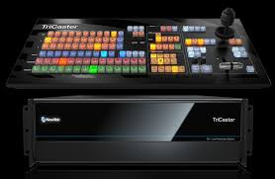

- Video Camera: Is a camera used for electronic motion picture acquisition, initially developed for the television industry but now common in other applications as well. There are types of shots using the Zoom, the Close up Shot, Medium Close up (MC) and the Medium long shot (MLS).
Experiences using the camera
Colour adjustment, Cropping, framing and composition of picture including the layout, PAN, the movement of camera from right to left. Tilt movement which include the up and down tilt movement. Light and create visual image, there are different types of light which is the fill light, the back light, the hard light, and the spot light.
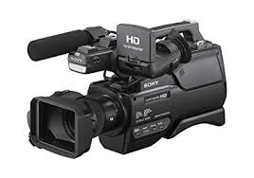

- Teleprompter: Is a display device that prompts the person speaking with an electronic visual text of a speech or script using a teleprompter is similar to using cue cards. I heard experiences on how weather forecast script to the teleprompter by highlighting all first then copy the document and clicking the teleprompter software, then add script and paste, then connect the teleprompter. A laptop was used to operate it to make it move fast and slow. Which was normally carried out by Mrs. Kemi Olorufemi.
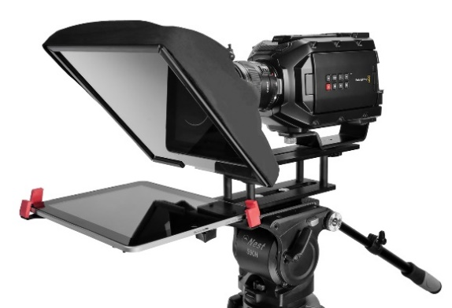

- Audio mixer: A mixer is an electronic device which is often used for changing the quality and the levels of audio signals. It is also known as a mixing console, an audio mixer, or a soundboard. Using a mixer is the most convenient way to route or combine various audio signals and even change the timbre and dynamics of the sound.

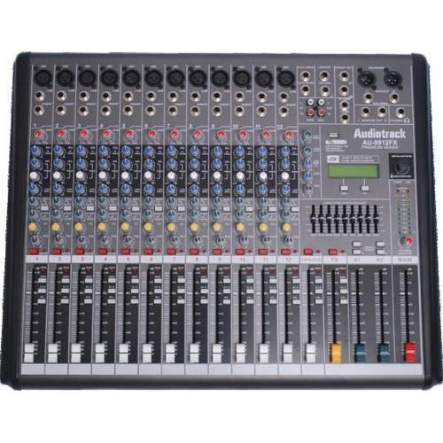

- Lapel microphone: Is a small microphone used for television, theatre, and public speaking, in order to allow for hands-free operation.
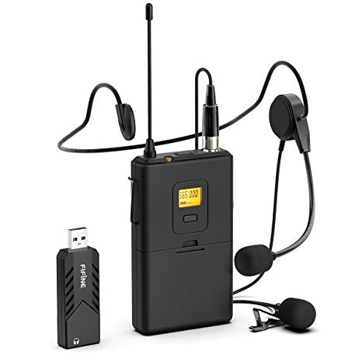

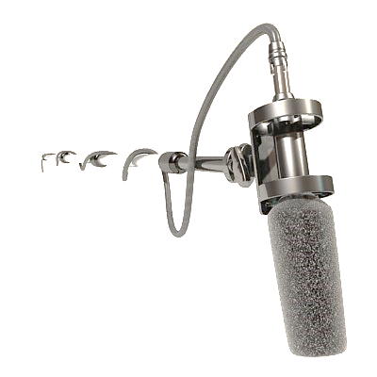
- Boom mic: is used to pick up sounds of the presenter and the guests, from ascending to decending order in all angels of the studio.

- Kenflo Lights: Is mainly used in the studio to clear shadows of an object, to also have a clear image of the subject or talent
Type of light
1. Fill Light is placed by the side of the subject to cast out shadow or to fill out shadows
2. Back lights are placed at the back of the subject to light him/her from behind.
3. Hard Light close to the natural light, source from the sun
4. Spot light is controlled narrowly focused beam of light
- Standing light is mainly used to have a clear picture or visual of the object behind the scene while a program or interview is being conducted
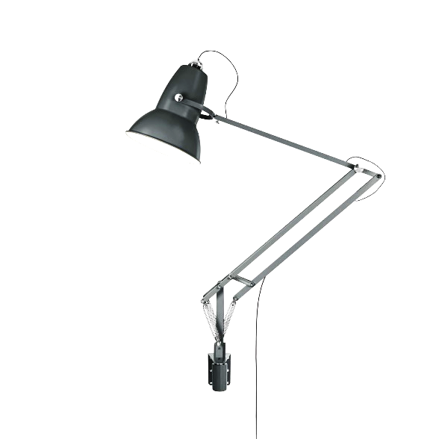

3.3 STRUCTURAL REPRESENTATION OF STUDIO SIGNS
Studio signs also refer to as using studio stickers with written words of instruction using to conduct the activities of a reporter in the studio. It is also used in order to avoid distortion while reporting news.
ADVERT
BREAK
STOP
ROUND-UP

STRETCH
OR
SLOW DOWN
SPEED-UP
STAND-BY
SLOW DOWN

COME
CLOSER
OK
30
SECONDS
15
SECONDS
CUT
ON
TIME

KEEP
TALKING
GO
BACK

STOP
DON’T
MOVE
A
MINUTES
COUNT
DOWN
CHAPTER FOUR
RECOMMENDATION AND CONCLUSION
4.1 RECOMMENDATION
The recommendations arising from the foregoing appraisal of the effectiveness of SIWES in the formation of competent and productive technical manpower for the economy are summarized as follows;
- The establishment of a National Commission for Student Industrial Training or a National Board for Cooperative Education was proposed to oversee the implementation of SIWES at the national level.
- Funds earmarked for SIWES should be appropriated directly by the National Assembly in the same way for the National Youth Service Corps Scheme in order to remove the bottlenecks associated with release of fund for the operation of the scheme.
- The Federal Government should make adequate provisions in the annual budget for proper funding for SIWES in view of the potentials of the scheme to contribute to enhancing the quality of pool of technical skills available to the economy.
- The stipulation that employers should accept students for SIWES should be strengthened with stiffer penalties put in place for defaulters.
- A review of the policies that guide and regulate SIWES is necessary to ensure that the scheme complies fully with the tenants of cooperative education or work-integrated learning.
4.2 CONCLUSION
The Student Industrial Work Experience Scheme (SIWES) plays a significant role in human resource development, it helps students develop new skills and enlightens them of what the present society holds for them after graduation and helps them adapt accordingly. As a result of the programme, I am now more confident to build my future my four (4) months industrial attachment has been one of the most interesting, productive and instructive experience in my life. Through this training, I have gained new insight and more comprehensive understanding about the real industrial working condition and practice; it has also improved my soft and functional skills. All these valuable experience and knowledge that I have gained were not only acquired through the direct involvement in task but also through other aspect of training such as work observation, interaction with colleges, superior and other people related to the field.

