

A TECHNICAL REPORT ON
STUDENT INDUSTRIAL WORK EXPERIENCE SCHEME
(SIWES)

HELD AT:
UNIVERSITY OF ILORIN TEACHING HOSPITAL
ALONG OLD-JEBBA ROAD, OKE-OYI ILORIN KWARA STATE

WRITTEN BY
SIKIRU FATHIA KEMISOLA
ND/23/SLT/FT/0048

SUBMITTED TO
DEPARTMENT OF SCIENCE LABORATORY TECHNOLOGY,
INSTITUTE OF APPLIED SCIENCE (IAS),
KWARA STATE POLYTECHNIC, ILORIN
IN PARTIAL FULFILLMENT OF THE REQUIREMENTS FOR THE
AWARD OF NATIONAL DIPLOMA (ND) IN SCIENCE LABORATORY TECHNOLOGY

AUGUST –NOVEMBER, 2024
DEDICATION
This report is dedicated foremost to Almighty Allah for his favour may and grace upon my life especially during my 4 months Siwes programme.
I would also like to dedicate it to my lovely parent and siblings for their love and support and everyone else that contribute towards making my Siwes training fun and successful one

ACKNOWLEDGEMENT
My profound gratitude to Almighty Allah for keeping me alive, the giver and taker of lives and also extend my gratitude to my parent for their supports and prayers toward my every step in life. I pray my parent live long to eat the fruit of their labour
My sincere appreciation also goes to my parent Mr. and Mrs. SIKIRU for their spiritual, moral and financially support towards the success of my SIWES programme.

TABLE OF CONTENTS

Table of Contents 1

Chapter One: Introduction
1.1 What is SIWES 2
1.2 Brief History of SIWES 2
1.3 Aim and Objectives of SIWES 3
1.4 Various Department in the Laboratory 3
1.5 Laboratory Rules and Regulations 3
1.6 Laboratory Equipments and their Uses 4

Chapter Two: Hematology Tests
2.1 Blood Group 6
2.2 Genotype 7
2.3 Hemoglobin test 7
2.4 Pack cell volume test 8
2.5 White blood cell count 9

Chapter Three: Serology Tests
3.1 Pregnancy test 10
3.2 Widal test 10
3.3 Typhoid fever test 11
3.4 Hepatitis B Surface Antigen test 12

Chapter Four: Clinical Chemistry Tests
4.1 Urinanalysis 14
4.2 Urine Macroscopy 14
4.3 Urine Chemistry 14
4.4 Urine microscopy 15

Chapter Five: Parasitology Tests
5.1 Stool analysis 16
5.2 Stool macroscopy 16
5.3 Stool microscopy 16
5.4 Malarial parasite test 17

Chapter Six: Microbiology Tests
6.1 Culture media 18
6.2 Preparation of media 18
6.3 Stool culture 18
6.4 High Vagina Swab microscopy 19
6.5 Semen analysis 19
6.6 Measurement of volume 20
6.7 Measurement of pH 20
6.8 Percentage and Viable spermatozoa 20
6.9 Semen culture 20
Chapter Seven: Relevance of SIWES 21

CHAPTER ONE

1.0 INTRODUCTION

WHAT IS SIWES:
SIWES (students industrial work experience scheme) is a scheme designed by the federal ministry of education, the industrial training fund is the National board for technical education and institution of high students in Nigeria.
SIWES (students industrial work experience scheme) is aimed at granting or exposing students to experience the nature of work they are to encounter when they finish their program in school depending on one discipline
The scheme also gives students opportunity to gain experience practically what was not taught in school during their programme.
It also helps students to practicalize the theory aspect of their lecture in school. It also gives the students the opportunity to be versatile .it makes the students popular, it also act as a medium of job opportunity when they finish their programme in school.
It gives a detailed account of all work carried out during SIWES and as well as the problems faced.

1.1 BRIEF HISTORY OF SIWES
The student Industrial Work Experience Scheme (SIWES) was established in 1973/1974 session by the Industrial Training Fund (ITF). Prior to the establishment of this scheme, there was a growing concern among our industrialists that graduates of our institutions of higher learning lacked adequate practices background studies preparatory to employment in the industries. It is against this background that the aim of initiating and designing the scheme was hinged.
Consequently, the scheme affords students the opportunity of familiarizing and exposing themselves, to the needed experience in handling equipment and machinery that are usually not available in the institutions.
The ITF solely funded the scheme during its formative years. It withdraws from the scheme in 1978 due to the financial problem. The federal government handed the scheme in 1979 to both the National University Commission (NUC) and the National Board of Technical Education (NBTE). Later, in November 1984, the federal government changed the management and implementation of the scheme to ITF and it was effectively taken over by the Industrial Training Fund (ITF) in July 1985 with the funding being solely borne by the federal government.

1.2 AIMS AND OBJECTIVES OF SIWES
- It act as medium for job opportunity for students
- It provides students with experience outside their programme in school
- It grants students opportunity to practicalize the theoretical aspect of their course in school
- Expose student to the kind of work experience they will encounter when they graduate
- Expose students to know the operation and function of the instruments involved in their course of study.
- It makes students know how to manage difficult in work when they graduate.

1.4 VARIOUS DEPARTMENT OF THE LABORATORY.

(1) RECEPTIONIST /COLLECTION SECTION:
This is the unit where patients are received and attended to regarding to the investigation written on their laboratory request forms by the doctor. Activities such as collection of clinical specimens and issuing of laboratory result forms are carried out in this section.
(2) SEROLOGY SECTION: This section is concerned with the laboratory investigation which involved the formation of immune complex (agglutination) from antigen and antigen and antibody reaction in the blood (serum). Clinical tests carried out in this section include Widal tests, hepatitis B surface Antigen (HBsAq) and Veneral Disease Research Laboratory (HIV) TESTS. Blood, especially serum which is used (3) PARASITOLOGY SECTION: This is the unit where clinical specimens are analyzed in search for parasitic organisms. The clinical specimens analyzed include stool, urine analysis.
- HEMATOLOGY: This section is concerned with Hemoglobin (blood penalty test), FBC, malaria test, HB-genotype , ABO groups.
- CHEMISTRY SECTION: This section is concerned with cholesterol, FBS and RBS,
- MICROBIOLOGY: Deals with urine, stool, HVS ( urine Swab), urethral, P.T (Pregnancy tests),
Sensitivity test etc.

1.5 LABORATORY RULES AND REGULATIONS
- Laboratory coat and hand gloves should be worn in the laboratory
- Eating, drinking, smoking and dancing should be avoided in the laboratory III. Hands should be washed after handling a sample and when leaving the laboratory IV. All benches should be cleaned before and after the day work.
V. Avoid being bare footed, cover shoes should be worn in the laboratory VI. Hairs should be covered with Hair net.
- Fingers and nails should be cut short
- Labeling of sample should be done with care

1.6 LABORATORY EQUIPMENTS AND THEIR USES
MICROSCOPE: this equipment is used of the examination of samples and magnification of microorganisms that cannot be seen with the naked eyes, its parts include object lens which have l00x,40x, and l0x objective lenses other parts are fine and coarse adjustment knobs
AUTOCALVE: this is used in sterilization of glass wares and media used in the laboratory to avoid contamination. It consists of chambers on which the articles are placed and treated with steam At high pressure.
INCUBATOR: It is used for incubating cultured plate for 24 hours -48 hours at the temperature between 37oc-4000c so as to obtain proper growth of microorganisms.
LABORATORY OVEN: It is used for sterilization of meta wares and also for preservation.
CENTRIFUGE: It is used for sedimentation of particles, is used in separating components of different densities in a liquid, using centrifugal force.
WEIGHING BALANCE: This is used for measuring mounts of substance required for analysis which measure in grams.
ELECTROPHORESIS MACHINE: It is used for carrying out test on genotype.
REFRIGERATOR: This is for the preservation of samples.
HAEMATOCRITE CENTRIFUGE: This is used for sampling blood with microhaeamatocrit capillary tubes to know the blood percentage of an individual.
SYRINGE: They are used to give injection and also for collection of blood sample through venous blood collection in the lab for laboratory practical.

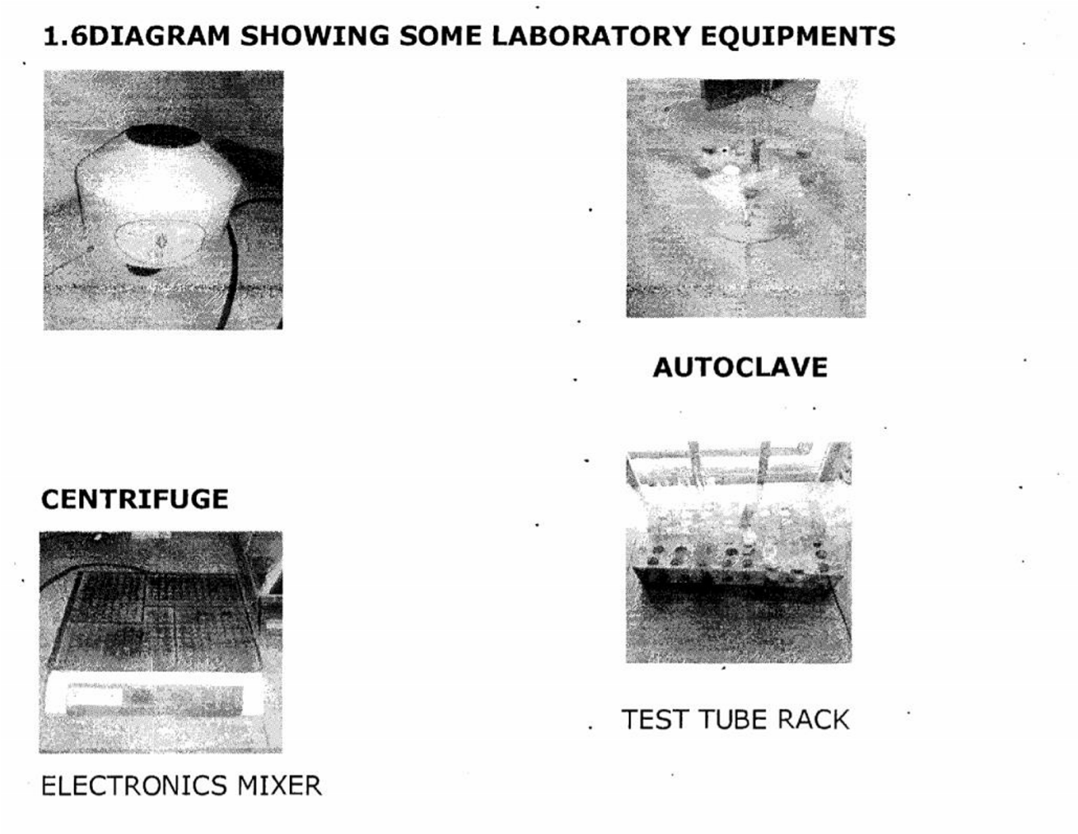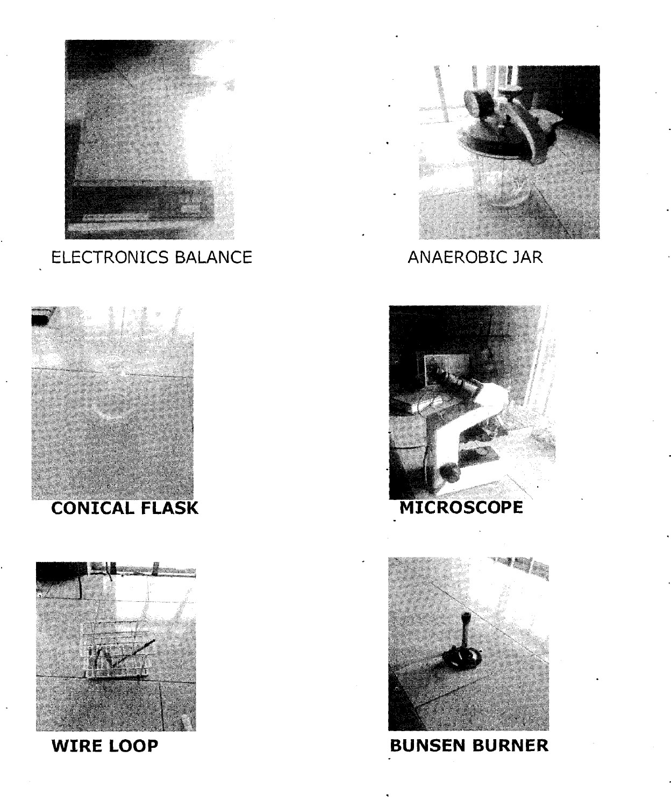

CHAPTER TWO

2.0 HAEMATOLOGY TEST
This is the test used in carrying out the investigation of anemia, infection and pyrexia 9 fever) of unknown origin, investigation heamoglobinopathics and monitoring patients receiving antiretroviral therapy (ART).

2.1 BLOOD GROUP
This is all ABC blood group system are clinically the most important. blood group donors and patients must be grouped correctly to avoid the death of the patients when the ABC is incompatible . The ABC blood group w have: AB, AB, A, K, B+, B, O+,0 AIM:
The aim is to determine a patient’s blood group Apparatus:
Anti sera A,B, and C clean and dry title applicators, sterile blood lancet, sterile swap and hand glove.

TECHNIQUES:
After a patient thumb has being cleaned with sterile swap and allow to dry, a puncture is made with the lancet and the first drop of the blood is cleaned off.
And then pressed to get another drop of blood which is drooped at three division on a tile.
Add one volume of the respective anti-sera A B and 0 to the blood samples
Using applicators mix the anti —sera with the blood respectively Rock for 2-3 minutes and then record your result. -

HOW TO READ YOUR RESULT

BLOOD TYPE ANTI -A ANTI -B ANTI-D
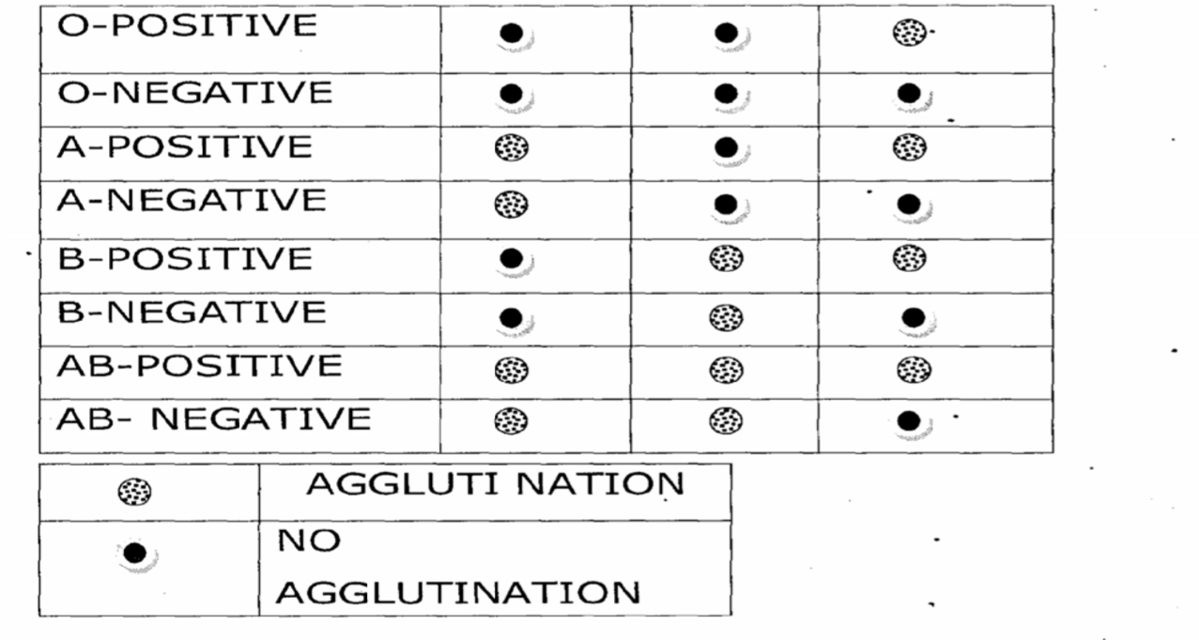

2.2 GENOTYPE
Genotype or haemoglobin electrophoresis is used to separate and identify the different haemoglobins by their migration within an electric field. Haemoglobin variants separate at different rates due to different in their surface electric charges as determined by their amino acid structure .the predominant Genotype are AA and AS ,SS while AC ,SC etc Aim :to detect ones genotype.
Apparatus: sterile swap, 2m1 syringe ,harid glove ,Tris buffer cellulose acetate membrane, clean and dry tile ,application ,a positive and negative control i.e. AS and. AA ,water, pasture’s pipettes, electrophoresis machine.

PROCEDURE:
After blood collection using pasture’s pipette
The blood is placed using on a clean tile also your control placed at a different division.
Using another pasture’s pipette ,pipette small volume of water and add to the respective blood samples..then mix separate using an application to make the mixture light for easy separate of the samples.
Using respectively applicators place the sample on a cellulose acetate member respectively .
Pour l00mis of this EDTA borate buffer ip each of the electrophoresis chamber.
Put the cellulose acetate member in an electrophoresis machine placed side down.
Cover the tank and correct to power supply leave for 25 minutes to separate.
RESULT : if the result is AA when there are two lines when the S migrate to the positive electrode and then A to the negative electrode then is AS. When A migrate only to the negative electrode then it is AA and when the S riigrate to positive electrode and another S migrate to the positive electrode then it is SS.

2.3 HB (HAEMOGLOBIN ) TEST
This test is measures to check anemia and its verity and also to monitor an anemic patient’s response to treatment. Also , when a patient’s is being treated with HIV.
AIM :the aim to detect the level of a patient haemoglobin level Apparatus :HB test tube HB pipette calibrated 2Ot, sterile blood lancet, hand glove, a clean tile, tissue paper, diluting fluid Hcl application, HB meter, sterile swap, tissue paper.

PROCEDURE:
After blood collection by puncture on the thumb and then cleaned and pressed to collect another blood
The blood is placed on a tile
A patient’s thumb is cleaned will sterile swap and allowed to dry, then a lancet is used to puncture deeply to allow free flow of blood and the first blood deaned with swap,
Then the thumb is pressed and blood is collected and placed on a clean tile.
The HB pipette is used to pipette 20 ml of blood exactly and if it is over a tissue paper is used to wipe it off.
The Hb pipette blood is dispersed into a test tube containing a diluting fluid (HCL) of about 0.4ml and rimed there
The HCL is used to dilute the blood until it looks exactly like the control , the result is recorded with 5.1 unit g1d
Result: Hb (gIdi) 140 Newborn infants
110 6 months-6 years
120 6years -14 years
130 Adult males
120 Non pregnant adult female 110 Pregnant adult females.

2.4 PCV (PACKED CELL VOLUME)
Packed cell volume also known as haematocrit is used to screen for anemia when (haemoglobin) Hb is not measured accurately is also used to check dehydration, burn derue haemorrhagic fever and cythaemia e.t.c
Aim: this is to detect packed cell volume in the blood
Apparatus: EDTA containing blood capillary tubes (2)micro haematocrit reader, sealant ,centurion micro haemtocrit centrifuge.
Procedure: using the capillary tubes collected blood from well mixed Edta anti coagulated blood container, respectively in the capillary tubes.
Seal the unfilled end of the capillary tubes with a sealant respectively.
Place capillary tubes in the haematocrit centrifuge and spinned for five (5) minutes.
Bring out the capillary tubes and place in a micro heamatocrit reader and take your reading.

Result:
Children at birth 44-54%
Children 2-5 years 34 -40 %
Children 6-12 years 35-45%
Adult men 40-54%
Adult women 36-46%

2.5 WHITE BLOOD CELL (DIFFERENTIAL)(WBC)
This is the examination of their blood film used in the investigation and management of anemia, infections and other conditions that produced change, in the appearance of blood cells, it’s is also used rapidly to report a patient’s condition.
AIM: it is aimed at detecting condition that can cause change, in the appearance of blood differential white cell.
APPARATUS: Hand glove, sterile lancet, sterile swap, clean grease free slide, a clean cover slip undiluted leishman’s stains, immersion oil.
PROCEDURE: Using a swap clean a patient thumb puncture with the lancet deeply to enable free flow clean up the first flow of blood
Then press to bring out another flow which is placed at a point in a clean slide Using the cover slip a well made thin film on the slide is prepared.
Allow to dry and then stain using leishman’s for 2 minutes
Wash off and dilute with water for 8 minutes
Wash off with tap water and then allow to dry a drop of oil immersion and then Add view using x l00 objective under the microscope.

RESULT:
Neutrophils | = |  | (40-75)%
Lymphocytes | = |  | (21-40)%
Monocytes | = |  | (2-10)
Eosinophils | = |  | (0-1)%
Children | = |  | (2-6)%
Neurophil | = |  | (20-4)%
Lymphocytes | = |  | (45-70)%
Monocytes | = |  | (2-10)%
Basophils | = |  | (0. 1-1)%.
N/B: In preparation of a thin film, a drop of blood is made on a slide, then the cover slip is drawn back to touch the drop blood and allowed to extend the edge of the spreader holding the spreader at an angle of 300; the length of the thin film should be about (40-50)mm.

CHAPTER THREE

3.0 SEROLOGY TESTS
Serology tests are tests that make use of the reaction between antigens and antibodies in serum. It is a study of blood serum and other body fluids especially with regard to the response of the immune system to the pathogens. It is defined as the portion of blood that can be found in a veil of blood is left standing long enough to separate.

3.1 PREGNANCY TEST (P.T)
AIM: Qualitative determination of Human Chorionic Gonadotrophin (HCG) in serum or urine.
PRINCIPLE: The P.T strip membrane is pre-coated with HCG antibodies on the test line region of the strip. During testing, the serum or urine specimen reacts with the particle coated with a HCG antibody. The mixture migrates upwards on the membrane chromatographically by capillary action to react with anti-HCG antibodies.
SAMPLES: Serum/plasma or urine of a pregnant woman.
MATERIAL: Pregnancy test-strip
PROCEDURE: Spin the blood sample in a centrifuge so as to separate the plasma and the blood. Remove the P.T strip from the pouch and dip the pregnancy test inside the available sample.
OBSERVATION: Two distinct lines, one at the control line region and the other at the test line region or just a single line at the control line region might be seen.
RESULT/CONCLUSION: When two distinct line are seen the result is positive but if one line is seen, the sample is negative.

3.2 WIDAL TEST
Widal test is a test used for the diagnosis of typhoid fever, based on agglutination of salmonella typhi by dilution of the patient serum. -
Aim: To detect the presence of antibodies against salmonella organism that causes paratyphoid (typhoid fever).
Principle: This is based on agglutination reaction between an antibody present in the serum, produced specifically against salmonella antigen and the salmonella antigen suspension to form immune complex. Materials: Cromatest widal kit, Pasteur pipette, White tile with eight (8) depressions, blood (serum), Test tube, Glass rod, Centrifuge, Rocking machine.

Procedure:
- The patient’s blood is collected •using a tourniquet and stringe.
- The patient’s blood sample was transferred into a test tube and spun for 10 minutes using the centrifuge to obtain the serum.
- A drop of the serum was placed on each of the depressions on the white tile using Pasteur pipette.
- Equal amount of each of the salmonella antigen suspension (salmonella ‘0’ and ‘H’ antigen suspensions) was dropped beside the already dropped serum.
- The fluid was mixed homogenously.
- The white tile was rocked continuously for about 2 minutes and the mixture was observed for agglutination.

Result:
The result is graded according to the degree of agglutination on each fluid ranging from 1:20<1:80<1:160<1:320. The diagnostic titre value of enteric fever is1:80. Hence, any titre value equal or greater than 1:80 is diagnostic of enteric fever. The table below is a sample of Widal test result:
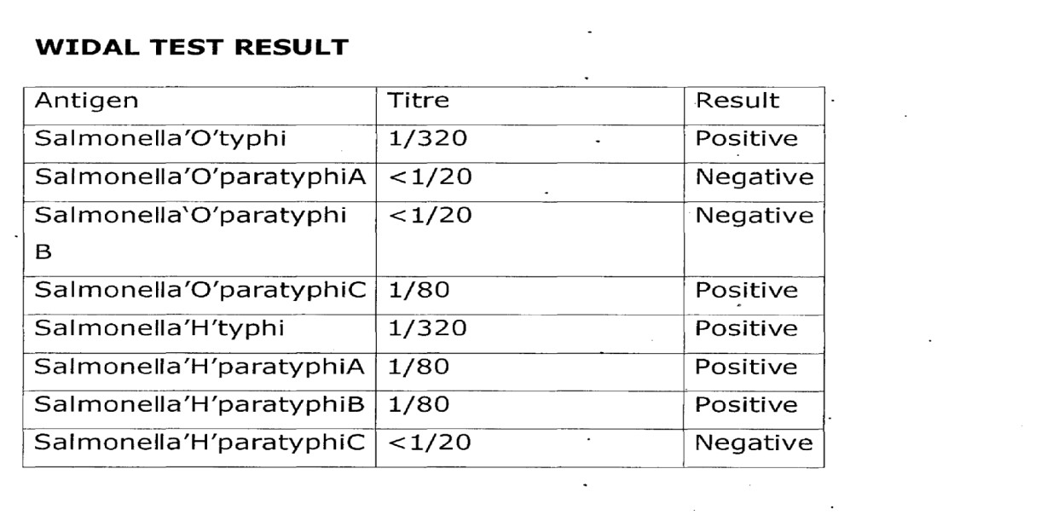

3.3 TYPHOID FEVER

Symptoms of Typhoid Fever
The symptoms of typhoid fever usually develop one or two weeks after a person becomes injected with the salmonella typhi bacteria.
- A high temperature which can reach up to 39-40°C (103- 104°F).
- Headache.
- Muscle ache.
- Stomach pain.
- Feeling sick, weakness and fatigue.
- Loss of appetite.
- Constipation or Diarrhea (Adults tend to constipation and children tend to get diarrhea).
- Dry cough.
- Weight loss
- Rashes made up of small pink spots.

Causes of Typhoid Fever
- Ingestion of contaminated water or food.
- Eating food or touching your mouth before washing your hands after going to the toilet.
- Eating seafood from a water source contaminated by infected faeces or urine.

Prevention of Typhoid Fever
- Get vaccinated against typhoid fever.
- Eat food that are thoroughly cooked-and are still hot.
- Avoid raw vegetable and fruits that cannot be peeled. Vegetable like lettuce are easily contaminated and are very hard to wash well.
- Avoid food and beverages from street vendors because it is difficult for food to be kept clean on the street, and many travelers get sick from food brought from the street vendors.
- Sanitation and maintenance of good hygiene.

Control of Typhoid Fever
- Safe drinking water. -
- Improved sanitation and adequate medical care.
- Taking vaccination against typhoid fever.
- Avoid raw fruits and vegetables.

3.4 HEPATITIS B SURFACE ANTIGEN (HSSAB) TEST
This is a serological test carried out to screen a patient blood for the hepatitis B surface antigen.
It aids in the diagnosis of Hepatitis B viral infection.
AIM: To screen a patient’s blood for Hepatitis B surface.
PRINCIPLE: Based on the agglutination reaction between an antibody produced in response to Hepatitis B viral infection and antigen embedded in the test strip.
MATERIAL: HBsAg test strip, Pasteur pipette, test tube, centrifuge and blood (serum) sample PROCEDURE:
- The blood sample was transferred into a test tube
- The sample was spun down by centrifugation at 3000 rpm for 10 minutes to obtain serum.
- Using Pasteur pipette, two drops of serum were placed on the absorbent end of the test strip. 4. The test strip was allowed to stand for 2 minutes and the result was observed

RESULT:
POSITIVE: Two distinct red lines, one line should be in control region (c) and another line should be in the test region.
NEGATIVE: One red line appears in the control region (c) no apparent red line appears in the test region (C).
INVALID: This occurs when the control Line fails to appear due to insufficient specimen volume or incorrect procedural techniques.

CHAPTER FOUR

4.0 CLINIC CHEMISTRY TESTS
In chemistry, a chemical test is a qualitative or quantitative procedure designed to prove the existence of, or to quantify a chemical compound or chemical group with the aid of a specific reagent

4.1 URINALYSIS:
This is a non-specific test that was used to detect the presence of some metabolites in urines whose concentration was used to determine the health condition of a patient such as diabetes, metabolic abnormalities, liver disease, binary and hepatic obstructions, hemolytic disease and urinary tract infection. Routine urinalysis consists of three testing groups which include urine microscopy, urine chemistry and urine microscopy.

4.2 URINE MACROSCOPY:
This measured the colour and transparency of urine sample which were determined from the visual observation of the sample in a sterile transparent container the physical characteristics of urine sample were noted as • Pale amber and clear
- Yellow and turbid
- Pale amber and clouding
- Yellow and clear
- Bloody

4.3 URINE CHEMISTRY
This was based on the dipping of the medi test combi-9 colour sections into the urine sample to check for the following parameters like pH, Glucose, Ascorbic acid, Protein, Nitrite, Ketone, Blood, Bilirubin and urobilinogen.
This test serves as a diagnostic tool which determines pathological changes in a patient’s urine in a standard urinalysis.
AIM: To determine pathological changes in patient urine
MATERIAL: Test tube, combi-9, urinalysis strip, test tube rack and sample container which contains the urine sample.

PROCEDURE
- A fresh urine sample of about l0mI was transferred from the transparent sample container into a test tube and fixed in the test tube rack.
- The combi-9 strip was dipped into the well-mixed urine sample contained in the test tube.
- The combi-9 strip was brought out from urine sample and the edge of the strip the supported over the mouth of the test tube to remove excess urine.
- The result was read within 60 seconds by matching the colour changes with the standard chromatic scale provided by the manufacturer on the combi-9 container,

RESULT:
There may be colour changes. On the urinalysis strip indicating the presence of the parameters like PH, blood, Glucose, Bilirubin, Ketone, ascorbic acid, protein urobilinogen.

4.4 URINE MICROSCOPY
Urine was examined under a microscope in search of cellular fragments such as pus cells, epithelia cells, red blood cells, yeast cells, casts, crystals, parasites like flagellate of trichomonas vaginalis, and bacteria. AIM: To check for cellular fragments in urine sample.
MATERIAL: Urine in a sterile container, clean grease-free glass slide, sterile cover slip, centrifuge, test tube and microscope.

PROCEDURE
- The urine sample was shaked to homogenize.
- Urine sample of about l0ml was transferred from the sample container into a test tube.
- The urine sample in the test tube was spun down by centrifugation at 3000rpm for 10 minutes.
- The supernatant fluid was decanted and the deposit was mixed with the last drop that drained back into tube,
- A drop of the deposit was placed on the clean grease-free glass slide and covered. With a sterile cover slip without entrapping air bubbles.
- The preparation was mounted on the microscope and examined with xl0 and x40 objective.

RESULT
Cellular fragments such as red blood, cells, pus cells, epithelial cells, yeast cells, crystals, bacterial cells, casts and trophozoite of trichomonas vaginalis ma’ be seen in urine deposit in microscopy view.

CHAPTER FIVE

5.0 PARASITOLOGY TEST
Parasitology test are test carried out indoor to diagnosis for parasite and is normally based upon the microscopic appearance of the parasite in the patients specimen.

5.1 STOOL ANALYSIS
Stool analysis involves the examination of faecal specimen collected from patients to investigate the presence of parasites. Two aspects of stool analysis are described below.

5.2 STOOL MACROSCOPY
In this aspect of stool analysis, the physical characteristics of stool specimen were investigated. These physical characteristics are the color, presence of blood, mucus or pus consistency of the stool (formed, semi-formed, unformed, watery etc)
AIM: To determine the physical appearance of stool samples.
MATERIAL: Transparent sample container containing the stool sample.

PROCEDURE
- Stool sample was received from a patients in a transparent sterile container,
- The physical characteristic were examined using the unaided eye.

RESULT
The stool sample may appear brown-formed with mucus etc.

5.3 STOOL MICROSCOPY
Here, the stool sample was examined microscopically to investigate the presence of cysts and trophozoites of protozoa, ova and larvae of helminthes, sometimes, pus cells and epithelial cells were also present in the stool.
AIM: To check for enteric parasites in a stool sample
MATERIAL: Stool sample in a clean dry transparent container, applicator stick, clean grease-free microscope glass slide, sterile cover slip, normal saline, microscope and Pasteur pipette.

PROCEDURE
1. A drop of normal saline was placed on the clean grease free microscope glass slide using Pasteur pipette. 2. A little portion of the stool sample was collected and emulsified in the normal saline on the glass slide using an applicator stick.
- The preparation on the glass slide was covered with a sterile cover slip without entrapping air bubbles.
- The preparation was mounted and examined under the microscope using xl0 and x 40 objectives.

RESULT
Cysts and trophozoites of protozoa such as entamoeba histolytica, gardia lambia etc as well as ova larvae of helminthes eg Ascaris lumbricoides etc may be seen. Other include epithelia cells, pus cells etc

5.4 MALARIA PARASITE TEST
Aim: to investigate the presence of malaria parasite (plasma odium) in the blood sample
PRINCIPLE: the thick blood film dictates the parasite present as Giemsa stain is used to stain the film which helps for easy identification with the addition of immerson oil.
SAMPLE: Whole Blood
MATERIALS: clean glass slide, cotton wool, spreader, staining rod, immersion oil, and microscope. .
PROCEDURE: inverse the blood container for the blood to mix then place 1-2drops of blood sample on a clean, dry grease free slide make a thick film or smear. Allow to air-dry and flood the slide with Giemsa stain and allow for -10 minutes, then allow to air-dry. When completely dry, apply a drop of immersion oil to an area of the cover an area of the 10mm in diameter. Select the examiner for malaria parasite.
OBSERVATION/RESULT: Trophozoites of plasmodium faeciparium and Monocytes containing black pigment was seen with x100 oil immersion. A thick red dot is found on these black pigments. If one red dot is seen, it is record as +, if two are seen, it is recorded as ++ etc.

CHAPTER SIX

6.0 MICROBIOLOGY TEST

6.1 CULTURE MEDIA
A culture medium is any nutrient, liquid or solid material that can support the growth of microorganisms.
The most important requirement of a culture medium is it’s ability to allow a detectable growth from a minute incubate within the shortest period of incubation.

6.2 PREPARATION OF MEDIA
- A weighing balance was kept on a fiat table and its scale was adjusted to zero. -
- A thin foil was placed on the balance and it’s weight was noted.
- The agar base powder was collected and placed on the foil using a spatula until the required quantity was obtained.
- The dehydrated agar medium was then tranferred into a clean dry graduated conical flask
- A corresponding volume of distilled water was measured using the measuring cylinder and was transferred into the conical flask containing each agar.
- The mixture was stirred gently to mix using
- The mouth of the conical flask was corked and placed in an autoclave.
- The mixture was sterilized at 121°c for l5mins.
- After autoclaving, the mixture w allowed to cool

6.3 STOOL CULTURE
This was used for the diagnosis of intestinal tract infection caused by especially enteric pathogens such as salmonella enteritidis, shigella dysenteria.
AIM: To detect the presence of enteric pathogens in stool sample.
MATERIALS: Wire loop, Bunsen burner, stool sample and agar plates (salmonella-shigella agar, bload agar and macConkey Agar plates) incubator.

PROCEDURE
- The wire loop was flamed to red hot in Bunsen flame and allowed to cool.
- Using the flame sterilized wire ioop, stool sample was introduced on the agar plates (macConkey agar, SS agar and blood agar).
- The wire loop was flamed again to red hot, allowed to cool and the inoculum was streaked out on the agar plates.
- The culture plates were incubated at 37°C for 24hours.
- The incubated plates were inspected for colonial growth after
24hours of incubation at 37°C

RESULTS
Bacteria such as salmonella enteritidis, shigella dysenteriae and Escherichia Coil as in the case of infantile gastroenteritis may be isolated. Sensitivity test was performed for the effective antibiotics to which the bacterial isolate was sensitive.

6.4 HIGH VAGINAL SWAB (HVS) MICROSCOPY
AIM: To detect the presence of yeast cells and motile organism.
METHOD: Direct wet mount.
MATERIALS: High vaginal swab sample, normal saline, clean grease free glass slide, sterile cover slip, Pasteur pipette and microscope.

PROCEDURE:
- 3-5 drops of normal saline were introduced into the swab stick to moisten it using Pasteur pipette.
- A drop of moistened specimen was placed on a clean grease free glass slide.
- The preparation was covered with a sterile cover slip without entrapping air bubbles.
- The preparation was mounted under the microscope and was examined with xl0 and x40 objective.

RESULT
A motile microorganism like Trichomonas vaginalis, and yeast cells, pus cells and epithelial cells may be seen.

6.5 SEMEN ANALYSIS
Semen analysis was carried out to investigate infertility in a human male adult. The parameters assessed in semen analysis include: 1. Measurement of volume
- Measurement of PH
- Examination of wet preparation to estimate the percentage of motile spermatozoa and viable forms and look for cells and bacteria. 4. Sperm count
5. Examination of stained preparation to estimate the percentage of spermatozoa with normal morphology. The appearance of semen- can be viscoid or hyperviscoid, but becomes liquefied within 60 minutes after ejaculation due to the action of fibrinolysin in the fluid.

6.6 MEASUREMENT OF VOLUME
Normal semen has a volume of 2ml or. above in the laboratory, it was measured using a small graduated cylinder after liquefaction.

6.7 MEASUREMENT OF PH
- A drop of liquefied semen was placed on a narrow range PH.
- After 30 seconds, the PH of the semen was recorded. The PH of normal semen should be PH 7.2 or more within 1 hour of ejaculation.
When the PH is over 7.8, this may be due to infection. When the PH is below 7.0 and the semen is found to contain no sperm, this may indicate dygensis of vas deferens, seminal vesicles or epididymis.

6.8 PERCENTAGE MOTILITY AND VIABLE SPERMATOZOA
- A drop of well-mixed liquefied semen was placed on a clean grease free glass slide and covered with a sterile cover slip.
- The specimen was focused on the microscope using the xl0 objective and the fields were examined to assess motility using x40 objective.
- A total of 100 spermatozoa was counted and the motile ones were noted out of the hundred. Then the percentage that were motile and non-motile were recorded. Normal motility is when over 50% of spermatozoa are motile within 60 minutes of ejaculation. When more than 6O% of spermatozoa are nonmotile, eosin preparation is examined to assess whether the spermatozoa are viable or non viable.

6.9 SEMEN CULTURE
Semen is sterile, as such, any microorganism found in it is said to be pathogenic. Pathogens may include staphylococcus aureus, Neisseria gonorrhea etc.
Semen culture was carried out when infection was suspected in a male adult.
AIM: To detect the presence of pathogens in semen sample.
MATERIALS: SEMEN sample, wire loop, blood agar plate and macConkey agar plate, Bunsen burner and incubator.

PROCEDURE
- An inoculating wire lop was flammed to red hot on a Bunsen flame and allowed to cool.
- The inoculum (semen sample) was inoculated into the agar plates (blood agar and macConkey agar plates) using a flame sterilized wire loop.
- The wire loop was sterilized again in a Bunsen flame to red hot, allowed to cool and used to streak the inoculate on the agar plates in a definite pattern.
- The culture plates were incubated at 37°c for 24hours. Culture plates were inspected far growth after the period of incubation 37°c.

RESULT:
Bacteria commonly isolated in semen culture include Escherichia coli, staphylococcus aureus etc. after isolation of bacteria growth, antibiogram was carried out for the effective antibiotics to which the bacteria isolate was sensitive.

CHAPTER SEVEN

7.0 RELEVANCE OF THE SIWES PROGRAMME
I benefit a lot during the programme which I believed is still relevant in the following areas:
It exposed me to work methods, techniques in handling equipments that are not available in school

7.1 ADVICE TO THE COMPANY/ORGANIZATION
There should be formal training and orientation for the students under their care.
There should be appreciative measure on the part of the company because a student will work when he/she is appreciated even if not monetary.
Monthly defense of what the student has learnt should be done.

7.2 ADVICE TO THE INSTITUTIONS
- Quality orientation programmes should be organized for all intending I.T. students and should be made compulsory (it should be on departmental/faculty levels due to the significance of each disciplines)
- Many I.T students roam about because of lack of placement. The institution should liaise (departmentally) with some industries/organizations who will always be ready to assist.
- Each I.T students should be allowed tcr defend their reports of SIWES programme instead of group defense.
- Visiting of the students by the institution should be taken with all seriousness.

7.3 ADVICE TO THE STUDENTS
- SIWES is not money-making ventures. Students should learn how to work now to get all necessary pay in the future.
- To those who refrain from active work, going around for personal businesses or selfish interest should stop it because the six months is not made for that but to acquire skills and knowledge.
- To all who really participated in the SIWES, please don’t forget all you have learnt and never trade for anything.

